No | Penghargaan Orang Tua kepada Anak | SS | s | R | TS | STS
' Pemberian Perhatian
1. | Saya senang ketika orang tua memperhatikan memperhatikan  aktivitas saya setiap hari.
2. | saya selalu diingatkan oleh orang tua untuk sarapan pagi sebelum  berangkat ke sekolah, agar dapat mengikuti mata pelajaran dengan  baik.
3. | Orang tua selalu mengingatkan agar saya memperhatikan  perlengkapan belajar sebelum berangkat ke sekolah.
4 | Orang tua memberikan semangat sebelum saya berangkat ke sekolah  agar dapat belajar dengan baik.
5 | Saya senang ketika pulang ke rumah orang tua menanyakan pelajaran  apa yang didapatkan dari guru di sekolah?
Pemberian Hadiah
6 | Saya senang ketika prestasi baik orang tua memeluk dan uicubcn  ancungan jempol.
~7^ | Saya senang diberi hadiah.
Saya selalu giat belajar karena orang tua memberi hadiah ketika
prestasi belajar saya meningkat di sekolah.
' saya senang meTfdapIu^hadiahT^ ___
baik ^{Orang tua ket}>ka pr_{e}s,’~^{r}T’-
 | prestasi belajar
'To' | -'Saya tidak Pe™ah^SRd555Fh5_{5SS}-_{s;T}_^_____________^  belajar saya baik. ^{ng 1113 mes}kipun prestasi | — |  |  | —
TT | Hadiah paling baik y^nT^T^^r  ^{g sa}ya ^{da}r»ik_{a}„  orang tua. ^{y aan} | —
hF | saya senang mendapIH^dUh^^T^TT^—
^{patU bdlu dari} orang tua ketika
prestasi belajar saya baik.
113 | Saya selalu semangat belajar agar prestasi belajar baik di sekolah dan  mendapat hadiah dari guru.
 | Pemberian Pujian
114 | Saya senang dipuji.
115 | Saya sering mendapat pujian.
116 | Saya senang dan selalu semangat belajar ketika orang tua memberi  pujian.
1.7 | Saya senang mendapat pujian dari orang tua ketika prestasi belajar  baik.
1 8 | Saya senang mendapat pujian dari orang tua ketika berhasil  menyelesaikan tugas PR.
1'9 | Saya selalu mengingingkan prestasi yang baik, meskipun orang tua  tidak memberi pujian.
’«0 | Pujian orang tua selalu mendorong saya untuk mengembangkan  potensi yang ada dalam diri saya.
’ll | Pujian orang tua selalu membuat saya senang dalam melakukan  tindakan yang baik.
12 | Saya senang di pujian orang tua ketika nilai ulangan baik.
!3 | Saya senang mendengar kata-kata pujian dari orang tua seperti, bagus  sekali nilai ulanganmu, indah sekali gambarmu, hebat sekali, dll.
.< | Saya akan merasa berharga ketika orang tua memuji saya dengan  tulus.
55 | Saya senang mendapat pujian dari orang tua tanpa pamrih.

I iNo | Prestasi Belajar Siswa | SS | S | R | TS | STS
—Ranking
i "'r  1 | Saya senang mendapat ranking di sekolah.
i "'r  1 | Saya selalu giat belajar karena ingin seperti teman-  teman mendapat ranking.
" r⁻  i | Saya mendapat ranking di sekolah ketika rajin belajar  dengan baik.
4 | Saya mendapat ranking karena orang tua selalu setia  membimbing dalam belajar.
5 | Saya ingin mendapat ranking agar dapat  membanggakan orang tua
6 | Saya selalu raji pergi ke sekolah agar cepat pintar dan  mendapat ranking.
7 | Saya senang ketika naik kelas, meskipun tidak dapat  ranking.
8 | Saya selalu berusaha mendapatkan yang terbaik ketika  orang tua memberi perhatian dalam belajar, walaupun  tidak mendapat ranking.
9 | Saya selalu berusaha mendapat ranking karena orang  tua menjanjikan saya untuk membelikan tas baru.
10 | Orang tua selalu memarahi saya kalau saya tidak  belajar karena mereka ingin prestasi saya baik dan  mendapat ranking.
11 | Orang tua tidak pema membimbing dalam belajar  tetapi saya selalu mendapat ranking.
12 | Orang tua senang ketika saya mendapat ranking.
13 | Saya senang mengikuti setiap mata pelajaran yang  diberikan oleh guru di sekolah agar mendapat prestasi  yang baik, naik kelas dan semoga mendapat ranking.
«et: SS  S | = Sangat Setuju  = Setuju
R | = Ragu-ragu
TS | = Tidak Setuju
STS | = Sangat Tidak Setuju
 | total | 115 | r H5 | f 122 | 1 1251 | CN  cn  m | i f los! | 125 [ | 100 / | LC | 1 115 i | M’  t—< | LT)’ | CT? | "s?
 | un | m- | m | tn | tn | CN  cn  m | i f los! |  |  |  |  |  |  |  |  | *-< | v^H  *—( | »—i  T-4 | S  T—< | m  o | 8  rH | rQ
 |  |  |  |  |  |  |  | in | M’ | in  m | M’ | m  in | tn | in | m | m | m |  |  | k
 | Mj  m | m- | m | LCJ | m | m | M' | LT) |  |  |  |  |  |  |  |  |  | M | m | M’ | U-) | cn  cn | ’to  CO | 3
 |  |  |  |  |  |  |  |  |  |  |  |  | in | W) | m | M’ | m | M’ | m | cn | M’ | oo | j-L  s  CO | 3
 | CN | ■m- | m | M* | tn | m | M’ | m | M’ | m | m | m | m | m | M | m | M’ | m | m | m |  | oo | cr> | o  3 | >
X  "□J  _Q  CO  'k_  CO  > .  C  CD  E  3  •4-» | CN | m- | M' | m | m | m | M’ | tn | M’ | m | m | m | tn | cn | M’ | m | M’ | m | m | cn | m | S | ’co | o'  I | >
X  "□J  _Q  CO  'k_  CO  > .  C  CD  E  3  •4-» | CN | m- | M’ | m | m | m | M’ | m | M | m | m | m | m | m | M | m | M’ | LT> | m | cn | m | s | _Q_  o’ | o'  3  o' | >
X  "□J  _Q  CO  'k_  CO  > .  C  CD  E  3  •4-» | O  CN | M' | M | tn | m | m | M’ | m | M’ | in | tn | M’ | m | cn | M’ | m | M’ | m | cn | M' | m | CO  oo | CM  CD | 3  o | >
X  "□J  _Q  CO  'k_  CO  > .  C  CD  E  3  •4-» | S | tn | M’ | m | m | m | M’ | m | M’ | in | m | LT> | m | m | M | m | M | m | m | m | m | cn  oo | S | 3  o' | >
X  "□J  _Q  CO  'k_  CO  > .  C  CD  E  3  •4-» | 00 | m | M' | m | m | m | M’ | m | M | m | m | m | m | cn | M | m | M’ | m | m | cn | cn | 00 | ’CD | 3  o' | >
X  "□J  _Q  CO  'k_  CO  > .  C  CD  E  3  •4-» |  | LH | M' | M | m | m | M | m | M’ | m | M’ | tn | m | m | cn | M | m | M’ | m | m | cn | 00 | "cn  LO  o’ | 3  o' | >
X  "□J  _Q  CO  'k_  CO  > .  C  CD  E  3  •4-» | UD  T—< | LH | m | LD | m | cn | M’ | m | M’ | m | M’ | in | in | m | cn | M’ | m | M’ | M’) | m | cn | cn  oo | o  CM  CD  .sL | 3  o' | >
X  "□J  _Q  CO  'k_  CO  > .  C  CD  E  3  •4-» | i_n | LH | m | m | tn | M | m | m | M | m | m | in | in | m | M | m | in | m | m | M) | M’ | CN  cn | o  oo  CD.  q’ | 3  o' | >
X  "□J  _Q  CO  'k_  CO  > .  C  CD  E  3  •4-» |  | m | m | m | m | m | m | m | M’ | m | M’ | in | in | m | cn | M | m | M’ | in | m | M’ | r-4  cn | o’ | 3  o' | >
LAMPIRAN 3  tabulisi data uji coba in | m | m | m | m | m | cn | M’ | m | M | m | M’ | m | in | m | cn | M’ | m | M’ | tf) | U’) | cn | cn  oo | o  (N  CP  O | 3  o' | >
LAMPIRAN 3  tabulisi data uji coba in | CN | LT) | M | m | m | m | m | m | M | in | m | m | m | m | M’ | m | M’ | in | cn | M’ | M’ | o  cn | cn  CD  ID  o | 3  o' | >
LAMPIRAN 3  tabulisi data uji coba in |  | m | M | m | Lf) | m | m | m | M’ | m | in | m | m | m | M | in | M | m | cn | M’ |  | o  O) | ‘CD  CD  lO | 3  o' | >
LAMPIRAN 3  tabulisi data uji coba in | O | m | M | m | m | m | m | m | M | m | m | LH | in | m | M’ | in | M | m | cn | M’ | M’ | o  cn | O>  (D  in  _Q_ | 3  o' | >
LAMPIRAN 3  tabulisi data uji coba in | CD | M | M' | m | m | m | m | m | M’ | LO | m | in | in | m | M | m | M | in | M’ | in | m | CN  0^ | C*)  cn  <D | 3  o' | >
LAMPIRAN 3  tabulisi data uji coba in | 00 | M’ | in | m | m | m | M’ | in | M | in | M | in | in | m | m | M’ | in | M’ | in | M’ | in | cn  00 | m  3  Q | 3  o' | >
LAMPIRAN 3  tabulisi data uji coba in | r- | m | m | M | m | in | M | m | M | m | m | m | lH | m | M | m | M | m | m | tn | m | m  cn | T“  M_  o’ | 3  o' | >
LAMPIRAN 3  tabulisi data uji coba in | <D | m | m | m | m | m | in | m | M | in | m | m | tn | m | M | m | M | m | M’ | m | in | S | CO  m  _jQ_ | 3  b' | >
LAMPIRAN 3  tabulisi data uji coba in | m | m | m | m | m | M’ | m | m | M | in | m | in | m | m | M | m | LD | m | cn | m | M’ | fN  O)  k— | o  CO  CD | 3  o' | >
LAMPIRAN 3  tabulisi data uji coba in | M- | M’ | LD | m | m | m | M | in | M | m | M | m | in | m | cn | M | m | M’ | m | M’ | m | cn  oo | ID  CD  o' | 3  o | >
LAMPIRAN 3  tabulisi data uji coba in | m | tn | m | m | in | m | M’ | m | M | in | M | m | in | in | cn | M’ | in | M | m | m | cn | (T>  00 | ’o  CN  CD  «si | 5  O | >
LAMPIRAN 3  tabulisi data uji coba in | <n | M | m | m | LH | cn | M | m | M’ | in | M | in | in | in | cn | M | m | M’ | m | M’ | in | cn  00  L | M’  CD | i  O | >
LAMPIRAN 3  tabulisi data uji coba in | c~< | m | un | m | m | M’ | m | m | M’ | vn | m | in | m | cn | M’ | m |  | m | cn | m | M’ | CN  O  i | o  CD  CD  <P | I  o | >
LAMPIRAN 3  tabulisi data uji coba in | cn  (D  CC | rH | CN | m | M’ | in | kD | hs | 00 | cn | o | rH | vH | cn | M | in | 2 | r* | S | 2 | O  (N | X  4-»  O | 00  c  □  -C | "o  -Q  (D | J

 |  |  | m  LD  k— | LD  m | 09  j
\jota\ | r4  LD  k— | O  ld  k— | m  LD  k— | LD  m | 09  j | LD  LD | rx  LD | LD | 2L_J | LD | f 59 | m  LD | cn  ID | CN  LD  LD | LD  ’t | cn  LD | 3 | 00  LD | O  LD | LD | 1164 |
H  H | LD | m | m | ’t | ’t | LD | ’t | LD | m | ’t | m | LD | ’t | CN  LD  LD | cn | LD | LD | LD | ’t |  | 00 | 0,833"*[ | S  c | 1
H  H | LH | m | m | m | in | LD | LD | t | cn | t | ID | LD | ’t | ’t | cn | LD | ’t | LD | LD | LD | CD | cn  o  (D | i  c | E  )
yH | t |  | in | ’t |  | LD | t | LD | cn | t | t | LD | t | LD | cn | LD | LD | LD | ’t | LD | 00 | 0,687** C | c | i' | >
10 | m | m | m | m | Lf) | LD | LD | LD | m | LD | t | LD | t | LD | t | t | LD | t | LD | cn | rH  O | CO  <D  d’ | c | ■  r | >
CD | ’t |  | m | m | m | LD | LD | LD | cn | LD | t | LD | t | LD | t | t | LD | t | LD | cn | (D  00 | 0,726" | c | i' | >
00 | m | in | m | m | LD | LD | LD | LD | m | LD | t | LD | t | LD | t | t | LD | t | LD | cn | 91 | 0,793“ | c |  | >
rs | in | in | m | ’t | t | LD | t | LD | cn | LD | ID | LD | t | t | t | LD | LD | t | t | cn | 00  00 | ‘ 0,771* | t  s  c | ) | >
LD | m | in | m | ’t | in | LD | LD | LD | t | m | LD | LD | t | LD | t | t | LD | t | LD | cn | i 92 | ’ 0,703*' | c | i' | >
m | m | m | m | ’t | m | LD | t | t | cn | m | m | LD | t | LD | cn | LD | LD | LD | LD | cn | LD  cn | «  (D  00  d  • | s  c |  | _>
t | m | ld | m | ’t | m | LD | t* | t | cn | m | m | LD | t | LD | cn | LD | LD | LD | t | t | o  cn | * 0,852* | O
cn | ’t | ’t | m | ’t | ’t | LD | t | m | cn | t | t | LD | t | LD | cn | m | LD | LD | t | LD | 00 | S  C0  (0  o' | c | ) | _>
(N | in | ’t | m | ’t | t | LD | t | LD | cn | in | m | LD | t | t | LD | t | LD |  | LD | LD | u  cn | 0,497* | ’C  ’C  c | )
H | LH | ’t | lh | 't | m | LD | t | t | cn | m | t | LD | m | m | cn | t | m | t | in | in | 1 89 | V“  0)  (0  6 | ’C  s  C | ) | _>
re rs | | H | fN | cn | t | m | ID | rs | 00 | cn | OT | H  ri | N  ri | cn  H | t  H | LD  H | ID  H | 1^  H | J 18 | 01  H | L 20 | total y | r hitung | r tabel |  | ket.

_Case Processing Summarv
 |  |  |  |  | N | %
Cases | Valid |  |  |  | 20 | 100,0
Cases | Excludedª |  |  |  | 0 | ,0
Cases | Total |  |  |  | 20 | 100,0
a. Listwise deletion based on all
variables in the procedure.
Reliability Statistics
Cronbach's  Alpha |  |  | Nof  Items
,754 |  |  | 26
Item Statistics
 |  | Mean |  | Std. Deviation |  |  | N
total_x |  | 111,90 |  | 11,281 |  |  | 20
VAR00001 |  | 4,60 |  | ,681 |  |  | 20
VAR00002 |  | 4,45 |  | ,686 |  |  | 20
VAR00003 |  | 4,45 |  | ,759 |  |  | 20
VAR00004 |  | 4,45 |  | ,686 |  |  | 20
VAR00005 |  | 4,60 |  | ,681 |  |  | 20
VAR00006 |  | 4,70 |  | .571 |  |  | 20
VAR00007 |  | 4,65 |  | ,587 |  |  | 20
VAR00008 |  | 4,45 |  | .686 |  |  | 20
VAR00009 |  | 4,60 |  | ,598 |  |  | 20
VAR00010 |  | 4,50 |  | ,688 |  |  | 20
VAR00011 |  | 4,50 |  | ,688 |  |  | 20
VAR00012 |  | 4,50 |  | ,688 |  |  | 20
VADfinn ~ ~~ r—
VAR00014  VAR00015__  VAR0001R |  | —_±45 |  | ——__759 |  | 20
 |  | —_155  —__£60 |  | __ ._.686  __ |  | 20  20
VAROOO17 |  | 4,45  4,35 |  | 759  745 |  | 20  20
VAR00018  VAROOO19 |  | 4,35 |  | .813, |  | 20
 |  | 4,45 |  | __ ,759 |  | on
VAR00020 |  | 4,30 |  | 733 |  | ZU  20
VAR00021 |  | 4,40 |  | ,754 |  | 20
VAR00022 |  | 4,40 |  | 754 |  | 20
VAR00023 |  | 4,35 |  | .745 |  | 20
VAR00024 |  | 4,35 |  | 745 |  | 20
VAR00025 |  | 4,45 |  | .686 |  | 20
ltem*Total Statistics
 | Scale Mean if  Item Deleted |  | Scale Variance  if Item Deleted |  | Corrected Item-  Total  Correlation |  | Cronbach’s  Alpha if Item  Deleted
total x | 111.90 |  | 127,253 |  | 1,000 |  | .939
VAR00001 | 219.20 |  | 488,589 |  | ,663 |  | 745
VAR00002 | 219,35 |  | 489,503 |  | ,627 |  | 745
VAR00003 | 219,35 |  | 488,345 |  | ,599 |  | 745
VAR00004 | 219.35 |  | 489,503 |  | .627 |  | 745
VAR00005 | 219,20 |  | 488,589 |  | ,663 |  | .745
VAR00006 | 219,10 |  | 494,726 |  | ,549 |  | 748
VAR00007 | 219,15 |  | 496,871 |  | ,451 |  | ,749
VAR00008 | 219,35 |  | 489,503 |  | ,627 |  | ,745
VAR00009 | 219,20 |  | 496,063 |  | .472 |  | ,749
VAR00010 | 219,30 |  | 491,800 |  | ,548 |  | •747
VAR00011 | 219,30 |  | 491,800 |  | ,548 |  | 247
VAR00012 | 219,30 |  | 491,800 |  | ,548 |  | .747
VAR00013 | 219,35 |  | 488,345 |  | ,599 |  | .745
VAR00014 | 219,25 |  | 494,724 |  | ,453 |  | ,748
VAR00015 | 219,20 |  | 488,589 |  | .663 |  | ,745
VAR00016 | 219,35 |  | 488,345 |  | ,599 |  | ,745
VAR00017 | 219,45 |  | 491,103 |  | ,525 |  | .746
VAR00018 | 219,45 |  | 481,103 |  | ,764 |  | ,741
VAR00019 | 219,35 | 483,503 | .747 | ,742
VAR00020 | 219,50 | 487,316 | .654 | ,744
VAR00021 | 219,40 | 484,147 | ,732 | ,742
VAR00022 | 219,40 | 484,147 | ,732 | ,742
VAR00023 | 219,45 | 484,368 | .734 | ,742
VAR00024 | 219,45 | 486,471 | ,669 | ,744
VAR00025 | 219,35 | 489,503 | ,627 | ,745
Uji Coba Reliability Y  Scale: ALLVARIABLES  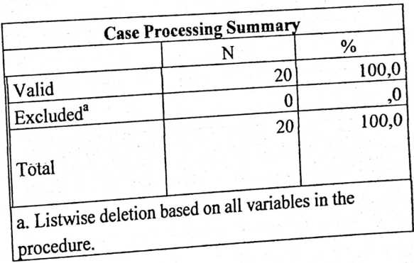  Cronbach's  Alpha | N of  Items
,769 | 14

VartwvvTT^
3 |  | 4,35 |  | ,671 |  |  | 20
VAROOOO  4 |  | 4,50 |  | ,688 |  |  | 20
VAROOOO  J |  | 4,50 |  | ,761 |  |  | 20
VAROOOO  6 |  | 4,60 |  | ,598 |  |  | 20
VAROOOO  7 |  | 4,40 |  | ,681 |  |  | 20
VAROOOO  8 |  | 4,55 |  | ,686 |  |  | 20
VAROOOO  9 |  | 4,45 |  | ,686 |  |  | 20
VAR0001  0 |  | 4,55 |  | ,686 |  |  | 20
VAR0001  1 |  | 4,35 |  | ,671 |  |  | 20
VAR0001  2 |  | 4,55 |  | ,686 |  |  | 20
VAR0001  3 |  | 4,45 |  | ,686 |  |  | 20
Kcm-Total Statistics
 | Scale Mean  ifltem  Deleted |  | Scale  Variance if  Item Deleted |  | Corrected  Item-Total  Correlation | Cronbach's  Alpha if Item  Deleted
total y | 58,20 |  | 41,747 |  | 1,000 | ,928
VAROOOO  1 | 111,95 |  | 155,208 |  | ,661 | ,754
VAROOOO  2 | 111,90 |  | 159,568 |  | ,460 | ,762
VAROOOO  3 | 112,05 |  | 155,524' |  | ,658 | ,754
VAROOOO  4 | 111,90 |  | 152,305 |  | ,837 | ,747
VAROOOO  5 | 111,90 |  | 150,516 |  | ,851 | ,744
VAROOOO  6 | 111,80 | 156,484 | ,678 | »755
V AKOOOO  7 | 112,00 | 153,895 | ,748 | ,751
VAROOOO  8 | 111,85 | 153,397 | ,772 | ,750
VAROOOO  9 | 111,95 | 154,576 | ,700 | ,752
VAR0001  0 | 111,85 | 153,397 | ,772 | ,750
VAR0001  1 | 112,05 | 155,524 | ,658 | ,754
VAR0001  2 | 111,85 | 156,766 | ,567 | ,757
VAR0001  3 | 111,95 | 152,682 | ,816 | ,748

I
}
i
i
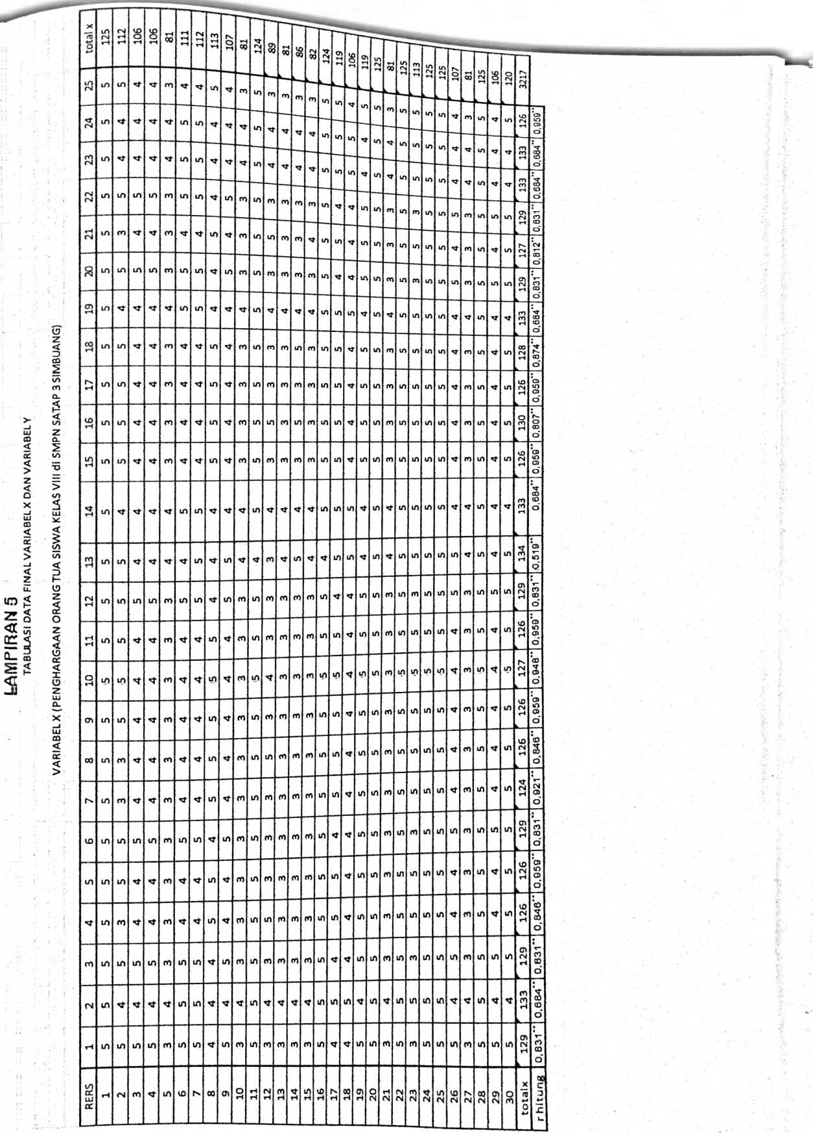
I

j
H

(Al
la
la
m
©
©
la
LA
■i
LA
!•'
LA
LA
©
LA
m
©
ini cni t
m
LA
© on
m
LA
t
LA
LA
LA
m
m
0)
(N
O
i
(N
LA
m
LD
(A
N
LA
N
cn
N
CD
fM
ul
rj
cn
CN
0)
©
Q
0)
©
O
o
©
0)
10
Al
CO
N
CD
N
00
(N
©
Q
t
H
0) O
rl CM
©
H
H
N
cd
CM
00
c
3
p
(M
©
O
CD
©
O
m
©
CD
m
(N
©
CD
m
CD
rs
n
m
nl
©
(N
©
©
©
©
©
CM
©
G)
00
N
0)
©
(B
N
LUJ
cr:
CD
cn
LA
LD
la
la
LA
cm m
LA (D
CM
LA
LA
U)
LA
©
n m
LA ©
m m
© ©
cd
m
(D
cn
la
G)
©
(D
la
LA
IA
LA
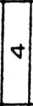
LA
la
m
CD
©
Q

ro
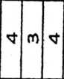
LA
LA
LA
LA
LAlcnist
©
©
(n
(N
k
m
cn
LA
LA
LA
LA
IA
LA
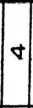
LA
’t
LA
m
LA
LA
m
ff)
St
LA
in
(N
N
’t
(N
01
N
O
CO
01
N
CD
©
D

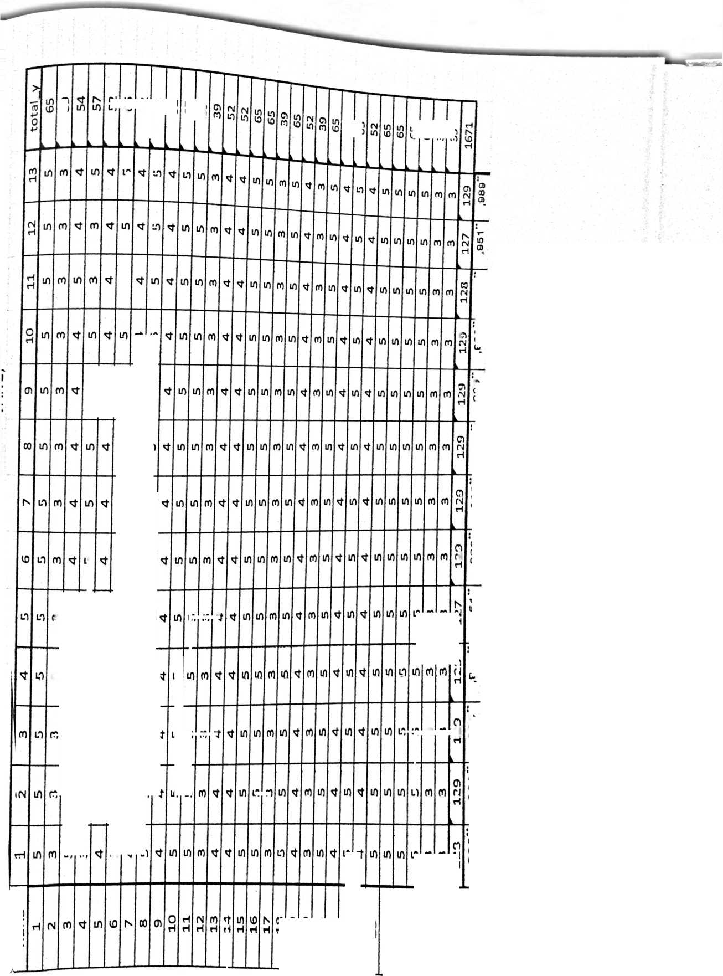
total_x
N | Valid | 30
N | Missing | 0
Mean |  | 107,23
Median |  | 111,50
Mode |  | 125
Std. Deviation |  | 16,494
Range |  | 44
Minimum |  | 81
Maximum |  | 125
total_x |  | Frequency | Percent | Valid Percent | Cumulative Percent
Valid | 81 | 5 | 16,7 | 16,7 | 16,7
Valid | 82 | 1 | 3,3 | 3,3 | 20,0
Valid | 86 | 1 | 3,3 | 3,3 | 23,3
Valid | 89 | 1 | 3,3 | 3,3 | 26,7
Valid | 106 | 4 | 13,3 | 13,3 | 40,0

 | 107 | ~2 ~ | ~~6J  ’ T3 | 6,7 | 46,7
 | 111  1 1 ? | 1  o | ~~6J  ’ T3 | 6,7 | 46,7
 |  |  |  | 3,3 | 50,0
 | 1 14, | Z | 6,7 | 6,7 | 56,7
 | 113 | 2 | 6,7 | __ | 56,7
 |  |  |  | 6,7 | 63,3
 | 119 | 2 | 6,7 | 6,7 | 70,0
 | 120 | 1 | 3,3 | 3,3 | 73,3
 | 124 | 2 | 6,7 | 6,7 | 80,0
 | 125 | 6 | 20,0 | 20,0 | 100,0
 | Total | 30 | 100,0 | 100,0

Frequency
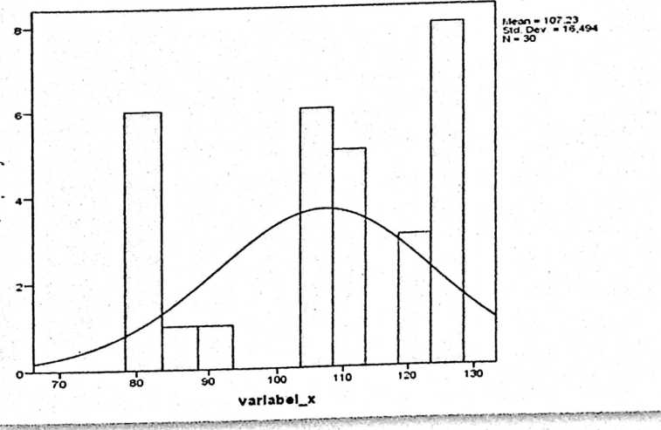
Lampiran 7
Deskripsi variabel Y
F^{r}equencies
Statistics
totaLy
N | Valid | 30
N | Missing | o
Mean |  | 55,70
Median |  | 55,50
Mode |  | 65
Std. Deviation |  | 10.168
Range |  | 26
Minimum |  | 39
Maximum |  | 65
totaLy |  | Frequency | Percent | Valid Percent | Cumulative Percent
Valid | 75 | 6 | 20,0 | 20,0 | 20,0
Valid | 100 | 8 | 26,7 | 26,7 | 46,7
Valid | 105 | 1 | 3,3 | 3,3 | 50,0
Valid | 111 | 1 | 3,3 | 3,3 | 53,3
Valid | 125 | 14 | 46,7 | 46,7 | 100,0
Valid | Total | 30 | 100,0 | 100,0

 |  | variabel_x
Normal  Distribution | Location | 107,23
Normal  Distribution | Scale | 16,494
The cases are unweighted.

 | total_y
Locatio | 107,20
Normal
n
Distribution
Scale | 19,556
The cases are unweighted.

Case Processing Summary
 | Cases
 | Included | Excluded | Total

 | N | Percent | N | Percent | N | Percent
Variabel_y *  variabel_x | 30 | 100,0% | 0 | 0,0% | 30 | 100,0%
Report |  | Variabel_y
variabel_x | Mean | N | Std. Deviation
81 | 115,00 | 5 | 13,693
82 | 125,00 | 1 | •
86 | 100,00 | 1 | •
89 | 75,00 | 1 | •
106 | 104,00 | 4 | 21,071
107 | 112,50 | 2 | 17,678
111 | 125,00 | 1 | •
112 | 87,50 | 2 | 17,678
113 | 125,00 | 2 | ,000
119 | 87,50 | 2 | 17,678
120 | 75,00 | 1 | -
124 | 125,00 | 2 | ,000
125 | 108,33 | 6 | 20,412
Total | 107,20 | 30 | 19,556
ANOVA Table —— ₍
 |  |  |  |  | Sum of Squares |  | F ~ |  | Sig.
Variab  el_y *  variabe  l_x | Between  Groups | (Combined) |  |  | 5987,967 |  | U62 |  | J64
Variab  el_y *  variabe  l_x | Between  Groups | Linearity |  |  | 79,387 |  | ,264 |  | ,614
Variab  el_y *  variabe  l_x | Between  Groups | Deviation from  Linearity |  |  | 5908,580 |  | 1,789 |  | ,136
Variab  el_y *  variabe  l_x | Within Groups |  |  |  | 5102,833
Variab  el_y *  variabe  l_x | Total |  |  |  | 11090,800 |  |  |  | 1
Measurcs of Association
 |  |  | R | R Squared |  | Eta |  | Eta Squared
Variabel_y * variabel_x |  |  | -,085 | ,007 |  | ,735 |  | ,540

Lampiran 11
Uji hipotesis

Regression
Variables Entered/Removedª
Mode  1 | Variables  Entered | Variables  Removed | Method
1 | variabel_x^{b} | • | Enter
a. Dependent Variable: Variabel_y
b. All requested variables entered.
Model Summary
Model |  | R | R Square |  | Adjusted R Square |  |  | Std. Error of the Estimate
1 |  | ,085ª | ,007 |  | -,028 |  |  | 19,831
a. Predictors: (Constant), variabel_x
ANOVA’
Model |  |  |  | Sum of Squares |  | Df | Mean Square |  | F | Sig.
1 | Regression |  |  | 79,387 |  | 1 | 79,387 |  | ,202 | ,657^{b}
1 | Residual |  |  | 11011,413 |  | 28 | 393,265
1 | Total |  |  | 11090,800 |  | 29
a. Dependent Variable: Variabel_y
b. Predictors: (Constant), variabel_x
Coefficients”
Model | Unstandardized Coefficients |  | Standardized  Coefficients | T | Sig.
Model | B | Std. Error | Beta | T | Sig.
(Constant)  1  variabel_x | 117,957 | 24,214 |  | 4,871 | ,000
(Constant)  1  variabel_x | -,100 | ,223 | -,085 | -,449 | ,657
a. Dependent Variable: Variabel_y

Lampiran 12:
N
3
4
5
6
7
8
9
10
11
12
13
14
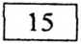
16
17
18
19
20

r tabel
NILAI-NILAI r PRODUCTMOMp^r"" “
]~ Taraf Signif

Taraf Signif
0.997
0.950
0.878
0.811
0.754
0.707
0.666
0.632
0.602
0.576
0.553
0.532
0.514
0.497
0.482
0.468
0.456
0.444
0.990
0.959
0.917
0.874
0.834
0.798
0.765
0.735
0.708
0.684
0.661
0.641
0.623
0.606
0.590
0.575
0.561

28
29
30
31
| Taraf Signif

5%

5%

1%
0.374
0.367
0.361
0.355
32 0.349
33
34
35
36
37
38
39
40
41
42
43
44
0.344
0.339
0.334
0.329
0.325
0.320
0.316
0.312
0.266
0.345
0.478 60 0.254
0.470
0.463
0.456
0.330
65
70
75
0.449 80
0.442
0.436
0.430
0.424
0.418
0.413
0.408
0.403
0.308 | | 0.398
0.304 | | 0.393
0.301 | | 0.389
0.297 ||| 0.384
0.244
0.235
0.227
0.220
0.317
0.306
0.296
0.286
85
90
95
100
125
150
175
200
300
400
500
600
0.213
0.207
0.202
0.195
0.176
0.159
0.148
0.138
0.113
| 0.098
0.088
0.080
0.278
0.270
0.263
0.256
0.230
0.210
0.194
0.181
0.148
0.128 |
0.115
0.105 I
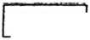
|0.433 | E^j49] | COlI | [jX294~| | Eojfo^] | Ctoo"]  r~8oo~
0.423 | [~6337~| | OOl] |  | {jU76~| | Ctoo"]  r~8oo~ | 0.074  A C\nr\ | f 0.097
0.413 | [~0^26~| | r~47~~] | [~0288~~| |  |  | v.0/0 | 0.09]
 |  | r~47~~] | [~0288~~| | P0.372~| | [~900~| | 0.065 | 0.086 |
0.404 | j~0.515 | |~48~| | [~0?284~| | |~0368~| | [Tooo | 0.062 | 0.081
0.396 | 0.505 | |~49~ | [~0.281 | P 0.364 | J | — | 1
0.388 | 0.496 | | 50 | P 0.279 | 0.361 |  |  | —

a = 0.1  L | 0.05 | 0.025  1 | 0.01  > ■ _{n}
ta= 1.282 | L645 | 1.960 | 2.326
3.078  1 ■ | 6.314  i | 12.706  ... | 31.821
. 1.886 : | 2.920 | 4.303 ; | 6.965
1.638 | 2.353! | 3.182 ! | 4.541
1.533 2.132'2.  0.005 0.001 0.0005  . 2.576 . 3.091 3.291 •'  t > v  < 1 J  63.656 318.289 636.578 i  5  6 i 1.440 U .943 [ 2.447  I ! I  7 1.415 1.895 . 2.365  ! 9.925 . 22.328 31.600  ' | !  iiTuinn^ii y irrfcWFW-JiT ~wn « i • ae  3.747  j- | i 4.604  •  t | 7.173 | 8.610 '  ¹
3.365  ■ | 4.032 | 5.894 | 6.869
: 3.143  !■ | 3.707 | 5.208 | 5.959 .
: 2.998  1 1 | 3.499  1  - - ■ | 4.785 | 5.408
: 2.896 . 3.355 4.501 ? 5.041  8 1.397 ; 1.860 i 2.306  9  10 1.372 1.812' 2.228  .— ........... ,. . ,_■ ....  11 j 1.363 11.796 2.201  12  1.356 1.782 2.179  1  13 : 1.350  2.764  2.718  2.681  j 3.250 | 4.297  r 7-.- . ..-r —1^
3.169 | 4.144
3.106 !  1 1 | 4.025 1  l
, - -g— . ■ -
■ 3.055 3.930
; “ ■
6-'- «■RR«OfieMi»^L|}r_{la}-

3.579  : - ■ | 3.883
I 3.552  r | 3.850
3.527 | 3.819
■  3.505 | 3.792 J
p''- - ¹ t  i 3.485  •! 1 | 3.768 j
3.745  25  -r. J- : r -■ ■ . ; -  1.316 1.708 2.060 2.485 2.787 3.450 3.725  26  27 [ 1.314 11.703^ 2.052 2.473 2.771 3.421 3.689  1.313 1.701 2.048  2.467 2.763 i 3.408 3.674  i !  iwi.m.ii fa>nn..niii.iiu i»* """t l—. T  29 1.311 1.699 2.045 2.462 2.756 3.396 3.660  30 | 1.310 | 1.697 | 2.042 | 2.457
60 | 1.296 | 1.671 | 2.000 | 2.390
120 | 1.289 | 1.658 | 1.980 | 2.358
00

i 2.617

1.6451 1.960 i 2.326 ; 2.576 . 3.091 3.291
1.282

Sumber: http://www.socr.ucla.edu/AppIets.dir/f-lable.html jam 09 15 H
Juni 2O15.Statistics Online Computational Resource
