1. | Nama | •
2. | Jenis Kelamin | ( ) Laki-laki  ( ) Perempuan
3. | Kelas | ( ) Kelas 3  ( ) Kelas 4  ( ) Kelas 5

- INSTRUMEN PENELITIAN (X nomor 1-16, dan Y nomor 17-26)
1. Dalam kelas guru perlu menceritakan pengalamannya
( ) Sangat Setuju
( ) Setuju
( ) Ragu-ragu
( ) Tidak Setuju
( ) Sangat Tidak Setuju
2. Guru meminta siswa menceritakan kepada teman tentang cara bergaul dalam
lingkungan
( ) Sangat Setuju
( ) Setuju
( ) Ragu-ragu
( ) Tidak Setuju
( ) Sangat Tidak Setuju
- Saya mendapat banyak teman melalui cerita pengalaman dalam pelajaran agama
( ) Sangat Setuju
( ) Setuju
( ) Ragu-ragu
( ) Tidak Setuju
( ) sangat Tidak Setuju
1
Dengan menceritakan pengalaman hidup, teman-teman dapat menolong( ) Sangat Setuju
( ) Setuju
( ) Ragu-ragu
( ) Tidak Setuju
( ) Sangat Tidak Setuju
- Saya menjadi berani berbicara saat guru agama membentuk diskusi di kelas
( ) Sangat Setuju
( ) Setuju
( ) Ragu-ragu
( ) Tidak Setuju
( ) Sangat Tidak Setuju
- Dalam diskusi pelajaran agama saya mendengar pendapat teman-teman
( ) Sangat Setuju
( ) Setuju
( ) Ragu-ragu
( ) Tidak Setuju
( ) Sangat Tidak Setuju
- Saya mengerti pelajaran yang disampaikan guru agama setelah ada diskusi
bersama teman.
( ) Sangat Setuju
( ) Setuju
( ) Ragu-ragu
( ) Tidak Setuju
( ) Sangat Tidak Setuju
- Saya senang menerapkan pengajaran agama yang telah didiskusikan di kelas.
( ) Sangat Setuju
( ) Setuju
( ) Ragu-ragu
( ) Tidak Setuju
( ) Sangat Tidak Setuju
- Saya tahu bagaimana menghadapi masalah melalui pelajaran agama.
( ) Sangat Setuju
( ) Setuju
( ) Ragu-ragu
( ) Tidak Setuju
( ) Sangat Tidak Setuju
- Kami diajak guru agama menemukan solusi dari masalah yang diceritakan.
( ) Sangat Setuju
( ) Setuju
( ) Ragu-ragu
( ) Tidak Setuju
( ) Sangat Tidak Setuju
2

- Guru agama meminta siswa menolong kelompok lain saat diskusi kelompok
dibuat di kelas.
( ) Sangat Setuju
( ) Setuju
( ) Ragu-ragu
( ) Tidak Setuju
( ) Sangat Tidak Setuju
- Guru agama memperlihatkan contoh-contoh masalah yang perlu diselesaikan.
( ) Sangat Setuju
( ) Setuju
( ) Ragu-ragu
( ) Tidak Setuju
( ) Sangat Tidak Setuju
- Guru agama perlu bertanya kepada teman satu persatu di kelas.
( ) Sangat Setuju
( ) Setuju
( ) Ragu-ragu
( ) Tidak Setuju
( ) Sangat Tidak Setuju
- Siswa dapat memberikan jawaban lebih banyak karena dipikirkan bersama.
( ) Sangat Setuju
( ) Setuju
( ) Ragu-ragu
( ) Tidak Setuju
( ) Sangat Tidak Setuju
- Materi yang disampaikann guru dapat dipahami lebih dalam melalui kelompok.
( ) Sangat Setuju
( ) Setuju
( ) Ragu-ragu
( ) Tidak Setuju
( ) Sangat Tidak Setuju
- Siswa dapat melengkapi jawaban teman atau kelompok lain dalam kelas.
( ) Sangat Setuju
( ) Setuju
( ) Ragu-ragu
( ) Tidak Setuju
( ) Sangat Tidak Setuju
- Saya senang belajar saat guru menceritakan pengalamannya
( ) Sangat Setuju
( ) Setuju
( ) Ragu-ragu
( ) Tidak Setuju
( ) Sangat Tidak Setuju
3

- Saya senang berteman melalui belajar agama
( ) Sangat Setuju
( ) Setuju
( ) Ragu-ragu
( ) Tidak Setuju
( ) Sangat Tidak Setuju
- Saya senang menolong teman setelah menceritakan pengalaman hidupnya melalui
belajar agama
( ) Sangat Setuju
( ) Setuju
( ) Ragu-ragu
( ) Tidak Setuju
( ) Sangat Tidak Setuju
- Saya senang berdiskusi dalam belajar agama
( ) Sangat Setuju
( ) Setuju
( ) Ragu-ragu
( ) Tidak Setuju
( ) Sangat Tidak Setuju
- Saya senang belajar agama karena menemukan jawaban dari permasalahan
( ) Sangat Setuju
( ) Setuju
( ) Ragu-ragu
( ) Tidak Setuju
( ) Sangat Tidak Setuju
- Saya sangat tertarik melakukan pelajaran melalui belajar agama
( ) Sangat Setuju
( ) Setuju
( ) Ragu-ragu
( ) Tidak Setuju
( ) Sangat Tidak Setuju
- Saya senang menjelaskan jawaban yang kami bicarakan dalam kelompok
( ) Sangat Setuju
( ) Setuju
( ) Ragu-ragu
( ) Tidak Setuju
( ) Sangat Tidak Setuju
- Saya senang belajar agama saat guru bertanya satu persatu kepada siswa di kelas
( ) Sangat Setuju
( ) Setuju
( ) Ragu-ragu
( ) Tidak Setuju
( ) Sangat Tidak Setuju
4

- Saya senang menambahkan jawaban pertanyaan yang diberikan kepada berteman
( ) Sangat Setuju
( ) Setuju
( ) Ragu-ragu
( ) Tidak Setuju
( ) Sangat Tidak Setuju
- Saya senang dangan penjelasan yang banyak dari materi pelajaran agama
( ) Sangat Setuju
( ) Setuju
( ) Ragu-ragu
( ) Tidak Setuju
( ) Sangat Tidak Setuju
Terima kasih untuk semua jawaban...
5

Respo-  den | Variabel X |  |  |  |  |  |  |  |  |  |  |  |  |  |  |  | Total
Respo-  den | 1 | 2 | 3 | 4 | 5 | 6 | 7 | 8 | 9 | 10 | 11 | 12 | 13 | 14 | 15 | 16 | Total
1 | 4 | 4 | 4 | 4 | 5 | 5 | 5 | 5 | 5 | 4 | 5 | 5 | 5 | 4 | 5 | 4 | 73
2 | 5 | 5 | 5 | 5 | 5 | 5 | 5 | 5 | 5 | 5 | 5 | 5 | 5 | 5 | 5 | 5 | 80
3 | 5 | 5 | 5 | 5 | 5 | 5 | 5 | 5 | 5 | 5 | 5 | 5 | 5 | 5 | 5 | 5 | 80
4 | 5 | 5 | 5 | 4 | 4 | 5 | 5 | 5 | 5 | 5 | 5 | 4 | 5 | 5 | 4 | 5 | 76
5 | 5 | 5 | 5 | 5 | 5 | 5 | 5 | 5 | 5 | 5 | 5 | 5 | 5 | 5 | 5 | 5 | 80
6 | 4 | 5 | 4 | 5 | 5 | 5 | 5 | 5 | 5 | 5 | 5 | 5 | 5 | 5 | 5 | 4 | 77
7 | 5 | 5 | 5 | 5 | 5 | 5 | 5 | 5 | 5 | 5 | 5 | 5 | 5 | 5 | 5 | 5 | 80
8 | 3 | 4 | 4 | 4 | 4 | 4 | 3 | 4 | 3 | 4 | 3 | 4 | 4 | 4 | 4 | 3 | 59
9 | 5 | 5 | 5 | 5 | 5 | 5 | 5 | 5 | 5 | 5 | 5 | 5 | 5 | 5 | 5 ₍ | 5 | 80
10 | 5 | 4 | 5 | 5 | 5 | 5 | 5 | 5 | 4 | 5 | 5 | 5 | 5 | 5 | 5 | 5 | 78
Jumlah | 46 | 47 | 47 | 47 | 48 | 49 | 48 | 49 | 47 | 48 | 48 | 48 | 49 | 48 | 48 | 46 | 763
r hitung | 0.907 | 0.667 | 0.703 | 0.738 | 0.712 | 0.933 | 0.667 | 0.667 | 0.831 | 0.833 | 0.933 | 0.712 | 0.933 | 0.833 | 0.712 | 0.907
r tabel | 0.63 | 0.63 | 0.63 | 0.63 | 0.63 | 0.63 | 0.63 | 0.63 | 0.63 | 0.63 | 0.63 | 0.63 | 0.63 | 0.63 | 0.63 | 0.63
Ket | valid | valid | valid | valid | valid | valid | valid | valid | valid | valid | valid | valid | valid | valid | valid | valid

 | 71 | —%—
Cases Valid | 10 | 100.0
Excludedª | 0 | 0.0
Total | 10 | 100.0
a. Listwise deletion based on all variables ln the  Reliability Statistics  Cronbach’s  Alpha | N of Items
.963 | 16
Item Statistics | Mean | —SS—  Deviation | N
P1 | 4.6000 | .69921 | 10
P2 | 4.7000 | .48305 | 10
p3 | 4.7000 | .48305 | 10
p4 | 4.7000 | .48305 | 10
p5 | 4.8000 | .42164 | 10
p6 | 4.9000 | .31623 | 10
P7 | 4.8000 | .63246 | 10
p8 | 4.9000 | .31623 | 10
p9 | 4.7000 | .67495 | 10
p10 | 4.8000 | .42164 | 10
p11 | 4.8000 | .63246 | 10
p12 | 4.8000 | .42164 | 10
p13 | 4.9000 | .31623 | 10
p14 | 4.8000 | .42164 | 10
p15 | 4.8000 | .42164 | 10
p16 | 4.6000 | .69921 | 10
Item-Total Statistics | Scale Mean  if Item  Deleted | Scale  Variance if  Item  Deleted | Corrected  Item-Total  Correlation | Cronbach’s  Alpha if  Item  Deleted
pi | '71.7®0 | 34.^78 | .885 | .959
P2 | 71.6000 | 38.489 | .623 | .963
p3 | 71.6000 | 38.267 | .662 | .963
p4 | 71.6000 | 38.044 | .701 | .962
p5 | 71.5000 | 38.722 | .678 | .962
p6 | 71.4000 | 38.711 | .926 | .960
P7 | 71.5000 | 35.167 | .918 | .958
p8 | 71.4000 | 38.711 | .926 | .960
p9 | 71.6000 | 35.600 | .795 | .961
p10 | 71.5000 | 38.056 | .812 | .960
p11 | 71.5000 | 35.167 | .918 | .958
p12 | 71.5000 | 38.722 | .678 | .962
p13 | 71.4000 | 38.711 | .926 | .960
p14 | 71.5000 | 38.056 | .812 | .960
p15 | 71.5000 | 38.722 | .678 | .962
p16 | 71.7000 | 34.678 | .885 | .959

Responden |  |  |  |  |  |  |  |  |  |  | Total
Responden | 1 | 2 | 3 | 4 | S | 6 | 7 | 8 | 9 | 10 | Total
1 | 5 | 5 | 5 | 5 | 5 | 5 | 5 | 5 | 5 | 5 | 50
2 | 4 | 5 | 5 | 5 | 5 | 5 | 4 | 5 | 5 | 4 | 47
3 | 5 | 5 | 5 | 5 | 5 | 5 | 5 | 5 | 5 | 5 | 50
4 | 4 | 4 | 4 | 4 | 4 | 4 | 4 | 4 | 4 | 4 | 40
5 | 4 | 4 | 4 | 4 | 4 | 4 | 4 | 4 | 4 | 4 | 40
6 | 5 | 5 | 5 | 5 | 5 | 5 | 5 | 5 | 5 | 5 | 50
7 | 5 | 5 | 4 | 5 | 5 | 4 | 5 | 5 | 5 | 5 | 48
8 | 4 | 5 | 5 | 5 | 5 | 5 | 5 | 5 | 5 | 5 | 49
9 | 5 | 5 | 5 | 5 | 5 | 5 | 5 | 5 | 5 | 5 | 50
10 | 4 | 4 | 4 | 5 | 5 | 4 | 4 | 4 | 5 | 5 | 44
Jumlah | 45 | 47 | 46 | 48 | 48 | 46 | 46 | 47 | 48 | 47 | 468
r hitung | 0.816 | 0.802 | 0.808 | 0.885 | 0.885 | 0.808 | 0.861 | 0.932 | 0.885 | 0.761
r tabel | 0.632 | 0.632 | 0.632 | 0.632 | 0.632 | 0.632 | 0.632 | 0.632 | 0.632 | 0.632
Ket | valid | valid | valid | valid | valid | valid | valid | valid | valid | valid
«li

 | N | %
Cases Valid | 10 | 100.0
Excludedª | 0 | 0.0
Total | 10 | 100.0
a. Listwise deletion based on all variables in the  Reliability Statistics  Cronbach's  Alpha | N of items
.955 | 10
Item Statistics | Mean | Std.  Deviation | N
p1 | 4.50 | .527 | 10
P2 | 4.70 | .483 | 10
P3 | 4.60 | .516 | 10
p4 | 4.80 | .422 | 10
p5 | 4.80 | .422 | 10
P6 | 4.60 | .516 | 10
p7 | 4.60 | .516 | 10
p8 | 4.70 | .483 | 10
p9 | 4.80 | .422 | 10
p10 | 4.70 | .483 | 10
 | Iterv | i-Total Statistics
 |  | Scale |  | Cronbach s
 | Scale Mean | Variance if | Corrected | Alpha if
 | if Item | Item | Item-Total | Item
 | Deleted | Deleted | Correlation | Deleted
p1 | 42.36 | 13.567 | .658 | .956
p2 | 42.10 | 12.989 | .913 | .945
P3 | 42.20 | 13.289 | .756 | .952
p4 | 42.00 | 13.556 | .859 | .948
p5 | 42.00 | 13.556 | .859 | .948
p6 | 42.20 | 13.289 | .756 | .952
p7 | 42.20 | 13.067 | .821 | .949
P8 | 42.10 | 12.989 | .913 | .945
p9  p10' | 42.00  42.10 | 13.556  13.656 | .859  .703 | .948  .954
P9 | 70.50 | 31.389 | .730 | .957
P10 | 70.40 | 32.044 | .658 | .958
P11 | 70.40 | 32.044 | .658 | .958
P12 | 70.50 | 31.167 | .771 | .956
P13 | 70.40 | 30.933 | .877 | .954
P14 | 70.30 | 31.344 | .923 | .954
P15 | 70.50 | 31.389 | .730 | .957
P16 | 70.40 | 31.600 | .745 | .957

NOMOR |  |  |  |  |  |  |  |  |  | PERTANYAAN VARIABEL X
RESP. | B1 | B2 | B3 | B4 | B5 | B6 | B7 | B8 | B9 | B10 | B11 | B12 | B13 | B14 | B15 | B16 | Total X
1 | 5 | 5 | 4 | 5 | 5 | 4 | 4 | 4 | 3 | 4 | 1 | 4 | 1 | 5 | 5 | 2 | 61
2 | 5 | 5 | 4 | 4 | 4 | 4 | 5 | 5 | 4 | 3 | 2 | 4 | 2 | 1 | 3 | 1 | 56
3 | 5 | 3 | 5 | 4 | 4 | 4 | 5 | 4 | 4 | 4 | 4 | 5 | 4 | 5 | 5 | 1 | 66
4 | 5 | 4 | 4 | 5 | 4 | 4 | 5 | 5 | 4 | 4 | 4 | 5 | 1 | 5 | 5 | 1 | 65
5 | 6 | 5 | 5 | 4 | 4 | 4 | 5 | 5 | 3 | 3 | 1 | 4 | 1 | 4 | 5 | 2 | 60
6 | 5 | 4 | 4 | 5 | 4 | 5 | 4 | 4 | 3 | 2 | 4 | 4 | 1 | 3 | 5 | 1 | 58
7 | 5 | 4 | 4 | 4 | 4 | 4 | 5 | 5 | 3 | 3 | 2 | 4 | 1 | 4 | 5 | 2 | 59
8 | 5 | 4 | 4 | 4 | 4 | 5 | 5 | 5 | 4 | 3 | 1 | 4 | 1 | 5 | 4 | 1 | 59
9 | 5 | 5 | ⁴ | 5 | 4 | 4 | 5 | 5 | 4 | 4 | 2 | 4 | 1 | 2 | 5 | 1 | 60
10 | 5 | 4 | 4 | 4 | 5 | 4 | 5 | 5 | 3 | 4 | 1 | 5 | 1 | 5 | 1 | 5 | 61
11 | 5 | 4 | 5 | 5 | 4 | 4 | 5 | 5 | 3 | 4 | 2 | 2 | 2 | 2 | 1 | 5 | 58
12 | 5 | 5 | 4 | 5 | 4 | 5 | 5 | 5 | 3 | 4 | 5 | 2 | 2 | 3 | 5 | 5 | 67
13 | 4 | 4 | 5 | 5 | 4 | 4 | 4 | 5 | 3 | 4 | 4 | 4 | 2 | 4 | 4 | 3 | 63
14 | 5 | 5 | 5 | 4 | 5 | 4 | 5 | 5 | 3 | 4 | 2 | 4 | 1 | 3 | 4 | 2 | 61
15 | 5 | 5 | 5 | 4 | 4 | 4 | 5 | 5 | 3 | 4 | 1 | 5 | 1 | 3 | 4 | 1 | 59
16 | 5 | 4 | 2 | 4 | 4 | 5 | 5 | 5 | 5 | 3 | 4 | 2 | 4 | 5 | 4 | 2 | 63
17 | 5 | 5 | 4 | 4 | 4 | 4 | 5 | 5 | 3 | 1 | 1 | 1 | 3 | 5 | 5 | 3 | 58
18 | 5 | 5 | 5 | 5 | 5 | 5 | 5 | 5 | 5 | 5 | 5 | 5 | 5 | 5 | 5 | 5 | 80
19 | 5 | 3 | 4 | 4 | 5 | 5 | 5 | 5 | 5 | 4 | 1 | 4 | 4 | 5 | 5 | 1 | 65
20 | 4 | 4 | 4 | 5 | 5 | 5 | 5 | 5 | 5 | 4 | 5 | 5 | 5 | 4 | 5 | 4 | 74
21 | 5 | 5 | 5 | 5 | 5 | 5 | 5 | 5 | 5 | 5 | 5 | 5 | 5 | 5 | 5 | 5 | 80
22 | 5 | 5 | 5 | 5 | 5 | 5 | 5 | 5 | 5 | 5 | 5 | 5 | 5 | 5 | 5 | 5 | 80
23 | 5 | 5 | 5 | 4 | 4 | 5 | 5 | 5 | 5 | 5 | 5 | 4 | 5 | 5 | 4 | 5 | 76
24 | 5 | 5 | 5 | 5 | 5 | 5 | 5 | 5 | 5 | 5 | 5 | 5 | 5 | 5 | 5 | 5 | 80
25 | 4 | 5 | 4 | 5 | 5 | 5 | 5 | 5 | 5 | 5 | 5 | 5 | 5 | 5 | 5 | 4 | 77
26 | 5 | 5 | 5 | 5 | 5 | 5 | 5 | 5 | 5 | 5 | 5 | 5 | 5 | 5 | 5 | 5 | 80
27 | 3 | 4 | 4 | 4 | 4 | 4 | 4 | 4 | 3 | 4 | 3 | 4 | 4 | 4 | 4 | 3 | 60
28 | 5 | 5 | 5 | 5 | 5 | 5 | 5 | 5 | 5 | 5 | 5 | 5 | 5 | 5 | 5 | 5 | 80
29 | 5 | 4 | 5 | 5 | | 5 | 5 | 5 | 5 | 4 | 5 | 5 | 5 | 5 | 5 | 5 | 5 | 78 |

Responden | PERTANYAAN VARIABEL Y
Responden | B1 | B2 | B3 | B4 | B5 | B6 | B7 | B8 | B9 | B10 | TOTAL Y
1 | 5 | 4 | 5 | 5 | 5 | 4 | 4 | 4 | 1 | 5 | 42
2 | 5 | 5 | 1 | 5 | 4 | 5 | 4 | 4 | 1 | 6 | 39
3 | 5 | 5 | 5 | 5 | 3 | 5 | 4 | 4 | 1 | 4 | 41
4 | 5 | 5 | 4 | 4 | 4 | 4 | 5 | 4 | 1 | 5 | 41
5 | 5 | 4 | 5 | 5 | 4 | 5 | 4 | 4 | 2 | 4 | 42
6 | 5 | 4 | 4 | 5 | 5 | 4 | 4 | 4 | 4 | 4 | 43
7 | 5 | 5 | 4 | 5 | 4 | 4 | 5 | 4 | 1 | 5 | 42
8 | 2 | 5 | 5 | 5 | 4 | 6 | 5 | 4 | 1 | 5 | 41
9 | 5 | 5 | 5 | 4 | 4 | 5 | 5 | 4 | 1 | 5 | 43
10 | 5 | 5 | 4 | 5 | 3 | 5 | 5 | 5 | 1 | 5 | 43
11 | 5 | 5 | 5 | 4 | 5 | 5 | 5 | 5 | 2 | 5 | 46
12 | 4 | 5 | 2 | 4 | 5 | 5 | 4 | 5 | 2 | 5 | 41
13 | 5 | 4 | 5 | 4 | 2 | 4 | 5 | 4 | 4 | 4 | 41
14 | 5 | 4 | 5 | 5 | 5 | 5 | 4 | 4 | 1 | 5 | 43
15 | 5 | 5 | 5 | 4 | 5 | 4 | 5 | 2 | 2 | 5 | 42
16 | 5 | 5 | 4 | 5 | 5 | 5 | 2 | 2 | 2 | 4 | 39
17 | 5 | 3 | 5 | 4 | 4 | 5 | 5 | 4 | 2 | 4 | 41
18 | 5 | 5 | 5 | 5 | 5 | 5 | 5 | 5 | 5 | 5 | 50
19 | 4 | 4 | 4 | 5 | 3 | 4 | 5 | 4 | 5 | 4 | 42
20 | 6 | 5 | 5 | 5 | 5 | 6 | 5 | 5 | 5 | 5 | 50
21 | 4 | 5 | 5 | 5 | 5 | 5 | 4 | 5 | 5 | 4 | 47
22 | 5 | 5 | 5 | 6 | 5 | 5 | 5 | 5 | 5 | 5 | 50
23 | 4 | 4 | 4 | 4 | 4 | 4 | 4 | 4 | 4 | 4 | 40
24 | 4 | 4 | 4 | 4 | 4 | 4 | 4 | 4 | 4 | 4 | 40
25 | 5 | 5 | 5 | 6 | 5 | 6 | 5 | 5 | 5 | 6 | 50
26 | 5 | ⁵ | 5 | 5 | 5 | 4 | 5 | 5 | 5 | 5 | 49
27 | 4 | 5 | 5 | 5 | 5 | 5 | 5 | 5 | 5 | 5 | 49
28 | 5 | 5 | 5 | 6 | 5 | 5 | 5 | 6 | 5 | 5 | 50
29 | 4 | 4 | 4 | 5 | 5 | 4 | 4 | 4 | 5 | 5 | 44

i Valid |  |  |  | 29
N
Missing |  |  |  | 0
Mean |  |  |  | 67.03
Median |  |  |  | 63.00
Mode |  |  |  | 80
Std. Deviation |  |  |  | 8.898
Range |  |  |  | 24
Minimum |  |  |  | 56
Maximum |  |  |  | 80
 | Frequency | Percent | Valid Percent |  | Cumulative  Percent
56 | 1 | 3.4 | 3.4 |  | 3.4
58 | 3 | 10.3 | 10.3 |  | 13.8
59 | 3 | 10.3 | 10.3 |  | 24.1
60 | 3 | 10.3 | 10.3 |  | 34.5
61 | 3 | 10.3 | 10.3 |  | 44.8
63 | 2 | 6.9 | 6.9 |  | 51.7
65 | 2 | 6.9 | 6.9 |  | 58.6
Valid 66 | 1 | 3.4 | 3.4 |  | 62.1
67 | 1 | 3.4 | 3.4 |  | 65.5
74 | 1 | 3.4 | 3.4 |  | 69.0
76 | 1 | 3.4 | 3.4 |  | 72.4
77 | 1 | 3.4 | 3.4 |  | 75.9
78 | 1 | 3.4 | 3.4 |  | 79.3
80 | 6 | 20.7 | 20.7 |  | 100.0
Total | 29 | 100.0 | 100.0

Fr«qu«ncy
Histogram
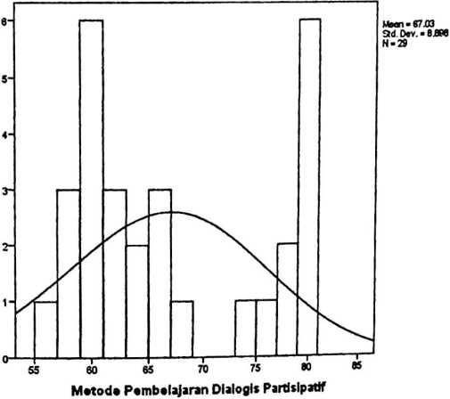

Valid | 29
N
Missing | 0
Mean | 43.83
Median | 42.00
Mode | 41
Std. Deviation | 3.790
Range | 11
Minimum | 39
Maximum | 50
Minat Belajar Peserta Didik Pada Mata Pelajaran PAK di SDN 355 Tibong | Frequency | Percent | Valid Percent | Cumulative  Percent
39 | 2 | 6.9 | 6.9 | 6.9
40 | 2 | 6.9 | 6.9 | 13.8
41 | 6 | 20.7 | 20.7 | 34.5
42 | 5 | 17.2 | 17.2 | 51.7
43 | 4 | 13.8 | 13.8 | 65.5
Valid 44 | 1 | 3.4 | 3.4 | 69.0
46 | 1 | 3.4 | 3.4 | 72.4
47 | 1 | 3.4 | 3.4 | 75.9
49 | 2 | 6.9 | 6.9 | 82.8
50 | 5 | 17.2 | 17.2 | 100.0
Total | 29 | 100.0 | 100.0

Frequ«ncy
Histogram
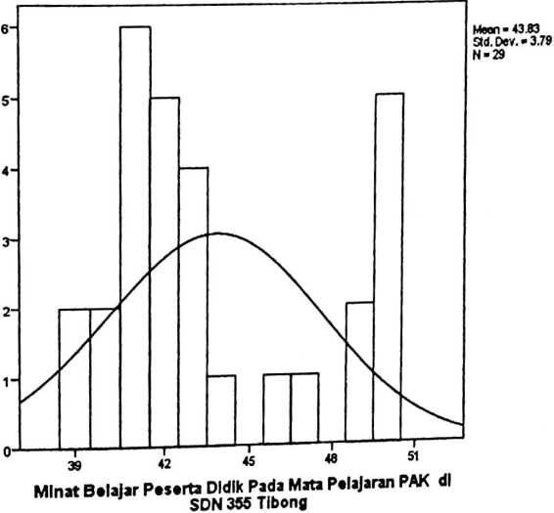

Metode
Pembelajaran
Dialogis
Partisipatif
Series or Sequence Length |  | 29
Number of Missing Values In | User-Missing | 0
the Plot | System-Missing | 0
The cases are unweighted.  Estimated Distribution Parameters |  | Metode  Pembelajaran  Dialogis  Partisipatif
Normal Distribution | Location  Scale | 67.03  8.898

The cases are unweighted.

Metode Pembelajaran Dialogis Partisipatif
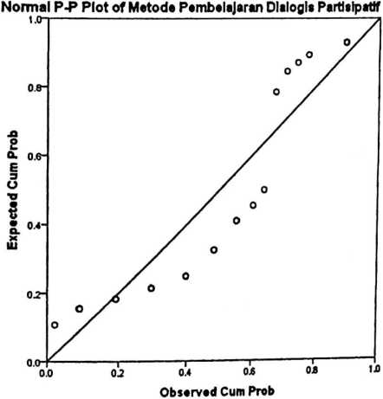
Detrended Normal P-P Plot of Matoda Pembelajaran Dialogis Partisipatif
E
E
£
1
Observed Cum Prob
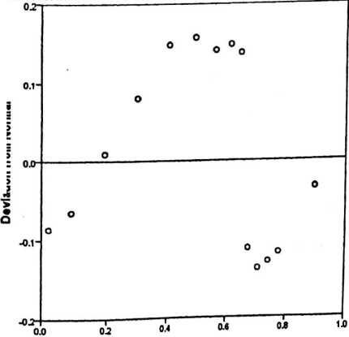
Minat Belajar
Peserta Didik
Pada Mata
Pelajaran PAK di
SDN 355 Tibong
Series or Sequence Length |  | 29
Number of Missing Values in | User-Misslng | 0
the Plot ' | System-Missing | 0
The cases are unweighted.  Estimated Distribution Parameters | Minat Belajar  Peserta Didik  Pada Mata  Pelajaran PAK di  SDN 355 Tibong
Location  Normal Distribution  Scale | 43.83  3.790

The cases are unweighted.

Minat Belajar Peserta Didik Pada Mata Pelajaran PAK di SDN 355

Tibong
Normal P-P Plot of Minat Belajar Peserta Didik Pada Mata Pelajaran PAK dl SDN
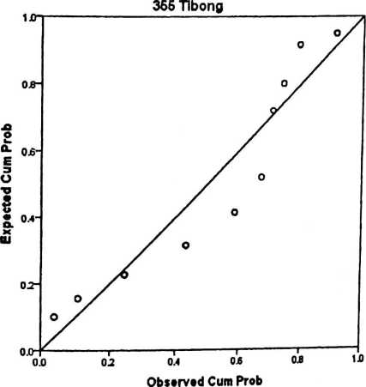
Detrended Normal P-P Plot of Minat Belajar Peserta Didik Pada Mata Pelajaran
PAK di SDN 355 Tibong
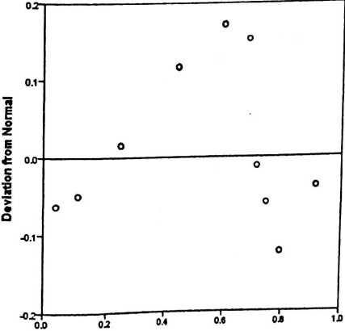
Observed Cum Prob

 | Cases —
 | InrJuded |  | Excluded |  |  | 'otal
 | N | Percent | N | Percent | N | Percent
Minat Belajar Peserta Didik  Pada Mata Pelajaran PAK di  SDN 355 Tibong * Metode  Pembelajaran Dialogis  Partisipatif | 29 | 100.0% | 0 | 0.0% | 29 | 100.0%
Report

Metode Pembelajaran Dialogis  Partisipatif | Mean | N | Std. Deviation
56 | 39.00 | 1 | •
58 | 43.33 | 3 | 2.517
59 | 41.67 | 3 | .577
60 | 44.67 | 3 | 3.786
61 | 42.67 | 3 | .577
63 | 40.00 | 2 | 1.414
65 | 41.60 | 2 | .707
66 | 41.00 | 1
67 | 41.00 | 1
74 | 50.00 | 1
76 | 40.00 | 1
77 | 50.00 | 1
78 | 44.00 | 1 | 3.933
80  Total | 47.67 | 6 | 3.933
80  Total | 43.83 | 29 | 3.790

 |  |  | Sum of  Squares |  | df | Mean  Square |  | F | Sig.
Minat Belajar Peserta (Combined) |  |  | 279.638 |  | 13 | 21.511 |  | 2.634 | .038
Didik Pada Mata Between Linearity |  |  | 129.673 |  | 1 | 129.673 |  | 15.878 | .001
Pelajaran PAK di SDN Groups Deviation from |  |  | 149.965 |  | 12 | 12.497 |  | 1.530 | .216
355Tibong ‘Metode Linearity
Pembelajaran Dialogis Within Groups |  |  | 122.500 |  | 15 | 8.167
Partisipatif _{Tota}| |  |  | 402.138 |  | 28
Measures o1 |  | Assoclation
 | R | R Squared |  | Eta |  |  | Eta Squared
Minat Belajar Peserta Didik  Pada Mata Pelajaran PAK di  SDN 355 Tibong * Metode  Pembelajaran Dialogis  Partisipatif | .568 | .322 |  | .834 |  |  | .695

Model | Variables Entered | Variables  Removed | Method
1 | Metode Pembelajaran Dialogis  Partisipatif*³ | • | Enter
a. Dependent Variable: Minat Belajar Peserta Didik Pada Mata Pelajaran PAK di SDN  355 Tibong  b. AU requested variables entered.  Model Summary  Model | R | R Square | Adjusted R  Square | Std. Errorofthe  Estimate
1 | .568’ | .322 | .297 | 3.177
a. Predictors: (Constant), Metode Pembelajaran Dialogis Partisipatif  ANOVA*  Model | Sum of  Squares | df | Mean Square | F | Sig.
Regression | 129.673 | 1 | 129.673 | 12.850 | .001
1 Residual | 272.465 | 27 | 10.091
Total | 402.138 | 28

Model |  | Unstandardized  Coefficients |  | Standardized  Coefficients | t | Sig.
 |  | B | Std. Error | Beta | t | Sig.
 | (Constant) | 27.61  5 | 4.561 |  | 6.055 | .000
1 | Metode Pembelajaran  Dialogis Partisipatif | .242 | .067 | .568 | 3.585 | .001

N | Taraf Signif |  | N | Taraf Signif |  | N | Taraf Signif
N | 5% | 1% | N | 5% | 1% | N | 5% | 1%
3 | 0.997 | 0.999 | 27 | 0.381 | 0.487 | 55 | 0.266 | 0.345
4 | 0.950 | 0.990 | 28 | 0.374 | 0.478 | 60 | 0.254 | 0.330
5 | 0.878 | 0.959 | 29 | 0.367 | 0.470 | 65 | 0.244 | 0.317
6 | 0.811 | 0.917 | 30 | 0.361 | 0.463 | 70 | 0.235 | 0.306
7 | 0.754 | 0.874 | 31 | 0.355 | 0.456 | 75 | 0.227 | 0.296
8 | 0.707 | 0.834 | 32 | 0.349 | 0.449 | 80 | 0.220 | 0.286
9 | 0.666 | 0.798 | 33 | 0.344 | 0.442 | 85 | 0.213 | 0.278
10 | 0.632 | 0.765 | 34 | 0.339 | 0.436 | 90 | 0.207 | 0.270
11 | 0.602 | 0.735 | 35 | 0.334 | 0.430 | 95 | 0.202 | 0.263
12 | 0.576 | 0.708 | 36 | 0.329 | 0.424 | 100 | 0.195 | 0.256
13 | 0.553 | 0.684 | 37 | 0.325 | 0.418 | 125 | 0.176 | 0.230
14 | 0.532 | 0.661 | 38 | 0.320 | 0.413 | 150 | 0.159 | 0.210
15 | 0.514 | 0.641 | 39 | 0.316 | 0.408 | 175 | 0.148 | 0.194
16 | 0.497 | 0.623 | 40 | 0.312 | 0.403 | 200 | 0.138 | 0.181
17 | 0.482 | 0.606 | 41 | 0.308 | 0.398 | 300 | 0.113 | 0.148
18 | 0.468 | 0.590 | 42 | 0.304 | 0.393 | 400 | 0.098 | 0.128
19 | 0.456 | 0.575 | 43 | 0.301 | 0.389 | 500 | 0.088 | 0.115
20 | 0.444 | 0.561 | 44 | 0.297 | 0.384 | 600 | 0.080 | 0.105
21 | 0.433 | 0.549 | 45 | 0.294 | 0.380 | 700 | 0.074 | 0.097
22 | 0.423 | 0.537 | 46 | 0.291 | 0.376 | 800 | 0.070 | 0.091
23 | 0.413 | 0.526 | 47 | 0.288 | 0.372 | 900 | 0.065 | 0.086
24 | 0.404 | 0.515 | 48 | 0.284 | 0.368 | 1000 | 0.062 | 0.081
25 | 0.396 | 0.505 | 49 | 0.281 | 0.364
26 | 0.388 | 0.496 | 50 | 0.279 | 0.361 |  | ■ —

df | a = 0.1 | 0.05 0.025 | 1 0.01 j 0.005 | 0.001 i | 0.0005
00 | ^=1.282 ? 1.645 1.960 |  | ; 2.326 2.576 | 3.091 | 3.291
1 | 3.078 | 6.314 j 12.706 | - 31.821 ; 63.656 | 318.289 | 636.578
2 | l 1.886 | 2.920 4.303 | j 6.965 i 9.925 | : 22.328 | 31.600
3 | 1.638 | 2.353 3.182 | 4.541 5.841 | 10.214 | 12.924
4 | ; 1.533 | 2.132 2.776 | j 3.747 ' 4.604 | 7.173 | 8.610
5 | 1.476 | 2.015 2.571 | 3.365 4.032 | 5.894 ' | 6.869
6 | 1.440 | 1.943 2.447 | 3.143 3.707 | 5.208 | 5.959
7 | ■ 1.415 | 1.895 2.365 | | 2.998 ; 3.499 ; | 4.785 ? | 5.408
8 | 1.397 | 1.860 2.306 | 2.896 ; 3.355 - | 4.501 | 5.041
9 | ■ 1.383 | 'i 1.833 2.262 | ’ 2.821 3.250 | 4.297 ? | 4.781
10 | 'j 1.372 | : 1.812 2.228 | 2.764 ' 3.169 | 4.144 J | 4.587
11 | 1.363 | ■ 1.796 2.201 | j 2.718 i 3.106 1 | 4.025 i | 4.437
12 | j 1.356 | 1.782 2.179 | . 2.681 j 3.055 j | 3.930 t | 4.318
13 | 1.350 | 1.771 2.160 | 2.650 3.012 | 3.852 | 4.221
14 | 1.345 | 1.761 1 2.145 | 2.624 ? 2.977 i | 3.787 ’ | 4.140
15 | i 1.341 | 1.753 j 2.131 | s 2.602 ' 2.947 • | 3.733 ’ | 4.073 i
16 | j 1.337 | ' 1.746 ' 2.120 ; | 2.583 j 2.921 i | 3.686 | 4.015 ■
17 | j 1.333 | j 1.740 j 2.110 \ | 2.567 j 2.898 | 3.646 i | 3.965 j
18 | 1.330 | 1.734 : 2.101 i  1 | 2.552 1 2.878 i | 3.610 3 | 3.922 i
19 | 1 1.328 | ' 1.729 ? 2.093 * | 2.539 ■ 2.861 ! | 3.579 ? | 3.883
20 | ; 1.325 : | . 1.725 . 2.086 . | 2.528 2.845 ■ | 3.552 ■ | 3.850
21 | '7 1.323 | 1.721 j 2.080 i | 2.518 i 2.831 | 3.527 j | 3.819
22 | ’f 1.321 : | 1.717 j 2.074 ] | 2.508 2.819 j | 3.505 | 3.792
23 | 1.319 | 1.714 j 2.069 i | 2.500 i 2.807 | 3.485 j | 3.768
24 | ’f 1.318 j | 1.711 : 2.064 ’ | 2.492 • 2.797 ! | 3.467 ’ | 3.745 ’j
25 | 1.316 ; | 1.708 ; 2.060 j | 2.485 I 2.787 . | 3.450 | 3.725 ■
26 | 1.315 ■ | 1.706 ! 2.056 | 2.479 2.779 . | 3.435 . | 3.707
27 | : 1-314 i | 1.703 j 2.052 ? | 2.473 i 2.771 j | 3.421 \ | 3.689
28 | ! 1.313 | ? 1.701 ( 2.048 ; | ' 2.467 | • 2.763 J  ..L. | 3.408 ’ | ! 3.674
29 | !. 1.311 | i 1.699 ‘ 2.045 | | 2.462 | ; 2.756 j | 3.396 i | | 3.660
30 | ? 1.310 | 11.697 ; 2.042 ' | ’ 2.457 | j 2.750 | 3.385 | 3.646
60 | 1.296 | j 1.671 i 2.000 ; | 2.390 | i 2.660 ? | 3.232 : | 3.460
120 | 1.289 | ■ 1.658; 1.980 ' | 2.358 | ; 2.617 | 3.160 . | 3.373
oo | 1.282 | 1 1.645 1.960 ‘ | 2.326 | 2.576 | 3.091 | 3.291
Sumber: http://www.socr.ucla.edu/Applets.dir/T-table.html (diunduh22agustus2011)
Statistics Online Computational Resource

