Instrumen Penelitian
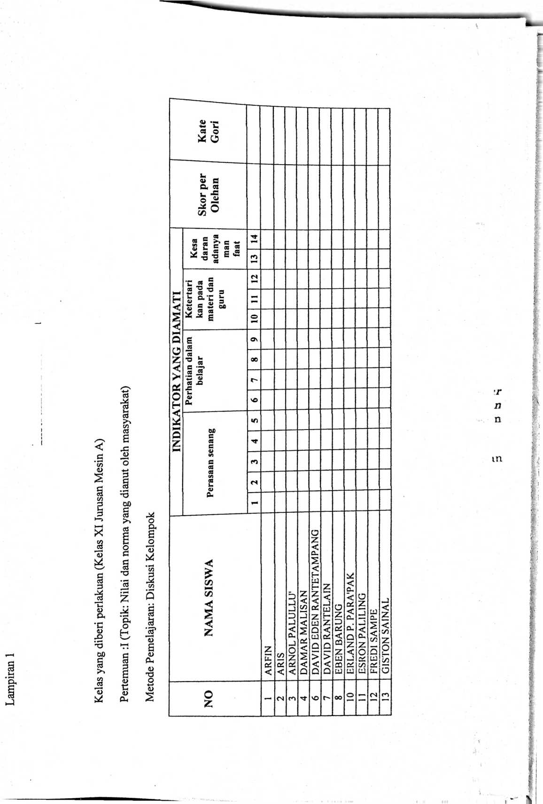
HARDfNAS 1 | HARIANTO ) | JULSEN ROMBE | JUN1AS BUNGANNA | LEKSI YUSUF BANNE i | z  <  3  z  <  2  H  O)  S | L1STA PALAMBA' | <  §  £  H  GO  I | MELIANUS DARWI T | | RICHARD j | , ROBERT BELO PAEMBONAN ’ | | RUSL1N RUBEN SIBALA' 1 | | SAFR1 PATAMBANG | | SAMSELIA MALLISA | | SEBERT1 SONGGO | | STEVEN HENOC RA’DAK | 1 TOLI MANGGIRI' | 1 W1LL1AM SAMBO | | YOBER TAMPANG | | YOHANES RUBEN KOTTO | 1 ZAINAL | | VIKTOR PANCA
•— | z | VO  *—M | T—H | oo  T—* | o  w—’ | o  04 | CN | 04  04 | cn  (N | ^{x}3⁻  (N | (N | 04 | 00  04 | 04 | o  cn | <n | 04  cn | cn  m | cn | m | cn

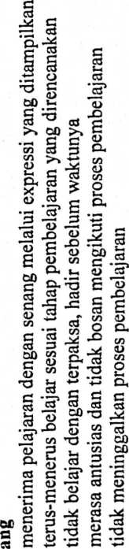
C d cU « «
Cfl </) C/l Crt C/2
§ <Z cZ iZ cZ cZ
ct
S! (N ri
u
Q
»r

n
n

m

c
W)
G
U
O
§
S 2
zp C
2 o
■C I
03 -'
S
cd
’O
O
£X O
O
2
o
<o
co

Perhatian dalam belajar

6. Siswa memberikan perhatian penuh terhadap pembelajaran
m
cs
£
C
O
tZi
a
o
£5
O

s
00

c
<D
CJ
S
O
S
O

S
’o c§

E >
w E

R

S’S
O

E
aj
£
CO
00
00

c
O

e
CO
55
oo
00
§
58
oo

2

§
s
s
0£
fi
CS
O
00

E
CS
£
CO
CO

O
es

E
es

’O
es
'E
O
4-»
cd
g
o
s
g
(U
s
o
2
o
o

•g
o
3
’o

E
S
a'
S

S 3
CO
E
§)
n s •
2
o
111
c o E
S
■o oo
o ~
£E 6
2
a
C3
CO
O
O

E

fl ~ -

J ? ?
O)
cd
e
O
c
a
o
4-*
aj
CO
00
r4
M
2" oo
«u -g
CO
O
CO

2
2
o
O
§
§
o
4-*
D
o
■w
O
*
es

«2
s
es

E
c<s
>>
C
es
’O
es
G
es
es
■o
es
GO
O
o
4-»
e
o

E
<D
a
<D

E
ctf
(Z)
00 <Z>
a>
T3
O

E
S
<D

£
O

E
2
a
CtJ
cn

tr

n

n

m

KATE
GORI
<
Ct W
O j z
* o
(/) X
Kd
CL,
INDIKATOR YANG DIAMATI | Kesa  daran  adanya  man  faat | •—
INDIKATOR YANG DIAMATI | Ketertari  kan pada  materi dan  guru | r«
INDIKATOR YANG DIAMATI | Ketertari  kan pada  materi dan  guru | W*
INDIKATOR YANG DIAMATI | Ketertari  kan pada  materi dan  guru | o  r-*
INDIKATOR YANG DIAMATI | Perhatian dalam  belajar | Os
INDIKATOR YANG DIAMATI | Perhatian dalam  belajar | 00
INDIKATOR YANG DIAMATI | Perhatian dalam  belajar | I-
INDIKATOR YANG DIAMATI | Perhatian dalam  belajar | MO
INDIKATOR YANG DIAMATI | Perasaan senang | <n
INDIKATOR YANG DIAMATI | Perasaan senang | C*) | — |  |  |  | —
NAMA SISWA |  |  | Ardianto Salinding | Agustinus La’bi Allo | Albert Kondolili | Alexander H | Andatrias Taruk Lembang | Ardy sampe Lalong | 1 Aryanto Hendrik Rame
O  Z |  |  |  | CM | m | ■'T |  | NO | r-

 |  | —
Boabab Matasak i | Dersan Sari i | Dominggus | | Efraim Taruk. Minanga | Erikson Mangngala j | Frebrian Dwi Putra | | Ingaran Sambaru | | K.ondo | | Marthen Seru | | uei-h | Rio Parenden | | ! Rios Sampetiku | | Risto Taruk Lamba 1 | | Robi Rombe | 1 Ronai | 1 Salmaneser Lendang | T  <  c  0  ’c  £  c  *  S £  <d a  GO U | iviuiuia a aivniivii  Simon Jos Toban | | SoniTarappa’ | | TrinoVianto Bumbu’ | 1 Wandra Pappang Bonga | | Yafet Kado’i | 1 Yandres P | 1 Yent Rukka’ | 1 Yisrel Maldi Patiung | Yosia Sampekara | | Arianto NugrahaPanggalo
oo | O\ | O  r— | *—« | <N  r—< | co | ² |  | KO |  | OO  r—» | 61 | o  (N | 21 | | 22 | 1 23 | 24 | 26 | 1 | 1 28 | | 29 | | 30 | CO | 1 32 | CO  CO |  | uo  CO

3T

m

m
'■
AD |

■
!
i
i?
I
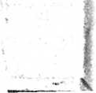
§ c
G

S
oo
00
C
09
G
O
C
09
09
oo
O
S

oo
§
co
Q
X
<D
00
cO
u
0? E
<D
g
00
! i
o
co
c3
03
G
S
g
<D
CO
<U
CO
O
2
00
G
a>
a

S
w
o
55
G'
s
oo
G
s
co
&
g
<D
a
00
(D
co
O
.M
’G'
O
a
G
2
S c
G> Q
8- ^{c}
co
C CO
S
g
G

£
<u
0)
’S
co
O
’g
O
S
M1
2
S
00
g
’E
<D
G
<u
g
00
CO
GO
cn
a
d)
G
<D
g
I
CO
2
al
00
*-< CM
00
c
<L>
J2'
’S
00
£
co
<Z)
CO
G
3
4-J
§
c0
CO
00
G
0)
g
00
?
CO
CO CO
§
G
00
00
C
•a
d>
g

.2.

2

S
03
£
CO
S
g
g

c
09
09
0)
s 2
G H
2
S
g
<D
cd
G
<D
G
£
<D
CO
C
O
G
2
&
g
G
G
<L>
S
O
G
O
<D
g
G
s
00
G
<D
e
<D
<D
00
§
r? c0
’C
<D
g
<D
e
c0
?
cn
O?
'O
2T

m
S
3
<D
g
G
c3
eo
S
cO
S ’G
o S
a n
§
_0O
S
OO

oo
G
09
s

’E
•w
09
CO
GO CO
£ ’E? S
rG <D —
00 ‘
c
<u
g
00
co
00
c
<D
g
G
£
CO
00
Os
09
0«
S
09
a
s
| S
c s
a
B s

00
§
3
S
c¹
CO -
‘G’
ca
S
s
G
’S
+-»
<D
00
c
<D
o
s
00
<D
CO
S
_0O
S
O
S
S
O
C
o
<U
09
S
G
09
2
09
§
g
<L>
g
C
«D
g'**’-
age
CO
o
l—
«V
g
00
CO
CO CO CO
0>
G
C
G
O
c
09
G
00 --
? £
co
CO
09
G
09
09
09
<u
g
<D
C
D
g
G
*
CO
(/S
G
G
00
&

