DAFTAR PUSTAKA

1. Alkitab, Kamus, Jurnal dan Ensiklopedi:
2. Alkitab. Jakarta: Lembaga Alkitab Indonesia, 2005.
3. Ensiklopedi Masa Kini I. Jakarta: YKBK/OMF, 2000.
4. Ensiklopedi Indonesia. Jakarta: Ichtiar bam Van Hoeve, 1980.
5. Etali, K. Prent. Kamus Latin Indonesia. Semarang: Kanisius, 1969.
6. “JURNAL. Akting Mengajar Bisa Merusak. Tanggal 4 Januari 2015.” Pendidikan. Januari-Februari. 2015.
7. Kamus Istilah Theologia. Jakarta: Soedarmo, R., 1991.
8. Tim Penyusun Kamus, Pusat Pembinaan dan Pengembangan Bahasa, Depertemen Pendidikan dan Kebudayaan. Kamus Besar Bahasa Indonesia Edisi Kedua. Jakarta: Balai Pustaka, 1995.
9. Buku dan Karangan:
10. Ismail, Andar dan Eli Yanya. Ajarkah Mereka Melakukan: Kumpulan Karangan Seputar Pandidikan Agama Kristen. Jakarta: BPK Gunung Mulia, 2006.
11. Azwar, Saifuddin. Reliabilitas dan Validitas. Yogyakarta: Pustaka Pelajar, 2003.
12. Brubaker, J Oemar dan Robert E, Clark. Memahami Sesama Kita. Malang: Gandum Mas, 1972.
13. Dalyono. Psikologi Pendidikan. Semarang: Rineka Cipta, 1996.
14. Depdikbud. Pendidikan Pancasila dan Kewarganegaraan. Jakarta: Ditjen Dikdesmen, 1997.
15. Durkheim, Emile. Pendidikan Moral Suatu Studi Teori dan Aplikasi Sosiologi Pendidikan. Jakarta: Erlangga, 1990.
16. Darmaputera, Eka. Etika Sederhana Untuk Semua. Jakarta: BPK Gunung Mulia, 1989.
17. Elmubarok, Zaim. Membumikan Pendidikan Nilai. Bandung: Alfabeta, 2009.
18. Go, Piet dan W.F. Maramis. Pendidikan Nilai di Sekolah Katolik. Malang: Dioma, 2005.
19. Gunarsa, Singgih D. Psikologi Praktis, Anak, Remaja dan Keluarga. Jakarta: BPK Gunung Mulia, 2000.
20. Hadi, Sutrisno. Metodologi Research 2. Yogyakarta: Fakultas Psikologi Universitas Gajah Mada, 2002.
21. Haricahyono, Cheppy. Dimensi-dimensi Pendidikan Moral. Semarang: HOP Semarang Press, 1989.
22. Homrighausen, E. G. dan I. H. Enklaar. Pendidikan Agama Kristen. Jakarta: BPK Gunung Mulia, 2005.
23. Iskandar, Metodologi Penelitian Pendidikan dan Sosial: Kuantitatif dan Kualitatif. Jakarta: Gaung Persada Press, 2009.
24. Kartono, Kartini, Tinjauan Holistik Mengenai Tujuan Pendidikan Nasional. Jakarta: Pradnya Paramita, 1997.
25. Kountor , Ronny. Statistik Praktis: pengolahan data/penyusunan skripsi dan tesis. Jakarta: PPM, 2005.
26. Majelis Luhur Persatuan Taman Siswa. Karya Ki Hajar Dewantar Bagian Pertama Pendidikan Cetakan Kedua. Yogyakarta: Majelis Luhur Taman Siswa, 1977.
27. Muhammadong, “ Kontribusi Kepemimpinan Guru Terhadap Pembentukan Moralitas Siswa di SMP Negeri 1 Makassar.” Makassar: UPT. Mata Kuliah Umum UNM, 2013.
28. N., Fred dan Howard B. Lee. Foundations of Behavioral Research Forth Worth: Harcout College Publisher, 2000.
29. Nana Syaodih Sukmadinata. Metode Penelitian Pendidikan. Bandung: PT. Remaja Rosdakarya. 2009.
30. Panggabean, Yusri. Strategi, Model, Dan Evaluasi. Bandung: Bina Media Informasi. 2007.
31. Riggs, Ralph M. Gembala Sidang yang Berhasil. Malang: Gandum Mas, 1996.
32. Sasmoko, Eliezer. Metode Penelitian, Pengukuran dan Analisis Data. Tangerang: Harvest Internasional Theological Seminary, 2005.
33. Sanjaya, Wina.. Kurikulum Dan Pembelajaran. Jakarta: Kencana, 2010.
34. Sumiyatiningsih, Dien. Mengajar Dengan Kreatif dan Menarik. Yogyakarta: ANDI, 2006.
35. Sudjana, M.A. Metode Statistika. Bandung: Tarsito, 1995.
36. Sudjana, Nana. Dasar-Dasar Proses Belajar Mengajar. Bandung: Sinar Baru, 1989.
37. Sugiyono, Statistika untuk Penelitian. Bandung: Alfabeta,1999.
38. Sijabat, B. S. Mangajar Secara Profesional, Bandung: Kalam Hidup,2009.
39. Windmiller, M. Moral Development, Understanding Adolescence: Current Developments in Adolescent Psychology. Boston: Allyn and Bacon, Inc., 1976.
40. Zamroni. Pengantar Pengembangan Teori Sosial. Yogyakarta: Tiara Wacana, 1992.
41. Zuriah, Nurul. Pendidikan Moral dan Budi Pekerti dalam Perspektif Perubahan: Menggagas Platfrom Pendidikan Budi Pekerti Secara Kontekstual dan Futuristik. Jakarta: Bumi Aksara, 2008.
42. Laporan, Artikel, Makalah dan Sumber-Sumber yang tidak Diterbitkan :
43. Makna Integritas. Diakses tanggal 13 Juli 2014. Didapat dari hhtp://artikel .sabda.org/daftar artikel//.
44. Perkembangan Psikologi Remaja. Diakses 10 Mei 2014. Didapat dari <http://belaiarpsikologi.com/perkembangan-psikologis-remaia/>.

Statistics

Integritas Guru PAK

|  |  |
| --- | --- |
| Valid  Missing | 219 |
| 0 |
| Mean | 43.53 |
| Median | 44.00 |
| Mode | 42 |
| Std. Deviation | 5.900 |
| Range | 29 |
| Minimum | 26 |
| Maximum | 55 |

**Integritas Guru PAK**

|  |  |  |  |  |
| --- | --- | --- | --- | --- |
|  | Frequenc  **y** | Percent | Valid  Percent | Cumulative  Percent |
| 26 | 1 | .5 | .5 | .5 |
| 27 | 2 | .9 | .9 | 1.4 |
| 28 | 2 | .9 | .9 | 2.3 |
| 29 | 2 | .9 | .9 | 3.2 |
| 30 | 1 | .5 | .5 | 3.7 |
| 31 | 1 | .5 | .5 | 4.1 |
| 32 | 2 | .9 | .9 | 5.0 |
| 33 | 3 | 1.4 | 1.4 | 6.4 |
| 34 | 1 | .5 | .5 | 6.8 |
| 35 | 5 | 2.3 | 2.3 | 9.1 |
| 36 | 3 | 1.4 | 1.4 | 10.5 |
| 37 | 3 | 1.4 | 1.4 | 11.9 |
| 38 | 11 | 5.0 | 5.0 | 16.9 |
| 39 | 9 | 4.1 | 4.1 | 21.0 |
| 40 | 15 | 6.8 | 6.8 | 27.9 |
| Valid 41 | 10 | 4.6 | 4.6 | 32.4 |
| 42 | 24 | 11.0 | 11.0 | 43.4 |
| 43 | 12 | 5.5 | 5.5 | 48.9 |
| 44 | 11 | 5.0 | 5.0 | 53.9 |
| 45 | 13 | 5.9 | 5.9 | 59.8 |
| 46 | 15 | 6.8 | 6.8 | 66.7 |
| 47 | 19 | 8.7 | 8.7 | 75.3 |
| 48 | 8 | 3.7 | 3.7 | 79.0 |
| 49 | 12 | 5.5 | 5.5 | 84.5 |
| 50 | 12 | 5.5 | 5.5 | 90.0 |
| 51 | 8 | 3.7 | 3.7 | 93.6 |
| 52 | 2 | .9 | .9 | 94.5 |
| 53 | 4 | 1.8 | 1.8 | 96.3 |
| 54 | 3 | 1.4 | 1.4 | 97.7 |
| 55 | 5 | 2.3 | 2.3 | 100.0 |
| Total | 219 | 100.0 | 100.0 |  |

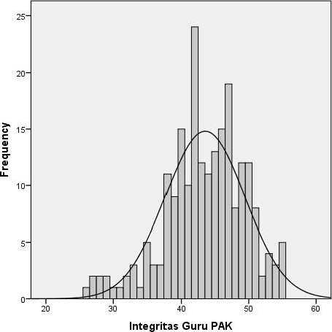

Histogram

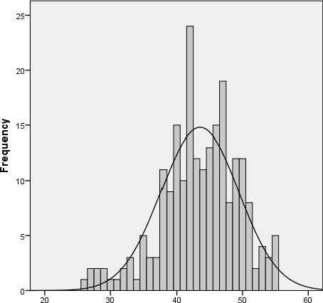

Integritas Guru PAK

Statistics

Moralitas Siswa

|  |  |
| --- | --- |
| ^ Valid Missing | 219 |
| 0 |
| Mean | 46.73 |
| Median | 47.00 |
| Mode | 46 |
| Std. Deviation | 5.585 |
| Range | 28 |
| Minimum | 30 |
| Maximum | 58 |

Moralitas Siswa

|  |  |  |  |  |
| --- | --- | --- | --- | --- |
|  | Frequenc  **y** | Percent | Valid  Percent | Cumulative  Percent |
| 30 | 1 | .5 | .5 | .5 |
| 32 | 1 | .5 | .5 | .9 |
| 33 | 1 | .5 | .5 | 1.4 |
| 34 | 1 | .5 | .5 | 1.8 |
| 35 | 2 | .9 | .9 | 2.7 |
| 36 | 4 | 1.8 | 1.8 | 4.6 |
| 37 | 5 | 2.3 | 2.3 | 6.8 |
| 38 | 3 | 1.4 | 1.4 | 8.2 |
| 39 | 4 | 1.8 | 1.8 | 10.0 |
| 40 | 6 | 2.7 | 2.7 | 12.8 |
| 41 | 8 | 3.7 | 3.7 | 16.4 |
| 42 | 13 | 5.9 | 5.9 | 22.4 |
| 43 | 12 | 5.5 | 5.5 | 27.9 |
| 44 | 11 | 5.0 | 5.0 | 32.9 |
| Valid 45 | 16 | 7.3 | 7.3 | 40.2 |
| 46 | 19 | 8.7 | 8.7 | 48.9 |
| 47 | 15 | 6.8 | 6.8 | 55.7 |
| 48 | 8 | 3.7 | 3.7 | 59.4 |
| 49 | 18 | 8.2 | 8.2 | 67.6 |
| 50 | 8 | 3.7 | 3.7 | 71.2 |
| 51 | 16 | 7.3 | 7.3 | 78.5 |
| 52 | 10 | 4.6 | 4.6 | 83.1 |
| 53 | 11 | 5.0 | 5.0 | 88.1 |
| **54** | 8 | 3.7 | 3.7 | 91.8 |
| 55 | 9 | 4.1 | 4.1 | 95.9 |
| 56 | 3 | 1.4 | 1.4 | 97.3 |
| 57 | 5 | 2.3 | 2.3 | 99.5 |
| 58 | 1 | .5 | .5 | 100.0 |
| Total | 219 | 100.0 | 100.0 |  |

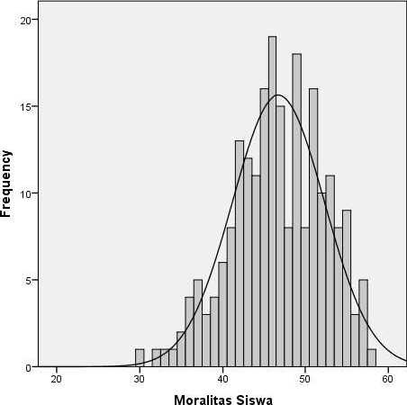

Means

jCase_Processlng^ummar^

|  |  |  |  |  |  |  |
| --- | --- | --- | --- | --- | --- | --- |
|  | Cases | | | | | |
|  | Included | | Excluded | | Total | |
|  | N | Percent | N | Percent | N | Percent |
| Moralitas Siswa * Integritas Guru PAK | 219 | 100.0% | 0 | 0.0% | 219 | 100.0% |

Report

Moralitas Siswa

|  |  |  |  |
| --- | --- | --- | --- |
| Inteqritas Guru PAK | Mean | N | Std. Deviation |
| 26 | 48.00 | 1 |  |
| 27 | 48.50 | 2 | 4.950 |
| 28 | 41.50 | 2 | 12.021 |
| 29 | 42.50 | 2 | .707 |
| 30 | 40.00 | 1 |  |
| 31 | 35.00 | 1 |  |
| 32 | 46.00 | 2 | 5.657 |
| 33 | 45.00 | 3 | 7.810 |
| 34 | 42.00 | 1 |  |
| 35 | 45.40 | 5 | 1.949 |
| 36 | 44.00 | 3 | 7.000 |
| 37 | 45.33 | 3 | 3.215 |
| 38 | 47.91 | 11 | 6.379 |
| 39 | 44.89 | 9 | 4.540 |

|  |  |  |  |
| --- | --- | --- | --- |
| 40 | 47.40 | 15 | 7.510 |
| 41 | 44.80 | 10 | 5.266 |
| 42 | 45.50 | 24 | 5.556 |
| 43 | 47.00 | 12 | 4.573 |
| 44 | 47.73 | 11 | 4.628 |
| 45 | 46.08 | 13 | 4.499 |
| 46 | 46.40 | 15 | 5.962 |
| 47 | 46.63 | 19 | 6.229 |
| 48 | 45.75 | 8 | 5.418 |
| 49 | 49.17 | 12 | 4.239 |
| 50 | 50.25 | 12 | 4.864 |
| 51 | 45.88 | 8 | 4.224 |
| 52 | 49.50 | 2 | 6.364 |
| 53 | 49.25 | 4 | 3.403 |
| 54 | 46.00 | 3 | 9.165 |
| 55 | 54.00 | 5 | 4.243 |
| Total | 46.73 | 219 | 5.585 |

|  |  |  |  |  |  |
| --- | --- | --- | --- | --- | --- |
|  | Sum of Sauares | df | Mean Sauare | F | Sia. |
| (Combined) | 1036.073 | 29 | 35.727 | 1.171 | .262 |
| Between Groups Linearity | 346.916 | 1 | 346.916 | 11.373 | .001 |
| Moralitas Siswa * Integritas |  |  |  |  |  |
| Deviation from Linearity | 689.156 | 28 | 24.613 | .807 | .744 |
| Guru PAK |  |  |  |  |  |
| Within Groups | 5765.032 | 189 | 30.503 |  |  |
| Total | 6801.105 | 218 |  |  |  |

**Measures of Association**

|  |  |  |  |  |
| --- | --- | --- | --- | --- |
|  | R | R Sauared | Eta | Eta Sauared |
| Moralitas Siswa * Integritas Gum PAK | .226 | .051 | .390 | .152 |

Regression

**Variables Entered/Removed\***

|  |  |  |  |
| --- | --- | --- | --- |
| Model | Variables  Entered | Variables  Removed | Method |
| 1 | Integritas Guru PAKb |  | Enter |

1. Dependent Variable: Moralitas Siswa
2. All requested variables entered.

**Model Summary**

|  |  |  |  |  |
| --- | --- | --- | --- | --- |
| Model | R | R Square | Adjusted R Sauare | Std. Error of the Estimate |
| 1 | .226* | .051 | .047 | 5.454 |

a. Predictors: (Constant), Integritas Guru PAK

**AN OVA\***

|  |  |  |  |  |  |
| --- | --- | --- | --- | --- | --- |
| Model | Sum of Sauares | df | Mean Sauare | F | Sig. |
| Regression | 346.916 | 1 | 346.916 | 11.664 | o  p |
| 1 Residual | 6454.189 | 217 | 29.743 |  |  |
| Total | 6801.105 | 218 |  |  |  |

1. Dependent Variable: Moralitas Siswa
2. Predictors: (Constant), Integritas Guru PAK

**Coefficients**8

|  |  |  |  |  |  |
| --- | --- | --- | --- | --- | --- |
| Model | Unstandardized Coefficients | | Standardized | t | Sig. |
|  |  |  | Coefficients |  |  |
|  | B | Std. Error | Beta |  |  |
| (Constant)  -I | 37.422 | 2.750 |  | 13.607 | .000 |
| Integritas Guru PAK | .214 | .063 | .226 | 3.415 | .001 |

a. Dependent Variable: Moralitas Siswa

PPIot

**Model Description**

|  |  |
| --- | --- |
| Model Name | MOD_1 |
| Series or Sequence 1 | Integritas Guru PAK |
| Transformation | None |
| Non-Seasonal Differencing | 0 |
| Seasonal Differencing | 0 |
| Length of Seasonal Period | No periodicity |
| Standardization | Not applied |
| Type | Normal |
| Distribution Location | estimated |
| Scale | estimated |
| Fractional Rank Estimation Method | Blom's |
| Rank Assigned to Ties | Mean rank of tied values |

Applying the model specifications from MOD_1

**Case Processing Summary**

|  |  |  |
| --- | --- | --- |
|  | | Integritas Guru PAK |
| Series or Sequence Length |  | 219 |
| Number of Missing Values in | User-Missing | 0 |
| the Plot | System-Missing | 0 |

The cases are unweighted.

**Estimated Distribution Parameters**

|  |  |
| --- | --- |
|  | Integritas Guru PAK |
| Location | 43.53 |
| Normal Distribution |  |
| Scale | 5.900 |

The cases are unweighted.

Integritas Guru PAK

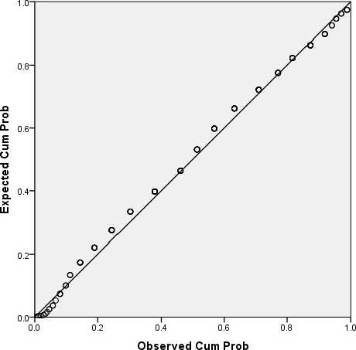

Detrended Normal P-P Plot of Integritas Guru PAK

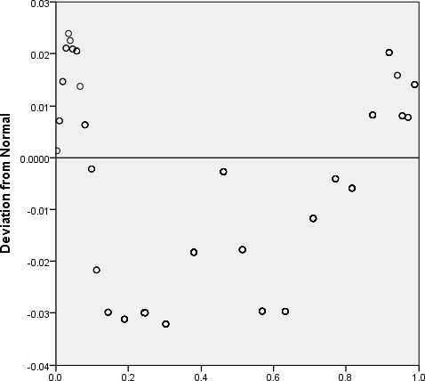

Observed Cum Prob

PPLOT

/VARIABLES=Variabel_Y

/NOLOG

/NOSTANDARDIZE /TYPE=P-P /FRACTION=BLOM /TIES=MEAN /DIST=NORMAL.

PPIot

**Modal Description**

|  |  |
| --- | --- |
| Model Name | MOD2 |
| Series or Sequence 1 | Moralitas Siswa |
| Transformation | None |
| Non-Seasonal Differencing | 0 |
| Seasonal Differencing | 0 |
| Length of Seasonal Period | No periodicity |
| Standardization | Not applied |
| Type | Normal |
| Distribution Location | estimated |
| Scale | estimated |
| Fractional Rank Estimation Method | Blom's |
| Rank Assigned to Ties | Mean rank of tied |
| values |

Applying the model specifications from MOD_2

**Case Processing Summary**

|  |  |  |
| --- | --- | --- |
|  | | Moralitas Siswa |
| Series or Sequence Length |  | 219 |
| Number of Missing Values in | User-Missing | 0 |
| the Plot | System-Missing | 0 |

The cases are unweighted.

**Estimated Distribution Parameters**

|  |  |
| --- | --- |
|  | Moralitas Siswa |
| Location | 46.73 |
| Normal Distribution |  |
| Scale | 5.585 |

The cases are unweighted.

Moralitas Siswa

Normal P-P Plot of Moralitas Siswa

