ANGKET PENELITIAN
A. Petunjuk Pengisian
I Beri tanda ceklis (^) pada kolom yang tersedia, yang sesuai dengan pendapat atau
kondisi anda
2. Keterangan
- SS = Sangat Setujuh
- S = Setujuh
- RR = Ragu-ragu
- TS = Tidak Setujuh
- STS- Sangat Tidak Setujuh
Instrumen Variabel X dan Y

Pernyataan

• ■ i Saya sangat senang belajar Pendidikan Agama Kristen
j_karena alat peraganya sangat menarik
2-* ; Saya suka belajar Pendidikan Agama Kristen karena
[guruPend i d i k an Agama Kristen kreatif dai ain mengajar
3«. ; Saya senang belajar kelompok karena saling berbagi
1 pendapat -

'f - ’ Saya cepat menguasai materi apabila guru menjelaskan
! dengan baik
- TSaya senang belajar kelompok karena saling memoantu
k-- • Saya cepat mengerti jika guru menggunakan alat peraga
I dalam mengaj ar. _
⁷” | Saya senang belajar karena guru memberikan semangat

j Saya senang belajar jika ada kedisiplinan
! Belajar kelompok membuat saya mengenal perbedaan-
—__4_P£rbedaan_te m a n
Saya selalu semangat dalam belajar kelompok karena ada
kerjasama.
• Saya senang belajar ketika teman-teman tidak ribut
-2. ! Saya lebih giat belajar ketika nilai saya bagus
23. Saya aktif menjawab pertanyaan dalam kelompok
Saya mendapatkan nilai yang bagus ketika belajar
-kelompok
^{s} Setiap selesai pembahasan materi, selalu diadakan tes

♦6. Saya diberikan tugas tambahan jika nilai saya kurang
Alternatif jawaban
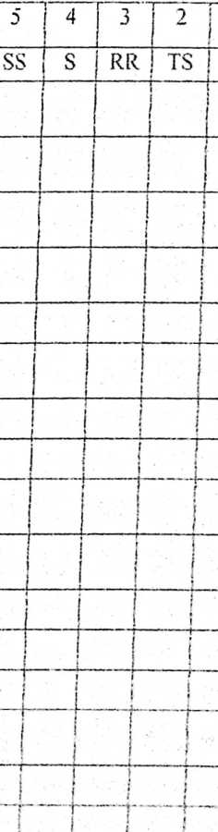
■Jtelornpok

—J 77. | ; Saya senang dengan belajar kelompok |  |  | T 1 1 !  f *
»88. | ; Saya senang jika guru menjelaskan tidak terlalu cepat. | i  i  I |  |  |  | 1  1 1  1
=5 w. | j Saya senang belajar jika guru mengajar dengan |  |  |  |  | —: 1  i
 | J. menggunakan LCD |  | 1 | 1 |  | 1 1  ! i
Vi^{r}i | Saya semangat belajar karena guru memberikan motivasi | l  1 |  | i |  | i
211. | kmru yang sabar mengajar membuat saya senang belajar | 1 | l | i
B» - — • | Setiap pagi sebelum masuk materi baru, guru selalu
 | tentang materi minggu lalu.
-2B. | ; Saya mempelajari kembali setiap materi pembelajaran |  |  | (> |  | i
 | liang diberikan oleh guru |  |  | i  i | I | r
244. | i kiuru memperlihatkan contoh disiplin yang baik kepada |  |  | 1  i | J  i  «
 | 1 siswa |  |  |  |  | i
i 2f5. | i Saya semangat belajar jika ada perhatian dari guru |  |  | i ' |  | 1  i I  j ;
Z 2(6.  i—__ | Saya dapat menghafal materi yang diberikan oleh guru. |  | r  i |  |  | i  1 1
r' | Saya mampu menjelaskan materi pelajaran dengan baik | s  ! | i |  | | | l’  1
■M  s | Saya mampu menyelesaikan tugas yang diberikan guru | i |  |  | 1
B | _dengan baik
12*9 | Saya cepat mengerti jika memperhatikan penjelasan
 | J^uru
; 3 W. j  l J | Saya cepat menguasai materi yang diajarkan oleh guru |  |  |  |  | 1  I  j
j 3»L j' | Saya berterima kasih jika ada teman yang membantu |  |  |  |  | 1
*-—-d | _daJam kesulitan mengerjakan soal |  | I |  | (  1 | 1  —J1
lEj | baya rajin bertanya jika penjelasan guru belum jelas [' |  |  |  |  | i  i
.- 3*3. T  i | Ihjjian dari guru membuat saya semangat untuk lebih giat | i | 1 |  | F | i
 | belajar. |  | 1 |  | f | 1
344. :  i | Saya berperilaku baik, sopan kepada semua orang | 1 | ! | { | [ | i
liTT | Saya menghargai guru dalam menjelaskan materi |  | i |  | i
L | pelajaran | 1  J_ | ( |  |  | i
316. | | Saya tidak sombong jika berprestasi di sekolah | 1 | i  1  f— |  | i | i
357. | | Saya mengakui akan kepintaran siswa lain. |  | 1  t |  |  | i
358. | Saya mengerjakan tugas yang diberikan oleh guru |  | i | 1 | j  • | 1
--4- | dengan baik |  | 1 | j | 1 | 1
339. J | Saya rajin mengikuti kegiatan yang diadakan di sekolah | L | i  j | j  f  v | i  • | i  1
4S0.j | Saya tetap mempersiapkan peralatan sekolah terlebih |  | j | r  1
Jj | jahulu agai' dapat mengikuti pelajaran dengan baik. j | L | I | r . *■ |  | 1

LAMPIRAN 2:
HASIL VALIDASI ISI TIM AHLI
MO
£
1 3
4
: s
_7
M
t 9
rwrit
10
11
12
13
14
15
16
17
18
19
i
L 20
21
23
24
25
26
27
28
29
30
31
32
33
34
35
36
37
VALIDATO
R
I
5
5
VALIDATO
R
II
5
5
VALIDATO
R
III
5
RATA-
RATA
KETERANGA
N
5
5
5
£
£
5
£
£
£
£
5
2
4
£
4
£
£
£
£
£
£
£
5
£
£
5
4
5
£
£
4
3
3
3
3
4
£
4
£
£
4
£
£
4
£
4
4
5
£
4
4
2
2
£
4_
£
4
£
£
5
5
3
2
£
3
5
4
£
5
£
5
£
£
£
4
£
4
£
4
4
3
3
4
4
4
4
4
5
4
4
4
5
5
4
4
4
4
4
3
3
4
4
4
£
4
4,7
4,7
4,7
4,7
4,3
4,7
4,0
4,3
4,0
4,0
4,3
4,3
4,0
3,3
4,3
4,3
4,0
4,3
4,0
4,7
4,0
4,7
4,3
4,7
4,7
4,0
4,7
4,7
4,3
4,0
3,3
3,7
3,7
4,0
4.0
4,3
4,3
Sangat Relevan dan Sangat Jelas
Sangat Relevan dan Sangat Jelas
Sangat Relevan dan Sangat Jelas
Sangat Relevan dan Sangat Jelas
Sangat Relevan dan Jelas
Sangat Relevan dan Sangat Jelas
Sangat Relevan dan Jelas

Sangat Relevan dan Jelas
Sangat Relevan dan Jelas
Sangat Relevan dan Jelas

Sangat Relevan dan Jelas
Sangat Relevan dan Jelas
Relevan dan Jelas
Sangat Relevan dan Jelas
Sangat Relevan dan Jelas
Sangat Relevan dan Jelas
Sangat Relevan dan Jelas
Sangat Relevan dan Jelas
Sangat Relevan dan Sangat Jelas
Sangat Relevan dan Jelas
Sangat Relevan dan Sangat Jelas
Sangat Relevan dan Jelas
Sangat Relevan dan Sangat Jelas
Sangat Relevan dan Sangat Jelas
Sangat Relevan dan Jelas
Sangat Relevan dan Sangat Jelas
Sangat Relevan dan Sangat Jelas
Sangat Relevan dan Jelas
Sangat Relevan dan Jelas
Relevan dan Jelas
Sangat Relevan dan Jelas
Sangat Relevan dan Jelas
Sangat Relevan dan Jelas
Sangat Relevan dan Jelas
Sangat Relevan dan Jelas
Sangat Relevan dan Jelas

38 | 5 | 5 | 4 | 4,7 | Sangat Relevan dan Sangat Jelas
39 | 5 | 4 | 5 | 4,7 | Sangat Relevan dan Sangat Jelas
«40 | 5 | 5 | 3 | 4,3 | Sangat Relevan dan Jelas
4,3 sangat relevan dan jelas

Tabulasi Uji Coba Variabel X (Metode Pembelajaran Tuntas)
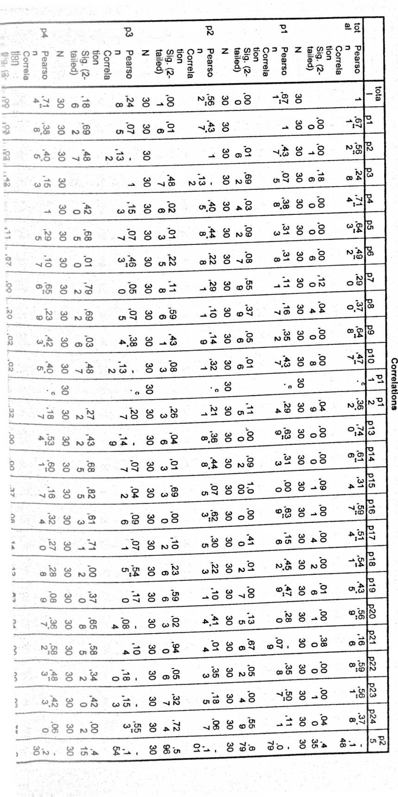
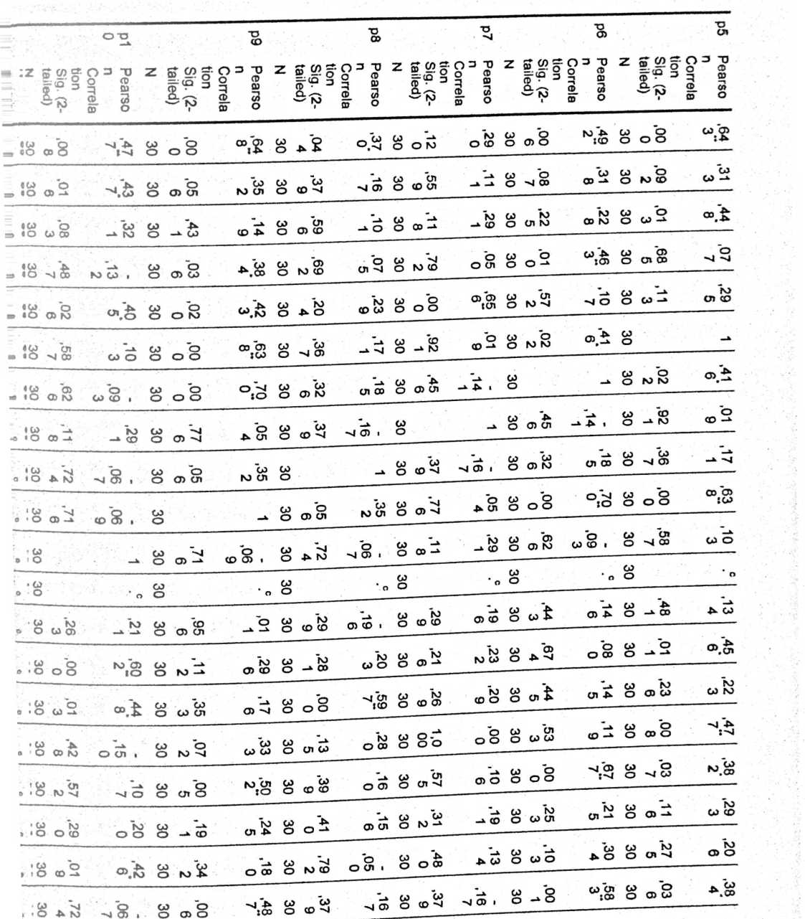
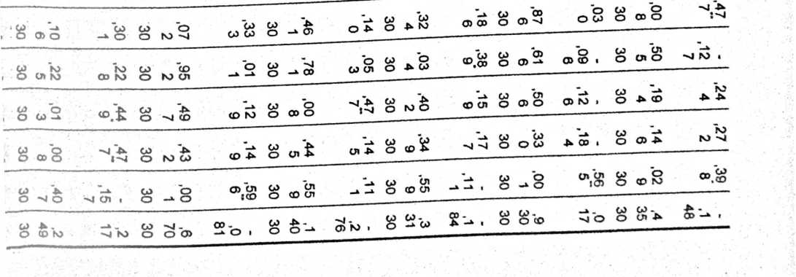
OOUOfi
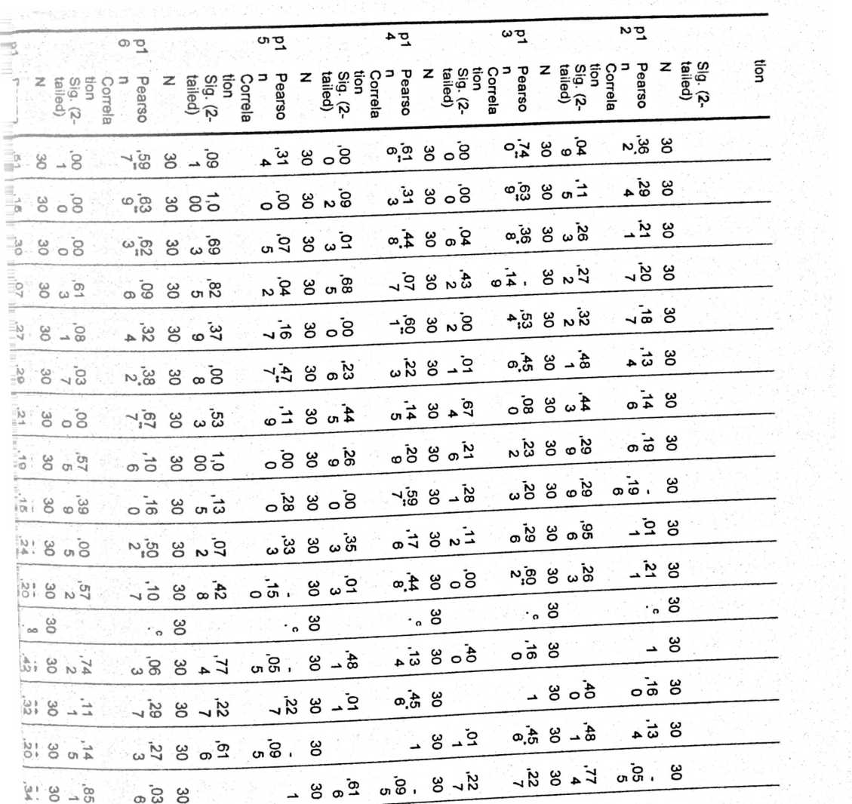
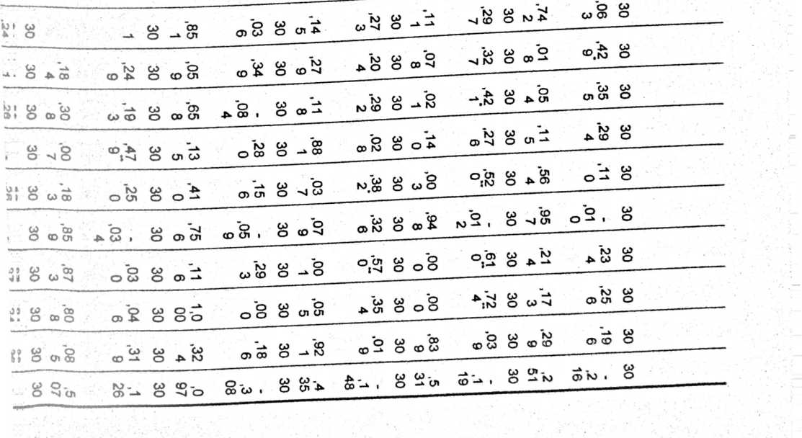
i ■  S_ | <8 | g | 0  00' |  | oo "cn  ICO | CP  o | GO  O OO | 05 6) | 30 | b  -» o | co cn  :0) | 30 | .01  6 | s | 30 | Z  00* | <E | 30 | P  00*
i ■  S_ | ’U b  IO | 30 | KD | so' | co  oo cn | 30 | .67  6 | 6  ZO* | 30 | cn go | no  o <x> | 30 | .00  7 | (D A  :-u | 30 | .01  2 |  | 30 | 0  IP'
E | cn co | 30 | U) | o  CD | GO  go cn | G0  O | oS | .01  4 | 30 | .02  3 | .41  4 | 30 | ,59  6 | -* o | GO  O | .23  6 | no  GO NO | 30 | NO O
* | Go s , | 30 | NO | ,34 | O 00 1 | 30 | cn  cn co | A O | 30 | .65  8 | b  A 00 i | CD  O | GO  O ’U | .17  0 | G0  O | .00  2 | .54  5~ | GO  O | .71  1
O CD N)  g |  | G0 | cn |  | CP | b | b | GO b | b | G0 | b | go cn | go | G0 | GO | no
z |  | O | CD o | CD NO i | O | 05 -*• | CD CD i | O 05 ’U | O CD | O | -*■ o | :oo | O CD o | a o | O | go cn
NO  CD U1  O CD ’U  O  s__ | A \|  IKO | 30 | °.  00 | O CD | 30 | CD A | .01  2 | 30 | .00  3 | o cn  :no | 30 | O -N | .27  6 | 30 | b  -* NO | .42  r | 30 | .07  8
s | ,35  4 | oe | t  00* |  | 30 | 6  ZO* | GO  05 NO | 30 | ,03  7 | ,38  2‘ | ; 30 | ,88  1 ' | .02  8 | 30 | —a  03 | NO  NO cd | 30 | ,27  9
4  5 | ,00  0 | I 30 | '⁹.  n/ | NO  GO CD | 30 | CD Cn | b  cd cn • | 30 | .41  0 | cd cn | 30 | cn go | .28  0 | 30 | ,65  8 | b  A 00 1 | 30 | ,05  9
1  3 | o S | 30 | .87  3J | b  O GO | 30 | 00  co cn | .03  4 | 30 | GO OO | .25 ¹  0 | I 30 | Z  00' | (D -A- | 30 | .30  8 | GO CD | 30 | A 00
0 | .24  9 | 30 | .04  3 | NO^ | 30 | 00  NO 05 | ,03  3 | 30 | NO 05 | .26  2 | i 30 | b  00 GO | ,03  ⁹ | 30 | A cn | Z  9Z‘ | 30
O NO o GO NO N» o NW aS O CD ’U CD CD O NO CD U1 N O -*• O A Cfl  k "v go b o CO CD  ’ O§. 8^8 N>”. ° °* °-X O N><O O  ^g_{M}? <3 8 o>3! ©g. O - o -’® oX o u“ ©a o wa  O  GO "’U O CO NO NO CO *”U "q co CO  -* O 0)01 CD cn 1 O -* (D NO -*■ I O ’U P (t) O M O)  ‘,2> CO GO UT “-A CO Q , < CO CO ’U P CD -* NO GO O  -* o cn CD -> o o no A .-u o A cn o CD » o go no -u oo o go a  GO o -X CD GO CO o CO o -sl cn CD CD O GO b w w '-*  o o o :co o no -u -* go i p -*■ o :cd o ’U cn a co o a a? o no o cn oo  cn a , | S 8o | 08 8 | O UT | 30  .14  1 | S b | 30  .00  0 | CD CO | NO GO O  O cn o co p | CD 'a go b  :Oo o oo a
-*b , | 8 8- | 8k> . 8 | ,9  30 | -a. GO  ’U O o | _a _  ’U co | A . CD  A O » O | CD b | CDO . o Sno | A NO . O O> A

I
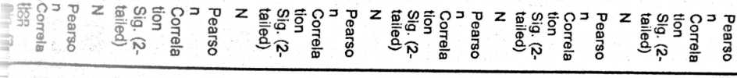
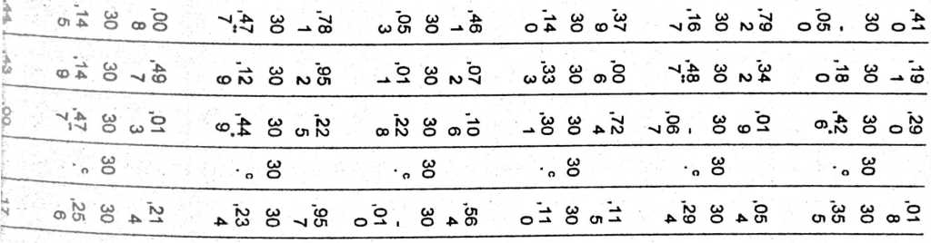
o
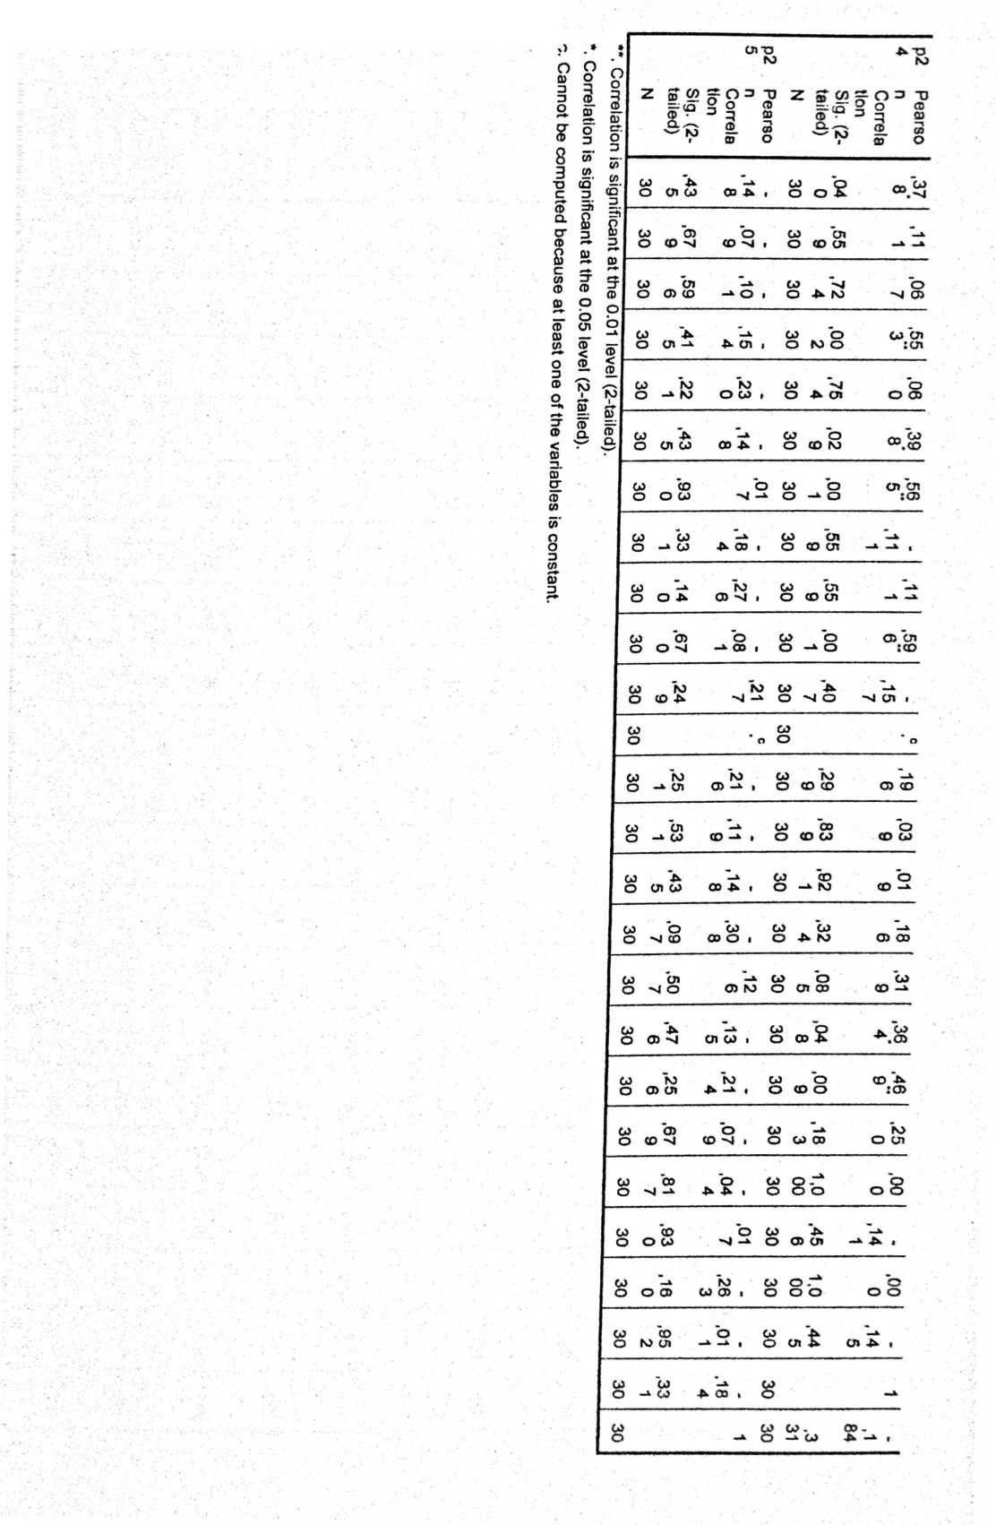
Uji Coba Validasi Variabel X (Metode Pembclajaaran Tuntas)
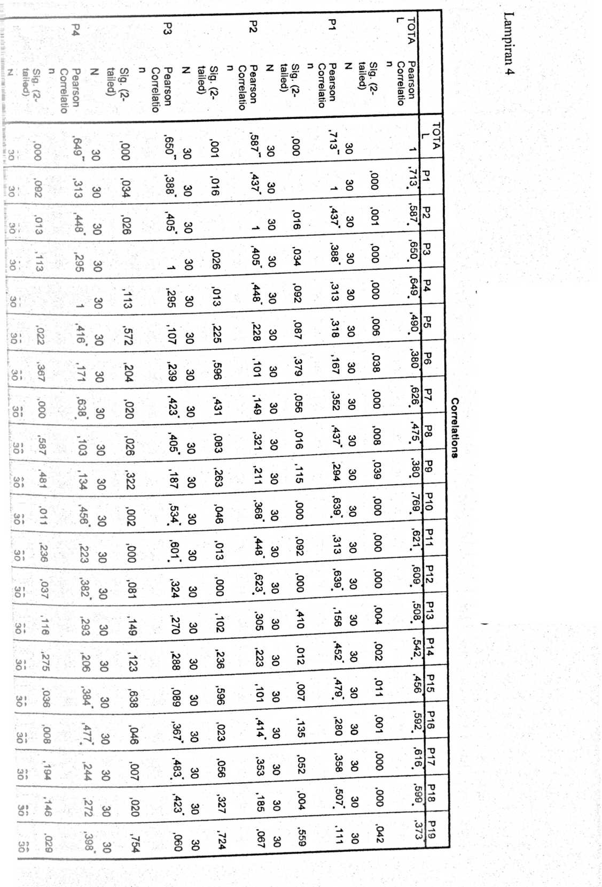
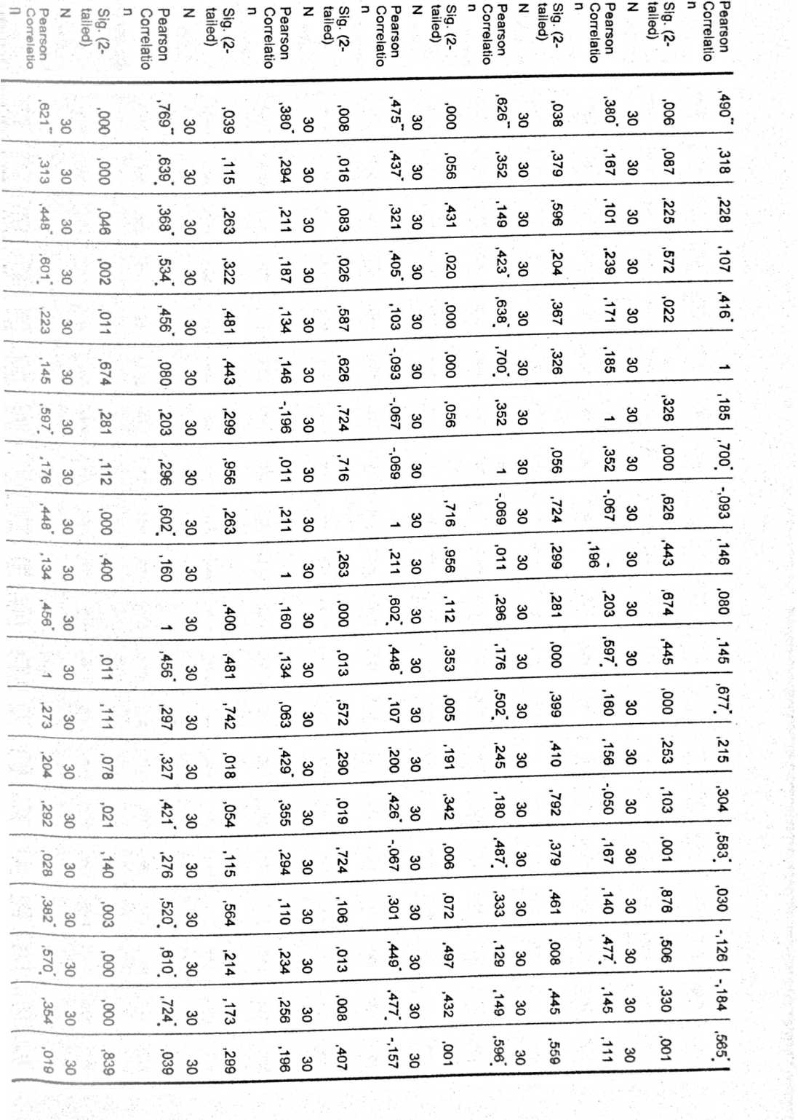
Cnrr olmtin
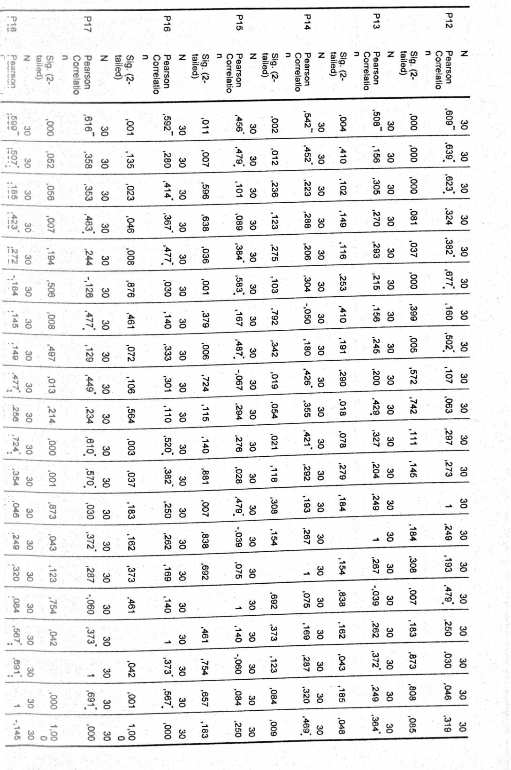
N)  ff  CD  CL  o  o  CD  £D  cx  o  65'  cn  CO  o  £  £D  3  CD  O  b  CD  ©  m  S’  ©  CL  Z | Sig. (2-  tailed) | "0  CD |  | Sig. (2-  tailed)
 | Sig. (2-  tailed) | Pearson  Correlatio  n | z | Sig. (2-  tailed)
 | o | CO |  | o
30 |  | co_{w} | 30 | 8
 | CD |  |  | O
CO | cn |  | co | g
o | CD | —x | o
CO | ,72 | 90’ | co | co  bO
o | 4^ | ’M | o
30 | ,754 | 090* | co  o | O  N?  O
 | • | CO
CO  o | )29 | CD  CO  4 | 30 | 46
30 | 8  • —X | 8  cn  > < | 30 | ,330
CO | cn  cn |  | co | ,44!
o | CD | —X | o | cn
30 | ,001 | cn  CD  CD, | 30 | ,432
 |  | ■
 |  | —X |  | o
30 | o | 57 | co  o | 08
 | nj | ~X |  | —X
30 | !99 | 96 | 30 | 73
 | CO | o |  | o
co | CO | co | co | o
o | CD | CD | o | o
 | CD | O |  | o
CO | bo |  | co | cn
o | _X | CD | o | cn
 | o | CO |  | CD
CO | 00 |  | co | o
o | cn | CD | o | CD
CO | "o | 2 | co | 00
o | 00 |  | o | cn
30 | 600* | o | 30 | ,084
 | "*_x | ’k) |  | o>
CO | 00 | cn | co | cn
o | CO | o | o
30 | o i | ,000 | 30 | 8
30 | O 8 | ,000 | 30 | 000’
co | .44 | _x | co
o | cn | cn | o
30 |  |  | co  o | ,445

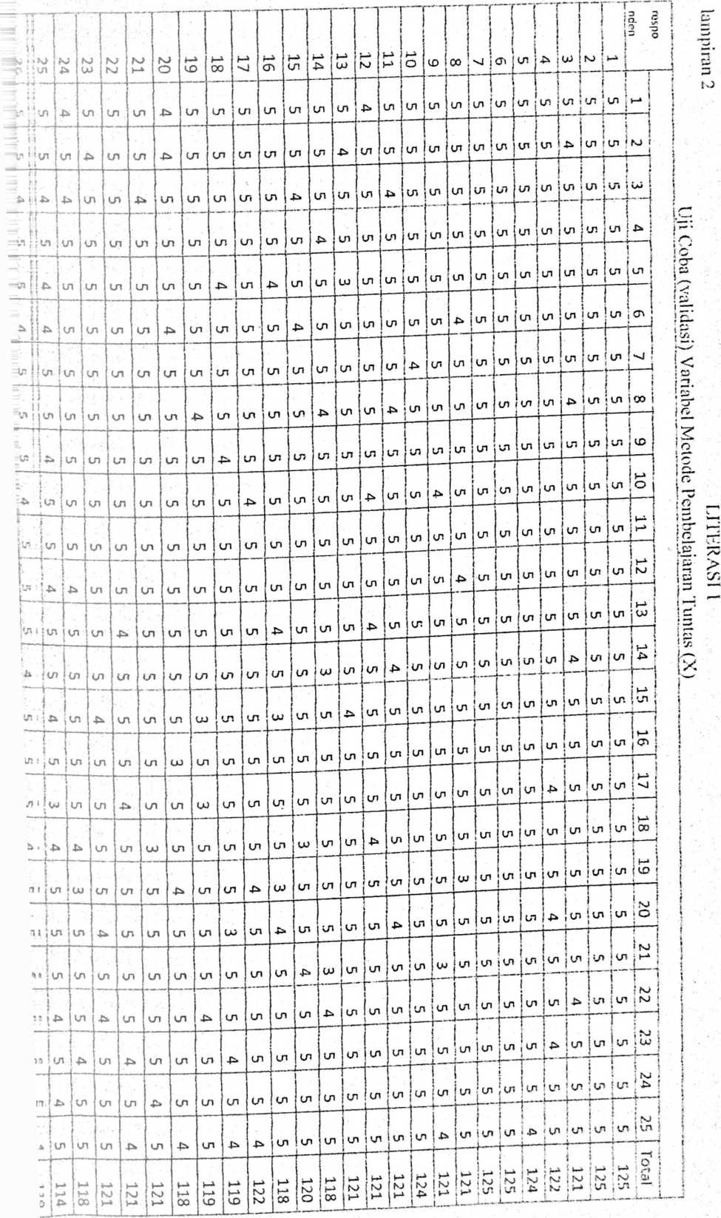

! jumla  ; h __ | . 30 ! | 67 j
i  1 H*  f li.  f -¹ | i  -U
1 | w
£> | v#1 | !^{v}
UJ | u>
i -  l>-> -t-  j |  | u>
!  NJ £ | u» | NJ
’ £  vi | * | cn
• 4^ 4^  i | LH | ■*
14  3 |  | NJ
»  L s | CM | <n
*  o u> | cn | un
i  • cr. |  | cn  u
i  1 J—*  j NJ -> | UJ
T  VI  L .. „.. | .u | £*
;O | cr.
i  L £  1 | - | r⁻  UJ
14 1  _1 | u» | .
i  ! u-j.  i oo cu | _{w}
1 J  i CC u? | LH
14 |  _0 | CM
i  |n> -> | * | UI  ■
1  .—¹  io «&I  t | UJ | U“.
l" l  J | CM | u»
i | tn  . | ->  —
‘’JU  ■ | LH | cn
</5  •• cn  ;gy | k0  O | 100

Uji Coba (validasi) Variabel Metode Pembelajaran Tuntas (X)
I
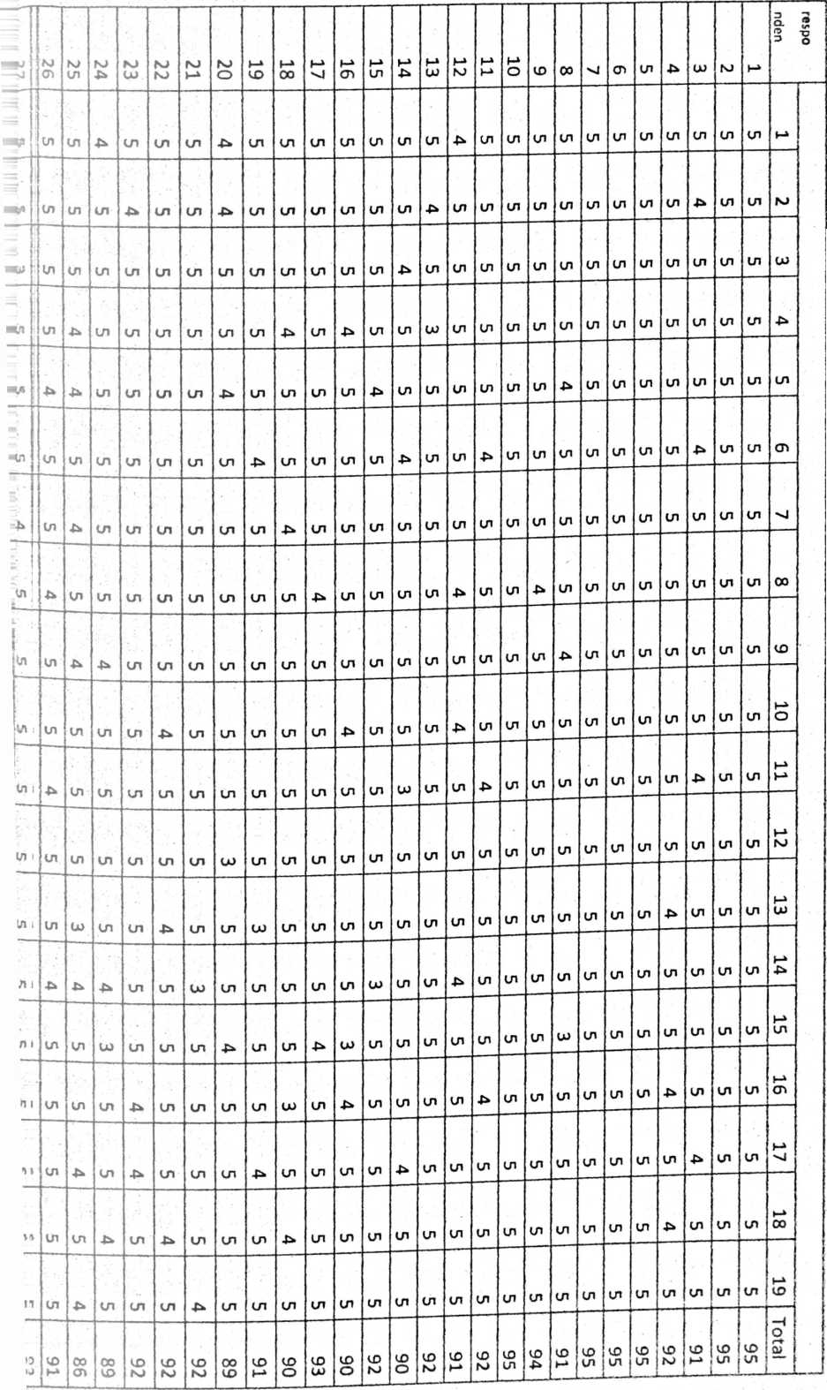
ket | rtabel | rhitung | jlh | 30 | 29
valid | 0,36 |  1 ¹ | p  UU H» | £ |  | ■U
valid | o  Lj  H* CD | 0,58 | tu | UU | •>
vali  d | O  Lu  CD | o  CD  CD | UJ | UJ
vali  d | O  Lu  CD | O  CD  m | £ |  | U)
vali  d | o  Lu  CD | O  CD | S | UI | NJ
valid | O  UJ  H* (D | O  Lu  00 |  | CD
valid | O  UJ  M CD | o  CD  CD NJ | fi | CD | NJ
valid | O  UJ  H» CD | O  cd 5 | UJ | UJ | UI
valid | 0,36  1 | o  Lu  00 | s  CD |  | CD
valid | o  UJ  H* CD | p  CD S | S  bu | UJ
vali  l_d | O  Lu  CD | O  CD  N) | £ | UJ | X*
valid | 0,36 I  1 | 6  09'0 | UI |  | UJ
valid | 0,36  ¹ | p  Ln  00 o | £ | UJ | 4^
vali  d | 0,36 | o  Ln  •U | LU  00 | UJ
vali  d | 0,36 | O  CD | UJ  00 | u» | bJ
vali  d | o  Lu  CD | O  Ln  CD | o | UJ
valid | O  uj  H* CD | O  CD  CD | o | UJ | CD
valid | O  Lu  »-* CD | O  Ln  CD CD | g | UJ | UI
valid | O  Lu  M- CD | O  Lu  UJ | g | L
 |  | i | 2702 |  | t  k

 | N | %
Valid | 30 | 100,0
Cases Excludedª | 0 | ,0
Total | 30 | 100,0
a. Listwise deletion based on all variables in the  procedure.  Relia bility Statistics  Cronbach's  Alpha | Cronbach's  Alpha Based on  Standardized  Items | N of Items
,744 | ,897 | 20
ftem Statistics | ! Mean | Std. Deviation | N
total | 90,07 | 6,113 | 30
P1 | 4,80 | ,407 | 30
P2 | 4,77 | ,504 | 30
P3 | 4,77 | ,568 | 30
p4 | 4,70 | ,596 | 30
p5 | 4,73 | ,640 | 30
p6 | 4,80 | ,407 | 30
p7 | 4,77 | ,626 | 30
p8 | 4,77 | ,504 | 30
p9 | 4,87 | ,346 | 30
p10 | 4,73 | ,583 | 30
p11 | 4,70 | ,596 | 30
P12 | 4,83 | .531 | 30
p13 | 4,70 | ,651 | 30
p14 | 4,60 | ,675 | 30
p15 | 4,60 | ,814 | 30
p16 | 4,67 | .606 | 30
p17 |  | 4,67 |  |  | ,711 |  |  | 30
p18 |  | 4,70 |  |  | ,702 |  |  | 30
p19 |  | 4,90 |  |  | ,305 |  |  | 30
 | Mean |  | Minimum | Maximum |  | Range | Maximum /  Minimum |  | Variance | N of Items
Hem Means  Item  Variances | 9,007  2,190 |  | 4,600  ,093 | 90,067  37,375 |  | 85,467  37,282 | 19,580  401,432 |  | 364,035  68,607 | 20  20
Scale Statistics  Mean | Variance | Std. Deviation | N of Items
180,13 | 149,499 | 12,227 | 20

 |  | tota  1 |  | P¹ |  | p2 |  | p3 | p4 | P> | P⁶ | P⁷ | p8
^aurso |  | 1 |  | ,79 |  | ,79 |  | ,78 | ,74 | ,80 | ,84 | ,61 | ,46
— |  |  |  | 1” |  | o” |  | 8” | 3” | 3” | 4” | 9” | 4
=wrela
DM
-£■•(2- |  |  |  | ,00 |  | ,00 |  | ,00 | ,00 | ,00 | ,oo | ,00 | ,01
■teed) |  |  |  | 0 |  | 0 |  | 0 | 0 | 0 | 0 | 0 | 0
 |  | 30 |  | 30 |  | 30 |  | 30 | 30 | 30 | 30 | 30 | 30
 |  | ,79 |  | 1 |  | ,67 |  | ,67 | ,58 | ,76 | ,59 | ,34 | .25
- |  | 1” |  |  |  | 3” |  | 3” | 7” | 3” | 5~ | 2 | 6
Drrrcla
g.. (2- |  | ,00 |  |  |  | ,00 |  | ,00 | ,00 | ,00 | ,00 | ,06 | ,17
rleed) |  | 0 |  |  |  | 0 |  | 0 | 1 | 0 | 1 | 4 | 1
 |  | 30 |  | 30 |  | 30 |  | 30 | 30 | 30 | 30 | 30 | 30
^ULTSO |  | ,79 |  | ,67 |  | 1 |  | ,62 | ,49 | .74 | ,56 | ,43 | ,31
 |  | O’* |  | 3” |  |  |  | 6” | 5" | 9“ | 9’* | 7 | 9
mrela
m®
g.. (2- |  | ,00 |  | .00 |  |  |  | ,00 | .00 | .00 | ,00 | ,01 | ,08
iffid) |  | 0 |  | 0 |  |  |  | 0 | 5 | 0 | 1 | 6 | 6
 |  | 30 |  | 30 |  | 30 |  | 30 | 30 | 30 | 30 | 30 | 30
arrso |  | ,78  8** |  | .67  3“ |  | .62  6” |  | 1 | .43  4’ | ,57  4” | .66  5“ | .26  8 | ,46  8~
rrrela
11 |  |  |  |  |  |  |  |  |  |  |  |  | ,00
t-(2- |  | ,00 |  | .00 |  | ,00 |  |  | ,01 | .00 | ,00 | .15 | ,00
e?d) |  | 0 |  | 0 |  | 0 |  |  | 7 | 1 | 0 | 1 | 9
 |  | 30 |  | 30 |  | 30 |  | 30 | 30 | 30 | 30 | 30 | 30
irrso |  | ,74 |  | ,58 |  | ,49 |  | ,43 | 1 | ,44 | ,73 | ,45 | ,12
 |  | 3’* |  | 7“ |  | 5” |  | 4* |  | 8* | o” | 6 | 6
■rrela
n |  |  |  |  |  |  |  |  |  |  |  |  | ,50
..(2- |  | ,00 |  | .00 |  | ,00 |  | .01 |  | .01 | .00 | .01 | ,50
r?d) |  | 0 |  | 1 |  | 5 |  | 7 |  | 3 | 0 | 1 | 8
 |  | 30 |  | 30 |  | 30 |  | 30 | 30 | 30 | 30 | 30 | 30
rrso |  | ,80 |  | ,76 |  | ,74 |  | ,57 | ,44 | 1 | ,49 | ,47 | ,30
 |  | 3” |  | 3” |  | 9“ |  | 4” | 8’ |  | 9“ | 9 | H  i
rrela |  |  |  |  |  |  |  |  |  |  |  |  | i
1  .(2- |  | ,00 |  | .00 |  | ,00 |  | ,00 | .01 |  | ,00 | .00 | .09 ■  „ 1
ed) |  | 0 |  | 0 |  | 0 |  | 1 | 3 |  | 5 | 7  ¹ | J j
 |  | 30 |  | 30 |  | 30 |  | 30 | 30 | 30 | 30 | 30 | 30 I
P9 | pio ! pii |  |  |  | p!2 |  | P¹³
,66 | ,78 |  | ,44 |  | ,79 |  | ,64
6” | 3 |  | o' |  | 6” |  | 9”
,00 | .00 |  | ,0. |  | .00 |  | .00
0 | 0 |  | 5 |  | 0 |  | 0
30 | 30 |  | 30 |  | 30 |  | 30
,31 | .37 |  | .49 |  | ,61 |  | ,39
9 | 0* |  | 1” |  | 1” |  | 6’
.08 | ,04 |  | ,00 |  | .00 |  | ,03
6 | 4 |  | 6 |  | 0 |  | o
30 | 30 |  | 30 |  | 30 |  | [ 30
.50 | .45 |  | ,32 |  | ,59 |  | .37
4” | 5' |  | 2 |  | 4" |  | o
,00 | .01 |  | ,08 |  | ,00 |  | .04
5 | 2 |  | 3 |  | i |  | 4
30 | 30 |  | 30 |  | 30 |  | 30
.50 | ,55 |  | .65 |  | .61 |  | .32
7“ | 7” |  | 3 |  | 6*’ |  | 4
.00 | .00 |  | .00 |  | ,00 |  | ,08
4 | 1 |  | 0 |  | o |  | o
30 | 30 |  | 30 |  | 30 |  | 30
,39 | ,57 |  | ,34 |  | .55 |  | .55
7* | 6*’ |  | 8 |  | 8“ |  | 1”
.03 | .00 |  | .06 |  | .00 |  | ,00
0 | 1 |  | °i |  | 1 |  | O
30 | 30 |  | 30 |  | 30 |  | 30
,41 | .60 |  | .27 |  | .62 |  | ,41
0* | 9" |  | ⁴!  ■ |  | 1” |  | 1’
.02 | ,00 |  | .141 |  | 1  .00 |  | ,02
4 | 0 |  | 1 !  — |  | 0' |  | 4
30 | »1 |  | 30 | |  | 30 | |  | 30
 |  | ,84  4“ |  | ,59  5** |  |  | ,56  9** |  | ,66  5” |  | ,73  0” |  | ,49  9°
^nrela  <«! ’ •  (2- |  | .00 |  | ,00 |  |  | ,00 |  | .00 |  | ,00 |  | .00
31'iczd) |  | 0 |  | 1 |  |  | 1 |  | 0 |  | 0 |  | 5
 |  | 30 |  | 30 |  |  | 30 |  | 30 |  | 30 |  | 30
^atrbo |  | ,61 |  | ,34 |  |  | ,43 |  | ,26 |  | ,45 |  | ,47
 |  | 9*’ |  | 2 |  |  | 7’ |  | 8 |  | 6’ |  | 9"
"mela  ■COl  3g..(2- |  | :00 |  | ,06 |  |  | ,01 |  | ,15 |  | ,01 |  | ,00
aileed) |  | 0 |  | 4 |  |  | 6 |  | 1 |  | 1 |  | 7
-5 |  | 30 |  | 30 |  |  | 30 |  | 30 |  | 30 |  | 30
"eaiirso |  | .46 |  | ,25 |  |  | ,31 |  | ,46 |  | .12 |  | ,30
■ ‘ |  | 4’* |  | 6 |  |  | 9 |  | 8“ |  | 6 |  | 8
Zorrrela  ■om.'  =^(2- |  | ,01 |  | ,17 |  |  | ,08 |  | ,00 |  | ,50 |  | ,09
aked) |  | 0 |  | 1 |  |  | 6 |  | 9 |  | 8 |  | 8
=i |  | 30 |  | 30 |  |  | 30 |  | 30 |  | 30 |  | 30
feaarso |  | ,66 |  | ,31 |  |  | ,50 |  | .50 |  | .39 |  | .41
i |  | 6” |  | 9 |  |  | 4*’ |  | 7** |  | 7* |  | 0*
fomela  fern  fcgg. (2- |  | ,00 |  | ,08 |  |  | ,00 |  | ,00 |  | ,03 |  | ,02
felied) |  | 0 |  | 6 |  |  | S |  | 4 |  | 0 |  | 4
I¹ ■ • |  | 30 |  | 30 |  |  | 30 |  | 30 |  | 30 |  | 30
taarso |  | ,78 |  | ,37 |  |  | ,45 |  | ,55 |  | ,57 |  | ,60
1 |  | 3“ |  | 0’ |  |  | 5* |  | 7“ |  | 6“ |  | 9*’
'onrrela  bm  4g2; (2~ |  | ,00 |  | ,04 |  |  | ,01 |  | .00 |  | ,00 |  | .00
rilled) |  | 0 |  | 4 |  |  | 2 |  | 1 |  | 1 |  | 0
L ' |  | 30 |  | 30 |  |  | 30 |  | 30 |  | 30 |  | 30
caarso |  | ,44 |  | ,49 |  |  | ,32 |  | ,65 |  | ,34 |  | .27
 |  | 0’ |  | r* |  |  | 2 |  | 3” |  | 8 |  | 4
oarrela  Ml  (2- |  | ,01 |  | ,00 |  |  | ,08 |  | ,00 |  | ,06 |  | ,14
illed) |  | 5 |  | 6 |  |  | 3 |  | 0 |  | 0 |  | 3
 |  | 30 |  | 30 |  |  | 30 |  | 30 |  | 30 |  | 30
sarso |  | ,79 |  | ,61 |  |  | ,59 |  | ,61 |  | ,55 |  | ,62
 |  | 6” |  | r* |  |  | 4*’ |  | 6** |  | 8** |  | r*
wrrela  MMl  S-(2- |  | ,00 |  | ,00 |  |  | ,00 |  | .00 |  | .00 |  | .00
iilcd) |  | 0 |  | 0 |  |  | 1 |  | 0 |  | 1 |  | 0
 |  | 30 |  | 30 |  |  | 30 |  | 30 |  | 30 |  | 30
rarso |  | ,64 |  | ,39 |  |  | ,37 |  | ,32 |  | .55 |  | .41
 |  | 9*’ |  | 6’ |  |  | 0* |  | 4 |  | r |  | r
orrela  on |  | ,00 |  | ,03 |  |  | ,04 |  | ,08 |  | ,00 |  | ■⁰²
1 | ,47 |  | ,43  o’ |  | ,52  9*‘ | ,69  l’* |  | .23  6 |  | 0  ■
 | .00 |  | ,01 |  | ,00 | ,00 |  | .20 |  | ■  .00 |  | 1 .00
 | 9 |  | 8 |  | 3 | 0 |  | 9 |  | 0 |  | 4  1
30 | 30 |  | 30 |  | 30 | 30 |  | 30 |  | 30 |  | 30
,47  1” | 1 |  | .06  2 |  | ,49  2" | ,55  1” |  | 0,0  00 |  | ,31  1 |  | ,77
,00 |  |  | ,74 |  | ,00 | ,00 |  | 1,0 |  | .09 |  | 1  ,00
9 |  |  | 4 |  | 6 | 2 |  | 00 |  | 4 |  | 0
30 | 30 |  | 30 |  | 30 | 30 |  | 30 |  | 30 |  | 30
,43 | ,06 |  | 1 |  | .44 | ,47 |  | ,11 |  | .46 |  | .18
0' | 2 |  |  |  | 3* | 9" |  | 6 |  | 7” |  | 8  1
,01 | ,74 |  |  |  | .01 | .00 |  | .54 |  | ,00 |  | 1  .32
8 | 4 |  |  |  | 4 | 7 |  | 0 |  | 9 |  | 0
30 | 30 |  | 30 |  | 30 | 30 |  | 30 |  | 30 |  | 30
.52 | .49 |  | ,44 |  | i | ,56 |  | ,32 |  | ,42 |  | .59
9“ | 2“ |  | 3* |  |  | 0” |  | 7 |  | 9* |  | 4”
,00 | ,00 |  | ,01 |  |  | ,00 |  | ,08 |  | ,02 |  | ,00
3 | 6 |  | 4 |  |  | 1 |  | 2 |  | 0 |  | J
30 | 30 |  | 30 |  | 30 | 30 |  | 30 |  | 30 |  | 30
.69 | ,55 |  | ,47 |  | ,56 | 1 |  | ,13 |  | •⁶£
1“ | 1” |  | 9° |  | o’’ |  |  | 9 |  | ⁰ |  | ⁶
,00 | .00 |  | .00 |  | .00 |  |  | .46 |  | ,00 |  | .00
0 | 2 |  | 7 |  | l |  |  | 2 |  | 0 |  | 0
30 | 30 |  | 30 |  | 30 | 30 |  | 30 |  | 30 |  | 30
,23 | 0,0 |  | ,11 |  | ,32 | .13 |  | 1 |  | •29 |  | -.05  *■
6 | 00 |  | 6 |  | 2 | 9 |  |  |  | 1 |  | 5
,20 | 1,0 |  | .54 |  | ,08 | .46 |  |  |  |  |  | ,7
9 | 00 |  | 0 |  | 7 | 2, |  |  |  | ⁹ |  | 4
30 | 30 |  | 30 |  | 30 | 30 |  | 30 |  | 30 |  | 30
.77 | ,31 |  | ,46 |  | .42 | ,66 |  | .29 |  | 1 |  | ,31
0“ | 1 |  | 7“ |  | 7* | 0”  1 |  | 1 |  | i  I |  | 3
,00 | ,09 |  | ,00 |  | .02 | ,00 |  | -H |  |  |  | ,09
0 | 4 |  | 9 |  | ■ 0 1 | 0 |  | 9 j |  |  |  | 7
30 | 30 |  | 30 |  | 30 | 30 i |  | 30 |  | 30 |  | 30
.50 | ,77 |  | .18 |  | .59 | •62 i |  | .05 | |  | 31 ; |  | 1
8“ | ’l |  | ⁸ i  • |  | 4” |  |  | S i  j  i
,00  1 | ,00  i |  | 32 j  1 |  | .00 | .00 j |  | j  .77 i  1 |  | .09 ;

Uji Coba Validasi Variabel Y (Prestasi belajar)
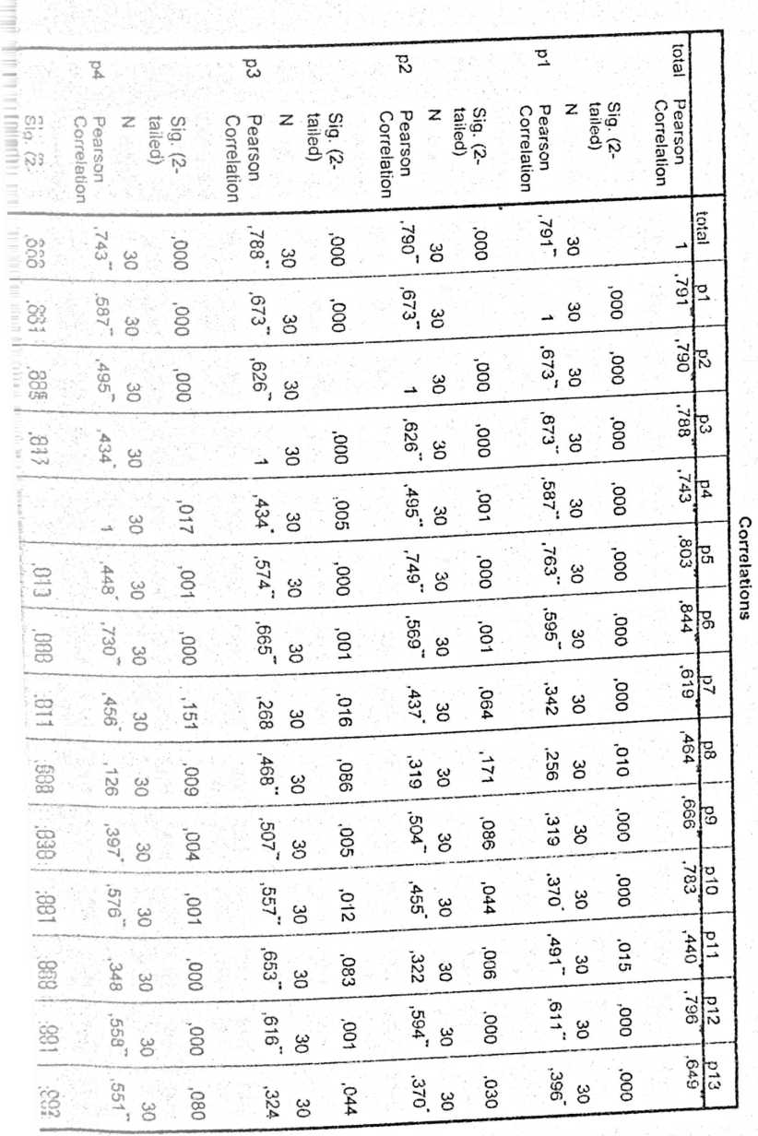
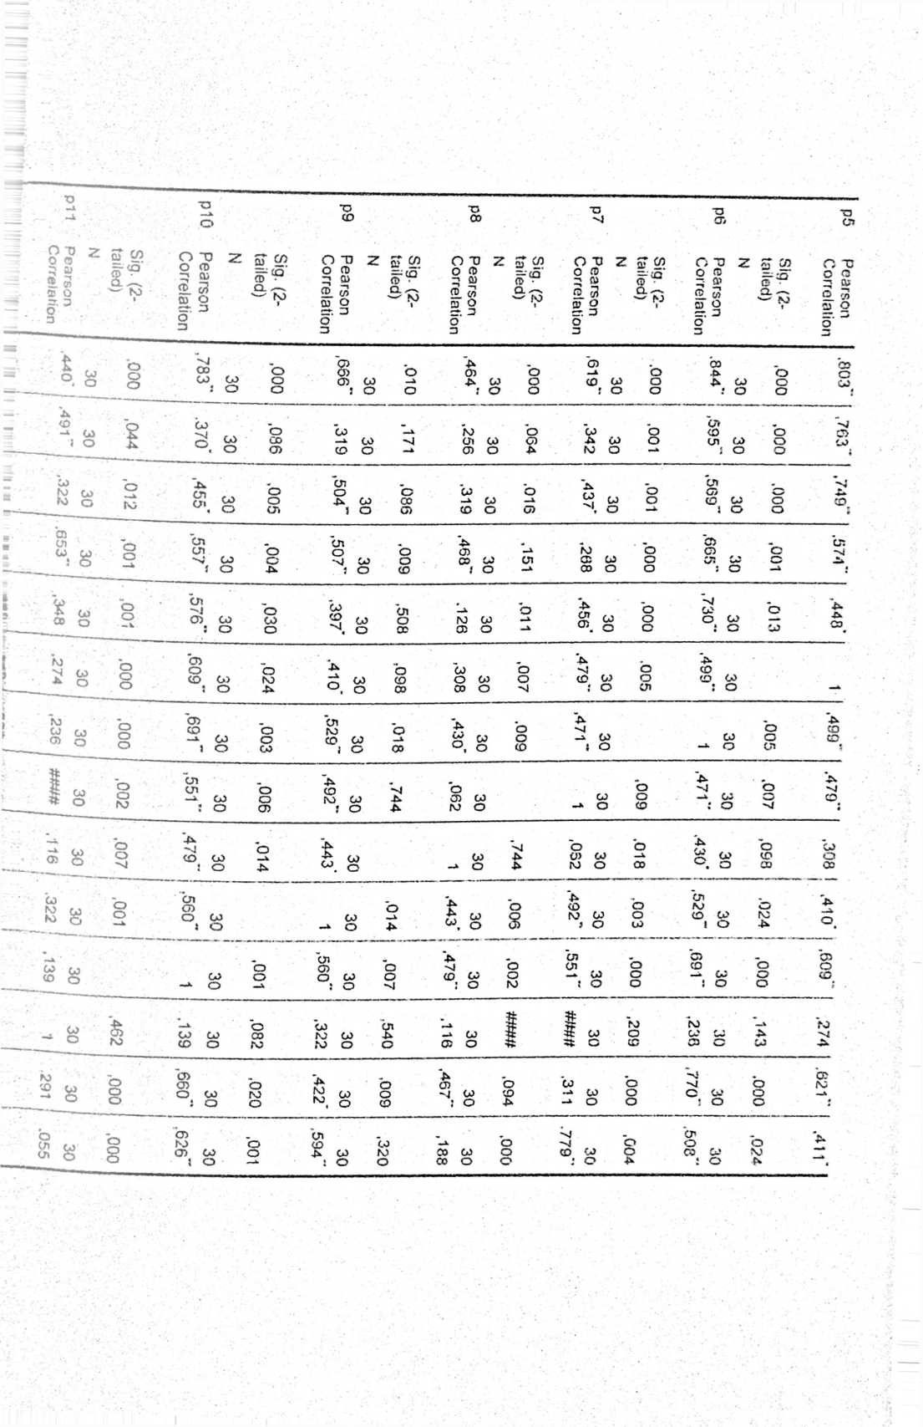
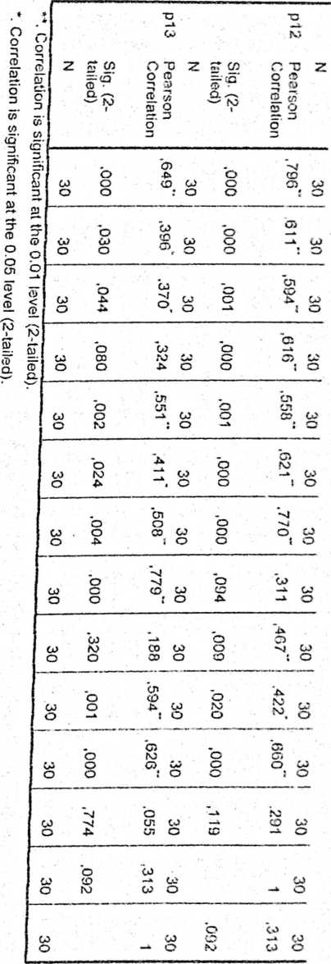

LH
Ln
LH
cn
ui
in
ui
cn
UD
LITERASI1
Uji Coba (Validasi) Variabel Prestasi Belajar Siswa Y
00
Ch
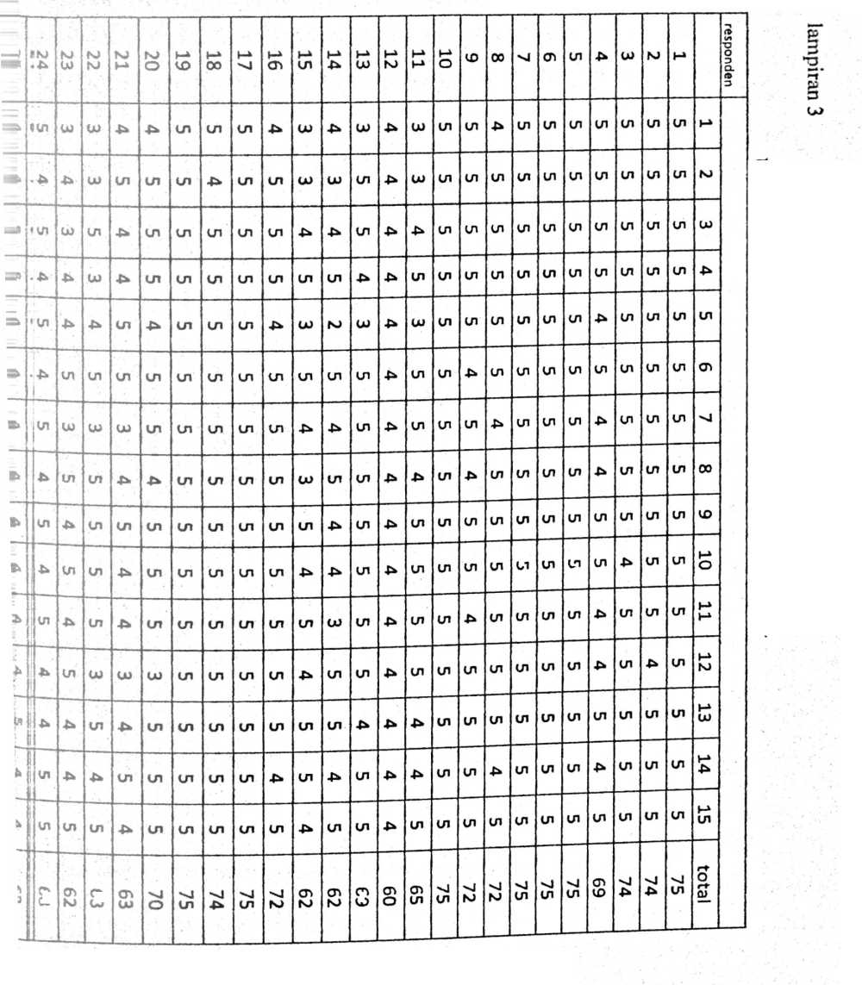
jumlah | 30 | 29 | 28
128 | UJ |  | U>
131 | UJ |  | LU
139 |  |  | ->
## |  | £* | NJ
127 | UJ | 4* | NJ
146 | UI | UI | UI
129 | UJ | K> | NJ
SET | U1 | 4* | W
## | UI | 4* | UI
140 |  | 4*
137 |  | 4* | N>
135 | UI | 4* | UI
142 | UJ | UI | UI
| 135 | U) | UJ | U»
144 | UI | UI | UJ
2051 | 58 | 60 | UI  O

 | 1 | 2 | ³ | 4 | 5 | 6 | 7 | 8 | ⁹ | i 10 | 11 | i¹² | U³ | total  —
1 | 5 | .J  5 | 5 | 5 | 5 | 5 | 5 | 5 | 5 | 5 | 5 | I 5 | i 5  — | I 65  —
2 1 | s | 5 | 5 | 5 | 5 | 5 | 5 | 5 |  | 5 |  | 5 | ! 5  j | 1 _6S
3 ! | 5 | 5 | 5 | 5 | 5 | 5 | 5 | 5 | 4 | 5 | 5 | 5 | s | ' ⁶⁴
4 | 5 | 5 | 5 | 5 | 4 | 4 | 4 | 5 | ⁵ | 4 | 5 | _4 | 5 | 60  --
5 | 5 | S | 5 | 5 | 5 | 5 |  | 5 |  | _5__ | i 5 | 5 | 5 | _A__
6 | 5 | 5 | 5 | 5 | 5 | 5 | _5 | 5 | 5 | 5 | 5 | 5 | Ll_ | ⁶⁵—
7 | 5 | —  5 | 5 | 5 | 5 | 5 | 5 | 5 | 5 | 5 | 5 | 5 | ⁵ | 65
8 | 4 | 5 | 5 | 5 | 5 | 4 | 5 | 5 | 1 5 _ | 5 | 5 | 4 | 5 | 1. Al_
9 | 5 | —  s | 5 | 5 | 5 | 5 | 4 | 5 | 5 | 4 | 5 | 5 | 5 | 63
10 | 5 | s | 5 | 5 | 5 | 5 | 5 | 5 | 5 | 5 | 5 | 5 | 5 | 65
11 | —  3 | 3 | 4 | 5 | 3 | 5 | 4 | 5 | 5 | 5 | 4 | 4 | 5
12 | 4_j | 4 | 4 | 4 | 4 | 4 | 4 | 4 | 4 | 4 | 4 | 4 | 4 | 52
13 | 3 | 5 | 5 | 4 | 3 | 5 | _5 | 5 | 5 | __5__ | 4 | 5  — | 5 | 59
14 | 4 | 3 | 4 | 5 | 2 | 4 | 5 | 4 | 4 | 3 | 5 | 4 | 5 | 52 ;  —■
~15 | —  3 | 3 | 4 | 5 | 3 | 4 | 3_ | 5 | 4 | 5 | □ | 5 | _4_ | ⁵- ]
16 | 4 | 5 | 5 | 5 | 4 | 5 | 5 | 5 | 5 | 5 |  | 4 | 5  —-— | —
17 | 5 | 5 | 5 | 5 | 5 | 5 | 5 | 5 | 5_ | 5 | 5 | 5 | 5 | 65 i  J
¹⁸ | 5 | 4 | 5 | 5 | 5 | 5 | _5 | 5 | 5 | 5 | 5 | 5 | 5 | 64 |  ¹
19 | 5 | 5 | 5 | 5 | 5 | 5 | 5 | 5 | 5 | 5 | 5 | 5 | 5 | 65 :
[ 20 | 4 | 5 | 5 | 5 | 4 | 5 | 4 | 5 |  | 5 | 5 | 5 |  | 62 !
21 | 4 | 5 | 4 | 4 | 5 | 3 | 4 | 5 |  | _±_ | 4 | 5 | 4 | 55 j
22 | 3 | 3 | 5 | 3 | 4 | 3 | 5 | 5 | 5 | _5_ | 5 | 4_ | _5_ | 55 !
23 | 3 | 4 | 3 | 4 | 4 | 3 | 5 | 4 | 5 | 4 | 4 | 4 | b | 52 J
24 | 5 | 4 | 5 | 4 | 5 | 5 | 4 | 5 | __4_ | 5 | 4 | 5 | _Ad  - t | 60 j
25 | 4 | 4 | 5 | 5 | 4 | 4 | 4 | 4 | 4 | 4 | 5 | 4 | 4  i | 55 _1
26 | 5 | 4 | 5 | 5 | 4 | 4 | 4 | _5 | 5 | 5 | 5 | -Jj | 2 ‘ | 6i i  1
27 | 5 | 5 | 5 | 5 | 5 | 5 | 5 | 5 | 5 | 5 | 5  1 | 5 [ | 5 i  —i | . ⁶⁵ _J
28 | 3 | 3 | 4 | 2 | 2 | 2 | .  2 | 5 | 4 | 2 |  |  | -A J  1 | 40 _ |
29 | 4 | 4 | 4 | 4 | 4 | 2 | 4 | 4 | 4 | 4 | -U | -M | 5 i  —t | _AL_J  ¹
30 | 3 | 3 | 3 | 4 | 3 | 3 | 5 | 5 _ | 4 | 4 | -M | -M | __5_J | 48 •
aumlah | 128 | 131 | 139 | 138 | 127 | 129 | _135_ | 145 | 140 | 137 | _142J | 135 ! | 144; | 1770 i

 | N | %
Valid | 30 | 100,0
Cases Excluded³ | 0 | ,0
Total | 30 | 100.0
a. Listwise deletion based on all variables in the  procedure.  Reliability Statistics  Cronbach’s  Alpha | Cronbach’s  Alpha Based on  Standardized  items | N of Items
,766 | ,932 | 14
Item Statistics | Mean | Std. Deviation | N f
total | 59,0000 | 6.47542 | 30
P1 | 4,2667 | ,82768 | 30
P2 | 4,3667 | ,80872 | 30
P3 | 4,6333 | ,61495 | 30
P4 | 4,6000 | ,72397 | 30
P5 | 4,2333 | ,93526 | 30
P6 | 4,3000 | .95231 | 30
P7 | 4,5000 | ,73108 | 30
P8 | 4,8333 | ,37905 | 30
P9 | 4,6667 | ,47946 | 30
P10 | 4,5667 | ,72793 | 30
P11 | 4.7333 | ,52083 | 30
P12 | 4,5000 | ,68229 | 30
P13 | 4,8000 | ,48423 | 30

 | Mean | Minimum | Maximum | Range | Maximum /  Minimum | Variance | N of Hems
■ 'eem Means | 8,429 | 4.233 | 59,000 | 54,767 | 13,937 | 211,898 | 14
■-teem Variances | 3,455 | ,144 | 41,931 | 41.787 | 291,840 | 122,694 | 14
Scale Statistics  Mean | Variance | Std. Deviation | N of Items
118,0000 | 167,724 | 12,95084 | 14

<  J •'  -s'bAj  ₉ KaJ | 21 | bJ  O | 19 | 18 | 17 | 16 | 15 | 14 | 13 | 12 | 11 | 10 | CD | 00 |  | CT> | cn | P* | CD | NJ |  |  | Responden
■*!  S ...  r* | tn | 4* | cn | Pk | cn | cn | cn | cn | cn | Pk | cn | p» | 4^ | cn | cn | Pk | cn | cn | 4* | cn | cn | M
SiCAA | V> | VI | cn | cn | cn | cn | p> | cn | cn | cn | tn | cn | 4* | cn | cn | CD | cn | P* | cn | cn | cn | bJ
j  ■ (UJI | tn | VI | P* | cn | cn | cn | cn | cn | cn | cn | cn | 4^ | CD | cn | cn | CD | cn | 4^ | cn | cn | cn | CD
i  ■ !V/I | LH | cn | P* | m | cn | cn | Pk | cn | cn | cn | cn | pk | CD | cn | cn | Pk | cn | bJ | Pk | cn | cn | P*
■ ’Pfc | Cn | UI | VI | cn | cn | P* | 4* | -P* | cn | 4* | cn | 4* | P* | cn | cn | cn | cn | cn | 4* | cn | cn | cn
* -■  • |un | cn | U1 | cn | cn | cn | cn | P> | cn | cn | cn | cn | 4^ | cn | cn | cn | cn | cn | P» | cn | cn | cn | CB
lp | VI | VI | P* | cn | cn | CD | UU | P* | cn | cn | cn | ■P* | bu | cn | cn | m | cn | bJ | 4* | cn | cn | -4
Li  i ⁵-uin | Cn | m | cn | cn | cn | cn | Pk | cn | cn | cn | cn | Pk | cn | cn | cn | CD | cn | cn | cn | cn | cn | 00
: [  i ;um  Lj | V) | VI | cn | cn | cn |  | cn | cn | cn | cn | cn | cn | P* | cn | cn | P* | cn | CD | Pk | cn | cn | CD
^jun | UU | <A | cn | P* | cn | CD | P* | cn | cn | Pk | cn | P* | uu | cn | cn | CD | cn | uu | CD | cn | cn | 10
1! | VI | cn | •U | P* | cn | Pk | Pk | Pk | cn | 4^ | cn | P* | CD | cn | cn | CD | cn | CD | P» | cn | cn | 11
1  'jCUH | UH | Cn | -u | cn | -u | CD | P> | cn | cn | cn | cn | bJ | 4^ | cn | cn | 4k | cn | Pk | cn | cn | cn | 12
T”  Jun  u | VI | Pk | V» | cn | cn | cn | cn | cn | cn | cn | cn | £» | P* | cn | cn | CD | cn | cn | P* | cn | cn | CD
4 - -  3  f UH | VT | Cn | cn | cn | cn | uu | cn | cn | cn | cn | cn | A | P> | cn | cn | UU | cn | cn | A | cn | cn | 14
1  i  j PU | UI | Ul | cn | cn | cn | p* | -P* | cn | cn | cn | cn | bJ | CD | cn | cn | cn | cn | 4* | P | cn | cn | 15
i  i uji | V | Cn | cn | cn | cn | p* | cn | Pk | cn | cn | cn | bJ |  | cn | cn | CD | cn | V | cn | cn | cn | 16
i  |  ;un | UI | cn | cn | cn | cn | cn | cn | cn | cn | cn | cn | hU | A | cn | cn | CD | cn | cn | CD | cn | cn | 17
1  jwn | V) | VJ | cn | cn | cn | cn | P* | cn | cn | uu | cn | bJ | cn | cn | cn | CD | cn | (D | cn | cn | cn | 18
|un | V | V | Pk | cn | cn | cn | cn | cn | cn | cn | cn | cn | P* | cn | cn | cn | cn | cn | cn | cn | cn | 19
Fft I | 93 | 93 | 89 | 92 | 94 | 82 | 00  cu | 91 | S6 | 00  CD | 95 | 69 | 72 | CD  cn | 95 | 71 | 95 | 76 | 82 | 95 | 95 |  | total
jumlah | 30 | 29¹ | r-u  oo | 27 | 26 | 25
138 | UT | UT |  | 4* | 4* | UT
2  NJ | UI | UT | UT | UT | -> | 4*
138 | UI | UT |  | CU | 4* | Ul
137 | UI | UI | UT | A | UI
UJ  00 | UI | UT |  | UT | u>
146 | UI | UT | UT | UT |  | UT
132 | UI | UT | A | •£* | UT | ■>
144 | UI | UT | 4^ | UT | UT | UI
143 | UI | UI | UT | UI | 4^ | UT
129 | UI | UT | 4* | 4* | UI
130 | UI | UT | 4* | UJ | UT
136 | UI | UT | UT | UT | 4^ | UT
139 | UI | UT | 4* | 4> | UT | 4>
o | UT | UT |  | Ui | 4* | Ul
140 | UI | UT | UT | UT | Ul | UT
138 | UT | UT | UT | 4* |  | A
139 | UI | UI | 4^ | 4^ | * | UT
137 | UT | UT | UT | UT | UT | 4*
146 | UT | UT | UT | UT | tn | r_
wJ |  | kD | 00 | CO | 00 | oo
N) | UT | UT  L- | UT | * | * | OT
1 J .1 UIHUHHii.il |  | M  ho | 21 | 20 | 19 | 18 | 17 | 16 | 51 | 14 | 13 | bJ | Tl | o | CD | 00 |  | cn | Ul |  | co | bJ |  |  | RESPONDEN
4> . |  | UT | 4> | 4» | 4x | 4> | Ul |  | Ul | Ul | Ul | -> | Ul | Ul | Ul | Ul | Ul | CD | Ul | co | 4* | Ul | Ul | H»
A. |  | UT | Ul | 4> | Ul | 4> | Ul | UJ | 4^ | Ul | Ul | 4* | Ul | 4> | Ul | Ul | Ul | CD | UT | bJ | 4> | Ul | UT | bJ
"Uli |  | UI | Ul | Ul | Ul | Ul | Ul | 4* | Ul | Ul | Ul | CO | Ul | A | Ul | Ul | Ul | CD | Ul | Ul | Ul | Ul | cn | CO
|UM |  | U1 | Ul | Ul | Ul | Ul | Ul | Ul | Ul | Ul | Ul | Ul | Ul | A |  | Ul | Ul | 4* | Ul | Ul | 4^ | Ul | cn | 4*
i |  | cn | Ul | Ul | 4* | Ul | Ul | 4* | 4* | Ul | Ul | Ul | Ul | 4* | Ul | Ul | Ul | co | Ul | nj | 4* | Ul | Ul | Ul
i |  | Ul | Ul | Ul | Ul | Ul | Ul | 4» | 4* | Ul | Ul | Ul | Ul | ru | Ul | Ul | Ul | CD | Ul | Ul | 4> | Ul | Ul | CD
i | W | Ul | Ul |  | 4* | Ul | Ul | uo | 4* | Ul | Ul | Ul | Ul | ru | 4> | Ul | Ul | Ul | Ul | co | Ul | Ul | Ul | >J
i | uri | Ul | Ul | Ul | Ul | Ul | Ul | U1 | Ul | Ul | Ul | Ul | Ul | Ul | Ul | Ul | Ul | cn | Ul | Ul | Ul | Ul | cn | 00
 | um | Ul | Ul | Ul | Ul | 4* | Ul | Ul | Ul | Ul | Ul | Ul | Ul | bo | Ul | Ul | Ul | 4* | Ul | Ul | Ul | Ul | Ul | co
 | inn | Ul | Ul | Ul | 4> | Ul | Ul | Ul | 4* | Ul | Ul | Ul | Ul | Ul | Ul | Ul | Ul | 4* | Ul | Ul | Ul | Ul | m | 10
 | /n | Ul | Ul | Ul | Ul | Ul | Ul | Ul | Ul | Ul | Ul | 4* | Ul | Ul | Ul | Ul | Ul | co | Ul | co | Ul | Ul | cn | 11
 | rn | Ul | Ul | Ul | Ul | Ul | Ul | Ul | 4> | Ul | UT | Ul | Ul | co | 4» | Ul | Ul | uo | Ul | Ul | 4» | cn | cn | 12
 | m | Ul | Ul | Ul | Ul | Ul | Ul | Ul | 4^ | Ul | Ul | UT | Ul | Ul | 4- | Ul | Ul | Ul | Ul | Ul | 4> | cn | cn | 13 1
 | i «1 | 65 | | 64 | o  hO | 19 | Ul  bO | 99 | 57 | 85 | 65 | 65 | 60 | 65 | 50 | 61 | 65 | cn  Ul | 8fr | 65 | Ul  co | Ul  00 | 65 | 65 |  | Total

Jumlah | w  o | 29 | 28 | 27 | 26
131 | UI | Ul | 4^ | UJ | 4*
133 | cn | UT | UT | UJ | Ul
! 139 | m | Ul | A | Ul | M
142 | Ul | Ul |  |  | UT
135 | UI | Ul | Ul |  | Ul
139 | Ul | Ul |  | Ul
137 | Ul | Ul | Ul | Ul | Ul
150 | Ul | Ul | Ul | Ul | Ul
144 | Ul | Ul | Ul | Ul | Ul
144 | Ul | Ul | m | Ul | Ul
143 | Ul | Ul | Ul | Ul
142 | Ul | Ul | Ul | Ul | •S»
145 | Ul | Ul | Ul |  | Ul
1824 | 65 | o  UT | 61 | S8 | Ul  00

Valid |  |  |  |  | 30
N
Missing |  |  |  |  | 0
Mean |  |  |  |  | 87,73
Median |  |  |  |  | 90,50
Mode |  |  |  |  | 95
Std. Deviation |  |  |  |  | 7_{t}891
Range |  |  |  |  | 26
Minimum |  |  |  |  | 69
Maximum |  |  |  |  | 95
Metode Pembelajaran Tuntas _
 |  | Frequency | Percent | Valid Percent |  | Cumulative  Percent
 | 69 | 1 | 3.3 | 3,3 |  | 3.3
 | 71 | 1 | 3,3 | 3,3 |  | 6.7
 | 72 | 1 | 3,3 | 3.3 |  | 10,0
 | 76 | 1 | 3,3 | 3,3 |  | 13,3
 | 81 | 1 | 3.3 | 3,3 |  | 16.7
 | 82 | 2 | 6.7 | 6,7 |  | 23,3
 | 83 | 1 | 3,3 | 3.3 |  | 26,7
 | 84 | 2 | 6.7 | 6.7 |  | 33.3 ■
Valid | 85 | 1 | 3.3 | 3.3 |  | 36,7
 | 86 | 1 | 3,3 | 3.3 |  | 40,0
 | 89 | 2 | 6.7 | 6.7 |  | 46,7 i
 | 90 | 1 | 3,3 | 3,3 |  | 50,0 j
 | 91 | 2 | 6,7 | 6.7 |  | 56,7
 | 92 | 1 | 3.3 | 3,3 |  | 60,0
 | 93 | 2 | 6.7 | 6.7 |  | 66,7
 | 94 | 1 | 3.3 | 3.3 |  | 70.0
95 | 9 | 30,0 | 30,0 | 100,0
Total | 30 | 100,0 | 100,0

Histogram
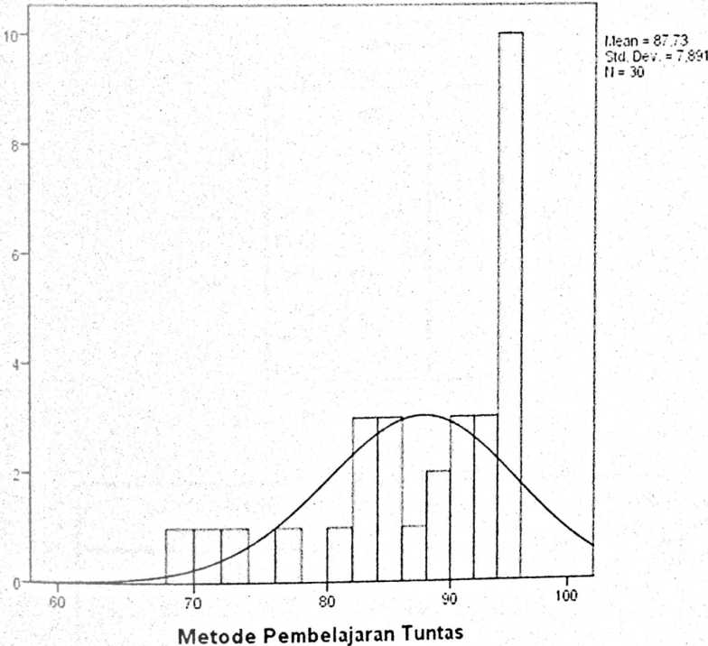

Valid | 30
N
Missing | 0
Mean | 60,80
•Median | 61,50
Mode | 65
I Std. Deviation | 4,881
1 Range | 17
1 Minimum | 48
1 Maximum ’ | 65
Prestasi Belajar PAK | Frequency | Percent | Valid Percent | Cumulative  Percent
48 | 1 | 3,3 | 3.3 | 3.3
50 | 1 | 3.3 | 3.3 | 6.7
52 | 1 | 3,3 | 3,3 | 10.0
53 | 1 | 3,3 | 3,3 | 13.3
57 | 1 | 3.3 | 3.3 | 16.7
58  Valid | 4 | 13,3 | 13,3 | 30.0
60 | 2 | 6,7 | 6,7 | 36,7
61 | 4 | 13,3 | 13.3 | 50,0
62 | 2 | 6.7 | 6.7 | 56,7
64 | 1 | 3,3 | 3.3 | 60,0
65 | 12 | 40,0 | 40,0 | 100,0
Total | 30 | 100.0 | 100.0

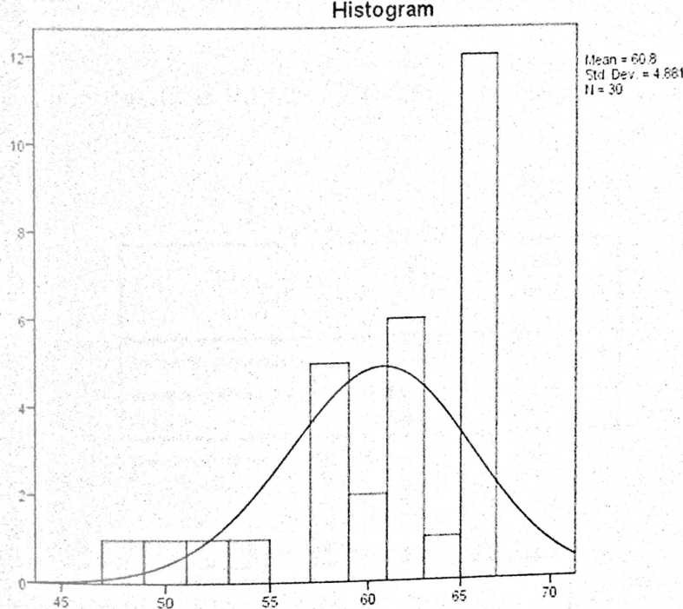
Prestasi Belajar PAK

Metode
Pembelajaran
Tuntas
Series or Sequence Length | 30
Number of Missing Values User-Missing | 0
in the Plot System-Missing | 0
The cases are unweighted.  Estimated Distribution Parameters | Metode  Pembelajaran  Tuntas
Location  Normal Distribution  Scale | 87,73  7,891

The cases are unweighted.
Metode Pembelajaran Tuntas
u il
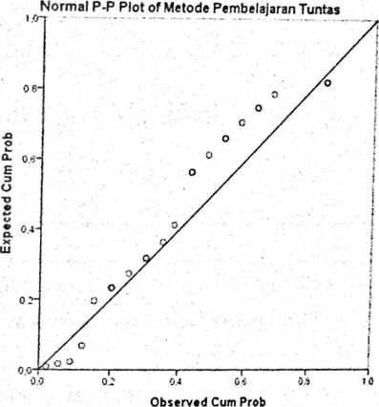
Detrended Norma) P-P Plot of Metode Pembelajaran Tuntas
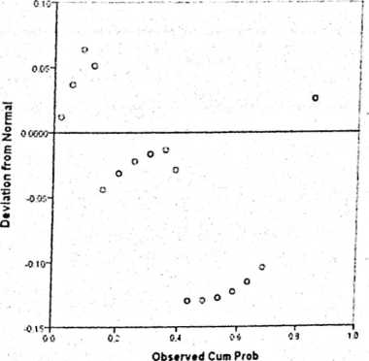

 | Prestasi Belajar
Series or Sequence Length | 30
Number of Missing Values User-Missing | 0
in the Plot System-Missing | 0
The cases are unweighted.  Estimated Distribution Parameters | Prestasi Belajar
Location | 60,80
Normal Distribution
Scale | 4,881
The cases are unweighted.
Prestasi Belajar
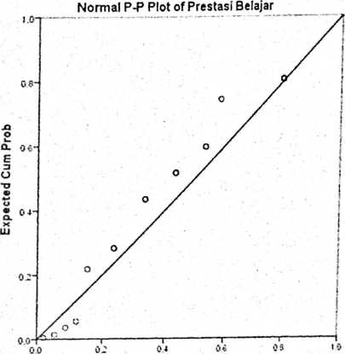
Observed Cum Prob

Deviation from Normal
Detrended Normal P-P Plot of Prestasi Belajar
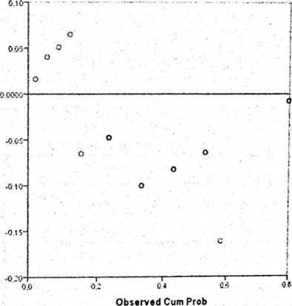

 | Cases _
 | Included |  | Excluded |  | Total
 | N | Percent | N | Percent | N | Percent
Prestasi Belajar *  Metode Pembelajaran  Tuntas | 30 | 100,0% | 0 | 0,0% | 30 | 100,0%
Report  ouicijai  Metode Pembelajaran  Tuntas | Mean | N | Std. Devialion
69 | 50.00 | 1
71 | 48,00 | 1
72 | 61,00 | 1
76 | 53,00 | 1
31 | 52,00 | 1
82 | 57,50 | 2 | .707
83 | 58,00 | 1
84 | 58,00 | 2 | .000
35 | 61,00 | 1
86 | 60,00 | 1
89 | 60,50 | 2 | .707
90 | 61,00 | 1
91 | 65,00 | 2 | .000
92 | 62.00 | 1
93 | 63,00 | 2 | 1,414
94 | 65.00 | 1
95 | 65,00 | 9 | .000
Total | 60,80 | 30 | 4,881

 | Cr35z*!^'
!
Included |
 | N | Percent | i ’
Prestasi Belajar *  Metode Pembelajaran  Tuntas | 30 | 1  10C,0«Sj  f  i | j  r _{s}  l

 | Sum of  Squares | df | Mean  Square | F | Sig.
Between (Combine  ^-restasi Belajar * _  Groups d) | 687,800 | 16 | 42,988 | 186,27  9 | .000
MUetode  Wrthin Groups  •belajaran Tuntas  Total | 3,000  690,800 | 13  29 | ,231
Measures of Association | Eta | Eta Squared
Prestasi Belajar * Metode  Pembelajaran Tuntas | ,998 | ,996

Model | Variables  Entered | Variables  Removed | Method
1 | Metode  Pembelajaran  Tuntas |  | Enter
a Dependent Variable: Prestasi Belajar  b. AH requested variables entered.  Model Summary*  Model | R | R Square | ivi'JUci vuniiiiwi/  Adjusted R  Sauare | Std. Error of the  Estimate | Durbin-Watson
1 | ,889* | .791 | ,784 | 2,270 | 2.046
a. Predictors: (Constant), Metode Pembelajaran Tuntas
b. Dependent Variable: Prestasi Belajar
ANOVAª
Model | Sum of Squares | df | Mean Square | F | ■„ ^{S;}2—
Regression  1 Residual | 546,465  144,335  690.800 | 1  28  29 | 546,465  5,155 | 106.011 | ,000'
a. Dependent Variable: Prestasi Belajar
b. Predictors: (Constant), Metode Pembelajaran Tuntas
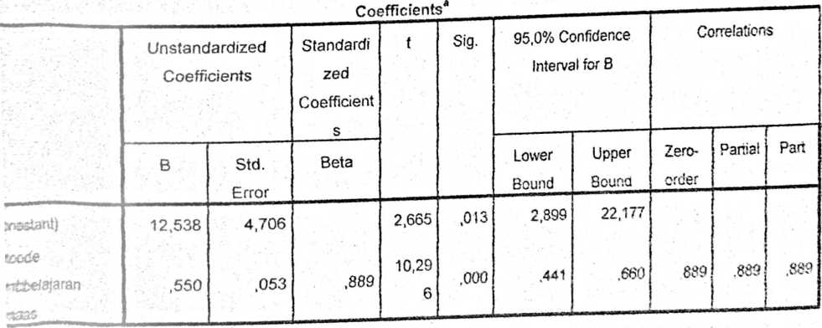
aeer* Variable: Prestasi Belajar

