Mereka Yang Terlupakan
Ruang Bagi Kaum Difabel Dalam Kurikulum Pendidikan Agama
Kristen (PAK) di STAKN Toraja

SKRIPSI

PERPUSTAKAAN '
INSTITUT AGAMA KRISTEN NEGERI
> 'IAKN TORAJA

Tgl. Terima : o-y - o-z - ■zc'z'z,

No. induk :^i ^gf/pp^/2018-c'

No. Kias \zbs^ " ■■■■
Dibeli/ . •
Hadiah dari *.

Terima dari

Harga • : <
Diajukan Kepada Sekolah Tinggi Agama Kristen (STAKN) Toraja Untuk
Memenuhi Salah Satu Syarat Untuk Memperoleh Gelar Pendidikan Agama
Kristen (S.Pd)
Oleh:
Feby Fitriani
Nirm: 20133691
Pendidikan Agama Kristen
Sekolah Tinggi Agama Kristen Negeri (STAKN) Toraja
TAHUN 2018

Judul Skripsi | : Mereka Yang Terlupakan
Sub Judul | : Ruang Bagi Kaum Difabel Dalam Kurikulum Pendidikan Agama Kristen  (PAK) di STAKN Toraja.
DiajukanOleh:  Nama | : Feby Fitriani
NIRM | : 20133691
Jurusan | : Pendidikan Agama Kristen
Setelah | diperiksa dan diteliti ulang, maka Skripsi ini memenuhi syarat untuk di

Judul Skripsi | : Mereka Yang Terlupakan
Sub Judul | : Ruang Bagi Kaum Difabel dalam Kurikulum Pendidikan  Agama Kristen (PAK) di STAKN Toraja.
Ditulis oleh | : Nama : Feby Fitriani  NIRM : 20133691
Jurusan : Pendidikan Agama Kristen
Telah dipertanggungjawabkan di hadapan dosen penguji dalam proses
ujian skripsi Stratum Satu (SI) Jurusan Pendidikan Agama Kristen (PAK), dan
diyudisium pada tanggal 24 Juli 2018 dengan peredikat memuaskan
Mengkendek, 24 Juli 2018
Dosen Penguji
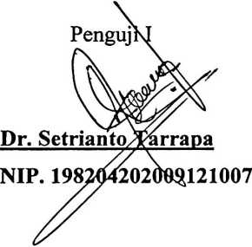

Mery Toban, S.Th, M.Pd.K
NIP.197905012007102003
Ketua

Mery Toban, S.Th, M.Pd.K
NIP.197905012007102003
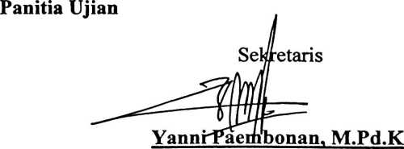
NIDN. 2020078701
Mengetahui
Toraja

anineku. M.Th
6701242005011003

ABSTRAK
Feby Filriani. 20133691. Majoring in Christian education. T'hcsis title: Those Who A re
Forgotten: Space for the Disabled in the Curriculum of Christian Rcligion Education at
STAKN Toraja. Supcrvised by Oktoviandy Rantelino, M.Si and Sanda Mongan, M.Pd.K.
Education is a human conseious cITort to overcomc life’s problcms. Educating and bcing
cducated is a chain that cannot bc scparated in human lifc. The Dapertement of Christian
education at STAKN Toraja is one of the platforms for fostering, forging, evcry student so
that someday they can bccorne educators especially sharing knowlcdgc in the lield of
Christian education in the communily.
The author appreciatcs the Vision and mission of the Christian education department with
which there is hope to be able to answer the nceds of society. However, from the
observations of the author during the lecture process, the writer tries to associate with the faet
that in the communily that there is still something that is forgetten in the curriculum space,
namely the disabled. Based on the background, what makes the writer concerned and makes
the reasons so that this thesis is wrilten.
Therefore the author conduclcd n researeh relaled to the problem by using qualitative
methods and intcrviews with sevcrnl lecturers from the Christian education department of
STAKN Toraja. The resulls of the sludy show that unti! now there is indeed no curriculum
in the Christian education department that diseusses the disabled. Based on these faets, the
authors suggest that space for people with disabilities is taken into consideration in the ncxt
curriculum revision.
iii

