z
I
o.
s
3
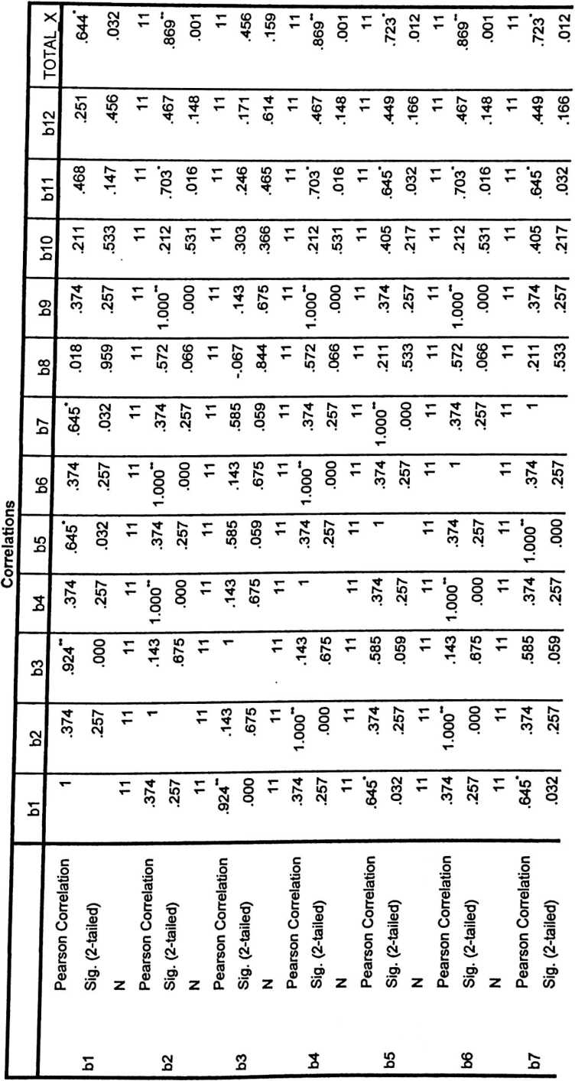

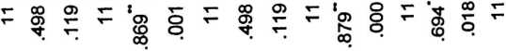
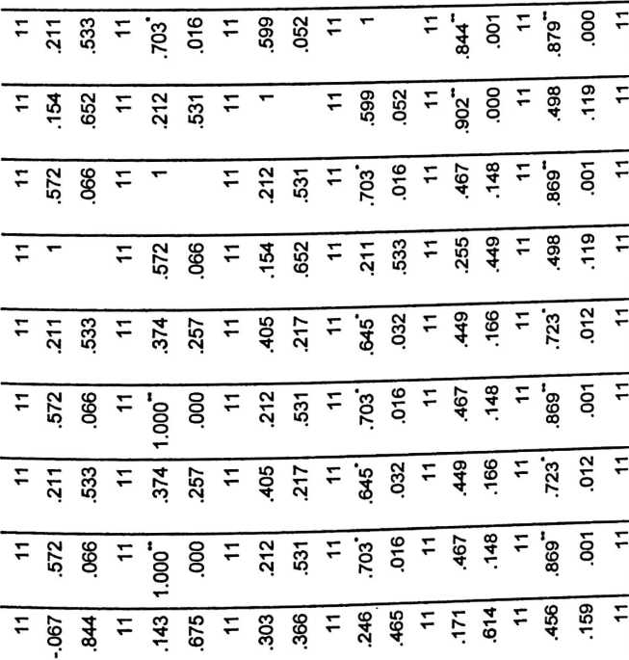
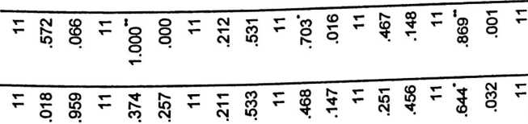
<D
5
0)
<v
>
<D
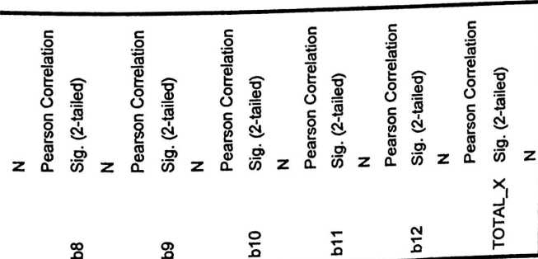

CM
S
CL
cm
LU

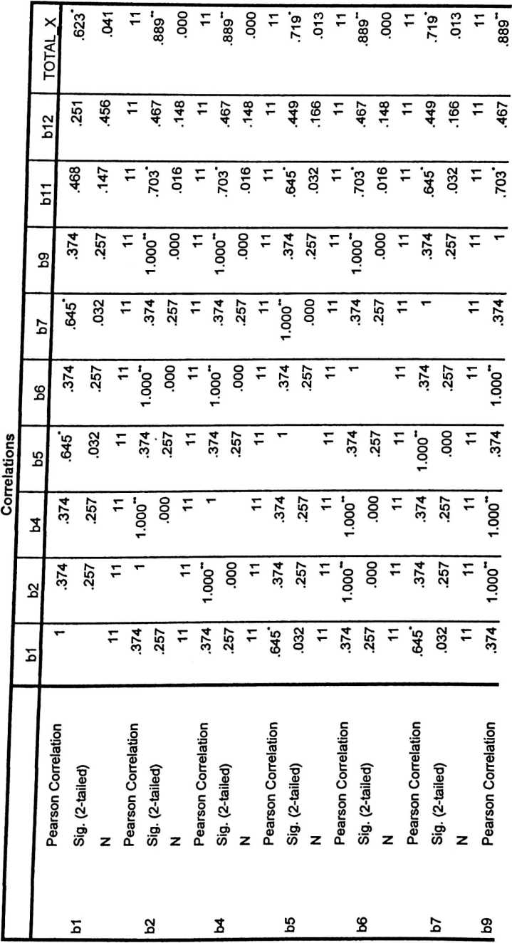
T!

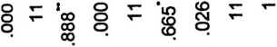
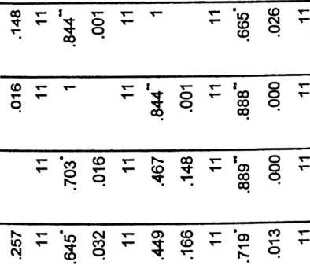
o
o
o
CD
O
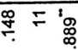
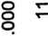
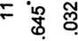
CD
CD
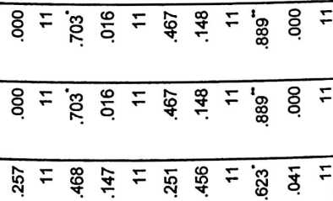
C
O
<0

f I f
5 c J?
i g CS
d> S .S’
CD Z O. CD
2
ro
o>

ro

c
E
E

23
UJI RELIABILITI X
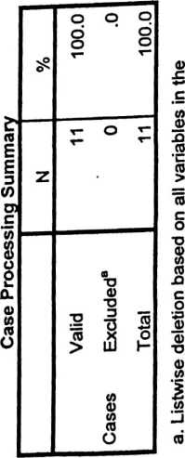
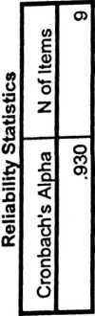
3.36 .809
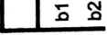
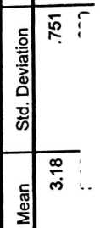
Cronbach's Alpha
if Item Deleted
Corrected Item-  Total Correlation | SS8383SS 8
Scale Variance if  Item Deleted | gu § H  8 8 8 8 8 8 a 8 8
Scale Mean if  Item Deleted | 8 8 8 8 8 8 8 88
v- CM
SS322!52EE

s
<
z
o
o
o
rZ
O
!
LU
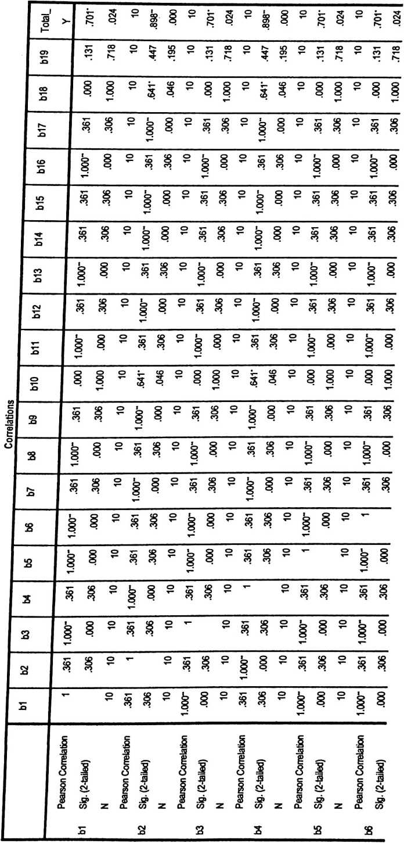

10 10
.447 .898"
.195 .000
10 10
.131 .701’
.718 .024
10 10
.447 .898"
.195 .000
10 10
.898" .600
.000 .066
10 10
.131 .701’
.718 .024
10 10
.447 .898“
.195 .000
10 10
.131 .701*
.718 .024
10 10
.447 .898“
.195 .000
10 10
.447 .898"
.195 .000
1—  O | .361 | .306  10 | 1.000"  .000  10 | .361 | .306 | o  ▼“ | .000 | 1.000  10 | 1.000"  .000 | 10  .361  .306 | 10  1.000" | 000’ | 10  .361 | .306  10 | .361 | | .306
o  T“ | 1.000" | .000  10 | .361  .306  10 | o  8 | 000’ | o  X— | s | .046  10 | .361  .306 | 10  1.000“  .000 | 10  .361 | .306 | 10  1.000" | .000  10
O | §  ’T— | .000  10 | .361  .306  10 | 1.000" | .000 | o  T— | § | .046  10 | .361  .306 | 10  1.000"  .000 | 10  .361 | .306 | o  V” | o  T— | o  8 | 2
o  T— | S  CO | 306  10 | 00"  000  10 | 361 | .306 | o  T— | § | .000  10 | 000"  .000 | 10  .361  .306 | o ▼"  ’T" |  | 10  .361 | .306  10 | .361 | £
 |  |  |  |  |  |  |  |  | ’T—

Slg. (2-taited)
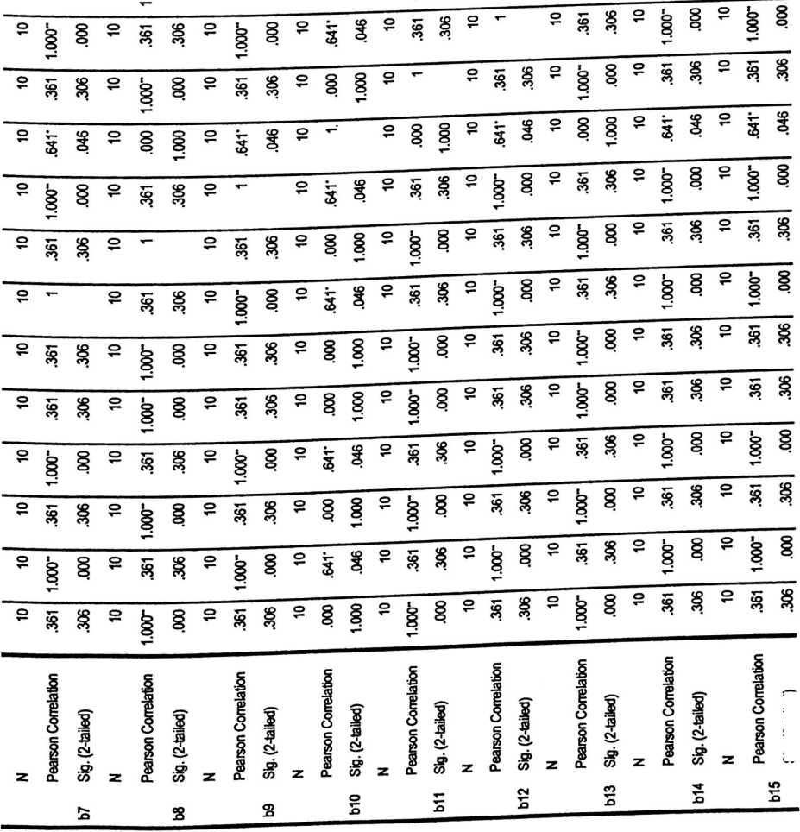
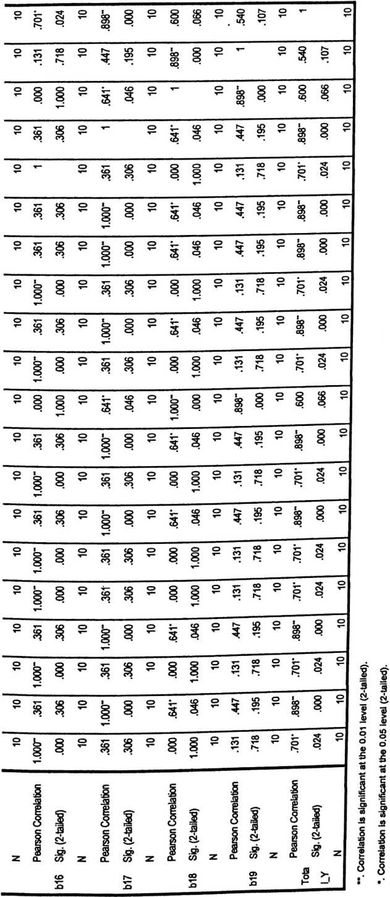
m
§
E
fN
—J
<
Z
o
<9
O
a'
O
S
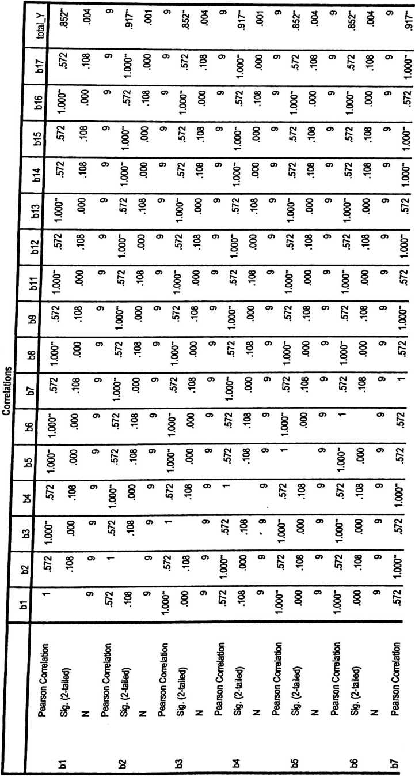

§ ‘ | ’ § §  oq | L00’  -Z 1-6’  6 | 9  .852“  .004 | 9  .917“  .001 | 9  .852“  .004 | 9  .917“  .001 | 9  .917“  .001 | o  M0’  -298’  6 | » b  3>
§ ‘ | 3  .572  .108 | 9  1.000“  .000 | 9  .572  .108 | 9  1.000“  .000 | 9  .572  .108 | " § §  ’T-* | ~ ‘  T— | y  .572  .108  9 | > X—
s ^{c}  x— | □  1.000“  .000, | 9  .572  .108 | 000‘  -0001  6 | 9  .572  .108 | 9  1.000“  .000 | 9  .572  .108 | 9  .572  .108 | D x- CT | ► CM
§ ° | .572  .108 | 9  1.000“  .000 | 9  .572  .108 | 9  1.000“  .000 | 9  .572  .108 | 9  1.000“  .000 | CD x- C | 3  .572  .108  9 | i  §  V
§ ^{CT} | .572  .108 j | 9  1.000“  .000 | 9  .572  .108 | 9  1.000“  .000 | 9  .572  .108 | CD x- i | “ § § °  X— | w  .572  .108  9 | t  §
3 ^{CT}  ▼— | 1.000“  .000 | o> CM CO  *O X- | 1 § | 9  .572  .108 | CD x- | 9  .572  .108 | y  .572  .108  9 | 1.000“  .000  9 | CM
§ “ | .572  .108 | 9  1.000“  .000 | 9  .572  .108 | 03 x- | 9  .572  .108 | y  1.000“  .000  n | 3  1.000“  .000  9 | .572  .108  9 | §  V
3 °>  T— | 1.000“  .000 | 9  .572  .108 | 03 x- < | 9  .572  .108 | y  1.000“  .000  r\ | 3  .572  .108  Q | .572  .108  9 | 1.000“  .000  9 | CM
§ ⁰⁵ | CM CO  U5 X- | CT> x— | 9  .572  .108 | y  1.000“  .000 | 3  .572  .108  a | 1.000“  .000  Q | **  1.000“  .000  9 | .572  .108  9 | 1.000“ I
8 ⁰⁵  X— |  | . ⁹  .572  .108 | 9  1.000“  .000  A | 3  .572  .108  a | v  1.000“  .000  9 | .572  .108  9 | .572  .108  9 | 1.000“  .000  9 | CM
O> | .572  .108 | ⁹  1.000“  .000 | 9  .572  .108  Q | 1.000“  .000  Q | .572  .108  9 | 1.000“  .000  9 | 1.000“  .000  9 | .572  .108  9 | §
3 ⁰⁵  t-; | 1.000“  .000 | 9  .572  .108 | y  1.000“  .000  9 | .572  .108  9 | 1.000"  .000  9 | .572  .108  9 | 572  .108  9 | 1.000"  .000  9 | CM
3  T— | 1.000"  .000 | 9  .572  .108  n | 3  1.000“  .000  9 | .572  .108  9 | 1.000“  .000  9 | .572  .108  9 | .572  .108  9 | 1.000“  .000  9 | CM  lo
§ ^{m} | .572  .108 | V  000’  -0001  6 | □  .572  .108  9 | 1.000“  .000  9 | .572  .108  9 | 1.000“  .000  9 | 1.000“  .000  9 | 572  .108  9 | 1  §
8 ⁰⁵  'r— | 1.000“  .000 | y  .572  .108  Q | ’ § § “  x— | .572  .108  9 | 1.000“  .000  9 | .572  .108  9 | 572  .108  9 | 1.000“  .000  9 | CM
§ ⁰⁵ | .572  .108  n | 3  1.000“  .000  9 | .572  .108  9 | 1.000“  .000  9 | .572  .108  9 | 1.000“  .000  9 | 1.000“  .000  9 | .572  .108  9 | O  8
3 ⁰⁵ | 1.000“  .000  n | a  572  .108  9 | 1.000“  .000  j ⁹ | 572  .108  9 | § §^{m}  T— | 572  .108  9 | .572  .108  9 | § §"  X— | CM

.001  9  1 |  |  |  | CD
 | °> k  5> |  | o  o | CD
3 | cd | t  CM | 3 | CD
v— |  |  | o
.000 | CD | t  cd | .001 | CD
.000 | CD | 1  CD | .001 | CD
s | CD | CM | 3 | CD
 |  | £ | o
.000 | CD | t  CD | .001 | CD
.108 | CD | .852" | .004 | CD
lOOO' | CD | k  CD | .001 | CD
.108 | CD | .852" | W0' | CD
| 000’ | CD | t | .— | CD
| 000’ |  | CD | 8
.108 | CD | t  CM  LO  CO | .004 | CD
.108 | CD | .852" | .004 | CD
§ | cd | k  CD | .001 | CD
8 | CD | CM  IO  CO | .004 | CD
000’ | CD | k  CD | .001 | CD
3 | CD | kl | 3 | CD
T— |  | £ | CD
 |  | I
3 |  | o | 3
St |  | i | -S  CM_
.52>  CO | Z | £ | .n>  CO | Z
 |  |  | 1

8 | 9 | Total X
4 | 4 | 34
4 | 4 | 28
3 | 3 | 30
3 | 3 | 29
2 | 4 | 29
4 | 4 | 30
2 | 2 | 29
3 | 2 | 29
3 | 2 | 28
3 | 3 | 34
3 | 4 | 30
4 | 4 | 30
4 | 2 | 28
4 | 4 | 34
4 | 2 | 29
4 | 3 | 28
4 | 4 | 30
4 | 4 | 30
3 | 3 | 29
3 | 2 | 33
4 | 3 | 31

NO  RESP. | 1 | 2 | 3 | 4 | 5 | 6 | 7 | 8 | 9 | 11 | 12 | 13 | 14 | 15 | 16 | 17 | TOTAL Y
1 | 4 | 3 | 4 | 3 | 4 | 4 | 3 | 4 | 3 | 4 | 3 | 4 | 3 | 3 | 4 | 3 | 56
2 | 2 | 2 | 2 | 2 | 2 | 2 | 2 | 2 | 2 | 2 | 2 | 2 | 2 | 2 | 2 | 2 | 32
3 | 3 | 2 | 3 | 2 | 3 | 3 | 2 | 3 | 2 | 3 | 2 | 3 | 2 | 2 | 3 | 2 | 40
4 | 2 | 2 | 2 | 2 | 2 | 2 | 2 | 2 | 2 | 2 | 2 | 2 | 2 | 2 | 2 | 2 | 32
5 | 3 | 2 | 3 | 2 | 3 | 3 | 2 | 3 | 2 | 3 | 2 | 3 | 2 | 2 | 3 | 2 | 40
6 | 4 | 2 | 4 | 2 | 4 | 4 | 2 | 4 | 2 | 4 | 2 | 4 | 2 | 2 | 4 | 2 | 48
7 | 4 | 4 | 4 | 4 | 4 | 4 | 4 | 4 | 4 | 4 | 4 | 4 | 4 | 4 | 4 | 4 | 64
8 | 4 | 3 | 4 | 3 | 4 | 4 | 3 | 4 | 3 | 4 | 3 | 4 | 3 | 3 | 4 | 3 | 56
9 | 4 | 4 | 4 | 4 | 4 | 4 | 4 | 4 | 4 | 4 | 4 | 4 | 4 | 4 | 4 | 4 | 64
10 | 4 | 4 | 4 | 4 | 4 | 4 | 4 | 4 | 4 | 4 | 4 | 4 | 4 | 4 | 4 | 4 | 64
11 | 2 | 2 | 3 | 2 | 3 | 3 | 2 | 2 | 2 | 3 | 2 | 3 | 2 | 2 | 2 | 2 | 37
12 | 3 | 4 | 3 | 4 | 3 | 3 | 4 | 3 | 4 | 3 | 4 | 3 | 4 | 4 | 3 | 4 | 56
13 | 3 | 2 | 4 | 2 | 4 | 4 | 2 | 3 | 2 | 4 | 2 | 4 | 2 | 2 | 3 | 2 | 45
14 | 2 | 4 | 3 | 4 | 3 | 3 | 4 | 2 | 4 | 3 | 4 | 3 | 4 | 4 | 2 | 4 | 53
15 | 2 | 4 | 3 | 4 | 3 | 3 | 4 | 2 | 4 | 3 | 4 | 3 | 4 | 4 | 2 | 4 | 53
16 | 3 | 3 | 3 | 3 | 3 | 3 | 3 | 3 | 3 | 3 | 3 | 3 | 3 | 3 | 3 | 3 | 48
17 | 3 | 4 | 3 | 4 | 3 | 3 | 4 | 3 | 4 | 3 | 4 | 3 | 4 | 4 | 3 | 4 | 56
18 | 2 | 2 | 3 | 2 | 3 | 3 | 2 | 2 | 2 | 3 | 2 | 3 | 2 | 2 | 2 | 2 | 37
19 | 3 | 3 | 4 | 3 | 4 | 4 | 3 | 3 | _3 | 4 | 3 | 4 | 3 | 3 | 3 | 3 | 53
20 | 3 | 4 | 3 | 4 | 3 | 3 | 4 | 3 | 4 | 3 | 4 | 3 | 4 | 4 | 3 | 4 | 56
21 | 4 | 3 | 4 | 3 | 4 | 4 | 3 | 4 | 3 | 4 | 3 | 4 | 3 | 3 | 4 | 3 | 56

Valid 1  N ... .  Missing  Mean | 21  0  38.43
Median | 38.00
Mode | 32ª
Std. Deviation | 4.895
Range | 18
Minimum | 30
Maximum | 48
a. Multiple modes exist. The  smallest value is shown | Frequency | Percent | Valid Percent | Cumulative  Percent
30  32  34  35  37  38  Valid  42  43  44  46  48  Total | 1  3  1  1  2  3  3  1  1  1  2  1  1  21 | 4.8  14.3  4.8  4.8  9.5  14.3  14.3  4.8  4.8  4.8  9.5  4.8  4.8  100.0 | 4.8  14.3  4.8  4.8  9.5  14.3  14.3  4.8  4.8  4.8  9.5  4.8  4.8  100.0 | 4.8  19.0  23.8  28.6  38.1  52.4  66.7  71.4  76.2  81.0  90.5  95.2  100.0

N ^{VaHd} |  |  |  | 21
Missing |  |  |  | 0
Mean |  |  |  | 49.81
Median |  |  |  | 53.00
Mode |  |  |  | 56
Std. Deviation |  |  |  | 10.122
Range |  |  |  | 32
Minimum |  |  |  | 32
Maximum |  |  |  | 64
 | Frequency | Percent | Valid Percent |  | Cumulative  Percent
32  37  40  45  Valid 48  53  56  64  Total | 2  2  2  1  2  3  6  3  21 | 9.5  9.5  9.5  4.8  9.5  14.3  28.6  14.3  100.0 | 9.5  9.5  9.5  4.8  9.5  14.3  28.6  14.3  100.0 |  | 9.5  19.0  28.6  33.3  42.9  57.1  85.7  100.0

case Processing oummary |  | Kedisiplinan
Series or Sequence Length |  | 21
Number of Missing Values in | User-Missing | 0
the Plot | System-Missing | 0
The cases are unweighted.  Estimated Distribution Parameters | Kedisiplinan
Location | 38.43
Normal Distribution
Scale | 4.895
The cases are unweighted.

Kedisiplinan
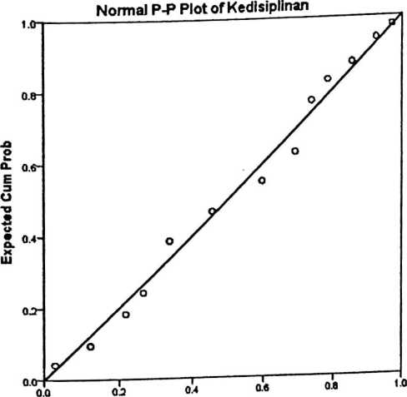
Observed Cum Prob

Detrended Normal P-P Plot of Kedisiplinan
Observed Cum Prob

 |  | Prestasi
Series or Sequence Length |  | 21
Number of Missing Values in | User-Missing | 0
the Plot | System-Missing | 0
The cases are unweighted.  Estimated Distribution Parameters | Prestasi
Location | 49.81
Normal Distribution
Scale | 10.122
The cases are unweighted.

Prestasi
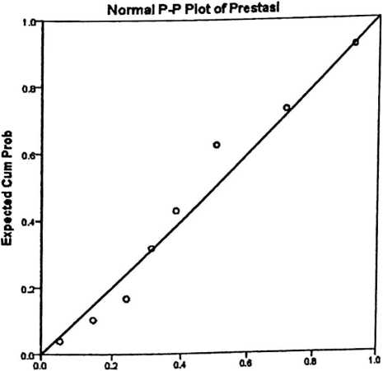
Obstrved Cum Prob

Dovlation from Normal
Detrended Normal P-P Plot of Prestasi
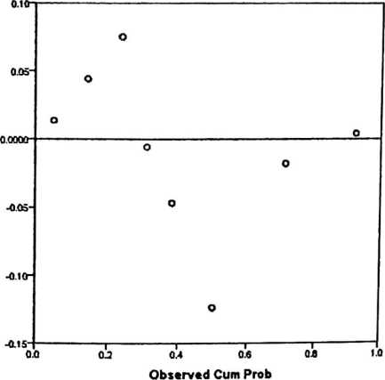

 | C ases —
 | Inr.luded |  | Excluded |  | Total
 | N | Percent | N | Percent | N | Percent
Kedisiplinan * Prestasi | 21 | 100.0% | 0 | 0.0% | 21 | 100.0%
Report  Kedisiplinan  Prestasi | Mean |  |  | N |  |  |  | Std. Deviation
32 | 38.50 |  |  | 2 |  |  |  | .707
37 | 33.00 |  |  | 2 |  |  |  | 1.414
40 | 39.50 |  |  | 2 |  |  |  | 6.364
45 | 32.00 |  |  | 1
48 | 34.00 |  |  | 2 |  |  |  | 5.657
53 | 40.33 |  |  | 3 |  |  |  | 7.371
56 | 40.50 |  |  | 6 |  |  |  | 4.135
64 | 40.33 |  |  | 3 |  |  |  | 3.215
Total | 38.43 |  |  | 21 |  |  |  | 4.895
 |  |  |  |  | Sum of  Squares |  | df |  |  | Mean  Square | F | Sig.
(Combined) |  |  |  |  | 189.310 |  | 7 |  |  | 27.044 | 1.213 | .362
Between Linearity |  |  |  |  | 55.985 |  | 1 |  |  | 55.985 | 2.511 | .137
Kedisiplinan * Groups Deviation from |  |  |  |  | 133.324 |  | 6 |  |  | 22.221 | .997 | .467
Prestasi Linearity
Within Groups |  |  |  |  | 289.833 |  | 13 |  |  | 22.295
Total |  |  |  |  | 479.143 |  | 20
 |  | mvaouica  R | R Squared |  |  | Eta |  |  | Eta Squared
Kedisiplinan * Prestasi |  | .342 | .117 |  |  | .629 |  |  | .395

f | Pernyataan | S | SR | KK | TP
f | Variabel X (Kedisiplinan orang tua membimbingng)  Orang tua selalu mengingatkan saya untuk belajar di rumah
— | Orang tua saya selalu menyempatkan waktu untuk  mendampingi saya belajar di rumah
Orang tua saya selalu memberikan arahan kepada saya untuk
belai ar di rum ah -
 | Orang tua sava selalu melengkapi fasilitas belajar saya
 | Orang tua selalu memotivasi saya untuk belajar di rumah
 | Orang tua selalu mengajar saya untuk belajar di rumah
Orang tua memperhatikan perkembangan anaknya baik secara
jasmani maupun rohani
 | Orang tua selalu memberikan perhatian dan kasih sayang
Orang tua menjadi teladan yang baik bagi anak -anak baik
dalam perkataan maupun perbuatan yang dilakukan
Orang tua selalu memberikan kesempatan belajar yang cukup
untuk mengulangi pelajaran yang diterima di sekolah
Variabel Y (prestasi belajar siswa)
Selalu mendapat peringkat di sekolah
Mampu menjelaskan dengan materi yang telah diterima saat
dimintn meni piaskan kembali —
 | Memahami pelajaran yang dijelaskan oleh guru di sekolah
Selalu mengingat pelajaran yang dijelaskan oleh guru i
sekolah
Mampu menyelesaikan soal yang diberikan oleh guru
sekolah dengan baik -—-—
 | Selalu mpndanat nilai tinggi saat ulangan/ semester
Orang tua selalu memperhatikan kebutuhan belajar saya di
sekolah _
Orang tua selalu memeriksa nilai yang saya peroleh
sekolah -
Selalu mengerjakan tugas yang di berikan oleh guru di
sekolah dengan baik -
 | Hubungan Guru dan orang tua teijalin harmonis L | — |  |  | —
Hubungan guru dan saya di sekolah terjalin harmonis
_-Orang tua selalu mendidik saya dengan penuh kasih sayang
_ Selalu fokus belajar di sekolah
_ _Selalu semangat belajar
_ _Hubungan saya dengan orang tua teijalin harmonis
Selalu membayar uang SPP tepat waktu
Selalu belajar dengan tekun
Orang tua mau mendengarkan dan berbagi dengan apa yang
saya alami

Keterangan:
S= Selalu
SR= Sering
KK=Kadang-kadang
TP= Tidak pema

PEMERINTAH KABUPATEN LUWU UTARA
DINAS PENDIDIKAN
SMP NEGER11 SEKO
Alamat: Poyahaang, Kec. Seko,Kab.Luwu Utara

SURAT KETERANGAN
Nomor:421/055/SMPN.1-SK/2013
Yang Bertanda tangan di bawah ini :
Nama
NIP
Pangkat/Gol
Jabatan

: SAFARUDDIN,S.Pd
: 19660810 199103 1 009
: Pembina — IV/a
: Kepala SMP Negeri 1 Seko
Dengan ini menerangkan Bahwa :
Nama
NIRM
Pekerjaan
Alamat

: NOVIS BERLIANTI
: 20082740
: Mahasiswa STAKN Toraja
: Rantepao
Telah melakukan penelitian Di SMP Negeri 1 Seko Kecamatan e o
Luwu Utara mulai dari tanggal 22 Agustus 2013 sampai tangga gu
dalam rangka penyusunan Skripsi dengan Judul Pengaru e isip m
tua membimbing anak belajar di rumah terhadap prestasi belajar siswa dalam
bidang studi Pendidikan Agama Kristen di SMPN1 e o
Demikian surat keterangan ini dibuat dengan sebenar-benarnya untuk dap
digunakan sebagaimana mestinya.
Poyahaang,05 September 2013


^s^^AFARUDDIN,S.Pd
^NlPrl 9660810 199103 1 009

