r
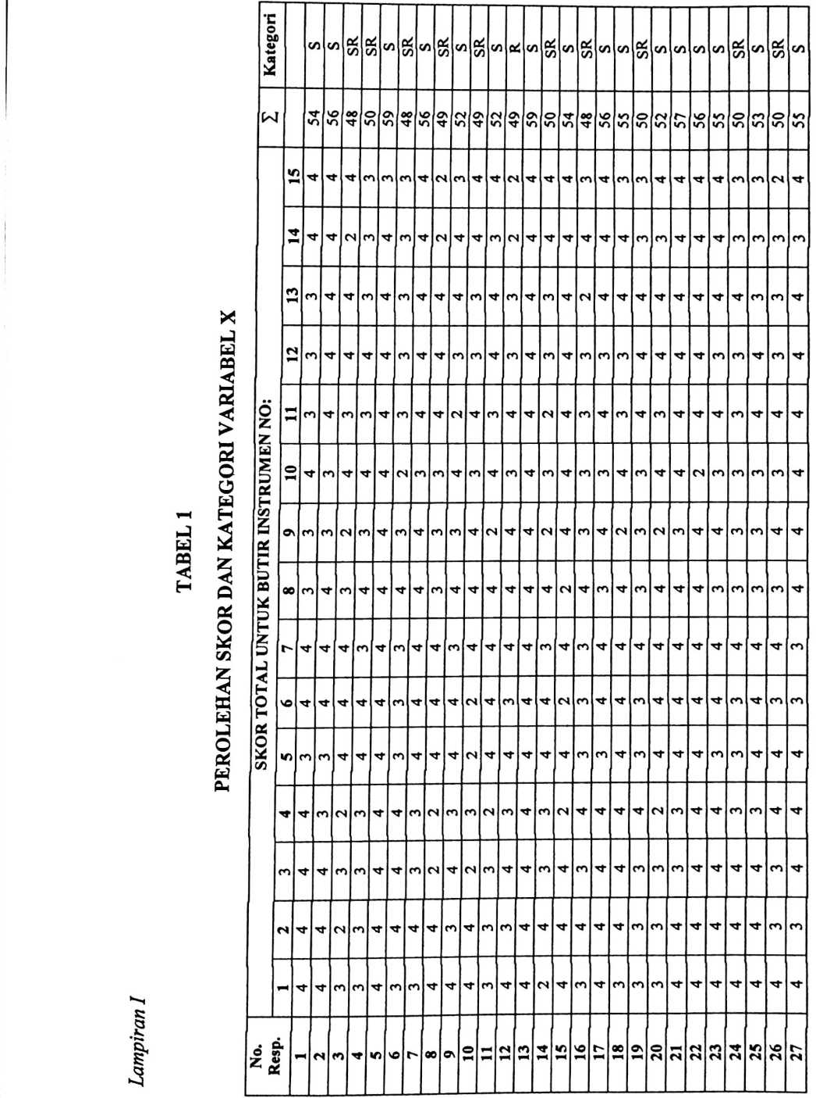
CO | 3 | £ | cz | &  u | * | SR  S | co v | ¹ c/ | ft  ) C/ | 5 C/ | 5^{5/1} | CO C/ | </ | V | CZ | V |  | Cr<  (Z) | w | CO | SR 1 | CO | co | SR | SR | co | co | co | SR
1 56 | 1 34 | oo  M' | c  «n | o  »n | C  M | o m  »n »n | *— (V  im u- | —  M | C  «r | «  M | 89 | «n J | c\  ir | c*  <r | 00  un | M  ’M | !n | O  M' | oo  ’M | »n | 42 ! | ’M | 56 I | 50 1 | | 6t | »n | «n | «n | 46 1 | 3106
cm | m | CM | M’ | cm | cm | cm M’ | M' M | C*" | C*" | M | M | CM M | M | M | CM | M | CM | M | M' | CM | CM | •—M | M | M' | CM | CM | M’ | M’ | C4 | 00  oo
M' | 04 | cm | cm | M’ | cm | M’ cm | m n" | r’ | c*” | (N | M' | CM M | M |  | M | CM | M’ | M | M' | M' | CM | M' | M' | CM | CM | M’ | CM | CM | CM | | 681
cm | m- | CM | cm | M' | M- | M' M' | M' M' | CM | CM | CM |  | T M | M' | M' | M' | CM | M' | M’ | M' | M' | M' | M | M' | M' | CM | M’ | M’ | M' | CM | 04
m- | 04 | M’ | M’ | cm | CM | cm M- | M' M’ | CM | M' | CM | M’ | T M' | CM | CM | M' | M’ | M’ | (N | M' | M' | CM | M' | M’ | M' | CM | M’ | M’ | M’ | CM | O  04
m- | 04 | 04 | M’ | CM | CM | CM M' | M' M’ | CM | CM | CM | M' ’ | T M' | CM | M' | M' | M' | M' | M’ | M' | CM | CM | CM | M' | CM | CM | M' | M’ | M’ | M’ | 200 |
M' | V—< | M’ | M | M' | CM | M' M | M’ M' | CM | M' | M' | M' c | M (N | r— | M’ | M' | M' | M' | M' | M' | CM | CM | CM | CM | M’ | M’ | M’ | M' | M' | CM | : 199
m- |  | CM | cm | cm | CM | cm M' | M' M' | CM | CM | CM | M’ C | 'l M' | M' | M' | CM | M' | CM | n | M' | CM | CM | M’ | CM | CM | CM | M’ | M' | M' | (N | O\
M’ | 04 | M’ | M' | CM | CM | cm M' | m 04 | CM | CM | M’ | CM X | r CM | CM | M’ | M' | CM | M' | OJ | CM | M' | M’ | CM | M’ | CM | M’ | M’ | CM | CS | M’ | O\
m- | 04 | cm | M' | M' | CM | M' cm | 04 M' | CM | M’ | M' | M' C* | 1 M' | M' | M’ | M' | M' | M | M’ | M’ | M' | M' | M' | M' | M’ | CM | M' | n | M’ | CM | 04
M' | cm | M’ | M' | cm | cm | cm cm | cm M' | 04 | M' | CM | M' C< | M | M | CM | M' | M’ | M' | M | M' | M' | CM | M' | M' | M' | M' | M’ | CM | M’ | M' | O  04
M' | cm | M’ | M' | cm | M' | cm M' | M' M' | CM | M' | M' | M’ M |  | M' | M' | M’ | M' | M' | M’ | M' | M’ | M’ | CM | CM | M' | M’ | M' | M’ | M’ | CM | OO  »—<  04
M' | 04 | cm | cm | CM | CM | m M' | M' CM | CM | CM | CM | CM c** | M' | CM | M' | M' | CM | M’ | CM | CM | CM | CM | CM | CM | CM | CM | M’ | M’ | CS | CM | S
M’ | 04 | m | M’ | M' | cm | M' M' | 04 cm | CM | M’ |  | M' c*~ | CM | M' | M’ | M’ | CM | M’ | CM | M' | M’ | CM | M’ | M’ | CM | CM | M’ | CN | CM | CM | 5\
m- | 04 | M’ | M’ | cm | m | *r cm | n cm | M' | M’ | ’M | M' M' | M' | M’ | M' |  | M' | M' | M | M' | M' | CM | M' | M' | CM | CM | M’ | CM | CM | M' | 1 211
m- | 04 | CM | M’ | CM | 04 | ~M M' ’ | T M' | ’M | M | “M | M’ M' | M' | CM | M' | M' | ’M | M' | M' | M’ | CM | CM | M' | M’ | CM | CM | M’ | M’ | M’ | C4 | | 200
28 | O\  CM | ©  m | FH  ’M | fM  M | ■n  M | m m  n m t | □o  37 | » C  M f | J\ <  M ’ | D  T | 41  42 | 43 | M  M | /)  M | O  M | ’f | X  M | 0\  M' | O  ’O | m | CS  «n | ⁵³ | M’  ’O | | 55 | i 56 | 57 | | 58 | IO | 09 1

Keterangan: S=Selalu, SR=Sering, KK=Kadang-Kadang, TP=Tidak Perna
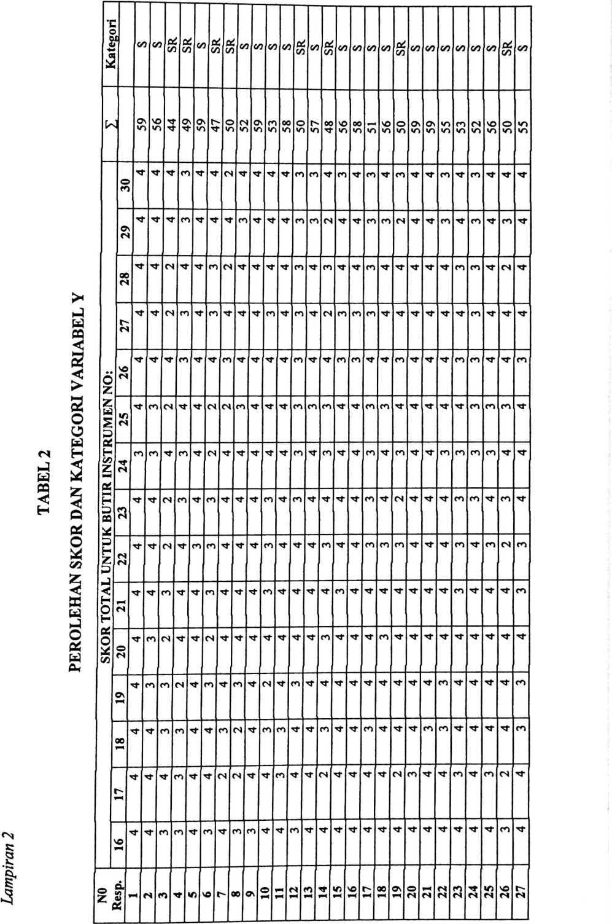
Keterangan: S= Selalu, SR= Sering, KK=Kadang-kadang, TP= Tidak Pema
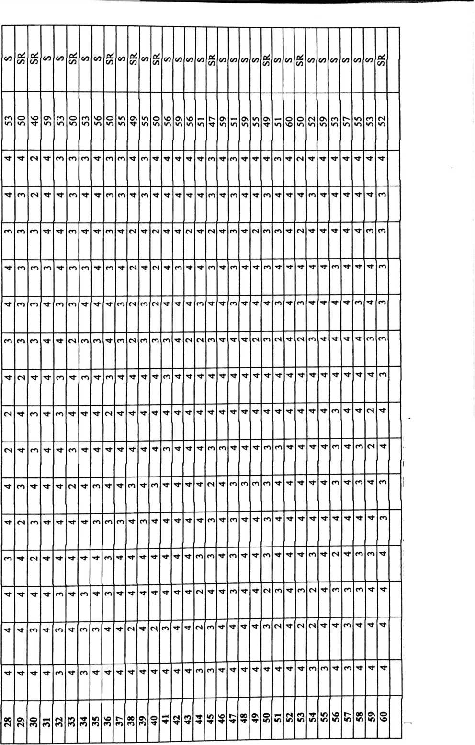
ARO  015 |  | —_  ,309* | .016 1  ■ | o  CD | .228 I | O  oo  o | 60 I | -.057  .668 |  | ⁶⁰1 | -.066  .618  60
 | o
VARO | 0014 | o  o  CO | o  o  cd | 09 | ,245 | ,059 | 60 | .642” | o  8 | 09 | .362“ | io  o  o | 09
o | CO |  | O) | o | *O4 | CO | Q | o | m | o | 04 | o | o
(E  < | x—  O | (D  Ol | co  CD_ | CD | CO  Ol | 3 | CO | in  o | o | CD | CO  O | 00 | CD
> | o |  |  |  |  |  |  | ■
VARO | 0012 | :  Ol  CD | o  o  o | 09 | ,321* | ,012 | 09 | ,101 | T“  5 | 09 | ,092 | .484 | 60
o |  | : | o | o |  | o | o |  | T“ | o | CO | 04 | o
(E  < | v-  O | oo  3 | o  o | CD | CO  CO | 8 | CD | 04  CO | T-  o | CD | CO  o |  | CD
> | O |  |  |  | -
o  □r  < | O  v-  O |  | ,000 | 09 | ,238 | ,067 | 09 | ,019 | ,883 | 60 | T—  m  V- | 8  O4_ | 8
> | o
o |  | 2 | o | o | • | o | o | o | M’ | o | 04 | Ol | O
or  £ | s  8 | CO  IO | 8 | CO | ,636 | 8 | CD | .25 | CD  O | CD | .25 | 90‘ | CD
o | 00 | *IO | 3 | o | m | 04 | O | 04 | CO | O | MT | CO | O
< | o  o | CO  CO | o |  | o | CO |  | ’r— | co_ |  | C0  Ol | o
> | o
O | fs. |  | 00 | 09 | 'oi | LD | 60 | ’CD | 33 | O  CD | CO | o | O  CD
u_  £ | o  8 | CO  <o | o |  | S | O_ |  | 04 | o |  | .41 | o_
o  o | CD | ‘k. | 00 | 09 | CO | CD | 09 | CD | 44 | 09 | 74 | 84 | 60 |
£E | O | 00 | o |  | T” | 04 |  | Ol | o |  | T- | v-
< | O
>
 |  |  | 04 | o | fs» | IO | o | O | CD | o | M’ | m | o
(E  < | ID  O  O | 3  04 | 3 | CD | Ol  T— | CO  CO | CO | CO  T⁻ | CD  v- | CD | O  O |  | CD
> | o
o |  | IO | 00 | 09 | ‘oo | CD  O | 09 |  | 04 | 09 | ’lD | 14 | 109
CE | o | CD | <D |  | IO | O |  | CD | CD |  | CO | o
$ | o
VAR | o  8 «  O | .511’ | o  o  o | 09 | 3  T— | 8  V" | 60 | m  o>  CM | ,022 | 09 | T" |  | I 60
o |  |  | o | o | ‘CO | M' | o  fn | ▼— |  | o  CD | *<o | Ol | O  CD
or  < | o  o | IN  v-  ID | o |  | CO | o |  |  |  |  | o>  Ol | o
> | o
ce | o | ‘cd | o  o | o  CO |  |  | 09 | *IO |  | O  CO | 94 | 38 | 09
3 | o ^{T}"  o | 3 | o |  |  |  |  | CO | o_ |  | T” | V-
o |  | T” |  | o |  | o | 8 | "ol | o | o |  | O | o  m
(E  £ | 8 |  |  | CD | 3 | o_ |  | r-  IO | o |  | T”  IO | o_

§  1 | CO  8 | o  CO | .084 1 | xr  CM  lO | o  CD | 1 141/ | .399 I | o  CD | .038 1 | CO | o  CO | -.115 I  .383 1 | s | 8  v-
,375" | ,003 | o  CO | -,156 | ££Z‘ | O  CD | .230 | o | O  CD | ‘o  s | ,013 | o  CD | .133  ,312 | o  CD | ,304*

8 3 S s 8 s ° s S s g <° s g
r - - - - cm. cm. ’T. v-.

o S ^{m} 8 o ® 't; § “ ? S S $ 3 S
co co •■ - ^{T}'l - cm.
§ s :3 § S 3?S £ S S 5 £ S £  CO CO o  CM CO CD  v- CO  o : o o o) ^ocmojo  CD T- y- CD T- 00 CD O CO CD  CO O O CO ■<- 'M-  CO - ■ - -  ,315' | o | 60 | ,004  ,975 |  | 09 | .174  ,184 |  | 09 | *00 | o  o | 09 | ’s  CM_ | ,028  60 |  | ,252
t | s | 09 | o  CO | CD  CD | 09 |  | 5 | 60 | *CD | CO  CO | 60 | CM  CM | CO  CD | 60 | o  VD
M | o |  | v  i“ | X” |  | CM. | O |  | CM. | o |  | T~ | CO |  | CM.
s ‘  00 | ,005 | 09 | .127 | ,335 | 60 | CD  x— | .219 | 60 | .312* | ,015 | 09 | .065 | ,622 | i 60 | ,636*
*IO  <n | O  o  o | 60 | ‘3  CM. | ,042 | 09 | S | 000‘ | 09 | T“  (O  «o | 000’ | 09 | ,365** | ,004 | 09 | *co  K>

,719 | 60 | ,334" | CD  O  O | o  CD | ,110 | ,403 | 09 | CD  CD  CO | 3  O | 09 | ,123 | ,350 | 09 | -,156 | ,233 | 09 | 3  O | ,524 | 09
o  o  o | 09 | ,079 | O  10  10 | 09 | m  co | CD  O  O | 60 | ,023 | ,862 | 09 | -.126 | ,338 | 09 | ,375“ | co  o  o | 60 | 900'- | .963 | 09
(XI  10  O | 09 | ,151 | ,250 | 60 | ,038 | ZZZ* | 09 | ,092 | ; ,484 | 09 | ,032 | ,810 | 09 | ,362 | ,005 | 60 | -,066 | co  Y“  CD | 09
X  o_ | 60 | -,019 | ,883 | 09 | ,326 | Y—  O | 09 | o  Y~ | ,441 | 60 | -.050 | ,705 | 60 | ,642“ | o  o  o | 09 | 10  O  r | .668 | 09
o  o  o | 09 | ,238 | ,067 | 09 | ,733’  • | o  o  o | 09 | ,321’ | ,012 | 09 | (XI  CD  (XI | ,043 | 60 | ,245 | .059 | 09 | .228 | o  00  o | o  CD
o | o | : | O | o | • | o | o |  | g | o |  | CD | o | ‘o | o  o | O  co | *CD | CD | O  CD
o | CD | 3 | o  o | CD | 3 | o | CD | CD  Yf | o |  | <0  CM | O |  | o  <0 | o |  | O  «o | o
‘5  i  U)  C/>  *o  CD  5  C\J  *<—X  U)  CO  Z  .o)  CO  TD  0)  S  I  CX|  z  ■a  <D  ■?  CN  6)  co  c  o  ro  f  b  Q  co  (0  ®  0-  •u  ®  S  £S  CD  CO  z  f" | f*
.2  co  ® | o  co  ®
§ o  U = | a f
c 2 | c 15
3 es | 8 es
S .2» | S -2¹
0. W Z | 0. CO z

*. Correlation is significant at the 0.01 level (2-tailed).
Correlation is significant at the 0.05 level (2-tailed).
Tabel 4
HASIL UJI VADILITAS VARIABEL Y
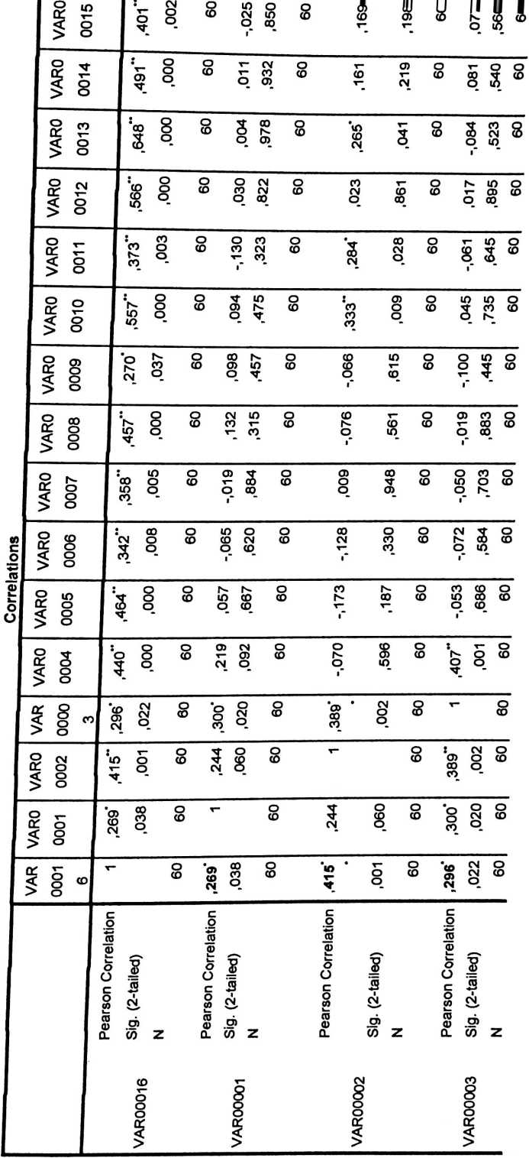

o | in |  | cd | 3> |  | o  v-  r | o | (0 | m  V | W  cn | UJ | II  V
,186 | ,154 | 09 | ,Z£€‘ | O  o | 09 | -,039 | ,765 | 60 | .081 | ,540 | 09 | ,193 | .140 | 60
CN  CN  O  i~ | ,867 | 09 | ,235 | T“  o | 60 | N-  CO  co_ | CO  o  o | 60 | .245 | .059 | 09 | .219 | .092 | 09
CN  CN | ,104 | 09 | ^{f}co  CO  CO | ,004 | 60 | :oo  o | o  o | 09 | (0  o | ,643 | 09 | ,180 | .168 | 09
O>  T  O  i" | O  x— | 09 | -,027 | ,838 | 60 | .235 | .071 | 09 | -.206 |  | 09 | CO  CO  O  r | 98Z' | 60
O  8  1 | ,649 | 09 | ,280* | o  CO  o | 09 | ,152 | ,246 | o  (0 | ,156 | ,234 | 60 | -,015 | ,912 | 60
o  o | 00C | 09 |  | )09 | 09 | )57 | >64 | 09 | 09C | CO  o | 09 | 247 | 10  Q | 09
 |  |  | CO |  |  | r |  |  | r | - |  | ■
vy | o  o | 09 | ,129 | .327 | 09 | s  o  l” | ,616 | 60 | ‘o  3 | 000* | 09 | T” |  | 09
,274 | ,034 | 09 | ,141 | ,284 | 09 | ,177 | .177 | 09 | X“ |  | 09 | ‘o  3 | O  O  O | 60
,181 | ,166 | 09 | ,315 | ,014 | 09 |  |  | 09 | .177 | ,177 | 09 | -.066 | ,616 | 09
v- |  | o  CO | ,186 | .154 | O  CD | ,181 | ,166 | O  CD | .274* | ,034 | o  CD |  | o  o | o  CD
O  M; | o  o | o  CD | £90'- | ,686 | O  CD | -072 | ,584 | O  CD | -.050 | ,703 | o  CD | -,019 | ,883 | o  CD
o  o  r | ,596 | O  CD | -.173 | CO  T⁻ | O  CD | CO  CN  v  r | ,330 | O  CD | 600’ | CO  3 | o  CD | CD  O  r | CD | o  CD
O)  x—  CN | ,092 | O  CD | .057 | .667 | O  CD | -.065 | ,620 | O  CD | OJ  o  i" | 3  oo_ | O  C0 | .132 | ,315 | O  CD
,440* | o  o  o | O  CD | ,464*  • | o  o  o | O  CD |  | CO  o  o | O  CD | ,358*  • | 900' | O  CD | !a  ’t | o  o  o | O  CD
Pearson Correlation | Sig. (2-tailed) | Z | Pearson Correlation | Sig. (2-tailed) | Z | Pearson Correlation | T?  a>  CN  U)  OT | Z | Pearson Correlation | Sig. (2-tailed) ! | Z | Pearson Correlation | Sig. (2-tailed) | Z

"■ 1 | .58 | (D | .20 | .12 | CD | ,383 | § | CD | LD  O | ,65- | 8 | co  CM | k | IB | w  T"
.247 | ,057 | 09 | io  CD  O | ,621 | 60 | ,132 | .314 | 60 | ,245 | ,059 | 09 | §  T~ | .406 | 09 | T'
m-  X—  O_  r | CD | 09 | ,654” | O  o  o | 09 | ZZZ' | CM  CO  o | 09 | ,406“ | o  o | 09 | T' |  | 09 | CD  O  T-
3 | ,160 | 09 | ,166 | ,206 | 60 | ,307* | o | 60 | T~ |  | 60 | r  8 | o  o | 60 | .245
CO  o_ | 00 | 09 | ,192 | V~  V~ | 60 | T— |  | 09 | ,307* | o | 09 | CM | ,032 | 60 | ,132
M’  v-  o | ,914 | 09 |  |  | 60 | .192 | .141 | 60 | ,166 | .206 | 09 | :3  co | o  o  o | 60 | ,065
x— |  | O  CD | 'M"  O | ,914 | 60 | co  o | .778 | 09 | ,184 | O  co | 09 | ,014 | m  T-  <D | 09 | CM

s g S 2 2 S 8 8 8 § 88 ? S 8 8
°_ O CD O b* v- T- CM O V-
5 8 9 <2 1 ° co o t- co o
CO p CD m CO CD O y- (D CD M CD
°_ v-CN CM v- O CD
s cd o •_{r}-> o o r- co o : V o io
S o CO co CO CD CM CO CD <D O CO CO
CO o JO O o co CD o CM
,000 | o  o  o | 09  i | -,060 | ,649 | 09 | o>  3  1 | o o  t- ° |  | ,212 | 09  NH* |  | -.022 | .867  60 |  | .186
o | 10 | o | 10 | m | o |  | tn | o |  | LD | o | 3 | co | o | X—
o  T—  l" | 5 | CD | 3 | co | CD | CD  O_ | 3 | C0 | o | CD  00 | CD | co  o_ | CM  tn | CD | CO  o_
CD  o  1 | ,615 | 09 | ,333” | 600’ | 09 | ‘3  CM | co  CM  O_ | 09 | ,023 | .861 | 09 | ,265* | 3 | 60 | .161
co |  | O |  | m | o | O | co | o | o | CM | o |  | 00 | o | T⁻
CD  O | ,45 | CD | CD  O |  | CD | CO  v | CM  CO | CD | .03 | CM  00 | CD | o  o | CD | CD | O
0Z3‘ 1 | CO  o | 09 | .557  • | o  o  o | 09 | ,373*  • | ,003 | 09 | .566* | o  o  o | 09 | ,648*  • | O  O  O | 09 | ,491*
I»  c |  | C
p  15  S' <3 | O  «  p  S' S 3 | p  w  J s
~ £  dt S | S c s | c -2
~ £  dt S | S
6) S | 6) 5 .9> | S
W Z CL | CD Z 0. CD Z | 0. (0 z

C  c | 60  1 |  | 09
 | o :  co co  5 | 09  L00‘
'M | o cm  > co co  r cm | ,074  60
O  u  c | ) O CR  > co m  o | ,655  60
M- o :  V- CO CO  CO CO  CC |  | co o  O CD  O  L
,621  60  903 |  | o o  Ol co
v  c | PZO  09 | ,588  60
o o ir  co c*"  V“ V |  | ,304  60
O O CC  S <°  1 |  | ,234  60
ID O CD C  CO CO O C |  |  | 60
o o ir  x- CO c  o c |  | , —-  ,969  60
,154  60  na* |  | ,520  60
c  5 | ,VT-?V  60  077 | 09  099'
CD O CD CO O
x- CO CO CD CD
CM x- x-
,932  60  _ oo^ |  | > c  u  > 0 | 60
,000  60  ,401*  nno |  |  | 09  ’rrt/y*
Sig. (2-tailed)  N  Pparenn r.nrrelatinn |  | VAR00015  Sig. (2-tailed)  N

w |  | V-) | 56 |  | 47 | 59 i | 47 ! | 54 ! | 50 1 | 55 | o  «n | 54 1 | 52 ! | 58 1 | 44 i | 58 | | 50 | 55 | 53 | 1 49 1 | 1 t? 1 | 00  «n | 00  «n | s©  «n | CM  «n | •n  •o | «n | —s— | e  Z)
SKOR TOTAL UNTUK BUTIR INSTRUMEN NO: | cm | ’e | e | e | co | e | e | e | CO | e | e | e | co | co | CM | e | e | CO | CO | CM | e | e | co | e | co | e | co | e | e
SKOR TOTAL UNTUK BUTIR INSTRUMEN NO: | 27 | |  | e | CM | co | e | CO | e | e | e | CO | e | CO | e | CM | CO | co | co | e | e | e | e | e | e | co | e | e | e | e
SKOR TOTAL UNTUK BUTIR INSTRUMEN NO: | 25 J | e | co | cm | e | e | (M | CM | CO | e | e | e | co | co | CO | e | e | co | CO | e | e | e | e | e | co | co | CO | e | CO
SKOR TOTAL UNTUK BUTIR INSTRUMEN NO: | 23 1 | Tf | e | CM | m | e | CO | e | e | e | CO | e | co | e | e | e | e | co | e | CM | e | e | e | CO | co | e | co | e | CM
SKOR TOTAL UNTUK BUTIR INSTRUMEN NO: | 21 .. I | Tt | e | co | e | e | CO | e | e | e | CO | e | e | e | e | CO | e | e | e | e | e | e | e | CO | e | e | e | co | e
SKOR TOTAL UNTUK BUTIR INSTRUMEN NO: | |6I | Tt" | co | co | cm | e | CO | e | CO | e | CM | e | co | e | e | e | e | e | e | e | e | e | CO | e | e | e | e | co | co
SKOR TOTAL UNTUK BUTIR INSTRUMEN NO: |  |  | e | e | CO | e | e | CM | CM | e | e | CO | e | e | CM | e | e | e | e | CM | CO | e | e | CO | e | co | CM | e | e
SKOR TOTAL UNTUK BUTIR INSTRUMEN NO: | 'F"* | e | e | e | CO | CO | CO | e | n | CO | e | e | CM | e | e | e | co | e | co | CO | e | e | e | e | co | CO | CM | e | co
SKOR TOTAL UNTUK BUTIR INSTRUMEN NO: | m | co | e | e | CO | e | co | e | e | e | CO | e | co | e | co | e | CM | e | e | e | e | e | e | e | e | co | co | e | CO
SKOR TOTAL UNTUK BUTIR INSTRUMEN NO: | ▼K | co | e | co | CO | e | CO | e | e | CM | e | CO | e | e | CM | e | CO | e | co | e | co | e | e | e | CO | e | e | e | e
SKOR TOTAL UNTUK BUTIR INSTRUMEN NO: | <3\ | co | co | CM | co | e | CO | e | CO | CO | e | CM | e | e | CM | e | cO | e | CM | co | CM | CO | e | e | CO | CO | e | e | e
SKOR TOTAL UNTUK BUTIR INSTRUMEN NO: | b | e | e | e | CO | e | CO | e | e | CO | e | e | e | e | CO | e | co | e | e | e | e | e | e | e | e | e | e | co | e
SKOR TOTAL UNTUK BUTIR INSTRUMEN NO: |  | co | co | e | e | e | CO | e | e | e | CM | e | e | e | e | e | co | CO | e | CO | e | e | e | co | CO | e | e | e | e
SKOR TOTAL UNTUK BUTIR INSTRUMEN NO: | fO | e | e | co | CO | e | e | CO | CM | e | CM | CO | e | e | co | e | co | e | e | CO | co | co | e | e | e | e | CO |  | e
SKOR TOTAL UNTUK BUTIR INSTRUMEN NO: | f-< | e | e | co | CO | e | CO | CO | e | e | e | CO | e | e | CM | e | co | e | co | CO | co | e | e | e | e | e | CO |  | e
O  Z | 1 Resp. | |  | cm | CO | e | v) | V0 | r* | 00 |  | r oi | F-< | r ii | r n | 1*_J | r «i | S©  w |  | 18 | _ 61 J | 1 20 | ™ | ZZ | | —Z | e  <M | iZ | f  e’ | r  N | 00  c*
I tt | 40 j | 57 |  | 44 ! |  | 56 | <n |  | 44 | 04  <n | 1 6t | 8? | 54 | 56 | 53 1 | 53 1 | 1 8S | 53 |  | 53 | 1 ts | «n | <n | un | « 2 | \o  «n | 48 | 1 1 |  | »n  •n | 1 9V 1
m | 04 | M’ | M' | cn | M' | M' | cn | cn | M’ | cn | M | M' | M’ | M’ | M' | m | M' | cn | M’ | M' | cn | M’ | M’ | M’ | cn | M’ | M | M’ | M | M’ | CM
cm | cn | m | M’ | cn | cn | M' | cn | M’ | 04 | M' | 04 | M' | cn | M' | M' | cn | M’ | cn | M’ | M' | cn | M’ | M’ | M’ | M | M’ | CM | M | M’ | M | CM
cn | cn | M' | M' | 04 | cn | cn | M' | cn | 04 | m | cn | cn | M' | 04 | 04 | cn | M’ | M' | M' | 04 | cn | 04 | M' | 04 | cn | M | M’ | M’ | M’ | CM | CM
m- | cn | M’ | m | M' | M' | M' | 04 | M' | M' | M' | M' | M’ | M | M' | M' | M’ | M | M' | M' | M' | M' | M’ | M' | M’ | M' | M’ | CM | M’ | M’ | 04 | M'
cm | M’ | M' | M' | 04 | M' | cn | M' | M’ | cn | M' | m | M' | M' | M' | M' | 04 | M’ | m | cn | m | cn | M' | M' | M’ | M’ | M’ | CM | M' | CM | M' | CM
M' | oi | M’ | M' | M' | M' | M' | cn | M' | M | M' | M | M' | M' | M' | (M | m | M' | cn | M’ | M' | cn | M’ | M' | M’ | cn | M’ | 04 | M’ | CM | CM | M'
M' | cn | M' | cn | M' | cn | cn | M' | M' | 04 | M' | 04 | cn | M' | M' | 04 | cn | M' | M’ | M’ | M | cn | 04 | M’ | 04 | 04 | M' | M’ | CM | M' | M' | M’
M- | 04 | M' | cn | cn | cn | M' | M' | M' | cn | cn | M' | M | cn | M' | M' | M’ | cn | M’ | m | M’ | M’ | cn | 04 | f-⁻* | M' | M | CM | CM | M’ | M’ | 04
M- | 04 | cn | M' | M' | M' | M' | M' | M' | cn | cn | 04 | M' | M' | M' | M’ | M' | M' | cn | M' | M' | M’ | M | M' | M’ | M' | M' | CM | M’ | M’ | M' | CM
04 | 04 | M' | 04 | 04 | cn | M' | M' | M' | 04 | 04 | cn | M' | M’ | M' | (M | M' | M' | M' | M’ | M' | M’ | cn | 04 | cn | M' | cn | CM | M’ | M’ | M’ | M’
f—* | 04 | cn | cn | 04 | cn | M' | M' | M | cn | cn | cn | M’ | 04 | M’ | M' | M’ | cn | M' | m | 04 | M’ | 04 | 04 | M’ | m | m | CM | M’ | M’ | M’ | 04
04 | cn | M’ | M' | 04 | M’ | cn | 04 | M | cn | M' | M' | M’ | m | M' | M’ | M' | M' | M' | M’ | M’ | M' | M | M' | M | M’ | M’ | CM | M’ | 04 | M’ | CM
cn | M' | M’ | cn | M' | cn | M' | M | M' | cn | M' | M' | M' | M’ | M' | M’ | M' | M’ | M' | M' | M' | M’ | M' | M' | cn | CM | M' | M’ | M’ | M' | M' | CM
04 | cn | M' | M' | cn | M' | M' | 04 | cn | cn | M' | M' | M' | m | 04 | M’ | M’ | M' | cn | M' | 04 | M’ | M' | m | M' | M' | CM | CM | M' | 04 | CM | CM
04 | 04 | M' | 04 | 04 | 04 | M' | M' | M' | m | cn | cn | M’ | M' | M’ | m | M’ | M’ | cn | M' | M’ | M’ |  | 04 | M' | M’ | CM | CM | M' | M' | M' | 04
' 29 1 | ! 30 | 31 | L 32 _ | m  m | 34 | 1 35 1 | 1361 | L 37 7 | 00  m | -■ 39 I | o  M | M | t* | m  M |  | r «t | ⁴⁶ J | 12 1 | - ⁴⁸ ■_ | 49 | 50 | w |  | 1 53 | M’ | | 55 | | 56 |  | 1 58 | 1 59 | 09

§
TABEL 6
DATA UNTUK ITEM GENAP
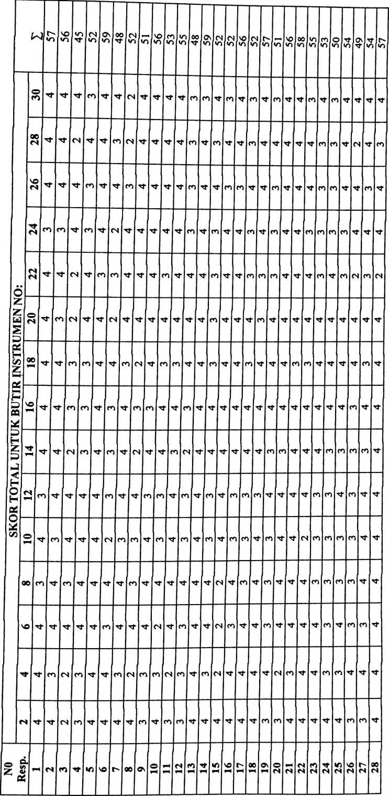

o | CM  <n | i 58 | 49 | 46 | 52 | L 9S 1 | <n | <n | 48 | CO  'O | r 49 | 56 ; |  | 54 | 50 i | <n | « | 52 | o  'O | w | 53 | | « 1 | 50 1 | O  <n | « | CO  »n |  | 1 «S 1 | 1 ES i | «n | 1 52 |
M’ | CM | m- | CO | co | co | M | co | co | M | CO | M’ | M' | M | M' | M | co | M | co | M’ | M’ | M | co | M | 04 | M' | M’ | M’ | M | M’ | M | M
co | m | M’ | M | co | M | M | co | M | CM | M | CM | M | M' | CM | M | CM | M | co | M’ | cs | CO | co | M' | 04 | M | M- | M | M’ | M | co | CO
co | co | M' | co | co | M | m | M | co | CM | CO | CM | M' | M' | M’ | CO | M' | M' | co | M | M’ | M’ | co | M' | CO | M’ | M' | M' | M | CO | M’ | CO
04 | M' | M’ | co | M’ | co | m | co | M | M | M | M | CO | M | M | M' | M | M | M' | M’ | M' | M | M | M' | M’ | M’ | M' | M’ | M’ | M | M | co
m | co | M' | M | co | M | M’ | M | M’ | M’ | M | M' | CO | M’ | M | M’ | CO | co | M | M | M | co | co | M' | M' | M’ | M' | co | M | CO | 04 | M
04 | cn | M’ | M | M | M | co | co | co | M | CO | M’ | M' | M' | M | M | CO | M | co | M' | M’ | co | M’ | M’ | M' | M' | M’ | M | M | M | M | co
M’ | M' | M | co | M | co | M' | co | M’ | M' | M' | M' | M | M | M’ | CM | M | M’ | co | M’ | M’ | 04 | co | M | CO | 04 | M' | CO | CO | CO | M | M
M’ | ■m | m | co | M | co | M’ | M | M | M’ | M' | M | M | M | M | CO | CO | M' | M | M' | M' | M' | M' | M | M | CO | CO | M | CO | M | M | M
04 | co | m | M | co | M | co | co | co | co | CO | CM | M’ | co | M' | M' | M’ | M' | co | M’ | M’ | M' | M' | co | M | M | co | co | M | CO | CO | CO
04 | M’ | m | co | co | co | M' | M | M’ | co | M | CO | M’ | M' | M | CO | CM | M’ | M’ | M | (N | M' | M' | CO | M’ | M | M' | co | M’ | M' | M | co
 | M' | m | M’ | CM | M | M | M | M | co | M' | M | M’ | CO | CM | r—* | M’ | M' | M | M | M’ | M | CO | 04 | 04 | CO | M' | M | M’ | M | M’ | co
04 | M' | m | CM | CM | co | M | co | CM | CM | CM | M' | CO | M' | CM | CO | M | M’ | co | M' | 04 | co | M' | M | CO | M | CO | M | M’ | CO | 04 | M
co | M' | M | co | co | co | co | co | M’ | CM | M' | CO | M’ | CO | M’ | M' | CO | M' | M' | M’ | M’ | M' | M’ | 04 | M’ | M | M’ | M’ | M | co | M | M'
04 | co | co | co | CM | co | M’ | M’ | CM | co | CO | CO | CO | CO | M' | CO | M' | M' | co | M' | 04 | CO | 04 | 04 | co | CO | 04 | CO | M' | M’ | 04 | co
CM | M' | M | co | co | M | co | co | m | M’ | M | CM | M | M | M | M' | M' | M' | M’ | M' | M | M’ | M’ | 04 | M’ | M’ | 04 | co | M’ | co | CO | M
os  CM | L 30 1 | 1 31 1 | 1 32 1 | 1 33 | | 1 34 | | 1 35 7 | 1 9£ I | r 4£ | 00  CO | C\  CO | 1 o* | M | - 42 J | L—«I | - 44. 1 | ■ 45 I | M | L* | 00 | | 49 | 50 | is | 04 | | 53 | 54 | V)  m | 56 | _ | 58 | 59 | 1 60

a untuk uji dua fihak (two tail test)
 | 0,50 | 020 | 0,10 | 0,05 | 1 0,02 | 0,01
 |  | a untuk uji satu fihak |  | (one tail test)
dk | 0,25 | 0,10 | 0,05 | 0,025 | 0,02 | 0,01
1 | 1,000 | 3,078 | 6,314 | 12,706 | 31,821 | 63,657
2 | 0,816 | 1,886 | 2,920 | 4,303 | 6,965 | 9,925
3 | 0,765 | 1,638 | 2,353 | 3,182 | 4,541 | 5,841
4 | 0,741 | 1,533 | 2,132 | 2,776 | 3,747 | 4,604
5 | 0,727 | 1,476 | 2,015 | 2.571 | 3,365 | 4.032
6 | 0,718 | 1,440 | 1,943 | 2,447 | 3,143 | 3,707
7 | 0,711 | 1,415 | 1,895 | 2,365 | 2,998 | 3,499
8 | 0,706 | 1,397 | 1,860 | 2,306 | 2,896 | 3,355
9 | 0,703 | 1,383 | 1,833 | 2,262 | 2,821 | 3,250
10 | 0,700 | 1,372 | 1,812 | 2,228 | 2,764 | 3,169
11 | 0,697 | 1,363 | 1,796 | 2,201 | 2,718 | 3,106
12 | 0,695 | 1,356 | 1,782 | 2,179 | 2,681 | 3,055
13 | 0,692 | 1,350 | 1,771 | 2.160 | 2,650 | 3,012
14 | 0,691 | 1,345 | 1,761 | 2,145 | 2,624 | 2,977
15 | 0,690 | 1,341 | 1,753 | 2,131 | 2,602 | 2,947 ■
16 | 0,689 | 1,337 | 1,746 | 2,120 | 2,583 | 2,921
17 | 0.688 | 1,333 | 1,740 | 2,110 | 2,567 | 2,898
18 | 0,688 | 1,330 | 1,734 | 2,101 | 2,552 | 2,878
19 | 0,687 | 1,328 | 1,729 | 2,093 | 2,539 | 2,861
20 | 0,687 | 1,325 | 1,725 | 2,086 | 2,528 | 2,845
21 | 0,686 | 1,323 | 1,721 | 2,080 | 2,518 | 2,831
22 | 0,686 | 1,321 | 1,717 | 2,074 | 2,508 | 2,819
23 | 0,685 | 1,319 | 1,714 | 2,069 | 2,500 | 2,807
24 | 0,685 | 1,318 | 1,711 | 2,064 | 2,492 | 2,797
25 | 0^684 | 1,316 | 1,708 | 2,060 | 2,485 | 2.787
26 | 0^684 | 1,315 | 1,706 | 2,056 | 2,479 | 2,779
27 | 0,684 | 1,314 | 1,703 | 2,052 | 2,473 | 2,771
28 | 0,683 | 1,313 | 1,701 | 2,048 | 2,467 | 2,763
29 | 0.683 | 1.311 | 1,699 | 2,045 | 2,462 | 2,756
30 | 0,683 | 1,310 | 1,697 | 2,042 | 2,457 | 2,750
40 | 0^681 | 1,303 | 1,684 | 2,021 | 2,423 | 2,704
60 | 0,679 | 1,296 | 1,671 | 2,000 | 2,390 | 2,660
120 | 0,677 | 1,289 | 1,658 | 1,980 | 2,358 | 2,617
00 | 0,674 | 1,282 | 1,645 | 1,960 | 2,362 | 2,576

N | Taraf  Signifikansi |  | N | Taraf Signifikansi |  | N | Taraf  Signifikansi
N | 5% | 1% | N | 5% | 1% | N | 5% | 1%
3 | 0,997 | 0,999 | 27 | 0,381 | 0,487 | 55 | 0,266 | 0,345
4 | 0,950 | 0,990 | 28 | 0,374 | 0,478 | 60 | 0,254 | 0330
5 | 0,878 | 0,959 | 29 | 0,367 | 0,470 | 65 | 0,244 | 0,317
6 | 0,811 | 0,917 | 30 | 0,361 | 0,463 | 70 | 0,235 | 0,306
7 | 0,754 | 0,874 | 31 | 0,355 | 0,456 | 75 | 0,227 | 0,296
8 | 0.707 | 0,834 | 32 | 0,349 | 0,449 | 80 | 0,220 | 0,286
9 | 0.666 | 0,798 | 33 | 0,344 | 0,442 | 85 | 0,213 | 0,278
10 | 0,632 | 0,765 | 34 | 0,339 | 0,436 | 90 | 0,207 | 0,270
11 | 0,602 | 0,735 | 35 | 0,334 | 0,430 | 95 | 0,202 | 0,263
12 | 0,576 | 0,708 | 36 | 0,329 | 0,424 | 100 | 0,195 | 0,256
13 | 0,553 | 0,684 | 37 | 0,325 | 0,418 | 125 | 0,176 | 0,230
14 | 0,532 | 0,661 | 38 | 0,320 | 0,413 | 150 | 0,159 | 0,210
15 | 0,514 | 0,641 | 39 | 0,316 | 0,408 | 175 | 0,148 | 0,194
16 | 0,497 | 0,623 | 40 | 0,312 | 0,403 | 200 | 0,138 | 0,181
17 | 0,482 | 0,606 | 41 | 0,308 | 0,398 | 300 | 0,113 | 0,148
18 | 0,468 | 0,590 | 42 | 0,304 | 0,393 | 400 | 0,098 | 0,128
19 | 0,456 | 0,575 | 43 | 0,301 | 0,389 | 500 | 0,088 | 0,115
20 | 0,444 | 0,561 | 44 | 0,297 | 0,384 | 600 | 0,080 | 0,105
21 | 0,433 | 0,549 | 45 | 0,294 | 0,380 | 700 | 0,074 | 0,097
22 | 0,423 | 0,537 | 46 | 0,291 | 0,376 | 800 | 0,070 | 0,091
23 | 0,413 | 0,526 | 47 | 0,288 | 0,372 | 900 | 0,065 | 0,086
24 | 0,404 | 0,515 | 48 | 0,284 | 0,368 | 1000 | 0,062 | 0,081
25 | 0,396 | 0,505 | 49 | 0,281 | 0,364
26 | 0,388 | 0,496 | 50 | 0,279 | 0,361

N= Sampel
Lampiran 9

DAFTAR PERNYATAAN ANGKET PENELITIAN
Di Gereja Toraja Jemaat Madandan Klasis Madandan
Oleh:Desty Leny Paiman, Mahasiswa STAKN Toraja
- Pengantar
Dalam rangka penelitian karya ilmiah (skripsi) dan untuk
menyelesaikan studi SI (Strata Satu) di Sekolah Tinggi Agama Kristen
Negeri (STAKN) Toraja, maka saya bermaksud melakukan penelitian
dalam bentuk angket kepada kepala keluarga (KK) di jemaat Madandan
Klasis Madandan, tentang Pengaruh Perkunjungan Pastoral Majelis
Jemaat Ditinjau Dari Segi Pendidikan Agama Kristen Dalam Keluarga.
Oleh karena itu, saya mohon bantuan dan kerja sama bapak/ibu.
Petunjuk:
- Bacalah pertanyaan di bawah ini dengan teliti dan memilih
salah satu jawaban yang menurut anda paling tepat dan sesuai
dengan kenyataan yang ada, dan memberi tanda () pada kolom
alternatif jawaban yang disediakan
- Jujur dalam memberikan jawaban karena jawaban dari setiap
keluarga akan sangat membantu dalam penulisan dan
penyelesaian skripsi ini.
- Tulislah identitas Anda pada tempat yang sudah disediakan
pada angket penelitian ini
- Kerahasiaan data dan informasi responden akan tetap dijaga
oleh peneliti.
5.

No | PERNYATAAN | ALTERNATIF
 |  | S | Sr | Kk | Tp
A. | Variabel X (Pelaksanaan Perkunjungan Pastoral Majelis Jemaat)
1. | Anggota keluarga mendapat perkunjungan pastoral ke rumah dari  majelis jemaat paling kurang 2x dalam setahun.
2 | Anggota keluarga dikunjungi oleh majelis, dalam setiap keadaan yang  dialami keluarga baik sukacita maupun dukacita.
3 | Dalam perkunjungan pastoral, majelis menanyakan keadaan anggota  keluarga dan masalah yang dialami dalam keluarga.
4 | Dalam perkunjungan pastoral anggota keluarga menceritakan  masalah-masalah yang dialami dalam keluarga kepada majelis.
5 | Anggota keluarga diberikan nasehat oleh majelis sesuai dengan Firman  Tuhan dalam perkunjungan pastoral.
6 | Anggota keluarga diberikan motivasi dan semangat oleh majelis dalam  perkunjungan pastoral.
7 | Anggota keluarga di doakan oleh majelis dalam perkunjungan pastoral
8 | Pokok pembicaraan majelis dalam perkunjungan, sesuai dengan  keadaan yang dialami keluarga.
9 | Anggota keluarga menceritakan masalah-masalah yang dialami dalam  keluarga kepada majelis jemaaat dalam perkunjungan pastoral.
10 | Majelis membimbing , membahas bersama dan memberikan solusi  pada masalah yang dialami anggota keluarga
11 | Dalam perkunjungan pastoral, ada waktu orang tua dibina oleh majelis  tentang pentingnya mendidik anak-anak dalam keluarga khususnya  pengenalan akan Tuhan dan hidup sesuai kehendak Tuhan.
12 | Orang tua dibimbing oleh majelis untuk menerapkan Pendidikan  agama Kristen dalam keluarga.
' 13 | Anggota keluarga dan majelis menjalin hubungan yang akrab baik  dalam perkunjungan maupun setelah perkunjungan.
! 14  L | Majelis jemaat menggunakan waktu dengan baik dalam perkunjungan  pastoral
¹ 15  1  1  11 | Anggota keluarga mendapat informasi sebelum majelis melaksanakan  perkunjungan pastoral ke rumah.
j: B. | Variabel Y (PAK Dalam Keluarga) | s | Sr | Kk | Tp
J 1 | Keluarga merasa terhibur dengan adanya pelaksanaan perkunjungan  majelis jemaat ke rumah.
2 | Ada perubahan yang dialami anggota keluarga setelah diadakan  perkunjungan pastoral.
13 | Dengan adanya perkunjungan pastoral majelis orang tua bisa  memahami pentingnya Pendidikan Agama Kristen diajarkan dalam  keluarga khususnya mendidik anak dalam keluarga.
4 | Orang tua mendidik anak-anaknya tentang pengenalan akan Tuhan  dan mendahulukan Tuhan dalam hidupnya
5 | Orang tua membimbing dan mengajarkan anak-anak berdoa.
6 | Orang tua memotivasi anak-anak untuk beribadah dan mengikuti  kegiatan-kegiatan persekutuan di gereja
7 | Orang tua membuat peraturan dalam keluarga untuk mendisiplinkan  anak.
8 | Orang tua memperhatikan perkembangan anak-anaknya baik secara  jasmani maupun secara rohani
9 | Orang tua menjadi teladan yang baik bagi anak-anak dalam perkataan  dan perbuatan yang dilakukan
10 | Menyelesaikan masalah-masalah yang dihadapi dalam keluarga secara  bersama antar anggota keluarga.
11 | Orang tua menjadi sahabat baik anak-anaknya dan mau mendengarkan  dan berbagi dengan apa yang dialami
12 | Anggota keluarga memiliki tekad untuk saling berkorban demi  kebutuhan anggota keluarga/Cinta kasih
13 | Anggota keluarga saling mendukung untuk aktif mengambil peran  dalam persekutuan dan kegiatan jemaat.
14 | Anak-anak dalam keluarga menghargai dan menghormati orang tua.
15 | Anak dalam keluarga mengasihi orang tua, dengan cara mendengarkan  orang tua serta membantu orang tua dalam bekerja
Terima Kasih Atas Kerjasama Bapak/Ibu
Tuhan Memberkati,..

