MA’KATI A
Tinjauan Teologis Tentang Makna Ma’katia dalam Rambu Solo’
Di Kalangan Gereja Toraja Jemaat Ledo, Klasis Buntao*
PERPUSTAKAAN
SEKOLAH T8NGG8 AGAMA
KHiSTEW NEGEkI TORAJA

TgL Terima:

Kias : I
Dibeli/ i
hadiah dan ¹

Terima dari: t4^z?z^v<£.
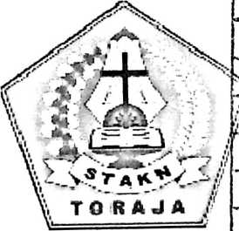
SKRIPSI
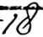
Diajukan kepada Sekolah Tinggi Agama Kristen Negeri (STAKN) Toraja
Untuk Memenuhi Salah Satu Persyaratan Guna Memperoleh
Gelar Sarjana Teologi (S.Th)
OLEH
KRISYANTO MADAUN
2020143789
TEOLOGI KRISTEN
Sekolah Tinggi Agama Kristen Negeri (STAKN) Toraja
2018

Judul | : Ma 'kalia
Sub Judul | :Tinjauan Teologis 'Pentang Makna Ma'katia dalam Rambu Solo¹ di Kalangan  Gereja Toraja Jemaat Lcdo, Klasis Buntao.
Diajukan oleh  Nama | : Krisyanto Madaun
N i rm | : 2020143789
Jurusan | : Teologi Kristen

Judul Skripsi | : Tinjauan Teologis Tentang Makna Ma’katia dalam Rambu  Solo’ di Kalangan Gereja Toraja Jemaat Ledo, Klasis Buntao’
Ditulis Oleh :  Nama | : Krisyanto Madaun
Nirm | :2020143789
Jurusan | : Teologi Kristen
Dosen Pembimbing :
1. Naomi Sampe, M.Th
2. Hasrat Dewy Rante AIlo, M.MG
Telah dipertahankan dan dipertanggungjawabkan oleh penulis dihadapan
dosen penguji dalam proses ujian skripsi Jurusan Teologi Kristen dan diyudisium
pada tanggal 2 Agustus 2018 dengan predikat kelulusan MEMUASKAN.
Dr.
ustin
Dosen Penguji
Dr. Setn
NIP. 1
p Tarrapa
204202009121007
Panitia Ujian
Mengkendek, 06 September 2018
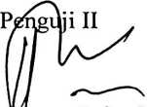
Syani B. Rante Salu, M. Pd. K
NIP.198908282015032006
Rubcny M. Th
NIP1 197608ff22008011011

Dr. Se nfo Tarrapa
NIP/T982042H2009121007
^.Mengetahui
Toraja
Tapingku, M. Th
NIP. 196701242005011003
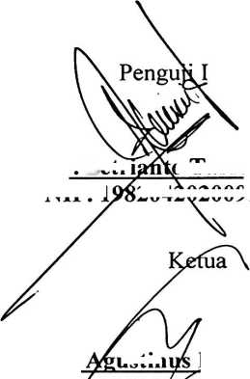
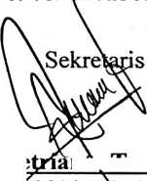

ABSTRACT
Ma 'katia dance is a dance which is always done in the funeral ceremony
(rambu solo’) and it still continue ap to now in Buntao’. But, not the people can
do that in that funeral ceremony (rambu solo’). Just for the high level people, and
it’s called tana’ bulaan and tana’ bassi which can do that and there is still the
element of trust called Aluk Todolo when having ma'katia dance, there are many
procontra at the rhyme like preyers and hopes but, on the ofher side there is the
element of trvsit called Aluk Todolo such as impressive the died person. That’s the
reason why the writer try to find hom the ritual impersson of ma 'katia dance. And
theological vien about ma 'katia dance ritual in Gereja Toraja Jemaat Ledo, Klasis
Buntao’
To collect the data, the writer use quaiitative methoad and data collection
tech, nique use intervien and ebservation. Aralyze tech nigue data use domain,
technique, taxonomy, components and culture theme. Next, analyze the data that
has been found.
The mearing o f ma 'katia dance has three elements the first element is say
weicome to the gvess who attended the ceremony. The second element there are
element tell abisut the dead person biography. And the ricrd element, there are
families’s prayers and hopis of the rhynes that is told by the ma ’katia dance.
Keyword: Dance, Ma ’katia, Ceremony, Aluk Todolo.
x

