DAMPAK PELAKSANAAN KURIKULUM KATEKISASI TERHADAP
PERKEMBANGAN SPIRITUAL KATEKISAN DI JEMAAT MORIA
ULUSALU KLASIS ULUSALU
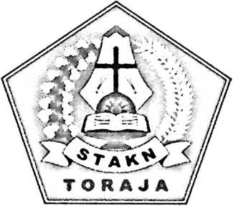
SKRIPSI
Diajukan Kepada Sekolah Tinggi Agama Kristen Negeri (STAKN) Toraja
untuk memenuhi sebagian dari persyaratan guna memperoleh gelar Sarjana
Pendidikan (S.Pd)
OLEH:
HERIYANTO PASANG
1020154159
JURUSAN PENDIDIKAN AGAMA KRISTEN
SEKOLAH TINGGI AGAMA KRISTEN NEGERI (STAKN) TORAJA
TAHUN 2019

Judul Skripsi | : Dampak Pelaksanaan Kurikulum Katekisasi Terhadap  Perkembangan Spiritual Katekisan di Jemaat Moria Ulusalu  Klasis Ulusalu
Dipersiapkan oleh | : Heriyanto Pasang
N1R.M | : 1020154159
Jurusan | : Pendidikan Agama Kristen

Judul Skripsi | : Dampak Pelaksanaan Kurikulum Katekisasi Terhadap Perkembangan  Spiritual Katekisan di Jemaat Moria Ulusalu Klasis Moria Ulusalu
Ditulis Oleh | : Heriyanto Pasang
NIRM | : 1020154159
Jurusan | : Pendidikan Agama Kristen
Pembimbing I | : Pdt. Yekhonya F.T. Timbang, M.Si
Pembimbing II | : Sanda Mongan, S.Th, M.PdK

Telah dipertanggungjawabkan oleh penulis di depan Dosen penguji skripsi Jurusan
Pendidikan Agama Kristen (PAK) dan di Yidisium dengan Predikat kelulusan:
MEMUASKAN
Tana Toraja, 29 Juli 2019
Dosen Penguji

Pdt. Ivan Sampe Buntu, M.Hum
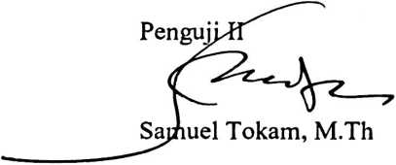
NIP.196703300006041001
N1DN. 2016117704
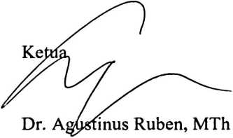
NIP.197608022008011011
Panitia Ujian
Sekretaris

Lorista Kerung, S. Kom,
NIP. 198806302015032007
Mengetahui
^KeiuaSTA
Toraja
^Dn~Jpni Tapingku, M.Th,
N ^{S}NIP. 196701242005011003

ABSTRACT
Key words: The impact of the implementation of the Catechisation curriculum,
spirituality.
In this writing, the author finds numb papunderstanding and knowledge related to the
process of implementing the Catechisation curriculum at the Toraja Church of Moria
Ulusalu. In this study obtained some data through the study of the library,
observation, interviews to the teachers catechisation and pupils catechization as well
as catechisation members who have been tried. The author uses several theories to
support this research. Tn this study will examine the catechisation, the spiritual and
the impact of the implementation of the curriculum catechization to the spiritual
development of Catechisan.
The purpose of this research is to determine the impact of the implementation of the
Catechization curriculum against the Spiritual development of Catechisan. By
conducting analysis of the literature and research fmdings, the authors concluded that
the impact of the process of implementing the Catechization curriculum for the
spiritual development of Catechisan tums out to have a good impact on spiritual
development Their. Where they are able to grow in faith believe thern through their
living pattems as Christian youth. And they were able to become Christian youth who
gave themselves in the Service of worship, able to be good examples for other youths
i n the attitude of deeds through their speech.

