Skripsi Maryam
ORIGINALFTY REPORT
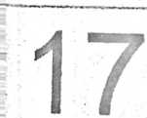
%
O
O
O
SIMILARITY INDEX
INTERNET SOURCES PUBLICATIONS
STUDENT PAPERS
f IPRIMARY SOURCES

piapiatomeladak.blogspot.com
Internet Source
aguspatang.blogspot.com
Internet Source
artikel.sabda.org
Internet Source
budimakaado.blogspot.com
Internet Source
albata.info
Internet Source
kristenituindahblog.wordpress.com
Internet Source
.com
www.scribd.com
Internet Source
2%
O
O
o
o
O
o/
/0
0
o/
/o

