fcFIJSTAKAAN
? SEKOLAH TINGGI AGAMA
KRISTEN NEGERI TORAJA
TgkTenma
NOi induk
'rlo.Klas
Dibeli/
Hadiah <ari
Terima dari
’Harga | J  —.— J

Diajukan Kepada Sekolah Tinggi Agama Kristen Negeri Toraja Untuk
Memenuhi Salah Satu Persyaratan Guna Memperoleh Gelar Sarjana
Pendidikan Agama Kristen (S.Pd)

Oleh

Lisa Vebrianti Kano

NIRM: 1020154053
PROGRAM STUDI PENDIDIKAN AGAMA KRISTEN
SEKOLAH TINGGI AGAMA KRISTEN NEGERI (STAKN) TORAJA
2019
HALAMAN PERSETUJUAN
Judul Skripsi : Kajian Hermeneutik Kolose 3:21 dan Implikasinya terhadap
Parenting bagi Anak Berkebutuhan Khusus di Lembang
Batualu.
Dipersiapkan Oleh : Lisa Vebrianti Kano
Nirm : 1020154053
Jurusan : Pendidikan Agama Kristen
Setelah melalui proses pembimbingan oleh dosen bimbingan, maka Skripsi ini
dinyalakan telah memenuhi persyaratan untuk mengikuti ujian Skripsi Sekolah Tinggi
Agama Kristen Negeri (STAKN) Toraja.
Mengkendek, 24 Juni 2019
Dosen Pembimbing
PeiAbimbing I
James A. Lola*, M.Th
Nip. 1986062320150310003
Pembimbing II
Petr iranda M. Th.
Nip. 197704122006041002
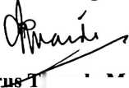
HALAMAN PENGESAHAN
Judul Skripsi
Ditulis oleh
N1RM
Jurusan
: Kajian Henneneutik Kolose 3:21 dan Implikasinya terhadap
Parenting bagi Anak Berkebutuhan Khusus di Lembang
Batualu.
: Lisa Vebrianti Kano
: 1020154053
: Pendidikan Agama Kristen
Dosen Pembimbing 1 : James A. Lola’, M.Th
Dosen Pembimbing 2 : Petrus Tiranda, M.Th
Telah dipertahankan oleh penulis di depan dosen penguji skripsi Jurusan
Pendidikan Agama Kristen dan diyudisium dengan predikat CUM LAUDE.
Mengkendek, 29 Juli 2019
Dosen Penguji
Penguji 1
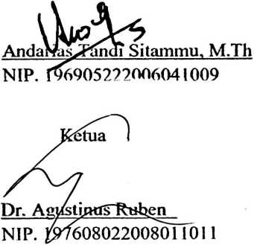
Panitia Ujian
iguji II
Yohanes KrisiViantyo Susanta, M.Th
NIDN. 2013128601
Sekretaris
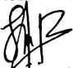
Lorista R£rung, S.Kom
NIP. 198806302015032007
Mengetahui,
Toraja
oni/Tapingku
lW49670/242005011003
iii
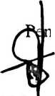

ABSTRACT
Lisa Vebrianti Kano, Reg. Number: 1020154053, complied a thesis entitled
“The Hermeneutic Study of Colossians 3:21 and Implications forward Father Parenting
to Exceptional Children at Lembang Batualu. Supervised by James A.Lola’, M.Th as
advisor l^{s}' and Petrus Tiranda, M.Th as advisor 2nd.
The writer interested in study this topic based on the desire to examine the
meaning of Colossians 3:21 and looking to existence of exceptional children at
lembang Batualu who lived with his grandmother because the father still lacked
meaning of God’s commands in Colossians 3:21. In conducted this research, the
approach that writer used qualitive research, by hermeneutic method grammatical-
historical.
The conclusions that writer obtained was Colossians 3:21 an order to every
father in educated children to avoid any form of action that can make children become
hurt, so thet they are not discouraged as a negative response to the education obtained
from their father. Colossians 3:21 a rebuke to the father who have exceptional children
at Lembang Batualu for carrying out his responsibilities to educate his children so that
children do not get discouraged and appreciate their lives behind their limitations. The
thing that should be done by the father for exceptional children to accept the existence
of children and show an authotitative attitude.
Hopefully through this study, expected that every father able to interpret God’s
commands in Colossians 3:21 to avoid any kind of action that can hurt children,
including exceptional children.
v

