STUDI EKSEGETIS MARKUS 10:35-45 DAN IMPLIKASINYA DALAM
MOTIVASI PELAYANAN MAJELIS GEREJA

TORAJA
SKRIPSI
Diajukan Kepada Institut Agama Kristen Negeri (IAKN) Toraja Sebagai
Persyaratan Untuk Memperoleh Gelar Sarjana Teologi (S. Th)
Oleh
Erfin Tosuli
2020164500
Teologi Kristen
INSTITUT AGAMA KRISTEN NEGERI ( IAKN TORAJA )
TAHUN 2020

Nama | : Erfin Tosuli
Nirim | :2020164500
Jurusan | : Teologi Kristen
Setelah diperiksa dan diteliti ulang, maka skripsi ini memenuhi
syarat untuk dipertanggungjawabkan di depan dewan penguji skripsi pada
jurusan Teologi Kristen, Insitut Agama Kristen Negeri (IAKN) Toraja.
Mengkendek, Agustus 2020
Menyetujui Dosen Pembimbing
Pembimbing II

Pembimbing I
arrung, M. Th
NIP. 1981050620060410003
Daniel Fajar Panuntun, M. Th
NIP. 199205182019031017
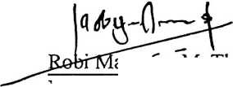
Judul Skripsi | : Studi Eksegetis Markuks 10:35-45 dan ImplikasinMotivasi  Pelayanan Majelis Gereja.
Ditulis oleh  Nama | : Erfin Tosuli
Nirm | : 2020164500
Jurusan | : Teologi Kristen
Dosen Pembimbing | :1. Robi ivlarrung, M. Th  2. Daniel Fajar Panuntun, M. Th

Telah dipertahankan oleh penulis di hadapan Dewan Penguji Sarjana (SI) Institut
Agama Kristen Negeri (IAKN) Toraja pada tanggal 14 Juli 2020.
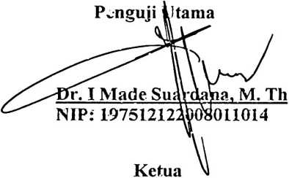
Dewan Penguji
Panitia Ujian

Samuel Tokani, M. Th
NLP: 196703302006041001
pingku, M.Th
1242005011003
GETAHUI
jp^AKN TORAJA
Penguji Pendamping

Feki Markus, M. Th
NIDN: 2024027904
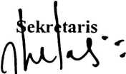
Fajar Kelana, M. Th
NIP: 197902172008011016

iii

ABSTRACT
Erfin Tosuli (2020164500), The Title: Exegetical Study Mark 10:35-45
and Its Implications in the Motivation of Church Assembly Service.
Service is the responsibility of a minister specific to the council of the
church. Service is a response by christians as a form of thanking all the good that
God bestows. In practice it demands a willingness in the motivation of church
assembly Service as attributed in Mark 10:35-45 conceming the request of James
and John not to rule but to serve.But sometimes the Service is done based on not
good motivation. The purpose was to find the meaning of James and John's
request as well as Jesus' ministry. In reviewing the request James and John did not
rule but rather served from the Gospel of Mark 10:35-45 used hermeneutic
approach methods by applying the principle of interpretation through exegesis and
field research.
Based on the results of the exegetical study, it is clear that the meaning of
James and John's request not to rule but to serve is a willingness to give
themselves sincerely, regardless of a position in taking Service, for as a servant
must sacrifice, take consequences, not worry in carrying out duties as servants of
the Lord. The church council ministiy in carrying out the mandate given by the
Lord Jesus as it is Matthew 28:19-20 therefore the servant of the assembly must
serve with an attitude as a servant who suffers even to death as does the ministry
that Jesus did who served with an attitude as a servant.

