PERPUSTAKAAN  INSTITUT AGAMA KRISTEN NEGERI  ’IAKN TORAJA | 1
Tgl. Terima : 05-22.-2322-
No. Induk | :i
No. Kias :
Di t oli/ •
Hadiah dari •
Terima dari | r
Harga : ^{J} !

Diajukan Kepada Sekolah Tinggi Agama Kristen Negeri (STAKN) Toraja Untuk Memenuhi
Persyaratan Guna Memperoleh Gelar Saijana Pendidikan Kristen (S.Pd)
OLEH
ARNAMAYALLIS
1020154150
Jurusan Pendidikan Agama Kristen (PAK)
SEKOLAH TINGGI AGAMA KRISTEN NEGERI (STAKN) TORAJA
TAHUN 2019

HALAMAN PERSETUJUAN
Judul Skripsi : Pola pendampingan bagi remaja usia 14-17 tahun yang
memiliki perilaku menyimpang di Dusun Beringin Desa
Bungadidi, Luwu Utara.
Dipersiapkan Oleh : Arnamayallis
Nirm : 1020154150
Jurusan : Pendidikan Agama Kristen
Setelah melalui proses pembimbingan, maka skripsi ini dinyatakan telah
memenuhi persyaratan untuk dipertahankan di depan dosen penguji dalam ujian
skripsi Sekolah Tinggi Agama Kristen Negeri (STAKN) Toraja.
Mengkendek, Mei 2019
Dosen Pembimbing
Pembimbing
Feriyanto M. Si
NIP. 199002012019031019
Ketua Panitia
ian/Skripsi
Dr. Agii^j^tis^Zben^M.Th
NIP. 19^608022008011011
iii


Judul | : Pola Pendampingan Bagi Remaja Usia 14-17 Tahun yang  Memiliki Perilaku Menyimpang di Dusun Beringin Desa  Bungadidi, Luwu Utara
Ditulis Oleh | : Amamayallis
Nirm | : 1020154150
Jurusan | : Pendidikan Agama Kristen
Dosen Pembimbing I : Feryanto, M.Si
Dosen Pembimbing II: Oktoviandy Rantelino, M.Si
Telah dipertahankan oleh penulis di depan dosen penguji skripsi jurusan
Pendidikan Agama Kristen dan diyudisium dengan predikat kelulusan: SANGAT
MEMUASKAN.
Dosen Penguji
Penguji I

Penguji II
Yelinda Sri
NIP. 198402
a. M.Th
019032012
NIP: 198010162009012005
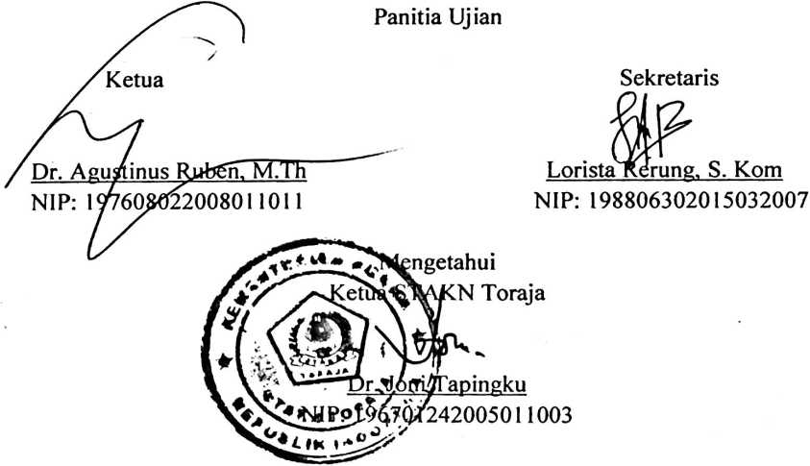
iv


ABSTRACT
ARNAMAYALLIS: 1020154150, in 2019. Compiled a thesis entitled
“Pattem of assistance for adolescents aged 14-17 years who have deviant behavior
in the Beringin Viliage Bungadidi Village, North Luwu. This paper aims to
describe the Pattem of assistance for adolescents aged 14-17 years who have
deviant behavior in the Beringin Village Bungadidi Village, North Luwu.
This research departs from the problem of the existence of adolescent
behaviors which are considered not supposed to be done or can be said to be
deviant. Behavioral deviations by some adolescents aged 14-17 years such as
getting drunk, smoking, even playing gambling. From this is said that some
adolescents often fail to pass transition period from small children to adults
because of the lack of self-defense against the influence of the outside world that
is not good. As the first and foremost educator for children in the family, parents
must educate their children so they can abandon their bad behavior. The
application of parental education to children can be done by paying attention to
parenting and providing assistance to adolescents who have problems. It is
intended to change bad behavior in a positive direction.
In this study, the method used is a qualitative method, where the author
conducts literature studies and field research (observation and interviews) to
obtain data.
At the end of the study, the authors concluded that parents were more
dominant applying authoritarian parenting to children, while other parents applied
permissive parenting, so that it also influenced adolescent behavior. Based on the
theory and results of the research, the application of democratic parenting for
adolescents who have deviant behavior is considered more appropriate, where in
the application of this parenting there is good communication, cooperation, and
involving children in decision making. As parents, it is very necessary to also
provide assistance to adolescents who have problems by applying the
behavioristic approach model or behavior therapy and behavior change. The
assistance aims to help adolescents change their bad behavior into positive
behavior.
Keywords: Accompaniment pattem, deviant behavior.
v

