Skripsi

by Yosi 2019

Emission date: 26-Jul-2019 08:26AM (UTC-0500) ibmission ID: 1155158004 <e name: **Yosi.pdf** (357.87K)

3rd count: 8112 naracter count: 52120

Skripsi

|  |  |
| --- | --- |
| ORIGINALITY REPORT | |
| 15% 15% 1 % | 7% |
| **SSIMILARITY INDEX INTERNET SOURCES PUBLICATIONS** | **STUDENT PAPERS** |
| RPRIMARY SOURCES | |
| 1 kumpulanmakalah01.blogspot.com  j **Internet Source** | 2% |
| 7 digilib.uinsby.ac.id  **Internet Source** | 2% |
| 1 barawati.blogspot.com O  J **Internet Source** “■ '° | |
| r 1 anzdoc.com  i **Internet Source** | 1 % |
| i perkembangan45.blogspot.co.id  **-**J **Internet Source** | 1 % |
| 7 es.scribd.com  **-—-J** **Internet Source** | 1 % |
| 1 Submitted to iGroup  **- • \*** **Student Paper** | 1 % |
| i jerryns-ilmukeperawatanj-ry.blogspot.com  **A** **Internet Source** | 1 % |

library.walisongo.ac.id

Internet Source

Exclude quotes Off Exclude matches <1%

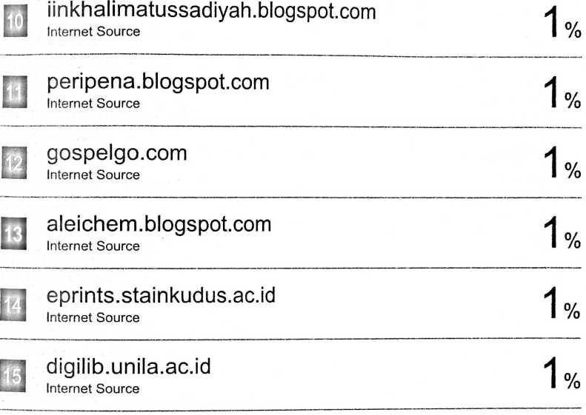

Exclude bibliography On