“afar Jena.

§ket Penelitiaan

**•***«»*+

**Oleh: Yani Dat**u Ra^;> **a. . .**

. . ~ !Ii^!«SWAW^rajj

etunjuk Pengisian Soal: i.

a. Bacalah soal secara teliti, beri tanda silang 00 ■ ,

SS : Apabila Anda SANGAT SETUJU

S : Apabila Anda SETUJU

r : Apabila anda RAGU-RAGU

TS : Apabila Anda TIDAK SETUJU

STS : Apabila Anda SANGAT TIDAK SETUJU

**b. Data Responden**

1. Jenis Kelamin

( ) Laki-laki ( ) Perempuan

2. Nilai

( ) Peringkat umum (1-3)

( ) Peringkat pertama sampai ketiga ( ) Peringkat keempat sampai sepuluh ( ) peringkat kesebelas dan setererusnya

Status tempat tinggal

**( )Kost** ( ) Menumpang

( ) dengan orang tua kandung

|  |  |  |  |  |  |  |  |
| --- | --- | --- | --- | --- | --- | --- | --- |
| C. Daftar pe  fi<0- | rtanyaan  Sub Indikator ^enrmaan | | | | | |  |
| 'u  Tb | “ ” PS,“<i,a -*  Saat ini suara | SS | S | R | TS | STS |  |
|  |  |  |  |  |
| 'U | -jaya |  |  |  |  |  |
|  | Saya merasa |  |  |  |  |  |
| 3.a | Saya merasa gelisa |  |  |  |  |  |
| berubah, (perempuan) payudara saya |  |  |  |  |  |
| 3.b | Sayu merasa malu (bemvanvi hprhjcam a; j ~ —— |
| suara saya berubah ^ teman) ketika |  |  |  |  |
| 1. | Bulu-bulu di tempat kemaluan savn oHih r7!:— |
| r ^UU<U1 ^ya suaan mulai tumbuh |  |  |  |  |  |
| 5. | Saya tidak nyaman ketika hnln-hni» \ra i. _ : |  |
| j j ™ tttmut uinu-Duiu kemaluan sava tumbuh |  |  |  |  |  |
| 6. | Saya tidak senang meUteTbid^Ihjk^ |  |  |  |  |  |
| "7. |  |
| ■> dUAUyd pcUumbuhan bulu-bulu kemaluan. |  |  |  |  |  |
| 8. | Saat ini wajah saya sudah ditumbuhi ierawat |  |  |  |  |  |
| 9. | Saya tidak nyaman ketika jerawat sudah mulai tumbuh |  |  |  |  |  |
| 10. | Saya lakui wajah saya tidak akan mulus lagi ketika jerawat sudah tumbuh |  |  |  |  |  |
| ll.a | baya tidak nyaman ketika teijadi menstruasi (perempuan) |  |  |  |  |  |
| Il.b | Saya merasa tidak nyaman ketika teijadi mimpi basah (laki-laki) |  |  |  |  |  |
| 12.a | Saya dewasa ketika teijadi menstruasi (perempuan) |  |  |  |  |  |
| 12.b | Saya dewasa ketika teijadi mimpi basah (laki-laki) |  |  |  |  |  |
| 13.a | Emosi saya tidak stabil ketika terjadi menstruasi (perempuan) |  |  |  |  |  |
| 13.b | Saya malu ketika teijadi mimpi basah (laki-laki) |  |  |  |  |  |
| 14. | Badan saya terasa lemas ketika sedang mengalami menstruasi |  |  |  |  |  |
| 15. | Saat ini pertumbuhan badan saya terasa sangat cepat |  |  |  |  |  |
| 16. | Saya sedih atau cepat marah ketika ada masalah |  |  |  |  |  |
| 17. | Saya takut ketika tidak mengerjakan tugas |  |  |  |  |  |
| 18. | Sava kuatir atau takut tidak akan mendapat nilai yang baik |  |  |  |  |  |
| 19. | Dinerhatikan mim adalah harapan saya |  |  |  |  |  |
| 20. | Sava suka bemenamnilan baik supaya terlihat cantik/ganteng |  |  |  |  |  |
| 21. |  |  |  |  |  |  |
|  |  |  |  |  |  |
| 22. | Saya malas belajar di rumah |
| 23. | Sya malas mengerjakan pekerjaan rumah .— |  |  |  |  |  |
| ~24T~ | Saya malas mengerjakan PR (Tugas) |  |  |  |  |  |
| _25. | .. .. ™^mhprik-an meas terlalu banyak |  |  |  |  |  |
| Saya tidak suka ketika guru memoemau iuga |  |  |  |  |  |
| ~267 |  |
| baya sering ainuKuni Karena iucieuigB^ f |  |  |  |  |  |
| 27. | 1 Saya suka cerita atau gosip ketika sedang j |  |  |  |  |
|  | Sering kali sava tidak mampu mengikuUj^d^^ |  |  |  |  |  |
| 29. | Tugas saya sering tertumpuk karena mal |  |  |  |  |  |
| 30. | Saya bosan dengan tugas yang banyak — |  |  |  |  |  |
| 31  ~32~ | Saya sering bosan belajar .—- |  |  |  |  |  |
|  | Saya sudah mulai menyukai lawanjeuis— |  |  |  |  |  |
| 33 | Saya sudah memiliki ketasm |  |  |  |  |  |
| 34 | — |  |  |  |  |  |
| 35 | ~~Sa^^MUte^^ |  |  |  |  |  |
| 36 | Saya senang berkunjung ke rumah_kek^_—__ |  |  |  |  |  |
| 37 | Saya sering bermimpi bertemu dengan | | | | | |  |

|  |  |  |  |  |  |  |
| --- | --- | --- | --- | --- | --- | --- |
|  | Saya suka pa r  yang ganteng W0K |  |  |  |  |  |
|  | Saya tidak pemah menunda^^aF^®^^ |  |  |  |  |  |
|  | Saya tidak menunda waktu untuk bekj^dlT^r |  |  |  |  |  |
|  | baya su&a k-cui^ guiu memberikan tugas kelompok |  |  |  |  |  |
|  | Saya lebih senang bekerja sam^aaiTtei^kite^v |  |  |  |  |  |
| it"’ | Ketika ada mgas kelompcdc saya"^5Tfc55iSte^5Sto5sH teman dalam mengenakannya. |  |  |  |  |  |
| jhT^l__ | Saya selalu mengeijakan tugas dengan tepat |  |  |  |  |  |
| '&Z-— | Saya selalu mengeijakan pekeijaan ramah dengan baik dan henar |  |  |  |  |  |
| 46 | Saya selalu membaca buku-buku pelajaran |  |  |  |  |  |
| -Tf Nilai saya selalu meningkat dap semester | |  |  |  |  |  |

Lampiran

Tabel

Aspek 1: Pembahan secara fisik

|  |  |  |  |  |  |  |  |  |  |  |  |  |  |  |  |  |  |
| --- | --- | --- | --- | --- | --- | --- | --- | --- | --- | --- | --- | --- | --- | --- | --- | --- | --- |
| No.  Responden |  |  |  |  | | | | | | | | | | | | | |
| i | 2 | 3 | 4 | 5 | 6  4  3 | 7  2  2 | 8 | 9 | 10 |  |  |  | | | Jumlah  56 | Kategori  T |
| 1   1. 3 | 5  3  4 | 1. 2   4 | 5  5  5 | 4  1  2 | 5  2 | 11 | 12  5  4 | 13  3  ? | 14  2  1 | 15  5  C |
| 1  3 | 5  3 | 4  3 | 3  5 |
| 4  5 | 4  4  4 | 5  3  3 | 5  5  C | 4  4 | 3  5 | 3  5  5 | 3   1. 3 | 4  4  4 | 1  1  4 | 4  4  4 | 3   1. 4 | 4  4  3 | 4  4  2 | 3  5  5 | 3   1. 4   4 | 44  51  62  cq | S  S  T |
| 7 | 2 | 3 | 4 | 4  5 | 5  3 | 5  4  4 | 3   1. 4 | 4 | 4 | 4 | 4 | 4 | 5 | 4 | 3 | 61 | 1  T |
| 8 | 4 | 2 | 4 | 2 | 4 | H- | 3 | 2 | b | 3  4 | 5  C | 4 | 2 | 53 | S |
| 2 | 4 | 3 | 3 |
| 9 | S | 2 | 5 | 4 | 4 | 4  3 | 5 | 3 | 3 | 4 | 5 | 5 | 3 | 3  5 | 5  3 | 55  60 | T |
| 10 | 4 | 4 | 4 | 2 | 2 | T |
| 3 | 2 | 5 | 5 |
| 5 | 5 | 5 | 3 | 5 | 57 | J |
| 11 | 4 | 4 | 2 | 3 | 3 | 1 | 2 | 3 | 5 | 4 | 4 | 4 | 3 | 3 | 5 | 50 | s |
| 12 | b | b | b | 3 | 4 | 5 | 4 | 3 | 4 | 3 | 5 | 5 | 4 | S | 5 | 65 | T |
| 13 | 3 | b | b | 5 | 5 | 2 | 1 | 1 | 2 | 5 | 3 | 3 | 5 | 5 | 5 | 55 | T |
| 14 | b | 4 | 4 | 5 | 2 | 5 | 3 | 2 | 3 | 5 | 3 | 4 | 5 | 3 | 5 | 58 | T |
| 15 | 5 | 4 | 4 | 5 | 2 | 3 | 5 | 5 | 5 | 5 | 5 | 5 | 5 | 2 | 5 | 65 | T |
| 16 | 4 | 2 | 2 | 1 | 1 | 2 | 2 | 3 | 4 | 4 | 4 | 4 | 5 | 5 | 5 | 48 | S |
| 17 | 5 | 5 | 1 | 5 | 5 | 1 | 5 | 2 | 1 | 5 | 5 | 5 | 5 | 5 | 5 | 60 | T |
| 18 | 5 | 5 | 5 | 5 | 1 | 5 | 5 | 1 | 4 | 1 | 5 | 5 | 5 | 5 | 1 | 58 | T |
| 19 | 5 | 5 | 5 | 5 | 2 | 5 | 5 | 5 | 3 | 3 | 5 | 5 | 5 | 5 | 5 | 68 | ST |
| 20 | 5 | 4 | 3 | 4 | 4 | 5 | 5 | 5 | 5 | 3 | 4 | 4 | 4 | 3 | 4 | 62 | T |
| 21 | 5 | 5 | 5 | 4 | 5 | 5 | 4 | 4 | 5 | 5 | 5 | 1 | 5 | 5 | 5 | 68 | ST |
| 22 | 5 | 4 | 4 | 4 | 4 | 4 | 4 | 4 | 4 | 4 | 3 | 5 | 3 | 5 | 5 | 62 | T |
| 23 | 5 | 3 | 5 | 3 | 5 | 4 | 5 | 2 | 3 | 4 | 4 | 4 | 4 | 5 | 5 | 61 | T |
| 24 | 4 | 4 | 4 | 4 | 3 | 3 | 3 | 4 | 4 | 5 | 5 | 4 | 3 | 5 | 5 | 60 | T |
| 25 | 5 | 5 | 5 | 4 | 4 | 4 | 3 | 3 | 3 | 3 | 3 | 3 | 4 | 4 | 4 | 57 | T |
| 26 | 3 | 3 | 4 | 4 | 4 | 2 | 2 | 5 | 5 | 5 | 3 | 5 | 5 | 5 | 5 | 60 | T |
| 27 | 5 | 4 | 4 | 3 | 5 | 4 | 5 | 3 | 5 | 2 | 5 | 3 | 4 | 5 | 5 | 62 | T |
| 28 | 5 | 4 | 4 | 5 | 5 | 3 | 2 | 5 | 5 | 5 | 5 | 4 | 4 | 4 | 4 | 64 | T |
| 29 | 5 | 4 | 5 | 4 | 3 | 2 | 4 | 5 | 3 | 4 | 3 | 5 | 5 | 4 | 3 | 59 | T |
| 30 | 3 | 3 | 3 | 3 | 2 | 2 | 3 | 4 | 4 | 4 | 3 | 3 | 5 | 5 | b | 52 | S |
| 5 | 4 | 5 | 5 | 3 | 2 | 4 | 59 | T |
| 31 | 3 | 4 | 2 | 4 | 4 | 4 | 5 | 5 |
| 32 | 3 | 4 | 3 | 4 | S | 3 | 4 | 2 | 5 | 5 | 3 | 5 | 5 | 3 | 2 | 56 | T |
| 33 | 4 | 4 | 4 | 3 | 3 | 5 | 2 | 3 | 4 | 3 | 2 | 4 | 4 | b | 5 | 55 | T |
| 34 | 3 | 4 | 4 | 3 | 5 | 4 | 5 | 3 | 3 | 5 | 4 | 2 | 4 | 5 | 5  c | 6? | I  j |
| 35 | 4 | 4 | 4 | 3 | 4 | 4 | 3   1. 3 | 3 | 4 | 4 | b | b  4 | 5  4 | 3  4 | 3 | 59 | T |
|  | C | 5 | S |
| 36 | 3 | 3 | 2 | 4 | 4 | b | 1. ~4   3  3   1. 3 | D  /1 | 3 | 4 | 3 | 3 | 4 | S | 52 | S |
| 37 | 3 | 3 | 4 | 4 | 3 | 2 | 4  5  A | 5 | 4 | 5 | 5 | 5 | 4 | 62 | T |
| 38 | 2 | 3 | 3 | 4 | 4 | 5_ | 5 | 5 | 5 | 64 | T |
| 4 | 5 | 5 | 5 |
| 39 | 4 | 4 | 3 | 3 | 5 | 4 | 5  4_  4 |  | 3 | 3 | 4 | 5 | 5 | 5 | 63 | T |
| 40 | 3 | 4 | 4 | 5 | 3 | _5_  5 | D  3 | 5 | 5 | 5 | 4 | 4 | 4  5 | 65  63 | T  T |
| *11  L | 4  4 | 4  4 | 5  3 | 5  3 | | . -3} j  4_ | 4_ | 4_ | 5^ | 5_ | 5 | b | 4 | i |  |  |  |  |

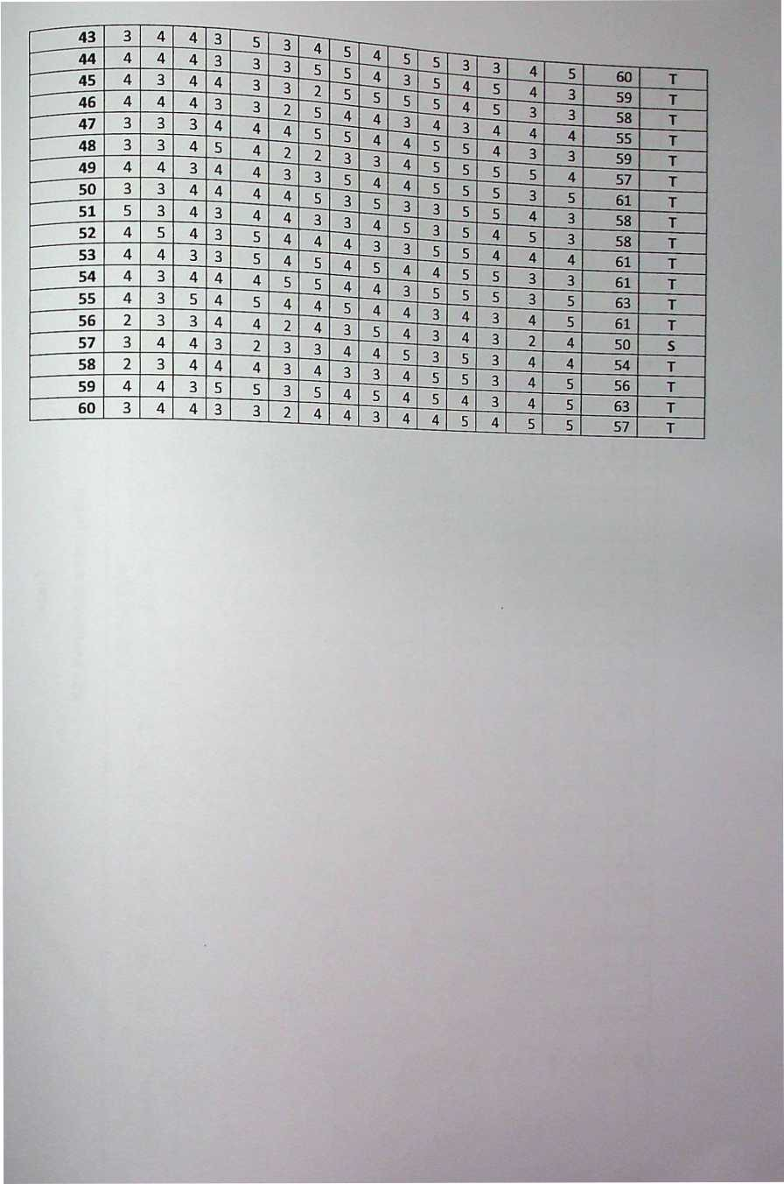

X2 : Perubahan secara psikis

|  |  |  |  |  |  |  |  |  |  |  |  |  |  |  |  |  |  |  |  |  |  |  |  |  |  |  |  |  |
| --- | --- | --- | --- | --- | --- | --- | --- | --- | --- | --- | --- | --- | --- | --- | --- | --- | --- | --- | --- | --- | --- | --- | --- | --- | --- | --- | --- | --- |
| Re |  | Item dan Opsi | | | | | | | | | | | | | | | | | | | | | | | |  | ah | Kategori |
| nu.  sponden | 16 | 17 | 18 | 19 | 20 | 21 | 22 | 23 | 24 | 25 | 26 | 27 | 28 | 29 | 30 | 31 | 32 | 33 | 34 | 35 | 36 | | 3' | 31 | 3 jum |
| 1 | | 5 | 4 | 3 | 5 | 5 | 5 | 5 | 2 | 1 | 2 | 5 | 1 | 2 | 1 | 1 | 3 | 4 | 1 | 2 | 3 | 3 | |  |  | 73 | | s |
| 2 | | 2 | 4 | 1 | 3 | 4 | 4 | 4 | 3 | 5 | 5 | 1 | 1 | 1 | 3 | 3 | 2 | 2 | 2 | 3 | 2 | 5 | |  |  | 70 | | s |
| 3 | | 5 | 3 | 4 | 5 | 5 | 5 | 4 | 4 | 4 | 3 | 2 | 3 | 2 | 2 | 4 | 2 | 3 | 2 | 1 | 5 | 3 | |  | ; | 75 | | s |
| 4 1 1 | | | 2 | 4 | 4 | 5 | 4 | 1 | 3 | 3 | 1 | 5 | 5 | 5 | 5 | 2 | 4 | 4 | 3 | 5 | 4 | 4 | | 5 | 3 | 82 | | T |
| 5 1 4 | | | 4 | 4 | 4 | 4 | 4 | 3 | 2 | 2 | 3 | 3 | 4 | 4 | 4 | 3 | 3 | 5 | 1 | 4 | 2 | 3 | | 3 | 4 | 77 | | 5 |
| 6 | | 4 | 5 5 | | | 4 | 4 | 4 | 3 | 2 | 2 | 3 | 3 | 3 | 3 | 4 | 3 | 5 | 5 | 1 | 1 | 3 | 3 | | 4 | 4 | 78 | | S |
| 1 7 | | 4 | 3 | | 3 | 5 | 3 | 4 | | 3 | 5 | 3 | 4 | 5 | 4 | 4 | 3 | 4 | 5 | 4 | 2 | 5 | 2 | 5 | | 3 | 4 | 87 | | T |
| 1 8 1 | | 2 | 4 | 4I 3 | | 4 | 4 | 5 | 5 | 5 | 5 | 4 | 4 | 2 | 4 | 4 | 3 | 3 | 3 | 3 | 3 | 3 | | 5 | 5 | 87 | | T |
| L | 9 1 5 | | 5 | 3 | 4 | 4 | 2 | 4 | 3 | 3 | 3 | 1 | 3 | 4 | 4 | 4 | 1 | 1 | 4 | 5 | 3 | 5 4 | | | 3 | 78 S | | |
| L | 10 | 5 | 2 | 5 | 5 | 5 | 5 | 3 | 3 | 3 | 5 | 2 | 5 | 5 | 5 | 5 | 5 | 2 | 2 | 3 | 3 | 3 2 | | | 2 | 85 | T | |
| L | 11 | 5 | 5 | 5 | 3 | 5 | 4 | 3 | 3 | 3 | 4 | 5 | 3 | 3 | 5 | 4 | 4 | 3 | 2 | 2 | 2 | 3 3 | | | 3 | 82 | fri | |
|  | 12 | 4 | i — | 5 | 1 | 4 | 3 | 3 | 5 | 5 | 5 | 3 | 4 | 3 | 3 | 3 | 3 | 3 | 4 | 3 | 2 | S 5 | | | 3 | 80 | ' T | |
|  | 13 | 5 | 5 | 5 | 5 | 3 | 5 | 3 | 5 | 5 | 5 | 5 | 3 | 4 | 4 | 4 | 4 | 4 | 3 | 1 | 2 | 5 | 5 | | 2 | 92 | T | |
|  | 14 | 2 | 4 | 5 | 4 | 5 | 5 | 4 | 3 | 4 | 3 | 4 | 3 | 5 | 3 | 5 | 4 | 4 | 5 | 3 | 2 | 3 | 5 | | 4 | 89 | T | |
| 15 5 | | 5 | 5 | 5 | 5 | 5 | 2 | 1 | 2 | 2 | 3 | 3 | 3 | 3 | 3 | 5 | 3 | 3 | 3 | 2 | 3 | 2 5 | | | 78 | S | |
| 16 | 3 | 3 | 3 | 2 | 2 | 2 | 2 | 2 | 5 | 4 | 3 | 4 | 4 | 5 | 5 | 5 | 5 | 5 | 3 | 3 | 3 | 4 | | 2 | 79 S | | |
| 17 | S | 5 | 5 | 5 | 5 | 4 | 1 | 5 | 3 | 4 | 4 | 3 | 4 | 3 | 3 | 3 | 5 | 5 | 3 | 5 | 1 | 5 | | 1 | 87 | T | |
| 1£ | 5 | 5 | 5 | 5 | 5 | 5 | 4 | 4 | 3 | 4 | 1 | 1 | 4 | 5 | 4 | 4 | 4 | 5 | 5 | 2 | 2 | 4 | | 4 | 90 | T | |
| 1‘ | 3 | 5 | 5 | 5 | 5 | 5 | 3 | 3 | 3 | 3 | 3 | 4 | 5 | 2 | 3 | 4 | 4 | 3 | 3 | 4 | 3 | 4 | | 4 | 86 | T | |
| 2( | ) E | 5 | 5 | 5 | 5 | 3 | 2 | 2 | 4 | 3 | 4 | 2 | 3 | 3 | 3 | 2 | 5 | 3 | 3 | 3 | 3 | 3 | | 4 | 80 | T | |
| 2 | 1 | E | 4 | 5 | 3 | 1 | 5 | 5 | 5 | 5 | 3 | 5 | 3 | 3 | 1 | 5 | 3 | 3 | 5 | 5 | 5 | 3 | | 3 | 90 | T | |
| 2 | 2 |  | **i** | 2 | 4 | 5 | 5 | 5 | 3 | 3 | 3 | 4 | 4 | 5 | 5 | 3 | 4 | 5 | 5 | 5 | 4 | 5 | | 5 | 97 | T | |
| 2 | 3 |  |  | 4 | 4 | 4 | 4 | 4 | 4 | 4 | 4 | 3 | 3 | 5 | 5 | 5 | 4 | 5 | 4 | 5 | 4 | 4 | | 5 | 93 | T | |

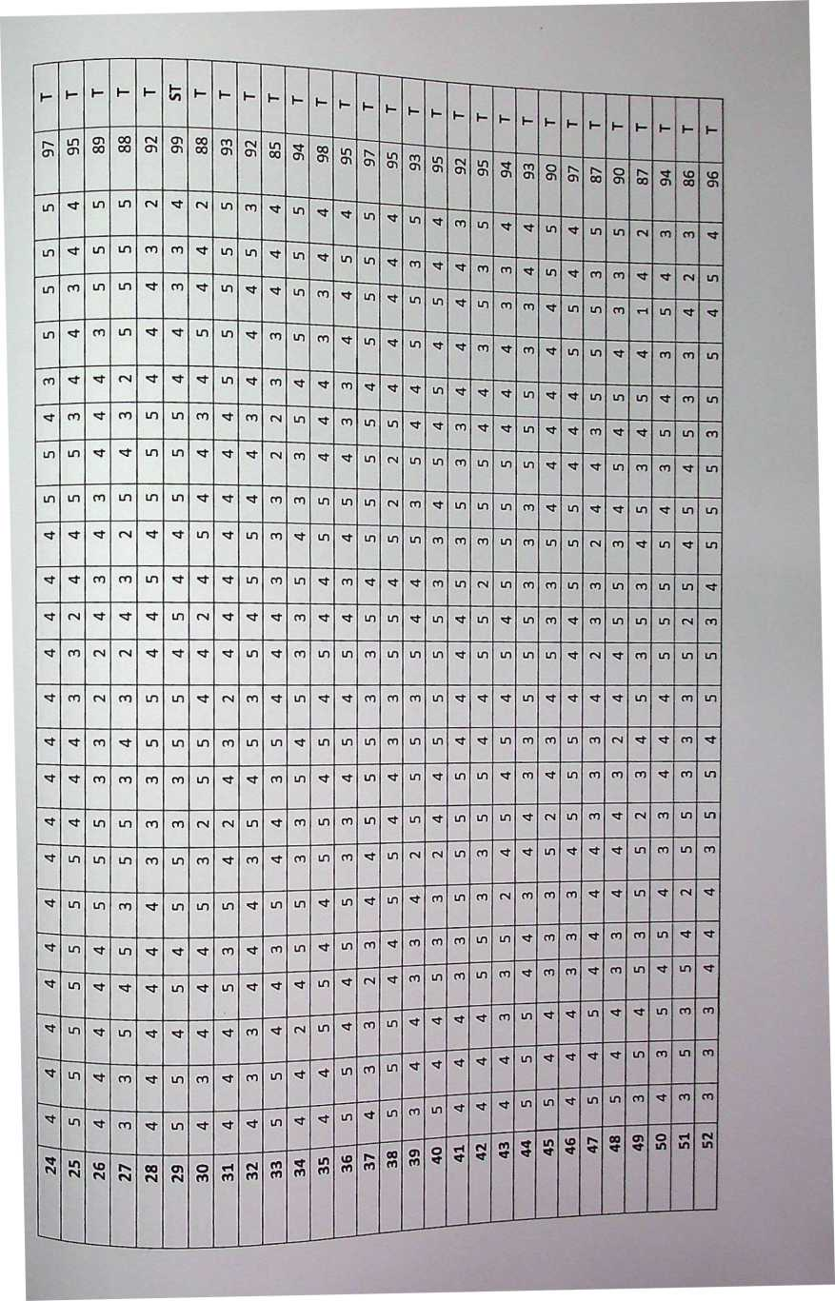

|  |  |  |  |  |  |  |  |
| --- | --- | --- | --- | --- | --- | --- | --- |
| **h\*** | **h\*** | **h-** | **h-** | **h-** | **1-** | **h** | **h-** |
|  | **CO** | **fN** | **00** | **fN** | **CO** | **c** | **CT»** |
| **CJl** | **CO** | **C** | **UI** | oc | O' | cr | **00** |
|  | **LD** |  | **LD** | **fN** | in |  | **m** |
| **m** | **m** |  | **LO** | **m** | in | co | in |
| in | **LH** | **LD** |  |  | co | co |  |
|  | **m** | **CO** |  | **(N** | **m** |  |  |
| **m** | **LO** | **LD** | **LD** | **LO** | **m** | in | co |
| **fN** |  | **UO** | **LO** | co | co |  |  |
|  | m | **CO** | **LO** |  |  |  |  |
| **m** | **c**t | **'3'** | **CO** | **fN** |  | **m** |  |
| **LD** | **\*=f** |  |  | **LD** |  | in |  |
|  | **<3-** | **LD** | **LO** | **fN** | co | **<3-** | cn |
| co | **m** |  | **LO** |  |  | co | co |
|  | **fN** | **CO** | **■^t** |  | in | co | **<N** |
| **fN** | **•'t** | **CO** | **LD** | co |  | in |  |
| **m** | **m** |  |  | **UI** | **CO** | in | co |
| **LO** |  | **LD** | co | **fN** | in | in |  |
|  | **m** | **CO** | **CO** | **LT)** | in | in |  |
| **LO** | in |  | **CO** | **fN** |  |  | **CO** |
| co | **<sf-** | **CO** |  |  |  | **fN** | in |
| **LO** | **fN** | **LO** | **LH** | **CO** | **fN** | **CO** |  |
| **m** | **CO** | **LD** |  | cn | **CO** | **CO** | in |
| **m** | **CO** |  | **m** |  | in | **CO** | in |
|  |  | **CO** | co |  |  |  | co |
| **U~)** |  |  | **LH** | **LD** |  |  |  |
| **m**  in | **\*fr**  **m** | **m** | **1D** | **IN** | **00** | **cn** | **o** |
| **m** | **m** | **m** | **in** | **in**  _ | **ID** |