DAFTAR PUSTAKA
- Alkitab, Kamus
Alkitab
- Perjanjian lama dan perjanjian baru, Jakarta: LAI
Alkitab Penuntun
2009, Hidup Dalam Berkelimpahan. (Malang: Gandum Mas)
Depertemen Pendidikan Nasional
- Kamus Besar Bahasa Indonesia, (Jakarta: Balai Pustaka)
- Buku Karangan
Abineno, J.L.CH
2009, Tafsiran Alkitab Surat Efesus. Jakarta: BPK Gunung Mulia.
Aswar Saifuddin,
2003, Reliabilitas dan Validitas. Yogyakarta: Pustaka Pelajar
Cremers, Agus
1995, Tahap-Tahap Perkembangan Kepercayaan Menurut James
W. Fowler, Yogyakarta: Penerbis Kanasius.
Dobron, Janes
1993, Masalah membesarkan Anak, Jakarta: Anggota IKPAI
Elieser Sasmoko
- Metode Penelitian, Pengukuran dan Analisis Data.
Tangerang: Harvest Internasional Theological Seinary.

Elisabeth
2009, Pembelajaran PAK pada usia dini, Jakarta: Bina Media
Informatika.
Faizi, Mastru
2012, Mendidik anak ala pendidikan orang hebat, Jogyakarta:
Falshbooks
Gunarsa dan Yulia
- Psikologi perkembangan anak dan remaja, Jakarta: BPK
Gunun Mulia.
Hadi Sutrisno,
2002, Metodologi Research 2. Jakarta: Fakultas Psikologi
Universitas Gaja Mada.
Hariwijaya dan Tri ton
Pedoman penulisan ilmiah proposal dan skripsi,
Y ogyakarta: Orisha
Hearth,Stenley
2005, Teologi Pendidikan, Bandung: Yayasan Kalam Hidup.
Homrighausen, Enklaar
- Pendidikan Agama Kristen, Jakarta: BPK Gunung Mulia.

Iskandar,
2009, Metodologi Penelitian dan Sosial: Kuantitatif dan kualitatif.
Jakarta: Gaung Persadan Press.
Ismail, Andar
- Selamat Menabur, Jakarta: BPK Gunung Mulia
Isnanto, Totok
2013, Mengasuh anak dengan bijaksana. Direktorat pendidikan
anak usia dini
Lee,Howard B.,
2005, Foundations Of Behavioral Research. Fouth Worth: Harcout
College Publisher
J.I. Cairs
2003, Tafsiran Kitab Ulangan Pasal 1-11. Jakarta: bpk Gunung
Mulia
Lilik,Paulus
- Prinsip dan praktek pendidikan Agama Kristen. Yogyakarta:
ANDI.
M, Rohina
2012, Mengembangkan Karakter Anak secara efektik di sekolah
dan di rumah, Yogyakarta: PT Pusaka Insan Madan.

Nainggolan, JM
- PAK dalam masyarakat majemuk, Bandung: Bina Media
Informasi.
Nainggolan, JM
2008, Strategi pendidikan warga gereja, Jabar: Generasi Info
Media.
Nasir, Moh
1983, Metodologi Penelitian, Jakarta: Ghalia Indonesia.
Santosa Gempur,
- Metodologi Penelitian Kuantitatif dan Kualitatif. Jakarta:
Prestasi Pustaka
Subagyo Andreas
2004, Pengantar riset kuantitatif dan kualitatif, Bandung: Yayasan
Kalam Hidup.
Sugiyono
2009, Metode penelitian pendidikan, Bandung: Alfabeta
1999, Statistika Untuk Penelitian, Bandung: Alfabeta.

- Lain-lain
Tim Penyusun
2011, Buku sejarah Berdirinya Jemaat Ranteba 'tan. Mengkendek: BPMJ
Ranteba’tan
http://ww.telaga.org/audi/mengajar anak berdoa
http://melyloelhabox.blogsot.com/2013/05/meh
http://asmbektim.tripod.com/renung/GSM01.htm

KEMENTERIAN AGAMA
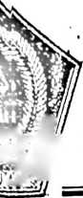
inmor
faat
nnpiran
dl
SEKOLAH TINGGI AGAMA KRISTEN NEGERI

(STAKN) TORAJA
Si '
grgw Jl. Poros Makale-Makassar Km. 11,5; Tlp/Fax. (0423)24620,24064 Batukila
.f W Mengkendek Tana Toraja Email; stakntoraja@yahoo.com
: Stk.05.1/PP.00.9/1358/2014
: Biasa
18 Agustus 2014
: Permohonan Penelitian
Yth. BPM GT Jemaat Ranteba’tan
Di -
Tempat
Dengan hormat,
Dalam rangka menyelesaikan studi SI di STAKN Toraja, maka perlu
diadakan penelitian lapangan. Untuk itu kami mohon kesediaan Bapak/Ibu
untuk memberikan izin penelitian kepada:
NAMA : Milka
N1RM ' : 20092916
Jurusan : Pendidikan Agama Kristen
Alamat : Mengkendek
yang akan meneliti tentang : “Pengaruh Peranan Orangtua Dalam Menyampaikan
iCerita Isi Alkitab Terhadap Proses Pertumbuhan Spiritualitas Anak Umur 2-12 Tahun
di Gereja Toraja Jemaat Ranteba’tan”.
Demikian, atas perhatian dan kerjasama yang baik, kami ucapkan terima
kasih.

sKKetua,
T$§almpn Pamantung, M.Th
4/NIP. /97607272006041001

®
GEREJA TORAJA
(Anggota PGI)
KLASIS SILLANAN
BADAN PEKERJA MAJELIS JEMAAT RANTEBA’TAN
Poros Mebaft-'Buntu km 2 Lembang Sidanan Kec. (jandasiCTana. Toraja
Surat Keterangan
Yang bertandatangan di bawah ini Majelis Gereja Jemaat Ranteba’tan menerangkan
hiwa :
Nama : Milka
N i r m : 2092916
Jurusan : PAK STAKN Tana Toraja
naar, telah melaksanakan penelitian skripsi dengan judul:
MGARUH PERANAN ORANG TUA DALAM MENYAMPAIKAN CERITA ISI ALKITAB
RIHADAP PROSES PERTUMBUHAN SPIRITUALITAS ANAK UMUR 02-12 TAHUN
\
1 (GEREJA TORAJA JEMAAT RANTEBA’TAN. Penelitian dilaksanakan dari tanggal 18-23
;uistus2014.
Demikian surat keterangan ini dibuat sesuai dengan yang sebenarnya dan dipergunakan
aggaimana mestinya.
Ranteba’tan, 02 September 2014
BPM Jerpaat'RanT^’tan
tua, /
v \
:kretaris,

/
i
Pdt. Peri
s-F|
nna Mika'
S;Th
. i' S/
ncong PaVpmboan

No | Peran Orangtua Dalam  Menyampaikan Cerita Isi Alkitab | Selalu | Sering | Kadang-  Kadang | Hampir  Tidak  Pernah | Tidak  Pernah
 | Memahami Isi Alkitab
1 | Saya membaca, mempelajari isi  Alkitab, baik PL maupun PB
2 | Saya senang menceritakan peristiwa-  peristiwa yang teijadi dalam Alkitab  kepada anak
3 | Setiap waktu, saya bercerita tentang  isi Alkitab kepada anak
4 | Saya berulang-ulang bercerita  kepada anak tentang isi Alkitab
Menghayati Agama Yang
Dianutnya
5 | Saya mempercayakan seluruh  kehidupan kepada Tuhan
6 | Bertindak sesuai dengan ajaran  agama
7 | Membekali anak dengan ajaran  agama yang dianut melalui metode  bercerita
Konsisten Dalam Mendidik dan
Mengajar anak
8 | Ayah dan ibu bekerja sama  mendidik dan mengajar anak
9 | Memberi hukuman kepada anak saat  melakukan kesalahan
10 | Memberi pujian ketika melakukan  sebuah kebaikan
 | Memberikan Contoh Lewat Sikap
11 | Ayah bersikap baik kepada ibu dan  sebaliknya
12 | saya mengasihi semua keluarga dan  orang yang ada di sekitar
13 | Saya rajin mengikuti ibadah, baik di  gereja maupun ibadah rumah tangga
A. Petunjuk pengisian
• Bacalah dengan saksama setiap pernyataan yang ada, kemudian beri tanda (^)
pada kolom selalu, sering, kadan-kadang, tidak pernah.
• Apabila ada tanda (^) yang akan diganti, gunakan tanda (x)
B. Data Responden (boleh tidak dicantumkan apabila ada alasan tertentu)
Nama :
Daftar Penilaian Proses Pertumbuhan Spritualitas Anak umur 2-12 Tahun di Gereja
Toraja Jemaat Ranteba’tan

No | Proses Pertumbuhan  Spiritualitas Anak Umur 2-  12 Tabun di Gereja Toraja  Jemaat Ranteba’tan | Selalu | Sering | Kadang-  Kadang | Hampir  Tidak  Pernah | Tidak  Pernah
Rutin Melaksanakan Ibadah
Keluarga
1 | Rutin melaksanaku ibadah  dalam keluarga
2 | Anak terlibat dalam ibadah  yang dilaksanakan dalam  keluarga
3 | Anak rajin mengikuti ibadah  keluarga
 | Mengajar Berdoa
4 | Anak terlibat ketika orangtua  berdoa
5 | Anak berdoa sebelum  melakukan sesuatu
6 | Anak rajin mendoakan  oranglain
7 | Anak menghafal doa Bapa  Kami
 | Membaca Firman Tuhan
8 | Anak terlibat ketika saya  membaca Alkitab
9 | Anak membiasakan diri untuk  membaca Alkitab
10 | Anak senang mendengar cerita  Alkitab
11 | Anak senang menceritakan  ulang cerita Alkitab
12 | anak keberatan ketika  orangtua tidak menceritakan  isi Alkitab
Membentuk Sikap Anak
(Jujur dan Disiplin)
13 | Anak berkata jujur
14 | Rajin mengikuti ibadah, baik  di rumah maupun di gereja
15 | Tekun mengeijakan pekeijaan  rumah

 | total | p1 | -P.²— | _21_ | —P⁴ | P⁵ | p6 | P⁷ | p8 | p9 | p10 | P¹¹ | P1  2 | p13
Pearson |  |  |  |  |  |  |  |  |  |  |  |  | .6 | .539
Correlation | 1 | .683" | .649" | .677” | .658” | .562" | .399* | .655" | .452 | .329 | .702" | .644” | 96  M | .539
Sig. (2-  tailed) |  | .000 | .000 | .000 | .000 | .001 | .029 | .000 | .012 | .076 | .000 | .000 | .0  00 | .002
N | 30 | 30 | 30 | 30 | 30 | 30 | 30 | 30 | 30 | 30 | 30 | 30 | 30 | 30
Pearson |  |  |  |  |  |  |  |  |  |  |  |  | .6
Correlation | .683" | 1 | .437* | .388* | .313 | .318 | .167 | .352 | .437* | .294 | .639" | .313 | 39 | .156
Sig. (2-  tailed) | .000 |  | .016 | .034 | .092 | .087 | .379 | .056 | .016 | .115 | .000 | .092 | .0  00 | .410
N | 30 | 30 | 30 | 30 | 30 | 30 | 30 | 30 | 30 | 30 | 30 | 30 | 30 | 30
Pearson |  |  |  |  |  |  |  |  |  |  |  |  | .6
Correlation | .649" | .437* | 1 | .405* | .448* | .228 | .101 | .149 | .321 | .211 | .368* | .448* | 23  •• | .305
Sig. (2-  tailed) | .000 | .016 |  | .026 | .013 | .225 | .596 | .431 | .083 | .263 | .046 | .013 | .0  00 | .102
N | 30 | 30 | 30 | 30 | 30 | 30 | 30 | 30 | 30 | 30 | 30 | 30 | 30 | 30
Pearson  Correlation | .677” | .388* | .405* | 1 | .295 | .107 | .239 | .423* | .405* | .187 | .534” | .601” | .3  24 | .270
Sig. (2-  tailed) | .000 | .034 | .026 |  | .113 | .572 | .204 | .020 | .026 | .322 | .002 | .000 | .0  81 | .149
N | 30 | 30 | 30 | 30 | 30 | 30 | 30 | 30 | 30 | 30 | 30 | 30 | 30 | 30
Pearson |  |  |  |  |  |  |  |  |  |  |  |  | .3
Correlation | .658** | .313 | .448* | .295 | 1 | .416* | .171 | .638” | .103 | .134 | .456 | .223 | 82  • | .293
Sig. (2-  tailed) | .000 | .092 | .013 | .113 |  | .022 | .367 | .000 | .587 | .481 | .011 | .236 | .0  37 | .116
N | 30 | 30 | 30 | 30 | 30 | 30 | 30 | 30 | 30 | 30 | 30 | 30 | 30 | 30
Pearson |  |  |  |  |  |  |  |  |  |  |  |  | .6
Correlation | .562” | .318 | .228 | .107 | .416* | 1 | .185 | .700” | -.093 | .146 | .080 | .145 | 77 | .215
Sig. (2-  tailed) | .001 | .087 | .225 | .572 | .022 |  | .326 | .000 | .626 | .443 | .674 | .445 | .0  00 | .253
N | 30 | 30 | 30 | 30 | 30 | 30 | 30 | 30 | 30 | 30 | 30 | 30 | 30 | 30
Pearson |  |  |  |  |  |  |  |  |  |  |  |  | 1 | .156
Correlation | .399* | .167 | .101 | .239 | .171 | .185 | 1 | .352 | -.067 | .196 | .203 | .597 | 60 | .156
Sig. (2-  tailed) | .029 | .379 | .596 | .204 | .367 | .326 |  | .056 | .724 | .299 | .281 | .000 | .3  99 | .410
N | 30 | 30 | 30 | 30 | 30 | 30 | 30 | 30 | 30 | 30 | 30 | 30 | 30 | 30
Pearson |  |  |  |  |  |  |  |  |  |  |  |  | .5 | .245
Correlation | .655” | .352 | .149 | .423* | .638” | .700** | .352 | 1 | -.069 | .011 | .296 | .176 | 02 | .245
Sig. (2-  tailed) | .000 | .056 | .431 | .020 | .000 | .000 | .056 |  | .716 | .956 | .112 | .353 | .0  05 | .191
N | 30 | 30 | 30 | 30 | 30 | 30 | 30 | 30 | 30 | 30 | 30 | 30 | 30 | 30
Pearson  Correlation | .452* | .437* | .321 | .405* | .103 | -.093 | -.067 | -.069 | 1 | .211 | .602" | .448* | .1  07 | .200
Sig. (2-  tailed) | .012 | .016 | .083 | .026 | .587 | .626 | .724 | .716 |  | .263 | .000 | .013 | .5  72 | .290
N | 30 | 30 | 30 | 30 | 30 | 30 | 30 | 30 | 30 | 30 | 30 | 30 | 30 | 30
Pearson  Correlation | .329 | .294 | .211 | .187 | .134 | .146 | -.196 | .011 | .211 | 1 | .160 | .134 | .0  63 | .429  •
Sig. (2-  tailed) | .076 | .115 | .263 | .322 | .481 | .443 | .299 | .956 | .263 |  | .400 | .481 | .7  42 | .018
N | 30 | 30 | 30 | 30 | 30 | 30 | 30 | 30 | 30 | 30 | 30 | 30 | 30 | 30
Pearson  Correlation | .702" | .639" | .368* | .534“ | .456’ | .080 | .203 | .296 | .602" | .160 | 1 | .456’ | .2  97 | .327
Sig. (2-  tailed) | .000 | .000 | .046 | .002 | .011 | .674 | .281 | .112 | .000 | .400 |  | .011 | .1  11 | .078
N | 30 | 30 | 30 | 30 | 30 | 30 | 30 | 30 | 30 | 30 | 30 | 30 | 30 | 30
Pearson  Correlation | .644“ | .313 | .448’ | .601“ | .223 | .145 | .597“ | .176 | .448* | .134 | .456’ | 1 | .2  73 | .204
Sig. (2-  taiied) | .000 | .092 | .013 | .000 | .236 | .445 | .000 | .353 | .013 | .481 | .011 |  | .1  45 | .279
N | 30 | 30 | 30 | 30 | 30 | 30 | 30 | 30 | 30 | 30 | 30 | 30 | 30 | 30
Pearson  Correlation | .696“ | .639“ | .623" | .324 | .382 | .677“ | .160 | .502“ | .107 | .063 | .297 | .273 | 1 | .249
Sig. (2-  tailed) | .000 | .000 | .000 | .081 | .037 | .000 | .399 | .005 | .572 | .742 | .111 | .145 |  | .184
N | 30 | 30 | 30 | 30 | 30 | 30 | 30 | 30 | 30 | 30 | 30 | 30 | 30 | 30
Pearson  Correlation | .539“ | .156 | .305 | .270 | .293 | .215 | .156 | .245 | .200 | .429’ | .327 | .204 | .2  49 | 1
Sig. (2-  tailed) | .002 | .410 | .102 | .149 | .116 | .253 | .410 | .191 | .290 | .018 | .078 | .279 | .1  84
N | 30 | 30 | 30 | 30 | 30 | 30 | 30 | 30 | 30 | 30 | 30 | 30 | 30 | 30

 | total | P¹— | _.P² | -P³- | P⁴ | P5 | p6 | P⁷ | p8 | p9 | p10 | p11 | P¹²
^rrson  rfnrelati | 1 | .675  M | .647" | .678" | .663 | .564" | .425* | .670" | .445* | .705“ | .649" | .708** | .515"
M(2-  ead) |  | .000 | .000 | .000 | .000 | .001 | .019 | .000 | .014 | .000 | .000 | .000 | .004
 | 30 | 30 | 30 | 30 | 30 | 30 | 30 | 30 | 30 | 30 | 30 | 30 | 30
arrson  -reelati | .675" | 1 | .437* | .388* | .313 | .318 | .167 | .352 | .437* | .639" | .313 | .639" | .156
-«2- | .000 |  | .016 | .034 | .092 | .087 | .379 | -.056 | .016 | .000 | .092 | .000 | .410
 | 30 | 30 | 30 | 30 | 30 | 30 | 30 | 30 | 30 | 30 | 30 | 30 | 30
irsson  reelati | .647** | .437  • | 1 | .405* | .448  • | .228 | .101 | .149 | .321 | .368* | .448* | .623** | .305
.(^2-  KtO | .000 | .016 |  | .026 | .013 | .225 | .596 | .431 | .083 | .046 | .013 | .000 | .102
 | 30 | 30 | 30 | 30 | 30 | 30 | 30 | 30 | 30 | 30 | 30 | 30 | 30
rssoo  redati | .678“ | .388 | .405* | 1 | .295 | .107 | .239 | .423* | .405* | .534** | .601** | .324 | .270
(22-  <W | .000 | .034 | .026 |  | .113 | .572 | .204 | .020 | .026 | .002 | .000 | .081 | .149
 | 30 | 30 | 30 | 30 | 30 | 30 | 30 | 30 | 30 | 30 | 30 | 30 | 30
^on  efilati | .663** | .313 | .448* | .295 | 1 | .416* | .171 | .638** | .103 | .456* | .223 | .382* | .293
(22-  0» | .000 | .092 | .013 | .113 |  | .022 | .367 | .000 | .587 | .011 | .236 | .037 | .116
 | 30 | 30 | 30 | 30 | 30 | 30 | 30 | 30 | 30 | 30 | 30 | 30 | 30
soon  Mati | .564** | .318 | .228 | .107 | .416 | 1 | .185 | .700** | -.093 | .080 | .145 | .677** | .215
22-  )' | .001 | .087 | .225 | .572 | .022 |  | .326 | .000 | .626 | .674 | .445 | .000 | .253
 | 30 | 30 | 30 | 30 | 30 | 30 | 30 | 30 | 30 | 30 | 30 | 30 | 30
>con  Isati | .425* | .167 | .101 | .239 | .171 | .185 | 1 | .352 | -.067 | .203 | .597** | .160 | .156
2!-  ) | .019 | .379 | .596 | .204 | .367 | .326 |  | .056 | .724 | .281 | .000 | .399 | .410
 | 30 | 30 | 30 | 30 | 30 | 30 | 30 | 30 | 30 | 30 | 30 | 30 | 30
on  Isati | .670** | .352 | .149 | .423* | •638 | .700** | .352 | 1 | -.069 | .296 | .176 | .502** | .245
|..(2-  eed) | .000 | .056 | .431 | .020 | .000 | .000 | .056 |  | .716 | .112 | .353 | .005 | .191
 | 30 | 30 | 30 | 30 | 30 | 30 | 30 | 30 | 30 | 30 | 30 | 30 | 30
anrson  melati | .445* | .437  • | .321 | .405* | .103 | -.093 | -.067 | -.069 | 1 | .602“ | .448* | .107 | .200
. P-  ecd) | .014 | .016 | .083 | .026 | .587 | .626 | .724 | .716 |  | .000 | .013 | .572 | .290
 | 30 | 30 | 30 | 30 | 30 | 30 | 30 | 30 | 30 | 30 | 30 | 30 | 30
arrson  melati | .705“ | .639  M | .368* | .534** | .456  • | .080 | .203 | .296 | .602“ | 1 | .456* | .297 | .327
•1(2-  ecd) | .000 | .000 | .046 | .002 | .011 | .674 | .281 | .112 | .000 |  | .011 | .111 | .078
 | 30 | 30 | 30 | 30 | 30 | 30 | 30 | 30 | 30 | 30 | 30 | 30 | 30
inrson  reelati | .649“ | .313 | .448* | .601“ | .223 | .145 | .597“ | .176 | .448* | .456* | 1 | .273 | .204
.((2-  Bdd) | .000 | .092 | .013 | '.000 | .236 | .445 | .000’ | .353 | .013 | .011 |  | .145 | .279
 | 30 | 30 | 30 | 30 | 30 | 30 | 30 | 30 | 30 | 30 | 30 | 30 | 30
irrson  reelati | .708“ | .639 | .623** | .324 | .382 | .677“ | .160 | .502“ | .107 | .297 | .273 | 1 | .249
•«2-  jdd) | .000 | .000 | .000 | .081 | .037 | .000 | .399 | .005 | .572 | .111 | .145 |  | .184
 | 30 | 30 | 30 | 30 | 30 | 30 | 30 | 30 | 30 | 30 | 30 | 30 | 30
irsson  reelati | .515“ | .156 | .305 | .270 | .293 | .215 | .156 | .245 | .200 | .327 | .204 | .249 | 1
(12-  <i) | .004 | .410 | .102 | .149 | .116 | .253 | .410 | .191 | .290 | .078 | .279 | .184
 | 30 | 30 | 30 | 30 | 30 | 30 | 30 | 30 | 30 | 30 | 30 | 30 | 30

 | N | %
Valid | 30 | 100.0
Jasses Excludedª | 0 | .0
Total | 30 | 100.0
Liistwise deletion based on all variables in the  roccedure.  Re | iability Statistics
Cronbach’s  Alpha | Cronbach's  Alpha Based on  Standardized  Items | N of Items
.752 | .882 | 13
Item Statistics | Mean | Std. Deviation | N
 | 57.07 | 4.068 | 30
1 | 4.80 | .407 | 30
2 | 4.77 | .504 | 30
3 | 4.77 | .568 | 30
< | 4.70 | .596 | 30
5 | 4.73 | .640 | 30
5 | 4.80 | .407 | 30
7 | 4.77 | .626 | 30
J | 4.77 | .504 | 30
» | 4.73 | .583 | 30
10 | 4.70 | .596 | 30
11 | 4.83 | .531 | 30
12 | 4.70 | .651 | 30

 | total | P1 | P² | p3 | p4 | P⁵ | _B6_ | _2Z_ |  | _£9_ | p10 | P¹¹ | P¹² | p13 | p14
Peearso  n |  | .817 | .468  M | .540  •• | .648  — | .574 | .598 | .468  M | .817  •• | .540 | .444  e | .648  M | .598  •• | .490“ | .574“
Coorrelat
bon
Sw(2-  taililed) |  | .000 | .009 | .002 | .000 | .001 | .000 | .009 | .000 | .002 | .014 | .000 | .000 | .006 | .001
N | 30 | 30 | 30 | 30 | 30 | 30 | 30 | 30 | 30 | 30 | 30 | 30 | 30 | 30 | 30
Peearso  n  Coorrelat  bm | .817" | 1 | .270 | .467  M | .451 | .423 | .421 | .270 | 1.00  o" | .467  — | .256 | .451 | .421  • | .389 | .423*
Sbg.(2-  laililed) | .000 |  | .149 | .009 | .012 | .020 | .021 | .149 | 0.00  0 | .009 | .173 | .012 | .021 | .034 | .020
N | 30 | 30 | 30 | 30 | 30 | 30 | 30 | 30 | 30 | 30 | 30 | 30 | 30 | 30 | 30
Peearso  n  Coorrelat  bm | .468“ | .270 | 1 | .155 | .005 | .017 | .316 | 1.00  o“ | .270 | .155 | .127 | .005 | .316 | .251 | .017
S®(2-  tai!i!ed) | .009 | .149 |  | .414 | .979 | .929 | .089 | 0.00  0 | .149 | .414 | .502 | .979 | .089 | .180 | .929
N | 30 | 30 | 30 | 30 | 30 | 30 | 30 | 30 | 30 | 30 | 30 | 30 | 30 | 30 | 30
Peearso  n  Coorrelat  bnn | .540“ | .467 | .155 | 1 | .241 | .330 | .014 | .155 | .467 | 1.00  o~ | .183 | .241 | .014 | .232 | .330
0.00
0
Sigg.(2-  iailded) | .002 | .009 | .414 |  | .199 | .075 | .941 | .414 | .009 | 0.00  0 | .333 | .199 | .941 | .218 | .075
1 | 30 | 30 | 30 | 30 | 30 | 30 | 30 | 30 | 30 | 30 | 30 | 30 | 30 | 30 | 30
’eaarso  i  kMwrelat | .648“ | .451  • | .005 | .241 | 1 | .499 | .186 | .005 | .451 | .241 | .227 | 1.00  0~ | .186 | .172 | .499“
Mil  *gj- (2-  illeed) | .000 | .012 | .979 | .199 |  | .005 | .325 | .979 | .012 | .199 | .227 | 0.00  0 | .325 | .363 | .005
Mil  *gj- (2-  illeed) | 30 | 30 | 30 | 30 | 30 | 30 | 30 | 30 | 30 | 30 | 30 | 30 | 30 | 30 | 30
eaarso  □nrrelat | .574“ | .423 | .017 | .330 | .499 | 1 | .224 | .017 | .423 | .330 | .088 | .499 | .224 | -.089 | 1.000
n.  gj(2-  leed) | .001 | .020 | .929 | .075 | .005 |  | .234 | .929 | .020 | .075 | .644 | .005 | .234 | .640 | 0.000
n.  gj(2-  leed) | 30 | 30 | 30 | 30 | 30 | 30 | 30 | 30 | 30 | 30 | 30 | 30 | 30 | 30 | 30
>aarso  melat | .598“ | .421 | .316 | .014 | .186 | .224 | 1 | .316 | .421 | .014 | .225 | .186 | 1.00  0~ | .305 | .224
1(2-  leed) | .000 | .021 | .089 | .941 | .325 | .234 |  | .089 | .021 | .941 | .232 | .325 | 0.00  0 | .101 | .234
1(2-  leed) | 30 | 30 | 30 | 30 | 30 | 30 | 30 | 30 | 30 | 30 | 30 | 30 | 30 | 30 | 30

.468“ | .270 | 1.00  o" | .155 | .005 | .017 | .316 | 1 | .270 | .155 | .127 | .005 | .316 | .251 | .017
.009 | .149 | 0.00  0 | .414 | .979 | .929 | .089 |  | .149 | .414 | .502 | .979 | .089 | .180 | .929
30 | 30 | 30 | 30 | 30 | 30 | 30 | 30 | 30 | 30 | 30 | 30 | 30 | 30 | 30
.817“ | 1.00  o" | .270 | .467 | .451 | .423  • | .421  • | .270 | 1 | .467  •• | .256 | .451 | .421  • | .389 | .423*
.000 | 0.00  0 | .149 | .009 | .012 | .020 | .021 | .149 |  | .009 | .173 | .012 | .021 | .034 | .020
30 | 30 | 30 | 30 | 30 | 30 | 30 | 30 | 30 | 30 | 30 | 30 | 30 | 30 | 30
.540“ | .467  M | .155 | 1.00  0" | .241 | .330 | .014 | .155 | .467 | 1 | .183 | .241 | .014 | .232 | .330
.002 | .009 | .414 | 0.00  0 | .199 | .075 | .941 | .414 | .009 |  | .333 | .199 | .941 | .218 | .075
30 | 30 | 30 | 30 | 30 | 30 | 30 | 30 | 30 | 30 | 30 | 30 | 30 | 30 | 30
.444’ | .256 | .127 | .183 | .227 | .088 | .225 | .127 | .256 | .183 | 1 | .227 | .225 | .321 | .088
.014 | .173 | .502 | .333 | .227 | .644 | .232 | .502 | .173 | .333 |  | .227 | .232 | .084 | .644
30 | 30 | 30 | 30 | 30 | 30 | 30 | 30 | 30 | 30 | 30 | 30 | 30 | 30 | 30
.648“ | .451 | .005 | .241 | 1.00  o" | .499 | .186 | .005 | .451 | .241 | .227 | 1 | .186 | .172 | .499“
.000 | .012 | .979 | .199 | 0.00  0 | .005 | .325 | .979 | .012 | .199 | .227 |  | .325 | .363 | .005
30 | 30 | 30 | 30 | 30 | 30 | 30 | 30 | 30 | 30 | 30 | 30 | 30 | 30 | 30
.598" | .421 | .316 | .014 | .186 | .224 | 1.00  0“ | .316 | .421 | .014 | .225 | .186 | 1 | .305 | .224
.000 | .021 | .089 | .941 | .325 | .234 | 0.00  0 | .089 | .021 | .941 | .232 | .325 |  | .101 | .234
30 | 30 | 30 | 30 | 30 | 30 | 30 | 30 | 30 | 30 | 30 | 30 | 30 | 30 | 30
.490“ | .389 | .251 | .232 | .172 | .089 | .305 | .251 | .389  • | .232 | .321 | .172 | .305 | 1 | -.089
.006 | .034 | .180 | .218 | .363 | .640 | .101 | .180 | .034 | .218 | .084 | .363 | .101 |  | .640
30 | 30 | 30 | 30 | 30 | 30 | 30 | 30 | 30 | 30 | 30 | 30 | 30 | 30 | 30
.574" | .423 | .017 | .330 | .499 | 1.00  0~ | .224 | .017 | .423 | .330 | .088 | .499 | .224 | -.089 | 1
.001 | .020 | .929 | .075 | .005 | 0.00  0 | .234 | .929 | .020 | .075 | .644 | .005 | .234 | .640

¹ | ³⁰ | ³⁰ I ³⁰ I ³⁰ | ³⁰ | ³⁰ | ³⁰ | 30 | 30 | 30 | 30 | 30 | 30 | 30 I 30
atition is significant at the 0.01 level (2-tailed). ^{U}“⁻“^{J} —¹ ¹
fa>n is significant at the 0.05 level (2-tailed).

Z* | N | %
¹ ¹
Valid | 30 | 100.0
Caises Excludedª | 0 | .0
Total  Z’ ■■ —J | 30 | 100.0
i.LLrstwise deletion based on all variables in the  pfo^cedure.  Re | iability Statistics
OCronbach’s  Alpha | Cronbach's  Alpha Based on  Standardized  Items | N of Items
.748 | .883 | 15
Item Statistics | Mean | Std. Deviation | N
otalil | 54.37 | 7.252 | 30
1 | 3.97 | .928 | 30
2 | 3.23 | .858 | 30
3 | 4.03 | .718 | 30
4 | 3.73 | 1.048 | 30
5 | 4.10 | .712 | 30
5 | 4.27 | .907 | 30
1 | 3.23 | .858 | 30
 | 3.97 | .928 | 30
 | 4.03 | .718 | 30
0 | 3.43 | .935 | 30
11 | 3.73 | 1.048 | 30
2 | 4.27 | .907 | 30
3 | 4.27 | .980 | 30
4 | 4.10 | .712 | 30
 | DATA TABULASI UJI COBA X
no.rspn | ' 1 | 2 | 3 | 4 | 5 | 6 | 7 | 8 | 9 | 10 | 11 | 12 | 13 | Total
1 | 5 | 5 | 5 | 5 | 5 | 5 | 5 | 4 | 5 | 5 | 5 | 5 | 5 | 65
2 | 5 | 5 | 5 | 5 | 5 | 5 | 5 | 4 | 5 | 5 | 5 | 5 | 5 | 65
3 | 4 | 4 | 5 | 4 | 4 | 4 | 5 | 4 | 5 | 5 | 5 | 4 | 4 | 58
4 | 3 | 2 | 5 | 5 | 2 | 5 | 3 | 4 | 5 | 5 | 3 | 5 | 5 | 53
5 | 5 | 5 | 5 | 5 | 5 | 5 | 5 | 3 | 5 | 5 | 5 | 5 | 5 | 65
6 | 3 | 3 | 3 | 4 | 3 | 3 | 5 | 3 | 4 | 4 | 3 | 3 | 5 | 48
7 | 5 | 5 | 5 | 5 | 5 | 5 | 5 | 5 | 5 | 5 | 5 | 5 | 5 | 65
8 | 5 | 5 | 5 | 5 | 5 | 5 | 5 | 5 | 5 | 5 | 5 | 5 | 5 | 65
9 | 5 | 5 | 5 | 4 | 5 | 5 | 4 | 4 | 5 | 5 | 5 | 4 | 4 | 61
10 | 5 | 4 | 4 | 4 | 4 | 2 | 2 | 5 | 2 | 5 | 5 | 3 | 5 | 50
11 | 5 | 5 | 5 | 5 | 5 | 5 | 5 | 4 | 5 | 5 | 5 | 5 | 5 | 65
12 | 4 | 4 | 3 | 5 | 5 | 5 | 5 | 5 | 5 | 5 | 4 | 5 | 5 | 60
13 | 5 | 5 | 5 | 5 | 5 | 5 | 5 | 4 | 5 | 5 | 5 | 5 | 5 | 65
14 | 5 | 5 | 5 | 5 | 5 | 5 | 5 | 5 | 5 | 5 | 5 | 5 | 5 | 65
15 | 5 | 4 | 5 | 5 | 4 | 4 | 4 | 4 | 5 | 4 | 5 | 4 | 4 | 58
16 | 4 | 3 | 4 | 5 | 4 | 4 | 3 | 3 | 5 | 5 | 5 | 5 | 5 | 57
17 | 5 | 5 | 5 | 5 | 5 | 5 | 5 | 5 | 5 | 5 | 5 | 5 | 5 | 65
18 | 4 | 4 | 5 | 5 | 5 | 5 | 5 | 3 | 4 | 5 | 5 | 5 | 5 | 62
19 | 4 | 5 | 5 | 5 | 4 | 5 | 4 | 5 | 5 | 4 | 5 | 5 | 5 | 61
20 | 4 | 4 | 5 | 5 | 5 | 5 | 4 | 4 | 5 | 5 | 5 | 5 | 5 | 62
21 | 4 | 5 | 5 | 5 | 5 | 5 | 5 | 5 | 5 | 5 | 5 | 5 | 5 | 64
22 | 5 | 5 | 5 | 5 | 5 | 5 | 5 | 4 | 5 | 5 | 5 | 5 | 5 | 65
23 | 4 | 4 | 5 | 5 | 4 | 4 | 5 | 5 | 5 | 5 | 5 | 5 | 5 | 61
24 | 3 | 4 | 4 | 4 | 2 | 5 | 4 | 4 | 4 | 3 | 4 | 5 | 5 | 52
25 | 4 | 5 | 5 | 4 | 5 | 5 | 4 | 5 | 5 | 4 | 5 | 5 | 4 | 60
26 | 4 | 5 | 2 | 5 | 5 | 4 | 5 | 5 | 5 | 5 | 4 | 4 | 5 | 58
27 | 3 | 3 | 5 | 4 | 4 | 5 | 5 | 4 | 5 | 5 | 5 | 5 | 4 | 58
28 | 4 | 5 | 4 | 4 | 5 | 4 | 5 | 5 | 5 | 5 | 5 | 5 | 5 | 61
29 | 5 | 5 | 5 | 5 | 5 | 5 | 5 | 4 | 5 | 5 | 5 | 5 | 5 | 65
L 30 | 5 | 5 | 5 | 5 | 5 | 5 | 5 | 3 | 5 | 5 | 5 | 5 | 5 | 65

noD. resp | 1 | 2 | 3 | 4 | 5 | 6 | 7 | 8 | 9 | 10 | 11 | 12 | total
1 | 5 | 5 | 5 | 5 | 5 | 5 | 5 | 5 | 5 | 5 | 5 | 5 | 60
2 | 5 | 5 | 5 | 5 | 5 | 5 | 5 | 5 | 5 | 5 | 5 | 5 | 60
3 | 5 | 4 | 5 | 5 | 5 | 4 | 5 | 5 | 5 | 4 | 5 | 5 | 57
4 | 5 | 5 | 5 | 5 | 5 | 5 | 5 | 5 | 5 | 5 | 5 | 4 | 59
5 | 5 | 5 | 5 | 5 | 5 | 5 | 5 | 5 | 5 | 5 | 5 | 5 | 60
6 | 5 | 5 | 5 | 5 | 5 | 5 | 5 | 5 | 5 | 5 | 5 | 5 | 60
7 | 5 | 5 | 5 | 5 | 5 | 5 | 5 | 5 | 5 | 5 | 5 | 5 | 60
8 | 5 | 5 | 5 | 5 | 4 | 5 | 5 | 5 | 5 | 5 | 5 | 5 | 59
9 | 5 | 5 | 5 | 5 | 5 | 5 | 5 | 4 | 5 | 5 | 5 | 5 | 59
10 | 5 | 5 | 5 | 5 | 5 | 5 | 5 | 5 | 5 | 5 | 5 | 5 | 60
11 | 5 | 5 | 5 | 5 | 5 | 4 | 5 | 5 | 5 | 4 | 5 | 5 | 58
12 | 4 | 5 | 5 | 5 | 5 | 5 | 5 | 4 | 4 | 5 | 5 | 5 | 57
13 | 5 | 4 | 5 | 3 | 5 | 5 | 5 | 5 | 5 | 5 | 5 | 5 | 57
14 | 5 | 5 | 4 | 5 | 5 | 4 | 5 | 5 | 5 | 3 | 5 | 5 | 56
15 | 5 | 5 | 5 | 5 | 4 | 5 | 5 | 5 | 5 | 5 | 5 | 5 | 59
16 | 5 | 5 | 5 | 4 | 5 | 5 | 5 | 5 | 4 | 5 | 5 | 5 | 58
17 | 5 | 5 | 5 | 5 | 5 | 5 | 5 | 4 | 5 | 5 | 5 | 5 | 59
18 | 5 | 5 | 5 | 4 | 5 | 5 | 4 | 5 | 5 | 5 | 5 | 5 | 58
19 | 5 | 5 | 5 | 5 | 5 | 4 | 5 | 5 | 5 | 5 | 5 | 3 | 57
20 | 4 | 4 | 5 | 5 | 4 | 5 | 5 | 5 | 5 | 5 | 3 | 5 | 55
21 | 5 | 5 | 5 | 5 | 5 | 5 | 5 | 5 | 5 | 5 | 5 | 5 | 60
22 | 5 | 5 | 5 | 5 | 5 | 5 | 5 | 5 | 4 | 5 | 5 | 4 | 58
23 | 5 | 4 | 5 | 5 | 5 | 5 | 5 | 5 | 5 | 5 | 5 | 5 | 59
24 | 4 | 5 | 5 | 5 | 5 | 5 | 5 | 5 | 5 | 5 | 5 | 5 | 59
25 | 5 | 5 | 5 | 4 | 4 | 5 | 4 | 5 | 5 | 5 | 5 | 3 | 55
26 | 5 | 5 | 5 | 5 | 4 | 5 | 5 | 4 | 5 | 4 | 5 | 5 | 57
27 | 5 | 5 | 3 | 5 | 5 | 5 | 4 | 5 | 5 | 5 | 5 | 5 | 57
28 | 4 | 5 | 4 | 4 | 5 | 4 | 4 | 4 | 3 | 4 | 5 | 5 | 51
29 | 4 | 4 | 4 | 3 | 2 | 4 | 2 | 5 | 4 | 4 | 3 | 4 | 43
30 | 4 | 3 | 3 | 4 | 5 | 5 | 5 | 3 | 3 | 3 | 4 | 3 | 45

1 | 2 | 3 | 4 | 5 | 6 | 7 | 8 | 9 | 10 | 11 | 12 | 13 | 14 | total
4 | 3 | 3 | 4 | 4 | 3 | 3 | 4 | 3 | 3 | 4 | 3 | 3 | 4 | 48
5 | 4 | 5 | 5 | 5 | 5 | 4 | 5 | 5 | 5 | 5 | 5 | 3 | 5 | 66
5 | 5 | 5 | 4 | 4 | 5 | 5 | 5 | 5 | 5 | 4 | 5 | 5 | 4 | 66
5 | 3 | 4 | 3 | 3 | 5 | 3 | 5 | 4 | 5 | 3 | 5 | 5 | 3 | 56
4 | 3 | 5 | 1 | 4 | 4 | 3 | 4 | 5 | 3 | 1 | 4 | 4 | 4 | 49
4 | 3 | 4 | 4 | 4 | 4 | 3 | 4 | 4 | 2 | 4 | 4 | 4 | 4 | 52
4 | 2 | 5 | 4 | 4 | 2 | 2 | 4 | 5 | 4 | 4 | 2 | 5 | 4 | 51
4 | 2 | 5 | 5 | 4 | 2 | 2 | 4 | 5 | 4 | 5 | 2 | 5 | 4 | 53
2 | 3 | 4 | 3 | 3 | 3 | 3 | 2 | 4 | 3 | 3 | 3 | 2 | 3 | 41
4 | 4 | 4 | 2 | 4 | 4 | 4 | 4 | 4 | 4 | 2 | 4 | 4 | 4 | 52
2 | 2 | 2 | 3 | 4 | 4 | 2 | 2 | 2 | 3 | 3 | 4 | 2 | 4 | 39
2 | 4 | 4 | 2 | 4 | 3 | 4 | 2 | 4 | 2 | 2 | 3 | 4 | 4 | 44
5 | 4 | 4 | 5 | 5 | 5 | 4 | 5 | 4 | 4 | 5 | 5 | 5 | 5 | 65
4 | 5 | 3 | 3 | 2 | 4 | 5 | 4 | 3 | 2 | 3 | 4 | 5 | 2 | 49
3 | 4 | 3 | 3 | 4 | 4 | 4 | 3 | 3 | 5 | 3 | 4 | 5 | 4 | 52
4 | 3 | 4 | 2 | 4 | 4 | 3 | 4 | 4 | 2 | 2 | 4 | 4 | 4 | 48
4 | 2 | 4 | 4 | 5 | 4 | 2 | 4 | 4 | 2 | 4 | 4 | 2 | 5 | 50
4 | 3 | 4 | 5 | 4 | 4 | 3 | 4 | 4 | 3 | 5 | 4 | 4 | 4 | 55
4 | 3 | 4 | 4 | 4 | 5 | 3 | 4 | 4 | 3 | 4 | 5 | 5 | 4 | 56
4 | 3 | 5 | 4 | 4 | 5 | 3 | 4 | 5 | 3 | 4 | 5 | 4 | 4 | 57
5 | 4 | 4 | 4 | 5 | 5 | 4 | 5 | 4 | 4 | 4 | 5 | 4 | 5 | 62
4 | 5 | 5 | 5 | 5 | 5 | 5 | 4 | 5 | 3 | 5 | 5 | 5 | 5 | 66
5 | 3 | 4 | 5 | 5 | 5 | 3 | 5 | 4 | 3 | 5 | 5 | 5 | 5 | 62
4 | 3 | 4 | 4 | 4 | 5 | 3 | 4 | 4 | 4 | 4 | 5 | 5 | 4 | 57
5 | 3 | 4 | 4 | 4 | 5 | 3 | 5 | 4 | 3 | 4 | 5 | 5 | 4 | 58
2 | 2 | 3 | 3 | 3 | 5 | 2 | 2 | 3 | 4 | 3 | 5 | 5 | 3 | 45
4 | 3 | 4 | 5 | 5 | 4 | 3 | 4 | 4 | 4 | 5 | 4 | 4 | 5 | 58
5 | 3 | 4 | 4 | 5 | 5 | 3 | 5 | 4 | 3 | 4 | 5 | 5 | 5 | 60
4 | 3 | 4 | 4 | 4 | 5 | 3 | 4 | 4 | 4 | 4 | 5 | 5 | 4 | 57
4 | 3 | 4 | 4 | 4 | 5 | 3 | 4 ' | 4 | 4 | 4 | 5 | 5 | 4 | 57

1 | 2 | 3 | 4 | 5 | 6 | 7 | 8 | 9 | 10 | 11 | 12 | X
5 | 5 | 5 | 5 | 5 | 5 | 5 | 5 | 4 | 4 | 4 | 5 | 57
3 | 4 | 5 | 3 | 3 | 4 | 4 | 4 | 4 | 4 | 4 | 3 | 45
3 | 3 | 5 | 3 | 4 | 4 | 4 | 4 | 2 | 5 | 5 | 3 | 45
4 | 3 | 4 | 4 | 4 | 3 | 4 | 4 | 4 | 4 | 4 | 3 | 45
4 | 4 | 5 | 3 | 4 | 3 | 4 | 4 | 3 | 4 | 4 | 2 | 44
4 | 4 | 4 | 4 | 4 | 4 | 4 | 4 | 4 | 4 | 4 | 5 | 49
4 | 3 | 5 | 3 | 5 | 5 | 3 | 4 | 3 | 4 | 5 | 3 | 47
4 | 4 | 5 | 3 | 4 | 5 | 3 | 4 | 5 | 5 | 5 | 4 | 51
4 | 3 | 5 | 5 | 4 | 4 | 5 | 5 | 4 | 4 | 4 | 4 | 51
3 | 4 | 5 | 4 | 5 | 4 | 5 | 5 | 4 | 5 | 5 | 5 | 54
3 | 3 | 4 | 3 | 4 | 4 | 4 | 4 | 3 | 4 | 4 | 4 | 44
3 | 4 | 4 | 4 | 4 | 4 | 4 | 4 | 4 | 4 | 4 | 4 | 47
4 | 4 | 4 | 4 | 4 | 4 | 4 | 4 | 3 | 4 | 4 | 3 | 46
4 | 3 | 4 | 3 | 4 | 3 | 3 | 5 | 5 | 5 | 5 | 3 | 47
3 | 4 | 4 | 4 | 3 | 3 | 5 | 5 | 5 | 5 | 5 | 4 | 50
3 | 3 | 4 | 4 | 4 | 4 | 5 | 5 | 5 | 5 | 4 | 3 | 49
4 | 4 | 4 | 3 | 4 | 4 | 4 | 4 | 4 | 3 | 4 | 4 | 46
4 | 3 | 4 | 3 | 3 | 4 | 5 | 5 | 5 | 4 | 4 | 4 | 48
5 | 4 | 4 | 4 | 5 | 5 | 5 | 5 | 4 | 5 | 5 | 4 | 55
3 | 3 | 4 | 4 | 5 | 3 | 4 | 4 | 5 | 4 | 4 | 4 | 47
4 | 3 | 4 | 4 | 4 | 4 | 4 | 4 | 5 | 4 | 4 | 4 | 48
4 | 5 | 4 | 5 | 4 | 4 | 4 | 3 | 3 | 4 | 4 | 4 | 48
4 | 5 | 4 | 5 | 3 | 3 | 4 | 4 | 4 | 4 | 4 | 3. | 47
4 | 4 | 4 | 4 | 4 | 4 | 4 | 4 | 4 | 4 | 4 | 3 | 47
4 | 4 | 4 | 4 | 4 | 4 | 4 | 4 | 4 | 4 | 4 | 4 | 48
4 | 4 | 5 | 4 | 5 | 4 | 4 | 5 | 4 | 4 | 4 | 5 | 52
4 | 3 | 3 | 5 | 3 | 5 | 4 | 4 | 5 | 4 | 4 | 3 | 47
5 | 4 | 4 | 4 | 3 | 4 | 4 | 4 | 4 | 4 | 4 | 4 | 48
4 | 4 | 5 | 3 | 5 | 5 | 4 ' | 5 | 5 | 5 | 5 | 4 | 54
3 | 3 | 5 | 4 | 5 | 5 | 5 | 5 | 5 | 5 | 5 | 4 | 54
4 | 4 | 5 | 4 | 5 | 5 | 4 | 4 | 3 | 4 | 4 | 4 | 50
3 | 4 | 4 | 4 | 4 | 4 | 4 | 4 | 3 | 4 | 3 | 5 | 46
4 | 4 | 4 | 3 | 4 | 4 | 4 | 4 | 3 | 4 | 3 | 4 | 45
4 | 3 | 4 | 3 | 4 | 5 | 4 | 5 | 4 | 5 | 5 | 4 | 50
4 | 3 | 3 | 4 | 4 | 4 | 4 | 4 | 4 | 4 | 3 | 4 | 45
4 | 4 | 4 | 5 | 4 | 3 | 4 | 4 | 4 | 4 | 3 | 5 | 48
4 | 4 | 5 | 4 | 5 | 4 | 4 | 4 | 4 | 4 | 4 | 4 | 50
5 | 5 | 5 | 4 | 5 | 5 | 5 | 5 | 4 | 5 | 5 | 5 | 58
4 | 4 | 4 | 4 | 5 | 5 | 4 | 5 | 5 | 4 | 5 | 5 | 54
5 | 4 | 5 | 4 | 4 | 4 | 5 | 5 | 5 | 4 | 4 | 4 | 53

NO.RSPN | 1 | 2 | 3 | 4 | 5 | 6 | 7 | 8 | 9 | 10 | 11 | 12 | 13 | 14 | total
1 | 3 | 5 | 5 | 5 | 5 | 5 | 5 | 5 | 5 | 5 | 2 | 5 | 5 | 4 | 64
2 | 3 | 4 | 4 | 4 | 5 | 5 | 4 | 4 | 4 | 4 | 4 | 4 | 4 | 4 | 57
3 | 5 | 5 | 5 | 5 | 4 | 4 | 4 | 4 | 4 | 5 | 3 | 5 | 4 | 4 | 61
4 | 3 | 2 | 2 | 3 | 3 | 4 | 2 | 2 | 5 | 4 | 2 | 4 | 4 | 5 | 45
5 | 4 | 2 | 2 | 4 | 3 | 5 | 5 | 4 | 4 | 4 | 4 | 5 | 4 | 5 | 55
6 | 4 | 4 | 4 | 4 | 4 | 5 | 4 | 4 | 4 | 4 | 3 | 5 | 4 | 5 | 58
7 | 5 | 2 | 2 | 3 | 4 | 5 | 3 | 3 | 4 | 2 | 5 | 5 | 3 | 5 | 51
8 | 4 | 3 | 3 | 4 | 4 | 4 | 4 | 2 | 5 | 3 | 4 | 5 | 4 | 4 | 53
9 | 3 | 2 | 3 | 4 | 3 | 5 | 3 | 4 | 5 | 3 | 5 | 4 | 3 | 3 | 50
10 | 3 | 2 | 4 | 3 | 3 | 4 | 3 | 3 | 4 | 4 | 4 | 5 | 3 | 4 | 49
11 | 3 | 3 | 3 | 3 | 3 | 4 | 4 | 3 | 5 | 4 | 3 | 4 | 2 | 5 | 49
12 | 2 | 3 | 3 | 4 | 4 | 5 | 4 | 3 | 3 | 3 | . 4 | 5 | 4 | 5 | 52
13 | 2 | 2 | 4 | 3 | 4 | 4 | 4 | 3 | 3 | 3 | 4 | 4 | 2 | 4 | 46
14 | 2 | 2 | 4 | 4 | 3 | 5 | 3 | 3 | 4 | 4 | 4 | 3 | 3 | 5 | 49
15 | 3 | 2 | 4 | 3 | 4 | 5 | 4 | 4 | 5 | 4 | 3 | 5 | 3 | 5 | 54
16 | 3 | 3 | 4 | 3 | 3 | 3 | 4 | 3 | 3 | 4 | 4 | 4 | 3 | 4 | 48
17 | 2 | 3 | 2 | 4 | 4 | 4 | 4 | 3 | 3 | 4 | 3 | 4 | 2 | 4 | 46
18 | 3 | 3 | 2 | 3 | 3 | 4 | 3 | 3 | 4 | 4 | 4 | 5 | 3 | 4 | 48
19 | 4 | 3 | 3 | 4 | 4 | 5 | 3 | 4 | 4 | 4 | 5 | 5 | 4 | 5 | 57
20 | 3 | 4 | 3 | 3 | 4 | 5 | 3 | 2 | 2 | 4 | 3 | 5 | 3 | 5 | 49
21 | 4 | 3 | 4 | 3 | 4 | 5 | 4 | 3 | 4 | 4 | 4 | 5 | 4 | 5 | 56
22 | 3 | 4 | 4 | 2 | 4 | 5 | 4 | 4 | 4 | 4 | 5 | 4 | 3 | 4 | 54
23 | 3 | 3 | 4 | 4 | 3 | 4 | 4 | 4 | 2 | 4 | 4 | 4 | 4 | 4 | 51
24 | 4 | 2 | 4 | 4 | 4 | 4 | 4 | 4 | 4 | 4 | 3 | 4 | 3 | 4 | 52
25 | 2 | 4 | 4 | 4 | 4 | 4 | 3 | 4 | 2 | 4 | 3 | 4 | 4 | 4 | 50
26 | 4 | 4 | 4 | 4 | 5 | 4 | 4 | 4 | 4 | 4 | 3 | 5 | 5 | 5 | 59
27 | 3 | 4 | 4 | 4 | 3 | 4 | 2 | 3 | 4 | 4 | 3 | 4 | 3 | 5 | 50
28 | 3 | 3 | 4 | 4 | 4 | 4 | 3 | 4 | 3 | 4 | 4 | 5 | 4 | 4 | 53
29 | 3 | 4 | 2 | 4 | 3 | 5 | 3 | 3 | 4 | 2 | 3 | 5 | 3 | 5 | 49
30 | 4 | 4 | 3 | 4 | 3 | 5 | 3 | 3 | 4 | 2 | 4 | 4 | 3 | 5 | 51
31 | 3 | 3 | 4 | 3 | 3 | 4 | 2 | 2 | 5 | 2 | 5 | 4 | 3 | 4 | 47
32 | 4 | 4 | 3 | 4 | 4 | 5 | 3 | 3 | 3 | 2 | 5 | 4 | 4 | 4 | 52
33 | 3 | 4 | 4 | 3 | 4 | 4 | 3 | 3 | 4 | 3 | 4 | 4 | 4 | 4 | 51
34 | 3 | 5 | 5 | 4 | 4 | 5 | 3 | 2 | 4 | 3 | 3 | 5 | 3 | 5 | 54
35 | 3 | 4 | 4 | 4 | 4 | 4 | 3 | 3 | 4 | 3 | 4 | 4 | 4 | 4 | 52
36 | 4 | 2 | 3 | 4 | 4 | 4 | 3 | 2 | 3 | 3 | 4 | 4 | 3 | 4 | 47
37 | 4 | 5 | 4 | 4 | 4 | 4 | 4 | 4 | 4 | 4 | 4 | 4 | 5 | 4 | 58
38 | 3 | 3 | 3 | 3 | 5 | 5 | 3 | 4 | 5 | 5 | 3 | 5 | 5 | 5 | 57
39 | 4 | 4 | 4 | 4 | 4 | 5 | 5 | 5 | 5 | 4 | 4 | 5 | 5 | 5 | 63
40 | 3 | 4 | 3 | 4 | 3 | 5 | 3 | 3 | 4 | 4 | 4 | 5 | 2 | 5 | 52

 | N | %
Valid | 30 | 100.0
nses Excludedª | 0 | .0
Total | 30 | 100.0
Listwise deletion based on all variables in the  xxedure.  Re | iability Statistics
Cronbach’s  Alpha | Cronbach’s  Alpha Based on  Standardized  Items | N of Items
.752 | .882 | 13
Item Statistics | Mean | Std. Deviation | N
all | 57.07 | 4.068 | 30
 | 4.80 | .407 | 30
 | 4.77 | .504 | 30
 | 4.77 | .568 | 30
 | 4.70 | .596 | 30
 | 4.73 | .640 | 30
 | 4.80 | .407 | 30
 | 4.77 | .626 | 30
 | 4.77 | .504 | 30
 | 4.73 | .583 | 30
i | 4.70 | .596 | 30
 | 4.83 | .531 | 30
- | 4.70 | .651 | 30

 | N | %
Valid | 30 | 100.0
s;es Excludedª | 0 | .0
Total | 30 | 100.0
jsstwise deletion based on all variables in the  ccedure.  Re | iability Statistics
Cfronbach’s  Alpha | Cronbach’s  Alpha Based on  Standardized  Items | N of Items
.748 | .883 | 15
Item Statistics | Mean | Std. Deviation | N
il | 54.37 | 7.252 | 30
 | 3.97 | .928 | 30
 | 3.23 | .858 | 30
 | 4.03 | .718 | 30
 | 3.73 | 1.048 | 30
 | 4.10 | .712 | 30
 | 4.27 | .907 | 30
 | 3.23 | .858 | 30
 | 3.97 | .928 | 30
 | 4.03 | .718 | 30
I | 3.43 | .935 | 30
 | 3.73 | 1.048 | 30
 | 4.27 | .907 | 30
I | 4.27 | .980 | 30
r | 4.10 | .712 | 30

Statistics
penran orangtua menyampaikan cerita isi
&iiitab .
1 | Valid | 40
 | Missing | 0
deaan |  | 48.98
tetdian |  | 48.00
Jocde |  | 47
5tdl. Deviation |  | 3.613
tonnge |  | 14
bCnnimum |  | 44
btadmum |  | 58
peran orangtua menyampaikan cerita isi alkitab | Frequency | Percent | Valid  Percent | Cumulative  Percent
/aliild | 2 | 5.0 | 5.0 | 5.0
45 | 5 | 12.5 | 12.5 | • 17.5
46 | 3 | 7.5 | 7.5 | 25.0
47 | 7 | 17.5 | 17.5 | 42.5
48 | 6 | 15.0 | 15.0 | 57.5
49 | 2 | 5.0 | 5.0 | 62.5
50 | 4 | 10.0 | 10.0 | 72.5
51 | 2 | 5.0 | 5.0 | 77.5
52 | 1 | 2.5 | 2.5 | 80.0
53 | 1 | 2.5 | 2.5 | 82.5
54 | 4 | 10.0 | 10.0 | 92.5
55 | 1 | 2.5 | 2.5 | 95.0
57 | 1 | 2.5 | 2.5 | 97.5
58 | 1 | 2.5 | 2.5 | 100.0
Total | 40 | 100.0 | 100.0

Histogram
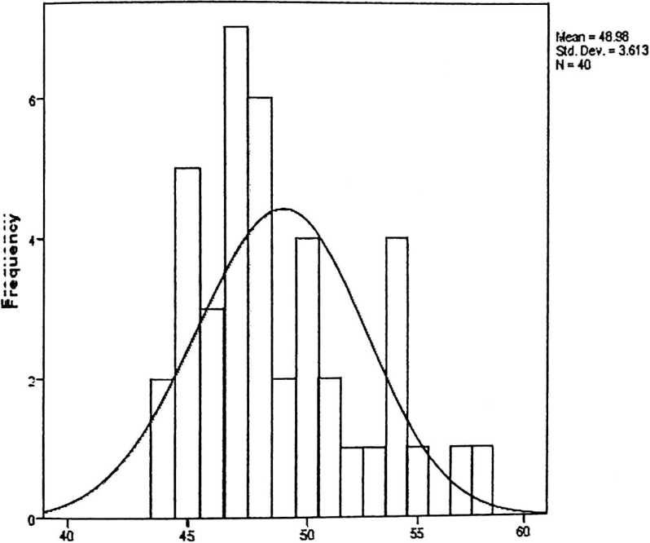
peran orangtua menyampaikan cerita isi alkitab

jj Valid | 40
Missing | 0
tfeaan | 52.48
WwJian | 52.00
Itoode | 49“
Stdi. Deviation | 4.630
Rarnge | 19
tfnnimum | 45
todmum | 64
i. Wultiple modes exist. The smallest value is s | hown
proses pertumbuhan spiritualitas anak | Frequency | Percent | Valid  Percent | Cumulative  Percent
/alilid 45 | 1 | 2.5 | 2.5 | 2.5
46 | 2 | 5.0 | 5.0 | 7.5
47 | 2 | 5.0 | 5.0 | 12.5
48 | 2 | 5.0 | 5.0 | 17.5
49 | 5 | 12.5 | 12.5 | 30.0
50 | 3 | 7.5 | 7.5 | 37.5
51 | 4 | 10.0 | 10.0 | 47.5
52 | 5 | 12.5 | 12.5 | 60.0
53 | 2 | 5.0 | 5.0 | 65.0
54 | 3 | 7.5 | 7.5 | 72.5
55 | 1 | 2.5 | 2.5 | 75.0
56 | 1 | 2.5 | 2.5 | 77.5
57 | 3 | 7.5 | 7.5 | 85.0
58 | 2 | 5.0 | 5.0 | 90.0
59 | 1 | 2.5 | 2.5 | 92.5
61 | 1 | 2.5 | 2.5 | 95.0
63 | 1 | 2.5 | 2.5 | 97.5
64 | 1 | 2.5 | 2.5 | 100.0
Total | 40 | 100.0 | 100.0

Histogram
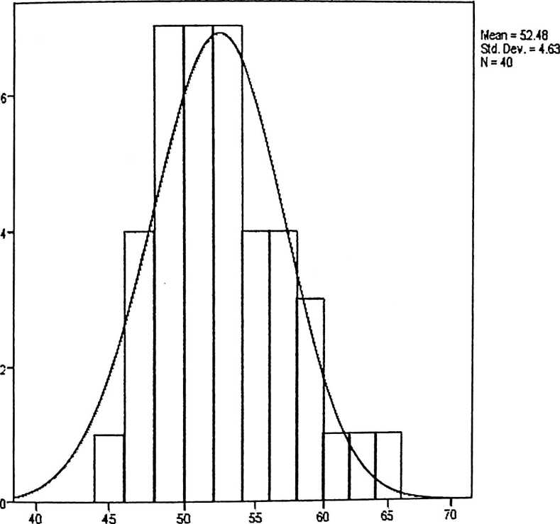
proses pertumbuhan spiritualitas anak

peran orangtua menyampaikan
cerita isi alkitab
Setries or Sequence  Lenngth  Nuiimber of User-  tfsssing Missing  Valluesin _{s tem}.  ^^{Plot} Missing | 40  0  0
Thee cases are unweighted.  Estimated | Distribution Parameters
peran orangtua menyampaikan
cerita isi alkitab
Nowmal Location  Disstribution  Scale | 48.98  3.613

Fhee cases are unweighted.
Normal P-P Plot of peran orangtua menyampaikan cerita isi alkitab
Expected Cum Prob
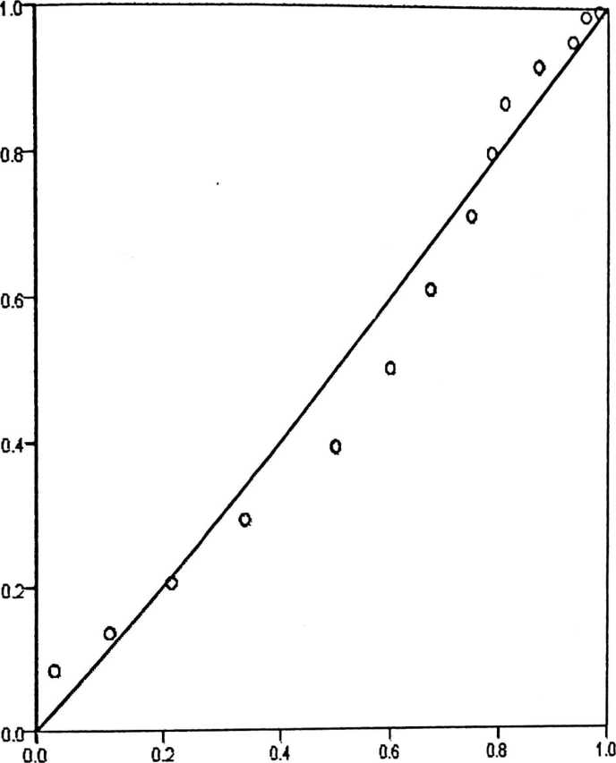
Observed Cum Prob

EDetrended Normal P-P Plot of peran orangtua menyampaikan cerita isi alkitab
Devlatlon from Normal
o.io-
0.05'
0.00
0.8
0-2
0.0
Observed Cum Prob
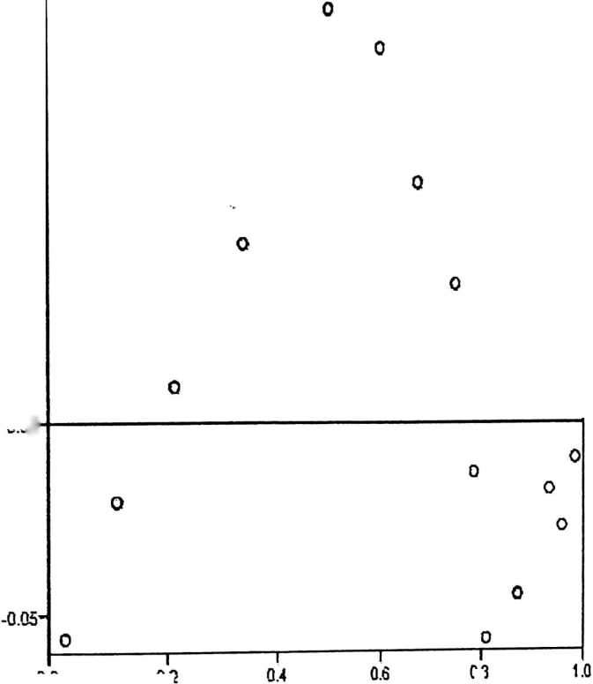
PERTUMBUHAN
SPIRITUAL
ANAK
erioes or Sequence | 40
enogth
urmber of User-
isssing Missing | 0
^{al}^^{s}₍^{in} System-  ¹⁶ ⁰ Missing | 0
: cases are unweighted.  E:stimated Distribution Parameters | PERTUMBUHAN  SPIRITUAL  ANAK
ommal Location  istnribution _  Scale | 52.48  4.630

he cases are unweighted.
Expected Cum Prob
Observed Cum Prob
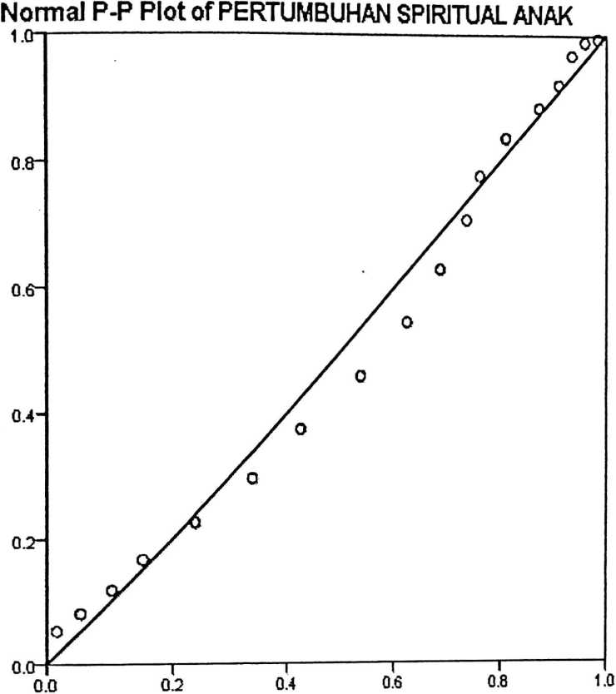
Deviation from Normal
Detrended Normal P-P Plot of PERTUMBUHAN SPIRITUAL ANAK
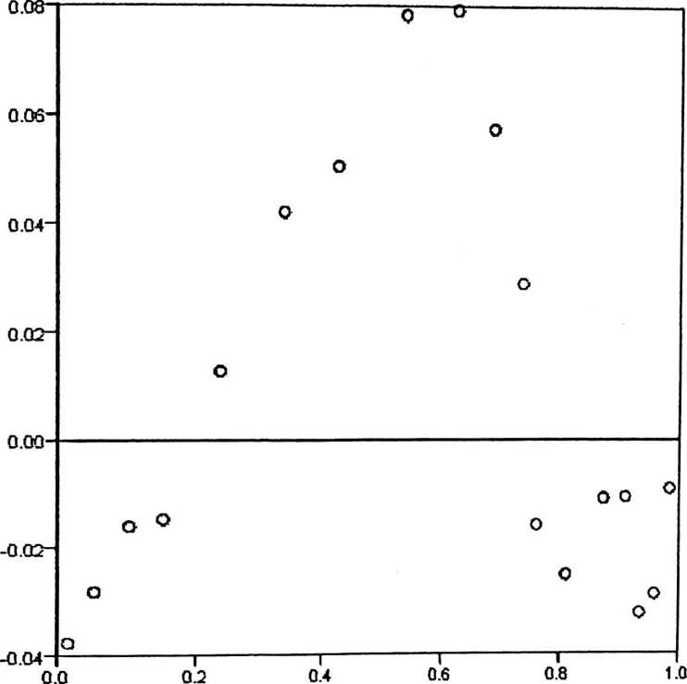
Observed Cum Prob

 | Cases
 | Induded |  | Exduded |  | Total
 | N | Percent | N | Percent | N | Percen  t
RCOSES PERTUMBUHAN  J>|I|RITUALITAS ANAK *  ■efranan orangtua  iehnyampaikan cerita  51/ALKITAB | 40 | 100.0% | 0 | 0.0% | 40 | 100.0%
Report  •RCOSES PERTUMBUHAN  PIIIRITUALITAS ANAK  EFRANAN ORANGTUA  lEfiNYAMPAIKAN CERITA  >IMLKITAB | Mean | N | Std.  Deviatio  n !
1 | 52.00 | 2 | 4.243
5 | 53.20 | 5 | 6.099
> | 48.00 | 3 | 3.464
r | 50.57 | 7 | 1.272
1 | 51.33 | 6 | 3.559
1 | 53.00 | 2 | 7.071
1 | 53.25 | 4 | 4.573
 | 51.50 | 2 | 2.121
1 | 59.00 | 1
• | 52.00 | 1
 | 53.00 | 4 | 6.733
1 | 57.00 | 1
 | 64.00 | 1
i | 57.00 | 1
•taal | 52.48 | 40 | 4.630

 | Sum of  Squares | df | Mean  Square | F | Sig.
sffiOSES PERTUMBUHAN Betwee (Combined  ;po|R[TUALITAS ANAK * n ) | 318.877 | 13 | 24.529 | 1.233 | .312
PERANAN ORANGTUA Groups .. .  menyampaikan cerita ^{L,neanty} | 124.249 | 1 | 124.24  g | 6.247 | .019
SI 1 ALKITAB Deviation
from | 194.628 | 12 | 16.219 | .816 | .633
Linearity
Within Groups | 517.098 | 26 | 19.888
Total | 835.975 | 39
Measures of Association | R | R Squared | Eta | Eta  Square  d
’RlOSES PERTUMBUHAN  SPI'IRITUALITAS ANAK *  ’EERANAN ORANGTUA  MENYAMPAIKAN CERITA  SI ALKITAB | .386 | .149 | .618 | .381

loodel | Variables Entered | Variables  Removed | Method
 | PERANAN  ORANGTUA  MENYAMPAIKAN  CERITA ISI  ALKITAB⁶ |  | Enter
. ODependent Variable: PROSES  EFRTUMBUHAN SPIRITUALITAS ANAK  . AAII requested variables entered.  Model Summary  loddel | R | R Square | Adjusted  R  Square | Std. Error of  the Estimate
 | .386ª | .149 | .126 | 4.328
. P’redictors: (Constant). PERANAN ORANGTUA  ONYAMPAIKAN CERITA ISI ALKITAB  ANOVAª  lodtfel | Sum of  Squares | df | Mean  Square | F | Sig.
Regression | 124.249 | 1 | 124.249 | 6.634 | .014^{b}
Residual | 711.726 | 38 | 18.730
Total | 835.975 | 39

loodel | Unstandardized  Coefficients |  | Standardized  Coefficients | t | Sig.
loodel | B | Std.  Error | Beta | t | Sig.
(Constant) | 28.277 | 9.420 |  | 3.002 | .005
PERANAN  ORANGTUA  MENYAMPAIKAN  CERITA ISI  ALKITAB | .494 | .192 | .386 | 2.576 | .014

N | Taraf Signif |  | N | Taraf Signif |  | N | Taraf Signif
N | 5% | 1% | N | 5% | 1% | N | 5% | 1%
3 | 0.997 | 0.999 | 27 | 0.381 | 0.487 | 55 | 0.266 | 0.345
4 | 0.950 | 0.990 | 28 | 0.374 | 0.478 | 60 | 0.254 | 0.330
5 | 0.878 | 0.959 | 29 | 0.367 | 0.470 | 65 | 0.244 | 0.317
6 | 0.811 | 0.917 | 30 | 0.361 | 0.463 | 70 | 0.235 | 0.306
7 | 0.754 | 0.874 | 31 | 0.355 | 0.456 | 75 | 0.227 | 0.296
8 | 0.707 | 0.834 | 32 | 0.349 | 0.449 | 80 | 0.220 | 0.286
9 | 0.666 | 0.798 | 33 | 0.344 | 0.442 | 85 | 0.213 | 0.278
10 | 0.632 | 0.765 | 34 | 0.339 | 0.436 | 90 | 0.207 | 0.270
11 | 0.602 | 0.735 | 35 | 0.334 | 0.430 | 95 | 0.202 | 0.263
12 | 0.576 | 0.708 | 36 | 0.329 | 0.424 | 100 | 0.195 | 0.256
13 | 0.553 | 0.684 | 37 | 0.325 | 0.418 | 125 | 0.176 | 0.230
14 | 0.532 | 0.661 | 38 | 0.320 | 0.413 | 150 | 0.159 | 0.210
15 | 0.514 | 0.641 | 39 | 0.316 | 0.408 | 175 | 0.148 | 0.194
16 | 0.497 | 0.623 | 40 | 0.312 | 0.403 | 200 | 0.138 | 0.181
17 | 0.482 | 0.606 | 41 | 0.308 | 0.398 | 300 | 0.113 | 0.148
18 | 0.468 | 0.590 | 42 | 0.304 | 0.393 | 400 | 0.098 | 0.128
19 | 0.456 | 0.575 | 43 | 0.301 | 0.389 | 500 | 0.088 | 0.115
20 | 0.444 | 0.561 | 44 | 0.297 | 0.384 | 600 | 0.080 | 0.105
21 | 0.433 | 0.549 | 45 | 0.294 | 0.380 | 700 | 0.074 | 0.097
22 | 0.423 | 0.537 | 46 | 0.291 | 0.376 | 800 | 0.070 | 0.091
23 | 0.413 | 0.526 | 47 | 0.288 | 0.372 | 900 | 0.065 | 0.086
24 | 0.404 | 0.515 | 48 | 0.284 | 0.368 | 1000 | 0.062 | 0.081
25 | 0.396 | 0.505 | 49 | 0.281 | 0.364
26 | 0.388 | 0.496 | 50 | 0.279 | 0.361

! ^{df} | a = 0.1 | j 0.05 | , 0.025 | 0.01  l | , 0.005  i | ; 0.001  j | 0.0005
00 | t„= 1.282 | i 1.645 | i 1.960 | 2.326 | < 2.576 | ! 3.091  1 | 3.291  1
1 | 3.078 | 6.314 | 12.706 | 31.821 | 63.656 | j 318.289  i  i | j 636.578 ■’
2 | 1.886 | <2.920 | j 4.303  i | 6.965  1 ■ | ; 9.925  !  i | 22.328  i | 31.600
' ³ | ; 1.638 | i 2.353  i | i 3.182 | : 4.541  1  1 | i 5.841  i | 10.214 | 12.924
■ ⁴ | ; 1.533 | j 2.132  • | 2.776 | \ 3.747  j | 4.604 | 1 7.173 | | 8.610
5 | 1.476 | 2.015 | 2.571 | ; 3.365  1 | 4.032 | 5.894 | 6.869
i ⁶  ¹ | 1.440  ! ’ | 1.943 | 2.447 | 3.143 ;  i | 3.707 | 5.208 | 5.959
7 | 1.415 ■  j i | 1.895 | 2.365 | 2.998 ! | 3.499 | 4.785 | 5.408
8 | 1.397 ;  i i | 1.860 ’  1 | 2.306  1 | 2.896 •'  1 | 3.355 'j  1  i | 4.501 | 5.041
9 | 1.383 .  1 | 1.833 i | 2.262 | 2.821 :  i | 3.250 :  1  i | 4.297 | 4.781
10 | 1.372 ; | 1.812 I | 2.228 ; | 2.764 ! | 3.169 i  j | 4.144  1 | 4.587
11 | 1.363 '  1 | 1.796 ■  1 | 2.201 i  1 | 2.718 • 3.106 !  > i |  | 4.025 | 4.437
12 | 1.356 ■ | 1.782 ' | 2.179 | 2.681 ' | 3.055 •  1 | 3.930 i  i  i | 4.318
13 | 1.350 ; | 1.771 | 2.160 | 2.650 ' | 3.012 i | 3.852 i | 4.221
14 |  | 1.345 |  | 1.761 | 2.145 |  | ‘2.624  .. |  | 2'977~ |  | IT7W |  | 4.140
15 |  | 1.341 |  | 1.753 | 2.131 |  | 2.602 |  | 2.947 |  | 3.733 |  | 4.073  J
16 |  | 1.337 |  | 1.746 | 2.120 |  | 2.583  J |  | 2.921 |  | 3.686  ) |  | 1 4.015  J
17 |  | 1.333 |  | 1.740 | 2.110  1 |  | 2.567 i  i  1 |  | 2.898 |  | 3.646 |  | | 3.965  i
18  1  i |  | 1.330 |  | 1.734 | 2.101  i  i |  | 2.552 i |  | 2.878 |  | ‘ 3.610 |  | ! 3.922  i  1
19  l  i |  | 1.328 |  | 1.729 j  i  J | 2.093 |  | 2.539 ■  i |  | 2.861 |  | 3.579 |  | | 3.883  t
i 20 |  | 1.325 |  | 1.725 ;  J | 2.086  1 |  | 2.528 .  i |  | 2.845 ; |  | 3.552 |  | 3.850
 |  | _ ... ............. |  | i | .. . |  |  |  |  |  |  |  | . -
; 21 |  | 1.323 : |  | 1.721 ; | 2.080 |  | 2.518 |  | 2.831 |  | 3.527 |  | 3.819
i  i  i ²² |  | 1.321 |  | ■ -1  1.717 : | 2.074 |  | 2.508 |  | i  2.819 ' |  | 3.505 |  | 1  3.792 ;
i'” 23 ; |  | 1.319 |  | 1.714 ■  1 | 2.069 |  | 2.500 |  | 2.807 <  j |  | — •  3.485  i |  | 3.768
24  ; » |  | 1.318 |  | 1.711 ;  r | 2.064 |  | 2.492 |  | 2.797 i  i |  | 3.467 : |  | 3.745 |
i ’ ’  ; 25  i |  | 1.316 |  | 1.708 | 2.060 |  | 2.485 |  | 2.787  i |  | 3.450 J  i |  | 3.725 j
²⁶ i |  | 1.315 |  | 1.706 :  i | 2.056 |  | 2.479 2.779 !  , i  ’ 1 |  |  |  | 3.435 ;  i  j |  | 3.707
“ 27  1 { |  | 1.314 { |  | 1.703 J  l  i | 2.052 |  | 2.473 2.771  : 1 |  |  |  | 3.421 |  | 3.689
)' ’ 2 8 j  1 |  | 1.313 ■ |  | 1.701 i | 2.048 2.467 2.763 i  i |  |  |  |  |  | 3.408 |  | 3.674
■ 29 '  i j |  | 1.311  !  i |  | 1.699 :  1 | 2.045 2.462 2.756 [  i |  |  |  |  |  | 3.396 ! |  | 3.660
30  j  l_ | ' 1.310  i  » |  | 1.697 ! 2.042 |  |  | 2.457 |  | 2.750 |  | : 3.385  ■ |  | 3.646  1
60 | 1.296  1 |  | ; 1.671 ; 2.000  1 1 |  |  | ' 2.390 |  | ! 2.660  1 |  | ’ 3.232 |  | * 3.460?
i 120 | : 1.289 |  | 1.658 ' 1.980  1 |  |  | ■ 2.358 |  | 2.617 |  | 3~160'  Z |  | 3.373’|  1
00 | i 1.282 |  | 1.645 > 1.960 |  |  | 2.326 |  | 2.576  1 |  | 3.091 j  i |  | i  3.291
http://www.socr.ucla.edu/Applets.dir/T-table.html (diunduh 22 agustus 2011)
Sumber:
Statistics Online Computational Resource

