111

Agustina
by runggangag@gmail.com 1
l

inssion date: 07-Feb-2023 03157PM (UTC-0700)
'Mssion ID: 2002430806
^rne: Agustina._SKRIPSI_LENGKAP.docx (543.66K)
• count 10595
;<Kter count: 68188

4
I

gusti n a
HSINALfTY REPORT
IMILARITYINDEX INTERNET SOURCES
5% 6%
PUBLICATIONS STUDENT PAPERS
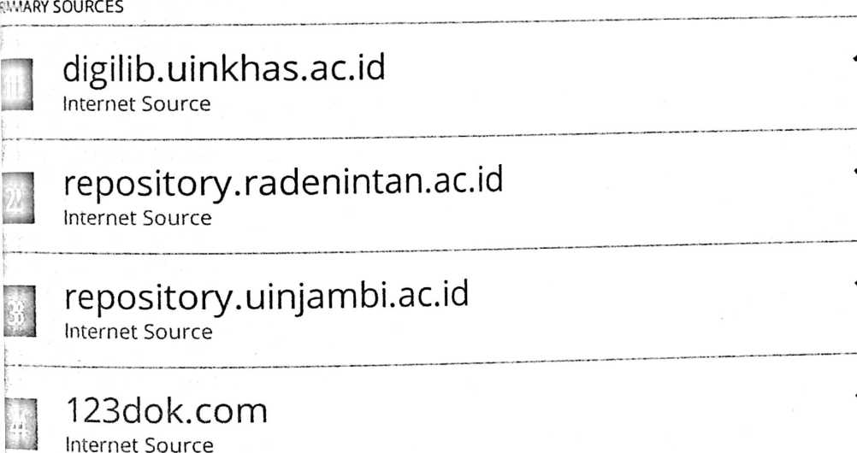
1 repository.uin-suska.ac.id
< J Internet Source
L_ .
r
1 repository.uinjkt.ac.id
—i Internet Source
1 repository.usd.ac.id
Internet Source

eprints.walisongo.ac.id
Internet Source

Matheus Mangentang, Tony Salurante.
"MEMBACA KONSEP KASIH DALAM INJIL
YOHANES MENGGUNAKAN LENSA

GEMBALA BAGI ORANG PERCAYA MASA KINI
DARI TITIK TOLAK TEOLOGI PENTAKOSTA”,
SOLA GRATIA: Jurnal Teologi Biblika dan
Praktika, 2021
Publication
j adinetto.wordpress.com
... J Internet Source
1 etheses.uinmataram.ac.id
• J Internet Source
gkkideiverbum.wordpress.com
J Internet Source
'l johannessimatupang.wordpress.com
■ -J Internet Source
1 dspace.uii.ac.id
* —J Internet Source
S repo.apmd.ac.id
uia Internet Source
p*- . ————• ■ ■
ejurnal.sttkadesiyogyakarta.ac.id
¹ -J Internet Source
1 pabrikpuisi.files.wordpress.com
'■--J Internet Source
T www.ayatalkitab.id
■Lj Internet Source

[Ajclude quotes On
E'tciude bibliography On
Exclude matches

