Submission author | Frans Rumbi
Assignment title: | A19
Submission titie: | CITRA DEWI SEPTIN-Teologi-Perba.
File name: | CITRA_DEWI_SEPTIN-Teologi-Perb.
File size: | 3.38M
Page count: | 123
Word count: | 18,983
Character count: | 114,993
Submission date: | 29-Aug-2020 03:06AM (UTC-0700)
Submission ID: | 1375927943

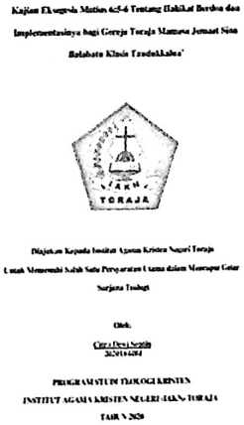
2020 Turniun. Ali rights reserved.

CITRA DEWI SEPTIN-Teologi-Perbaikan03
r*IGINALITY REPORT

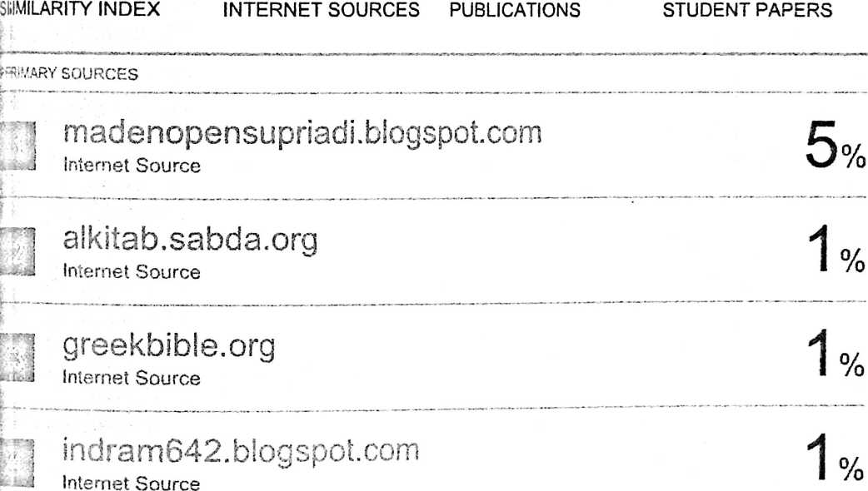
j darminberutu.blogspot.com
- --J Internet Source
'J mafiadoc.com
--•■•J Internet Source
0
0
1 satuhala.blogspot.com
—J Internet Source
1 Submitted to Houston Baptist University
J Student Paper

0
o/
/o

