Lampiran angket uji validasi
ANGKET UJI VALIDASI
Kajian Teologis-Praktis Tentang Hikmat dan Implementasinya bagi Guru
PAK
se-Kelurahan Rantekalua’, Kecamatan Mengkendek Kabupaten Tana Toraja
- Petunjuk Pengisian Angket
- Mohon dengan hormat bantuan dan kesediaan bapak/ibu/sdr untuk
menjawab seluruh pernyataan yang ada
- Berilah tanada (V) pada kolom bapak/ibu/sdr pilih sesuai dengan keadaan
yang sebenarnya
- Ada lima alternatif jawaban, yaitu:
Sangat Setuju= (SS)
Setuju= (S)
NetrabTidak Tahu =(N)
Kurang Setuju= (KS)
Tidak Setuju =(TS)
- Karakteristik Responden
- Nama sekolah tempat mengajar :
- Bidang study yang diajarkan :
- Umur
- Jenis kelamin :
- Jabatan
- Golongan :

NO | PERNYATAAN | ALTERNATIF  JAWABAN
NO | PERNYATAAN | SS | S | N | KS | TS
1 | Saya mengajar dengan penuh kelemah  lembutan
2 | Setiap pagi saya memiliki waktu yang  khusus dengan Tuhan untuk mencari  kehendak-Nya lewat membaca Alkitab.
³ | Banyak sikap saya yang tidak bisa menjadi  contoh kepada peserta didik
4 | Saya seorang guru yang takut akan Tuhan
5 | Saya tidak asal-asalan dalam memberikan  nilai kepada siswa.
6  1—■ | Guru yang takut akan Tuhan adalah guru  PAK
7 | Saya mendahulukan Tuhan dalam setiap  pengajaran
8 | Yesus satu-satunya guru Agung yang saya  teladani dalam proses pembelajaran
9 | Saya selalu siap menjawab setiap  pertanyaan dari siswa.
10 | Hikmat memberikan ide-ide pengetahuan  tentang jalan Allah yang harus  diterapkan/dituruti di dalam kehidupan  sehari-hari
11 | Semua materi yang saya ajarkan adalah hasil  dari menafsir Alkitab.
12 | Dalam memahami Alkitab saya  menggunakan alat bantu tafsir.
13 | Saya bijak dalam merencanakan  pembelajaran
14 | Saya menggunakan akal budi dengan benar  dalam mengajar.
15 | Saya menggunakan buku-buku penunjang  lebih dari 2 dalam mengajar
16 | Saya mementingkan kepentingan siswa  daripada kepentingan pribadi
17 | Saya tidak mengetahui karakteristik masing-  masing peserta didik yang saya ajar.
¹⁸ | Setiap perkara yang saya putuskan adalah  benar
¹⁹ | Saya terkadang tidak medidik dengan kasih
[20' | Saya seorang yang sedang Bertumbuh dalam  pengetahuan Alkitab yang benar dan  menerima Yesus sebagai satu-satunya jalan  kebenaran
21 | Siswa membantu saya dalam memahami  materi yang saya ajarkan
| 22 | Saya seorang guru yang memiliki mora  yang baik
23  L | Siswa yang saya ajar selalu menerima nilai  yang saya berikan dengan senang hati.
24  1 | Penilaian yang saya berikan sesuai dengan  keinginan siswa.
25 | Saya tidak curang dalam mengajar
26 | Saya mengajar dengan tulus iklas
27 | Saya mengambil waktu guru mata pelajaran  lain untuk menyelesaikan materi.
28 | Saya tidak merugikan peserta didik dalam  mengajar
|29  1 | Saya tidak sewenang-wenang  memperlakukan peserta didik
30 | Saat ada urusan keluarga saya tidak masuk  di kelas
³¹  ■  1 | Hikmat sifatnya religious, karena itu saya  hanya bisa memahaminya lewat relasi yang  pribadi dengan Tuhan
32 | Saya tidak suka marah-marah saat masuk di  kelas
33 | Saat siswa saya ada yang bandel memukul  adalah salah satu cara saya mendidik.
34 | Saya bersikap hati-hati dalam setiap  tindakan saya.
35 | Saya seorang guru yang bisa mengendalikan  diri
36 | Sebagian besar rekan saya tidak menyukai  cara saya menyampaikan pendapat
37 | Saya disegani oleh murid-murid
38 | Setiap malam saya mendoakan siswa-siswi  saya |  |  |  |  | •
39 | Murid-murid senang ketika saya tidak  masuk mengajar
40 | Saya menegur siswa yang tidak disiplin
 | dalam belajar
41 | Saya taat pada etika kerja
42 | Ketika saya melanggar aturan/tata tertib  sekolah saya diam-diam tidak mengakui  kesalahan
43 | Kebenaran adalah Allah
[44 | Saya tidak kesulitan dalam mengajar, jenis  karakter apapun yang dilimiiiki siswa saya  dapat mengaggulanginya dengan metode  yang efektif.
45  L— | Saya masih ragu-ragu apakah saya sudah  diselamatkan di dalam Yesus Kristus
46 | Saya memberikan contoh teladan yang patut  diguguh oleh peserta didik
47 | Saya menjadi teladan bagi rekan-rekan guru
48  <  1 | Hikmat yang sifatnya religious saya tidak  dapat memahaminya

■ , ... «— |  | •4 | 5 | "~6 | 7 | 8 | 9 | 10 | 11 | 12 | 13 | 14 | 15 | 16
5 | 5 ; | 5 | 5 | 1 | 5 | 5 | 5 | 5 | 5 | 5 | 5 | 4 | 5 | 5
5 | 4 i | 5 | 5 | 2 | 4 | 5 | 4 | 5 | 4 | 4 | 5 | 5 | 4 | 3
4 | • 4 i | 4 | 4 | 3 | 4 | 4 | 4 | 4 | 4 | 3 | 4 | 4 | 4 | 4
5 | > 5 | 5 | 5 | 4 | 5 | 4 | 4 | 4 | 2 | 4 | 4 | 4 | 5 | 4
4 | f 4j | 5 | 4 | 4 | 5 | 5 | 5 | 4 | 2 | 4 | 4 | 5 | 4 | 5
5 | 5 - | 4 | 4 | 4 | 5 | 5 | 5 | 5 | 5 | 5 | 4 | 4 | 3 | 4
5 | 4 j | 5 | 4 | 5 | 5 | 5 | 5 | 4 | 1 | 5 | 5 | 4 | 4 | 2
3 | k > * | 4 | 3 | 4 | 5 | 5 | 5 | 4 | 4 | 4 | 3 | 3 | 2 | 3
5 | ' 5 | | 4 | 4 | 5 | 5 ’ | ’ 5' | 5' | 4 | 1 | 3 | 5 | 4 | 3 | 5
5 | 3 ' | 3 | 4 | 5 | 5 | 5 | 2 | 2 | 3 | 5 | 5 | 3 | 5 | 3
5 | j’- 3 'j | 4 | 4 | 4 | 4 | 4 | 5 | 4 | 1 | 4 | 4 | 3 | 4 | 4
5 | 4 | 3 | 4 | 5 | 5 | 5 | 5 | 4 | 5 | 5 | 5 | 5 | 3 | 5
5 | ’ A 4 | 3 | 3 | 4 | 3 | 4 | 4 | 3 | 4 | 4 | 4 | 4 | 4 | 5
5 | t 5 | 4 | 4 | 5 | 5 | 4 | 5 | 5 | 3 | 5 | 4 | 2 | 4 | 4
4 | ' 5 | 4 | 4 | 4 | 5 | 4 | 5 | 3 | 2 | 5 | 4 | 4 | 4 | 4
4 | ; 5 ■ | 5 | 4 | 5 | 5 | 5 | 2 | 4 | 3 | 4 | 4 | 4 | 5 | 4
5 | 5 i | 5 | 5 | 5 | 5 | 5 | 5 | 5 | 5 | 4 | 3 | 5 | 5 | 4
5 | 5 | 5 | 4 | 4 | 4 | 5 | 5 | 5 | 5 | 4 | 2 | 5 | 4 | 4
4 | 5 | 4 | 4 | 4 | 4 | 5 | 5 | 5 | 5 | 5 | 4 | 4 | 4 | 4
4 | 4 ’ | 4 | 5 | 4 | 5 | 5 | 5 | 5 | 5 | 5 | 4 | 2 | 4 | 4
5 | 2 ; | 4 | 5 | 1 | 4 | 4 | 4 | 4 | 4 | 5 | 5 | 5 | 5 | 5
5 | 3 | 4 | 5 | 3 | 5 | 5 | 4 | 5 | 2 | 3 | 3 | 3 | 4 | 4
5 | : 5 ¹ | 5 | 4 | 1 | 5 | 5 | 4 | 4 | 4 | 4 | 4 | 5 | 5 | 5
4 | 5 • | 5 | 5 | 1 | 5 | 5 | 5 | 4 | 2 | 5 | 4 | 5 | 5 | 5
4 | it 4 i | 4 | 4 | 4 | 5 | 5 | 4 | 5 | 4 | 5 | 4 | 4 | 5 | 4
4 | 2 | 5 | 3 | 5 | 5 | 4 | 2 | 3 | 3 | 4 | 3 | 5 | 3 | 5
3 | 3 | 5 | 5 | 1 | 5 | 5 | 5 | 5 | 3 | 4 | 5 | 4 | 4 | 5
3 | r 2 ’ | 4 | 3 | 3 | 5 | 4 | 3 | 4 | 5 | 4 | 5 | 5 | 5 | 5
5 | i 4 | 5 | 4 | 5 | 3 | 5 | 5 | 4 | 5 | 4 | 5 | 4 | 4 | 5
4 | 3 | 4 | 5 | 4 | 5 | 4 | 5 | 5 | 4 | 5 | 4 | 4 | 5 | 5
 | 122 | 130' | 126 | 109 | 140 | 140 | 131 | 127 | 105 | 130 | 124 | 122 | 125 | 128

 | "n⁴ | 22 | 23 | 24 | 25 | 26 | 27 | 28 | 29 | 30 | 31 | 32 | 33 | 34 | 35
5 |  | 4 | 5 | 2 | 5 | 5 | 2 | 5 | 5 | 4 | 5 | 3 | 5 | 5 | 3
4 | • 5 | 4 | 1 | 5 | 4 | 5 | 4 | 4 | 4 | 5 | 1 | 4 | 5 | 4 | 4
4 | A | 4 | 2 | 4 | 4 | 4 | 2 | 4 | 4 | 3 | 2 | 4 | 2 | 4 | 4
5 | s | 2 | 3 | 4 | 4 | 4 | 5 | 3 | 4 | 3 | 4 | 4 | 5 | 4 | 4
5 |  | 5 | 4 | 4 | 5 | 5 | 2 | 5 | 4 | 4 | 5 | 5 | 5 | 4 | 4
5 | 5 | 4 | 5 | 5 | 5 | 5 | 5 | 5 | 5 | 5 | 4 | 4 | 5 | 4 | 5
4 | s | 4 | 5 | 5 | 4 | 5 | 5 | 5 | 5 | 5 | 4 | 5 | 5 | 5 | 5
4 | r" 3 | 4 | 2 | 5 | 3 | 3 | 5 | 4 | 5 | 5 | 5 | 4 | 4 | 5 | 5
4 | i 4 ; | 4 | 4 | 5 | 3 | 3 | 4 | 4 | 4 | 5 | 4 | 4 | 3 | 5 | 4
3 | ■ > ■< | 4 | 3 | 4 | 4 | 3 | 5 | 5 | 2 | 3 | 5 | 4 | 4 | 3 | 5
2 | f 3 '• | 3 | 3 | 4 | 5 | 4 | 4 | 4 | 4 | 5 | 4 | 3 | 4 | 4 | 5
3 | f 4 ; | 4 | 5 | 5 | 4 | 4 | 4 | 5 | 5 | 5 | 3 | 3 | 3 | 5 | 5
5' | 1 5 ' | 4 | 4 | 4 | 5 | 4 | 4 | 4 | 4 | 5 | 3 | 5 | 4 | 5 | 4
5 |  | 4 | 5 | 4 | 5 | 4 | 4 | 4 | 3 | 4 | 5 | 4 | 5 | 4 | 5
4 | l 4 ■ | 4 | 4 | 4 | 3 | 4 | 4 | 4 | 4 | 5 | 4 | 4 | 4 | 5 | 4
4 | i* 4 = | 4 | 5 | 5 | 5 | 5 | 4 | 4 | 5 | 4 | 5 | 4 | 4 | 4 | 4
5 | 5 | 4 | 4 | 4 | 4 | 4 | 4 | 4 | 5 | 4 | 4 | 4 | 4 | 5 | 5
4 | 3 | 3 | 4 | 4 | 5 | 5 | 5 | 5 | 5 | 4 | 5 | 5 | 5 | 5 | 5
5 | 5 | 3 | 4 | 4 | 4 | 4 | 5 ' | 5 | 4 | 4 | 5 | 5 | 4 | 4 | 5
4 | 4 \ | 4 | 4 | 2 | 4 | 4 | 4 | 4 | 4 | 4 | 4 | 4 | 4 | 4 | 4
5 | ■ 5 j | 5 | 5 | 2 | 4 | 5 | 3 | 5 | 5 | 3 | 4 | 4 | 2 | 2 | 2
5 | 7 v * | 4 | 5 | 5 | 5 | 5 | 5 | 5 | 5 | 5 | 4 | 4 | n  J | 5 | 3
4 | 4 1 | 4 | 5 | 1 | 5 | 5 | 5 | 5 | 5 | 5 | 5 | 5 | 5 | 4 | 4
5 | 1 | 4 | 4 | 4 | 5 | 5 | 4 | 5 | 5 | 3 | 4 | 4 | 4 | 4 | 3
5 | ■■ 4⁷ | 4 | 4 | 5 | 5 | 5 | 4 | 5 | 5 | 5 | 4 | 4 | 5 | 5 | 4
5 | 15 ■ | 5 | 5 | 2 | 5 | 5 | 5 | 4 | 3 | 5 | 5 | 3 | 5 | 3 | 3
5 | 1 | 5 | 4 | 5 | 4 | 4 | 5 | 5 | 1 | 5 | 5 | 4 | 3 | 5 | 5
4 | 4 ' | 5 | 5 | 5 | 5 | 5 | 4 | 5 | 5 | 3 | 4 | 5 | 5 | 5 | 5
5 |  | 4 | 4 | 3 | 4 | 5 | 5 | 4 | 5 | 4 | 4 | 0 | 3 | 4 | 5
4 | 5 | 3 | 4 | 4 | 5 | 4 | 5 | 3 | 4 | 5 | 5 | 0 | 2 | 5 | 5
 |  | 119 | 121 | 119 | 132 | 132 | | 126|133 |  | 128 | 129 | 125 | 115 | 121 | 130 | 128
 |  |  |  | 41 | 42 | 43 | 44 | 45 | 46 | 47 | 48 | Jmlh
1_ | _5 |  | 5 | 5 | 5 | 5 | 4 | 5 | 5 | 3 | 5 | 208
2 | _4 |  | 4 | 4 | 5 | 5 | 1 | 5 | 5 | 4 | 4 | 197
3 | J |  | 4 | 4 | 2 | 3 | 2 | 4 | 4 | 3 | 3 | 169
■ ³d | _4 |  | 5 | 4 | 5 | 1 | 4 | 4 | 4 | 3 | 5 | 192
M | 4 |  | 4 | 4 | 1 | 5 | 4 | 2 | 4 | 4 | 2 | 191
5 | 4 |  | 4 | 5 | 5 | 5 | 5 | 5 | 5 | 5 | 5 | 221
5 | 5 |  | 5 | 5 | 5 | 5 | 5 | 5 | 4 | 5 | 5 | 217
s_ | 5 |  | 5 | 5 | 5 | 4 | 5 | 4 | 5 | 4 | 5 | 201
 | 5 |  | 5 | 5 | 5 | 5 | 5 | 4 | 5 | 4 | 4 | 204
—  5 | 5 |  | 5 | 5 | 1 | 5 | 5 | 5 | 3 | 3 | 3 | 187
4, | 4 |  | 5 | 3 | 4 | 4 | 5 | 5 | 4 | 4 | 4 | 185
 | 5 |  | 5 | 5 | 5 | 5 | 4 | 5 | 4 | 4 | 4 | 210
. 4 | 5 |  | 4 | 4 | 4 | 5 | 5 | 4 | 4 | 5 | 5 | 201
4j | 4 |  | 4 | 5 | 5 | 4 | 4 | 3 | 5 | 4 | 5 | 204
4 | 5 |  | 5 | 4 | 4 | 4 | 4 | 4 | 5 | 5 | 5 | 198
2j | 4 |  | 5 | 4 | 4 | 5 | 5 | 4 | 5 | 4 | 5 | 204
4 | 4 |  | 4 | 4 | 5 | 5 | 5 | 5 | 5 | 5 | 4 | 214
5 | _5_ |  | 5 | 5 | 5 | 5 | 5 | 5 | 4 | 5 | 5 | 215:
5, | 4 |  | 4 | 4 | 3 ' | 4 | 5 | 4 | 5 | 4 | 4 | 209
4 | 5 |  | 4 | 4 | 4 | 4 | 4 | 4 | 4 | 5 | 4 | 197
4 | 4 |  | 4 | 3 | 5 | 4 | 4 | 5 | 4 | 4 | 2 | 184
nr | 5 |  | 4 | 5 | 5 | 3 | 3 | 3 | 5 | 4 | 3 | 197
4 | 5 |  | 5 | 5 | 5 | 4 | 4 | 5 | 4 | 4 | 5 | 212
4_ | 2 |  | 5 | 5 | 5 | 5 | 5 | 5 | 5 | 5 | 5 | 200
4 | 4 |  | 4 | 5 | 5 | 5 | 4 | 5 | 4 | 4 | 4 | 211
5 | _0 |  | 4 | 4 | 5 | 4 | 3 | 5 | 5 | 3 | 1 | 178
1 | 4 |  | 5 | 5 | 5 | 5 | 3 | 5 | 4 | 3 | 3 | 194
5 ~ | 5 |  | 4 | 5 | 4 | 5 | 5 | 5 | 5 | 5 | 3 | 206
5_ | 5 |  | 5 | 5 | 5 | 4 | 4 | 5 | 5 | 5 | 2 | 203
5 | 5 |  | 5 | 4 | 3 | 5 | 4 | 5 | 4 | 4 | 3 | 202.
 |  |  | 136 | 134 | 129 | 132 | 125 | 134 | 134 | 124 | 117

 |  | total | 1 | 2 | 3 | 4 | 5 | 6 | 7 | 8 | 9 | 10 | 11 | ¹² i
&al Ptaraoo |  | 1 | .143 | .192 | .517” | .103 | -.014 | .135 | .176 | .514” | 378* | .435* | 316 | 328
 | Cofreiabon |  |  |  |  |  |  |  |  |  |  |  |  | .077
 | Sig. (2-tailed) |  | .452 | .310 | .003 | .589 | .941 | .476 | 352 | .004 | .040 | .016 | .089 | .077
 | N | 30 | 30 | 30 | 30 | 30 | 30 | 30 | 30 | 30 | 30 | 30 | 30 | 30
1 | Pearson |  | 1 | .080 | .215 | -.206 | .184 | -.185 | -.112 | .199 | .268 | -.070 | 0.000 | 288
 | CorrelatM» |  |  |  |  |  |  |  |  |  |  |  | 1.000
 | Sig (2-tailed) | .452 |  | .675 | .255 | 275 | 329 | 329 | 355 | 292 | .152 | .712 | 1.000 | .122
 | N | 30 | 30 | 30 | 30 | 30 | 30 | 30 | 30 | 30 | 30 | 30 | 30 | 30
2 | Pearson |  | .080 | 1 | 203 | -.051 | 244 | .149 | -.278 | .070 | .098 | -.017 | -.075 | .026
 | Correlation |  |  |  |  |  |  |  |  |  |  | .927 | .696
 | Sig (2-tailed) | 310 | .675 |  | 283 | .789 | .194 | .431 | .137 | .712 | .607 | .927 | .696 | .894
 | N | 30 | 30 | 30 | 30 | 30 | 30 | 30 | 30 | 30 | 30 | 30 | 30 | 30
3 | Pearson | .517” | .215 | 203 | 1 | .223 | .082 | .115 | .093 | .402* | .432* | 243 | .050 | .069
 | Czvrelatkn  Sig (2-taited) | .003 | .255 | .283 |  | .237 | .667 | .546 | .624 | .028 | .017 | .196 | .793 | .719
 | N ■ | 30 | 30 | 30 | 30 | 30 | 30 | 30 | 30 | 30 | 30 | 30 | 30 | 30
4 |  |  | -.206 | -.051 | .223 | 1 | 314 | -.273 | .115 | 254 | .072 | 315 | -.115 | -.184
 | C<rrretation  Sig, (2-tailed) | .589 | 275 | .789 | 237 |  | .091 | .144 | .546 | .176 | .705 | .090 | .544 | 330
 | N | 30 | 30 | 30 | 30 | 30 | 30 | 30 | 30 | 30 | 30 | 30 | 30 | 30
5 | Pearson |  | .184 | 244 | .082 | .314 | 1 | -.437’ | .171 | 217 | .312 | .510” | -.038 | .157
 | Correlation  Sig (2-tailed) | .941 | .329 | .194 | .667 | .091 |  | .016 | .366 | 250 | .093 | .004 | .841 | .407
 | N | 30 | 30 | 30 | 30 | 30 | 30 | 30 | 30 | 30 | 30 | 30 | 30 | 30
6 | Pearson | 30 | -.185 | .149 | .115 | -273 | -.437* | l | .014 | -.034 | -.101 | -236 | -.100 | -.012
 | Correlation  Sig, (2-tailed) | .476 | 329 | .431 | .546 | .144 | .016 |  | .943 | .858 | .595 | 209 | .600 | .948
 | N | 30 | 30 | 30 | 30 | 30 | 30 | 30 | 30 | 30 | 30 | 30 | 30 | 30
7 | Pearson |  | -.112 | -.278 | .093 | .115 | .171 | .014 | 1 | .198 | -.079 | .098 | -251 | 201
 | rrelation |  |  |  |  |  | 366 | .943 |  | 295 | .680 | .607 | .181 | 287
 | Sig, (2-tailed) | .352 | .555 | .137 | .624 | .546 | 366 | .943
 | N | 30 | 30 | 30 | 30 | 30 | 30 | 30 | 30 | 30 | 30 | 30 | 30 | 30
8 | Pearson | .514” | .199 | .070 | .402* | .254 | .217 | -.034 | .198 | 1 | .199 | 310 | .159 | .036
 | Correlation  Sig, (2-tailed) | .004 | .292 | .712 | .028 | .176 | 250 | .858 | .295 |  | 292 | .096 | .402 | .849
 | N | 30 | 30 | 30 | 30 | 30 | 30 | 30 | 30 | 30 | 30 | 30 | 30 | 30
9 | Pearson | .378* | 268 | .098 | .432’ | .072 | 312 | -.101 | -.079 | .199 | 1 | .528” | .039 | .180
 | Correlation  Sig. (2-tailed) | .040 | .152 | .607 | .017 | .705 | .093 | .595 | .680 | .292 |  | .003 | 83o | .340
 | N | 30 | 30 | 30 | 30 | 30 | 30 | 30 | 30 | 30 | 30 | 30 | 30 | 30
10 | Pearson | .435* | -.070 | -.017 | .243 | .315 | .510** | -236 | .098 | 310 | .528” | 1 | .344 | .045
 | Correlation  Sig (2-tailed) | .016 | .712 | .927 | .196 | .090 | .004 | 209 | .607 | .096 | .003 |  | .062 | .814
 | N | 30 | 30 | 30 | 30 | 30 | 30 | 30 | 30 | 30 | 30 | 30 | 30 | 30
n | Pearson |  | 0.000 | -.075 | .050 | -.115 | -.038 | -.100 | -251 | .159 | .039 | .344 | 1 | 230
 | Correlation
 |  | Sig (2'tKiled) |  |  | .089 | 1.000 | .696 | .793 | .544 | .841 | .600 | .181 | .402 | .836 | .062 | 220
 |  | 12 |  |  | 30 | 30 | 30 | 30 | 30 | 30 | 30 | 30 | 30 | 30 | 30 | 30 | 30
 |  | 12 | Pesraoo  GMTetatioo |  |  | .288 | .026 | .069 | -.184 | .157 | -.012 | 201 | .036 | .180 | .045 | .230 | 1
 |  |  | Sig. (2-tailed) |  | .077 | .122 | .894 | .719 | .330 | .407 | .948 | 287 | .849 | .340 | .814 | 220
 |  |  | N |  | 30 | 30 | 30 | 30 | 30 | 30 | 30 | 30 | 30 | 30 | 30 | 30 | 30
 |  | 13 | Pearson |  |  | .719” | .074 | -231 | -.157 | .147 | -207 | -.049 | .031 | -.022 | -.168 | -.065 | 247
 |  |  | C orreUtion |  |  |  |  |  |  |  |  |  |  | .910 |  | .731 | .189
 |  |  | Sig. (2-taited) |  | .821 | .000 | .698 | .220 | .408 | .438 | .272 | .798 | .871 | .910 | 374 | .731 | .189
 |  |  | N |  | 30 | 30 | 30 | 30 | 30 | 30 | 30 | 30 | 30 | 30 | 30 | 30 | 30  -.100
 |  | 14 | FVanwn  < *rrelatMMi |  |  | -.078 | .004 | -.083 | 381* | -.024 | -.291 | -.087 | .055  .772 | -.113  .554 | -.075  .693 | .175 | 30  -.100
 |  |  | Shg (2-tmled) |  | .545 | .680 | .984 | .661 | .038 | .900 | .119 | .646 | .055  .772 | -.113  .554 | -.075  .693 | 354 | .599
 |  |  | N |  | 30 | 30 | 30 | 30 | 30 | 30 | 30 | 30  .048 | 30  -.121 | 30 | 30  .047 | 30  .048 | y s
 |  | 15 | Pearaon  Carrelmion |  |  | .017 | .107 | -.100 | .220 | .459* | -347 | 30  .048 | 30  -.121 | -264  .159 | 30  .047 | 30  .048 | y s
 |  |  |  |  |  |  |  |  |  |  |  |  |  | -264  .159 |  | .80! | 243
 |  |  | Sig. (2-tailed) |  | .951 | .928 | .575 | 398 | .243 | .011 | .060 | .802 | 324 | -264  .159 | .806 | .80! | 243
 |  |  | N |  | 30 | 30 | 30 | 30 | 30 | 30  .026 | 30 | a §  1 | 30  -214 | 30  .049 | 30  .008 | 30  .194 | 30  -.111
 |  | 16 | Pesrson  CowelMkjn |  |  | -.087 | -.112 | -.196 | .022 | 30  .026 | -316
 |  |  |  |  |  |  |  |  |  |  | -316 |  |  | .799 | .968
 |  |  | Sig (2-tailed) |  | .572 | .649 | .557 | .299 | .907 | .890 | .089 | .612 | 257 | .799 | .968 | .304 | .560
 |  |  | N |  | 30 | 30 | 30 | 30 | 30 | 30 | 30 | 30 | 30 | 30 | 30 | 30 | 30
 |  |  |  |  |  |  |  |  | .029 |  | -.044 | -.032 | 321 | 333 | .457’ | 255 | .073
 |  | 17 | P»r«rson  CorrelMion |  |  | -.046 | .319 | .595” | .029 | 252 |  |  |  |  |  | .174 | .073
 |  |  |  |  |  |  |  |  |  | 252 | .818 | .868 | .084 | .072 | .011 | .174 | .703
 |  |  | Sig, (2-tailed) |  | .055 | .811 | .086 | .001 | .879 | .180
 |  |  | N |  | 30 | 30 | 30 | 30 | 30  -.044 | 30  -.070 | 30  .425* | 30  .095 | 30  .181 | 30  .162 | 30  .142 | 30  -.106 | 30  .000
 |  | 18 | P-arsoo  xrtl«iion |  |  | .034 | -.144 | .165
 |  |  |  |  |  |  |  |  |  |  | .019 | .616 | 338 | 392 | .454 | 375 | 1.000
 |  |  | Sig (2-iailed) |  | .149 | .857 | .447 | .383 | .818 | .714
 |  |  | N |  | 30 | 30 | 30 | 30 | 30 | 30 | 30 | 30 | 30 | 30 | 30 | 30 | 30
 |  |  |  |  |  |  |  |  | .164 | 293 | -.178 | -.018 | 316 | .191 | .434* | .191 | -.180
 |  | 19 | Paoson  CaMTcIMMMI |  |  | .051 | .079 | .534” |  |  |  |  | .089 | .191 | .434* | .191 | 340
 |  |  |  |  |  |  |  |  |  | .116 |  | .925 | .089 | .312 | .017 | 311 | 340
 |  |  | Sig (2-tailed) |  | .161 | .788 | .676 | .002 | .387 | .116 | .347
 |  |  | N |  | 30 | 30 | 30 | 30 | 30 | 30 | 30 | 30 | 30 | 30 | 30 | 30 | 30
 |  |  |  |  |  |  |  |  |  | .190 | -.224 | -.025 | .063 | .092 | 317 | .183 | .023
’ t |  | 20 | K^arson |  |  | .018 | -.075 | .145 | 364
 |  |  | Oarrelatian |  |  |  |  |  | .048 | .315 | .234 | .897 | .742 | .629 | .088 | 334 | .905
1 |  |  | Sig. (2-tailed) |  | .470 | .926 | .694 | .444
1 |  |  | N |  | 30 | 30 | 30 | 30 | 30 | 30 | 30 | . 30 | 30 | 30 | 30 | 30 | 30
 |  |  |  |  | 30 |  |  |  | -.201 | -.072 | 243 | -.131 | -333 | -.187 | .048 | 294 | .161
 |  | 21 | 1 TSTSOO  Corretatkm |  |  | .031 | .343 | .010 |  |  |  |  | .072 | -.187 | .048 | .115 | 396
 |  |  |  |  |  |  |  |  |  | .705 | .196 | .489 | .072 | 321 | .801 | .115 | 396
 |  |  | Sig (2-tailed) |  | .323 | .869 | .063 | .956 | 287
 |  |  | N |  | 30 | 30 | 30 | 30 | 30 | 30 | 30 | 30 | 30 | 30 | 30 | 30 | 30
 |  |  |  |  |  |  |  |  | .026 | -217 | -234 | .142 | .072 | -248 | -.184 | .057 | -.052
 |  | 22 | Pewsoo |  |  | -.041 | -343 | -.454* |  |  |  |  |  |  |  | .057
 |  |  | onetation |  |  |  |  |  | .891 | 249 | 213 | .455 | .707 | .187 | 329 | .765 | .785
 |  |  | Stg. (2-tailed) |  | .337 | .831 | .063 | .012
 |  |  | N |  | 30 | 30 | 30 | 30 | 30 | 30 | 30 | 30 | 30 | 30 | 30 | 30 | 30
 |  | 23 | ^{;J}^T5On |  | .411’ | -.211 | .124 | -.101 | .034 | -.060 | .033 | 293 | .023 | -.047 | .076 | .061 | 286
 |  |  | Telation  Sig (2-tailed) |  | .024 | 263 | .514 | .596 | .860 | .752 | .864 | .116 | .903 | .804 | .689 | .747 | .125
 |  |  | . N ••. |  | 30 | 30 | 30 | 30 | 30 | 30 | 30 | 30 | 30 | 30 | 30 | 30 | 30
24 |  |  | .193 | -.203 | .092 | -.216 | -.129 | 319 | .134 | .170 | .075 | .128 | -.236 | -169
 | C&relatian
 | Sig (2-tailcd) | .220 | .307 | .282 | .628 | 252 | .498 | .086 | .479 | .369 | .694 | .502 | .209 | 371
 | N | 30 | 30 | 30 | 30 | 30 | 30 | 30 | 30 | 30 | 30 | 30 | 30 | 30
25 | Pearson |  | -.424* | .105 | -.191 | .155 | -.031 | -.168 | .000 | -.107 | -233 | 211 | .113 | .077
 | Conelarion
 | Sig (2-taited) | .530 | .020 | .581 | .311 | .414 | .872 | 376 | 1.000 | 375 | 215 | 262 | 2553 | .685
 | ... N | 30 | 30 | 30 | 30 | 30 | 30 | 30 | 30 | 30 | 30 | 30 | 30 | 30
26 | Pesreoo |  | -.303 | .105 | -.141 | .541” | .123 | -350 | -.084 | .107 | -.127 | .277 | .151 | .077
 | C^rdaiion |  |  |  |  |  |  |  |  |  |  | .138 | .427 | .685
 | Sig. (2-tailed) | .276 | .104 | .581 | .457 | .002 | .517 | .058 | .658 | 375 | 503 | .138 | .427 | .685
 | N | 30 | 30 | 30 | 30 | 30 | 30 | 30 | 30 | 30 | 30 | 30 | 30 | 30
27 | Pearson |  | -.088 | .011 | -.015 | .000 | -.123 | 271 | .061 | .156 | -.085 | -.019 | -.027 | .056
 | Conceiation |  |  |  |  |  |  |  |  |  |  |  |  | .767
 | Sig. (2-fccited) | .072 | .642 | .954 | .939 | 1.000 | .516 | .147 | .747 | .412 | .655 | .919 | 885 | .767
 | N | 30 | 30 | 30 | 30 | 30 | 30 | 30 | 30 | 30 | 30 | 30 | 30 | 30
28 | Pearson |  | .043 | -.005 | -.101 | -.028 | -.050 | -.363’ | .121 | .498” | .013 | .069 | .142 | .222
 | Correlation  Sig. C 2-tailed) | .114 | .819 | .977 | .594 | .884 | .794 | .049 | .524 | .005 | .944 | .718 | .454 | 238
 | N | 30 | 30 | 30 | 30 | 30 | 30 | 30 | 30 | 30 | 30 | 30 | 30 | 30
» | Pearaon | .482” | -.028 | .220 | .293 | .124 | -.032 | -.027 | -.077 | .196 | .185 | 233 | .259 | .018
 | Correlation  Sig (2-tailed) | .007 | .884 | .242 | .115 | .513 | .868 | .888 | .685 | 300 | .328 | .215 | .167 | .926
 | N | 30 | 30 | 30 | 30 | 30 | 30 | 30 | 30 | 30 | 30 | 30 | 30 | 30
JO | Pearson |  | -.103 | .051 | .060 | -.066 | -.183 | .164 | .072 | .181 | .257 | .163 | -.144
 | Correlation  Sig. (2-taikd) | .087 | .589 | .789 | .753 | .730 | 333 | 386 | .707 | 338 | .171 | .390 | .448 | .730
 | N | 30 | 30 | 30 | 30 | 30 | 30 | 30 | 30 | 30 | 30 | 30 | 30 | 30
M | Pearson |  | -.244 | -.231 | .060 | .183 | -.109 | .099 | 399’ | .126 | -.031 | -.008 | -.067 | 238
 | Correlatioo  Sig, (2-tailed) | .305 | .194 | .220 | .754 | 333 | .565 | .602 | .029 | .506 | .869 | .967 | .726 | 205
 | N | 30 | 30 | 30 | 30 | 30 | 30 | 30 | 30 | 30 | 30 | 30 | 30 | 30
32 | Pearson |  | .002 | -.118 | .153 | .091 | -.223 | -.030 | -236 | .119 | .062 | .027 | .074 | -.085
 | < omdation  Sig. (2-tailed) | .083 | .990 | .549 | .437 | .645 | 254 | .881 | 226 | .545 | .754 | 893 | .710 | .668
 | N | 28 | 28 | 28 | 28 | 28 | 28 | 28 | 28 | 28 | 28 | 28 | 28 | 28
33 | Pearson | .390’ | -.177 | .078 | .304 | .348 | -270 | .083 | .247 | .168 | -.120 | .034 | -.013 | .191
 | Cone lahan  Sig (2-tailed) | .033 | .349 | .683 | .103 | .059 | .149 | .663 | .189 | 375 | .526 | .858 | .947 | .311
 | N | 30 | 30 | 30 | 30 | 30 | 30 | 30 | 30 | 30 | 30 | 30 | 30 | 30
34 | Pearson | .543” | -.018 | -.178 | .329 | -.023 | -.068 | .119 | .175 | 221 | .440’ | 333 | .033 | -.161
 | Correlation  Sig (2-tailed) | .002 | .925 | .347 | .076 | .904 | .719 | .531 | .355 | .240 | .015 | .072 | .861 | 397
 | N | 30 | 30 | 30 | 30 | 30 | 30 | 30 | 30 | 30 | 30 | 30 | 30 | 30
35 | Pearson | .401’ | .115 | -.106 | .183 | -.168 | -.288 | .503” | -.023 | .145 | 262 | .115 | .184 | 084
 | Correlation  Sig (2-tailed) | .028 | .545 | .577 | .332 | .375 | .122 | .005 | .904 | .445 | .162 | .546 | .330 | .659
 | N | 30 | 30 | 30 | 30 | 30 | 30 | 30 | 30 | 30 | 30 | 30 | 30 | 30
36 | £*earson |  | .416* | -.023 | -.008 | -.118 | -.035 | -.164 | .000 | 244 | .117 | -.035 | .129 | .118
 | melati oo
 | Sig (2-tailed) 1 | .116 | .022 | .904 | .968 | .535 | .853 | 386 | 1.000 | .194 | .537 | .853 | .496 | 335
 | N ’ | | 30 | 30 | 30 | 30 | 30 | 30 | 30 | 30 | 30 | 30 | 30 | 30 | 30
37 | Pewson  Cor-dalKMi |  | -.169 | .021 | -.058 | -.308 | -.542** | .580” | -.067 | -.085 | -.020 | -.307 | 034 | J 54  .416
 | Sig (2-tailed) | .265 | 372 | .913 | .760 | .098 | .002 | .001 | .724 | .655 | .916 | .099 | .860 | J 54  .416
 | N | 30 | 30 | 30 | 30 | 30 | 30 | 30 | 30 | 30 | 30 | 30 | 30 | 30
38 | Pearson  Conelation | .469” | .315 | .200 | .203 | -.322 | .067 | .067 | -.070 | .244 | 333 | .129 | .164 | .064
 | Sig (2-tailed) | .009 | .090 | .290 | .281 | .083 | .724 | .726 | .713 | .194 | .072 | .496 | 385 | .735
 | N | 30 | 30 | 30 | 30 | 30 | 30 | 30 | 30 | 30 | 30  -.146 | 30  -.147 | 30  .025 | 30  -.101
39 | Prarson  Correlation | MMM | -.277 | .059 | -.343 | -.405* | -363* | 387’ | .000 | -.070
 |  |  |  |  |  |  |  |  |  |  | .442 | .438 |  | .594
 | Sig (2-tailed) | .669 | .138 | .757 | .064 | .026 | .049 | .035 | 1.000 | .714 | .442 | .438 | .897 | .594
 | N | 30 | 30 | 30 | 30 | 30 | 30  .082 | 30  -.006 | 30  .149 | 30  .189 | 30  .150 | 30  -240 | 30  -300 | 30  .069
40 | Prsrsoa  Corrriatkm |  | 315 | .053 | .263 | .171
 |  |  |  |  |  |  |  |  |  |  |  |  |  | .719
 |  |  |  |  |  |  |  | .973 | .431 | 317 | .428 | 201 | .107 | .719
 | Sig (2-tailed) | .429 | 255 | .780 | .160 | .365 | .667
 | N | 30 | 30 | 30 | 30 | 30 | 30 | 30 | 30 | 30 | 30 | 30 | 30 | 30
41 | Pearson  Correlation | .537” | .087 | -.043 | .274 | .028 | -.149 | .005 | 332 | .534” | .106 | .123  .518 | .121  .524 | .028  .885
 | Sig (2-tailed) | .002 | .649 | .822 | .143 | .885 | .433 | .978 | .073 | .002 | .577 | .123  .518 | .121  .524 | .028  .885
 | N | 30 | 30 | 30 | 30 | 30 | 30 | 30 | 30 | 30 | 30 | 30 | 30 | 30
42 | Pearsoa | .434* | .000 | 206 | .184 | 310 | .141 | -.182 | .048 | .122 | 234 | 374’ | .075 | .000
 | kjrrelation  Sig (2-tailed) | .017 | 1.000 | .275 | .329 | .096 | .458 | 337 | .800 | .521 | .214 | .042 | 692 | 1.000
 | N | 30 | 30 | 30 | 30 | 30 | 30 | 30 | 30 | 30 | 30 | 30 | 30 | 30
43 | Pearaan | .442* | .091 | -.091 | -.030 | -.058 | -.139 | .011 | .064 | .402’ | .064 | .060 | .199 | 292
 | orrelation  Sig (2-taited) | .015 | .631 | .634 | .873 | .759 | .463 | .954 | .739 | .028 | .737 | .754 | 293 | .118
 | N | 30 | 30 | 30 | 30 | 30 | 30 | 30 | 30 | 30 | 30 | 30 | 30 | 30
M | Pearson | .485” | .138 | .034 | 264 | -.194 | -316 | 345 | .096 | .122 | .115 | -.188 | -.039 | 282
 | Corrclalion  Sig (2-tailed) | .007 | .467 | .857 | .158 | 304 | .089 | .062 | .613 | .522 | .545 | 319 | .839 | .131
 | N | 30 | 30 | 30 | 30 | 30 | 30 | 30 | 30 | 30 | 30 | 30 | 30 | 30
 | N |  |  |  |  | .090 | .080 | -218 | -.098 | .062 | -.098 | -.015 | 327 | 291
45 | Pearson  Correlatioo |  | .123 | .096 | -.216 |  |  |  |  |  |  |  | .078 | .118
 |  |  |  |  |  | .638 | .673 | 248 | .608 | .746 | .605 | .936 | .078 | .118
 | Sig (2-tailed) | .266 | .518 | .615 | 252
 | N | 30 | 30 | 30 | 30 | 30 | 30 | 30 | 30 | 30 | 30 | 30 | 30 | 30
 |  |  |  |  |  | 304 | -.073 | .006 | .066 | .084 | 117 | 291 | .089 | -.152
46 | Peareoo | 1 | -.048 | -.136 | 301
 | Correlatioa |  |  |  | .106 | .102 | .703 | .976 | .728 | .659 | .539 | .119 | .640 | .422
 | Sig (2-tailed) | .158 | .803 | .474 |  |  |  |  |  |  |  |  | .640
 | N | 30 | 30 | 30 | 30 | 30 | 30 | 30 | 30 | 30 | 30 | 30 | 30 | 30
47 | Pearson | .569” | -.019 | .079 | .220 | -.024 | -.128 | .184 | -.208 | .131 | .369’ | .126 | .174 | .191
 | Correlation  Sig (2-tailed) | .001 | .922 | .680 | .242 | .901 | .501 | 330 | 271 | .489 | .045 | .507 | 358 | 313
 | N | 30 | 30 | 30 | 30 | 30 | 30 | 30 | 30 | 30 | 30 | 30 | 30 | 30
48 | P^arson | .578” | .248 | .193 | .771” | .000 | .027 | -.023 | .148 | .187 | 313 | .181 | -.033 | 226
 | Correlation  Sig (2-tailed) | .001 | .187 | .308 | .000 | 1.000 | .888 | .902 | .436 | 323 | .093 | 338 | .863 | .230
 | N | 30 | 30 | 30 | 30 | 30 | 30 | 30 | 30 | 30 | 30 | 30 | 30 | 30

13 | 14 | 15 | 16 | 17 | 18 | 19 | 20 | 21 | 22 | 23 | 23 | 25 | 26 | 27
..043 | .115 | .012 | -.107 | .354 | .270 | 263 | .137 | .187 | -.181 | .411* | .231 | .119 | 206 | 333
.821 | .545 | .951 | .572 | .055 | .149 | .161 | .470 | 323 | 337 | .024 | .220 | 330 | 276 | .072
30 | 30 | 30 | 30 | 30 | 30 | 30 | 30 | 30 | 30 | 30 | 30 | 30 | 30 | 30
.719" | -.078 | .017 | -.087 | -.046 | .034 | .051 | .018 | X)31 | -.041 | -.211 | .193 | -.424* | -303 | -.088
.000 | .680 | .928 | .649 | .811 | .857 | .788 | .926 | .869 | .831 | 263 | 307 | .020 | .104 | .642
30 | 30 | 30 | 30 | 30 | 30 | 30 | 30 | 30 | 30 | 30 | 30 | 30 | 30 | 30
.074 | .004 | .107 | -.112 | .319 | -.144 | .079 | -.075 | 343 | -.343 | .124 | -.203 | .105 | .105 | .011
.698 | .984 | .575 | .557 | .086 | .447 | .676 | .694 | .063 | .063 | .514 | 282 | .581 | .581 | .954
30 | 30 | 30 | 30 | 30 | 30 | 30 | 30 | 30 | 30 | 30 | 30 | 30 | 30 | 30
.231 | -.083 | -.100 | -.196 | .595" | .165 | .534" | .145 | .010 | -.454’ | -.101 | .092 | -.191 | -.141 | -.015
.220 | .661 | .598 | .299 | .001 | .383 | .002 | .444 | .956 | .012 | .596 | .628 | 311 | .457 | .939
30 | 30 | 30 | 30 | 30 | 30 | 30 | 30 | 30 | 30 | 30 | 30 | 30 | 30 | 30
-.157 | .381* | .220 | .022 | .029 | -.044 | .164 | .364’ | -.201 | .026 | .034 | -216 | .155 | .541" | .000
.408 | .038 | 243 | .907 | .879 | .818 | .387 | .048 | 287 | .891 | .860 | 252 | .414 | .002 | 1.000
30 | 30 | 30 | 30 | 30 | 30 | 30 | 30 | 30 | 30 | 30 | 30 | 30 | 30 | 30
.147 | -.024 | .459’ | .026 | .252 | -.070 | 293 | .190 | -.072 | -217 | -.060 | -.129 | -.031 | .123 | -.123
.438 | 900 | .011 | .890 | .180 | .714 | .116 | 315 | .705 | .249 | .752 | .498 | .872 | 317 | 316
30 | 30 | 30 | 30 | 30 | 30 | 30 | 30 | 30 | 30 | 30 | 30 | 30 | 30 | 30
-207 | -.291 | -.347 | -.316 | -.044 | .425’ | -.178 | -.224 | .243 | -.234 | .033 | 319 | -.168 | -.350 | 271
.272 | .119 | .060 | .089 | .818 | .019 | 347 | 234 | .196 | 213 | .864 | .086 | 376 | .058 | .147
30 | 30 | 30 | 30 | 30 | 30 | 30 | 30 | 30 | 30 | 30 | 30 | 30 | 30 | 30
-.049 | -.087 | .048 | -.097 | -.032 | .095 | -.018 | -.025 | -.131 | .142 | .293 | .134 | .000 | -.084 | .061
.798 | .646 | .802 | .612 | .868 | .616 | .925 | .897 | .489 | .455 | .116 | .479 | 1.000 | .658 | .747
30 | 30 | 30 | 30 | 30 | 30 | 30 | 30 | 30 | 30 | 30 | 30 | 30 | 30 | 30
.031 | .055 | -.121 | -.214 | .321 | .181 | 316 | .063 | -333 | .072 | 023 | .170 | -.107 | .107 | .156
.871 | .772 | .524 | .257 | .084 | .338 | .089 | .742 | .072 | .707 | .903 | 369 | 375 | 375 | .412
30 | 30 | 30 | 30 | 30 | 30 | 30 | 30 | 30 | 30 | 30 | 30 | 30 | 30 | 30
-.022 | -.113 | -.264 | .049 | .333 | .162 | .191 | .092 | -.187 | -.248 | -.047 | .075 | -233 | -.127 | -.085
.910 | .554 | .159 | .799 | .072 | .392 | 312 | .629 | 321 | .187 | .804 | .694 | .215 | .503 | .655
30 | 30 | 30 | 30 | 30 | 30 | 30 | 30 | 30 | 30 | 30 | 30 | 30 | 30 | 30
-.168 | -.075 | .047 | .008 | .457* | .142 | .434* | 317 | .048 | -.184 | .076 | .128 | 211 | .277 | -.019
374 | .693 | .806 | .968 | .011 | .454 | .017 | .088 | .801 | 329 | .689 | .502 | .262 | .138 | .919
30 | 30 | 30 | 30 | 30 | 30 | 30 | 30 | 30 | 30 | 30 | 30 | 30 | 30 | 30
 | .175 | .048 | .194 | 255 | -.106 | .191 | .183 | .294 | .057 | .061 | -236 | .113 | .151 | -.027

.731 | 354 | .801 | .304 | .174 | .575 | .311 | 334 | .115 | .765 | .747 | .209 | .553 | .427 | .885
30 | 30 | 30 | 30 | 30 | 30 | 30 | 30 | 30 | 30 | 30 | 30 | 30 | 30 | 30
247 | -J 00 | .220 | -.111 | .073 | .000 | -.180 | .023 | .161 | -.052 | 286 | -.169 | .077 | .077 | .056
.189 | 399 | .243 | .560 | .703 | 1.000 | .340 | .905 | 396 | .785 | .125 | 371 | .685 | .685 | .767
<30 | 30 | 30 | 30 | 30 | 30 | 30 | 30 | 30 | 30 | 30 | 30 | 30 | 30 | 30
1 | .038 | .187 | .109 | -.265 | -.164 | -.195 | -.143 | .027 | 275 | .037 | .045 | -237 | -.040 | -.231
 | .844 | .322 | .565 | .157 | .386 | 301 | .450 | .886 | .142 | .845 | .815 | 207 | .836 | .220
30 | 30 | 30 | 30 | 30 | 30 | 30 | 30 | 30 | 30 | 30 | 30 | 30 | 30 | 30
.038 | 1 | .184 | .378* | -.069 | -.240 | -.162 | .170 | .012 | 242 | .113 | -.068 | .129 | .483” | -.146
.844 |  | .330 | .040 | .719 | .202 | .392 | 370 | .949 | .199 | .553 | .721 | .495 | .007 | .441
30 | 30 | 30 | 30 | 30 | 30 | 30 | 30 | 30 | 30 | 30 | 30 | 30 | 30 | 30
.187 | .184 | I | .148 | .158 | -.439* | 274 | .123 | .034 | -.119 | .162 | -.264 | 387* | 323 | -.188
.322 | 330 |  | .435 | .405 | .015 | .143 | .516 | .860 | 330 | 394 | .159 | .034 | .082 | 319
30 | 30 | 30 | 30 | 30 | 30 | 30 | 30 | 30 | 30 | 30 | 30 | 30 | 30 | 30
.109 | 378* | .148 | 1 | -.120 | -.324 | -.055 | 291 | -217 | 280 | .414* | -379* | 313 | .182 | -266
.565 | .040 | .435 |  | .528 | .080 | .772 | .119 | .250 | .134 | .023 | .039 | .093 | 335 | .155
30 | 30 | 30 | 30 | 30 | 30 | 30 | 30 | 30 | 30 | 30 | 30 | 30 | 30 | 30
-265 | -.069 | .158 | -.120 | l | -.063 | .797” | -.070 | .027 | -.581” | -.238 | -.012 | 239 | .068 | -.131
.157 | .719 | .405 | .528 |  | .741 | .000 | .712 | .889 | .001 | 205 | .950 | 203 | .720 | .490
30 | 30 | 30 | 30 | 30 | 30 | 30 | 30 | 30 | 30 | 30 | 30 | 30 | 30 | 30
-.164 | -.240 | -.439* | -.324 | -.063 | 1 | .027 | .091 | .080 | -.104 | -.073 | .471" | -223 | -223 | .544”
386 | .202 | .015 | .080 | .741 |  | .886 | .633 | .673 | .585 | .702 | .008 | 236 | .236 | .002
30 | 30 | 30 | 30 | 30 | 30 | 30 | 30 | 30 | 30 | 30 | 30 | 30 | 30 | 30
-.195 | -.162 | .274 | -.055 | .797” | .027 | 1 | .156 | -.125 | -.453* | -304 | .077 | .193 | .048 | -.070
301 | .392 | .143 | .772 | .000 | .886 |  | .411 | .510 | .012 | .102 | .687 | 308 | .800 | .712
30 | 30 | 30 | 30 | 30 | 30 | 30 | 30 | 30 | 30 | 30 | 30 | 30 | 30 | 30
-.143 | .170 | .123 | 291 | -.070 | .091 | .156 | 1 | .007 | 227 | .289 | -.145 | .174 | 374* | -.059
.450 | .370 | .516 | .119 | .712 | .633 | .411 |  | .971 | 228 | .121 | .444 | 359 | .042 | .759
30 | 30 | 30 | 30 | 30 | 30 | 30 | 30 | 30 | 30 | 30 | 30 | 30 | 30 | 30
.027 | .012 | .034 | -.217 | .027 | .080 | -.125 | .007 | 1 | -286 | .082 | -.122 | -.102 | -.024 | .178
.886 | .949 | .860 | 250 | .889 | .673 | .510 | .971 |  | .125 | .665 | .519 | .590 | .901 | 346
. 30 | 30 | 30 | 30 | 30 | 30 | 30 | 30 | 30 | 30 | 30 | 30 | 30 | 30 | 30
.275 | .242 | -.119 | .280 | -.581” | -.104 | -.453* | 227 | -.286 | 1 | 301 | -.093 | .031 | .260 | -.323
.142 | .199 | .530 | .134 | .001 | .585 | .012 | .228 | .125 |  | .106 | .625 | .873 | .165 | .081
30 | 30 | 30 | 30 | 30 | 30 | 30 | 30 | 30 | 30 | 30 | 30 | 30 | 30 | 30
.037 | .113 | .162 | .414* | -.238 | -.073 | -.304 | .289 | .082 | 301 | l | -.235 | .425* | .425* | .065
845 | .553 | .394 | .023 | 205 | .702 | .102 | .121 | .665 | .106 |  | 210 | .019 | .019 | .733
30 | 30 | 30 | 30 | 30 | 30| | 30 | 30 | 30 | 30 | 30 | 30 | 30 | 30 | 30

.045 | -.068 | -.264 | -379* | -.012 | .477** | .077 | -.145 | -.122 | -.093 | -.235 | 1 | -.163 | -.208 | .172
.815 | .721 | .159 | .039 | .950 | .008 | .687 | .444 | .519 | .625 | 210 |  | 390 | .269 | 364
30 | 30 | 30 | 30 | 30 | 30 | 30 | 30 | 30 | 30 | 30 | 30 | 30 | 30 | 30
-237 | .129 | 387* | 313 | 239 | -223 | .193 | .174 | -.102 | .031 | .425* | -.163 | 1 | .621” | -.077
.207 | .495 | .034 | .093 | 203 | 236 | .308 | .359 | .590 | .873 | .019 | .390 |  | .000 | .684
30 | 30 | 30 | 30 | 30 | 30 | 30 | 30 | 30 | 30 | 30 | 30 | 30 | 30 | 30
-.040 | ,483** | .323 | .182 | .068 | -223 | .048 | 374' | -.024 | 260 | .425’ | -208 | .621** | 1 | -.133
.836 | .007 | .082 | 335 | .720 | .236 | .800 | .042 | .901 | .165 | .019 | .269 | .000 |  | .485
30 | 30 | 30 | 30 | 30 | 30 | 30 | 30 | 30 | 30 | 30 | 30 | 30 | 30 | 30
-231 | -.146 | -.188 | -.266 | -.131 | .544** | -.070 | -.059 | .178 | -.323 | .065 | .172 | -.077 | -.133 | 1
220 | .441 | .319 | .155 | .490 | .002 | .712 | .759 | .346 | .081 | .733 | .364 | .684 | .485
30 | 30 | 30 | 30 | 30 | 30 | 30 | 30 | 30 | 30 | 30 | 30 | 30 | 30 | 30
161 | 262 | .058 | .037 | .003 | -268 | -.138 | .089 | -357 | .448* | .403* | .021 | .229 | 392* | -.095
396 | .162 | .761 | .844 | .987 | .152 | .466 | .641 | .053 | .013 | .027 | .912 | .224 | .032 | .616
30 | 30 | 30 | 30 | 30 | 30 | 30 | 30 | 30 | 30 | 30 | 30 | 30 | 30 | 30
-.184 | .302 | .074 | -.006 | 345 | -.142 | .221 | .049 | 233 | -.144 | 229 | -.023 | .146 | .459* | -.137
330 | .104 | .697 | .975 | .062 | .455 | .241 | .797 | 215 | .448 | 223 | .905 | .441 | .011 | .471
30 | 30 | 30 | 30 | 30 | 30 | 30 | 30 | 30 | 30 | 30 | 30 | 30 | 30 | 30
-.123 | -.080 | -.521” | -.077 | .044 | .386* | .000 | -.131 | .127 | .019 | .071 | 204 | -.039 | -.039 | .338
.517 | .674 | .003 | .684 | .819 | .035 | 1.000 | .492 | .503 | .919 | .708 | .280 | .839 | .839 | .068
.30 | 30 | 30 | 30 | 30 | 30 | 30 | 30 | 30 | 30 | 30 | 30 | 30 | 30 | 30
-.265 | -.181 | .099 | .170 | -.142 | -.030 | -.114 | .150 | -.280 | .009 | .486** | -.252 | 215 | -.054 | 275
.157 | 338 | .601 | 370 | .455 | .873 | .549 | .428 | .134 | .962 | .006 | .179 | .253 | .778 | .142
30 | 30 | 30 | 30 | 30 | 30 | 30 | 30 | 30 | 30 | 30 | 30 | 30 | 30 | 30
-.099 | .182 | .188 | -.123 | .067 | .166 | .165 | .221 | -.061 | 0.000 | .049 | .102 | .071 | .157 | .163
.616 | 353 | 337 | .533 | .736 | 398 | .401 | .258 | .759 | 1.000 | .804 | .606 | .721 | .426 | .408
28 | 28 | 28 | 28 | 28 | 28 | 28 | 28 | 28 | 28 | 28 | 28 | 28 | 28 | 28
-.184 | 077 | .036 | -.275 | .273 | -.017 | 206 | .119 | .032 | -.050 | .099 | -.030 | .338 | 338 | .104
331 | .687 | .849 | .141 | .144 | .927 | 275 | .532 | .867 | .794 | .603 | .877 | .068 | .068 | .583
30 | 30 | 30 | 30 | 30 | 30 | 30 | 30 | 30 | 30 | 30 | 30 | 30 | 30 | 30
-.137 | -.035 | -.153 | -.039 | .254 | .305 | .400* | -.040 | -.070 | -.181 | .029 | .497** | -.067 | -.135 | .098
.471 | .855 | .419 | .839 | .176 | .101 | .029 | .835 | .713 | .337 | .878 | .005 | .723 | .477 | .605
30 | 30 | 30 | 30 | 30 | 30 | 30 | 30 | 30 | 30 | 30 | 30 | 30 | 30 | 30
-.004 | -.218 | -228 | -326 | .130 | .391* | .065 | -.378* | -.013 | -295 | -.172 | .453* | -.136 | -383* | .423*
.985 | .248 | 225 | .079 | .493 | .032 | .731 | .040 | .946 | .114 | 363 | .012 | .474 | .037 | .020
. 30 | 30 | 30 | 30 | 30 | 30 | 30 | 30 | 30 | 30 | 30 | 30 | 30 | 30 | 30
.482" | .036 | .025 | -.189 | -.117 | -.157 | -.073 | -311 | .078 | .181 | -.079 | .072 | -.416* | -.185 | -.025

.007 | .851 | .897 | .318 | .537 | .407 | .700 | .095 | .682 | 339 | .677 | .703 | .022 | .328 | .894
30 | 30 | 30 | 30 | 30 | 30 | 30 | 30 | 30 | 30 | 30 | 30 | 30 | 30 | 30
-231 | .002 | -.264 | -.106 | -.114 | .246 | -384* | -.185 | .184 | -.093 | .149 | .026 | -.072 | -.163 | .403’
.220 | .990 | .159 | .576 | .548 | .190 | .036 | 328 | 331 | .625 | .433 | .891 | .704 | .390 | .027
30 | 30 | 30 | 30 | 30 | 30 | 30 | 30 | 30 | 30 | 30 | 30 | 30 | 30 | 30
.244 | -.277 | .067 | -.168 | .233 | .032 | 321 | -.289 | .039 | -226 | .023 | .177 | -246 | -246 | .083
.194 | .139 | .724 | .375 | .215 | .866 | .084 | .121 | .836 | .230 | .905 | 349 | .190 | .190 | .664
30 | 30 | 30 | 30 | 30 | 30 | 30 | 30 | 30 | 30 | 30 | 30 | 30 | 30 | 30
-.121 | -.092 | -.254 | .017 | -341 | .039 | -.410* | -.140 | .186 | .160 | 350 | .065 | -.020 | -.169 | 355
.525 | .627 | .176 | .929 | .065 | .837 | .024 | .461 | 326 | 398 | .058 | .732 | .917 | 373 | .055
30 | 30 | 30 | 30 | 30 | 30 | 30 | 30 | 30 | 30 | 30 | 30 | 30 | 30 | 30
.163 | -.005 | .029 | -.023 | -.030 | -.034 | .021 | -.432* | -251 | -352 | -.035 | .032 | -242 | -.242 | .279
.388 | .978 | .881 | .904 | .874 | .858 | .911 | .017 | .180 | .056 | .854 | .866 | .198 | .198 | .135
30 | 30 | 30 | 30 | 30 | 30 | 30 | 30 | 30 | 30 | 30 | 30 | 30 | 30 | 30
.080 | -.059 | -.162 | -.051 | .116 | .212 | .241 | .134 | -.262 | .120 | 241 | 266 | .033 | .033 | .308
.674 | .757 | .393 | .788 | .541 | .262 | .199 | .481 | .162 | .527 | .200 | .156 | .865 | .865 | .097
30 | 30 | 30 | 30 | 30 | 30 | 30 | 30 | 30 | 30 | 30 | 30 | 30 | 30 | 30
-.083 | .115 | -.166 | .060 | -.068 | .113 | .000 | 256 | .266 | -.031 | 275 | -.018 | -.026 | 277 | 323
.663 | .547 | .380 | .754 | .719 | .553 | 1.000 | .172 | .155 | .872 | .142 | .924 | .891 | .138 | .082
30 | 30 | 30 | 30 | 30 | 30 | 30 | 30 | 30 | 30 | 30 | 30 | 30 | 30 | 30
.219 | .275 | .000 | .088 | -.045 | .091 | -.182 | -.121 | -.166 | .427’ | 209 | .219 | .183 | .126 | -.100
246 | .141 | 1.000 | .642 | .813 | .634 | 337 | .524 | 379 | .019 | 268 | 246 | 333 | .508 | .599
30 | 30 | 30 | 30 | 30 | 30 | 30 | 30 | 30 | 30 | 30 | 30 | 30 | 30 | 30
-.120 | -.094 | .052 | -.015 | -.049 | .000 | -.176 | -.130 | -.027 | -.201 | .367* | .098 | .052 | -.207 | 227
.527 | .62! | .787 | .938 | .798 | 1.000 | .353 | .495 | .887 | .288 | .046 | .606 | .785 | 271 | .228
30 | 30 | 30 | 30 | 30 | 30 | 30 | 30 | 30 | 30 | 30 | 30 | 30 | 30 | 30
237 | .362* | .206 | .015 | -.129 | -.239 | -.265 | -.240 | .301 | -.035 | .023 | -.139 | .026 | .158 | 298
.208 | .050 | .275 | .937 | .498 | .204 | .157 | .201 | .106 | .853 | .904 | .464 | .890 | .404 | .110
30 | 30 | 30 | 30 | 30 | 30 | 30 | 30 | 30 | 30 | 30 | 30 | 30 | 30 | 30
-.145 | .074 | -254 | .097 | .027 | .385’ | .095 | 384’ | .130 | .132 | .148 | .132 | -.054 | 215 | .013
.444 | .697 | .175 | .609 | .888 | .036 | .618 | .036 | .493 | .486 | .435 | .487 | .778 | .255 | .945
30 | 30 | 30 | 30 | 30 | 30 | 30 | 30 | 30 | 30 | 30 | 30 | 30 | 30 | 30
-.1$4 | .094 | -.040 | -.064 | .074 | .301 | -.030 | .033 | .066 | .009 | 222 | .131 | .028 | .238 | .163
.416 | .620 | .835 | .736 | .699 | .106 | .876 | .863 | .731 | .961 | 238 | .490 | .883 | 205 | 388
30 | 30 | 30 | 30 | 30 | 30 | 30 | 30 | 30 | 30 | 30 | 30 | 30 | 30 | 30
-, 138 | -.199 | .019 | -.350 | .464** | .120 | .422* | -.113 | .170 | -.496” | -.026 | 209 | -.035 | -.124 | .116
4AA | .291 | .921 | .058 | .010 | .527 | .020 | .552 | .368 | .005 | .892 | 268 | .853 | .514 | .541
30 | 30 | 30 | 30 | 30 | 30 | 30 | 30 | 30 | 30 | 30 | 30 | 30 | 30 | 30

28 | 29 | 30 | 31 | 32 | 33 | 34 | 35 | 36 | 37 | 38 | 39 | 40 | 41
,is4 | ,482⁴ | .318 | .194 | .333 | 390* | .543“ | .401’ | .293 | .210 | .469“ | .081 | .150
.114 | .007 | .087 | .305 | .083 | .033 | .002 | .028 | .116 | .265 | .009 | .669 | .429 | .002
30 | 30 | 30 | 30 | 28 | 30 | 30 | 30 | 30 | 30 | 30 | 30 | 30 | 30
.043 | -.028 | -.103 | -.244 | .002 | -.177 | -.018 | .115 | .416* | -.169 | 315 | -.277 | 215 | .087
.819 | .884 | .589 | .194 | .990 | .349 | .925 | .545 | .022 | 372 | .090 | .138 | 255 | .649
30 | 30 | 30 | 30 | 28 | 30 | 30 | 30 | 30 | 30 | 30 | 30 | 30 | 30
• -.005 | .220 | .051 | -.231 | -.118 | .078 | -.178 | -.106 | -.023 | .021 | 200 | .059 | .053 | -.043
.977 | .242 | .789 | .220 | .549 | .683 | .347 | .577 | .904 | .913 | .290 | .757 | .780 | .822
30 | 30 | 30 | 30 | 28 | 30 | 30 | 30 | 30 | 30 | 30 | 30 | 30 | 30
-.101 | .293 | .060 | .060 | .153 | .304 | .329 | .183 | -.008 | -.058 | 203 | -.343 | 263 | 274
.594 | .115 | .753 | .754 | .437 | .103 | .076 | .332 | .968 | .760 | .281 | .064 | .160 | .143
30 | 30 | 30 | 30 | 28 | 30 | 30 | 30 | 30 | 30 | 30 | 30 | 30 | 30
-.028 | .124 | -.066 | .183 | .091 | .348 | -.023 | -.168 | -.118 | -.308 | -322 | -.405* | .171 | .028
.884 | .513 | .730 | .333 | .645 | .059 | .904 | .375 | .535 | .098 | .083 | .026 | 365 | .885
30 | 30 | 30 | 30 | 28 | 30 | 30 | 30 | 30 | 30 | 30 | 30 | 30 | 30
-.050 | -.032 | -.183 | -.109 | -.223 | -.270 | -.068 | -.288 | -.035 | -.542** | .067 | -.363’ | .082 | -.149
.794 | .868 | .333 | .565 | .254 | .149 | .719 | .122 | .853 | .002 | .724 | .049 | .667 | .433
30 | 30 | 30 | 30 | 28 | 30 | 30 | 30 | 30 | 30 | 30 | 30 | 30 | 30
 | -.027 | .164 | .099 | -.030 | .083 | .119 | .503** | -.164 | .580** | .067 | 387* | -.006 | .005
.049 | .888 | .386 | .602 | .881 | .663 | .531 | .005 | .386 | .001 | .726 | .035 | .973 | .978
30 | 30 | 30 | 30 | 28 | 30 | 30 | 30 | 30 | 30 | 30 | 30 | 30 | 30
.12! | -.077 | .072 | .399* | -.236 | .247 | .175 | -.023 | .000 | -.067 | -.070 | .000 | .149 | 332
.524 | .685 | .707 | .029 | .226 | .189 | .355 | .904 | 1.000 | .724 | .713 | 1.000 | .431 | .073
30 | 30 | 30 | 30 | 28 | 30 | 30 | 30 | 30 | 30 | 30 | 30 | 30 | 30
.498** | .196 | .181 | .126 | .119 | .168 | 221 | .145 | 244 | -.085 | 244 | -.070 | .189 | .534**
005 | .300 | .338 | .506 | .545 | .375 | .240 | .445 | .194 | .655 | .194 | .714 | .317 | .002
30 | 30 | 30 | 30 | 28 | 30 | 30 | 30 | 30 | 30 | 30 | 30 | 30 | 30
.013 | .185 | .257 | -.031 | .062 | -.120 | .440’ | .262 | .117 | -.020 | .333 | -.146 | .150 | .106
.944 | .328 | .171 | .869 | .754 | .526 | .015 | .162 | 337 | .916 | .072 | .442 | .428 | S77
30 | 30 | 30 | 30 | 28 | 30 | 30 | 30 | 30 | 30 | 30 | 30 | 30 | 30
,069 | .233 | .163 | -.008 | .027 | .034 | .333 | .115 | -.035 | -.307 | .129 | -.147 | -240 | .123
.718 | .215 | .390 | .967 | .893 | .858 | .072 | .546 | .853 | .099 | .496 | .438 | 201 | .518
30 | 30 | 30 | 30 | 28 | 30 | 30 | 30 | 30 | 30 | 30 | 30 | 30 | 30
.142 | .259 | -.144 | -.067 | .074 | -.013 | .033 | .184 | .129 | .034 | .164 | .025 | -.300 | .121

.454 | .167 | .448 | .726 | .710 | .947 | .861 | .330 | .496 | .860 | .385 | .897 | .107 | .524
30 | 30 | 30 | 30 | 28 | 30 | 30 | 30 | 30 | 30 | 30 | 30 | 30 | 30
222 | .018 | -.066 | .238 | -.085 | .191 | -.161 | .084 | .118 | .154 | .064 | -.101 | .069 | .028
.238 | .926 | .730 | .205 | .668 | .311 | .397 | .659 | .535 | .416 | .735 | 394 | .719 | .885
.30 | 30 | 30 | 30 | 28 | 30 | 30 | 30 | 30 | 30 | 30 | 30 | 30 | 30
.161 | -.184 | -.123 | -.265 | -.099 | -.184 | -.137 | -.004 | .482** | -.231 | .244 | -.121 | .163 | .080
396 | .330 | .517 | .157 | .616 | .331 | .471 | .985 | .007 | .220 | .194 | .525 | 388 | 674
30 | 30 | 30 | 30 | 28 | 30 | 30 | 30 | 30 | 30 | 30 | 30 | 30 | 30
262 | .302 | -.080 | -.181 | .182 | .077 | -.035 | -218 | .036 | .002 | -277 | -.092 | -.005 | -.059
.162 | .104 | .674 | .338 | .353 | .687 | .855 | .248 | .851 | .990 | .139 | .627 | .978 | .757
30 | 30 | 30 | 30 | 28 | 30 | 30 | 30 | 30 | 30 | 30 | 30 | 30 | 30
.058 | .074 | -.521” | .099 | .188 | .036 | -.153 | -228 | .025 | -264 | .067 | -254 | .029 | -.162
.761 | .697 | .003 | .601 | .337 | .849 | .419 | .225 | .897 | .159 | .724 | .176 | .881 | 393
30 | 30 | 30 | 30 | 28 | 30 | 30 | 30 | 30 | 30 | 30 | 30 | 30 | 30
.037 | -.006 | -.077 | .170 | -.123 | -275 | -.039 | -326 | -.189 | -.106 | -.168 | .017 | -.023 | -.051
.844 | .975 | .684 | .370 | .533 | .141 | .839 | .079 | .318 | .576 | 375 | .929 | .904 | .788
30 | 30 | 30 | 30 | 28 | 30 | 30 | 30 | 30 | 30 | 30 | 30 | 30 | 30
1»3 | .345 | .044 | -.142 | .067 | 373 | .254 | .130 | -.117 | -.114 | .233 | -.341 | -.030 | .116
.987 | .062 | .819 | .455 | .736 | .144 | .176 | .493 | .537 | .548 | .215 | .065 | .874 | .541
30 | 30 | 30 | 30 | 28 | 30 | 30 | 30 | 30 | 30 | 30 | 30 | 30 | 30
-.268 | -.142 | .386* | -.030 | .166 | -.017 | .305 | .391’ | -.157 | 246 | .032 | .039 | -.034 | 212
,152 | .455 | .035 | .873 | 398 | .927 | .101 | .032 | .407 | .190 | .866 | .837 | .858 | 262
30 | 30 | 30 | 30 | 28 | 30 | 30 | 30 | 30 | 30 | 30 | 30 | 30 | 30
-.138 | .221 | .000 | -.114 | .165 | 306 | .400* | .065 | -.073 | -.384* | 321 | -.410* | .021 | .241
.466 | 241 | 1.000 | .549 | .401 | 375 | .029 | .731 | .700 | .036 | .084 | .024 | .911 | .199
30 | 30 | 30 | 30 | 28 | 30 | 30 | 30 | 30 | 30 | 30 | 30 | 30 | 30
.089 | .049 | -.131 | .150 | 321 | .119 | -.040 | -.378’ | -.311 | -.185 | -.289 | -.140 | -.432’ | .134
.641 | .797 | .492 | .428 | .258 | .532 | .835 | .040 | .095 | 328 | .121 | .461 | .017 | .481
30 | 30 | 30 | 30 | 28 | 30 | 30 | 30 | 30 | 30 | 30 | 30 | 30 | 30
-357 | .233 | .127 | -.280 | -.061 | .032 | -.070 | -.013 | .078 | .184 | .039 | .186 | -.251 | -.262
.053 | .215 | .503 | .134 | .759 | .867 | .713 | .946 | .682 | .331 | .836 | 326 | .180 | .162
30 | 30 | 30 | 30 | 28 | 30 | 30 | 30 | 30 | 30 | 30 | 30 | 30 | 30
.448’ | -.144 | .019 | .009 | 0.000 | -.050 | -.181 | -.295 | .181 | -.093 | -.226 | .160 | -.352 | .120
.013 | .448 | .919 | .962 | 1.000 | .794 | .337 | .114 | .339 | .625 | .230 | 398 | .056 | .527
30 | 30 | 30 | 30 | 28 | 30 | 30 | 30 | 30 | 30 | 30 | 30 | 30 | 30
.403’ | .229 | .071 | .486” | .049 | .099 | .029 | -.172 | -.079 | .149 | .023 | 350 | -.035 | .241
.027 | .223 | .708 | .006 | .804 | .603 | .878 | .363 | .677 | .433 | .905 | .058 | .854 | .200
30 | 30 | 30 | 30 | 28 | 30 | 30 | 30 | 30 | 30 | 30 | 30 | 30 | 30

.021 | -.023 | .204 | -.252 | .102 | -.030 | .497” | .453' | .072 | .026 | .177 | .065 | .032 | 266
.912 | .905 | .280 | .179 | .606 | .877 | .005 | .012 | .703 | .891 | .349 | .732 | .866 | .156
30 | 30 | 30 | 30 | 28 | 30 | 30 | 30 | 30 | 30 | 30 | 30 | 30 | 30
229 | .146 | -.039 | .215 | .071 | .338 | -.067 | -.136 | -.416’ | -.072 | -.246 | -.020 | -242 | .033
.224 | .441 | .839 | .253 | .721 | .068 | .723 | .474 | .022 | .704 | .190 | .917 | .198 | .865
30 | 30 | 30 | 30 | 28 | 30 | 30 | 30 | 30 | 30 | 30 | 30 | 30 | 30
392* | .459’ | -.039 | -.054 | .157 | .338 | -.135 | -.383* | -.185 | -.163 | -.246 | -.169 | -242 | .033
.032 | .011 | .839 | .778 | .426 | .068 | .477 | .037 | 328 | 390 | .190 | 373 | .198 | .865
30 | 30 | 30 | 30 | 28 | 30 | 30 | 30 | 30 | 30 | 30 | 30 | 30 | 30
-.095 | -.137 | .338 | .275 | .163 | .104 | .098 | .423’ | -.025 | .403* | .083 | 355 | 279 | 308
.616 | .471 | .068 | .142 | .408 | .583 | .605 | .020 | .894 | .027 | .664 | .055 | .135 | .097
30 | 30 | 30 | 30 | 28 | 30 | 30 | 30 | 30 | 30 | 30 | 30 | 30 | 30
i | .142 | -.062 | .164 | .255 | .197 | -.024 | -.098 | .230 | -.028 | .078 | .128 | -.101 | .432’
 | .453 | .743 | .386 | .190 | 298 | .899 | .608 | .221 | .885 | .681 | .499 | .594 | .017
30 | 30 | 30 | 30 | 28 | 30 | 30 | 30 | 30 | 30 | 30 | 30 | 30 | 30
.142 | 1 | -.018 | -.160 | .132 | .096 | 201 | -.176 | .008 | .226 | .224 | -.157 | -.018 | .071
.453 |  | .926 | .397 | .503 | .613 | 287 | 353 | .967 | .229 | .235 | .407 | .923 | .710
30 | 30 | 30 | 30 | 28 | 30 | 30 | 30 | 30 | 30 | 30 | 30 | 30 | 30
-;062 | -.018 | 1 | -.023 | -.135 | .074 | .458* | .189 | 201 | .012 | .145 | 388’ | .103 | .124
.743 | .926 |  | .905 | .493 | .698 | .011 | 318 | .286 | .952 | .446 | .034 | .589 | 313
30 | 30 | 30 | 30 | 28 | 30 | 30 | 30 | 30 | 30 | 30 | 30 | 30 | 30
164 | -.160 | -.023 | 1 | .095 | .176 | -.032 | .117 | .021 | 230 | .022 | .247 | 310 | 212
.386 | .397 | .905 |  | .629 | .353 | .867 | .538 | .914 | .221 | .906 | .189 | .095 | 261
30 | 30 | 30 | 30 | 28 | 30 | 30 | 30 | 30 | 30 | 30 | 30 | 30 | 30
.255 | .132 | -.135 | .095 | 1 | .226 | .155 | .237 | .236 | 328 | .340 | .193 | -.173 | .149
390 | .503 | .493 | .629 |  | 248 | .430 | .224 | 226 | .088 | .077 | 325 | 377 | .451
28 | 28 | 28 | 28 | 28 | 28 | 28 | 28 | 28 | 28 | 28 | 28 | 28 | 28
,197 | .096 | .074 | .176 | J226 | 1 | .076 | .114 | -.004 | .032 | -.104 | -241 | -.104 | .249
298 | .613 | .698 | .353 | .248 |  | .690 | .549 | .984 | .868 | .583 | .199 | .583 | .185
30 | 30 | 30 | 30 | 28 | 30 | 30 | 30 | 30 | 30 | 30 | 30 | 30 | 30
-.024 | .201 | .458’ | -.032 | .155 | .076 | 1 | .403’ | .206 | -.107 | .477“ | .044 | 239 | .458’
.899 | .287 | .011 | .867 | .430 | .690 |  | .027 | 276 | .572 | .008 | .817 | 203 | .011
30 | 30 | 30 | 30 | 28 | 30 | 30 | 30 | 30 | 30 | 30 | 30 | 30 | 30
-.098 | -.176 | .189 | .117 | 237 | .114 | .403* | 1 | 245 | .342 | 380’ | 259 | .224 | 283
.608 | 353 | .318 | 338 | 224 | .549 | .027 |  | .192 | .064 | .038 | .167 | 233 | .130
30 | 30 | 30 | 30 | 28 | 30 | 30 | 30 | 30 | 30 | 30 | 30 | 30 | 30
230 | .008 | 201 | .021 | 236 | -.004 | .206 | 245 | 1 | -.066 | .692” | 204 | 261 | .099

.221 | .967 | .286 | .914 | .226 | .984 | 27( | .!£ |  | .731 | .000 | .279 | .163 | .602
30 | 30 | 30 | 30 | 28 | 30 | 3( | 3( | 30 | 30 | 30 | 30 | 30 | 30
-.028 | .226 | .012 | .230 | .328 | .032 | -.10; | .34; | -.066 | 1 | .036 | .421* | -.028 | .071
.885 | .229 | .952 | .221 | .088 | .868 | .572 | .064 | .731 |  | .851 | .021 | .883 | .708
30 | 30 | 30 | 30 | 28 | 30 | 3C | 30 | 30 | 30 | 30 | 30 | 30 | 30
.078 | .224 | .145 | .022 | .340 | -.104 | .477" | .380’ | .692” | .036 | 1 | .229 | 298 | .267
.681 | .235 | .446 | .906 | .077 | .583 | .008 | .038 | .000 | .851 |  | 223 | .110 | .153
30 | 30 | 30 | 30 | 28 | 30 | 30 | 30 | 30 | 30 | 30 | 30 | 30 | 30
.128 | -.157 | 388* | 247 | .193 | -.241 | .044 | .259 | .204 | .421* | .229 | 1 | -.079 | .064
.499 | .407 | .034 | .189 | .325 | .199 | .817 | .167 | .279 | .021 | 223 |  | .678 | .737
30 | 30 | 30 | 30 | 28 | 30 | 30 | 30 | 30 | 30 | 30 | 30 | 30 | 30
<101 | -.018 | .103 | .310 | -.173 | -.104 | .239 | .224 | .261 | -.028 | 298 | -.079 | 1 | 274
.594 | .923 | .589 | .095 | .377 | .583 | .203 | .233 | .163 | .883 | .110 | .678 |  | .143
30 | 30 | 30 | 30 | 28 | 30 | 30 | 30 | 30 | 30 | 30 | 30 | 30 | 30
.432* | .071 | .124 | .212 | .149 | .249 | .458* | .283 | .099 | .071 | 267 | .064 | 274 | 1
.017 | .710 | .513 | .261 | .451 | .185 | .011 | .130 | .602 | .708 | .153 | .737 | .143
30 | 30 | 30 | 30 | 28 | 30 | 30 | 30 | 30 | 30 | 30 | 30 | 30 | 30
.005 | 346 | .342 | -.077 | -.246 | .167 | .232 | -.156 | -.030 | -.148 | -.038 | -.079 | .127 | 270
.980 | .061 | .064 | .686 | .207 | .378 | .218 | .412 | .876 | .436 | .842 | .676 | .504 | .149
30  .419* | 30  .031 | 30  .262 | 30  .081 | 28  .117 | 30  .100 | 30  .254 | 30  .224 | 30  383* | 30  .116 | 30  .136 | 30  .097 | 30  .046 | 30  .270
.021 | .869 | .162 | .670 | .553 | .598 | .175 | .235 | .036 | .541 | .475 | .609 | .811 | .149
.7. 30  .1158 | 30  .274 | 30  -.110 | 30  .522” | 28  .258 | 30  .169 | 30  .154 | 30  .324 | 30  .138 | 30  .563” | 30  281 | 30  .170 | s g | 30  .148
4W3 | .143 | .562 | .003 | .186 | .371 | .417 | .081 | .466 | .001 | .133 | .370 | .109 | .434
3*0  __3T7 | 30  .103 | 30  .045 | 30  -.109 | 28  -.245 | 30  -.021 | 30  -.039 | 30  .122 | 30  .231 | 30  .058 | 30  -.071 | 30  .009 | 30  .309 | S 3
-*?o» | .589 | .814 | .566 | .209 | .913 | .838 | .522 | .219 | .762 | .708 | .964 | .096 | .586
 | 30  .324 | 30  .137 | 30  -.021 | 28  -.142 | 30  .153 | 30  .186 | 30  -.126 | 30  -.164 | 30  -.029 | 30  -209 | 30  -398* | 30  -.174 | 30  .141
r— -*  , J | .080 | .471 | .912 | .470 | .420 | .326 | .506 | .387 | .881 | .269 | .029 | .357 | .453
 | 30  .*527** | 30  .107 | 30  -.133 | 28  .454* | 30  .135 | 30  .291 | 30  .224 | 30  .085 | 30  .466” | 30  .303 | 30  .009 | 30  -.105 | 30  .085
 | ..003 | .574 | .485 | .015 | .475 | .119 | .233 | .654 | .010 | .104 | .962 | .579 | .655
 | 30 | 30 | 30 | 28 | 30 | 30 | 30 | 30 | 30 | 30 | 30 | 30 | 30
^__2’98 |  | .147 | -.016 | .157 | .391* | .433* | .209 | .145 | -.108 | .354 | -272 | .325 | 256
— | -JO9 | 440 | .934 | .424 | .033 | .017 | .267 | .444 | .569 | .055 | .146 | .075 | .172
300 |  | 30 | 30 | 28 | 30 | 30 | 30 | 30 | 30 | 30 | 30 | 30 | 30
42 | 43 | 44 | 45 | 46 | 47 | 48
.434* | .442* | .485“ | .210 | .264 | .569° | .578”
.017 | .015 | .007 | .266 | .158 | .001 | .001
30 | 30 | 30 | 30 | 30 | 30 | 30
.000 | .091 | .138 | .123 | -.048 | -.019 | 248
1.000 | .631 | .467 | .518 | .803 | .922 | .187
30 | 30 | 30 | 30 | 30 | 30 | 30
206 | -.091 | .034 | .096 | -.136 | .079 | .193
J75 | .634 | .857 | .615 | .474 | .680 | 308
30 | 30 | 30 | 30 | 30 | 30 | 30
184 | -.030 | .264 | -.216 | .301 | .220 | .771“
329 | .873 | .158 | .252 | .106 | .242 | .000
30 | 30 | 30 | 30 | 30 | 30 | 30
.310 | -.058 | -.194 | .090 | .304 | -.024 | .000
.096 | .759 | .304 | .638 | .102 | .901 | 1.000
30 | 30 | 30 | 30 | 30 | 30 | 30
.141 | -.139 | -.316 | .080 | -.073 | -.128 | .027
.458 | .463 | .089 | .673 | .703 | .501 | .888
30 | 30 | 30 | 30 | 30 | 30 | 30
. -.m | .011 | .345 | -.218 | .006 | .184 | -.023
.337 | .954 | .062 | 348 | .976 | 330 | .902
30 | 30 | 30 | 30 | 30 | 30 | 30
.048 | .064 | 096 | -.098 | .066 | -.208 | .148
.800 | 739 | .613 | .608 | .728 | 371 | .436
30 | 30 | 30 | 30 | 30 | 30 | 30
.122 | .402* | .122 | .062 | .084 | .131 | .187
321 | .028 | .522 | .746 | .659 | .489 | 323
30 | 30 | 30 | 30 | 30 | 30 | 30
.234 | .064 | .115 | -.098 | .117 | .369* | 313
214 | .737 | .545 | .605 | .539 | .045 | .093
30 | 30 | 30 | 30 | 30 | 30 | 30
.374* | .060 | -.188 | -.015 | .291 | .126 | .181
.042 | .754 | .319 | .936 | .119 | .507 | 338
30 | 30 | 30 | 30 | 30 | 30 | 30
.075 | .199 | -.039 | .327 | .089 | .174 | -.033

.692 | .293 | .839 | .078 | .640 | .358 | .863
. 30 | 30 | 30 | 30 | 30 | 30 | 30
.000 | .292 | .282 | .291 | -.152 | .191 | .226
1.000 | .118 | .131 | .118 | .422 | .313 | .230
30 | 30 | 30 | 30 | 30 | 30 | 30
-.083 | .219 | -.120 | .237 | -.145 | -.154 | -.138
.663 | .246 | .527 | .208 | .444 | .416 | .466
30 | 30 | 30 | 30 | 30 | 30 | 30
.115 | 275 | -.094 | .362’ | .074 | .094 | -.199
.547 | .141 | .621 | .050 | .697 | .620 | .291
30 | 30 | 30 | 30 | 30 | 30 | 30
-.166 | .000 | .052 | .206 | -254 | -.040 | .019
.380 | 1.000 | .787 | .275 | .175 | .835 | .921
. 30 | 30 | 30 | 30 | 30 | 30 | 30
.060 | .088 | -.015 | .015 | .097 | -.064 | -.350
.754 | .642 | .938 | .937 | .609 | .736 | .058
30 | 30 | 30 | 30 | 30 | 30 | 30
-JD68 | -.045 | -.049 | -.129 | .027 | .074 | .464“
.719 | .813 | .798 | .498 | .888 | .699 | .010
30 | 30 | 30 | 30 | 30 | 30 | 30
,113 | .091 | .000 | -.239 | .385’ | .301 | .120
553 | .634 | 1.000 | .204 | .036 | .106 | .527
30 | 30 | 30 | 30 | 30 | 30 | 30
.000 | -.182 | -.176 | -.265 | .095 | -.030 | .422*
1.000 | .337 | .353 | .157 | .618 | .876 | .020
30 | 30 | 30 | 30 | 30 | 30 | 30
.256 | -.121 | -.130 | -.240 | .384’ | .033 | -.113
.172 | .524 | .495 | .201 | .036 | .863 | .552
30 | 30 | 30 | 30 | 30 | 30 | 30
.266 | -.166 | -.027 | .301 | .130 | .066 | .170
.155 | .379 | .887 | .106 | .493 | .731 | .368
30 | 30 | 30 | 30 | 30 | 30 | 30
-.031 | .427’ | -.201 | -.035 | .132 | .009 | -.496“
.«72 | .019 | .288 | .853 | .486 | .961 | .005
30 | 30 | 30 | 30 | 30 | 30 | 30
275 | .209 | .367’ | .023 | .148 | .222 | -.026
.142 | .268 | .046 | .904 | .435 | .238 | .892
30 | 30 | 30 | 30 | 30 | 30 | 30

-.018 | .219 | .098 | -.139 | .132 | .131 | 209
.924 | .246 | .606 | .464 | .487 | .490 | 268
30 | 30 | 30 | 30 | 30 | 30 | 30
-.026 | .183 | .052 | .026 | -.054 | .028 | -.035
.891 | .333 | .785 | .890 | .778 | .883 | .853
30 | 30 | 30 | 30 | 30 | 30 | 30
.277 | .126 | -.207 | .158 | .215 | .238 | -.124
.138 | .508 | .271 | .404 | .255 | .205 | .514
30 | 30 | 30 | 30 | 30 | 30 | 30
.323 | -.100 | .227 | .298 | .013 | .163 | .116
.082 | .599 | .228 | .110 | .945 | .388 | .541
30 | 30 | 30 | 30 | 30 | 30 | 30
.005 | .419* | .158 | .137 | -.103 | .096 | -.033
.980 | .021 | .403 | .470 | .589 | .616 | .861
30 | 30 | 30 | 30 | 30 | 30 | 30
346 | .031 | .274 | .103 | .324 | .527** | 298
.061 | .869 | .143 | .589 | .080 | .003 | .109
30 | 30 | 30 | 30 | 30 | 30 | 30
.342 | .262 | -.110 | .045 | .137 | .107 | .147
.064 | .162 | .562 | .814 | .471 | .574 | .440
30 | 30 | 30 | 30 | 30 | 30 | 30
-.077 | .081 | .522*’ | -.109 | -.021 | -.133 | -.016
.686 | .670 | .003 | .566 | .912 | .485 | .934
30 | 30 | 30 | 30 | 30 | 30 | 30
-246 | .117 | 258 | -.245 | -.142 | .454* | .157
207 | .553 | .186 | .209 | .470 | .015 | .424
28 | 28 | 28 | 28 | 28 | 28 | 28
.167 | .100 | .169 | -.021 | .153 | .135 | .391’
378 | .598 | .371 | .913 | .420 | .475 | .033
30 | 30 | 30 | 30 | 30 | 30 | 30
.232 | .254 | .154 | -.039 | .186 | 291 | .433*
.218 | .175 | .417 | .838 | .326 | .119 | .017
30 | 30 | 30 | 30 | 30 | 30 | 30
-.156 | .224 | .324 | .122 | -.126 | 224 | 209
.412 | .235 | .081 | 522 | .506 | 233 | 267
30 | 30 | 30 | 30 | 30 | 30 | 30
-.030 | .383* | .138 | 231 | -.164 | .085 | .145

.876 | .036 | .466 | .219 | .387 | .654 | .444
30 | 30 | 30 | 30 | 30 | 30 | 30
-.148 | .116 | .563” | .058 | -.029 | .466” | -.108
.436 | .541 | .001 | .762 | .881 | .010 | .569
30 | 30 | 30 | 30 | 30 | 30 | 30
-.038 | .136 | .281 | -.071 | -.209 | .303 | .354
.842 | .475 | .133 | .708 | .269 | .104 | .055
30 | 30 | 30 | 30 | 30 | 30 | 30
-.079 | .097 | .170 | .009 | -.398* | .009 | -272
.676 | .609 | .370 | .964 | .029 | .962 | .146
30 | 30 | 30 | 30 | 30 | 30 | 30
.127 | .046 | .299 | .309 | -.174 | -.105 | .329
.504 | .811 | .109 | .096 | 357 | .579 | .075
30 | 30 | 30 | 30 | 30 | 30 | 30
270 | .270 | .148 | .104 | .141 | .085 | 256
.149 | .149 | .434 | .586 | .458 | .655 | .172
30 | 30 | 30 | 30 | 30 | 30 | 30
l | -.052 | -.015 | .369* | .451* | .232 | 327
 | .784 | .938 | .045 | .012 | 217 | .078
30 | 30 | 30 | 30 | 30 | 30 | 30
-.052 | 1 | .274 | .318 | .027 | .338 | .040
.784 |  | .143 | .087 | .887 | .068 | .834
30 | 30 | 30 | 30 | 30 | 30 | 30
-.015 | .274 | 1 | .075 | -.020 | .447* | .379’
.938 | .143 |  | .693 | .915 | .013 | .039
30 | 30 | 30 | 30 | 30 | 30 | 30
369* | .318 | .075 | 1 | -.119 | .069 | .015
.045 | .087 | .693 |  | .530 | .717 | .936
30 | 30 | 30 | 30 | 30 | 30 | 30
.451* | .027 | -.020 | -.119 | 1 | 259 | .125
.012 | .887 | .915 | .530 |  | .167 | .509
30 | 30 | 30 | 30 | 30 | 30 | 30
.232 | .338 | .447* | .069 | .259 | 1 | .302
.217 | .068 | .013 | .717 | .167 |  | .104
30 | 30 | 30 | 30 | 30 | 30 | 30
.327 | .040 | .379* | .015 | .125 | .302 | 1
.078 | .834 | .039 | .936 | .509 | .104
30 | 30 | 30 | 30 | 30 | 30 | 30

 | 8 | 9 | 10 | 23 | 29 | 33 | 34 | 35 | 38 | 41 | 42 | 43 | 44 | 47 | 48 | jml’i
 | 5 | 5 | 5 | 5 | 5 | 5 | 5 | 3 | 5 | 5 | 5 | 5 | 4 | 3 | 5 | 75
 | 5 | 4 | 5 | 1 | 4 | 5 | 4 | 4 | 4 | 4 | 5 | 5 | 1 | 4 | 4 | 63
r-—-— h | 4 | 4 | 4 | 2 | _4 | 2 | 4 | 4 | 3 | 4 | 2 | 3 | 2 | 3 | 3 | 52 ■;
 | 4 | 4 | 4 | 3 | 4 | 5 | 4 | 4 | 4 | 4 | 5 | 1 | 4 | 3 | 5 | 63.:
 | 5 | 5 | 4 | 4 | 4 | ' 5 | 4 | 4 | 4 | 4 | l | 5 | 4 | 4 | 2 | 63
 | 5 | 5 | 5 | 5 | 5 | 5 | 4 | 5 | 4 | 5 | 5 | 5 | 5 | 5 | 5 | 78
 | 5 | 5 | 4 | 5 | 5 | 5 | 5 | 5 | 5 | 5 | 5_ | 5 | 5 | 5 | 5 | 78
 | 5 | 5 | 4 | 2 | 5 | 4 | 5 | 5 | 5 | 5 | 5 | 4 | 5 | 4 | 5 | 73
 | 5 | 5 | 4 | 4 | ‘4 | 3 | 5 | 4 | 5 | ' 5 | 5 | 5 | 5 | 4 | 4 | /2
 | 5 | 2 | 2 | 3 | 2 | 4 | 3 | 5 | 5 | 5 | 1 | 5 | 5 | 3 | 3 | 56
r ^{r} ' —rH | —■—  4 | 5 | 4 | 3 | 4 | 4 | 4 | 5 | 4 | 3 | 4 | 4 | 5 | 4 | 4 | 64
 | 5 | 5 | 4 | 5 | 5 | 3 | 5 | 5 | 5 | 5 | 5 | 5 | 4 | 4 | 4 | 73
 | 4 | 4 | 3 | 4 | 4 | 4 | 5 | 4 | 5 | 4 | 4 | 5 | 5 | 5 | 5 | 69
 | 4 | 5 | 5 | 5 | 3 | 5 | 4 | 5 | 4 | 5 | 5 | 4 | 4 | 4 | 5 | 72
 | 4 | 5 | 3 | 4 | 4 | 4 | 5 | 4 | 5 | 4 | 4 | 4 | 4 | 5 | 5 | 69
 | 5 | 2 | 4 | 5 | 5 | 4 | 4 | 4 | 4 | 4 | 4 | 5 | 5 | 4 | 5 | 69
. - _{r} | 5 | 5 | 5 | 4 | 5 | 4 | 5 | 5 | 4 | 4 | 5 | 5 | 5 | 5 | 4 | 75
>■ -1....... | 5 | 5 | 5 | 4 | 5 | 5 | 5 | 5 | 5 | 5 | 5 | 5 | 5 | 5 | 5 | 79
 | 5 | 5 | 5 | 4 | 4 | 4 | 4 | 5 | 4 | 4 | 3 | 4 | 5 | 4 | 4 | 69
r : ; i  2 } | 5 | 5 | 5 | 4 | 4 | 4 | 4 | 4 | 5 | 4 | 4 | 4 | 4 | 5 | 4 | 69
r : ; i  2 } | 4 | 4 | 4 | 5 | 5 | 2 | 2 | 2 | 4 | 3 | 5 | 4 | 4 | 4 | 2 | 56
f— 3 | 5 | 4 | 5 | 5 | 5 | 3 | 5 | 3 | 5 | 5 | 5 | 3 | 3 | 4 | 3 | 66  , e
 | 5 | 4 | 4 | 5 | 5 | 5 | 4 | 4 | 5 | 5 | 5 | 4 | 4 | 4 | 5 | 73 ;;
 | 5 | 5 | 4 | 4 | 5 | 4 | 4 | 3 | 2 | 5 | 5 | 5 | 5 | 5 | 5 | 71
_{c}, . . — ■;■ ■■ 1. .'«f | 5 | 4 | 5 | 4 | 5 | 5 | 5 | 4 | 4 | 5 | 5 | 5 | 4 | 4 | 4 | T2
r—* | 4 | 2 | 3 | 5 | 3 | 5 | 3 | 3 | 0 | 4 | 5 | 4 | 3 | 3 | 1 | 50;
 | 5 | 5 | 5 | 4 | 1 | 3 | 5 | 5 | 4 | 5 | 5 | 5 | 3 | 3 | 3 | 64
H '"Hi | 4 | 3 | 4 | 5 | 5 | 5 | 5 | 5 | 5 | 5 | 4 | 5 | 5 | 5 | 3 | 70
 | 5 | 5 | 4 | 4 | 5 | 3 | 4 | 5 | 5 | 5 | 5 | 4 | 4 | 5 | 2 | 69
i 3 | 4 | S | 5 | 4 | 4 | 2 | 5 | 5 | 5 | 4 | 3 | 5 | 4 | 4 | 3 | 65
122 | 140 | 131 | 127 | 121 | 128 | 121 | 130 | 128 | 128 | 134 | 129 | 132 | 125 | 124 | 117

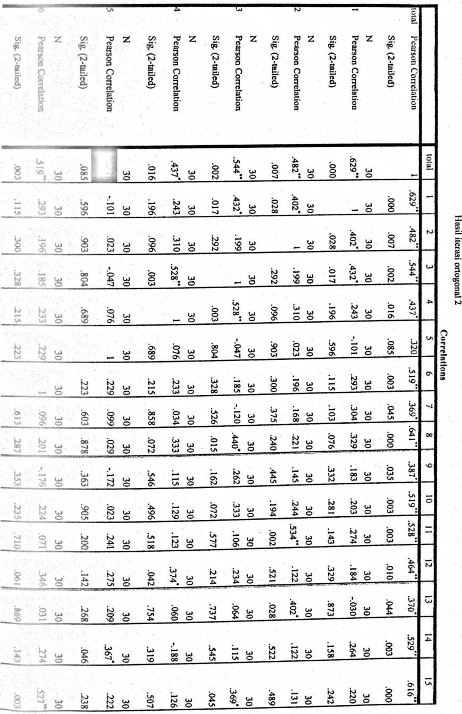
Lampiran hasil iterasi ortogonal 2

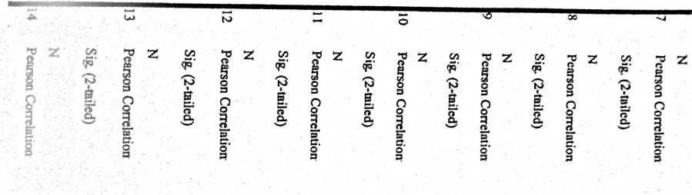
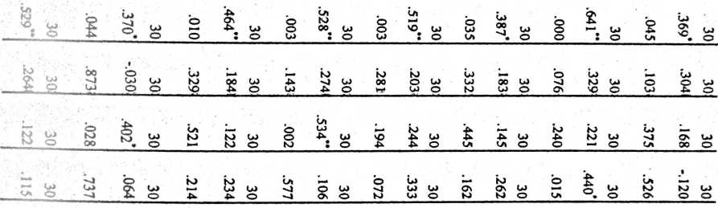
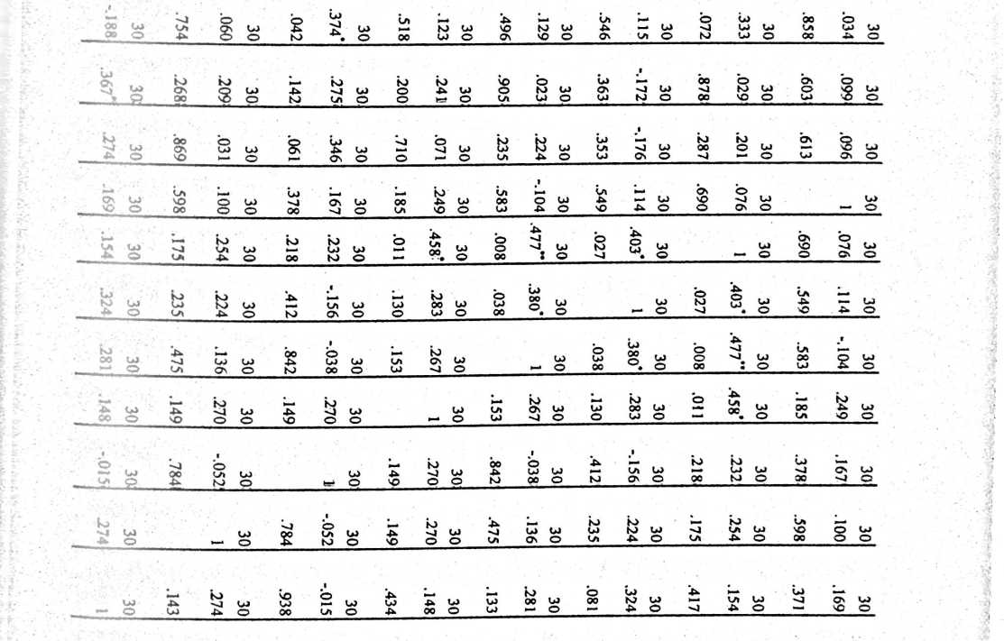

S’— | '■"1 | 81 | 1 n _ | 16 | 1 15 _ | 14 | r 13 | 12 | rr*  h—‘ | 1 10 | O | oo | 'U | O\ | LA | 4^ | LU | N) | R— | No. Rspdn |
 |  | LA | La | LA | LA | LA |  | 4^ | LU | LU | LA | LA | 4^ | LA | -4- | LA | 4^ | A | LA | LU
LA | LA | LA | LA | LA | 4^ | 4L | 4^ | LA | 4^ | LA | LA | LA | LA | LA | LA | 4^ | 4x | LA | LA | CC
LA | LA | LA | LA | N) | la | LA | 4» | LA | LA | bJ | LA | LA | LA | LA | LA | 4^ | 4> | 4- | LA
LA | LA | LA | LA | 4l | LU | LA | LU | 4^ | 4x | to | 4^ | 4^ | 4- | LA | A | 4k | 4^ | LA | LA | _1P_1
4^ | -U | LA | L/i | LA | 4^ | LU | 4^ | LA | 4^ | to | 4^ | LA | LA | LA | 4^ | 4^ | A | 4^ | LA | \o
 | 4*- | LA | 4^ | 4^ | 4* | LA | 4^ | LU | 4- | 4^ | LU | 4- | LA | LA | LA | LA | tu | Lr« | L/i | LU  LU
-U | 4^ | LA | LA | -P- | LA | 4^ | LA | LA | 4^ | LU | LA | LA | LA | 4^ | A | 4» | 4^ | 4^ | LA | 34
-U | LA | LA | LA | 4*- | 4* | LA | 4> | LA | LA | LA | 4* | LA | LA | LA | 4^ | 4^ | A | 4^ | LU | LU  LA
LA | -U | LA | 4^ | 4^ | LA | 4^ | LA | LA | 4^ | LA | LA | LA | LA | -P> |  | 4^ | LU | 4- | LA | Li  00
4x | 4x | LA | 4^ | 4* | 4^ | LA | 4^ | LA | LU | LA | LA | LA | LA | LA | A | 4^ | 4- | 4^ | LA | r—*
 | LU | LA | LA | 4^ | 4- | LA | 4U | LA | 4^ | <—* | LA | LA | LA | LA | — | L/i | M | LA | LA | 42
4x | 4^ | LA | LA | LA | 4> | 4^ | LA | LA | 4» | LA | LA | 4^ | LA | LA | LA |  | LU | LA | LA | LJ
 | LA | LA | LA | LA | 4* | 4> | LA | A | LA | LA | LA | LA | LA | LA |  | 4* | 64 | i—* | 4^
LA | 4x | LA | LA | 4^ | LA | 4* | LA | 4> | 4^ | LU | 4^ | 4> | LA | LA | 4x | LU | LU | 4^ | LU | 47[
 |  | LA | 4* | LA | LA | LA | LA | 4* | 4* | LU | 4^ | LA | LA | LA | N) | LA | LU | 4^ | LA | 48 1
h |  | -~4 | Lj | £. | | s9 | 67 j | 65 | cr  QQ | Ch | 53 | 68 | H—* | 1 73 | 73 | 59 | 60 i | 50 | Ch  M | O | zr.

c  3  D  tr | j 30 | bu  c | j 28 | 1 LZ | | 1 . 93 | | LA | tu  4. | 1 1 | 1 z? 1 | r u
j 122 | LU | X» | M | LU | tu | 4^ | LA | LA | LU | bU
j 140 | 4x | LA | 4^ | LA | 4^ | LA | LA | LA | LA | 4^
| 131 | LA | LA | LU | LA | N) |  | LA | 4^ | 4* | 4^
1 127 | la | 4^ | 4^ | LA | LU | LA | 4*- | 4- | LA | 4^
1 128 | 4* | LA | LA | r—* | LU | LA | LA | LA | LA | LA
j 121 | M | LU | LA | LU | LA | LA | 4- | LA | LU | M
[ 130 | LA | 4^ | LA | LA | LU | LA | 4^ | 4- | LA | M
| 128 | LA | LA | LA | LA | LU | 4^ | LU | 4^ | LU | M
00 | LA | LA | LA |  | O | 4- | N) | LA | LA | 4^
1 134 | 4^ | LA | LA | LA | 4^ | LA | LA | LA | LA | LU
f 129 | LU | LA | 4- | LA | LA | LA | LA | LA | A | LA
j 132 | LA | 4^ | LA | LA | 4x | LA | LA | 4- | LU | 4^
1 125 | 4^ | 4> | LA | lu | LU | 4^ | LA | 4^ | LU | 4^
£124 | 4^ | LA | LA | LU | LU | 4». | LA | 4* | 4^ | 4^
117 | LU | N) | LU | LU |  | 4^ | LA | LA | LU | b->
 |  | 1 65 | | 65 | | 60 | 45 .! | |68j | 62U | oc | o\ | 1

iran hasil iterasi ortogonal 3
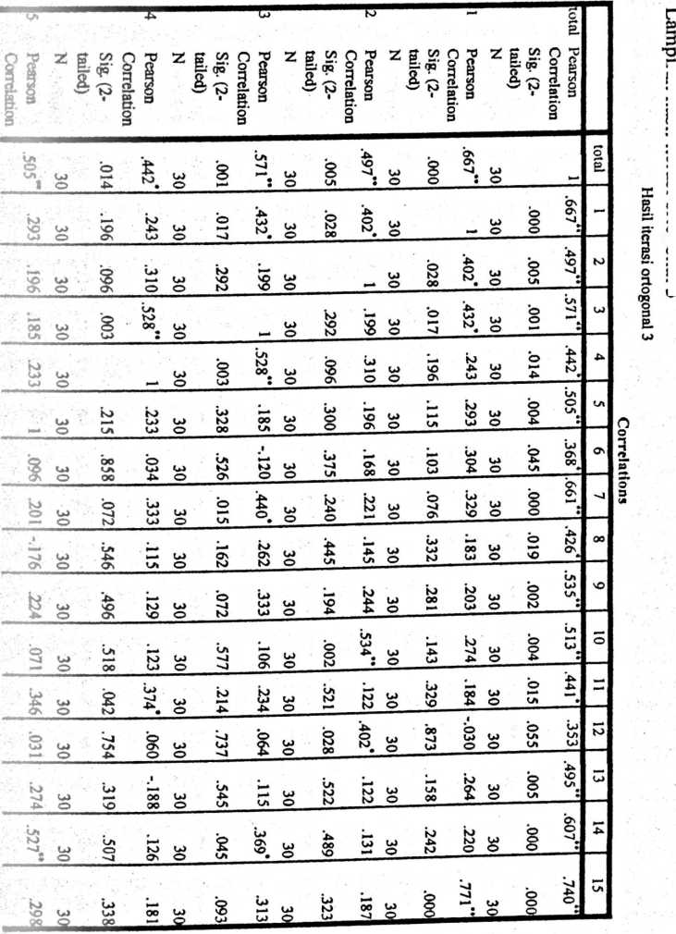
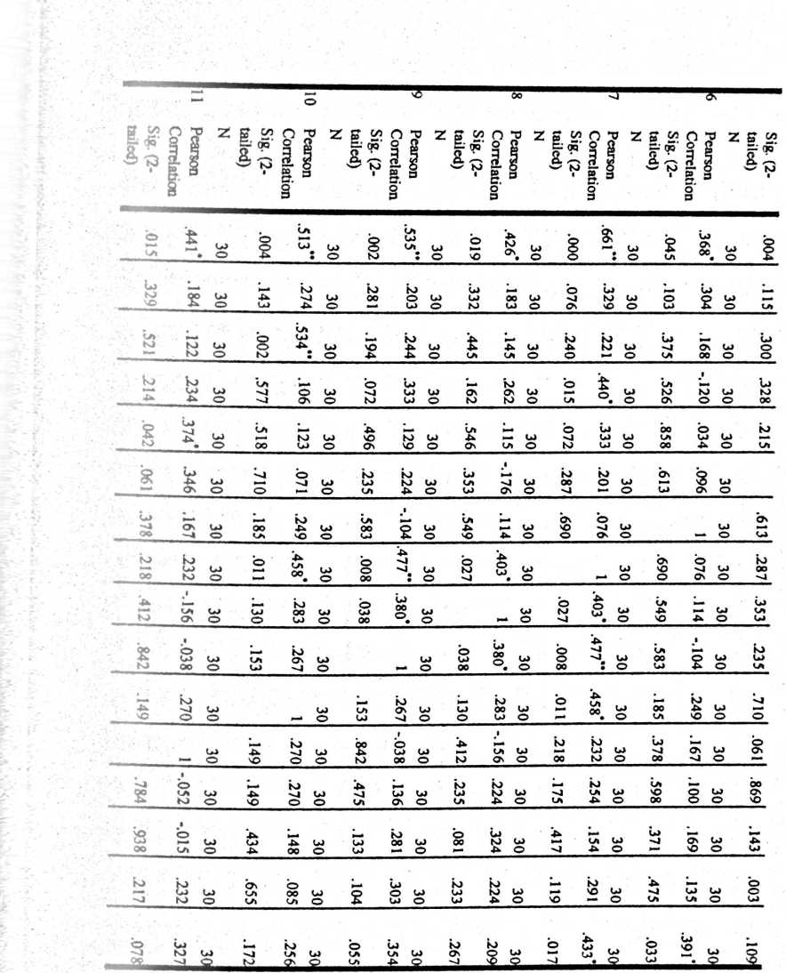

J1
m
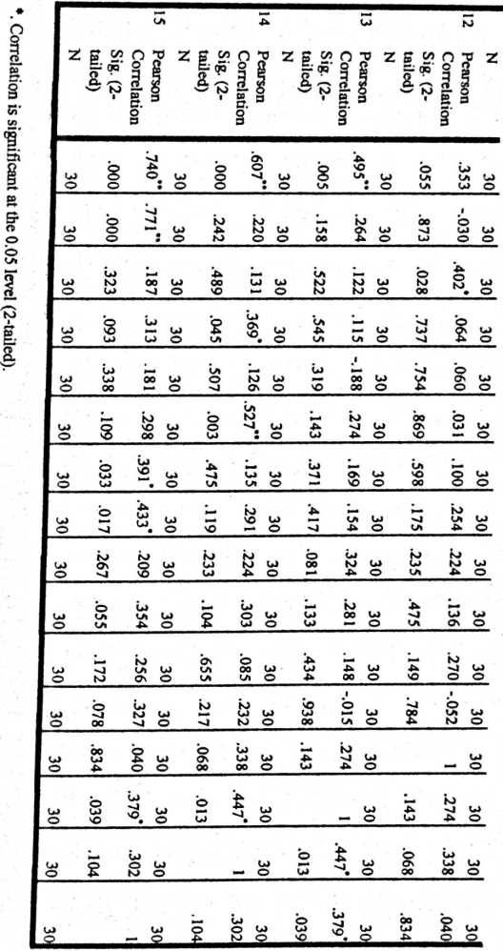

Lampiran angket penelitian
ANGKET PENELITIAN
Kajian Teologis-Praktis Tentang Hikmat dan Implementasinya
bagi Guru PAK
se-Kelurahan Rantekalua’, Kecamatan Mengkendek
- Petunjuk Pengisian Angket
- Mohon dengan hormat bantuan dan kesediaan bapak/ibu/sdr untuk
menjawab seluruh pernyataan yang ada
- Berilah tanada (V) pada kolom bapak/ibu/sdr pilih sesuai dengan keadaan
yang sebenarnya
- Ada lima alternatif jawaban, yaitu:
Sangat Setuju= (SS)
Setuju= (S)
Netral/Tidak Tahu =(N)
Kurang Setuju= (KS)
Tidak Setuju =(TS)
- Karakteristik Responden
- Nama sekolah tempat mengajar :
- Bidang studi yang diajarkan :
- Umur
- Jenis kelamin :
- Jabatan :
- Golongan

NO | PERNYATAAN | ALTERNATIF  JAWABAN
NO | PERNYATAAN | SS | S | N | KS | TS
1 | Banyak sikap saya yang tidak bisa menjadi  contoh kepada peserta didik
2 | Yesus satu-satunya guru Agung yang saya  teladani dalam proses pembelajaran
3 | Saya selalu siap menjawab setiap pertanyaan  dari siswa.
4 | Hikmat memberikan ide-ide pengetahuan  tentang jalan Allah yang harus  diterapkan/dituruti di dalam kehidupan sehari-  hari
5 | Saya tidak sewenang-wenang memperlakukan  peserta didik
6 | Saat siswa saya ada yang bandel memukul  adalah salah satu cara saya mendidik.
7 | Saya bersikap hati-hati dalam setiap tindakan  saya.
8 | Saya seorang guru yang bisa mengendalikan diri
9 | Setiap malam saya mendoakan siswa-siswi saya
10 | Saya taat pada etika kerja
11 | Ketika saya melanggar aturan/tata tertib sekolah  saya diam-diam tidak mengakui kesalahan
12 | Kebenaran adalah Allah
13 | Saya tidak kesulitan dalam mengajar, jenis  karakter apapun yang dilimiliki siswa saya dapat  mengaggulanginya dengan metode yang efektif.
14 | Saya menjadi teladan bagi rekan-rekan guru
15 | Hikmat yang sifatnya religious saya tidak dapat  memahaminya
20 | 61  0 T | 17  1 o | 16 | 15 | 4^ | 13 | U | L2 | O | 00 |  | Os | LA | 4^ | LP | bJ | 1— | Responden]
40 | ^P  bO h- | 36 | K | 35 | t | 42 | 36  'IA | 34 | N) | 26 | 27 ! | 42 < | 49 | 47 j | 52 | 42 j | 46 | c  5  c
Perempuan | rcicnipiuui  Laki-laki | Laki-laki  r» — | Perempuan | Perempuan | Perempuan | JL  Perempuan | Perempuan | Perempuan | Perempuan | Laki-laki | Perempuan | | Perempuan | | Perempuan | Laki-laki | | Perempuan | Laki-laki | | Perempuan | iender
IV/A | II/C | I1I/A  TTT/ A | a/in | V/AI | IV/A | V/AI  w/ a nr | IV/A  T\T/A | IV/A | V/AI | o | o | IVA j | ! VAI | ni/D | | | V/AI | m/D | | V/AI | golongan
 |  |  |  |  |  |  |  |  |  |  |  |  |  |  |  |  |  | lama
13 | -J | ^{D} O | 13 | 13 | 18 | 19 | J tA | CP | 4^ | i—* | 4^ | >—* | LZ | 00 | 29 | 14 | oo | menga
 |  |  |  |  |  |  |  |  |  |  |  |  |  |  |  |  |  | JBf
CZ)  f—-* | 00 cz  ►—* *— | oo  -» ►—* | w | ►—* | 00 | 00 c/ | cn  ►—* | GO  i—* | C/J | C/5  »—* | Sl | Sl | Sl | Sl | Sl | Sl | Sl | Pendidik
 |  |  |  |  |  |  |  |  |  |  |  |  |  |  |  |  |  | s
s | TK | SDN  CTYKT | SMTK | SMTK 5 | 1 SMTK | | oivi i rv  SMTK | TK | SMK 1 | SMK ! | SMP ? | SMP 1 | SDN 1 | TK | SMP | | SDN | SMA | SMA | Tempat Mengajar

n | 20 | 19 | 81 | 17 | 16 | LA | 1* | n | 12 | H-*  >—* | ►—*  O | \O | 00 | •"J | G\ | LA | 4^ | LP | bJ | ■—- | Z  c
 | LA | LA | 4» | 4^ | 4^ | LA | 4^ | LA | LA | LA | LA | LA | LA | LA | LA | LA | -4 | 4“ | LA | LA | h— | spiritual 1
 | LA | 4* | LP | LA | LP | 4> | 44 | N> | 4^ | 4^ | 4 | LA | 4 | 4 | 4 | 4 | 4^ | 4^ | LA | LA | bJ | spiritual |j
 |  | LA | LA | LA | LA | 4- | 4L | LP | 4- | la | LA | Ln | 4. | ’Vl | 4 | N) | LA | LP | 4- | 'VI |  | spiritual 1
 | LA | bO | LA | LA | 4^ | LA | LA | N) | LA | LA | LA | LA | LA | LA | LA | LA | 4^ | 4^ | 4 | LA | - • | <ebijaksanaan 11
i | Vi | LA | 4*- | LP | 4» | LA | 4^ | bJ | 4^ | LA | LA | LA | 4 | LA | 4 | 4 | 4^ | 4> | 4> | LA | LA | cebijaksanaan 1
 | LA | LA | 4» | -P* | LA | 4* | LA | LA | LA | LA | LA | LA | LP | LA | -P- | 4i |  | M | »—* | -t. | Cs | cebijaksanaan 1
 | 4^ | 4» | -4 | LA | 4- | LP | 4^ | 4 | LP | 4- | LA | LA | 4 | 4 | 4 | LA | LA | N) | LA | LA |  | cearifan 1
 | LA | 4^ | LA | 4> | LA | LA | 4- | LP | LA | LA | LA | 4 | 4 | 4 | 4 | 4^ | 4^ | 4^ | 4^ | LA | CO | cearifan

 | LA | 4 | 4 | LA | 4 | LA | LA | LA | 4 | LA | LA | LA | 4 | O | 4 | 4 | 4 | 4 | 4 | LU | >O | G  S.  □
1  I |  | 4 | la | 4 | LA | LA | 4 | LA | LA | LA | LA | 4 | 4 | 4 | 4 | 4 | 4 | LU | 4 | LA | 10 | z  o  p  p^  p
 |  | fy | 4 | LA | 4 | LA | LU | LA | LA | LA | LA | LA | 4 | LA | 4 | 4 | 4 | 4 | 4 | ’^A | — | A  P  P⁵  O
 |  |  | 4 | LA | 4 | LA | 4 | >—• | LA | LA | LA | LA | 4 | LA | 4 | —- | LA | bu | LA | LA |  | G  P  >-* •  p⁵  p
 | cn | la | LA | LA | 4 | 4 | LU | LU | LA | LA | 4 | LA | LU | LA | LU | 4 | LA | 4 | 4 | LA | 13 | d.  p⁻  CL  S
 | LA | LA | 4 | 4 | LA | LA | 4 | LA | LA | 4 | LA | LA | 4 | LA | 4 | LA | >—* | LU | LA | LA | 14 | SL  p  CL  P  3
 |  | 4 | LA | 4 | LA | 4 | 4 | LU | 4 | 4 | LA | LA | 4 | LA | 4 | 4 | LU | LU | 4 | LU | 15 J | 2-  p"  CL  §
 |  | L£2J | 1 65j | 67 | [S9 | O\ | o\ | LA  LU | 68 | -4 |  | U | |09 | 99 | Os | Ln | |09 | 50] | 62] | 'L | >—i  ZT*

 | Frequency | Percent | Valid Percent | Cumulative Percent
Valid 50 | 1 | 5.0 | 5.0 | 5.0
53 | 1 | 5.0 | 5.0 | 10.0
59 | 1 | 5.0 | 5.0 | 15.0
60 | 2 | 10.0 | 10.0 | 25.0
61 | 2 | 10.0 | 10.0 | 35.0
62 | 1 | 5.0 | 5.0 | 40.0
64 | 1 | 5.0 | 5.0 | 45.0
65 | 2 | 10.0 | 10.0 | 55.0
66 | 1 | 5.0 | 5.0 | 60.0
67 | 1 | 5.0 | 5.0 | 65.0
68 | 2 | 10.0 | 10.0 | 75.0
70 | 1 | 5.0 | 5.0 | 80.0
71 | 2 | 10.0 | 10.0 | 90.0
73 | 2 | 10.0 | 10.0 | 100.0
Total | 20 | 100.0 | 100.0

z
r-J
9Q

-ampiran tabel tabulasi hasil penelitian
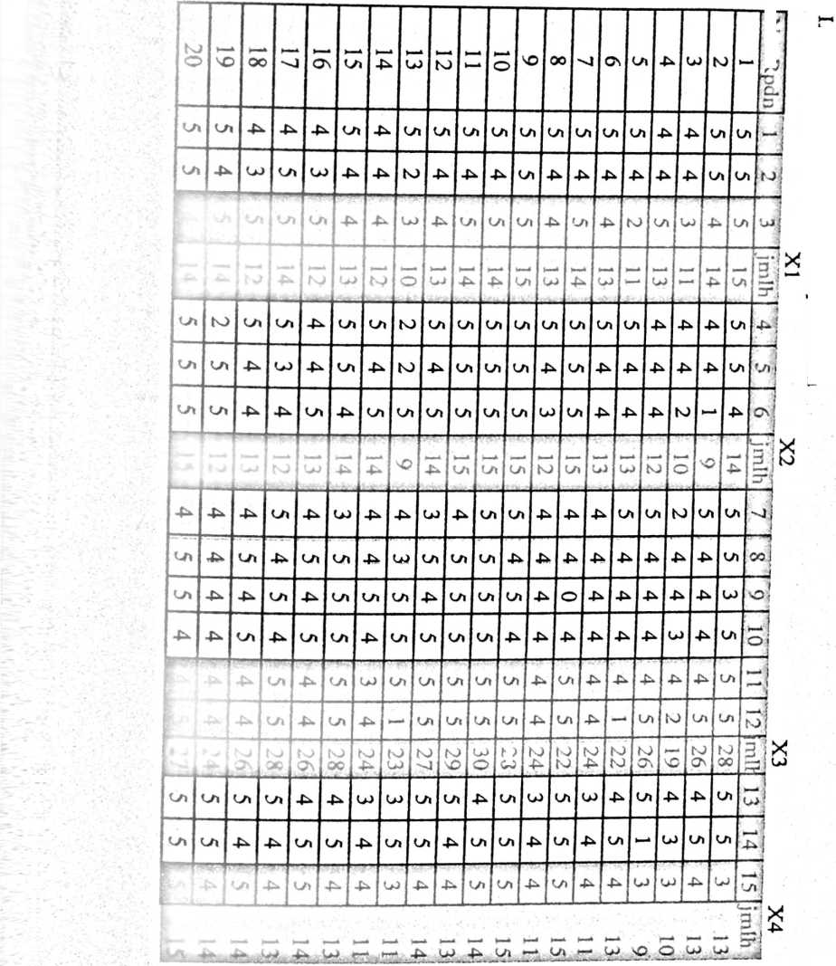
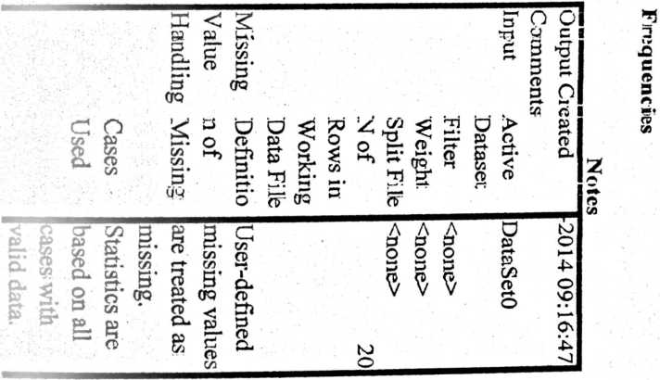
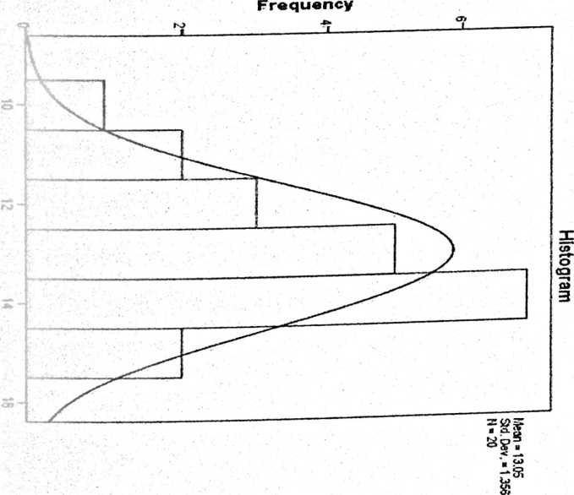
I’Hn QUENCIES VARI ABLES-X U
/STATISTICS*STDDEV VARIANCE RANGE MINIMUM MAXIMUM MEAN MEDIAN MODE
/U’ SIOGRAM NORMAL
/ORDER-ANALYSIS.

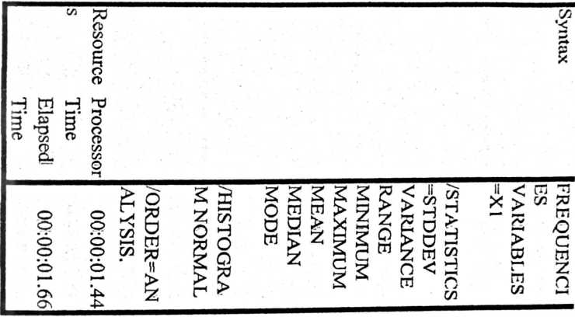

<
£.
O-*
LA £ W NJ C
i»
>—•
O N> ^{w} ’”⁴ | Frequenc  i y
O — LP M >-* >-  o o J⁷¹ p  o b o o 6 o o | Percent
LP bJ  o o y' H¹  o o o o o o o | Valid  Percent
►—*  o o la o y» y*  o o o o b o | Cumulati  ve  Percent

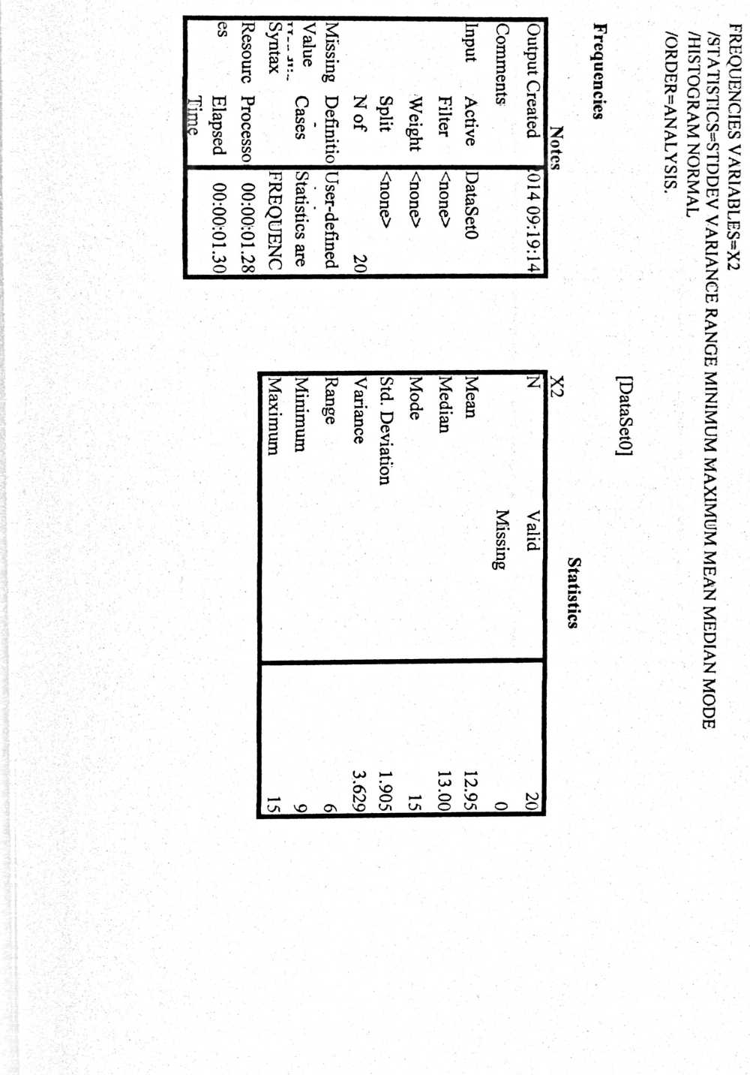

t
I
Frt^ency
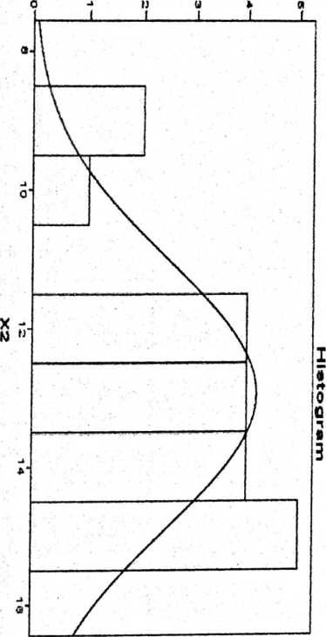
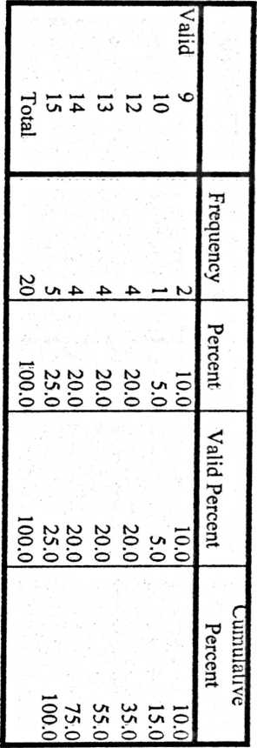
K
i
I
i
I
*

Output Created  Comments | 014 09:22:50
Fnput Active | DataSetO
Dataset
Filter | <none>
Weight | <none>
Split | <none>
File
Nof | 20
Rows in
lissi Definiti | User-defined
on of | missing
due Cases | Statistics are
and¹ Used | based on all
Syntax | FREQUENC
 | IES
esou Process | 00:00:0136
ces or Time
Elapsed | 00:00:01.60
Time
Statis tics  X3  N | Valid | 20
 | Missing | 0
Mean |  | 25.55
Median |  | 26.00
Mode |  | 24ª
Std.  Deviation |  | 2.762
Variance |  | 7.629
Range |  | 11
Minimum |  | 19
Maximum |  | 30

Output Created |  | -JUL-2014 09:25:36
Comments
Input | Active Dataset | DataSetO
 | Filter | <none>
 | Weight | <none>
 | Split File | <none>
 | N of Rows in  Working Data  File | 20
fissing | Definition of | User-defined
Value | Missing | missing values are
landling |  | treated as missing.
 | Cases Used | Statistics are based  on all cases with  valid data.
Syntax |  | FREQUENCES  VARIABLES=X4  /STATISTICS=ST  DDEV  VARIANCE  RANGE  MINIMUM  MAXIMUM  MEAN MEDIAN  MODE  /HISTOGRAM
NORMAL
/ORDER=ANALY
SIS.
’esource | Processor Time | 00:00:01.22
 | Elapsed Time | 00:00:01.35

N Valid | 20
Missing | 0
Mean | 12.80
Median | 13.00
Mode | 13
Std. Deviation | 1.735
Variance | 3.011
rlange | 6
Minimum | 9
Vfaximum | 15
X4 | Frequency | Percent | Valid Percent
IValid 9 | 1 | 5.0 | 5.0
10 | 1 | 5.0 | 5.0
11 | 4 | 20.0 | 20.0
13 | 6 | 30.0 | 30.0
14 | 5 | 25.0 | 25.0
15 | 3 | 15.0 | 15.0
Total | 20 | 100.0 | 100.0
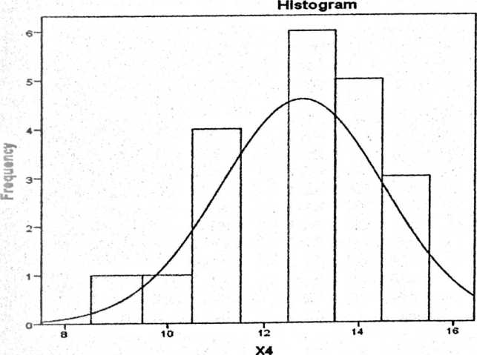

 | Frequency | Percent | Perce  nt | Cumulative  Percent
[Valid 19 | 1 | 5.0 | 5.0 | 5.0
22 | 2 | 10.0 | 10.0 | 15.0
23 | 1 | 5.0 | 5.0 | 20.0
24 | 4 | 20.0 | 20.0 | 40.0
26 | 4 | 20.0 | 20.0 | 60.0
27 | 2 | 10.0 | 10.0 | 70.0
28 | 4 | 20.0 | 20.0 | 90.0
29 | 1 | 5.0 | 5.0 | 95.0
30 | 1 | 5.0 | 5.0 | 100.0
Total | 20 | 100.0 | 100.0
