<D

(V
CL
£ O
X
<D
bD w

S) Sd
bD £
s J
'E o
0)
3

2 S)
I §
TJ X
X W)
s
03
03
E
03
cn
03
’£T
(V
03
3
o
w
03
c
03
3
03

s I
t:
3
03

§ £
o
bp £
3
(0
cn
03
£
03
O
bD
3
O
-*-»
o
bD
C
03
bD
3
<D
c
03
’O
5
U
<V
3
03 £
3
03
W

d'
03
3
w
O
w
£
3
3
03
Oj
S
bD

oJ
03
U
OJ
cn
* a
'(A

.s
M)

,2
03
W
03
03
cn
03
<U
03
03
bD
O
0
0)
V)
0>
a
w
bD
C
03
3 r
03 £
03 .2
</) .3.
bD 05
(D
bD
a
03
’O
3
>-
3
.2.
£
’S
bD

'E
3

□
E
'S
o •;
* ;
S i
<D '
E i
*
3 *■
«J ,
</)
3
3
03
E
(D
03
U
03
03
3
’O
a>
w
O
3
3
OT
3
£
3 _
S
3 W)
3
«U

2 CL

5 2 3
03
y»
3
O
(D
V)
O
3
03
3
X
03
3^3
£ 3 3
2 0g
bO-* ^{c}

u .
«3
□
3
03
<Z)
03
£
03
03

2

3
3
03
5
X
S
s
bD
c
<p
3
03
03
S
3
(V
E
03
(U
W

1
03
(/)
03
OD £
3
03
n
E
0)
bD
3 w
o
4-»
(U
E
3
03
X
03
3
3
bD
bD
3
(V
E
a
CL
E
03
E
03
bD
3
(V
3
<y
3
w
X)
3
3
3
’S
3

□
w
0
LAMPIRAN-LAMPIRAN
rb
OJ
'S
C
<D
S
03
S
B
OJ
cn
cn
o
o
.*-»
cn
<P
g
<D
cn

£
*<n
3
a>
-*-»
<u
03
bD 3
03
3
03
03
‘(S
3
03
£
03
S
03
bD
3
o
E
§

’S)

5

S
03
0)
-M
3
0>
o
CL
3 ⁶
E £
2Z 3
03 ‘X
bD X
3 ~
a>
E
3
03
03
i
O
03
>>
03
X
bD
S

s
CM
O
Cl
w
03
3
bD
O
3
oT
w
bD
C
3 w
X 03
«5 £
bo
3
(V
£
o
w
E
o
rc
3
03 _7
bD 3
3 2
bD g
<y
3
<y
£
3
03
03

%
03
03
>
3 - -
’U C 3
3 3 »-*
£ g
- 3 j
’c S x
o ^{v} -
w
bD
O
o
o
3
w
0)
3
O
<V
W
3
0)
03
U
<V
E
<p
E
3

2
c
3
03
>
£
03
E
£
3
03
3
o
E
o
-r 3
§ £
g
(S
j-»
O
3^ ^{c} E
6 £ *
03
X
O 3
03
>
3
a>
E
3
03
O

S
03

S

s
w
3
o
3
E x
_{w} bD

E E E
-M -
3
a>
E
03
E
wv

g s
cc
03
03
03
>
3
5
03
’O
03
bD
C
0)
3
OJ
3
o
E
§
g
OJ
M
OJ
U
(D
W
3* 03
E
s
£
’O cu
bD X

5 ■

s
O
O)
w

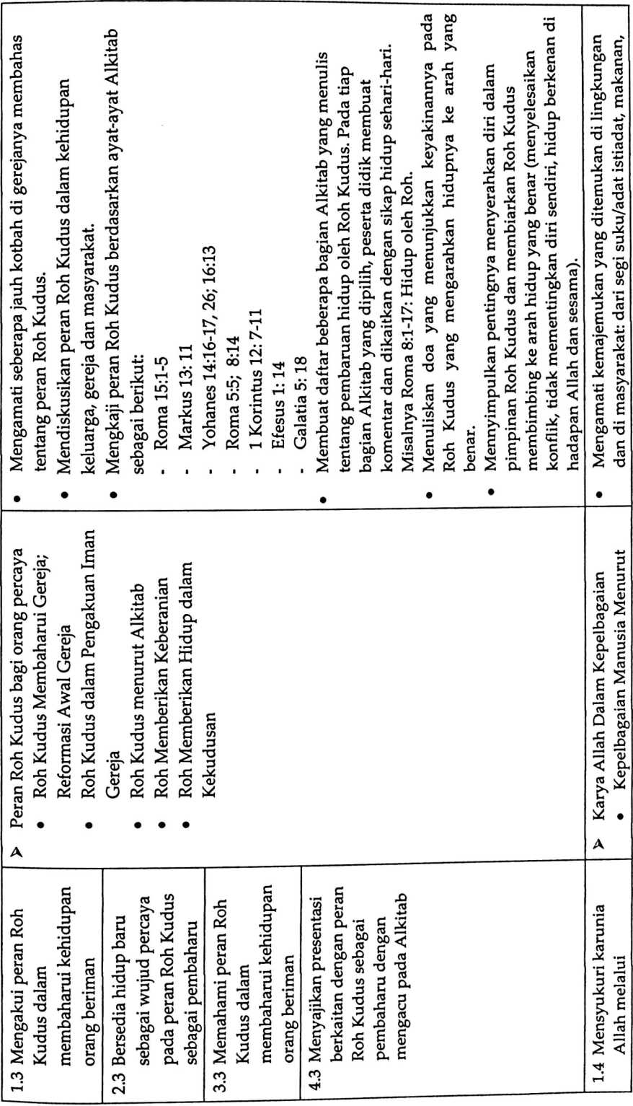

o
C
03
KD
00
O
03
00
C
(D
<0
03
(3
03
Cl
GJ
CM
i
00
00
c
Cs
Tt<
CM
w
CD
03
cn
as
0
C
00
as
00
C
as
C
as
00
C
CD
C
as
w
as
C
as
as
C
G
CD
4-»
cn
C
CD
C
CD
a
as
w
0
cn
(D
o
w
0
05
w
</)
C
03
X
CD
C/3
00
C
as
(D
U
CO
C/3
H
a
X w
00 .E
c *-•
c5 d
C
c
□
(D
E
£
S
o
■s
00
00
o
<d
o
<D
O
as
00
00
S
cn
CD
C
as
00
0
03
a
(D
C
as
00
oo
C
S
c
CD
S
CD
C/S
04
(D
cd
c
as
00
a
as
as
w
as
cn
a3
as
a
E
03
C
2
CD
a
as
X
E
CD
as
0:
00
S
S
E
as
cn
kebersamaan dengan Alkitab bahasa/ dialek, agama, dsb. Melaporkan hasil
orang lain tanpa • Karunia Allah dalam Kepelbagaian pengamatannya melalui berbagai penampilan seperti:
00
o
as
E
as
00
as
75
2
2
75
’c
CD
E
as
52
0
E

C
as
00
C
0
X
0
W
05
as
E
C
as
as
C
as
Z
as
E
E
as
00
as
E
as
00
as
00
£
as
E
52
2
oo
c
<D
52.
as
E
CD
as
00
as
X
CD
cn
as
04
CD
<D
E
03
O
E
as
00
00
c
as
E
bD
,E
cn
as
E
00
as
£1
E
c
as
C
as
E
CD
00
C
u
’S
c
CD
00
c
CD
E
g
c
00
§
C
03
4-»
as
8
00
c
as
C
E
(O
00

S

s
C
CD
E
c
as
cn
52
75
oo
c
as
4-»
C
CD
4-»
as
2
as
S
0
0
OS
S
52
oo
E
■H
E
52
75

as
E
o
P4

C
as
Q
E
(D
c
o
V)
E
c
as
X
E
(D
E
as
52
75
0
03
00
C
as

s
03
’6B
c
C
03
4-»
as
X
CQ
X
as
w
aJ
g
04
as
E
as
>
Z
I
•c

s
65
cn
<D
C
as
X
O
cn
03

I s.“
00 - ^{Kr}
as
CD
X
<D
00
05
CM
8
§
X
o
p
00

5
S
C
as
E
CD
&
CV
w
as

2
0
E
CD
S
as
X
i
cb
as
4->
03
X
as
0
§

55
C
S
.E
75
oo
a
<D
00
c
(D
E
O
G
as
00
G
CD
as
u
as
C
03
E
c5
00
as
§
S
C
as
as
u
as
0
cn
c
03

5.
S
cfl
C3

u
I
as
as
U
00
C
cn
k<
o
<D
</)
CD
CO
as
0
X
E
CD
E
00
c
as
03
0
52
a>
00 c
G S
£2 cn
as
4-»
C

U
c
as
0
CO
as
w
as
&
’w
<D
w
C
75
as
S
-M
C
cs
E
52
75
C
03
E
i—<
c
03
.as.
as
0
8
cn
as
a
as
S
X
<D
CQ

s
£
as
0
C
<D
CD
E
c
as
00
c
<D
c
03
>
52
£
.as
’c?
E
CD

&
C
JS3
3
03
00
S
c
as
03
U
03
CM
m
</>
CD

S
C
o
CD
X
E
(D
E
c
as
00
C
<D
C
(D
0
as
M
as
03
00
C
(D
O\
m5
C
as
03
a
«J
X
<D
CM
.2
as
O
CD O'
O\
CM
i
CM
<n
as
00
C
CD
E
00
c
75
cn
M)
§

S
w
CD
W
75
as
00
w
(D
C
as
X
O
c
as
cn
as
as
V)
03

S s
(D
CL
E
CD
E
as
X
E
CD
cn
(D
g
75
oo
c
as
O
00
c
CD
0
«3
E
(0
w
(D
3
Q
A
CD
E
CD
E
as
g
C
CD
00
C
as
4-»
C
CD
as
00

5

2
<D
0
C
CD
U
C
as
(/)
w
cn
03

&
C
as

«
CD
00
C
CD
c
D
4-»
c/)

S
52,
’aT
E
£
C
as
as
‘a?

z
c
as
a

-g
C
as
04
00
C
c
as

e
00
.S.
03
03
03
0
03
.as,
’c?
00
as
E
CD
X
CD
CM
in
V)
CD
C
<u
X
O
'O
as
00
as
X
CD
w
03
w
as
O
O
E
£
75
cn
as
E
c§
c
as
X
0
cn
CD
C
03
X
o
O
C
03
E

CM
cn
0
£
<D
OT
E
w
cn
as
!S
CD
CD
as
cn
as
E
x
2
75
w
as
S
CD
0
C
CD
O
c
cu
cn
as
00
C
03
C
<D
03
0
03
,<D
03
c
o
cn
C
as
E
03
X
as
E
<D
(D
0
C
CD
O
c
as
w
£
.2
‘as
E
CD
OS
cn
-
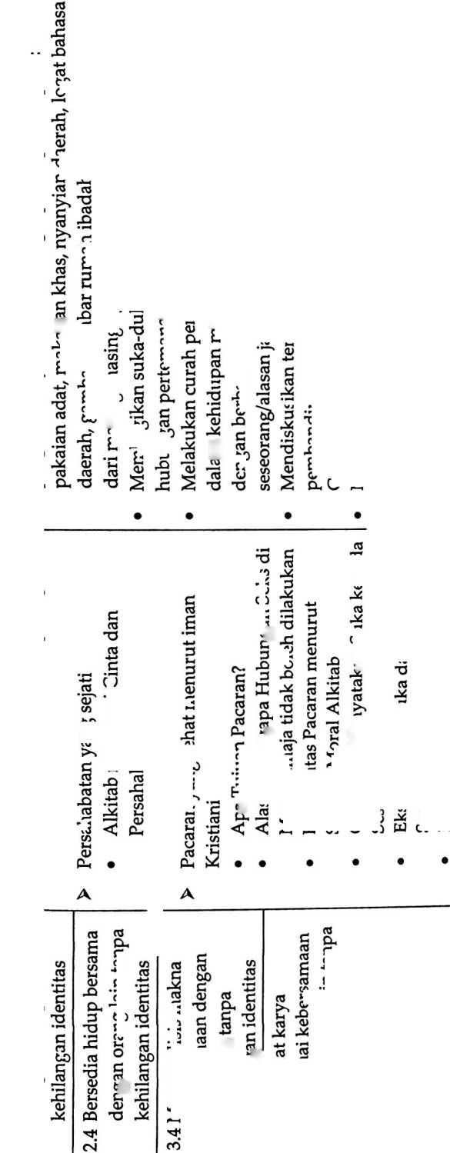
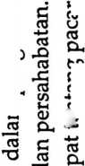
OJ
60 Ph

’C £
0)
u z:

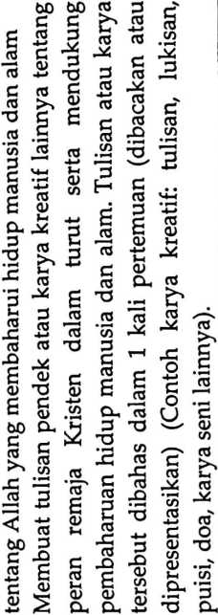
o
CN

CD
C
bO
C
03
D
05
E
03
2
O
2Z
CD
ca
cn
bO
ca
□
S
C
bb

,s
05
CA
03
C
03
X
CA
03

£1
CA
bO
bO
C
03

’O
(0
>
c
<D
.2.
J?
’S
JD
o
bO
G
bO
C
O
S
CA
3
C
E
D
03
O
03
05
3
O
CD
ca
O
bO
C
03
03
3
E
05
CM
Z
03
E
03
CA
03
<D
Q
O
S
Z
ca
w
*
W
U
Z
w
co
CD
bO
CD
S
cn
E
05
bo
C
«3
C
CD
C
o
>
o
03
C
05
C
05
bO
C
03
E
D
03
a
o
ca
03
D
C
c
03
CA
03
£
03
O
05
4-»
D
E
a
03
03
□
o
<D
ca
O
bO
C
O
4-»
O
bO
□
o
CD
c
B
<v
C
03
bD
C
(D
03
3
ca
CD
ca
C
03
03
C
O
bb
CD
03
£
3
C
03
bD
C
03
C
cs
CA
03

$
05
CD
C
CD
U
C
03
CD
S
m
co
X
c
CD
O
c
05
CA
05
£
03
£
C
03
bO
C
CD
C
05
3
05
4-»
CD
bO
C
(D
§ •
bO -

I s
r- ^{1/3}
E u
5 CA
bO CD
C T5
D ‘
05
E
03
bO
03
§
J-4
’cn'
C
03
03
E
03
bO
G
D
E
05

O
C
„ S
S £
B □
a
D
CA
a
o
a
03
a
03
bD
c
<D
05
CD
C
D
E
05
<D
ca
C
05
2
S
CA
03
E
c
03
«5
O
«J
V)
£5
05
o
4-»
CD
E
c
05
05
C
CD
05
03
U
D
CA
CA
■Z
03

□ I

* C
(3 03
03
03
□
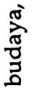
(V
C
03
bO
(D
C
03
CA
bO
C
03
CD
CA
§
03
E
03
bO
C
CD
E
c
03
05
6
G
03
6
o
E
CD
cn
(V
V)
03
O
4-*
03
C
CD
03
a
c
CD
ca
S
CQ
3
’O
2
05
c
(V
D
c
a
□
03
S
04
bO
C
O
bO
C
03
ca
03
C
CD
CA
CD
CQ
oo
C
os
o
C
03
bD
C
03
00
C
03
03
03
E
03
CA
U
D
£1
D
3
s
s
E
05
a
c
03
4-»
g
5
bO
C
05
O
bD
C
(D
03
E
03
CA
CD
bO
C
D
£
3
cx
£
03
E
CU
C
D
03
C
03
03
U
<D
£
D
E
C
03
CD
CA
03
(D
03
C
CD
£
o
c
CD
<D
2
c
3
O
>
E
.£
E
S c S c
bO 03 CU O
C
O
E
S
03
4-*
CD

C
S o
CA
ca
03
a
C
(D
5
C
O
c
03
03
£>
CD
>
C
05
a
cn
£
2
S
D
'S
03
CS
U
CD
ca
*CA
C

jD
S
E
o
S
-S
s
c
bO d
C S
bJO 03
C '
CD
bO
g
<D
CD
C
03
-D
05
03
X
03
2 v
E «
C
03
bD
C
CD
c
CD
£
a
05
03

’O

C
’■£
D
a
05
03
S
03
CA
D
.D
CD
3
s
S
E
03
CU
a
03
C
03
bO
c
03
O
c
05
bO
C
(D
C
03
00
C
” £ «
--.“'S
- C <= SS
E
C
05
03
c
05
E
03
05
U
_ ■§ Si

- U i
*P c
C 0)
2
S
c
CD
£
<D
C
CD
bO
£
bD
CD
C
CD
E
D
s
ca
C
O
03
V)
ca
<D
03
E
05
(A
S
§ £
2 .1
bD —
O
CD
CA
'T
D
’cA

C
CD
4J
CD
Cl
E
o
.E
S
bO
c
03
O

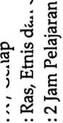
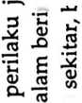
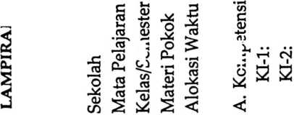
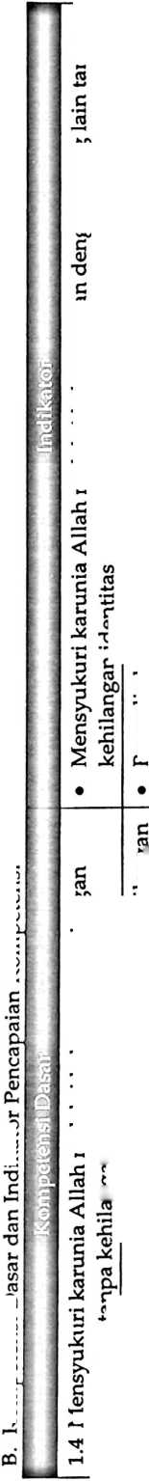
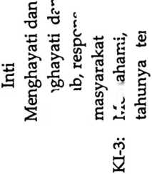
 | • Menjelaskan pemahaman mengenai ras, etnis dan gender  • Menjelaskan persoalan yang dihadapi menyangkut ras, etnis, dan gender  di tempat masing-masing. | • Menceritakan mengenai sikap yang baik yang dapat dilakukannya dalam  kaitannya dengan perbedaan ras, etnis dan gender.  • Membuat karya tulis mengenai perbedaan ras, etnis, dan gender yang  bersifat memperkaya pengalaman dalam bergaul dengan orang yang  berbeda dengannya tanpa kehilangan identitas.  • Menyusun laporan hasil wawancara, observasi terkait keberagaman  manusia baik secara ras, etnis, dan gender.
identitas | 3.4 Menganalisis makna kebersamaan dengan orang lain tanpa  kehilangan identitas | 4.4 Membuat proyek mengenai kebersamaan dengan orang lain  tanpa kehilangan identitas

c
.B.
js
’o
£
o
U
o
U)

5
O
TJ
C
O
M) 3
- «J
5 2?
T3 o
CA
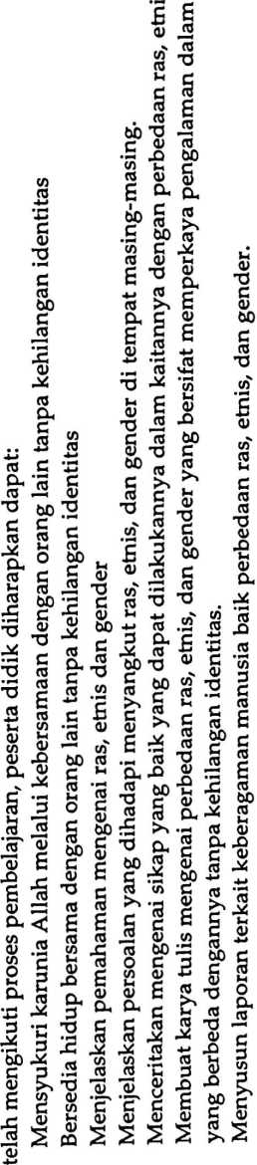
o
(/)••••••
o

■o
c

a>

oo
a
a
O
CM
C
3
X
«5
□
\O
W
H
c
o
CM
C
01

c
4-1
O
v?
«J
C
rc
a
O
o
o
a
’O
a
Oq
K
E
a
St
E
V
8
c

jy
7)
8
3
§
(3
S
uo
c/5
es
cr
(D
c
B
W
’O
C
<u
E
o

iZ

X'
<fi
-2

’aJ
«i
S
w
in
c
o
-M
</)

CO
V)

2
c
O
00
CO
CM
OJ
</)
E

.2.
’c?
e
u
c3
A
E
GJ
3
03
E
a
00
(3
E
«j
00
d<
CM
(3
E
<v
V
(3
Dm
E
a>
o
w
C
«j
00
G
3
2^
00
c
§
c
n3
a
.2
2
E
(D
.2
£
2
O
nS
§
<D
>
O
cu
-X
in
£
g
U
S
S
U
w
E
D
2.
^2
o
-Q

§
2.
S
aJ
t
a
v>
'S
L- ^{C}
(U
’o 3
cn tj
E
3 •
CO
C5
c
(V

5
X
3

ca
O
(D
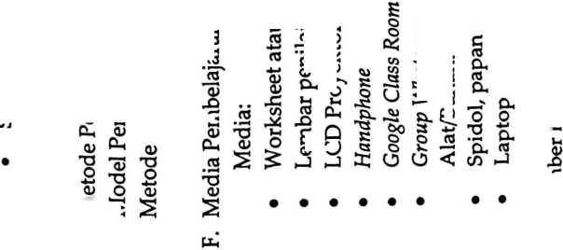
 |  | 4-1
 |  | a
 |  | s
 |  | o
 |  | c
 |  | 3
 |  | 3
 |  | 03
O
C
 |  | Ph
S
4-1
 |  | 00
4J
'E
 | s
 | 35
 | X
c  03 | CM
u<  .2.  ’oT | ^{r}T*  (D  S/
’S  X  c | c  03
c  <y  Cm  X | 3  E  <D  4-1
 | <D
C
X
03
00
J  I | T-< |  | Guru:
03
'O
03

C
03
3
’oT
00
S

2
cn
os
>
X
O

2
2
00
c
□
<n
00
03
03
cn
3
E
<y
o
o
00
C
03
03
O
03
00
c
□
00
O
00
C
03
3
E
<D
(D
03
O
03
C
OS
O
4-*
03
c
03
W
03
C
03
□
E
<v
<D
03
O
03
c
03

.2.

j?
S
n
E
o
c
03
3
2
a
03
c
03
03
>
C
03
C/3
03
X
03
C
03
■X
03
00
C
03
S
03
.2.
S
w
C
O
4-»
(D
CL
£
o
C
cn
C
O
'S
a
£
o

03
a
E
03
>
S
s
<D
Pk
C
03
X
.1
’oF
00
5

2
<D
4-»
03
E
c
03
□
X
S
oo
§
4-»
C
cu
4-»
S
03
X
3
X
03
<D
o
a
£
o
S
s
8
C
03
o
n
£
cv
<D
X
E
<D
S
<D
X
E
o
S
C

2

’ob
03

x
E
w
ra
E
£

c

bD
as
c 2
c S
2
E .2
v bC
u
>
G
as
03
C/5
2
as
5
2
2
E
C
03
as

$
as
C
03
6
as
cn
as
E
o
c
c
as
03
2
c
03
4-»
O
«5
cn
u
bD
C
0)
E
C
as
2^
as
03
■O
C
O)

s
2
c
5
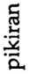
00
c
as
as
C
as
(V
03
O
C/)
as
2

5
X3
E
0)
E

5
c
u
c
as
>
C
as
03
V)
U
E
0)
E
c
as
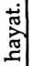
OC
C
as
C
v
0)
’U
C
0)
□
as
■M
as
O
03
>
as
’U
0)
TJ
C
03
O
S
C bD
2 C
2 *
’bb
03
o>
bJD
w

‘5
w
c/T
as
C
as
03
as
£
2.
c
03
E
2
03
03
03
2
s
03
bO
as
(D
as
u
03
(D
V)
03
C
as
-E
as
03
E
o
3
U
O
E
in
2
as
2 S
E
h? 03
£3
E
03
C
G
C
as
03 03
Dl
^{c} S
rc s
4-» 03
lh cn
C
c
E
o
c
ba
71
(D
□
U
2
c
bO
a
<5
2 ’c
^{c} §
bO
G
03
L«
CL. _{c}
5 S
4-»
03
a
E
03
o
4-»
as
6
bJD
C
03
4->
C
0)
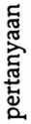
E
03

bo
C
E
as
E
C
as
>
03
2
bo
C
03
<v
£3
E
(D
E
bO
C
as
c
03
t
«
(U
O
«
a
c
as
03
§ o
4J «M
as
bJD

5
S
E
as
03
3
E
3
bD
C
(D
E
c
S
2
bb
as
E
03
bD
§
s
E
C 03
03 ±i
as
E
as
bD
C
o>
E
o
as
4->
as
03
<u
2
as
bD
as
(n
£
M
cn
as

X
as
C
as
2
0)
03
E
as
■S
5 S
«’S
a>
03
C
as
bD
§
bO
C
03
a
03
as
u
as
£3
E
03
E
C
03
03
4-»
as
s
as
E
as
cn
X
03
w
C
as
bD
C
03
’U
bD
C
□
cn
bD
c
as
C
03
aS
u
C
0)
E

c
as
bD
C
03
03
4->
as
E
bD
C
as
4-»
C
03
c
03

e
<B
£
03
E
V
OS

a
as
£
2
bD
«J
03
C
as
□
bD
5
as
4->
as
03
03
V)

g ^{E}
C as
as
bD
C
03
as
bD
_{w} C
S
03
CL
■* ’G
O 5
CL 03
E ’S
2 E
<v ._
⁰³ ‘zr
4-» as
O 2

52 CL
bo .tr
« bo
C
as
U
03
W
.2
4-*
03
CD
w
a;
4-»
□
OT
03
0)
C
as
5
£
as
2
bD
C
(D
bO

a .u
E as
O 2-

bo 2

a ‘
as
O
as
U
as

a
03
W
2
2
c
r-
03 C
C

2 •—
»-< as
u
bD
a
as
U
03
W
bO
C
as
c

2

2
OT
C
as
03
E
□
w
as
u
as
£3
E
03
S
C
as
4-»
as
'S)
03
C
as

2
E
.E
5
w
03
£3
E
as
C
03
E .
as *u
C 03
3 ’i?
w>2
03
«J

a

o
c/s
(Z
as
u
03
cn
03
£3
E
J
V)
as
bD
03
bD
a
as
U
0)
cn
bD
C
as
V)
03
>
(D
'U
C
0)

U
c
as
as
as
bD ’U
£ w
03

§ 5
E S
E

o
G- £

j’
03
W
«H'
as
C
as
.2
4-»
03
cn
as
E
bD
C
03
E
03
bD
C
<v
03
4-»
as
E
03
n
E
3
w
as
as
C
C
as
bD
C
03
03
£

.2.
03
>
C
as
03
as
u
a
as
£
as
’55
as
03
(/)
£3
O
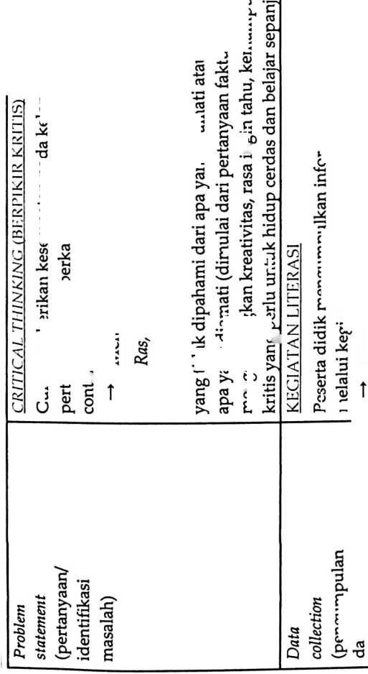

S1
3 ~
-C
03

e
bO
C
03
</)
03
24
C

3
6
o
24
O
c
03
bO
o
o o
hn B
„ O
(D G
n. ^{c}
C
03
24
03
M li
c³
5 o
E
c
03
bO
C
— v
bO ”0
03
3
C3
O
cn

x:
o
o
O
03
bO
c:
G
E
O
W -0
03
£ E
.E £
E 24
24 L
⁹ E
O

o
E
o
o
03
03
o
v>
3
24
w
a
03
JZ
03
<v
u
c
m
bO C
C 03
o □
’O 0.
g E ..
2 03 .03.
' 3

<v ’a
•* .9-
.2 C ’O
’o -g .
bO 7k S
C bO 03
03
>
.2.

a
E
0)
bO
c

o
E
bO
c ;
2 I
o ;
4-» '
03 .,
03
03
U

CL &
03 bO
TJ rc

C -fi
S ¥
03
n
E

<v
« S/5
(0
o.
3
03
4-»
03

cz
Tri
CC
Z
03
4-i
O 03
8 5?
- 03
n
o
V)

C
03
S <
o '
cn :
(V ’U,
0-< .2.
c
03 .ti
bO -5
03
03
U
C
03
bO
C

<v
’O
c
03
G3
£
03
bO
C
O
W
03
n
S
'S
bO
g -S
c
bO £
C
<D
E 03
. F
c j
o .:
^{W}x c
M 03
3
a
E ^{c}
S 03
bO
C
O
E
c
03
3
E 45
Z
w
j
E

o
03
>>
03
£
b£
C
.2.
E
03
O
bO
C
O
E
<n
3
24
V)
Q)
n
03
>
a
24
O
a
E
o
o
24
E
’E
S
a S
3) o.
03
24
W

C
03
24
⁶⁰

g a
03
(U
w
.2.
E
o
a
a
3
24
3
42
03
’O
S. •£ 5 .!
~ -M K 24 '
a 03 03 r- ’o

5 'V £
H Cl 03 M yy .
o
o
03
03
03 4-»
W) 03
bD Cu
^{m} s
03

Z
op-o 5
C2
2
bO 3 bO ’p 2 .2
c c a -E s x>
E
03
03
W
<D 03 03 C
c
u
03
o
cn
O
bO
.S
w
cn
o
u
O

w
05
ctf
3
£
C
03
a
3
o
g

05
n
S
CD
2
’Eb 45
cd ^3
os
c
03
03
’O
3
cn
bD £

8 §
bD

S
g
c
_2
05
bb
CD
a
OS
>
C
03
o
05
4-»
05
05
75
W
3
O
w
os
2
a
3
3
n
o
w
O
<D
03
S
05
a
«5
bb
3
05
C
<D
4^
’w
3
-X
w
<d
C
05
bb
C
o
bb
03
E
75
V)
CD
C
03
(D
4-*
bO

5 3
Cu
E cu
.3 03
W 'Z
(D OS
^4 w
05
C
<D
o
O
’O
C
O
U
W
£
3
03
05
§
(D
§

2
3
05
CD
’O
e
o
U
C
05
cn
£
V)
05
a>
75
E
75
3
CD
bb
3
<D
E
03
75
E
03
bb
3
CD
bb
3
os
bb
C
05
05
CD
3
<D
E
W)
05
cn
05
<D
>
E
(D
E
3
05
w
05
E
o
S
3
05
03
a
CD
3
Cl
E
05
E
CD
CD
*■»
05
E
bb
S
05
4-»
3
(D
03
Cl
E
03
W
05
£ S
CD 3
s
L-t (V
S s
d e
05 “
5
03
75
bb
os
a
<U
£
cn
os
03
C
O
bb
C
O
bD
J
3
w
bO
S
o
w
03
&
E
O
c
O ’O
M)

& s
03
■3
OS
O
(D
□
os
<D
(D
05
05
75
’O
(V
E ’o
<D 4U
t
§
o
R
<3
U4
8
E
o
w
£
w
w
c
E
CD
5
o
E
3
05
3
Cl
E
05
E
CD
CD
n
E
!
75
bO
03
w
c
03
W)
S
n
E
CD _
bb
S r-
<D 3
e'*' 05
’O
C
05
bD
§
« u-
g £
£
C
bo
C
O
W)
bb
C
O
bb
S
S
bb
CD
£ •-
os bO
bO
3
aj
3
« - 3
bb .Sx ’S
3 3
c^
c
o
bb
3
cd
E
CD
D
E
3
w
3
C
03
w
os
3
"CD
E
03
S
S
3
□
3
03
O
bb x->

5 I
c
o
CO
(D
05
O
W
I
75
o
w
C
03
X)
05
£
os.
w
03
-3
03
3
E
O
E
03
E
05
W
I
03
E
05
W
O
05
03
U
<D
W
a
05
(V
cd
’O
C
o
U
3
03
w
£
w
03
£
3
05
3
bO
&
Z
S
C
3
a
E
c
<D
E
os
O
w
<D
05
CC
2
3
05
bb
3
O
<D
w
<D
z
’w
3
J4
w
<D
a
O
O
Z
S
S
C
05
<D
W
o
03
3
cd
E
a
o
2
<D
3
a>
o
3
D-
E
'w
CD
a
03
bb
3
05
X
E
<d
bb
3
CD
£
2
05
03
.S
’O
CD
E
3
03
4-»
03
W
CD —
75 2
cv
bb
a
a
bb
C
05
4-»
C
CD
W
□
24
W
w
05
3
03
§
cu
o
w
C
05
bO
C
(D
05
a
05
C
<D
c
05
CD
4-»
05
E
bb
3
05
4-<
C
CD
03
bo
rr 03
□
bp S
G
(D
E
w
3
03
E
<D
s ⁷¹
3 ’w
03 L.
w .3
J4
05
(0
os
u
<d
V)
o
a
E
o
aJ
05
05
U
<d
w
w
’w
75
C
03
V
W
3
24
W
’w
03
5 CO
05 W
3
CD
CD
3
05
3
E 8
03 3
E 3
<D “
’w
w
C
03
O
O
<v
03
’w
05
4-t
3
o
w
o
E
<D
S
b
^5
§
O
a
,w
E
tq
8
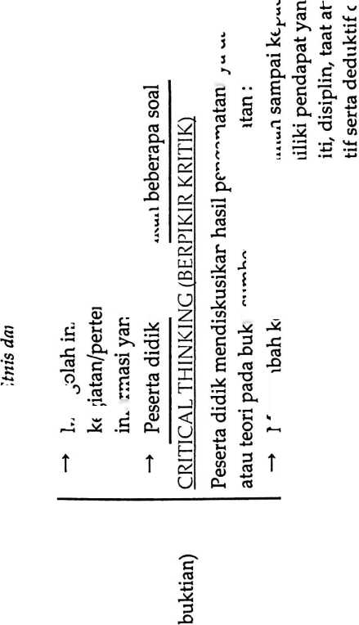
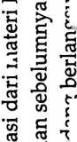
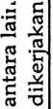
re
OJ
w
3
OJ
o
«J
3
(U
3
O
re
W)
re
re
o
C
(D
bD
re
o
re
w
5
re
re
re
re
o
b£
O
S
O
<D
re
o
re
re
O
O
1
3
&
U
O
4-»
re
bD
O
w
o
cn
O
C
re
bD
bD
<D
W
C
re
re
re
o
C
o
(V
U)
o
C
re
C
re
bD
W
G
O
o
K
re
re
w
re
bo
C
re
3
re
4-»
re
C
re
re
bD
C
re
.3
*3
a
re
bC
C
re
3
4-»
G
C
(D
C
re
□
re
re
C
re
C
o
U
re
(0
o
o
w
G
re
re
8
(D
W
C
re
X
re
bD
C
44
C
o
w
re
C
O
U
E
re
re
0)
44
re

s
E
o
o
E
3
w
fi
W
w
£
C
re
re
’bb
o
re i

h

o
3
bD
C •-
o
bD
S
o
bD
c
C
E
S
s
re
c
re
C
re
o
O
w
o
3
u
a
5
E
re
5
C
S
re
4-»
re
U
re
E
2
'o
cn
3
D
g
o
s
Mengemukakan pendapat atas presentasi yang dilakukan tentanag materi Ras, Etnis dan Gender dan
ditanggapi oleh kelompok yang mempresentasikan.
Bertanya atas presentasi tentang materi Pengertian Ras, Etnis dan Gender yang dilakukan dan peserta
didik lain diberi kesempatan untuk menjawabnya.
b0
C
G
re
,re
’re
o
£>
S
oo
<u
S
3
w
a

z
E
bO
a
bD
S
C
O
bO
re
C
OJ
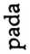

re
£
w
w
re
re
0)
n
o
o
4-»
re
E
bD
C
re
4-4
c
<v
C
U
C
re
C
re
re
5
fe
re
cS
u
(O
V)
C
re
re
g
re
bo
C
<D
4-4
re
E
bD
C
re
c
<0
(D
4-»
bD
C
re
b
§
O
st
a
w
5
C
re
re
C
re
<u
re
n
E
oj
S w
* E
w
w
re
a
re
E
re
E
c
E
2
re
E
c
re
bD
C
O
o

u
o

bo
C
o
E
re B
’P c
.22
£
w
w
re
2
c
□
re
o

Q re g
44

re
E
□
c
re
re
w
O
2
>
C
(D
a>
44
re
CU *w
c
re
bC
C
3
E
bO
C
re ’O
re □
^{M} r
2 re
re *-
o C
£ ‘5
E c
(U —
Cl re
w
re
E
re
re
re

$
w
re
£
re
’bC
C
re
E
c
o
S
re
’bb
(U
g
’o
g
6
bD
C
re
44
C
o
C
re
re
W
o
O
w
re
bo
C
re
o
c
O
O
c
re
cn
’E
44
w
W
re
re
>
£
□
(D
C
re
3
S
o
(D

re
re
re
re
o
g
O
g
w
g
re
bD
C
re
re
(D
44 rj
6
re

2
re
bD
C
o
E
3
M
bO c
i
bo C
C ^{C}
□ "
w
bO
C
re
a
o
U
C
re

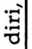
E .E
o

O
E
w
re
C
.2
’w
re
c
C §

re £ h

bo 5 2
C re
C
w) 2
a
o
o
E
2
o
(U
C
o
O
C
“J
'O
w
£
w
w
re c
C* *
o
44
re
6
2
c
□
re
c
E S
E T
bO %
c
re
4-4
c
o
44
c
O
C
re
re
C
<D
bD
re
bD
o
£ §
O
a 2
5
’c
3
^O
s
o
O
□
O
O
b
w
⁰³ _c
bD ”3
g
2
□
re
4-»
re
O
44
re
g
§
re
3
re
re
o
O
w
g
c
a>
bo •
re i.
bO re
a 3
<D
S
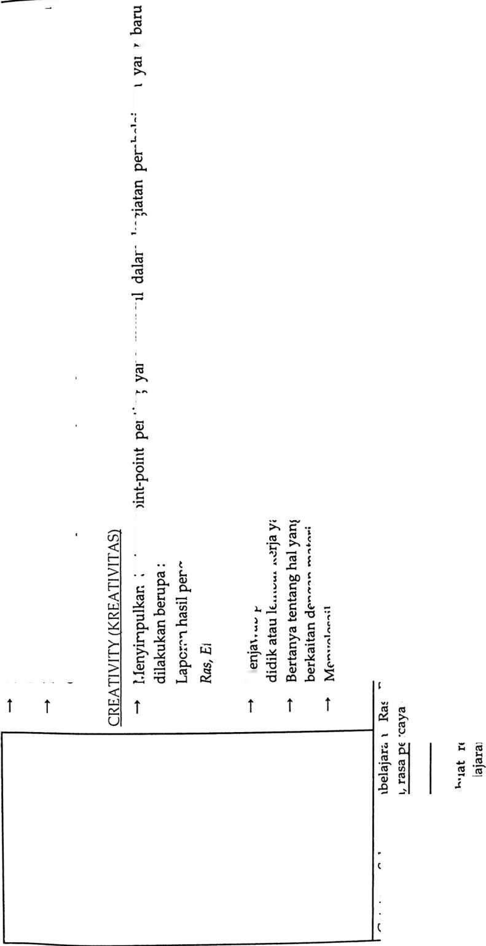

bn
E
E
gj
P
0)
o
(3
CD
2
E
Gj
ia
s
(D
co
C
gj
£
M*
CO
O
bD
C
£3
E
Q
X
GJ
O
J-»
bD
C
<D
o
w
CO
'57
»>
cn
E
GJ
bD
GJ
-O
<n
</)
3
24
GJ
bD
GJ
bD
GJ
<D
cn
’O
□
CO
E
C
C3
GJ
cn
GJ
£
<D
GJ
5
X
E
<D

S
GJ
£
GJ'
U
GJ
-D
£
(D
E

3
c
<D
X)

E
J2
GJ
O
GJ
Ur
GJ
bD
<sl
V/ T' —
GJ
n
c
U GJ
’T* GJ
2 x
a>
GJ
CD
<D
£
Q
C
oj
OJ
D

E
o
E
bD

2
Cu
bD

o
r“
G5
bD
c
(D
Q
p
GJ

E
bD
05
x>
<D
LH
bD
P
GJ
£
CD
S

2
(D
bD
C
bD
C
(D
05
C
P
05
bD
GJ
£
E
£J
C

E
oO
C
E

E
.2
‘E
P
E
2
5
D
C/J
P
GJ
bD
bD
C
gj
X
2^
E
<D

£
cn

5

S
GJ
bD
GJ
CD
cn
X
3
JG

E

3
<D
CD
C
GJ
24
bD

E
CD
bD
§
s
CD

E
E
2
S
bD

5

S
c
<d

s
bO
C
GJ
nf\
§
Oh
bo u
bO
C
GJ
bp
E

E
5
65
CL
C
<0
□

2
£

E
bO
C
GJ

E *<z
CD «
o
□
C
<d
C
GJ
bD
c
CD
C
GJ
bo
GJ
G
E
bD
<3 x
bD -2
c 2
<u . -

s
CD -

S S E S
g
GJ
c
co
CO
C
CD
O
c
GJ
4-»
cS
GJ

’c
CD

E
bD

S

£ E
£
M
GJ
<d
Cl
cn
O
<n
O
.2
’E
x>

E
CD
Pk

§

□

3 E
gj a>
§ — i
bD '
C
GJ
O
c
co
bD
C
<D
O
GJ
bs
C
Gj
>»
C
c
G3
bD
C
5
(D

. E
« J5
a «
GJ ’O
jo
E
75
GJ
!5
c
CD
-D
bD
C
GJ
C
GJ
GJ
U
GJ
C
GJ
GJ
(J
GJ
C
GJ
cn
GJ

E
.2
’gj

E

£
c
GJ
GJ
U
GJ
2

’E
<D
„ n

E

2

E

o
cn
GJ
4->
GJ
«5
o
CO
S 3
cn t
o ^{J}
3 .
‘bb •;
c
CD

E
J2
’E
.2.
o
(V
cn
C
o
X
GJ
£
JZ
GJ
G
C
cn
GJ
4-*
GJ
C
(0
n .
S
en
co

3

® 75
cn bD -X

E
GJ
S S 5 §
S S S S
bD
C
GJ
24
E
W
(D
’O
C
CD

E
p
d

E
GJ
S
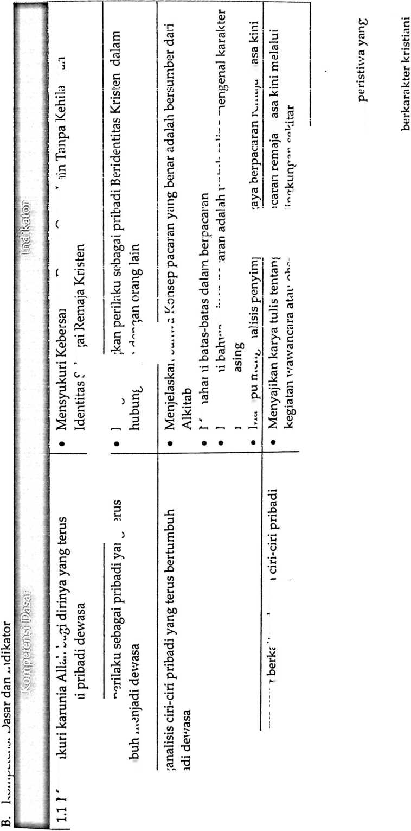
3
(C
(C
(C
01

£
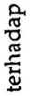
1/3
<7)

s
C
as
3
as
as
GS

c
as
as
<n
(w
3
GS
<D
g
CH
(VJ
cn
X)
O

c
CN
C
□
r-
(C
\O
V)
3
4-<
C
o
c
o
cu
_{t}C3
o
a>
0)
O
TJ
3
C
01
C/3
C
ro
£
as
w
3
CM
C
GJ
aj
r*
a
GS
tx
cc
cn
tc
E
c
s
§
E
£
S
S
U
Q
O>
a
o
U5
Z
01
01
CQ
C
ai
g?
c
0
E
01
5
o
£
«5
P

S
C
cc
bO
C
bo
bp
S
c
o>
*-*
w

Qj

S
£
ra

a
05

C
ca

J-M
ns
jc

o

E

E
01

£
0>
01

’S
5
(C
X)

£
01
U
0
U
01

x>

E
3

<n
3
'O
O

S
’O

c
c

E
01
X

aj
'-D
T⁻^

65
V)
□
■M

a
a>
X
as

w

<75

e
co
cO
CM

’S
V)

s

Lingkungan setempat

Internet
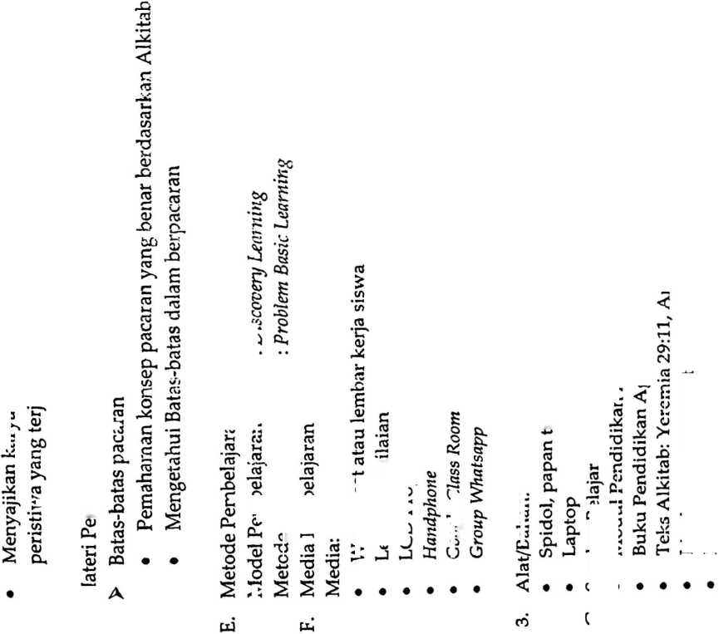
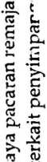
c
05
03
03
p
03
’O
03
Cl
cd
C
03
bD
G
(D
os
05
a
03
G
a
w
C
03
O
cn
a
G3
03.
G
05
g
CD
g
G
05
as
G
os
2
2
a
£
E
a
03
a
cn
a
C
03
E
2
75
bO
c
o
G
05
bO
C
a
c
03
3
2
'O
c
□
<D
E
2
75
<2
J2
’a
03
X
03
£
(U
C
03
bO
C
a
03
CA
05
3
H
bO
C
3
V)
bD
a
bO
C
05
C
cn
3
£
a
<D
05
■o
05

6

S

LD
G
03
3

3
G
03
13
G
(D
OS
CJ
03
G
E
(D
E
G
05
03
bb
a
C
03
X
3
X.
03
03
bO
C
03
03
2Z
05

’E
'bb
CD
5
S
m
X
04
03
2Z
bD
03
bD
c
03
3
E
<D
0)
cn
03
5
U
(D
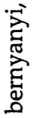

c
05
.2.
2
o
bp^
£
bO
bD
C
3
tn
bD
C
03
03
05
CA
C
05
3
£
a
G
05
O
4J
03
C 5
05
cn
a
£ E
<D ”
05
2^
3
£5
E
(D
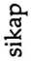
05
£
05
bD
G
o
E
g
2
75
G
05
2Z
05
bD
C
05
03
C
03
o
C
05
bD
G
o
O
bO
G
os
rr
2 w
O 05
05 ’O
05
'G 5
,S ^{w}
S' G
g
05
bD
05
D
CD
W
<d
c/s 7G
CD V)
D
tZ)
(D
C
03
bD •
c
05
.2
2
a
G
E
a
G
05
-*-»
2
bb
a
03
c
03
05
£
<D
S
C
05
05
£
a
a
£
a
w
6
<D
2
g
03
G
<D
05 G
bD C
C 5
(V ’
2 5
2 a
cn
05 05
g

S! ’S
E
a
E
4-»
03
03
C
03
E
05
c
03
bD
C
(V
2
•52
£
e
c
E
c
05
3
£
a
U)
05
CA
C
O
a
a
C
£
o
05
U
05
a
4-»
03
£
bO
C
05
C
03
3
2
o
s
03
O
s
a
g
<n
05
(/)
CD
g
<D
S

cn
a
a
(D
o
4-»
05
E
s
’E
bD

5

S
05
£
E
a
bO JZ
C
03
«5
a
05
6
a
C
03
03
>
G
03
t
a
C
03
03
bD 3
a
4->
C3
E
.S 'S'
bO bO

5 S

S 2
’S
05
>
O
c
bO os
C
03
c
a
4-i
C
03
03
,2
o
6 :
05 .,
C
05
a
£
£
a
C
03
E
a
<D
4-»
03
E
05
05
a
s
E
s
g
a
u
a
a
co
£
bO
C
05
4-»
C
a
4-»
C
m
cn
2
’a
'g' s
a
s
<3
<A
C
³ -S
E
05
K
CS
a
05 a
C
03
2
2
’a
x>
E
a
C
05
3

2
c
05
G
05
05
>
C
05
<D
03
C
05
E 2
05 “
05
C C
a -•
_ <D
S s
C
05
C
cu
a
£
E
a
03 J
bO .:
C .,
03 '
G
C
03
.2
03
o
05
E
c
03
2Z
3
G
03
w
C
a
4-»
a
a
£
o
bO
C
03
4-<
C
a
G
os
2Z
3
G
05
a
£
E
_ a

S s
a
£
E
a
Pembagian kelompok belajar
Menjelaskan mekanisme pelaksanaan pengalaman belajar sesuai dengan langkah-langkah pembelajaran dengan menerapkan
O
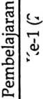
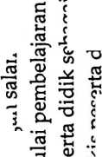
03
<D
0)
03
.w
<D
cn
<D
03
bc
c
(D
4-»
CD
03
*-<
03
<n
03
03
W
03
03
<D
4-»
C
C
03
C
03
V)
03
4-»
03
03
(A
<D
C
03
C
o
4-»
W
(A
(0
4-»
03
ca
03
W
03
C
C
c
03
d
C
03
(D
03
E
03
E
O
-D
E
(D
o
2
o
C
O
E
03
(D
c
C
<D
CD
w
c
o
2
c
g
E
D
c
03
(5
w
03
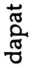

2
c
c
c
<D
4-»
ia
C
03
E
D
V)
C
O
CD
C
E
CD
E
5
2^
3
c
03
E
zj
03
4-1
03
3
d
o
E
o
V)
a
o
(0
03
03
CQ
C
03
00
C
D
D
4-J
03
E
03
O
03
n
E
o
E
c
03
00
C
D
O
JZ
<D
(fl
C
03
00
a
□
n
3
oo
C
03
C
03
03
U
03
D
4-*
C
03
03
O
03
w
03
E
£
c
2
o
c
d
ca
• —<
C
03
D
cn
C
O
D
4->
03
E
75
C
D
00
C
D
E
75
£>
O
00
03
U
C
CD
E
d
03
Kegiatan Inti (60 Menit)
2
c
C
03
00
C
<D
>
O
7d
E
CD
CD
T5
O
S
C
03
00
C C
03 CD
W
00
00
C
03
£
03
E
□
03
E
C
03
00
C
CD
o
o
E
’d
c
03
-X
03
•2 c
oo s
c £
03 h-5
’c
3
C
C
03
03
E
03
00
c
o
C
03
03
U
03
03
O
E
03
00
C
03
*
00
03
E
03
00
C
CD
S
03
E
CO
S
03
-Q
E
D
«3
CD
e
o c
n, Q
5
O
C
O
C
03
D
n
E
D
O
W
CD
a
03
00
§
n
E
D
03
U
03
E
D
S
c
*<a
03
CD
(/)
03
03
ca
03
00
03
03
U
(D
ca
C
03
03
’ob
o
£
’U
•44
•52
&
S
<3
E
e-
VJ
R
2
C
03
D
E
3
tn
O
D
4->
03
£
c
03
03
4-*
C
03
00
C
OJ
w
3
C
D
S
c
o
4~»
CA

s
03
00
a
o
d

6
S
S
s
<D
E
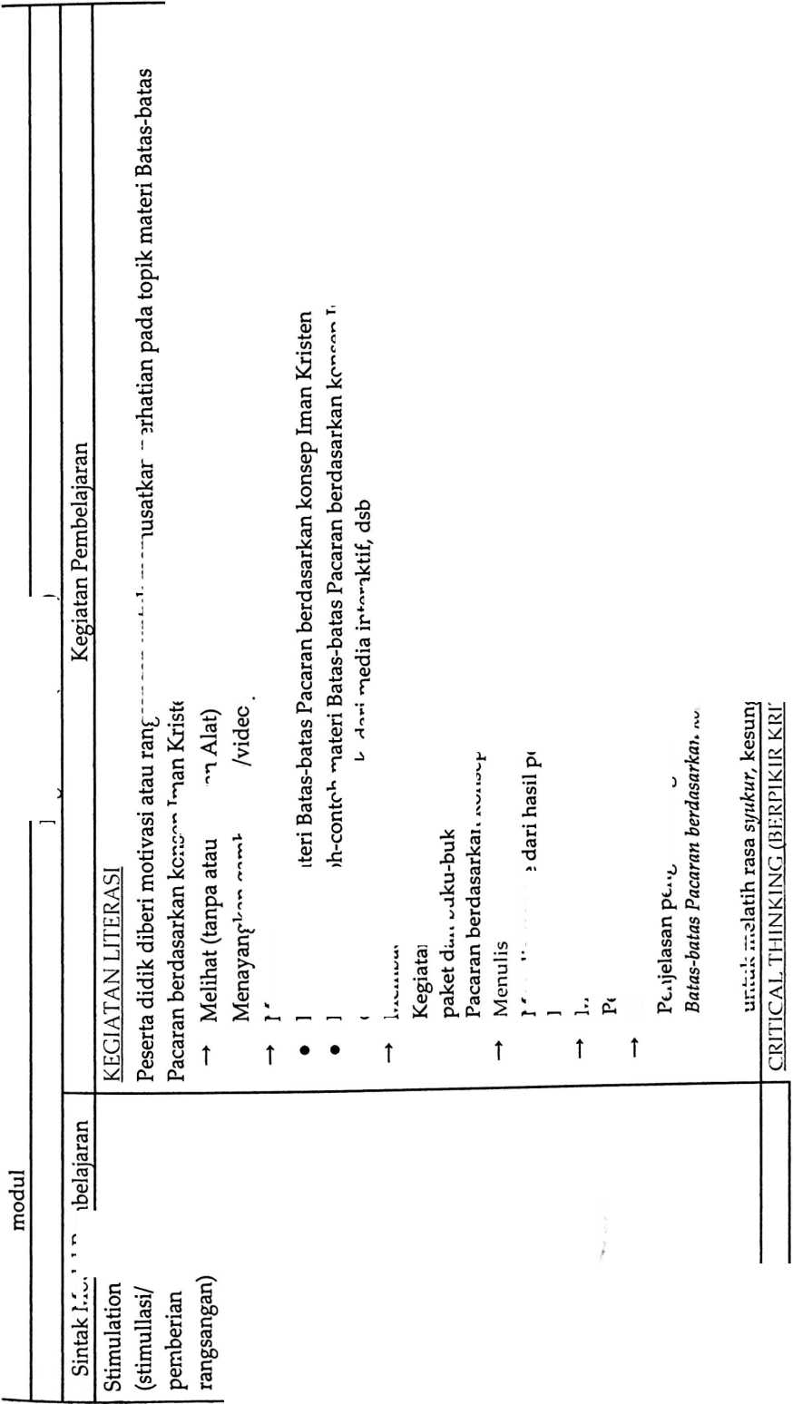
bD
a
(C
bD
C
C
(C
cc
>
C
05
C
CV
4-»
C
05
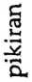
C
(V
ca
05
2
c
3
<P ..
05

>
C
-C
o
4-»
c
o
bD
3
E
£
03
C
CV
bD
C
cC
'O
(V
ca
bD
C
cc
c
V
V)
cc
c8
u
CO
C
cc
TJ
c
CC
CC
V)
cc
CA
5
S
o
ca
cc
CC
03
f <3
05
E
g
2
2
a
3
05
05
05
C
CV
bD
5
g
2
c
cc
bb
cv
3
2
2
£
cC
£
.2.
(A
cv
bD
cc
cc
C
cc
c
(V
S
CV
c
03 C
05 05
C
03
CV
o
bD
C
cc
C
cc
>
C
cc
<V
C
05
E
cv
ca
C
O
C
cc
05
n
o
u
C
(V
E
(C
bD
05
ca
(C
cc
CO
O)
Mengajukan pertanyaan berkaiatan dengan materi Batas-batas Pacaran berdasarkan konsep Iman Kristen
yang telah disusun dalam daftar pertanyaan kepada guru.
cc
E
bO
C
<V
E
c
cc
2
bb w
<M 2
<v
a
05
yu
CC
U
05
d-
CA
(V
CO
E
bD
C
05
4-»
C
<v
ca
cc
05
CD
cc
CJ
05
X)
E
cv
E
§
(0

§
-X
’cc
CA
E
(0
3
cc
<v
4-«
CC
E
G
o;
bD
C
(V
CC
CA
cc
cc
£
cc
C
(V
£
E
CC
r:
cc
CA
3
E -
E :
cv I
s -
c '
3 -
Cl
E
03
E
cv
bD
C
05
CC
0.
CC
O
cc
CC
05
U
C
<v
E
c
CO
bD
C
cv
c
3
C
05
>% es
S g
03
CA
<V
bD
C
2.
c
a
S
CC
o
05
cv .2.
Qu ’cc
C
05
CA
05
4-1
C
<v
ca
cv
E
3
2
a
05
2
c
3
C
cc
>
'o
CV
05
.ca
cv
2
cv
CV
bD
a
cc
CC
'<V
05
bD
S
s

f “
CO
a
E
<V
CA
cv
3
Si
E
o
c
2
c
3
c
05
n

E
05
bD
C
cc
bD
C
(V
ca
CC
4-»
cc
v
(V
n
E
<v
E
c
05
U
E
bD
C
S
E
o
3
cc
05
c
05
s:
a
£
S’
CA
K
£
Si
cc
cc
05

E
CA
cc
CO
ca
O’
(V

CA
05
E
o
c
c
03
3
O.
£
cv
2
E
05
E
CO
CA
24
<V
CA
C
03
bD
C
cv
CC
JD
E
05
bD
2
c
(V
C
cc
g s
c
cv
E
E
2
2
cc
>
C
C
cc
£
‘ca
05
4-»
CA
«V
c
S
2
bb
05
E
cc
bD
5
S
CC
E
CO
bD
S
s
cc
2"
2
(V
4-»
C
'bb
C
cv
E
<n
<D
4-»
□
.X
□
CA
CC
CV
c
05
□
r
CC
4J
<V
bD
C
cv
bD
a
cc
•o
<v
CA
bD
C
ca
05
3 «
bO ’o
.£
2
2
CA
c
2
CV
-D
E
3
CA
CC
u
05
E
<V
S
c
CC
4-»
S
'bb
<v
c
CO
3
2
2
E
c
• r-H
(0
X)
E
CO
C
(V
E
05
c
c
<V
4-«
ca
c
05
E
C
O
CC
CO
CV bD
Z §
§ -
2P
e' ’cc
V)
cc
4->
CC
C
cc
05
<V
ca
C
05
ca
cc
cc
u
(V
cn
CV
s C
3 -
CA
2 ._{w}
bD CA
05 g
O
cc
CO
CO
(D
O c
CV cc
cc
05
CA
s
>
C
3
CA
C
v
c
cv
4->
CA
«§
£
C
cc
E
(V
E
(V
CA
0
o
c
cv
05
2
c
o
v
o
3
D.
E
c s
*
cv
jO
E

s
co
cc
C
C
05
bD
C
<V
05
£
ca
cc
>
C
cc
CO
CO
u
C
CC
£
CO
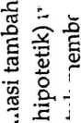
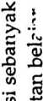
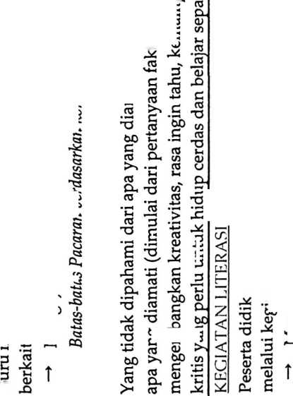
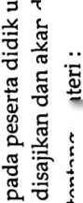
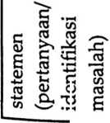
COLLABORATION (KERIASAMA)

Peserta didik dibentuk dalam beberapa kelompok untuk:

—* Mendiskusikan

Peserta didik dan guru secara bersama-sama membahas contoh dalam buku paket mengenai materi

Batas-batas Pacaran berdasarkan konsep Iman Kristen
05

£P W
s s

> -
C
(D
4-»
W
cd
oo
c
05

3
05
>
(0
o
(D
CL
05
w
05
S
C3
-Si
l
W
C
CQ
E
o
E
2
00
.£
'c?
CA
E
(D
E
g
5
S
T
c
05

s
CL
O
w
C
O
24
C
05
24
05
w
05
U
<D
n
C
05
(S
05
X
w
05
4-»
05
X
i
w
05
05
E
oo

c
05
E
c
05
W
05
05
X
S
05
24
05
C
3
00
00
c
E
c
05
s -a
a e

2 ⁷⁼¹
O <n
M)-S

5 S
X <v

x: E
3 S
24
05
C
3
00
o
V)

x
0)
o
<D
3
4-»
C
□
4->
05
E
(D
u
C
05
00
C
05
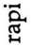
00
3
c
05
W

3
c
05
00
C
<D
U
w
05
00
2
~C?
S
E
o
s
t
00
C
(D
’O
(D
4-»
05
E
c
05
X
’w
05
4-»
5
w
<D
CL
E
CD
E
3
05
4-»
05
C
05
W
05
05
U
CD
W
C
05
□
£
o
y
oo
c
E
05
E
05
05
E
(D
CL.
C
05
00
C
<D
■o
05
3
w
(D
W
C
(D
4-»
W
C
05
E
—<
a
o
w
C
O
X
S
O
4-»
05
E
00

c
05
4-J
C
<D
4-»
’w
05
E
o

c
.$2

£
Si
a
S
&
w
K
K

-g
a
w
<3

’S
st
C
05
24
00
c
05
X
E
(D
00
C
<u
E
*c
EL 2
g ST
cu <d
E
<y ’O
00
C
05
05
05
O
05
00
05
X
<y

x
§ *5
G- -3
05
’S 2
oo g
05
X
00
L
<D
w
05
24
C
3
E
o
X
S
00 24
05
4/ 13
E
15
O
c -
d 15 .
00 bo 05
S -g ’
1 5

•f -
05
00
00
c
<D
3

J
o
24
° a
E
’o
24
’w
3
24
w
’O
C
m
x
05
X
05
E
o
aJ
05
(0
’C*
(D
24
05
X
E
OJ
cfl
X
05
a
3
05
4-»
05
00
c
05
O
05
(X
05
22
C
Z
2

z

Mengolah informasi dari materi Batas-batas Pacaran berdasarkan konsep Iman Kristen yang sudah

dikumpulkan dari hasil kegiatan/pertemuan sebelumnya mau pun hasil dari kegiatan mengamati dan
05
05
U
C
05
00
C
o
'O
C
2
2
E
05
00
c
o
X
’w
05
X
05
4-*
05
’O
X
2
o
00
c
(D
E
’w
3
X
w
’O
QJ
X
05
C
X
O
x
E
o
’o
24
E
2
2
’O
x
2
’O
05
4-»
S
w
«D
,W
£
s
&
W
Ji
c
•g
W
C
’l
Si
g
<3
C3
8
i
W
cs
«
CQ
W
W 2
c E
Q) L<

M
05 C
X
C
w
3
U
’O

S ;
S i
<D '
CL

£ -u.
00 3
C
05 _>
00 X
O
CL O
3
24 “
3
X
Cp T5
S) ra g.
s -o cl s £
3 “.s i
s
00-00
§ 2 c <5 J x
2 05 o5 r c °
Q X E C 24
05
4->
»-•
<D
w ._{w}
o oo
05
X
CD
W
O
O
05
05
c
05
W
C
05

2 gp
O
"* 3

a _{%M}

I^{g}
c
(V
E
c
05
3
X
E
05
E
(V

0£ ?5
C ’O
(D
w

M
oT
O
X
C
05
2
Z
c
c
05
O
C
05
o
05
V)
05

O

cc
C
U
o
05
5
S
’O
05
4J
05
’O
00
C

2
c
V
4-»
W
3
24
w
’O
S
X
t
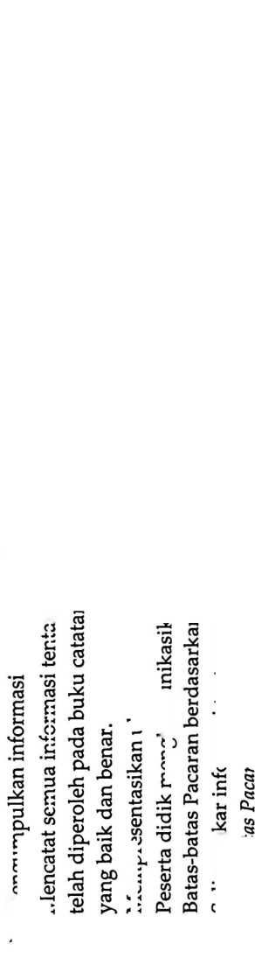
6
2
05
cn
3
O
cn
2
05
>
C
05
O
CD
cn
C
O
05
05
C
05
03
a
03
C
05
03
cn
03
(D
CD
C
03
bO
C
CD
05
CJ
a
CD
S
03
C
05
bO
C
S
c
CD
3
X?
CD
cn
O
C
05
05
cn
CD
CD
bD
a
05
2
c
05
C
05
03
CJ
05
05
E
03
bD
C
CD
bJD
a
05
05
C
03
bJD
C
CD
05
4-»
05
cn
05
bO
C
3
cn
bO
cn
os
4-*
05
CQ
’S
CD
4-»
05
S
as
C
(D
bO
C
CD
£
05
O
cn
os
Om
05
CD
-D
CD
cn
05
cn
05
E
o
c
c
05
05
Cl
CD
05
CD
C
CD
E
a
05
E
05
E
D
CD
15
E
bD
C
CD
o
bo
C
03
05
O
cn
C
<D
44
C/)
c
05
E
2
c
3
03
05
a
05
O
c
(D
berdasarkan konsep Iman Kristen dan ditanggapi oleh kelompok yang mempresentasikan.
Bertanya atas presentasi tentang materi Batas-batas Pacaran berdasarkan konsep Iman Kristen yang
dilakukan dan peserta didik lain diberi kesempatan untuk menjawabnya.
C
03
05
U
05
2
05
•o
D
E
3

o»
03
cn
03
bD
C
3
bD
C
<d
E
cn
cn
03
03
<D
cn
a
o
05
O
cn
C
03
&
05
£
.2.
cn
05
X
05
X
E
D
E
05
E
03
cn
i
05
g
03
cn
<D
cn
S
CQ
05
E
<D
4-»
cn
cn
2
CD
05
cn
05
<D
4-»
05
E
bO
05
C
05
4-»
C
(D
C
03
X
3
2
2
bD
c
03
<D
03
E
bD
C
05
4-»
C
CD
’S
Cl
E
05
cn
05
’O
CD
Cn
05
CD
D
c
03
cn
C
05
05
CJ
03
3
n
E
D
E
E

03
Ul
03
CJ
D
cn
3
03 CL
<D
O
bO
C
CD
a
05
05
CD
>
E
CD
E
c
05
CD
bo
C
V)
(3
05
C
03
2
05
05
CD
M)
CD
cn
bO
C
05
S
£)
E
CD
E
E
□
CD
05
05
bO
05
□
a
CD
cn
'S
CQ
cn
C
03
bo
c
(D
E
E
05
bJD
a
CD
E
D
E
bD
C
03
cn
03
05
CO
05
cn
03
E
o
c
c
03
3
P
£
05
ET
CD
bD
C
CD
E
E
CD
C
03
c
St
«S
§

e-
05
05
CJ
CD
cn
C
05
z
2
c
05
CD
03
E
D
cn
‘cn
2
C
03
bO
C ^{w}
g
05
E
CD
cn
05
3
a
E
c
(D
E
C
CD
cn
3
cn
C
03
03
OT
05
cn
C
05
CD
O
03
03
U
CD
cn
E
’o
o
a
E
o
o
3
3
cn
3
X
cn
4m
VJ
C
st
a
E

e-
cn
St
O
cn
S
C
CD
cn
(D
St
c
CD
E
c
03
4-»
05
’bb
CD
D
E
a
03
cn
03
CD
<D
X
E
3
cn
□
05
X
E
03

S

s
E
CD
bJD
C
CD
E
E
03
E
D
8
S
3
E
CD
C
O
03
CD
’O
ca
<D
cn
CD
05
C
05
bO
C
CD
g
S
03
03
4-»
c
05
CD
cn
CD
O
O
C
05
03_
CD
Z
C
2
c
3
’cn
3
cn
’cn
03
S
D
05
W
03
cs
cn
cs

<D
Z
2
O
u
05
C
CD
E
a
o
05
S
C
<D
O

<D
cn
CD
3
CL
E
cn
<D
a
—
3
03 os
>

5
S
cn
C
05
s C
05
X
E
(D
bO
C
D
E
2
<D
C
03
O
cn
a
03
bO
C
(D
3
05
£
’cn
03
4-»
C
CD
cn
CD
V)
03
U
4-»
03
a
03
O
C
(D
g
8
cs
8
g
CD
S
cn
G
CO
C
05
03
3
E
(D
bD

5
S
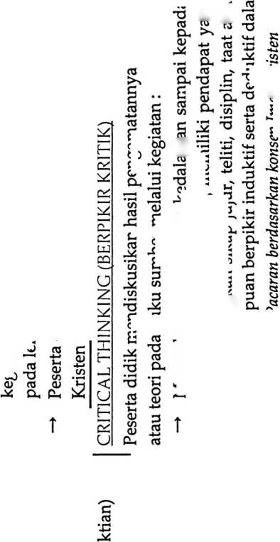
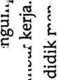
<
H
LxJ
CZ

<
UJ
u
2
’Eb
o
es
’O
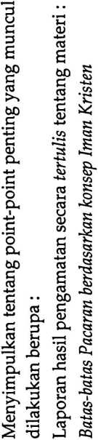
T
bO
c
03
>>
c
<u
a)
c
03
E
OJ
cn
C
O
3
03
03
(Z)
OS
(V
n
c
03
cS
3
03
.2
’O
o
V)
2
bO
C
03
>>
'2>
S
05
£
cn
S
03
O
05
Cl
(D
03
<D
D.
03
a
03
(D
-Q
O
05
Cl
S
2
"S
E
3
JP-O
w
2
'S
V)
3
<D
c/1
03
bO
3
O
4J
U)
c
03
6
<u
cn
C
O
X
c
03
03
(X)
03
Q
E
2
3
03
3 <D
s
S C!
o
03
E
bO
3
05
C
O
OJ
W
(U
O.
C
03
bD
3
03
bD
<u
E
3
'S
.D
bD
W
03
4-»
03
CQ
C
03
03
O
(D
W
C
03
3
05
E
S .2
a
V)
3
O
3
05
(V
W
03
V)
03
(D
4->
bD
.2
S
E
2
ra
T3
03
£
2
'S
03
E
03
bD
05
£
05
'5B
c
3
bO
bD
3
03
01
>
£
3
2
S
w
03
E
05
’O
05
-C
bD
E S
C
2
C3
K
<D
Z
E
2
05
C
tn
X
3
05
05
£
bD
3
05
3
2
w
S
§
E
(D
3
E
2
<D
3
3
E
(D
cn
3
O
X
a
03
-Z
05
V)
05
o
£ ³
2
S
E
3
03
bD
3
U
£
3
03
05
U
03
Ph
cn
05
4-»
05
£
i
W
05
4-»
03
ca
2
03
E
2
3
3
*w
C
2
S
a.
s «
3
05
E .2
2
05
■o
Cu a?
3
05
4-»
05
03
2
S
05
E
bO bD
C C
3 «
cn
bD
3
2
S
£
3
<U
cn
3
3
E

S
LD
OJ
£
S
<D
W
3
O
■X
§
J 3
bD 8
S ~
^{c}
8
3 ’O
O L-
0)
n
3
05
05
U
03
bD
3
4-»
3
Q>
n. w

c S
o 3
CX 03

.'p

0^2
cn
05
03
2*
S
cu
£
0)
E
OT
3
05
£
bO
<D
£
3
03
05
U
03
cu
w
03
4-»
03
£
i
V)
03
4-»
03
CD
2
S
cn
OJ
a
c
03
bO
a
03
bO
03
£
cn
w
3
03
03
W
05
3
bC
3
O
o
o
C
03
03
w
03

2
3
3
O
03
‘K
o
•E T
o. J’
(f)
bD 3
S ‘
05
3
0)
4J
3
O
3
03
X
t-
03
03
c*
£ J2
05
OT
2
’S
3
(V
s
03
o
u
o
b£
a
(U
E

2
c
3
£
3
03
03
U
05
V)
03
4->
03
£
i
(A
03
4-»
03
CQ

S
»-<
05
O
03
>
03
U
<D
a
03
<n
03
a»
E
w
os
c
.2
S
05
3
3
03
b£
C
3
03
w
04 .E
<V X
£ <U
E E s
'U T5
IX *P X
<D
£-
05
E
2
’S
cn
c
03
4-»
05
4-»
05
U
3
03
J-t
.2
2
S
01
4->
3
K
3
3 05
5 £
x 05
0)
03
44
<v
w
0)
n
bD
3
01
03
o
03
X
w
05
S
5
E
05
4-*
05
£
cn
03
4-»
05
CQ
C
05
05
2
O
,2
&
3
'E'
3
£
S
O
o
(D
05
E

2

c
3
05
cn
<y
<y
4-»
03
E
2
c
3
X
cn
E
3
O
O
bD
C
3
w
bD
C
03
3
bD .
2
TJ J)
z-s 05

f I
s
4-»
05
E
bD
3
03
4-»
3
o
4-»
3
03
05
2*
S
§ 5 S! _
3 S
P
CZ
U
<u
E

2
<D
05
3
£
E
0)
2
3
05
■2
S
-Z
<y
Cu
3
05
2
05 U
3 *
5 £
bD 05
03 cn
bD O
O
'o
<n
r
’S
E
3
£
3
05
4->
05
£
3
05
4-»
05
S
4->
03
S
S
O
<D
W
E
03

c
O
bD •
05 'v ,
bD os
3 ~
(D
□
3
O
03
W
2
S
W
bD
C
03
(3
£
w
w
C
05
o
■X
a>
a
03
W
E
<u

s
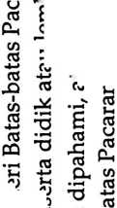
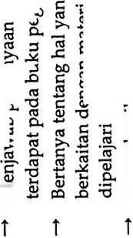
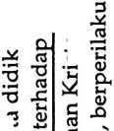
<y
03
t
<V
V)
'£
03
o
n
£
o
o
os
O
03
Cl
OJ
(U
o
V3
K
03
03
C
(V
a
03
£
c
03
00
C
O
o
cn
C
O

c
O'
O
o
O
2
O
05
c/>
03
<D
a
03
>-<
03
U
03
cn
05
(D
S
<D
O
cn
03
-*-»
03
CQ
C
o
• »—<
C
oo
£
00

2
03
ET
<D
00
C
<D
g
g
cn
a>
aJ
cn
00
C
05
g
S
c
c
03
OO
C
(D
O
O
«s
00
C
00
03
r;
oo
C
03
g
(D
o
g
o
a
g
(V
S
g
a>
g
oo
2
3
5
S
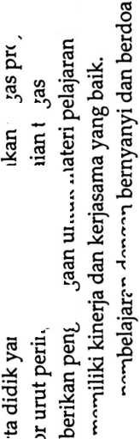
w
as
C
cd
<d
•t-»
CD
as
w
as
2 w

S’?
5
w
C
as
60
>—<
i
%
CD
as
§
U

’S
W
£
CD
W
C
o
a;
o

o
Ph
3
CP
S
.S
.2
60
c
03
o
a
aS
60
C
<D
as
S
as
w
CD
3
as
(0
as
0)
O
C
<D
60
C
cn
S <
2 £
60 '
C S
as
S
O w
CD
(D
as
C
(D
w
cd
w
as
C
<d
8
<3
C3
03
E
C3
w
CD
■§
as
C
X
as
E
E
as
E
a
E
2
c
□
-X
.2
’c?
as
£
W
w
2
CC
-S
CQ

i
cs
CP
X
C
as
X
as
CP
CD
4-»
H3
E
.2
C?
>
C
CD
as
£
2
w
3
w
3
as
as
u
(D
w
c
as
as
U
cn
<d
W
as
75
E
as
E
<D
E
3
CL
E
C3
E
c
as
as
S
05
c
a
60
C
CD
E
as
C
<D
CQ
C
as
60
c
cd
C
as
X
w
w
a
O
5
E
3
CL
E
CU
E
c
as
os
as

cd 5b
c &
G -X
3
2
’S
E
3
a
E
as
E
as
as
fe

S
o
c
g
3 as c .
w £ S c
5 w 60 2>

s
O
‘c?
E

S
’c5
60
as

’S
w
7*5
E'-S
bO x>
>2
2
S
a
E
0)
E
LAMPIRAN 3. MODUL PAK
3
’O
O
S
§
W
as
CQ
£
w
'w
as
cn
as
§
W
c
S
as
Q>
as
aS
S
W
/S
o
s
3
03
£
E
CD
w
S
4-*
QJ
S
£
E
2
3
Q
3
aJ
CL
60
§
as
E
as
W
«D
£
CD
p
’c
2
o
CD
E
as
4M
(D
W
§
I j
5 g
as
as
as
CL
as
(D
w
as
4-»
4-1
C
CD
w
as
4-»
4-»
C
<d
w
as
60
C **
E j*
£
N
8
*
2
as
60 Z
as
cn
'w
2
as
60
C
as
£
2
75
3
O
O
E
C
as
as
as
X
S
as
as
a
E
3
£>
U
w
<D
as
c
^2
’S
cn
CQ
as
CD
_ w

£ ^{c}
S «

ct «>
c
c e
2 c
60 £
CD ..m
(D
60
as
2
60 C
C 7
as
O
C
as
60

S
as
75
w
as
Cfl
E
as
w
a
n
(D
(D
n
E -
§ .2
as
as

u
(D
W
e' ’E
o -S
3
’O
o
E
2 £ E

bb I f 11

| g a) S S
S E cn
w
as

s g>-s
.2
c?
E
CD
2
75
w
ro
E
as
m-»
<D
w
as
si
S
A
W
CS
Ct
Si
Si
g
a
<3
as
as
Mm
C
as

s
as
60
C
2
C
a
§
3
3
03
O
C
<D
E
-X
2
c
3
03
W
’w
2
c
as
£
E
CD
£
4-»
ctf _
CL a;
»2 *w
T3 .i;
E £
S
.E ’
3
’O
O
E
60
C
2 -
a>
a
a
cn
as
3
X
a
CL
E
CD
E
c
x
as
E
<D
w
C
cu
3
£
u
a
c
3
’O
O
S
o
X
o
□
CP
C
w
2
5

I

s s
60 2
« ’J
h C
±i CD
S N)
CL _{r}
a> G
% 2
£
as
60
C
<D
E
as
E
CD
E
c
as
CL
.2
7?
S
Cl
E
<D
E
E
2
75
as
>
C
<d
CL
E
2
75
’O
c
as
3
2
as
w
.E
CD
w'
2
c
as
as
’O
CD
£
as S
’c? ¹

h
’C
as 4-»
60
as

■s
w
2' ®

o jS
a -
as
4-»
as
E
as
O
as
c
v
2-.
a
as
as
X
C
as
as
as
E
C3
w
CD
cn
S
60
C
(D
’O
C
as
£
W
w
M
.2
2
S
3
C
3
C
<D
E
S
a
as
S
C
<D
£
60
C
as
>
C
as
E
as
£
as
E
0)
S

s
as
C
CD
W
o
C
as
3
S
w
a
X
as
as
w
a
3
>4 S
3 CD
& E
60
C v
<D ’G
p< 2
. 3 P
60 E'
§1
.2
as
C3
,7.
as
6
as
g
S
as
u
as
CP

03 05
CL
03
C
E
(0
03
73
03
E
D
£
£
2
H
00
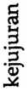
C
03
00
C
o
c
03
2^
c3
73
(S
D
03
H
■o
c
a>
03
73
03
£
D
(D
'O
C
<D
bO
3
r*
3
bO
C
CD
E
2
c
£
o
a3
o
o
73
D
cn
03
03
S
4-»
73
E
2
H
00
c
D
E
03
bO
C
03
O
03
'O
03
CL
D
73
03
C
03
'c
3
O
O
E
E
2
’H
03
ti
03
bO
3
C
CD
CD
4-*
03
g
C
03
c
03
E
03
cn
u
D
7)
C
3
2
03
03
03
’O
3
03
73
03"
B
bO
bO
C
bO
C
3
73
C
03
bO
C
(D
<D
H
E
c
03
03
73
cn
c
o
03
3
TJ
O
S
g)
00
c
□
71
o
03*
03
n
(D
73
C
05
£
D
3
03
44
03
C
• ^4
3
o
S
03
g
03
D
73
D
4-4
bJD

S
2.
D
73
'H
3 O
§) B
oo E
c ~
3
73
^{c} e
⁰³ E
oo 2
c
D
O
D
D
4-»
03
S
bO
§

5
73
03
3
75

5
g
’S
o
73
C
03
73
*3

’S
4-4
D
bO
C
D
g
4-»
03
CU
03
03
03
D
OJ
C
(D
□
S
73
CD
73
£
D
73*
03
03
s
s
CD
73
§
O
st
•52
£
uq
7?
«3
CD
bO
C
CD
E
o
'c?
E
D
T5
C
O)
00
73
E
D
C
CD
bO
C
(D
E
E
D
44
03
05
m
C CT3
.£ CL
E

.2,
•2 c
n
CL ,y
g
<U 3
E 3

S 12
-X ’O
03
o, 9-
□ ’O
03
4-»
D
73
D
a
a
03
E
03
03
d
o
CM
E
D
C
03
73
03
bO
3
C
<D
03
4-»
D
73
(D
CX
03
bD
bO
C
2
D
73
C
03
2
bb
(D
§
%
3
X
O
C
03
.2.
2
aJ
X
E
CD

E
CD
E
5
4-»
73
o
E
E
2
H
i
a
H
|
E
D
E
03
D
CO
C
CD
c
03
_{e}c3
jj
’o
E
D
C4
’C
D
4-»
03
S
03
’os
E
<D
S
00
-Q
CD
73
03
OO
00
C
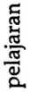
73
St
a
g

3
U
O
E
E
CD
’H
E
c
03
03
73
03
E
:§
a
§
E
&-§

§ §
Cl a
E
«
c
a>
b£>
C
<v
g
a

E
2
75
Q
!S
4-»
2
D
71
S
2
’H
c
03
C C 00 03
8> & g ’§
" c
c 2
c
03
>
03
X
D

8 5.

S

g
c5
2
’d
CM
E
03
00
03
s
75
03
E
(0 c
m E
-** 2
03
<D ’S
2

g.<
§ §
•• 2Z
03
2 E
‘ti
05
7)
05
O
T5
C
D
00
C
03
0)
C
03
c
D
2
55
5
3
T3
O
E
3
’O
O
E
E
2
H
cu
E
cn
E
D
C
D
E
05
D
73
E
03
03
E
r§
\D C
CO “
i
m
CM
.2
73
3
03
E
w
03
X
5
03
"O
03
0)
73
ri O
C
03
• M
D
C
03
2
2
’d
x>
E
D
E
D
05
2
O
a
c
03
U
H
a
D
00
C
d
(0
D
4-4
* c
£ 5
03
’O
05
D. _
bO £
C
03
4*4
03
V)
03
X
03
£
03
03
E
2
’d
D
E
c
03
M
cn
2
c
2
00 'O
S .2
& 3
§ ™
& S
c .
D u
u
03
44
S
73
C
03
X
C
3
D
X
03
§
73
03
O
E
D
03
9* ⁰³
g c 5

2 & c
oo
c

H
o
Dm 7)
05
C
D
00
c
D
3
03
00
E
3
E
D
’O
c
£
44 _{C} O
H g
73^ ^{C}
2 ^{w}
•p £
73“
2
c
C
D
5 P .« «

to ^{c} -
c
D
g
03
£
03
E
D
D
03
£
03
5
05
bO <D
z
05 C
E
2
H
(D D
CL a
£ p
D C
E 2
4^
S.
03
c
C
□
£
w
d
05 u
D
c «
D >
bo a
c
05
D
D
E
03
C
? w
c
E
03
w
03
C
03
C
3
D
03
oo
03
C 3 ’3
0.3 g
M « 2 W
E
2 -S

S
7)
03
X
05
£)
E
D
03
X)
E
D
E
03
a) ;
T? i
03 •'
73
C
03
00

S
03
15
03
d
c
05
X
05
’O
C
D
D
’t?
03
.£
E
73
03
£
g
H
00
03
E
03

S
E
D
E
d
03
a
05
3
E
03
c
2 s
:s «
xi
«> 6
E
•S ²
03
03
44
H
E
2
H
03
E
03
D
D
O
C
D
00
§
73
£
d
t?
2
c
03
03
’O
D
03
00
B
B
03
3
73
C
03
X
’H
71
2
'S
c
D
E
03
4-J
D
05
C
D
00
C
D
g
CO
X
C
73
05

£
0C
C
05
U
D
£
2
c
5
D
B
c
□
’a
§
O
a
'a
bb *2
S
2?
7)
03
U
B
<D X
cx £
(0 '
O
03
.2.

u*
5o .2
oo
c jp.S
3 C ‘
7) 00 qJ
? § “
’C
5
(D
71
D
3
i
73
O
CL

S £
a
73
St
cs
g?
bQ
K
C
03
§
0
Z
03
E
.2 ^{M} oo c
g £ S) <5 -o
” flj
£
D
D
£
2
'a
a
H
S
u
w
O
Z
w
□
D
S
cn
00
C
D
4-*
03
M
03
<J
C
03
£
03
5
S)
S |
8 o
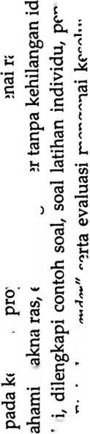
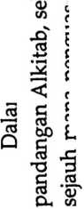
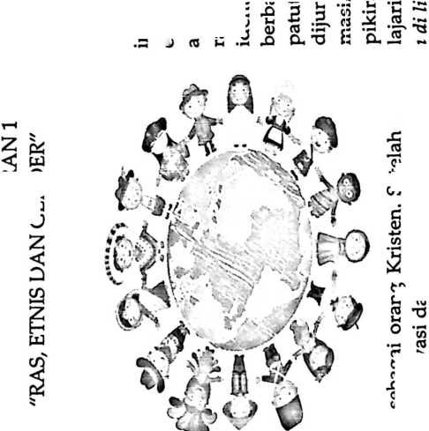
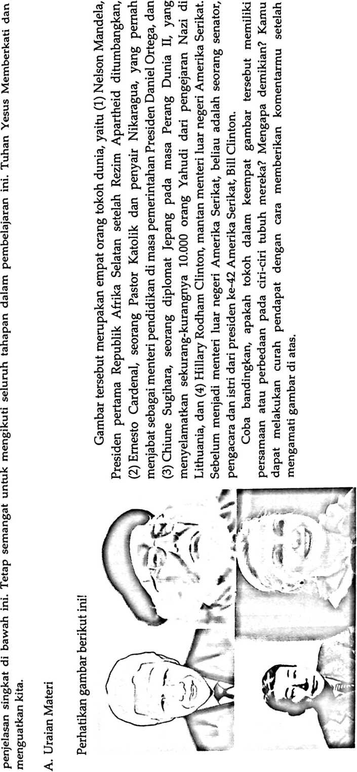

CO
co

5

i
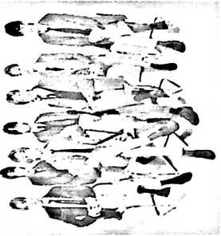
O
3
CO
CO
60
C
co
J-4
O
2
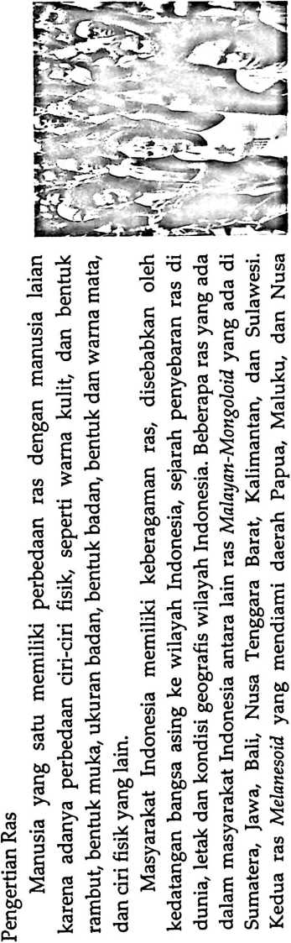
co

0
CO
co

CL

E
CD
CD
CO
CD
O
G
co
60
C
co

a.
<D
co
O
g
60

c

o
60
C
co
O
CD

a
CD

W
60
St

•S
cn
co
CO
60
G
(D
G
£
CO
CO
60
60
C
CD
CM
co
w
G

E
c
co
co
0
CD
(D

E
co

75
co
co
CD

E
co

a

o
CO
’cO

£
co
G
60
G
CD
G
e
co
2
g
«j
(0
CO
C/3
cO
C
co
g
$

a
(0
g
co
G
CD
□
g
CO
CO
S
G
g
<D
4-»
60
C
co
C
G
Cl
co
CO
C
<D
60
CD
co
60
(0

60
<D
co
(0
a
CD
60
CD
co
CO
g
(D
60
CD
co
co
<D
CO
5
co
G
60
60
C
cd
60
C
CD
<ZJ
CO
’G
L-(
<D
CD
co
G
S
£

c
co
G
co
0
G
'S
2
CO

£
G
CO
CO

a
CD
»-«
CO

E
CO
G
CO
(D

O
3
g)
60
C
G
60
C
CO
CO

’S
G
CD
60
60
G
CO
C
co
60
C
CD
CO
’O
co
60

c
CO
G

’c
G
G
CD

E
G
CO

E

E
CO
60
co

s
60
co
cn
co
CO
<d
CM
CO

E

o

X
(D TG

CU X»
CD
w
co
C
CO
CO
0
CD
(V
60
C
(0

c
co
60
2
co
CO
w
CO
C
co
CO
G

E
CD
cn
co

E
co
cn
60
CO

>

Z

c
CO
CO
G
X
60
G
co
>>
C
(D

E
60
C
co G
co cO
0 ‘
(D
O
CO

0
CO
G
G
co
CO
•G
co

•s
60
C
cO
O
cO

S
C
G

a

2
CO
O)
co
0
co
CO
G

£
CD
co
G
co
4-»
co

2
CO
cn
60
C
co
co
G

E
(D
cn
(0
CO
§
co

c
<D
co
G
co
G
CO
0
co
2

c
co
X
G
«j
a;

E
CO
’cO

S
CO
CO

E
<D

E
60
C
co
O
CO
G

£
CD
W
*60
co
CO

z
co
<0

a
CD
co

£
60
C
co
O
<D
co
(D
60
C
CO

B
C
cd
0
cd
bJD
C
05
>
CO
05
O
Ln
■o

S
S
0
g
03
4-»
03
03
<D
0
CD
03
05
&
01
C
05
E
0
0
0
0
£
CD
0
0
03
05
03
c
03
03
V)
0
S
o
O
a
E
o
a)
0
Z
CD
CD
E
0
B
0
co
§
0
C
d)
E
bD
0
0
0
’co
0
E

o
0
E
o
dJ
-4
0)
CO
0
T3
0
CL
D
a
0
CD
3
O
(D

5

CD
g
4-»
0
0
0
0
co
05
bD
os
<d
C
d)
co
0
0
0
CO
2
(D
bD
C
cd
co
£
CD
^4
O
cu
E
2
'd)
B
0
CO
§
0
0
E
bD
0
0
bD
C3
0
0
0

a)
g
75
0
0)
0
24
0
n
£
cd
2
.2.
*0
o
bO
0
2
5
05
0
03
0
0
bO
0
bD
C
co
0
bD
C
<D
£>
bD
C
05
.2
0
g
0
cn
bO
O
C
03
bD
C
cd
0
05
bp
d)
0
Cl
E
0

u
o
0
0
<u
0
bD
03
CO
0
CO
cd
0
0
0
g
0
CO
a>
co
.2
’co
0
0
>
C
co
0
0
CD
X>
0
bD
Z
0
0
bD
0
CD
0
E
C
<d
03
CQ
C
03
24
bD
bD
05
£5
a)
cu
cd
24
05
0
05
bO
§
2
bD
S
co
0
bD
G
0
O
’bb
0
CD
Q
bO
C
0
bD
§
M
O
2
0
■o
0
C
0
p
bD
0
0
4-»
0
<D
tS

S
E
bO
C
0
>>
0
0
0
E
0
O.
E
<D

cn
05
bD
0
0
g
0
0
(D
E
0
0
cu
.2
’co
bD
E
0
□
E
D
co
03
O
CO
0
0
E
24
0
C
<D
0
75
0
05
2
CO
0
co
0
E
CD
0
bD
05
’C
CD
0
24
d)
d)
E
§
bD
a
05
0
E
0
CL
E
<d
□
bD
03
■o
05
.2
0
E
0
cn
bD
0
0
O
0
bD
0
n
a>
CO
bJO
G
0
0
C
0
0
0
E
0
cn
0
O
i
bD
C
01
O
g
0
E
0
CO
«D
co
0
£
r
0
0
’E
0

5
g
0
£
a,
co
0
0
0)
(V
co
05
>
C
03
•*-»
CD
bD
C
0 co
£
d)
0
24
<D
O
E
0
24
<D
S
g
0
0
0
0.
<D
0
E
0
bO
0
CO
0
4->
0
2
75
0
05
2
’co
0
05
0
05
bD
C
05
0
£
0
0
<D
£
0
TJ
a
o
bO
C
0
TJ
C
0
E
(D
E
'd)
0
CO
►—<
bD
C
0
O
C
0
co
0
4^
0
x>
•0
0
£
’d)
E
0
E
0
CO
(D
CO
*8b
0
0
bD
0
0
• •■M
0
g
0
CD
bD
0
0
O
E
0
E
0
CO
CD
cn

•2>
'0^
bO
C
d)
E
co
0
co
d)
C
75
CO
CD
CO
C
0
X
0
2
0
bO
0
co
0
bD
(D
n
bD
c
0
0
co
bD
C
0
n
0
<d
CD
n
E
CD
E
co
fi
W
0
<D
O
0
co
0
bO
05
a
05
03
CQ
a
05
bD
C
0
03
(V
0
(D
0
03
4-»
0
.2
0
E
0
cn
'M
E
(D
E
2
CD
CO
cd
n
E
a>
E
CD
E
g
2
CD
g
CD
E
24

2
c
o
0
2
bO
0
0
S
CD
E
co
0
CO
CD
E
(D
4-*
.2
co
C
0
bD
a
(D
0
0
0
24
0
E
CD
E
0
CO
0
C
0
E

CM
64
CM

0
0

s

0

'a)
*
0
co
bD
£
co
0
bD
bD
O
5
3
.tl
co
<D

S
O
co
0
■o
E
c
(D
S
bD
(/3
03
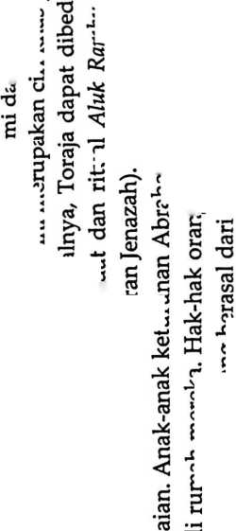
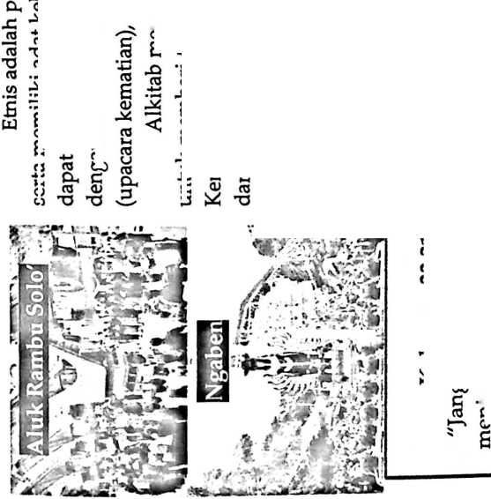
D
3

5

u

cn
B

c
3
4-»
03
24
03
S
V)
03
E
C
03
24
B
(D
V)
3
3
03
E
03
E
CD
E
CA
2
B
24

i

r
03
X)
60 E ^{w}
a)
o
B
c
CD
03
E
K
O
C
03
E
o
c
3
03
-*-»
(6
03
’S
3
03
B
C

S) J2
a
03
03
60 2
2
3
60
C
CD
60 C
05
60
C
CD
ca
O
ca
(D
E
c
05
3
03
3
ca
CD
ca
60
CD
C
CD
60
■S 2
60 2
ol as
CD
03
C
CD
E
3
03
03
e'
CD
E
60
c
03

2
03
C
o
CD

- 5
c
«3
c
2
c
03
03
3
<D
-D
(D
03
3
C6
CD
3
§

u
E
CD
CD
S
03
2

5
24
03
TJ
CD
n
E
<D
E
E
CD
£

bo jj
60
60
^{C} xz
O 24
S
CO
>
60 £
£
60
cs
2
c
o
»-<
CD
c
(6
B
c
<D
B
CA
03
E
&
2
60
G
01
£
(6
CD
03
C
fCJ
03
C
CD
<D
3
S
03
C
o
U
3
03
4-J
03
C
E
B
B
E
2
S
S
CD
24
S
B
c
CD
03
’O
2
4-»
01

s
£
03
E
03
60
CD
ca
03
03
CD
n
E
E
03
N
C
03
60
S
cu
Z
£
03
3
Cl
E
CD
CD

03
E S

CM
i
\O
03
ca
3
£
cc
£
C
03
3
’c
3
C
CD
E
CA
05

S
CA
3
60
ZZ VJ

S
u A
CD
g
v5
3
C
03
£
«J

.7 s
CD
(6
03
03
CQ

5 3 2
M g
03
E
CD
CA
CU
03
CJ
<D
CA
.2
’ca
3
S
s
c’
03
§
c 2
3
(D
ca
(D
□
01
«s
■o
C6
60
60
C
03
T-t
<D •-
60 C
c -
03
>
C6
3
(6
^4
03
03
J
(D
03
5
.S a
03
V)
01
4-»
03
C3
CA
01
3
E
3
B
60
S
2 w
3 “

n

i
60
C
□
3
(A

m
44
ai
C
ai
B
n
E
03
60
3
C
<D
E
03
C
05
E
03
CA
<D
V)
01
X3
03
03
03
>
£
.2.
’S
(D
01
03
24
CD
D
£
03
(6
£ -
□
03
C
01
03
£
£
03
£3
C
03
CD
4-»
CA
rc
4-»
03
c
03
O
03
03
O
3
03
C
(D
03
24
C
2
B
w
C
03
3
a _{x}
⁶ c
<D 2
3 i
■Q
E
<D |
E ₍
6o ;
c
£ !
C ..
F
t: ¹
c '
03 >
B
c
S |
oi :
B ^{J}
60
CD ’l
CA
CA |
03 (
B ;
5 :
60
g B
6
3

3

5
E
3
2 ..
3 v)
al
3
C
cn
E
c
al
24
al
01
X
E
CO
60
3
01
3
C
CD
E
01
05
24
<D
CD
E
01
>>
Z
c
01
24
cu
03
>

z s
i 24
03 _S
as
>
03
D _
E K
6o 2 £ K
£ S E B
E 60’O
C
03
3
a
£
(D
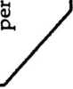
01
C S
2 «
a> g
& ®
<D

S.s e-S
m J2 .2 -3
o> 4S ”*

S
60 S
_ C £
X • rt O
~ C ’g
E
03
ol
C
E
03
X
c
03
O
01
CA
—K
(6
V)
60
C
03
S J
S
(«
03
60 •;
c ’i
CD G
’O W
’Sb 2 3 ’l
c
QU r_.
60 ^{H} ~
C 60
a
03
’C
CD
01
X
£
B

o
c
oi
24
03

8
U
C
CD
CD
44
V)
W

2
ctf
P4
05
’S
60
C
<D
E
c
03
(D
CA
B
03
CA
h-M
03
CA
60 -
r 03
H V)
01 «3

•° s

8
3
CL.
£ .S
P a.
g
_ B
S E
E
<D
E
60
G
(C
C
3
01
X
03
> V
§ 2
§
3
a
E
(D
»4
0)
E
E
60

S |
c c
5 ’C
E E

a> *
E
<D
S
CO
(A
60 £

5 ⁵

S
c
03
03
’O
3
05
CA
60 60

S ii

s -e
03
01
M
3
3
ol
w
3
s
60
a
03
CD
J
<D
a
E

2

B
O
vi
O
CD
£
>
CA
03
01
S
(6
M <D
O —•
d. b£)
§^{s}
a
3
03
E
t S
3 c§
03
h
03
E
03
CA
60
C
03 60

>
«5 C
03
O
C
s
E
B
03
»-i
03
I
05

8
ca
01

£
03
E
01
CA
2
B
3
E
2
B
E
B
2
60
C
CD
E
c 7:
CD (6
S
i
S. -B
E 2 | 2
z> e g -
E E 2
CD
(D C c
" " §
E
05
3
E
CD
CA
G
03
(D
E
S
01
O
4-»
C
o
U
c
03
24
(3
TJ
D
£
E
(D
E
24
B
C
03
CA
01
B
03
3
ol
•- E
« 5
g U
E s
2
B
g
S- .
E B
03

CD 2
03
CA _
— 60 X
S) §
al
’O
as
03
O
2
B
■o
03
E
03
(D
V)
D
Q
.2
’E
<D
ca
24
<D
CA
c
01
3
C*

E >>
05
E
03
D
ca
W
B
03
S

s
3
(A
O
W r'
C ’O

S
X
(6
E
CD
2
B
co
G
60
C
03
O
D
CA
B
60
03
£5 _

S -O
S <=
CD
03
CA
(D 0)
03
(D
03

J3
03
CA
.2
’S

&
B
c
03
as
E
2
B
c g
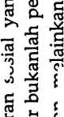
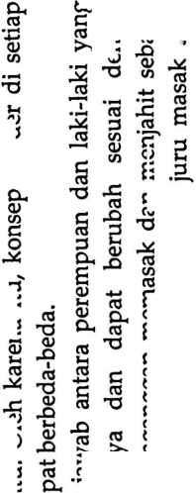
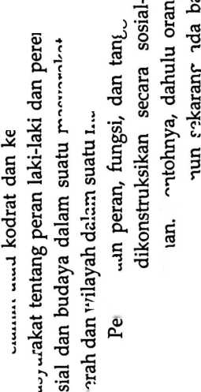
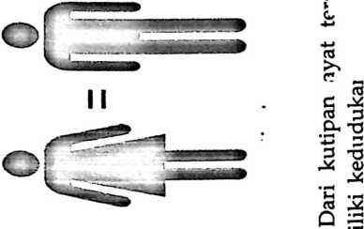
gj

g
gj

’S
§
s
gj
gj
GJ
C
GJ
GJ

a
2
CD
E

c
GJ
3
Cl
E
<d
CD
.2

775
3
C
GJ
E
00
c
GJ
ca
CD
ca
□
a
£
CD
CD
«J
OJ
(U
00
C
GJ
GJ
CD
C
GJ
GJ
U
C
0)
C
GJ
GJ
‘S
(A
GJ
d
GJ
CD
E
(A
CD
cn
E
GJ
CA
c
GJ
□
Cl
£
o
a
E
3
GJ
CD
o
c
o
00
s
s
(D
w
<D

2
GJ
ca
OO
a
GJ
GJ
d
GJ
2

775
3
c
GJ

E

75
00
GJ

n
CD
GJ
E
C
GJ

2
ob
CD
GJ
n
c
<D
CD
E
c
01
<D
GJ
GJ
a
Gj
gj
£1
GJ
00
(D
C
GJ
bO
C
GJ
GJ
£
’S
E
<D
o5
E
O)
Q
c
GJ
3
5

a
E
775
C
GJ
S
(B
.^{C}
C
CD
GJ
£
V)
GJ
4-»
GJ
w
GJ
cn
GJ
E
D
E
GJ
GJ
(U
C
GJ
d
E

GJ

(75
s
GJ
E
c
GJ
-X
00
<d
V)
C
GJ
d
E
0)
S
E
gj

S
(A
E

oo
GJ
E
GJ
(n
GJ

S
E
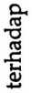
00
c
GJ
2

775
□
§
E
ca
GJ
GJ
C
GJ
GJ
GJ
3
CD
ca
E
CD
E
00
GJ
c75
3
C
GJ
E
O
Cl
E

o

a5
3
n
CD
ca
GJ
CD
E
cn
GJ
C^
GJ
ca
GJ
C
CD
gj
GJ
gj
4-*

c
GJ
S

775
O
ca
00
c
CD
c
GJ
2

S
E
GJ
GJ
E
GJ
cn
cd
C
GJ
GJ
d
CD
<D
GJ
O
OO
00
c
GJ
GJ
GJ
00
00
c
GJ
E
00
c
GJ
2

<75
□
S
GJ

S
00
c

o

o
00
3
n
<D
(A
§
s
E
cn
C
GJ
GJ
00
a
GJ
c
GJ
C
2
<D
ca
GJ
00
GJ
3
n
CD
(A
§
GJ
ca
GJ
<D
§
(0
E
3
E
□
GJ
GJ
Q
CD
<n
o

oo

c
3
CA
00
C
gj
GJ
GJ
CD
CD
CA
00
ca
CD
GJ
»-i
GJ
C
GJ
K
GJ
co
00
2
S
CD
3
n
<D
ca

JS

’S
d
GJ
CD
5
u
GJ
>
2
i
2
GJ
S
E
2
'E
GJ
O
CD
C
GJ
GJ
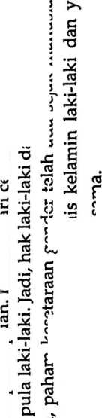
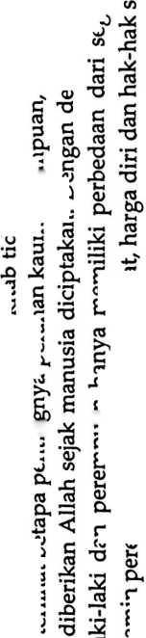

Penilaian Diri | Tidak
Penilaian Diri | Ya
Penilaian Diri | Pernyataan | Setelah mempelajari modul ini_{z} saya memahami  pengertian ras, etnis dan gender | Setelah mempelajari modul ini, saya menyadari bahwa  terjadi diskriminasi ras, etnis maupun gender karena  dipengaruhi oleh kepentingan sosial, ekonomi, politik,  kekuasaan dan sebaginya.
Penilaian Diri | o  Z | rH | CM
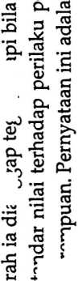
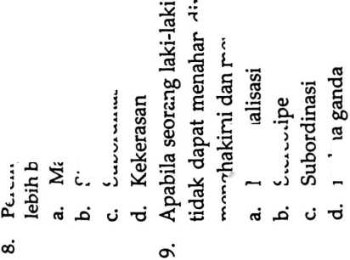


Di tengah perbedaan ras, etnis dan gender saya  memahami perlunya saling menghargai setiap  perbedaan yang ada agar tidak saling mendiskriminasi. | Setelah mempelajari materi tentang ras, etnis dan  gender saya menyadari bahwa Tuhan menciptakan  perbedaan agar kehidupan manusia itu indah seperti  pelangi yang warnanya berbeda-beda tetapi saling  melengkapi | Saya memahami bahwa setiap orang diciptakan oleh  Tuhan itu mulia. Baik dari ras, etnis, gender apapun.
cn |  | ir>

TJ 05
rS
7ZJ o
M ODUL II
BATAS-BATAS PACARAN

itulah kisah cinta sejati. Pada mulanya, Laban telah berjanji untuk menikahkan Yakub dengan Rahel tetapi ternyata di hari
pernikahan, yang diberikan padanya adalah Lea saudari Rahel. Laban telah menipu Yakub.

Di kalangan masyarakat Yahudi, seorang mempelai wanita akan mengenakan penutup di seluruh wajahnya hingga

mempelai pria tidak dapat melihat wajah mempelai wanita. Itulah sebabnya Yakub tidak tahu bahwa yang ada di hadapannya

adalah Lea, bukan Rahel. Setelah mengetahui bahwa Laban telah menipunya, Yakub bersedia bekerja lagi kepada Laban selama
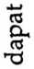
2
c
s
(D
as
2
as
6
r5
03
aS
<D
«3
as
<D

’S
as
.2
GS
4-»
.S
00
(D
C4
as
as
as
oi
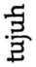
C
Q>
</)
as
(D
as
<D
*
5
a;
as
as
aS
u
GS

.s
C
G3
a;
0)
3
«s
ai
(V
as
O
GS
as
S
7S
as
03

K
as
c
CD
03
00
.S
4-*
as
a3
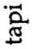
<V
cn
G5
.£

o
C
a»
00
c
Gj
5
as
as

1

O
<D
—
'S
00
c
as
O
O
W
03
as
as
cu
C
GS
03
as
00
00
C
O)
£
as
(D
3
5
a
□
2
(3
C
o
(/)
■n
c
01
00
as
*-<
05
U
=3
as
'S
GS
E
GJ
24
00
as
S
O
C
01
Sm
U
GS
U
GS
0)
3
E
as
00
a
<D
GS
GS
00
C
as
ra
*<v
03
GS
00
C
<D
O
(D
2

3
cn
<D
u
as
bO
O
a
GS
S

aS
S
as
aS
a
(v
S
5
S
as
u
as
5

'5
as
u
as
O
GS
a
cn
GS
4-»
as
m
as
4-»
as
00
c
(D
GS
as
u
c
as
as
5
o
E
3
GS
GS
GS
4->
GS
c
oo
(D
c
o
O
G3
5
GS
C
GS
00
C
o
cn
O
24
O
’ob
as
G
GS
as

yang menjadi pusat perhatian hanya pada diri sendiri sehingga pada masa pacaran timbul istilah bahwa dunia ini hanya
milik berdua. Apakah pacaran ada unsur asmara? Mengacu pada pendapat para filsuf dan psikolog pada pelajaran
sebelumnya, asmara itu mempunyai dua unsur yaitu antara cinta kasih atau cinta berahi.
Pada dasarnya asmara itu bukan cinta, karena asmara itu naksir/keinginan yang berpusat pada diri sendiri, sedangkan
cinta kasih sejati adalah perasaan mengasihi di mana ada sikap saling memperhatikan, menghargai dan menghormati. Cinta

S
'S
Batas-Batas Pacaran menurut Standar Moral Alkitab
03
cn
O
75
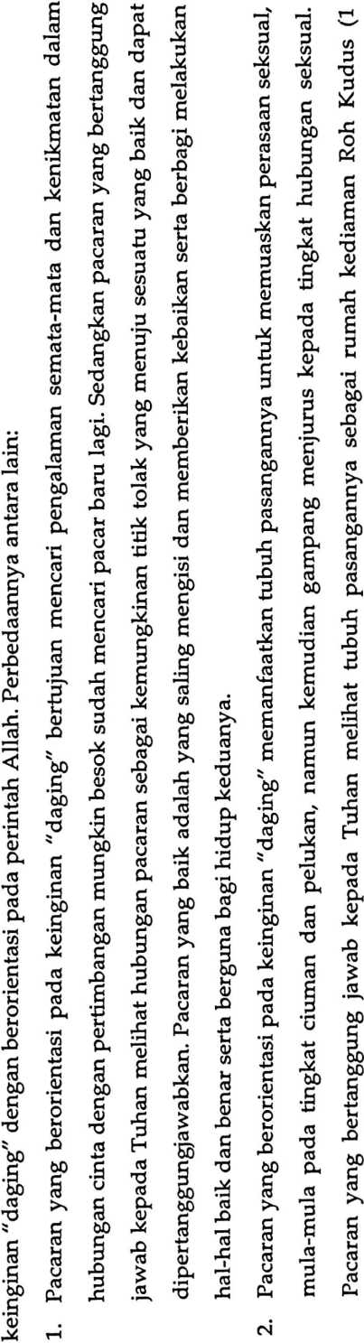

Korintus 3:16) yang dikagumi dan dihargai sebagai ciptaan Allah. Ciuman dan pelukan antara seorang pemuda dan pemudi
merupakan kontak fisik untuk mendapatkan hasrat seksual dan kenikmatan. Ada empat tingkat intensitas hubungan fisik,
dimulai dari yang paling lemah sampai yang paling kuat.
Keempat tingkat tersebut ialah:

CL,
GJ
'a

S
C
o
i
<

.h
75

J
’O

•d

•S
o
£
5

.ti
• 1“^
czi
GS
bO

§
O

s
’O
as
bD
o
bO

§

s
’O
bJD
§
>A
as
rH
cn
O
§
6
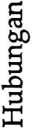


J
as
’O

0
0
a;
O
§
’O

B

•rH
l—M
O
4-*
(U
w
ia
r—H
ia
’O
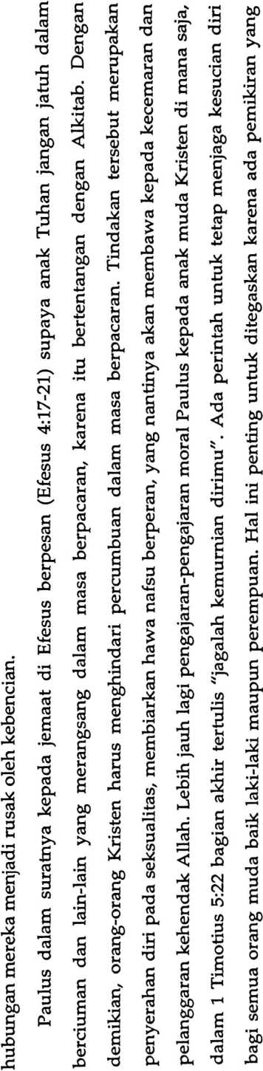

s
a
<D
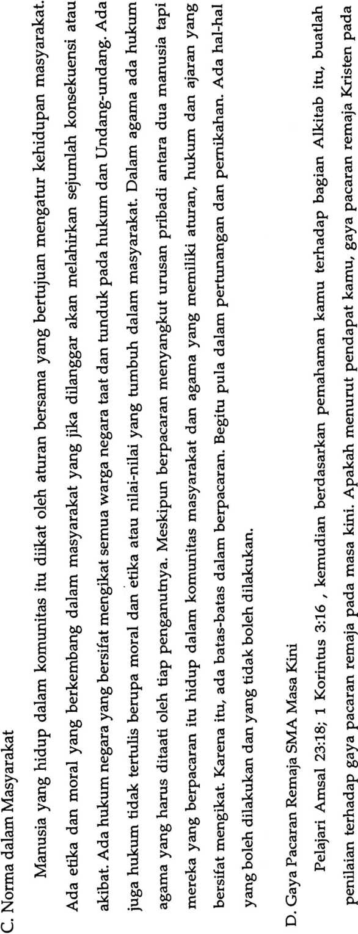

masa kini sesuai dengan prinsip Alkitab? Jika menurut kamu sudah sesuai dengan prinsip Alkitab, apakah alasan kamu
menjawab demikian? Sebaliknya, jika tidak sesuai dengan prinsip Alkitab, mengapa demikian? Untuk memahami pertanyaan di
atas, marilah menyimak kasus di bawah ini:
1. Cinta Berujung Maut
Kamis, 5 November 2020 13:43. Merdeka.com-Kisah miris datang dari Kabupaten Tana Toraja, Sulawesi Selatan.
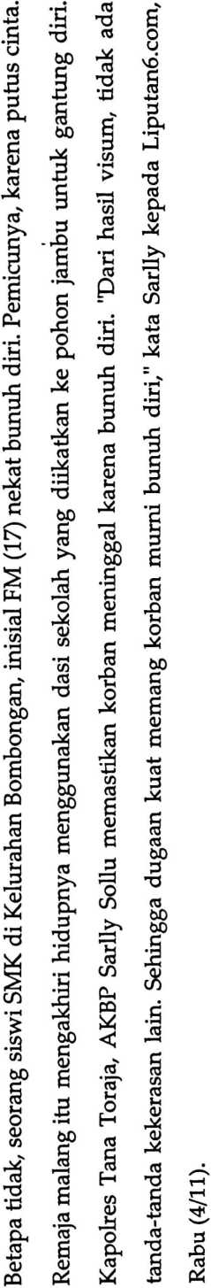
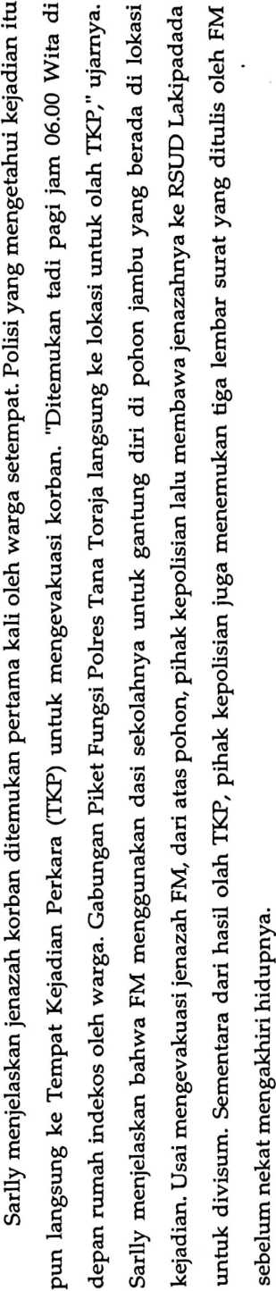

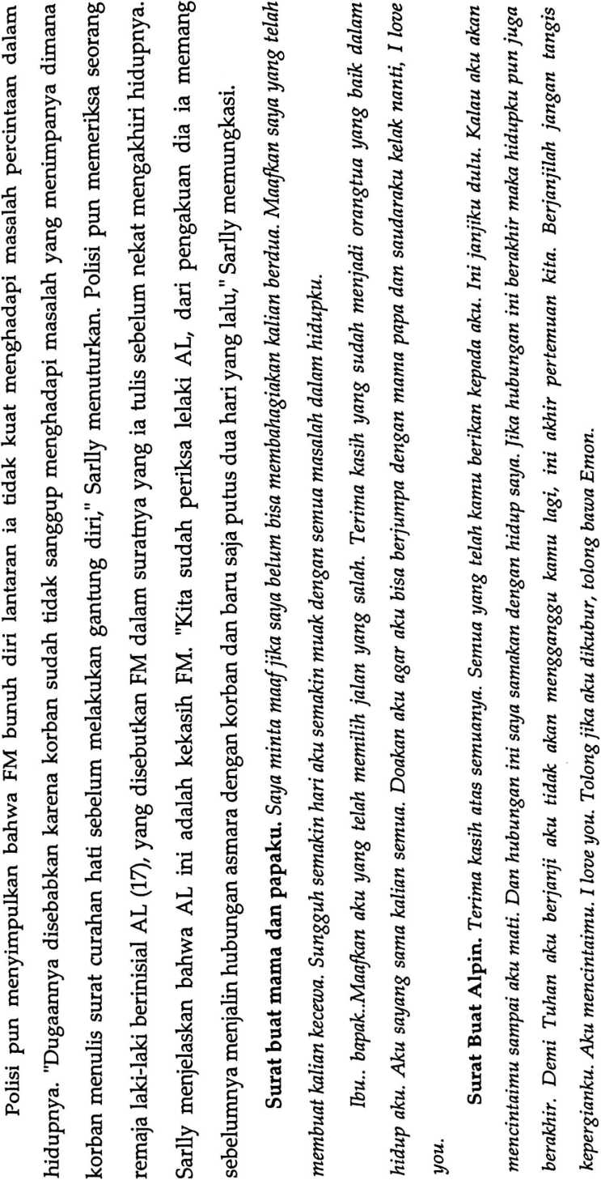

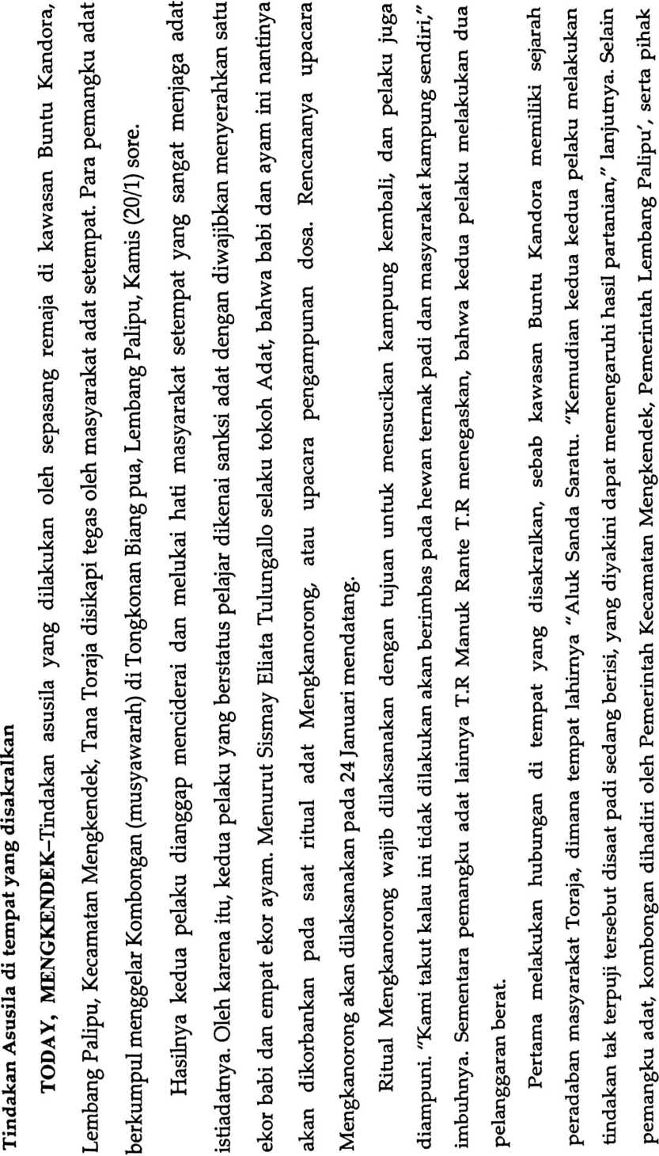
keluarga pelaku. Sementara itu, Kepala Lembang Palipu, Semuel Manukrante mengapresiasi pihak keluarga kedua pelaku

yang bersedia hadir dalam Kombongan. "Terima kasih kepada pelaku dan keluarga yang bersedia datang meminta maaf
atas kejadian di buntu kandora yang sempat viral," katanya kepada torajadaily. Sebelumnya, pelaku penyebar video asusila
berinisial YP telah ditersangkakan oleh penyidik. Ia dijerat pasal 37 UU nomor 44 tahun 2008 tentang pornografi dengan
pidana singkat 1 tahun dan paling lama 12 tahun dengan denda Rp500 juta.
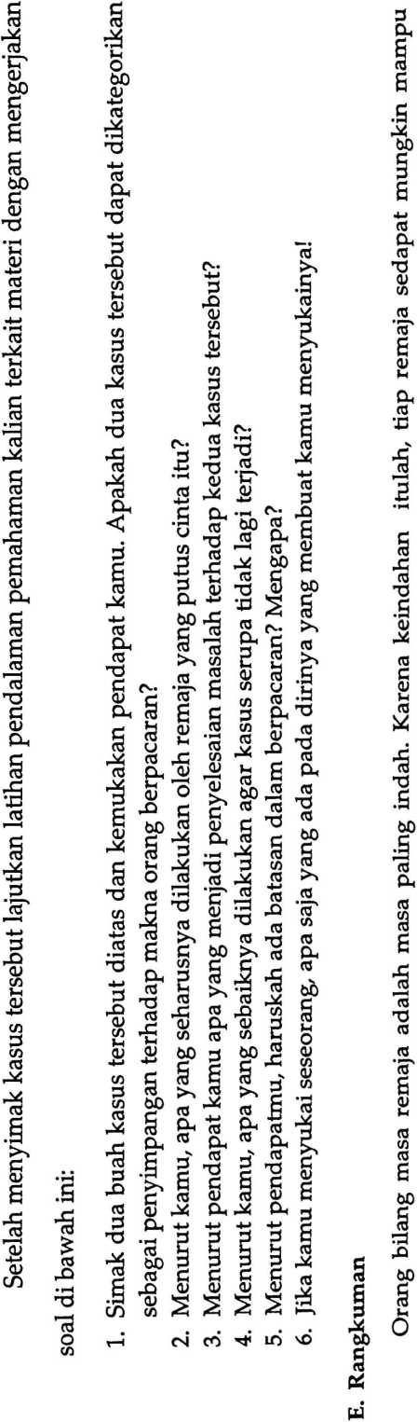
menahan diri dari berbagai hal yang merugikan. Dengan begitu, mereka dapat menikmati keindahan masa remaja menuju
kedewasaan. Pada saat kini, di kalangan remaja muncul pemikiran seolah-olah seseorang menjadi orang aneh jika belum
berpacaran. Kalaupun pacaran dan tidak melakukan berbagai tindakan seperti mencium dan menyentuh badan lainnya maka
sikap itu dipandang kuno. Orang dapat memutuskan untuk berpacaran ataukah tidak jika ia sudah yakin akan tindakannya. Jadi

keputusan untuk berpacaran haruslah berdasarkan alasan yang benar, bukan hanya karena ketertarikan fisik atau supaya tidak
disebut sebagai manusia kuno. Ingatlah, apa yang ditanam sekarang akan berpengaruh pada masa depan seseorang. Semua
orang pernah melakukan kesalahan, namun tidak semua orang mampu untuk memperbaiki berbagai perbuatan yang salah dan
menyimpang, bahkan banyak meninggalkan bekasnya. Oleh karena itu, lebih baik bagi kamu untuk mencegah diri tidak
melakukan berbagai hal yang menyimpang sehingga masa muda kamu memiliki jejak yang baik dan patut ditiru oleh orang lain.

Keterangan | RPP yang digunakan merupakan hasil dowload dari Internet | Terdapat LCD, namun tidak digunakan, karena guru tidak  menggunakan perangkat atau Laptop. | Guru tidak memahami langkah menyusun modul, dan Pihak sekolah  tidak menyiapkan LKS | Buku yang digunakan adalah buku kemendikbud edisi revisi 2017 | Penilaian dilakukan terhadap Aspek kognitif, afeksi dan psikomotorik  siswa
H
>4
Pernyataan/ Aspek yang diamati | Guru menyusun RPP dan Silabus sebelum memulai  kegiatan pembelajaran | Guru menggunakan media dalam pembelajaran | Guru menyiapkan bahan ajar seperti LKS dan modul  .. _ | Guru menyiapkan buku siswa dan buku guru | Guru menyusun jurnal penilaian siswa
No | r-4 | CM | CO |  | m

SIKAP | 1 Disiplin | | 1 SB | | 100 |  |  |  |  |  | *> |  |  | y | y | y
SIKAP | 1 Disiplin | | ca | m |  |  |  | 'y | 'y |  | y | y |  |  |  | y
SIKAP | 1 Disiplin | | Q | ©  m
SIKAP | 1 Disiplin | | iZ | 04 m
SIKAP | i P. diri | 8S 1 | 100 |  |  |  |  |  |  |  |  | y |  | y
SIKAP | i P. diri | CQ | »T) | y | y |  | 'y |  | 'y |  | y |  |  |  | y
SIKAP | i P. diri | U | ©  m |  |  | 'y |  | 'y |  | y |  |  | y
SIKAP | i P. diri |  | in
SIKAP | C  S  ■*-*  C  as  CO | 8S | 100 | "z | 'y | y | 'y | 'y | y |  |  | y | y | y | y
SIKAP | C  S  ■*-*  C  as  CO | CQ | m |  |  |  |  |  |  |  | y
SIKAP | C  S  ■*-*  C  as  CO | U | ©  m |  |  |  |  |  |  | y
SIKAP | C  S  ■*-*  C  as  CO |  | in  04
SIKAP | C  S  ■*-*  C  as  CO | Lasi | 100 |  |  |  |  |  |  |  |  | 'y |  | y
SIKAP | Kerjasama 1 | CQ | jn | y | y | 'y | 'y | 'y |  | y | y |  |  |  | y
SIKAP | Kerjasama 1 | u | ©  m |  |  |  |  |  |  |  |  |  | y
SIKAP | Kerjasama 1 | * | m  04
SIKAP | □  73  Q>  CU | SB | 100 |  |  |  |  |  | y |  |  | y |  | y
SIKAP | □  73  Q>  CU |  | m | y | 'y | y | 'y | 'y |  | y | y |  | y |  | y
SIKAP | □  73  Q>  CU | U | ©  m
SIKAP | □  73  Q>  CU | * | ID  04
SIKAP | 3 | SB | 100 | y | 'y | 'y |  |  | y |  |  | y | y | y | y
SIKAP | 3 | CO | m |  |  |  | 'y | 'y |  | y | y
SIKAP |  | u | ©  m
SIKAP |  | * | m  04
SIKAP | £>  03  £  03  H | 8S | 100 | 'y | 'y | 'y |  |  | y |  | y | y | y | y
SIKAP | £>  03  £  03  H | Cfi | m |  |  |  | 'y | 'y |  | y |  |  |  |  | y
SIKAP | £>  03  £  03  H | u | ©  m
SIKAP | £>  03  £  03  H | * | ID  04
« «  Z 6 |  |  |  | AG | AE | a.  < | lAL | AK | AM 1 | vvj | S | AR  P | a  W o | M < | , HA
No |  |  |  | rH | o4 | cn | ’t | m’ | £> | ts | od | as | o | rH | 04
SIKAP | | Disiplin | | ISBj | 100 | 'y | 'y |  | 'y | 'y | 'y | 'y |  | 'y | 'y | 'y | 'Z | 'y | 'y |  | 'y | 'Z |  | 'y | —— | 'y | 'y | 'y
SIKAP | | Disiplin | | co | m |  |  | 'y |  |  |  |  | 'y |  |  |  |  |  |  | 'y |  |  | 'y
SIKAP | | Disiplin | | U | o  m |  |  |  |  |  |  |  |  |  |  |  |  |  |  |  |  |  |  |  | 'Z
SIKAP | | Disiplin | |  | cm m
SIKAP | P. diri | as | 100 | ~y | 'y |  |  |  | 'y | 'y |  |  | 'y |  |  |  |  | 'y
SIKAP | P. diri | CO | m |  |  | 'y | 'y | 'y |  |  | 'y | 'y |  | 'y |  | 'y | 'y |  | 'y |  | 'y | 'y | 'Z | 'y | 'y | 'y
SIKAP | P. diri | u | o  m |  |  |  |  |  |  |  |  |  |  |  | 'y |  |  |  |  | 'Z
SIKAP | P. diri |  | m  cm
SIKAP | Santun | as | 100 | 'y | 'y | 'y | 'y | 'y | 'y | 'y | 'y | 'y | 'y | 'y | 'y | 'y | 'y |  | ~y | 'y |  |  |  | 'y | 'y | 'y
SIKAP | Santun | CO | m |  |  |  |  |  |  |  |  |  |  |  |  |  |  | 'y |  |  |  | 'y | 'y
SIKAP | Santun | w | o  m |  |  |  |  |  |  |  |  |  |  |  |  |  |  |  |  |  | 'y
SIKAP | Santun |  | m  cm
SIKAP | Santun | as | 100 |  | ~y |  | 'y | 'y | 'y | 'y |  |  |  |  |  |  |  | 'y |  |  |  |  |  |  | 'y | 'y
SIKAP | Kerjasama | CO | m | 'y |  |  |  |  |  |  | 'y | 'y | 'y | 'y | 'y | 'y | 'y |  | 'y | 'y | 'y | 'y | 'y | 'y
SIKAP | Kerjasama | u | o  m |  |  | 'y
SIKAP | Kerjasama |  | m  n
SIKAP | Peduli | | as | 100 | 'y | 'y |  |  |  |  | 'y |  |  | 'y | ~y |  | 'y |  |  |  |  |  |  |  |  | 'y
SIKAP | Peduli | | 00 | jn |  |  | 'y | 'y | 'y | 'y |  | 'y | 'y |  |  | 'y |  | 'y | 'y | 'y | 'y | 'y | 'y | 'y | 'y |  | ~y
SIKAP | Peduli | | u | o  m
SIKAP | Peduli | | * | m  cm
SIKAP | Jujur 1 | as | 100 | 'y | 'y |  |  | ~y | 'y | 'y |  |  | 'y | 'y | 'y | 'y |  | ~y | ~y | 'y |  | 'y |  | 'y | 'y | 'y
SIKAP | Jujur 1 | CO | m  r- |  |  | 'y | 'y |  |  |  | 'y | ~y |  |  |  |  | 'y |  |  |  | 'y |  | 'y
SIKAP | Jujur 1 | u | o  m
SIKAP | Jujur 1 |  | «n  CM
SIKAP | T.Jawab | | as | 100 | "z | 'y | 'y | 'y | 'y | 'y | 'y | 'y |  | 'y | 'y | 'y | 'y |  | ~y | 'y | 'y | 'y | 'y |  | 'y | 'y | 'y
SIKAP | T.Jawab | | CO | m |  |  |  |  |  |  |  |  | 'y |  |  |  |  | 'y |  |  |  |  |  | 'y
SIKAP | T.Jawab | | O | o  m
SIKAP | T.Jawab | |  | m  CM
Na  ma |  |  |  | IYS | GA |  | £ | KN | n | MN | MA | MB | MT | ND | NN | OP | CL  Om | VS | 'Z  (/) | TL | £ | WK | YY | YW | U  > | YN
o |  |  |  | 2 | 3 | iri  rH | v5 | M | 00 | 3 | O  CM | CM | CM  CM |  | CM | s | ^0  CM | t>  C4 | 00  CM | CM | o  CO | co | CM  CO | co  CO | CO | LiJ  CO

’ diamati | | Kom. | SB | 001
’ diamati | | Kom. |  | m |  |  | “T’ | 'T | "p | "p' | "p | "p |  |  |  |  |  | "p |  |  |  | "p | "P | v | "p | "p | "p |  | "p
’ diamati | | Kom. | u | o  m |  |  |  |  |  |  |  |  |  | "p |  |  |  |  |  |  | "p
’ diamati | | Kom. | * | m  n
’ diamati | | Santun | as | 100 |  |  |  |  |  | "p |  |  | "p |  |  |  |  |  |  |  |  |  |  |  | "p |  |  | ~P | "p
’ diamati | | Santun | 0Q | m | "7^ | "p | "p | T | "p |  | "p | "P |  | "p’ |  | "p | "P | "p |  | "p | "p | "p | "P | v |  | "p | "p
’ diamati | | Santun | O | o
’ diamati | | Santun | * | m  n
Aspek Yan$ | Rasa Ingin Tahu | as | 100 |  |  |  |  |  | "p' |  |  |  |  |  |  |  |  |  |  |  |  | "P | "p | "p
Aspek Yan$ | Rasa Ingin Tahu | CQ | m | "p | "p | "p | "p | "p |  | "P | "P | "P | "p |  | "p | "P | "p |  | "p | "p | "p |  |  |  | "p | "p | "P | "p
Aspek Yan$ | Rasa Ingin Tahu | U | o  m
Aspek Yan$ | Rasa Ingin Tahu |  | «n  04
Aspek Yan$ | Kerja Sama | as | 001 | "p | "p | "p |  |  | "p |  | "P | "P | "p |  | "p |  | "p |  | "p | "P | "p | "P | "p | "p | "p |  | "p | "p
Aspek Yan$ | Kerja Sama | CQ | jn |  |  |  | "p | "p |  | "P |  |  |  |  |  | "P |  |  |  |  |  |  |  |  |  | "p
Aspek Yan$ | Kerja Sama | u | o  m
Aspek Yan$ | Kerja Sama |  | m  04
Nama |  |  |  | AG | av | AP | AL | KY. | AM |  | S | A RP | EGG |  | j EMA | VH | SAI |  | GA | ►—> |  | KN | LT | MN | MA | MB | MT | ND.
No |  |  |  | rH | n | cn |  | m | d |  | 00 |  | C |  | VH | S | cr |  | h' | 55 | H | t> | aj | 3 | d  n | 04 | a | a
g diamati 1 | Kom. | CO  GO | 100
g diamati 1 | Kom. | CO | io | 'T* | ’T* |  | ’T* | ’T* | ’T* | ’T* | 'T* | T* | ’T* | 'T* | T*
g diamati 1 | Kom. | u | o  m
g diamati 1 | Kom. |  | m  (M
g diamati 1 | | Santun | CO  CO | 100 |  | T* |  |  |  |  |  |  |  |  | 'T*
g diamati 1 | | Santun | CO | io | 'T* |  |  | ’T* | ’T* | 'T* | ’T* | 'T* | ’T* | 'T* |  | T*
g diamati 1 | | Santun | U | o  IO
g diamati 1 | | Santun |  | CM
[ Aspek Yan; | | Rasa Ingin Tahu | CO  CO | 100 |  |  |  |  |  |  |  |  |  |  | 'T* | 'T*
[ Aspek Yan; | | Rasa Ingin Tahu | CO | m |  | 'T* |  | 'T* | T* | ’T* | ’T* | 'T* | ’T* | 'T*
[ Aspek Yan; | | Rasa Ingin Tahu | U | o  m
[ Aspek Yan; | | Rasa Ingin Tahu | * | m  CM
[ Aspek Yan; | j Kerja Sama | CO  CO | 100 | T* | T* |  | “T* | ’T* |  | 'T* | T* |  | 'T* | 'T* | T*
[ Aspek Yan; | j Kerja Sama | CO | «n |  |  |  |  |  |  |  |  | "T*
[ Aspek Yan; | j Kerja Sama | u | o
[ Aspek Yan; | j Kerja Sama |  | <n  CM
Nama |  |  |  | NN | CU  O | CL,  CL. | <  <S) | Z  CO | H | WP | WK | s | YW |  | YN
o  Z |  |  |  | CM | m  CM | vO  CM | CM | 00  CM | □<  CM | o  cn | cn | CM  CO | cn  cn | CO | Ln  CO

KET | Dari 25 siswa yang  mengisi lembar penilaian  Sebanyak 20 siswa yang  menolak atau tidak setuju  dengan metode yang  klasik. | Dari 25 siswa sebagian  besar kurang memiliki  motivasi apabila tanpa  adanya media dalam  pembelajaran | Belajar dengan hanya  menggunakan buku siswa  membuat siswa kurang  termotivasi. | Siswa menunjukkan minat  belajar mandiri apabila  ada sarana yang  menunjang pembelajaran | Perlunya kreativitas  dalam memberi  penugasan kepada siswa
S | 19  (76%) | 2  (8%) | 5  (20%) | 3  (12%) | 7  (28%)
KS | 3  (12%) | 10  (40%) | 7  (28%) | 8  (32%) | 4  (16%)
cn | 2  (8%) | 8  (32%) | 8  (32%) | 5  (20%) | 5  (20%)
ss | 1  (4%) | 5  (20%) | 5  (20%) | 9  (36%) | 9  (36%)
PERNYATAAN | Saya memiliki motivasi dalam diri saya sendiri selama proses  pembelajaran melalui metode belajar yang diterapkan oleh guru | Saya memiliki motivasi dalam belajar meski hanya tidak  menggunakan media pembelajaran | Belajar menggunakan Buku Siswa memudahkan saya memahami  materi. | Meskipun tanpa kehadiran guru saya menunjukkan sikap konsisten  dalam proses pembelajaran karena adanya buku siswa/LKS | Saya selalu membaca dan mengerjakan penugasan yang ada di  dalam Buku Siswa/LKS
ON | v-< | CM | cn |  | m

Ket | Sebanyak 40% siswa tertarik  menggunakan modul | 60% termotivasi dengan modul  karena bahasa yang digunakan  sederhana. | Lebih memahami materi karena  dengan menggunakan modul | 40% siswa aktif belajar mandiri  karena adanya modul | Siswa mengerjakan tugas secara  mandiri karena adanya modul
TS | 4  (16%) | 1  (4%) | 2  (8%) | 6  (24%) | 3  (12%)
3 | 4  (16%) | 1  (4%) | 1  (4%) | 3  (12%)
cn | 7  (28%) | 10  (40%) | 10  (40%) | 6  (24%) | 3  (12%)
ss | 10  (40%) | 15  (60%) | 15  (60%) | 10  (40%) | 15  (60%)
Pernyataan | Saya memiliki motivasi dalam diri saya sendiri selama  proses pembelajaran dengan menggunakan modul | Bahasa yang dipakai di dalam modul sederhana menarik  dan mudah dipahami | Belajar menggunakan modul memudahkan saya  memahami materi yang ada di dalam modul | Meskipun tanpa kehadiran guru saya menunjukkan  sikap konsisten dalam proses pembelajaran karena  dibantu dengan adanya modul | Saya selalu membaca dan mengerjakan penugasan yang  ada di dalam modul
No | T-H | CM | CO |  | LO

'No | Kegiatan | Bulan/Tahun
'No | Kegiatan | 2021 |  | 2022
'No | Kegiatan | Nov | Des | Jan | Feb | Mar | Apr | Mei | Juni
1 | Pengajuan judul dan penentuan  lokasi penelitian
2 | Penyusunan proposal skripsi
3 | Ujian proposal skripsi
4 | Pelaksanaan Penelitian
5 | Pengolahan Data, analisis data, dan  laporan penelitian
6 | Seminar hasil
7 | Ujian skripsi

