OftGiNALnY REPON
7 %  SIMJLARHY!NDEX | 7%  INTERNET SOURCES | 3%  PUBUCATIONS | 2%  STUDENTPAPERS
PfcMAfftSOUftCCS
eprints.uny.ac.id 'j _{oz}

id.scribd.com
Internet So^CC?
S
jamarfiskimudin98.blogspot.com
Internet Sour<e
repository.stkippacitan.ac.id
Internet Suzce

docplayer.info
internet Sou.ce

core.ac.uk
M text-id.123dok.com
|!W| repository.radenintan.ac.id
r⁻1 repository.widyamataram.ac.id
ir.tr boutcc
<1 %
<1 %
< 1 %
<1 %
<1 %
<1 %
zombiedoc.com
1r»:e*nei Source

lib.unnes.ac.id
tmcfnw Sobvcc

jurnal.unej.ac.id

repository.uksw.edu
fnteiue: bource

etheses.uinmataram.ac.id

repository.upi.edu
Sourcc

repository.usd.ac.id
Internet Soufce

digilib.uin-suka.ac.id
f r. *.vr r.c’ So-jrce

repository.uinsu.ac.id

tr.scribd.com
Ir.tprnot Source

www.scribd.com
■ • •'

eprints.walisongo.ac.id
IT

i.

digilibadmin.unismuh.ac.id
fr.scribd.com
Submitted to Universitas Negeri Makassar
sttsabdaagung.ac.id
bagawanabiyasa.wordpress.com
lrtv:riutCC
e-campus.iainbukittinggi.ac.id
repositori.uin-alauddin.ac.id
www.slideshare.net
repository.uinsaizu.ac.id
www.ejournal.unma.ac.id
Hartini Hartini. "Peningkatan Kemandirian dan
. . . • 'O
Paedagogie, 2019

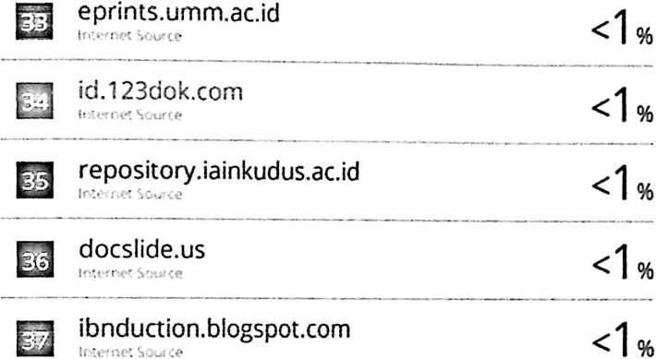
berandamadina.wordpress.com
r~n ekamayangsafitri.blogspot.com
k - J Scu ■:«?
~1 hendrosetiadiwiguna.blogspot.com
niedia.neiiti.com
rsi repository.uinjambi.ac.id
L .'J :• !
Andina Widhayanti, Muhammad Abduh.
"Peningkatan Motivasi Belajar Melalui Media

