JAngel Rante
CPRIGINALITY REPORT
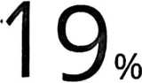

£|MILARITYINDEX
18%
INTERNET SOURCES
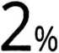

P’RIMARY SOURCES



2%
STUDENT PAPERS
PUBLICATIONS

www.scribd.com
Internet Source

vbook.pub
Internet Source
rdtharianja.blogspot.com
>» J Internet Source
r—
LzJ
core.ac.uk
Internet Source


supportartikel.blogspot.com
Internet Source


www.coursehero.com
Internet Source


www.journals.ukitoraja.ac.id
Internet Source


yesushidup.wordpress.com
Internet Source

123dok.com
L—J Internet Source

