welsi

by Rian Rinaldus tanduklangi
{ "■
ubmission date: 26-Aug-2020 04:29AM (UTC-0700)
nubmission ID: 1372608191
ile name: skripsi__welsi_pi_-.docx (494.61 K)
Vord count: 7859
haracter count: 50571

PRIMARY SOURCES
 | edoc.pub  Internet Source | 4°x
 | www.scribd.com  Internet Source | 1
 | ' www.cahayapengharapan.org  Internet Source | 1 °Z
E3 | ¹ id.123dok.com  i Internet Source | h
 | etheses.iainponorogo.ac.id  Internet Source | <1 °z

Submitted to Universitas Pelita Harapan
Student Paper


repository.uinsu.ac.id
Internet Source
8
docplayer.info
Internet Source
9¹
Submitted to Universitas Muhammadiyah
Yogyakarta
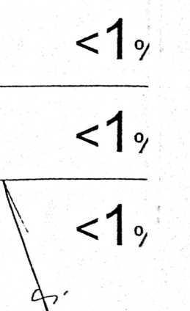
r W U!" wiir T m« I III IIII llllll

