Skripsi Medianto Tangkela'bi
' ORIGINALITY report

i 0% 10% 1 % 3%
ISIMILARITYINDEX INTERNET SOURCES PUBLICATIONS STUDENT PAPERS
IPRIMARY SOURCES
alkitab.sabda.org
J Internet Source
eprints.unm.ac.id
Internet Source

repository.uksw.edu
Internet Source
.... culturetoraja.blogspot.com
_.l Internet Source

www.scribd.com
Internet Source
repository.radenintan.ac.id
- Internet Source

www.sarapanpagi.org
Internet Source

bagawanabiyasa.wordpress.com
Internet Source

123dok.com
Internet Source

W fkip-unswagati.ac.id
"d Internet Source
RHl repository.ar-raniry.ac.id
Internet Source
plS edoc.pub
¹—J Internet Source
’F? journal.uinsgd.ac.id
-—J Internet Source
W paulusmtangke.wordpress.com
—J Internet Source
iR? repository.unair.ac.id
J Internet Source
o
maiindaa68.wordpress.com
¹ j Internet Source

’O lib.unnes.ac.id
-—-I Internet Source
W fadlanhidayatnk.blogspot.com
—J Internet Source
[W repository.iainpurwokerto.ac.id
< Internet Source
IW sajjacob.blogspot.com
*-—-J Internet Source

r w  S | Submitted to Sriwijaya University < ^{z}  Student Paper ' " | I %
[i | I Submitted to Universitas Negeri Makassar < ^{z}  j Student Paper | %  1  II
B | ] binsarspeaks.net <1  | Internet Source | %
 | j journal.walisongo.ac.id <1  | Internet Source | %
H | rifqimulyawan.com <1  | Internet Source | %
f  lo | repository.isi-ska.ac.id  Internet Source | %
n  LM | repo.unand.ac.id </|  Internet Source | 1%
[j%8 | azliaivonisevic.blogspot.com <**]  Internet Source | %
w  i | Submitted to Universitas Negeri Jakarta <  Student Paper | %
! | kc.umn.ac.id <1  Internet Source | %
 | rindaambarita.blogspot.com <1  Internet Source | %

 | Submitted to Politeknik Negeri Bandung < ^{z}  [ Student Paper | I %
I W° | kesalahanquran.wordpress.com </  | Internet Source | I %
I ¹¹ ">  IL& | Submitted to State Islamic University of  Alauddin Makassar <  Student Paper | %
■r—’  a?  li | www.seciko.com <**]  Internet Source | %
1  j 4)1, | id.123dok.com <**!  Internet Source | %
T"”’  : m | powermathematics.blogspot.co.id < **|  Internet Source | %
 | cari-carimakalah.blogspot.com <  Internet Source | %

 |  | Surakarta < d  Student Paper ' | %
 | 3 | eprints.iain-surakarta.ac.id  Internet Source | | %
 |  | phantar.blogspot.com < d  Internet Source « | %
 |  | etheses.uin-malang.ac.id <4  Internet Source * | %
 | - | de.slideshare.net  Internet Source | %
 |  | ejournal.iainkendari.ac.id  Internet Source | %
 | jjgo | id.scribd.com <1  j Internet Source | %
 |  | erhikoyari.blogspot.com <1  Internet Source | %
 |  | j Eckhard Zemmrich. "Developing Christian  Identity", Ecclesial Practices, 2014  Publication | I %
1 | "  Ji | text-id.123dok.com <  Internet Source | l%
 | 'Z] hendrapujiutama.wordpress.com <'  *._J Internet Source |  | l%

docplayer.info
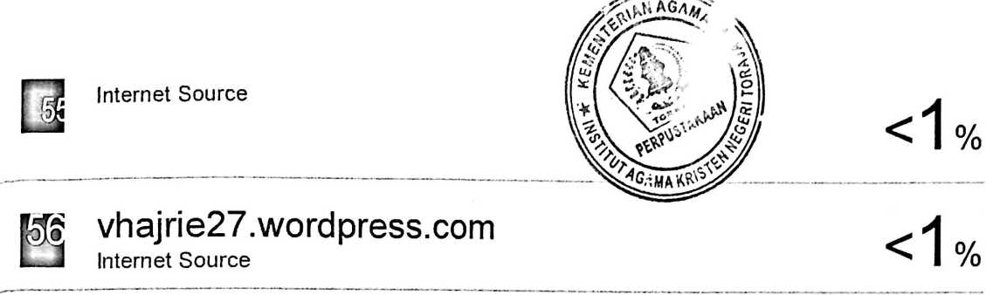
0
inisastraku.blogspot.com
Internet Source

S
blog.isi-dps.ac.id
Internet Source

%
H
andriianty.blogspot.com
Internet Source



epiq-rumpu-rampe.blogspot.com
Internet Source

H
tempatwisataseru.com
Internet Source
%
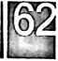

dokumenberita.blogspot.com
Internet Source

<1 %

S
eprints.uns.ac.id
Internet Source
%

digiiib.uin-suka.ac.id
Internet Source

<’1 %

iW
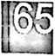

media.neliti.com
Internet Source
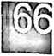

melianalumbantoruan.wordpress.com
Internet Source
< 1 %

%

s | | tatorboys.blogspot.com | 1 %
ll (|j(o | download.isi-dps.ac.id  | Internet Source | %
O mesa85.wordpress.com <1  Internet Source 1 |  | %
 | nnavit.blogspot.com < A  Internet Source | %
1 | perhatikanlah.wordpress.com < 1  Internet Source | %
!  i Z2 | rimatrian.blogspot.com </|  Internet Source | %
E | Ida Ayu Gede Prayitna Dewi, 1 Kadek Satria.  "KONSEP TRI ANGGA DALAM BELAJAR < 1  TEKNIK TARI BALI", WIDYANATYA, 2020  Publication | %
1 | repository.uin-suska.ac.id </|  Internet Source | %
 | archive.org <^|  Internet Source | %
1—n  i | repository.usd.ac.id </|  Internet Source | %

