k

Skripsi Mirna

by Catur Joko Santoso
iiubmission date: 01-Sep-2020 09:22AM (UTC-0500)
iiubmission ID: 1371730532
::ile name: BAB__l_ke_empat_mima.docx (69.93K)
Word count: 7970
Xharacter count: 51750
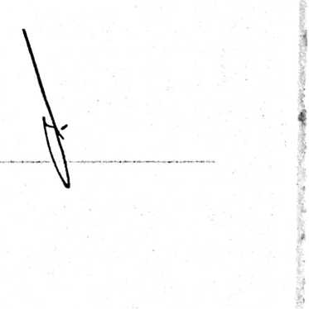

19% | 19% | 2% | 6%
=SIMILARITY INDEX | INTERNET SOURCES | PUBLICATIONS | STUDENT PAPERS
PRIMARY SOURCES | repository.uksw.edu  Internet Source | 3%
 | id.rn.wikipedia.org  Internet Source | s?  CXJ  I
 | neti7.blogspot.com  Internet Source | xP |  (N !
• | i d. seri bd.com  Internet Source | 1 %
 | ojs.sttjaffray.ac.id  Internet Source | 1 %
 | www.slideshare.net  Internet Source | 1 %
□ | etheses.uin-malang.ac.id  Internet Source | <1 %
□ | buyatthelegend.blogspot.com  Internet Source | •-O i  i  V ¹  V  1  1  1  1  1
anen9.blogspot.com \
Internet Source m I %

