Skripsi Damaris Pandi
CDRIGINALITY REPORT
I % 16% 5% 10%
SIMILARITYINDEX INTERNET SOURCES PUBLICATIONS STUDENT PAPERS

FPRIMARY SOURCES
E
repository.radenintan.ac.id
a Internet Source


heaven-of-world. blogspot.com
Internet Source
%

□
etheses.uin-malang.ac.id
Internet Source

o
Submitted to iGroup
Student Paper

id.123dok.com
Internet Source

o
Submitted to Universitas Negeri Jakarta
Student Paper

0

arizkasalsabila98.blogspot.com
Internet Source

8

’o
oursince.blogspot.com
Internet Source

0
yebefo.com
Internet Source
’o

10
www.utakatikotak.com
Internet Source
11
finaniswati.blogspot.com
Internet Source

<1%

<1 %
□
eprints.iain-surakarta.ac.id e d o
Internet Source I %
Submitted to Konsorsium Turnitin Relawan
Jurnal Indonesia
Student Paper
0
14
repository.ump.ac.id
Internet Source
0
□
repository.usu.ac.id
Internet Source
o
E
remantotumanggoryahoocom-rey.blogspot.com
—4 Internet Source
repository.iainpurwokerto.ac.id
Internet Source
o
17
o
E
varianwisatabudayasundakecil.blogspot.com
Internet Source
0
sulutlink.com
Internet Source
E
l rizkyhardiansyah.blogspot.com
■J Internet Source
repo.iain-tulungagung.ac.id

Internet Source
%
id.scribd.com
Internet Source
www.schrammek.co.id
Internet Source
0
www.ilmupendidikan.net
Internet Source
0
www.fmedia.co.id
Internet Source
0
hchairunnisa.blogspot.com
Internet Source
eprints.stainkudus.ac.id
Internet Source
0
domugreeting.blogspot.com
Internet Source
29
text-id.123dok.com
Internet Source
E
scholar.unand.ac.id
J Internet Source
o
0
ghamblang.blogspot.com
Internet Source
o
0
Submitted to Universitas International Batam
Student Paper
o

33
eprints.uny.ac.id
Internet Source

0
36
38
40
41
43
Submitted to Universitas Islam Indonesia
Student Paper
0
mafiadoc.com
Internet Source
digilib.uin-suka.ac.id
Internet Source
pt.scribd.com
Internet Source
genpurple2014.blogspot.com
Internet Source
www.jakartaconsulting.com
Internet Source
docplayer.info
Internet Source
eprints.ums.ac.id
Internet Source
yonzay.blogspot.com
Internet Source
vithowd.blogspot.com
Internet Source
£ J simsayamohoso.blogspot.com
0
0
0
0
’O
0
’o
'O

Internet Source

vitabumins.blogspot.com
Internet Source

digilib.unila.ac.id
Internet Source

47
48
50

www.scribd.com
Internet Source

Submitted to Universitas Terbuka
Student Paper

Didi Hilman. "PENGARUH GAYA
KEPEMIMPINAN DEKANAT DAN REKTORAT
TERHADAP KINERJA PEGAWAI DI
UNIVERSITAS IBN KHALDUN BOGOR", Jurnal
Ilmiah Binaniaga, 2018
Publication
reithatp.blogspot.com
Internet Source

etheses.iainponorogo.ac.id
Internet Source
sitimalikah.blogspot.com
Internet Source

f ] Submitted to British International School,
Jakarta
Student Paper
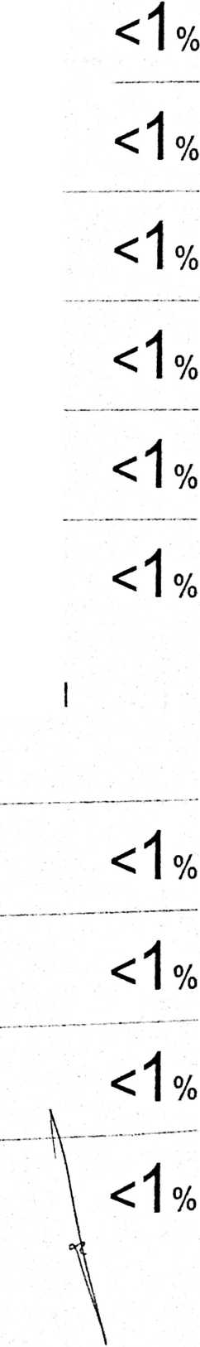
Submitted to Universitas Pendidikan Indonesia
Student Paper I %
edoc.site d
Internet Source I %
repository.uinsu.ac.id
Internet Source ■ %
e-repository.perpus.iainsalatiga.ac.id
Internet Source
%
www.pustakakristen.com
Internet Source
<1%
es.scribd.com
Internet Source
berbagiituindah07.blogspot.com
Internet Source
indeksprestasi.blogspot.com
Internet Source
www.lentera-ilahi.org
Internet Source
Ngimadudin Ngimadudin. "CMC EDUCATION %
BERBASIS KEARIFAN LOKAL", Edification
Journal, 2019 ₍
Publication \
harjumnurdin.blogspot.com \ <’j ₀,
Internet Source \ ⁰
\\

65
alfalumempow.blogspot.com
Internet Source

<1%

Rahayu Apriliaswati. "Strategi Membangun
Kecerdasan Moral dalam Pembelajaran Bahasa
di Sekolah", Jurnal Visi Jlmu Pendidikan, 2012
Publication
<1 o/
I /o
68
69

ahsinrifqy.blogspot.com
Internet Source
maribelajarips.blogspot.com
Internet Source
eprints.uinsby.ac.id
Internet Source
repository.usd.ac.id
Internet Source

<1°/c

<1%
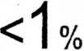
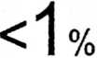
Exclude quotes Off
Exclude bibliography On
Exclude matches Otf

