TINJAUAN TEOLOGIS PERAN MAJELIS GEREJA DALAM
PERKUNJUNGAN PASTORAL BAGI WARGA JEMAAT
GEREJA TORAJA JEMAAT SALUKOMBONG
KLASIS BUAKAYU
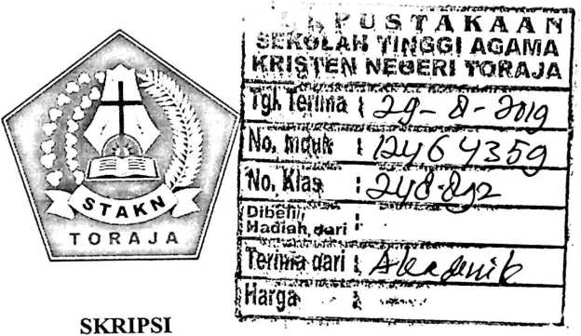
Diajukan Kepada Sekolah Tinggi Agama Kristen Negeri (Stakn) Toraja
Untuk Memenuhi Salah Satu Persyaratan Guna Memperoleh Gelar
Sarjana Teologi ( S.Th)
Oleh
HERLINA SATTU
2020154035
SEKOLAH TINGGI AGAMA KRISTEN NEGERI (STAKN) TORAJA
TAHUN 2019

TINJAUAN TEOLOGIS PERAN MAJELIS GEREJA DALAM
PERKUNJUNGAN PASTORAL BAGI WARGA JEMAAT
GEREJA TORAJA JEMAAT SALUKOMBONG
KLASIS BUAKAYU
SKRIPSI
Diajukan Kepada Sekolah Tinggi Agama Kristen Negeri (Stakn) Toraja
Untuk Memenuhi Salah Satu Persyaratan Guna Memperoleh Gelar
Sarjana Teologi ( S.Th)
Oleh
HERLINA SATTU
2020154035
SEKOLAH TINGGI AGAMA KRISTEN NEGERI (STAKN) TORAJA
TAHUN 2019

Nama | : Herlina Sattu
NIRM | :2020154035
Judul Skripsi | : Tinjauan Teologis Tentang Peran Majelis Gereja  Dalam Perkunjungan Pastoral Bagi Warga Jemaat  Gereja Toraja Jemaat Salukombong Klasis  Buakayu.

Tanggal Pemeriksaan : Rabu, 24 Juli 2019
Similarity
:5%
Dinyatakan MEMENUHI SYARAT ambang batas toleransi. Jika di kemudian
hari ditemukan kekeliruan karena keterbatasan aplikasi, seperti adanya kesamaan
dengan kaiya ilmiah lain yang lebih awal mendapatkan pengakuan sebagai hak
cipta (misalnya: karya ilmiah tersebut belum publish secara online), maka semua
konsekuensi yang ditimbulkan menjadi tanggung jawab penulis skripsi.
Demikian surat keterangan ini, untuk dipergunakan sebagaimana mestinya.
Penulis Skrif ^4 ETer ai
TEMPEL
X „>3BB7ADF094492720

6000 0
Hcrlina satt ^{E}^^{RiauRUR1AH}
Mengkendek, 31 Juli 2019
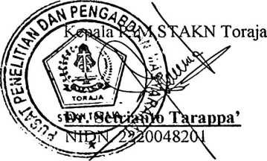


HALAMAN PERSETUJUAN
Judul
:Tinjauan Teologis Peran Majelis Gereja Dalam Perkunjungan
Pastoral Bagi Warga Jemaat Gereja Toraja Jemaat Salukombong
Klasis Buakayu
Disiapkan oleh
Nama : Herlina Sattu
NIRM: 2020154035
Jurusan: Teologi Kristen
Skripsi ini telah melalui proses pembimbingan oleh dosen pembinbing dan
dinyatakan telah melalui persyaratan untuk diuji oleh Dewan penguji Sekolah
Tinggi Agama Kristen Negeri (STAKN) Toraja.
Mengkendek, 26 Juni 2019
Dosen Pembimbing
Pembimbing I
Pembimbing II

Hermin Bollan, M.Th
NIP. 196307112000032001

Herman Titting, M.Pd.K
NIDN : 0902018404

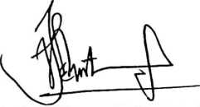

ABSTRACK

Herlina Sattu 2020154035: "Theological review of the role of the

Assembly of the church in the Pastoral visit of the Church of the

congregation Toraja Salukombong Klasis Buakayu"
This title was chosen because the church assembly did not conduct
pastoral visitation for the congregation who were struggling and inactive in
fellowship in the congregation.
The formulation of the problems examined in this thesis is what is the
obstacle for the Assembly in the pastoral visit of the Congregation of the Church
of Toraja Congregational Salukombong Klasis Buakayu. The purpose of this
study is to explain the constraints for the Assembly in conducting pastoral visits
for the citizens of the Church of the Toraja churches of the Salukombong Klasis
Buakayu.
Pastoral Visitation is one of the forms of grazing in the congregation.
Church assemblies can guide, accompany, direct the congregation, pay attention,
and know the State of the congregation. The method by which the author used in
this research is a qualitative method, where the authors use two techniques
analyzing the form of interviews directly with the informant, and the form of
observation/observation directly in place Research in the Klasis Buakayu
Salukombong Church.
In this study that became an obstacle to the Church assembly in doing
pastoral visitation was that the Church assembly had never gained pastoral
guidance, felt reluctionant, and there was no good cooperation between the
Church assemblies so that there were residents An inactive congregation in the
Fellowship.
Seeing this, it is hoped that the Church's mejelis to make training programs
on pastoral visits in congregations and church assemblies need to understand that
its role and duties as the Shepherd of the congregation is to do pastoral visitation.
For the people of the congregation who are struggling and inactive in communion
so as to grow in Christ.
iv

HALAMAN PENGESAHAN
Judul Skripsi :Tinjauan Teologis Peran Majelis Gereja Dalam Perkunjungan
Pastoral Bagi Warga Jemaat Gereja Toraja Jemaat Salukombong
Klasis Buakayu
Ditulis oleh :
Nama : Herlina Sattu
Nirm : 2020154035
Jurusan : Teologi Kristen
Telah dipertahankan oleh penulis di depan dosen penguji dalam proses ujian
skripsi Strata satu (SI) Prodi Teologi Kristen pada tanggal 04 Juli 2019, dan
dinyatakan lulus dengan nilai B, dan diyudisium pada tanggal 09 Juli 2019 dengan
predikat kelulusan MEMUASKAN.
Mengkendek, Juli 2019
Dosen Penguji
Penguji I


Algu S. Pabangke, M.Pd
NIP. 198808162011012010
Panitia Ujian
Ketua

Algu S. Pabangke, M.Pd
Penguji II
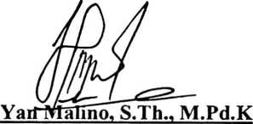
NIP. 197711222009011007
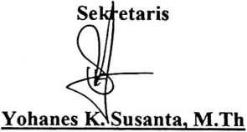
NIP.198808162011012010 NIP. 198612132019031012
kAN A
Toraja,

THfTfapingku, M.Th
761242005011003
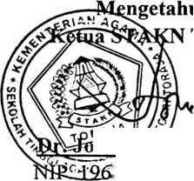
ABSTRACK
Herlina Sattu 2020154035: "Theological review of the role of the
Assembly of the church in the Pastoral visit of the Church of the
congregation Toraja Salukombong Klasis Buakayu"
This title was chosen because the church assembly did not conduct
pastoral visitation for the congregation who were struggling and inactive in
fellowship in the congregation.
The formulation of the problems examined in this thesis is what is the
obstacle for the Assembly in the pastoral visit of the Congregation of the Church
of Toraja Congregational Salukombong Klasis Buakayu. The purpose of this
study is to explain the constraints for the Assembly in conducting pastoral visits
for the citizens of the Church of the Toraja churches of the Salukombong Klasis
Buakayu.
Pastoral Visitation is one of the forms of grazing in the congregation.
Church assemblies can guide, accompany, direct the congregation, pay attention,
and know the State of the congregation. The method by which the author used in
this research is a qualitative method, where the authors use two techniques
analyzing the form of interviews directly with the informant, and the form of
observation/observation directly in place Research in the Klasis Buakayu
Salukombong Church.
In this study that became an obstacle to the Church assembly in doing
pastoral visitation was that the Church assembly had never gained pastoral
guidance, felt reluctionant, and there was no good cooperation between the
Church assemblies so that there were residents An inactive congregation in the
Fellowship.
Seeing this, it is hoped that the Church's mejelis to make training programs
on pastoral visits in congregations and church assemblies need to understand that
its role and duties as the Shepherd of the congregation is to do pastoral visitation.
For the people of the congregation who are struggling and inactive in communion
so as to grow in Christ.
iv

