Skripsi Febriersi Bontong
b_{y} Catur Joko Santoso
•brmission date: 11-Sep-2020 08:26AM (UTC-0500)
-irmission ID: 1371730532
-t nname: FEBRIERSI_BONTONG._SKRIPSI-1.rtf (352.26K)
count: 7253
■’rracter count: 47229

Skripsi Febriersi Bontong
*• *^ *■***- ^ '■•**'- • '*■- bvi •#» * 'i m r ■ «“»r ■ ■ a
| ORIGINALITY REPORT
SIMILARITYINDEX INTERNET SOURCES PUBLICATIONS STUDENT PAPERS
PRIMARY SOURCES
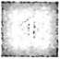
gmki.or.id
Internet Source
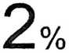

Submitted to President University
Student Paper
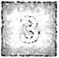
id.123dok.com
Internet Source
I
»
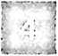

sahlanpermana.blogspot.com
Internet Source

sabda.org
internet Source
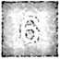

repository.radenintan.ac.id
Internet Source
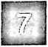

Submitted to IAIN Metro Lampung
Student Paper
%
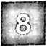

www.koleksiedukasi.web.id
Internet Source
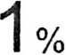

repository.ar-raniry.ac.id
J Internet Source
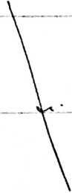

0

katyinmars.blogspot.com
internet Source

E
’ agneslintangsari.wordpress.com
Internet Source

0
0
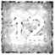

www.scribd.com
Internet Source
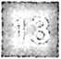

ejurnal.poltekkes-tjk.ac.id
Internet Source
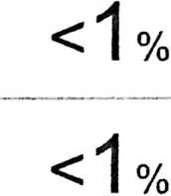
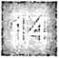

archive.org
Internet Source

%


%

eprints.perbanas.ac.id
Internet Source


rzi Submitted to Universitas Negeri Jakarta
t. J Student Paper
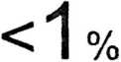
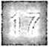

es.slideshare.net
Internet Source

<1 %


es.scribd.com
Internet Source

%


Submitted to iGroup
Student Paper


eprints. iain-surakarta. ac.id
Internet Source



Submitted to Sogang University
Student Paper
%
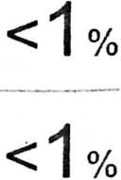

Submitted to UIN Syarif Hidayatuilah Jakarta
Student Paper

0
o

text-id.123dok.com
Internet Source
id.scribd.com
Internet Source

JJ blessingcawala.blogspot.com
.J Internet Source

0

o/
/o
o

mariasll 009.blogspot.com
Internet Source

0

sayapm.blogspot.com
Internet Source

repository.iainpurwokerto.ac.id
..j Internet Source

o/
/o
g hkbpindrapurakota.wordpress.com
„J Internet Source

0

www.siideshare.net
Internet Source

0
I -
'1

supportartikel.blogspot.com
Internet Source

0

0
docplayer.info
Internet Source

Submitted to Universitas Negeri Surabaya The

State University of Surabaya
Student Paper
core.ac.uk
Internet Source
0
repositori.kemdikbud.go.id
Internet Source
0
UU Submitted to IAIN Surakarta
L. .'.J Student Paper
Submitted to Universitas Negeri Padang
J Student Paper
0
HgJ itministryblogaddress.blogspot.com
internet Source
0
i mudhofar.biogspot.com
i Internet Source
0
digilib.uin-suka.ac.id
J Internet Source
0
.'1 eprints.walisongo.ac.id
Internet Source
0
r j digilib.iain-palangkaraya.ac.id
J Internet Source
o
rgl citrametro.blogspot.com
Internet Source
0

www.komkat-kwi.org
Internet Source
0

H
smp2klaten.blogspot.com
Internet Source

dekorasiacarapernikahanbandung.wordpress.com
L.. j Internet Source

0

H
ejournal.upnvj.ac.id

Internet Source
o
repository.uinjkt.ac.id
, .\j Internet Source

0
mekasa.blogspot.com
Internet Source
0

maryoindramanjaruni.wordpress.com
Internet Source
0
andyaagisa.blogspot.com
Internet Source
<1 %

f Dame R. Marbun. "Gambaran Kebiasaan
■ ^{J} Menyirih dan Lesi Mukosa Mulut pada
Mahasiswa Papua Di Manado", e-GIGl, 2013
Publication
%


etheses.iainponorogo.ac.id
Internet Source

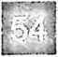

repository.ub.ac.id
Internet Source

eprints.uny.ac.id
Internet Source

%
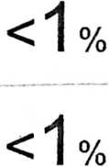

www.newlifeimage.com
Internet Source
Submitted to Universitas Pendidikan Indonesia
Student Paper
•'o'1
0
library.binus.ac.id
Internet Source
kamalyasya.wordpress.com
L_J Internet Source
0
ikaoktaviani1705.blogspot.com
L... .J Internet Source
0
pensilwama.blogspot.com
L/.’.__J Internet Source
0
www.herry.blog.untan.ac.id
Internet Source
0
rp jurnalmahasiswa.unesa.ac.id
L./. Internet Source
o
idoc.pub
L. ’J Internet Source
o
etheses.uin-malang.ac.id
k. /'J Internet Source
o
www.publikzone.com
.„...lJ Internet Source
0

