IMPLEMENTASI PELAKSANAAN KURIKULUM 2013 PADA
MATA PELAJARAN PENDIDIKAN AGAMA KRISTEN
DI SEKOLAH MENENGAH PERTAMA (SMP)
NEGERI 2 RANTETAYO

SKRIPSI
Diajukan Kepada Sekolah Tinggi Agama Kristen Negeri (STAKN) Toraja Sebagai Salah
Satu Persyaratan Akademik Untuk Memperoleh Gelar Sarjana Pendidikan (S.Pd)
Oleh:
RINA MATTU S
1020143769
JURUSAN PENDIDIKAN AGAMA KRISTEN

SEKOLAH TINGGI AGAMA KRISTEN NEGERI (STAKN)

TORAJA

2018

Judul Skripsi | : IMPLEMENTASI PELAKSANAAN KURIKULUM 2013
PADA MATA PELAJARAN PENDIDIKAN AGAMA
KRISTEN (PAK) DI SEKOLAH MENENGAH PERTAMA
(SMP) NEGERI 2 RANTETAYO
Diajukan Oleh  Nama | : Rina Matius
Nirm | :1020143769
Jurusan | : Pendidikan Agama Kristen

Setelah diperiksa dan diteliti ulang, ternyata telah memenuhi persyaratan
untuk dipertahankan oleh penulis di hadapan panitia dan dewan penguji dalam ujian
skripsi jurusan Pendidikan Agama Kristen STAKN Toraja.
Mengkendek, 28 November 2018
Pembimbing I
Dr. 1 Made Suardana, M.Th
NIP. 197512122008011014
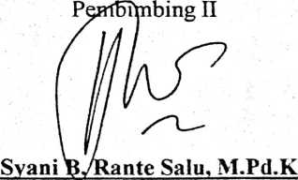
NIP. 198908282015032006

HALAMAN PENGESAHAN  Judul | : Implementasi Pelaksanaan Kurikulum 2013 Pada Mata  Pelajaran Pendidikan Agama Kristen (PAK) Di Sekolah  Menengah Pertama (SMP) Negeri 2 Rantetayo.
Ditulis Oleh | : Nama : Rina Matius  Nirm : 1020143769  Jurusan : Pendidikan Agama Kristen

Telah dipertanggung jawabkan di hadapan dosen penguji dalam proses
ujian skripsi Stratum Satu (SI) Jurusan Pendidikan Agama Kristen.
Mengkendek, 18 Desember 2018
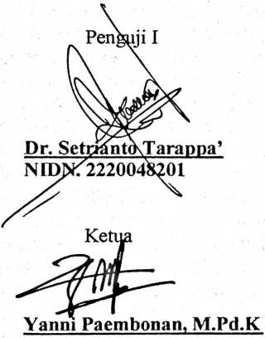
NIDN. 0920078702
Panatia Ujian
Dosen Penguji
Penguji II
Yosef Patandung. M.Pd
NIDN. 0921057601
Sekretaris

NIDN. 0902018404
Mengetahui
Ketua STAKN Toraja

Dr. Joni Tapingku
NIDN. 2224016701


ABSTRACT
Curriculum is the main reference in the implementation of leaming
activities in schools. The provisions of the success or failure of an education are
dependent on the curriculum used. With the change in curriculum requires
adjustments and more deepen knowledge about the 2013 curriculum. 2013
leaming is the center of attention for students with the hope of experiencing an
increase and balance between hard skills dan soft soft skills which includes three
aspects namely attitudes, skill and knowledge, teachers can apply leaming to
require adjustments in the implementation of leaming. Even in preparing leaming
based on the 2013 curriculum which is not fully understood. And as a Christian
aducation teacher who teaches about the character of Jesus , that Jesus example in
students is not taught well, even students are only able to understand it but are
unable to apply in their lives the character of Jesus. Education success depends on
the teacher in carrying out leaming and seeing the results of student leaming.
Thus in the preparation of this thesis the author would like to examine how the
implementation of the 2013 curriculum in leaming Christian Religious Education.
In completing this writing, the author uses a qualitative research method
that sees in fact the events that occur in the field. As well as to more accurately
obtain the data needed the author uses several types of data collection techniques
namely observation, interviews, library studies, with qualitative data analysis
techniques through the process of reduction, data presentation, data verification
and data interpretation.
As for the results of research conducted by the author through the results
of interviews and observations with teachers and students at Rantetayo 2 Junior
High School, showing that the implementation of the 2013 curriculum in leaming
Christian Education is fully implemented well, it can be seen from the leaming
process in the classroom, that the teacher teaches by adjusting to the leaming
device in the copy paste through leaming the scientific approach that students
observe, ask, collect Information, associate and communicate the results.
However, the constraints in implementing leaming are experienced by schools,
namely facilities and infrastructure that have not supported such as leaming
rooms, lack of understanding of techonological sophistication, leaming activities
that lack communication between teachers and students and so on. But there are
efforts made by the school that are collaborating between teachers, so that the
improvement in students llaeming outcomes changes, even though the change is
not significant, but at least through the 2013 curriculum applied, students
experience changes in student leaming outcomes, and student attitudes that
appear as children God has maturity in faith.
Keywords : Curriculum, Learning, Maturity, Faith.
iii

