Skripsi Ratna Pasapa
by Catur Joko Santoso
brmission date: 27-Dec-2020 06:29PM (UTC-0800)
bmission ID: 1481575157
^niame: SKRIPSI_RATNA_PASAPA_REVISI.docx (289.14K)
^rdlcount: 13545
practer count: 96864

Skripsi Ratna Pasapa
ORIGINALITY REPORT


4%
SIMILARITY INDEX
7% 2%
INTERNET SOURCES PUBLICATIONS
STUDENT PAPERS


perkembangan-komputer-dan-
informasi.blogspot.com

repository.radenintan.ac.id
Internet Source
<1%
<1 %

Submitted to Universitas Negeri Jakarta


www. a n ta ra n e ws. co m
internet Source


zombiedoc.com
Internet Source

journal.trunojoyo.ac.id
Internet Source

repository.ar-raniry.ac.id
Internet Source
%
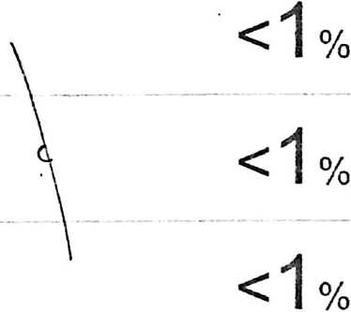
eprints.ums.ac.id

Internet Source
S
repository.uin-suska.ac.id
Internet Source
< 1 %
<1 %

ojs.unm.ac.id
Internet Source
lll

id.123dok.com
Internet Source

ra Submitted to King Mongkut’s University of < i ₀
^{J} Technology Thonburi
Student Paper
Submitted to Syiah Kuala University < d o
feie-3 Student Paper ■ %
O moam.info
L. J Internet Source



eprints.iain-surakarta.ac.id
Internet Source
ainamulyana.blogspot.com
Internet Source
firmankaukabah.blogspot.com
Internet Source
rry text-id.123dok.com
Internet Source

<1 °/c


ri digilib.uinsby.ac.id
LL.J Internet Source I %
r,Z; exploringsriwahyunisam.blogspot.com <i ₀
Internet Source I %

suteki.co.id
Internet Scu/ce

ejournal.iainbengkulu.ac.id
Internet Source
%


prezi.com
internet Source
%


Submitted to Universitas Negeri Makassar
S-udent Paper
Dita Ratna Sari, Mizaniya Mizaniya, Ahmad
Noviansah. "PERILAKU AGRESIF ANAK
DISEBABKAN ORANG TUA MERANTAU", Al-
Madrasah: Jurnal Pendidikan Madrasah
<1 %

Ibtidaiyah, 2020


Submitted to Dewan Perwakilan Rakyat
repository.uinjkt.ac.id \
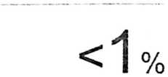



beiajarbiog53.blogspot.com
Internet Source
docobook.com
Internet Source
<1 %
<1'0/0
www.tokokursi.com
Internet Source
www.pasundanekspres.co
Internet Source
0/
/0
es.scribd.com
Internet Source
0
Oktavianto Nugroho Saputro, Soebijantoro
Soebijantoro. "Pengembangan Wedus Gembel
(Wayang Kardus Gembira Dan Belajar) Sebagai
Media Membangun Jiwa Nasionalisme Sejak
Dini Pada Siswa TKK Santo Yusuf Kota
Madiun”, AGASTYA: JURNAL SEJARAH DAN
PEMBELAJARANNYA, 2015
Publicanon

eprints.umm.ac.id
Internet Source .
www.kompasiana.com \
Internet Source C,
repository.iainpurwokerto.ac.id \\
Internet Source

eprints.uny.ac.id
Internet Source
kotarajabungas.blogspot.com
Internet Source
id.scribd.com
siedoo.com
Internet Source
digilib.uin-suka.ac.id
Internet Source
www.scribd.com
Internet Source

e-repository.perpus.iainsalatiga.ac.id
Internet Source
digilibadmin.unismuh.ac.id
Internet Source
docplayer.info
Internet Source
nonakupang.com
Internet Source
123dok.com
Internet Source
syrisna.biogspot.com

B
pai.iaingorontalo.ac.id
Internet Source

<1%

<1%
pl www.jurnalfai~uikabogor.org
L'* j Internet Source

lib.unnes.ac.id
Irusrnot Sourco

<1%

<1%
Exclude cuoles
Exclude matohes
Ezclude dibliography

