Skripsi Yoni Suli Mappadang
by Catur Joko Santoso

liission date: 14-Dec-2020 04:04PM (UTC-0600)
liission ID: 1376777485
lame: SKRIPSI_YONI_SULI_MAPPADANG_-_TURNITIN.doc (180.5K)
I 'Count: 6774
3'Cter count: 43703


"k:ripsi Yoni Suli Mappadang
=IG3INALITY REPORT

18%
NIIILARITYINDEX INTERNET SOURCES PUBLICATIONS
:IM3ARY SOURCES
0
media.repository.sttjaffray.ac.id
Internet Source
H lailanisak.wordpress.com
imJ Internet Source
a
budimakaado.blogspot.com
Internet Source
STUDENT PAPERS
2%
0
0
'j~] r e p o s i t o r y. r a d e n i n t a n. a c. i d
—J Internet Source
0
gn repository.iainpurwokerto.ac.id
Internet Source
0
www.wawasan-edukasi.web.id
Internet Source
n paulusmtangke.wordpress.com
—I Internet Source
H Journal.stbi.ac.id
« Internet Source
□ docplayer.info
—J Internet Source
repository.ar-raniry.ac.id
Internet Source
id.123dok.com
Internet Source
eprints.walisongo.ac.id
Internet Source
www.zonareferensi.com
Internet Source
123dok.com
Internet Source

ojs.unpkediri.ac.id
Internet Source
%
rinarxivdipi.go.id
Internet Source
livinglarger.multiply.com
Internet Source
%
core.ac.uk
Internet Source
Submitted to Universitas Pendidikan Indonesia
Student Paper
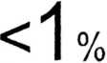
<1o/
I /c
%
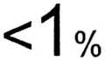

%
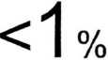
www.scribd.com
Internet Source
zombiedoc.com
Internet Source
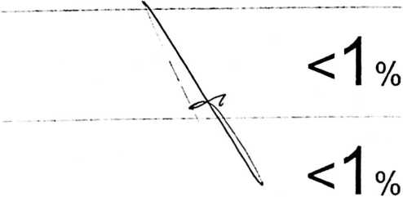

repository.uinjkt.ac.id  Internet Source | <1 %
eprints.poltekkesjogja. ac.id  Internet Source | <1 %
repository.usd.ac.id  Internet Source | <1 %
www.nesabamedia.com  Internet Source | <1 %

eprints.ums.ac.id
Internet Source
sangsabda.wordpress.com
Internet Source
ejournal.uki.ac.id
Internet Source
ejournal.undiksha.ac.id
Internet Source
www.researchgate.net
Internet Source
%
Submitted to Universitas Katolik Widya Mandala < **] o
Student Paper
scholar. unand.ac.id
Internet Source
<1°/

ramadhanmuawad.wordpress.com d
Internet Source I %

journal-old.unhas.ac.id
Internet Source

<1 %

pt.scribd.com
Internet Source
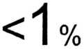

antazula.student.umm.ac.id
Internet Source
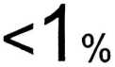

Syamsul Bachri. "Kewenangan kejaksaan
terhadap tindak pidana korupsi atas kerugian
keuangan negara", Ekspose: Jurnal Penelitian
Hukum dan Pendidikan, 2020
Publication

moam.info
Internet Source

i Q L..'- i t O ? y L-5 . O C . 1 - . -
Internet Source

Alexander Stevanus Luhukay. "ANALISIS
TEOLOGIS MENGENAI BERIBADAH DI
RUMAH DI TENGAH PANDEMI COVID-19 DI
INDONESIA", VISIO DEL JURNAL TEOLOGI
KRISTEN, 2020
Publication

%

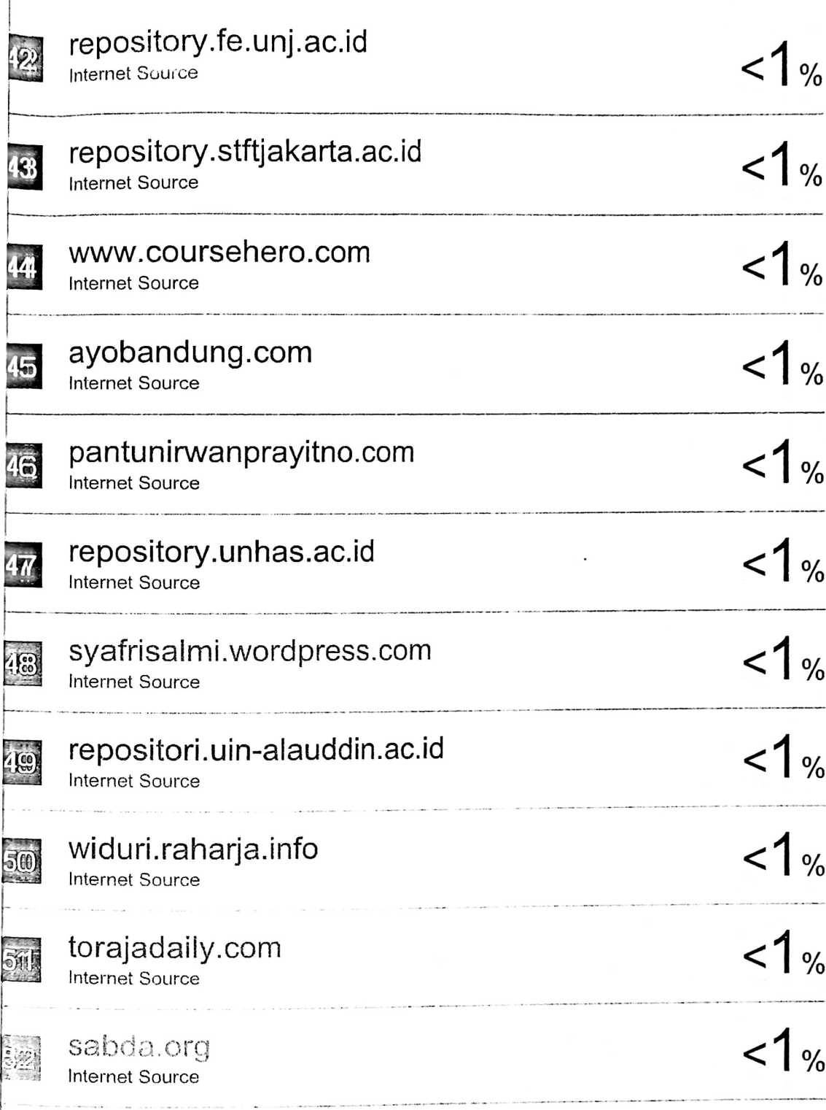
0
benediktusricardostisi.blogspot.com
Internet Source

alfallahu.blogspot.com
Internet Source
<1 °/c
rimbakita.com
Internet Source
docobook.com
Internet Source
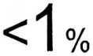
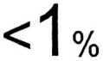
583
maghrobiahmad.blogspot.com
Internet Source
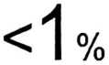
59
worldwidescience.org
Internet Source
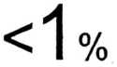
issuu.com
Internet Source
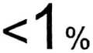
g bisnisankecil.biogspot.com
J Internet Source
I - - '
a
agungsetiadi17.blogspot.com
Internet Source
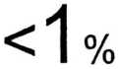
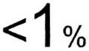
SI www.medcom.id
Internet Source
1 Iibraryofmorons.blogspot.com
Internet Source
j
fei w w w. k o I e k s i e d u k a s i. w e b. i d
U• * Internet Source

<1 %
" afidburhanuddin.wordpress.com



Internet Source

elitasuratmi.wordpress.com
Internet Source
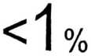
cIHude quotes Off
tcIUude bibliography On
Exclude matches Off

