Fien
by Yohanes Krismantyo Susanta
Submission date: 27-Aug-2020 12:23PM (UTC+1000)
Submisslon 10:1282490075
File nama: Fien_Sendana_Cek_Plagiarisme.docx (1.39M)
Word count: 12399
Character count: 80156

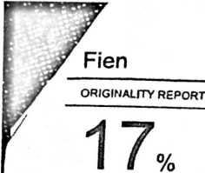
SIMILARITY INDEX

17% 2% 5%
INTERNET SOURCES PUBLICATIONS STUDENT PAPERS
PRIMARY SOURCES

• hasratl 23.blogspot.com
J Internet Source

3%

media.neliti.com
Internet Source
2
%

repository.uinjkt.ac.id
Internet Source
%

repositori.kemdikbud.go.id
_J Internet Source

www.scribd.com
Internet Source
(3;
__J

Submitted to Universitas Pendidikan Indonesia
Student Paper

□
mafiadoc.com
Internet Source
'o

e-journal.usd.ac.id
Internet Source

steveneugrr.blogspot.com
Internet Source
'o

