Skripsi Ramsi
by Catur Joko Santoso
>rmission date: 07-Jan-2021 09:17PM (UTC-0800)
’rmission ID: 1484432267
iname: Ramsi__Skripsi_OKE.docx (56.48K)
■cd count: 7260
rracter count: 46423

Skripsi Ramsi
pJRIGINALITY REPORT




iSolMILARITY INDEX
INTERNETSOURCES
PUBLICATIONS
STUDENT PAPERS
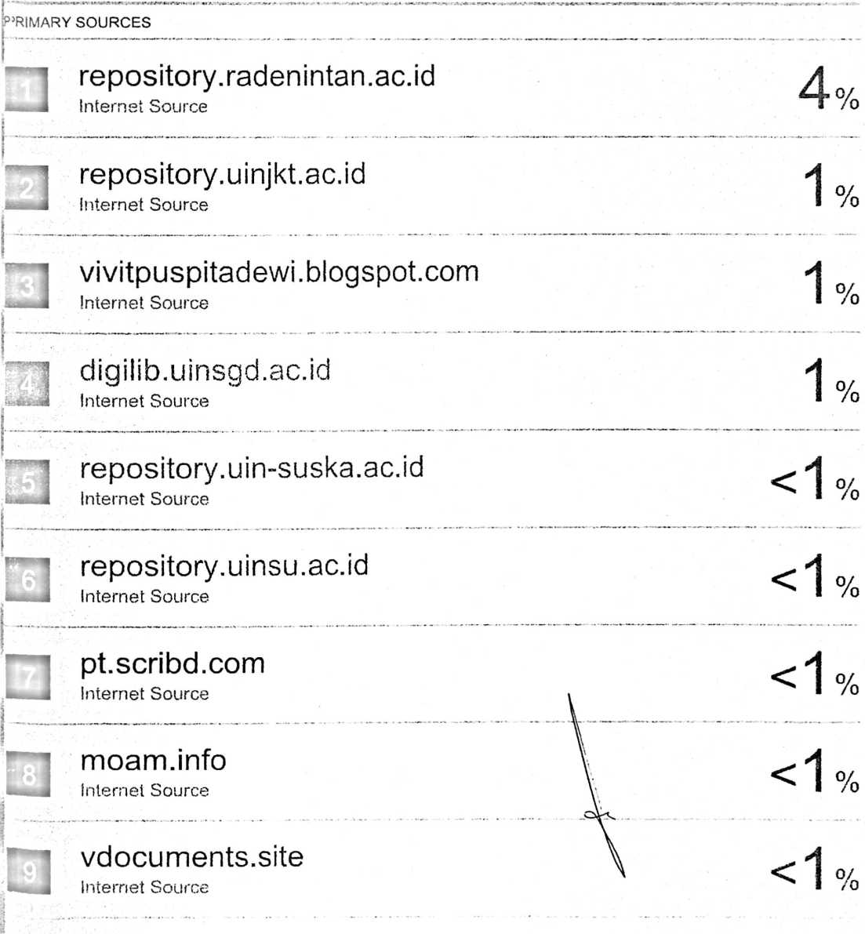

arnesvhe.blogspot.com

eprints.ums.ac.id
Internet Source

mediacerdik.blogspot.com
Internet Source

id.scribd.com
Internet Source
--- • .««M**. • —- ..M» - _ - * - . M . • — • - - ....... . . . . •• • - —«•••—■ -■***«• ' • --

id.123dok.com
Internet Source
W-‘- -M» - — —- . - • • —— - • •• •- — — - • — — • •— —• “•*“ - — - ■

123dok.com
Internet Source

re p o s i to r y. a r-ra n i ry. a c. i d
Internet Source

deniutomosite.blogspot.com
Internet Source

bagawanabiyasa.wordpress.com
Internet Source

nurulinab.blogspot.com
Internet Source
W *• — . • •.«>«• • -*-*• •• - . . ...«■> • *•» '«UI *
penulissejarah.wordpress.com
Internet Source

repo.iain-tulungagung.ac.id
Internet Source

e-repository.perpus.iainsalatiga.ac.id
internet Source

es.scribd.com
Internet Source

<1 %
gudangmakalahku.blogspot.com
internet Source

eprints.iain-surakarta.ac.id
Internet Source
aguspatang.blogspot.com
Internet Source

library.binus.ac.id
Internet Source

ejournal.uki.ac.id
Internet Source

<1 %

<1 %

<1 %

<1 7c
contohtesis.idtesis.com
Internet Source
tariezra.blogspot.com
Internet Source

Juliana Juliana, Indra Ibrahim, Afrizal Sano.
"Konsep Diri Remaja pada Masa Pubertas dan
Implikasinya terhadap Layanan Bimbingan dan
Konseling", Jurnal Konseling dan Pendidikan,
2014
Publicalion

<1 %

<1%
%
i

www.isomwebs.net
Internet Source
0
repository.unhas.ac.id
«mJI Internet Source
repository.uinbanten.ac.id
J Internet Source
' sitijahara26.blogspot.com
«■hI Internet Source
0
0
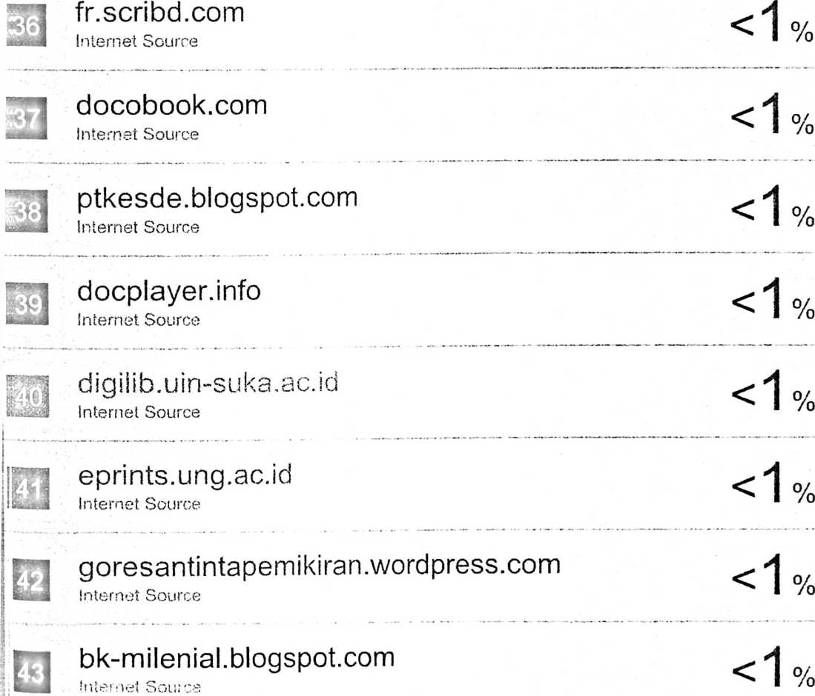
il

zombiedoc.com
Internet Source
eprints.undip.ac.id
Internet Source
repository.syekhnurjati.ac.id
Internet Source
www.scribd.com
Internet Source
Iutfymeilanimediabki2017.wordpress.com
Internet Source
mutiarahati-pujaanhati.blogspot.com
Internet Source
www.smknl kawali, sch.id
Internet Source
play.google.com
internet Source
chem-eng.its.ac.id
Internet Source
www.jurnalbia.com
Internet Source
rifansby5.blogspot.com
Internet Source
Hanum Jazimah. "Implementasi Manajemen Diri

Mahasiswa dalam Pendidikan Islam",
MUDARRISA: Journal of Islamic Education,
2015
Publication

eprints.uny.ac.id
Internet Source



m-belajar.blogspot.com
Internet Source
o

rizkiauliarahmawati2012.blogspot.com
Internet Source

o/
/o
whynasblog.blogspot.com
Internet Source
qdoc.tips
Internet Source
o
tugasfitrianurmalasari.wordpress.com
j Internet Source
o
Exclude quotes Off
Exclude bibliography Off
Exclude matches

