INSTRUMEN HUBUNGAN PROFESIONALISME GURU PAK DENGAN  
PERTUMBUHAN IMAN SISWA DI  
SMP NEGERI 1 RANTEPAO

Petunjuk pengisian

1. Bacalah dengan seksama dan pahamilah setiap pernyataan yang ada sebelum mengisi dan memberi tanda.
2. Berilah tanda cek **(V)** pada kolom jawaban yang ada, yang paling cocok dan sesuai dengan pemahaman bapak/ibu, saudara/i dengan keterangan sebagai berikut:

A = jika merasa pernyataan tersebut selalu terlaksana B = jika merasa pernyataan tersebut sering terlaksana C = jika merasa pernyataan tersebut kadang-kadang terlaksana D = jika merasa pernyataan tersebut hampir tidak pernah terlaksana E = jika merasa pernyataan tersebut tidak pernah terlaksana

1. Saya sangat menghargai dan berterima kasih atas kesediaan bapak/ibu, saudara/i mengisi instrumen ini.

|  |  |  |  |  |  |  |
| --- | --- | --- | --- | --- | --- | --- |
| **No** | **INSTRUMEN** | **A** | **B** | **C** | **D** | **E** |
| **Variabel: Profesionalisme Guru Pendidikan Agama Kristen** | | | | | | |
| **I** | **Guru menjelaskan pokok-pokok materi pada pertemuan pertama, yang akan dipelajari selama satu semester** |  |  |  |  |  |
| **2** | **Guru mengajar dengan menggunakan lebih dari satu buku (misalnya; Alkitab, cermin remaja, dan lain-lain)** |  |  |  |  |  |
| **3** | **Guru menggunakan contoh-contoh praktis dalam mengajar** |  |  |  |  |  |
| **4** | **Guru menjelaskan materi pelajaran dan menghubungkan dengan mata pelajaran lain yang berhubungan, misalnya PKN, IPA dan lain-lain** |  |  |  |  |  |
| **5** | **Guru mengenal peserta didik baik menghafal nama, tempat tinggal, dan lain-lain** |  |  |  |  |  |
| **6** | **Guru melaksanakan pembelajaran dengan baik dan menarik karena menggunakan beberapa buku, menggunakan LCD, dan penjelasannya yang muda dipahami.** |  |  |  |  |  |

A = Selalu, B = Sering C = Kadang-kadang

D = Hampir tidak pemah E = Tidak pernah

10

11

12

**13**

**14**

**15**

**16**

**17**

**18**

**19**

20

21

**23**

**Guru terus memberi motivasi kepada siswa untuk terus rajin belajar**

**Guru memiliki sikap yang baik yang dapat diteladani oleh siswa (baik, ramah, dll)**

**Guru tidak membeda-bedakan siswanya (misalnya: memberi perhatian, memberi nilai)**

**Guru menegur siswanya yang berbuat tidak baik dan memberi nasehat.**

**Guru mendidik dan menasehati siswa yang dengan sabar dan setia (misalnya kepada siswa yang nakal dan kepada semua siswa)**

**Guru menjalin hubungan yang baik dengan siswa (menjadi orangtua yang baik bagi siswa)**

**Guru bekerja sama dengan guru mata pelajaran yang lain dan pegawai**

**Guru menjalin hubungan yang baik dengan orangtua siswa dan masyarakat secara umum**

**Guru memulai dan mengakhiri pelajaran dengan bernyanyi dan berdoa**

**Guru mengajak siswa untuk rajin ke gereja**

**Guru mempraktekkan kasih bagi sesama dan lingkungan. Misalnya melalui mendoakan yang sakit, ikut menjaga kebersihan, dll.**

**Guru menghafal beberapa ayat Alkitab ketika sedang mengajar**

**Guru senang menasehati siswanya yang berbuat tidak baik**

**Guru mengajak siswa untuk selalu berdoa membaca Alkitab minimal 1 kali dalam satu hari (bisa juga dengan memberi kepada siswa ayat hafalan).**

**Variabel: Pertumbuhan Iman**

**Mengerti penjelasan guru tentang pelajaran yang dipelajari**

**Mampu menjelaskan dengan baik apa yang telah dipelajari (melalui tes-tes kecil)**

**Mampu menjawab setiap tugas yang diberikan dengan baik dan**

**Perhatikan:**

**A = Selalu,**

**B = Sering**

**C = Kadang-kadang**

**D = Hampir tidak pernah E = Tidak pernah**

|  |  |  |  |  |  |  |
| --- | --- | --- | --- | --- | --- | --- |
|  | **tepat** |  |  |  |  |  |
| **24** | **Mendapat nilai yang bagus dari setiap tugas-tugas** |  |  |  |  |  |
| **25** | **Mendapat nilai rapor yang diatas KKM** |  |  |  |  |  |
| **26** | **Memperhatikan guru pada saat belajar (tidak bermain-main saat belajar)** |  |  |  |  |  |
| **27** | **Mengerjakan tugas-tugasnya dengan tekun** |  |  |  |  |  |
| **28** | **Mendengar pada saat dinasehati guru** |  |  |  |  |  |
| **29** | **Menerima dengan baik nasehat yang diberikan oleh guru** |  |  |  |  |  |
| **30** | **Menjadikan Alkitab sebagai pedoman hidup (melakukan apa yang menjadi perintah dan menjauhi apa yang menjadi larangan di dalam Alkitab)** |  |  |  |  |  |
| **31** | **Sopan terhadap guru (misalnya : menyapa pada saat bertemu, berbicara dengan baik dan santun)** |  |  |  |  |  |
| **32** | **Suka membaca Alkitab (dilingkari)**   1. **tidak pernah** 2. **1 x 1 minggu** 3. **3 x 1 minggu** 4. **5 x 1 minggu** 5. **Jebih dari 6 x dalam satu minggu** |  |  |  |  |  |
| **33** | **Suka menolong temannya (misalnya ; meminjamkan pulpen, pencil, buku cetak, membantu mereka yang tidak mengerti pelajaran, dll)** |  |  |  |  |  |
| **34** | **Senang ikut ibadah (misalnya ; ibadah hari minggu, ibadah KKR, ibadah kumpulan sekolah minggu, dan ibadah-ibadah lainnya)** |  |  |  |  |  |
| **35** | **Mewujudkan imannya melalui tindakan sehari-hari (misalnya ; menjadi orang yang dapat membawa damai melalui sikap dan tindakannya dengan tidak suka berantam dengan teman- temanya, tidak merokok, tidak membuang sampah di sembarang tempat ,dll)** |  |  |  |  |  |

„ . A = Selalu, B = Sering C= Kadang-kadang

Perhatikan: _. ,

D = Hampir tidak pernah E = Tidak pernah

r

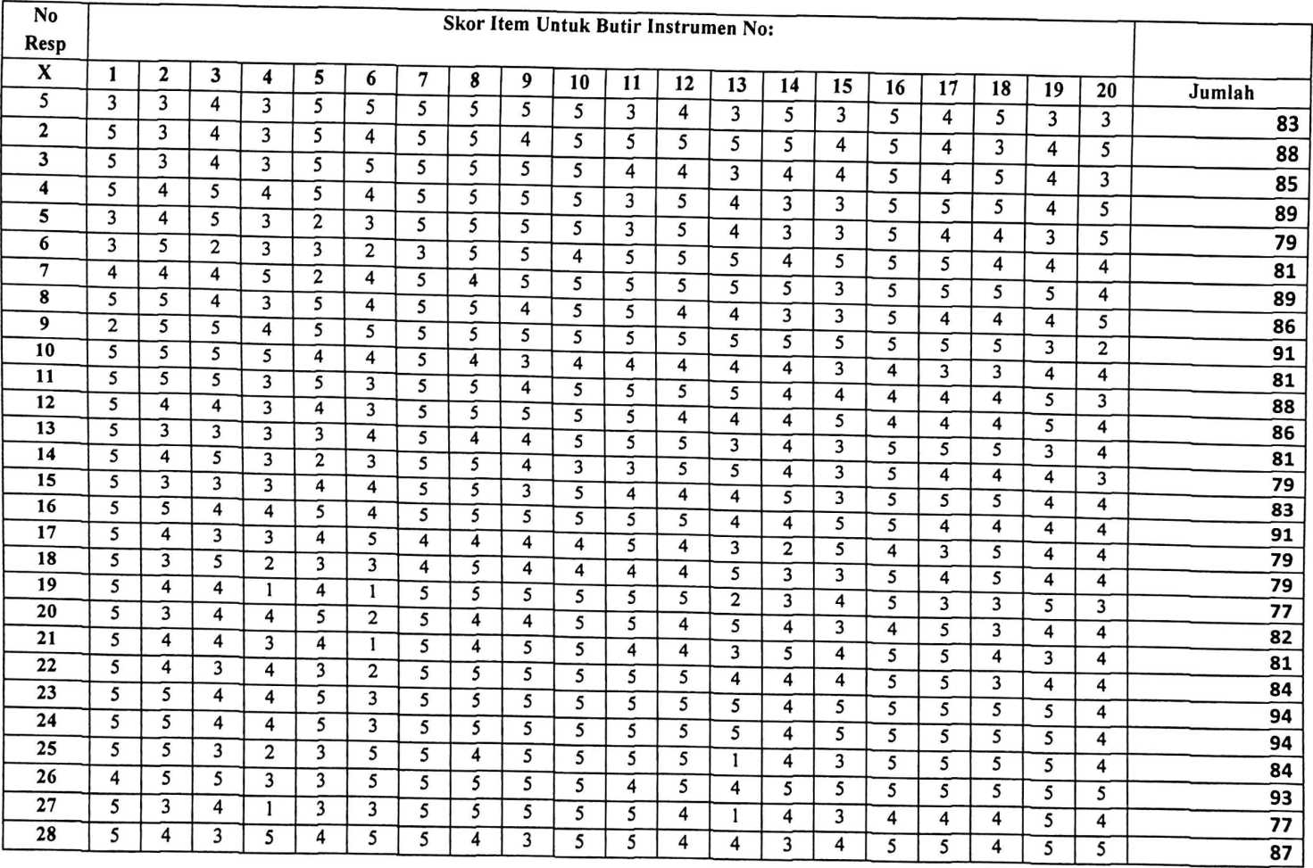

r



|  |  |  |  |  |  |  |  |  |  |  |  |  |  |  |  |  |  |  |  |  |  |  |  |  |  |  |  |  |  |  |  |  |
| --- | --- | --- | --- | --- | --- | --- | --- | --- | --- | --- | --- | --- | --- | --- | --- | --- | --- | --- | --- | --- | --- | --- | --- | --- | --- | --- | --- | --- | --- | --- | --- | --- |
| rs  00 | N  DO | \D  00 | m  cn | cr>  00 | vo  00 | 00  00 | H  O) | co  00 | in  00 | 10  00 | 10  00 | (N  00 | m  00 | 10  00 | fN  00 | 10  00 | rH  00 | in 00 | O)  00 | 00 | H  00 | 10  00 | m  00 | 00 | (0  00 | 00  00 | m  00 | 00  00 | o>  00 | «f  r* | 00 | rs  00 |
| 'O | ro | 'O | 'O | 't | 't | 'O | 't | - | 'O | 't | 't | 'O | 'O | 't | CO | 'O | CO | CO | 'O | CO | 't | CO | CO | CO | 't | 't | CO | 't | •o | 't | 't | 'f |
| 'O | «o | CO | 'O | 'O | 't | 'O | 'O | 't | 't | CO | 't | CO | «o | 't | CO | 't | 't | «o | 'O | 't | 'O | 't | CO | 't | 'O | 't | 'O | 'O | 'O | co | 't | co |
| 't | 'O | 't | 'O | 'O | 'O | 'O | 't | 'O | CO | 't | CO | 't | 't | «o | «o | 't | 't | CO | 'O | 'O | 'O | 'O | «o | 'O | 'O | CO | CO | 'O | co | 't | 'O | 't |
| CO  't | 'O | 'O | 'O | 't | 'O | 'O | 'O | 't | 'O | 'O | 'O | «o | CO | 't | 'O | CO | 't | 'O | CO | 't | 'O | CO | 'f | 't | CO | 'O | 't | CO | «o | 'O | 'O | 'O |
| 'O | 'O | 'O | 'O | 'O | 'O | 'O | 'O | 'O | 'O | 'O | 'O | 'O | 'O | 'O | «o | 't | CO | CO | 'O | «o | 'O | 'O | 'O | CO | 'O | 'O | 't | 'O | co | «o | co |
| 't | 't | CO | 'O | 'O | 't | CO | 'O | 'O | 't | 't | 't | 't | 't | CO | CO | CO | 'O | CO | 'O | CO | 't | CO | CO | CO | 'O | 't | 'O | CO | 't | co | 't | 'O |
| ro | CO | 't | (N | 't | CO | <N | 't | 'O | 'O | (N | (O | <o | CO | 't | 't | 't | 'O | CO | 'O | 't | (N | 'O | 't | 't | 'O | 't | ro | 'O | co | - | co | 'O |
| 't | CO | 'O | 'O | 'O | CO | CO | 'O | CO | 't | CO | CO | 't | 'O | 'O | CO | 'O | 't | 'O | 'O | 't | 't | CO | CO | CO | «o | 'O | CO | 'O | 'O | 't | 't | 'O |
| 'O | 'O | «o | 'O | 'O | 'O | 'O | 'O | CO | 't | 'O | 'O | 'O | 't | 'O | 'O | 't | 'O | 'O | 'O | 't | 'O | 't | 't | 't | 'O | 'O | 'O | 'O | 'O | co | 'O | 'O |
| 't | 'O | 't | 'O | 'O | 'O | 'O | 'O | 't | 'O | 'O | 'O | 'O | 'O | 't | 'O | 'O | CO | 'O | 't | 'O | 'O | 't | 't | 't | 'O | 'O | VO | 'O | vo | co | 't | 'O |
| «o | 'O | 'O | 'O | 'O | 't | 'O | 'O | 'O | 't | CO | CO | 'O | 'O | 't | 'O | 'O | 'O | 'O | 'O | 'O | «o | «o | 'O | 'O | 'O | 't | «o | vo | 'O | co | «o | 'O |
| 'O | 'O | 'O | 'O | 'O | 'O | 'O | 't | 'O | 'O | 't | 't | 't | 'O | 'O | 'O | 't | 't | 'O | 'O | 'O | «o | 'O | «o | 'O | «o | «o | 'O | 'O | 'O | 'O | 't | 't |
| 'O | 'O | 'O | 'O | 'O | 'O | 'O | 'O | 't | 'O | 'O | 'O | 'O | 't | vo | VO | 'O | 'O | 'O | 'O | VO | 'O | 'O | 'O | 'O | 'O | 'O | 'O | VO | 'O | 'O | 'O | vo |
| 'O | 'O | 'O | 'O | 'O | 'O | 'O | 'O | 'O | 'O | 'O | 'O | 't | 't | 'O | 'O | 'O | 't | 'O | 't | 'O | «o | 'O | 'O | 'O | CO | 'O | 'O | 'O | 'O | 'O | 'O | 'O |
| 'O | CO | (N | 'O | 't | 'O | CO | 'O | CO | CO | 'O | 'O | (N | CO | 't | CO | 't | CO | 'O | 'O | CO | CO | 'O | «o | «o | CO | 't | CO | CO | co | (N | co | 't |
| CO | 'O | 't | CO | CO |  | 'O | CO | CO | CO | 'O | 'O | CO | CO | CO | CO | 'f | CO | 'O | 'O | 't | (N | CO | CO | «o | CO | 'O | CO | co | co | co | co | 'O |
| 't | 't | CO | «o | CO | 't | CO | 't | 't | 't | 't | 't | CO | CO | 't | CO | 'O | CO | CO | 't | CO | - | 't | CO | CO | 't | 't | CO | CO | co | co | 't | co  't |
| 't | 't | 'O | 'O | CO | 't | 't | 'O | 'O | CO | 't | 't | <o | 'O | CO | CO | 'f | CO | 't | CO | 't | CO | 'O | 'O | 't | 'O | CO | 'O | 'O | 'O | 'O | 'O |
| «o | CO | 't | 'O | 't | 'O | 'O | 't | 'O | 't | 'O | 'O | 'O | CO | 'O | 't | 't | 'O | CO | 't | 'O | 't | 't | 't | CO | CO | 'O | CO | «o | vo | 'O | 'O | co |
| 'O | 'O | 'O | 'O | 'O | 't | 'O | 't | 'O | 'O | 'O | 'O | 'O | 'O | 't | 'O | 't | 'O | 'O | 't | 't | 't | 'O | «o | «o | 'O | 't | «o | «o | 'O | 'O | 'O | 'O |
| ON  cs | o  fO | CO | cs  CO | CO  co | 't  CO | 'O  CO | 'O  CO | f"  ro | 00  CO | co | o  't | 't | c*  t | fO  't | 't  't | 10  't | VO  't | r-  'f | 00  't | as  'f | o  10 | 10 | (S  10 | co  »0 | 't  10 | »0  «0 | vo  10 | r-  10 | 00  10 | Ov  10 | o  vo | vo |



n

|  |  |  |  |  |  |  |  |  |  |  |  |  |  |  |  |  |  |  |  |  |  |
| --- | --- | --- | --- | --- | --- | --- | --- | --- | --- | --- | --- | --- | --- | --- | --- | --- | --- | --- | --- | --- | --- |
| 62 | 5 | 5 | 4 | 3 | 5 | 5 | 5 | 5 | 5 | 5 | 4 | 4 | 3 | 4 | 3 | 5 | 4 | 5 | 4 | 5 | 88 |
| 63 | 4 | 4 | 5 | 5 | 4 | 5 | 3 | 4 | 4 | 4 | 4 | 4 | 4 | 4 | 4 | 4 | 5 | 5 | 5 | 5 | 86 |
| 64 | 5 | 5 | 4 | 5 | 5 | 5 | 4 | 4 | 5 | 4 | 5 | 3 | 2 | 5 | 3 | 5 | 4 | 5 | 4 | 5 | 87 |
| 65 | 4 | 4 | 5 | 5 | 4 | 5 | 4 | 4 | 4 | 5 | 5 | 5 | 5 | 4 | 4 | 5 | 4 | 4 | 5 | 5 | 90 |
| 66 | 4 | 4 | 5 | 5 | 4 | 5 | 3 | 4 | 4 | 5 | 5 | 5 | 5 | 4 | 4 | 5 | 4 | 4 | 5 | 5 | 89 |
| 67 | 5 | 4 | 4 | 3 | 5 | 4 | 5 | 5 | 5 | 5 | 5 | 5 | 4 | 4 | 3 | 5 | 5 | 5 | 5 | 4 | 90 |
| 68 | 5 | 4 | 4 | 5 | 4 | 3 | 5 | 5 | 5 | 5 | 5 | 5 | 3 | 4 | 5 | 5 | 4 | 5 | 5 | 4 | 90 |
| 69 | 5 | 5 | 4 | 5 | 3 | 4 | 5 | 5 | 5 | 5 | 5 | 5 | 5 | 5 | 4 | 5 | 5 | 4 | 5 | 5 | 94 |
| 70 | 4 | 3 | 5 | 3 | 4 | 4 | 5 | 4 | 5 | 5 | 5 | 4 | 4 | 4 | 4 | 5 | 5 | 4 | 5 | 5 | 87 |
| 71 | 4 | 3 | 5 | 4 | 4 | 4 | 5 | 4 | 5 | 5 | 5 | 5 | 4 | 3 | 3 | 5 | 5 | 4 | 5 | 5 | 87 |
| 72 | 5 | 5 | 3 | 3 | 3 | 5 | 5 | 5 | 5 | 5 | 3 | 5 | 3 | 5 | 3 | 5 | 5 | 5 | 5 | 5 | 88 |
| 73 | 5 | 5 | 5 | 3 | 3 | 4 | 5 | 5 | 5 | 5 | 5 | 5 | 5 | 5 | 4 | 5 | 5 | 5 | 5 | 4 | 93 |
| 74 | 5 | 5 | 5 | 3 | 3 | 3 | 5 | 5 | 5 | 5 | 5 | 5 | 5 | 5 | 2 | 5 | 5 | 5 | 5 | 3 | 89 |
| 75 | 5 | 5 | 5 | 4 | 3 | 4 | 5 | 5 | 5 | 5 | 5 | 3 | 3 | 3 | 5 | 5 | 5 | 3 | 5 | 5 | 88 |
| 76 | 5 | 5 | 5 | 5 | 3 | 3 | 5 | 5 | 5 | 5 | 5 | 5 | 3 | 5 | 4 | 5 | 5 | 5 | 5 | 4 | 92 |
| 77 | 5 | 5 | 5 | 3 | 3 | 4 | 5 | 5 | 5 | 5 | 3 | 5 | 3 | 4 | 5 | 5 | 5 | 3 | 5 | 5 | 88 |
| 78 | 5 | 5 | 5 | 3 | 3 | 3 | 5 | 5 | 5 | 5 | 5 | 3 | 4 | 3 | 3 | 5 | 5 | 3 | 5 | 5 | 85 |
| 79 | 5 | 5 | 4 | 3 | 3 | 2 | 4 | 3 | 4 | 4 | 3 | 4 | 3 | 3 | 5 | 5 | 5 | 4 | 5 | 5 | 79 |
| 80 | 5 | 5 | 5 | 4 | 4 | 4 | 5 | 5 | 4 | 5 | 4 | 3 | 3 | 4 | 1 | 5 | 5 | 4 | 5 | 5 | 85 |
| 81 | 5 | 5 | 3 | 3 | 3 | 4 | 4 | 4 | 3 | 4 | 3 | 3 | 2 | 4 | 3 | 5 | 5 | 4 | 5 | 5 | 77 |
| 82 | 5 | 5 | 5 | 4 | 4 | 3 | 4 | 5 | 5 | 4 | 4 | 4 | 4 | 2 | 1 | 5 | 4 | 4 | 4 | 3 | 79 |
| 83 | 5 | 5 | 4 | 4 | 4 | 3 | 4 | 4 | 3 | 5 | 4 | 3 | 4 | 4 | 3 | 5 | 5 | 4 | 5 | 4 | 82 |
| 84 | 4 | 5 | 3 | 3 | 1 | 4 | 5 | 4 | 4 | 3 | 3 | 3 | 5 | 3 | 3 | 5 | 4 | 5 | 5 | 4 | 76 |
| 85 | 4 | 4 | 4 | 4 | 4 | 4 | 4 | 3 | 2 | 3 | 5 | 4 | 3 | 5 | 4 | 4 | 3 | 4 | 3 | 3 | 74 |
| 86 | 4 | 4 | 4 | 3 | 4 | 4 | 3 | 3 | 2 | 5 | 4 | 3 | 5 | 2 | 3 | 3 | 2 | 3 | 3 | 4 | 68 |
| 87 | 5 | 5 | 5 | 5 | 5 | 5 | 4 | 4 | 3 | 5 | 3 | 3 | 4 | 4 | 5 | 5 | 4 | 4 | 5 | 4 | 87 |
| Jumlah | 410 | 374 | 363 | 306 | 323 | 325 | 411 | 409 | 395 | 410 | 390 | 388 | | 342 | 332 | 327 | 412 | 383 | 373 | 379 | 357 | 7181 |

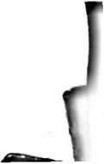

|  |  |  |  |  |  |  |  |  |  |  |  |  |  |  |  |  |
| --- | --- | --- | --- | --- | --- | --- | --- | --- | --- | --- | --- | --- | --- | --- | --- | --- |
| No  Resp | Skor Item Untuk Butir Instrumen No: | | | | | | | | | | | | | | |  |
| Y | 1 | 2 | 3 | 4 | 5 | 6 | 7 | 8 | 9 | 10 | 11 | 12 | 13 | 14 | 15 | Jumlah |
| 1 | 4 | 5 | 4 | 3 | 4 | 5 | 5 | 4 | 5 | 3 | 4 | 3 | 4 | 4 | 4 | 61 |
| 2 | 4 | 4 | 5 | 4 | 3 | 4 | 5 | 5 | 5 | 5 | 5 | 3 | 4 | 3 | 5 | 64 |
| 3 | 4 | 3 | 4 | 3 | 4 | 5 | 5 | 4 | 5 | 3 | 3 | 5 | 3 | 5 | 3 | 59 |
| 4 | 4 | 4 | 4 | 4 | 4 | 4 | 3 | 5 | 5 | 3 | 4 | 3 | 3 | 3 | 3 | 56 |
| 5 | 4 | 3 | 4 | 3 | 4 | 4 | 3 | 5 | 5 | 3 | 4 | 3 | 3 | 4 | 5 | 57 |
| 6 | 4 | 4 | 4 | 3 | 4 | 5 | 5 | 5 | 4 | 4 | 5 | 3 | 4 | 5 | 3 | 62 |
| 7 | 4 | 3 | 4 | 5 | 4 | 3 | 5 | 5 | 5 | 5 | 5 | 3 | 5 | 5 | 5 | 66 |
| 8 | 5 | 4 | 5 | 4 | 5 | 5 | 5 | 5 | 4 | 5 | 5 | 3 | 5 | 4 | 5 | 69 |
| 9 | 4 | 5 | 5 | 3 | 3 | 3 | 3 | 5 | 5 | 5 | 5 | 5 | 5 | 5 | 5 | 66 |
| 10 | 4 | 5 | 4 | 4 | 5 | 4 | 5 | 5 | 5 | 5 | 4 | 4 | 4 | 4 | 5 | 67 |
| 11 | 4 | 4 | 4 | 3 | 3 | 3 | 3 | 3 | 4 | 4 | 5 | 2 | 5 | 5 | 5 | 57 |
| 12 | 4 | 4 | 5 | 4 | 4 | 5 | 5 | 4 | 5 | 5 | 5 | 2 | 4 | 5 | 5 | 66 |
| 13 | 4 | 3 | 3 | 3 | 4 | 4 | 5 | 4 | 5 | 5 | 4 | 3 | 3 | 4 | 3 | 57 |
| 14 | 4 | 4 | 4 | 4 | 3 | 4 | 3 | 5 | 5 | 5 | 4 | 5 | 3 | 4 | 5 | 62 |
| 15 | 5 | 4 | 4 | 4 | 4 | 5 | 5 | 5 | 4 | 4 | 4 | 3 | 4 | 5 | 5 | 65 |
| 16 | 5 | 5 | 4 | 4 | 4 | 4 | 4 | 4 | 4 | 5 | 4 | 2 | 4 | 5 | 4 | 62 |
| 17 | 4 | 4 | 4 | 4 | 5 | 4 | 4 | 5 | 5 | 4 | 4 | 4 | 5 | 4 | 4 | 64 |
| 18 | 4 | 5 | 5 | 3 | 5 | 4 | 5 | 5 | 4 | 5 | 4 | 3 | 4 | 5 | 5 | 66 |
| 19 | 5 | 4 | 4 | 4 | 4 | 3 | 3 | 5 | 5 | 5 | 3 | 4 | 4 | 4 | 4 | 61 |
| 20 | 4 | 4 | 4 | 4 | 4 | 4 | 4 | 4 | 3 | 5 | 5 | 3 | 4 | 4 | 4 | 60 |
| 21 | 5 | 4 | 5 | 5 | 4 | 3 | 4 | 4 | 5 | 5 | 4 | 4 | 4 | 3 | 4 | 63 |
| 22 | 4 | 5 | 5 | 5 | 3 | 5 | 4 | 5 | 5 | 5 | 5 | 3 | 4 | 5 | 4 | 67 |
| 23 | 5 | 5 | 5 | 4 | 4 | 3 | 4 | 4 | 4 | 4 | 5 | 4 | 4 | 5 | 4 | 64 |
| 24 | 5 | 5 | 5 | 4 | 4 | 3 | 4 | 4 | 4 | 4 | 5 | 4 | 4 | 4 | 3 | 62 |
| 25 | 5 | 4 | 5 | 4 | 3 | 3 | 4 | 4 | 5 | 4 | 5 | 3 | 4 | 4 | 3 | 60 |
| 26 | 5 | 4 | 5 | 4 | 5 | 4 | 5 | 5 | 5 | 4 | 4 | 4 | 5 | 5 | 5 | 69 |
| 27 | 5 | 4 | 4 | 4 | 4 | 3 | 4 | 5 | 5 | 5 | 3 | 5 | 4 | 3 | 5 | 63 |
| 28 | 4 | 5 | 4 | 4 | 5 | 3 | 4 | 5 | 5 | 5 | 5 | 4 | 4 | 4 | 4 | 65 |
| 29 | 5 | 5 | 4 | 4 | 5 | 4 | 4 | 5 | 5 | 5 | 5 | 3 | 5 | 5 | 4 | 68 |
| 30 | 5 | 5 | 5 | 5 | 5 | 4 | 5 | 4 | 5 | 5 | 5 | 5 | 4 | 5 | 5 | 72 |

|  |  |  |  |  |  |  |  |  |  |  |  |  |  |  |  |  |
| --- | --- | --- | --- | --- | --- | --- | --- | --- | --- | --- | --- | --- | --- | --- | --- | --- |
| 64 | 5 | 4 | 5 | 4 | 4 | 5 | 3 | 5 | 4 | 4 | | 5 | 4 | 5 | 4 | 5 | **66** |
| 65 | 5 | 5 | 4 | 4 | 4 | 4 | 4 | 5 | 5 | 4 | 3 | 4 | 5 | 5 | 5 | **66** |
| 66 | 5 | 5 | 4 | 4 | 4 | 4 | 4 | 5 | 5 | 4 | 3 | 4 | 5 | 5 | 5 | **66** |
| 67 | 5 | 5 | 4 | 4 | 4 | 4 | 4 | 4 | 5 | 4 | 4 | 4 | 4 | 4 | 4 | **63** |
| 68 | 4 | 4 | 4 | 4 | 4 | 4 | 4 | 4 | 4 | 5 | 4 | 3 | 4 | 4 | 4 | **60** |
| 69 | 4 | 4 | 4 | 5 | 5 | 5 | 5 | 5 | 5 | 5 | 4 | 2 | 5 | 5 | 5 | **68** |
| 70 | 4 | 4 | 4 | 4 | 5 | 4 | 4 | 5 | 5 | 5 | 3 | 4 | 5 | 4 | 4 | **64** |
| 71 | 4 | 3 | 4 | 4 | 3 | 4 | 4 | 4 | 4 | 5 | 5 | 3 | 3 | 5 | 5 | **60** |
| 72 | 4 | 4 | 3 | 4 | 4 | 3 | 5 | 5 | 4 | 5 | 4 | 2 | 3 | 5 | 3 | **58** |
| 73 | 3 | 5 | 4 | 4 | 5 | 5 | 3 | 5 | 4 | 5 | 5 | 5 | 5 | 5 | 3 | **66** |
| 74 | 4 | 4 | 3 | 3 | 3 | 4 | 3 | 5 | 4 | 5 | 5 | 5 | 5 | 5 | 3 | **61** |
| 75 | 4 | 5 | 4 | 4 | 5 | 5 | 3 | 5 | 5 | 5 | 5 | 5 | 5 | 5 | 3 | **68** |
| 76 | 3 | 5 | 4 | 4 | 5 | 2 | 5 | 3 | 4 | 3 | 4 | 5 | 4 | 4 | 5 | **60** |
| 77 | 4 | 5 | 4 | 3 | 5 | 3 | 5 | 3 | 4 | 3 | 4 | 5 | 5 | 5 | 3 | **61** |
| 78 | 3 | 5 | 3 | 4 | 5 | 5 | 3 | 5 | 5 | 5 | 5 | 5 | 5 | 5 | 3 | **66** |
| 79 | 5 | 4 | 4 | 4 | 4 | 5 | 5 | 5 | 5 | 4 | 5 | 3 | 4 | 4 | 4 | **65** |
| 80 | 5 | 4 | 4 | 3 | 5 | 4 | 5 | 5 | 5 | 5 | 5 | 3 | 4 | 5 | 5 | **67** |
| 81 | 5 | 3 | 5 | 4 | 4 | 4 | 5 | 5 | 5 | 4 | 5 | 4 | 5 | 5 | 5 |  |
| 82 | 5 | 4 | 4 | 4 | 5 | 5 | 4 | 5 | 5 | 5 | 4 | 5 | 4 | 5 | 4 | 6ft |
| 83 | 4 | 5 | 5 | 5 | 5 | 5 | 5 | 5 | 4 | 4 | 4 | 3 | 5 | 5 | 4 | 6ft |
| 84 | 5 | 3 | 4 | 3 | 4 | 3 | 1 | 3 | 3 | 5 | 4 | 2 | 4 | 3 | 3 | 50 |
| 85 | 4 | 4 | 4 | 4 | 5 | 3 | 1 | 2 | 2 | 2 | 3 | 3 | 3 | 3 | 2 | 45 |
| 86 | 4 | 3 | 4 | 5 | 3 | 3 | 3 | 3 | 4 | 3 | 4 | 3 | 3 | 3 | 4 | 52 |
| 87 | 5 | 4 | 4 | 4 | 5 | 4 | 5 | 5 | 4 | 4 | 5 | 3 | 3 | 4 | 5 | 64 |
| Jumlah | 374 | 362 | 366 | 345 | 358 | 350 | 360 | 387 | 391 | 378 | 371 | 321 | 352 | 381 | 364 | 5462 |

**Correlations**

VA

RO

000

1

VA

RO

000

2

VA

R0

000

3

VA

R0

000

4

VA

R0

000

5

Correia

tion

Coeffic

ient

Sig. (2- tailed)

N

Correia

tion

Coeffic

ient

Sig. (2- tailed)

N

Correia

tion

Coeffic

ient

Sig. (2- tailed)

N

Correia

tion

Coeffic

ient

Sig. (2- tailed)

N

Correia

tion

Coeffic

ient

|  |  |  |  |  |  |  |  |  |  |
| --- | --- | --- | --- | --- | --- | --- | --- | --- | --- |
| 1 | 2 | 3 | 4 | 5 | 6 | 7 | 8 | 9 | 10 |
| 1.00  0 | .078 | .033 | -.141 | .076 | .246* | .165 | .177 | .007 | .130 |
|  | .471 | .761 | .192 | .487 | .022 | .128 | .102 | .947 | .231 |
| 87 | 87 | 87 | 87 | 87 | 87 | 87 | 87 | 87 | 87 |
| .078 | 1.00  0 | .039 | .176 | -.131 | -.011 | .011 | .103 | .028 | .224* |
| .471 |  | .720 | .103 | .225 | .921 | .917 | .341 | .798 | .037 |
| 87 | 87 | 87 | 87 | 87 | 87 | 87 | 87 | 87 | 87 |
| .033 | .039 | 1.00  0 | .176 | -.061 | -.011 | .040 | .040 | .090 | .151 |
| .761 | .720 |  | .103 | .573 | .921 | .711 | .712 | .409 | .164 |
| 87 | 87 | 87 | 87 | 87 | 87 | 87 | 87 | 87 | 87 |
| -.141 | .176 | .176 | 1.00  0 | .188 | .287'  • | -.116 | -.193 | -.133 | -.094 |
| .192 | .103 | .103 |  | .082 | .007 | .284 | .073 | .219 | .387 |
| 87 | 87 | 87 | 87 | 87 | 87 | 87 | 87 | 87 | 87 |
| .076 | -.131 | -.061 | .188 | 1.00  0 | .243' | -.008 | -.002 | -.133 | .104 |

|  |  |  |  |  |  |  |  |  |  |
| --- | --- | --- | --- | --- | --- | --- | --- | --- | --- |
| 11 | 12 | 13 | 14 | 15 | 16 | 17 | 18 | 19 | 20 |
| o  o | -.074 | .276* | -.068 | -.027 | .025 | .071 | -.087 | .086 | -.044 |
| .969 | .494 | .010 | .531 | .801 | .821 | .512 | .420 | .430 | .683 |
| 87 | 87 | 87 | 87 | 87 | 87 | 87 | 87 | 87 | 87 |
| -.117 | .007 | -.034 | -.060 | .067 | .168 | .192 | .022 | .113 | .143 |
| .279 | .950 | .752 | .582 | .536 | .121 | .075 | .837 | .299 | .185 |
| 87 | 87 | 87 | 87 | 87 | 87 | 87 | 87 | 87 | 87 |
| -.117 | -.056 | .150 | -.045 | -.018 | .011 | -.073 | -.073 | .153 | .033 |
| .280 | .610 | .166 | .677 | .867 | .919 | .501 | .503 | .158 | .760 |
| 87 | 87 | 87 | 87 | 87 | 87 | 87 | 87 | 87 | 87 |
| .124 | .011 | .142 | .132 | .194 | .056 | .033 | -.008 | .097 | .176 |
| .254 | .918 | .189 | .222 | .072 | .609 | .758 | .939 | .369 | .103 |
| 87 | 87 | 87 | 87 | 87 | 87 | 87 | 87 | 87 | 87 |
| .133 | -.072 | -.015 | .035 | .026 | .122 | -.059 | -.068 | -.142 | -.055 |

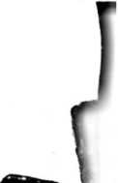

N

87

VA Correia RO tion I .246 000 Coeffic 6 ient

07

.011

07

.011

87

.287’

87

.243'

07

1 00 0

87 I 87 .000 -.119

«■»**

07

.126

Sig. (2- tailed)

N

VA Correia RO tion 000 Coeffic

1. ient

Sig. (2- tailed)

N

VA Correia R0 tion 000 Coeffic

1. ient

Sig. (2- tailed)

N

VA Correia

RO tion

1. Coeffic
2. ient

Sig. (2- tailed)

N

VA Correia

R0 tion

1. Coeffic

0 ient

Sig. (2- tailed)

N

.022 .921 .921

87

87

.165 .011

87

.040

.007 | .023

87 I 87 I 87 -.116 -.008 I .000

,128 I .917 I .711 I .284 | .938 | .998

87 | 87 | 87 | 87 | 87 l 87

,177 | .103 I .040 | -.193 | -.002 | -.119

102 I .341 I .712 I .073 | .984 | .270

87 I 87 | 87 I 87 | 87 l 87

.007 | .028 I .090 | -.133 l -.133 | -.126

.947 .798 .409 .219 .220 .245

87 I 87 .130

.224'

.231 .037

87 87

.998 .270

87

87

1.00 I .458 0

87 .458*

.000

87

.397’

.245

87

397'

.000

87

1.00 0

.000

87

.456’

.771

87

290'

.006

87

.196

87

.456'

.000 .000

.000

87

1.00

0

87 | 87 I 87 I 87

.151 I -.094 I .104 | -.032

,164 .387 .339 .771

87 87 87 87

87

.290’

87

196

87

.275’

.006 .069

87 87

.010

87

|  |  |  |  |  |  |  |  |  |  |
| --- | --- | --- | --- | --- | --- | --- | --- | --- | --- |
| a-r  07 | QT  07 | <3 CD | M'-  ccco |  |  |  | CCD  ^-1 | N-*-  CQD | 8? |
| .080 | -.034 | -.100 | .102 ;  i | .015 | .019 | -.109 | .230’ | .041 | .130 |
| .463 | .751 | .357 | .349 | .892 | .864 | .317 | .032 | .704 | .231 |
| 87 | 87 | 87 | 87 | 87 | 87 | 87 | 87 | 87 | 87 |
| .151 | .242' | -.097 | .032 |  .  i | -.145 | .255’ | .291] | .054 | -.011 | -.133 |
| .162 | .024 | .372 | .770 !  i | .181 | .017 | .006 | .617 | .916 | .218 |
| 87 | 87 | 87 | 87 **j** | 87 | 87 | 87 | 87 | 87 | 87 |
| .084 | .430] | .097 | .011 | .057 | .106 | .091 | .094 | -.062 | -.144 |
| .437 | .000 | .371 | .918 | .598 | .328 | .403 | .387 | .570 | .183 |
| 87 | 87 | 87 | 87 | 87 | 87 | 87 | 87 | 87 | 87 |
| .173 | .295] | -.086 | .091 | .055 | .194 | .103 | .266* | .158 | -.073 |
| .108 | .006 | .430 | .400 | .612 | .072 | .345 | .013 | .143 | .500 |
| 87 | 87 | 87 | 87 | 87 | 87 | 87 | 87 | 87 | 87 |
| .189 | .228’ | .082 | .201 | .091 | .087 | .031 | .105 | .270’ | .051 |
| .080 | .033 | .452 | .063 | .403 | .424 | .773 | .334 | .011 | .641 |
| 87 | 87 | 87 | 87 | 87 | 87 | 87 | 87 | 87 | 87 |

07

-.032

.069

87

.275’

.010

87

1.00

0

87

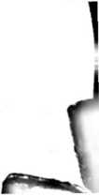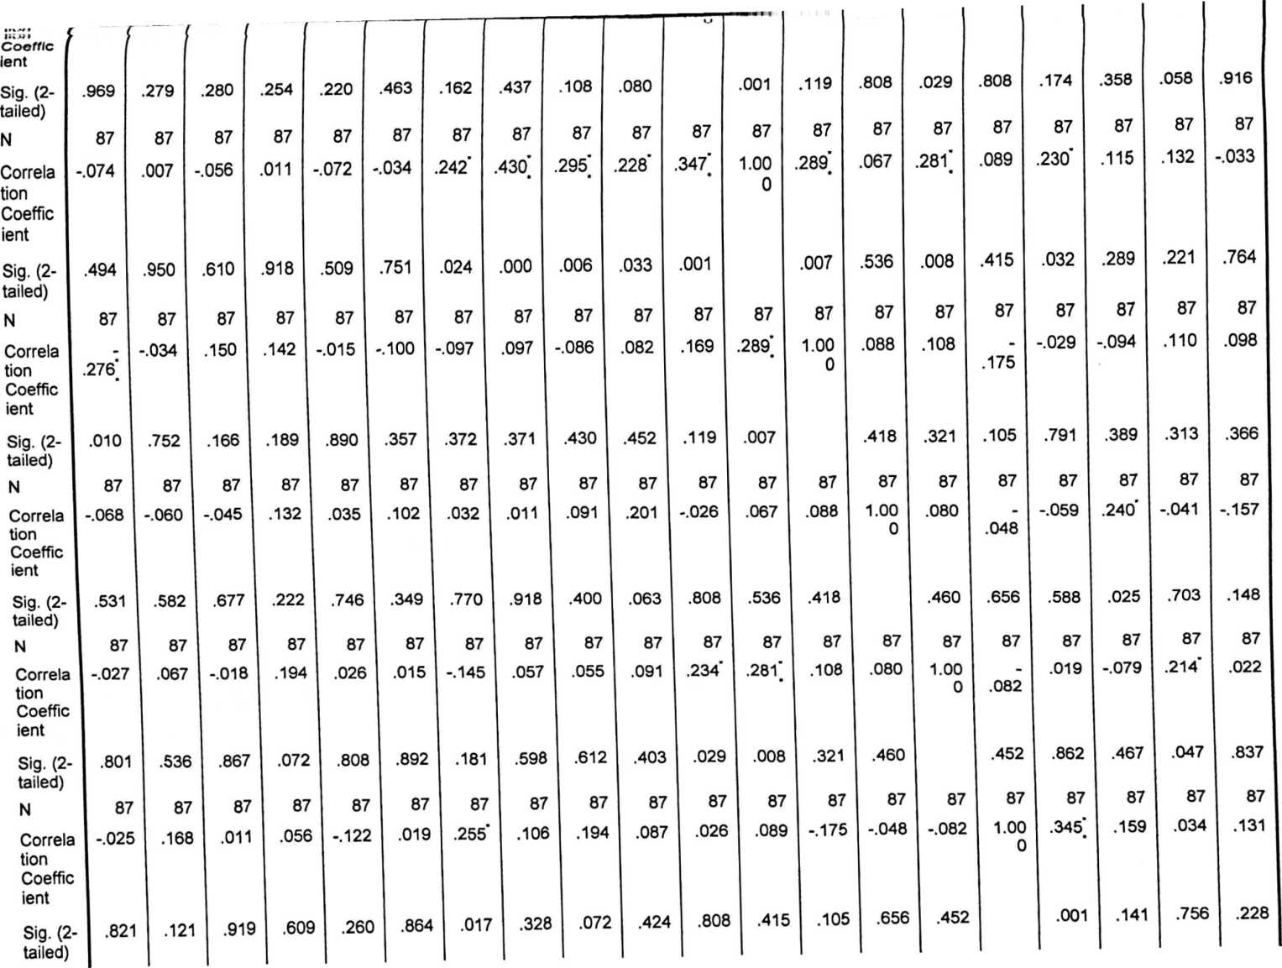

O01 1

VA

RO

001

2

VA

RO

001

3

VA

RO

001

4

VA

RO

001

5

VA

RO

001

6

|  |  |  |  |  |  |  |  |  |  |  |  |  |  |  |  |  |  |  |  |  |  |
| --- | --- | --- | --- | --- | --- | --- | --- | --- | --- | --- | --- | --- | --- | --- | --- | --- | --- | --- | --- | --- | --- |
|  | uurroin  IUb  tion | ur r | . r is«r |  |  | *.uou | 1UU |  | ,UU1 | . 103 | .031 | .1-17 | 230 | - 020 | - OGO | .010 | » | 1.00 | ~.0‘\A | .S'** | .211* |
| 001 | Coeffic |  |  |  |  |  |  |  |  |  |  |  |  |  |  |  |  | 0 |  |  |  |
| 7 | ient |  |  |  |  |  |  |  |  |  |  |  |  |  |  |  |  |  |  |  |  |
|  | Sig. (2- tailed) | .512 | .075 | .501 | .758 | .585 | .317 | .006 | .403 | .345 | .773 | .174 | .032 | .791 | .588 | .862 | .001 |  | .899 | .292 | .050 |
|  | N | 87 | 87 | 87 | 87 | 87 | 87 | 87 | 87 | 87 | 87 | 87 | 87 | 87 | 87 | 87 | 87 | 87 | 87 | 87 | 87 |
| VA | Correia | -.087 | .022 | -.073 | -.008 | -.068 | .230' | .054 | .094 | .266' | .105 | -.100 | .115 | -.094 | .240' | -.079 | .159 | -.014 | 1.00 | .032 | -.207 |
| RO | tion |  |  |  |  |  |  |  |  |  |  |  |  |  |  |  | 0 |
| 001 | Coeffic |  |  |  |  |  |  |  |  |  |  |  |  |  |  |  |  |  |  |  |  |
| 8 | ient |  |  |  |  |  |  |  |  |  |  |  |  |  |  |  |  |  |  |  |  |
|  | Sig. (2- tailed) | .420 | .837 | .503 | .939 | .529 | .032 | .617 | .387 | .013 | .334 | .358 | .289 | .389 | .025 | .467 | .141 | .899 |  | .772 | .054 |
|  | N | 87 | 87 | 87 | 87 | 87 | 87 | 87 | 87 | 87 | 87 | 87 | 87 | 87 | 87 | 87 | 87 | 87 | 87 | 87 | 87 |
| VA  RO | Correia  tion | .086 | .113 | .153 | .097 | -.142 | .041 | -.011 | -.062 | .158 | .270* | .204 | .132 | .110 | -.041 | .214* | .034 | .114 | .032 | 1.00 | .278 |
| 001 | Coeffic |  |  |  |  |  |  |  |  |  |  |  |  |  |  |  |  |  |  | 0 |  |
| 9 | ient |  |  |  |  |  |  |  |  |  |  |  |  |  |  |  |  |  |  |  |  |
|  | Sig. (2- tailed) | .430 | .299 | .158 | .369 | .189 | .704 | .916 | .570 | .143 | .011 | .058 | .221 | .313 | .703 | .047 | .756 | .292 | .772 |  | .009 |
| VA  RO | N | 87 | 87 | 87 | 87 | 87 | 87 | 87 | 87 | 87 | 87 | 87 | 87 | 87 | 87 | 87 | 87 | 87 | 87 | 87 | 87 |
| Correia  tion | -.044 | .143 | .033 | .176 | -.055 | .130 | -.133 | -.144 | -.073 | .051 | -.011 | -.033 | .098 | -.157 | .022 | .131 | .211’ | -.207 | .278* | 1.00 |
| 002 | Coeffic |  |  |  |  |  |  |  |  |  |  |  |  |  |  |  |  |  |  |  | 0 |
| 0 | ient |  |  |  |  |  |  |  |  |  |  |  |  |  |  |  |  |  |  |  |  |
|  | Sig. (2- tailed) | .683 | .185 | .760 | .103 | .616 | .231 | .218 | .183 | .500 | .641 | .916 | .764 | .366 | .148 | .837 | .228 | .050 | .054 | .009 |  |
|  | N | 87 | 87 | 87 | 87 | 87 | 87 | 87 | 87 | 87 | 87 | 87 | 87 | 87 | 87 | 87 | 87 | 87 | 87 | 87 | 87 |
| . correlation is significant at the 0.05 level (2-tailed). | | | | | | | | | | | |  |  |  |  |  |  |  |  |  |  |

**. Correlation is significant at the 0.01 level (2-tailed).

correlations

|  |  |  |  |  |  |  |  |  |  |
| --- | --- | --- | --- | --- | --- | --- | --- | --- | --- |
|  | | | **1** | **2** | **3** | **4** | **5** | **6** | **7** |
| **b**  **p** | VA  RO | Correlati  on | 1.000 | .108 | .291" | .158 | .053 | -.077 | .022 |
| e | 000 | Coeffici |  |  |  |  |  |  |  |
| **a**  r | 1 | ent |  |  |  |  |  |  |  |
| l  **m**  **a** |  | Sig. (2- tailed) |  | .321 | .006 | .143 | .624 | .478 | .842 |
| **n**  i |  | **N** | 87 | 87 | 87 | 87 | 87 | 87 | 87 |
| **s** | VA  RO | Correlati  on | .108 | 1.000 | .269' | .076 | .213' | .003 | .043 |
| **r** | 000 | Coeffici |  |  |  |  |  |  |  |
| **h** | 2 | ent |  |  |  |  |  |  |  |
| **0** |  | Sig. (2- tailed) | .321 |  | .012 | .483 | .048 | .980 | .692 |
|  |  | **N** | 87 | 87 | 87 | 87 | 87 | 87 | 87 |
|  | VA  RO | Correlati  on | .291” | .269' | 1.000 | .333" | -.081 | .020 | .111 |
|  | 000 | Coeffici |  |  |  |  |  |  |  |
|  | 3 | ent |  |  |  |  |  |  |  |
|  |  | Sig. (2- tailed) | .006 | .012 |  | .002 | .455 | .853 | .306 |
|  |  | **N** | 87 | 87 | 87 | 87 | 87 | 87 | 87 |
|  | VA  R0 | Correlati  on | .158 | .076 | .333” | 1.000 | .170 | .118 | .060 |
|  | 000 | Coeffici |  |  |  |  |  |  |  |
|  | 4 | ent |  |  |  |  |  |  |  |
|  |  | Sig. (2- tailed) | .143 | .483 | .002 |  | .114 | .277 | .580 |
|  |  | **N** | 87 | 87 | 87 | 87 | 87 | 87 | 87 |
|  | VA | Correlati | .053 | .213' | -.081 | .170 | 1.000 | .144 | .276" |
|  | RO | on |  |  |  |  |  |
|  | 000 | Coeffici |  |  |  |  |  |  |  |
|  | 5 | ent |  |  |  |  |  |  |  |
|  |  | Sig. (2- tailed) | .624 | .048 | .455 | .114 |  | .183 | .010 |

.666

87

.178

.100

87

.061

.578

87

.152

.159

87

.211'

|  |  |  |  |  |  |  |
| --- | --- | --- | --- | --- | --- | --- |
| J | 10 | 11 | 12 | 13 | 14 | 15 |
| .028 | .090 | .064 | -.022 | .105 | -.007 | .139 |
| .795 | .407 | .555 | .841 | .335 | .946 | .198 |
| 87 | 87 | 87 | 87 | 87 | 87 | 87 |
| .077 | .147 | .143 | .150 | .444" | CD  (30  CVJ | .098 |
| .479 | .173 | .186 | .166 | .000 | .007 | .367 |
| 87 | 87 | 87 | 87 | 87 | 87 | 87 |
| .067 | .041 | .272' | .108 | ro  CD | .106 | .281" |
| .540 | .709 | .011 | .322 | .015 | .327 | .008 |
| 87 | 87 | 87 | 87 | 87 | 87 | 87 |
| .081 | .182 | -.024 | .114 | .139 | .039 | .176 |
| .456 | .091 | .822 | .295 | .198 | .717 | .103 |
| 87 | 87 | 87 | 87 | 87 | 87 | 87 |
| -.021 | .109 | -.109 | .122 | .272' | .117 | .004 |
| .849 | .317 | .315 | .259 | .011 | .281 | .969 |

.050



■.Wf f

RO on

000 Coeffici 6 ent

Sig. (2- tailed)

N

Correlati

on

VA RO

000 Coeffici

1. ent

Sig. (2- tailed)

N

Correlati on

000 Coeffici

1. ent

Sig. (2- tailed)

N

VA Correlati RO on

1. Coeffici
2. ent

Sig. (2- tailed)

N

VA Correlati RO on

1. Coeffici
2. ent

Sig. (2- tailed)

N

VA Correlati RO on

1. Coeffici

1 ent

VA

RO

.478

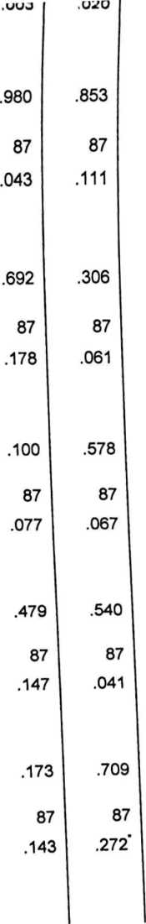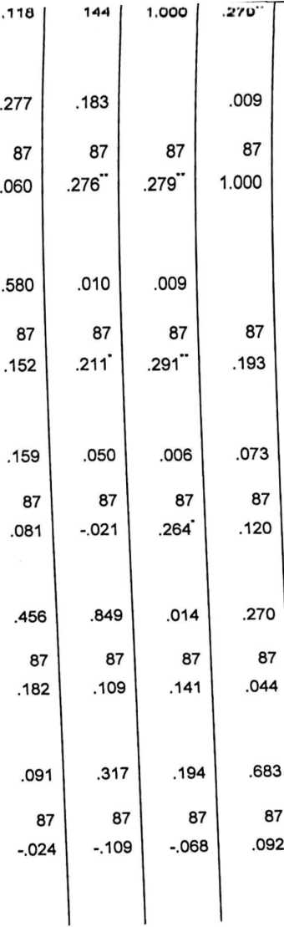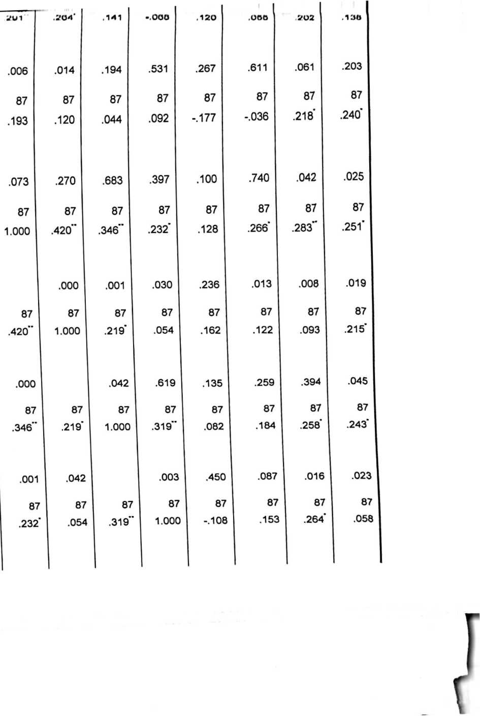

|  |  |  |  |  |  |  |  |  |
| --- | --- | --- | --- | --- | --- | --- | --- | --- |
| r | K | 07  o > | 87  o» | 87  O 9 | 87  9 » | 87  i «t | 07 | 87 |
| VA | Correlati | -.022 | .150 | .108 | .114 | .122 | .120 | -.177 |
| RO | on |  |  |  |  |  |  |  |
| 001 | Coeffici |  |  |  |  |  |  |  |
| 2 | ent |  |  |  |  |  |  |  |
|  | Sig. (2- tailed) | .841 | .166 | .322 | .295 | .259 | .267 | .100 |
|  | N | 87 | 87 | 87 | 87 | 87 | 87 | 87 |
| VA | Correlati | .105 | .444" | .261' | .139 | .272' | .055 | -.036 |
| R0 | on |  |  |  |  |  |  |  |
| 001 | Coeffici |  |  |  |  |  |  |  |
| 3 | ent |  |  |  |  |  |  |  |
|  | Sig. (2- tailed) | .335 | .000 | .015 | .198 | .011 | .611 | .740 |
|  | N | 87 | 87 | 87 | 87 | 87 | 87 | 87 |
| VA | Correlati | -.007 | .286” | .106 | .039 | .117 | .202 | .218’ |
| R0 | on |  |  |  |  |  |  |
| 001 | Coeffici |  |  |  |  |  |  |  |
| 4 | ent |  |  |  |  |  |  |  |
|  | Sig. (2- tailed) | .946 | .007 | .327 | .717 | .281 | .061 | .042 |
|  | N | 87 | 87 | 87 | 87 | 87 | 87 | 87 |
| VA | Correlati | .139 | .098 | .281" | .176 | .004 | .138 | .240' |
| R0 | on |  |  |  |  |  |  |
| 001 | Coeffici |  |  |  |  |  |  |  |
| 5 | ent |  |  |  |  |  |  |  |
|  | Sig. (2- tailed) | .198 | .367 | .008 | .103 | .969 | .203 | .025 |
|  | N | 87 | 87 | 87 | 87 | 87 | 87 | 87 |

**. Correlation is significant at the 0.01 level (2-tailed).

87

.128

.236

87

.266

.013

87

283”

.008

87

.251’

.019

8787

.162

.135

87

.122

.259

87

.093

.394

87

.215'

.045

8787

.082

.450

87

.184

.087

87

.258'

.016

87

.243'

.023

87

87

-.108

.319

87

.153

.157

87

.264'

.014

87

.058

.597

87

87

1.000

87

.192

.075

87

.137

.206

87

-.006

.953

8787

.192

.075

87

1.000

87

.470”

.000

87

.163

.130

8787

.137

.206

87

.470"

.000

87

1.000

87

.160

.139

8787

-.006

.953

87

.163

.130

87

.160

.139

87

1.000

87

*. Correlation is significant at the 0.05 level (2-tailed).

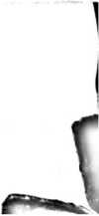

■«aoggmaggaCT jt ***fiijS***CilG± i-tltiS*

**NO**

**NAMA**

**KELAS**

**Stefanni Karisma Tanan**

**VII 1**

Rebecca Angelia B

**VII 1**

Risti R Palulun

VII

Vanessa Tesalonika

VII

Mari Manganda Batu Alio

Winda Sasmita

Windi Maulana Kalelean

**Sheren.G.N**

**Natalia K. Situngkir**

**VII 2**

**VII 2**

**VII 2**

**VII 2**

**VII 3**

10

11

12

**13**

**14**

**15**

**16**

**17**

**18**

**19**

20

21

22

**23**

**24**

**Medi Rante**

**Yosua Gabriel Rumengan**

**Vila Duma’**

**Marsyela Tambing**

**Sambri S**

**Indah Batu Randan**

**Nielson Siappa Batu**

**Reynaldi Tonapa Tandibura**

**Juniarsi Lukas Tato**

**Lewi**

**Gabriel Kevin.M**

**Pauline S Popang**

**Sindi D.L**

**Kevin**

**Carol G.G.P**

**VII 3**

**VII 3**

**VII 4**

**VII 4**

**VII 4**

**VII 5**

**VII 5**

**VII 5**

**VII 6**

**VII 6**

**VII 6**

**VII 7**

**VII 7**

**VII 7**

**VII 8**

|  |  |  |
| --- | --- | --- |
|  | Alhmy 1 limy | VII H |
| **26** | **Yunatri Palimbong** | **VII 9** |
| **27** | **Widia Gita** | **VII 9** |
| **28** | **Gilang D.Pratama** | **VII 9** |
| **29** | Anjrivan A.P | **VII 10** |
| **30** | Gustiranda Alik | **VII 10** |
| **31** | Aprindo Kondo Sura’ | **VII 10** |
| **32** | Firdaus Bara Langi Ambarura | **VII11** |
| **33** | Cevin Buli | **VII 11** |
| **34** | Julio S.B Tonapa | **VII 11** |
| **35** | **Nichel Lamba’** | **VII 12** |
| **37** | **Hany** | **VII 12** |
| **38** | **Silvia Dea** | **VII 12** |
| **39** | **Harianti B** | **VII 13** |
| **40** | **TioP** | **VII 13** |
| **41** | **Felix Dio A** | **VII 13** |
| **42** | **Irmawati Putri Intan S.R** | **VII 14** |
| **43** | **Agnesia P.K** | **VII 14** |
| **44** | **Amanda** | **VII 14** |
| **45** | **Natalia Tulak** | **VIII 1** |
| **46** | **Rita Patiung** | **VIII 1** |
| **47** | **Maria** | **VIII 1** |
| **48** | **Sapta Noven Tonapa** | **VIII 1** |
| **49** | **Feryanti Sannang** | **VIII 2** |
| **50** | **Vebiola Sonia Salunda** | **VIII 2** |
| **51** | **Rivaldo.M** | **VIII 2** |
| **52** | **Nikita S** | **VIII 2** |

§4

**55**

**56**

57

58

59

60

61

62

63

**64**

**65**

66

**67**

68

**69**

**70**

**71**

**72**

**73**

**74**

**75**

**76**

**77**

**78**

**79**

VsRu Tiaa Usml Bid

**Lively Patiung**

**Loreniye Parongko’**

**Renaldo Alik**

Rannu Tandireru

Zeriyanti Tandisole

Berlian Rantetondok

Dhesry

Sania Edwinda P

**Marlin Smggi**

**Vini Salempa**

**Marto D.Songgo**

**Garbiel**

**Andy Payung**

**Dalfin Pakando**

**Andika T.U**

**Reinal**

**Emmanuel N.A.R**

**Heru H**

**Soni S.T**

**Risna Rante Sampe**

**Lenny Ayu Popang**

**Elma Dea R.L**

**Rini**

**Melani KumiaToban**

**Vivin Jayanty**

\ n 11 *>

VIII 3

**VIII 3**

**VIII 3**

VIII 4

VIII 4

VIII4

VIII4

VIII 5

VIII 5

VIII 5

VIII 5

**VIII 6**

**VIII 6**

**VIII 6**

**VIII 6**

**VIII 7**

**VIII 7**

**VIII 7**

**VIII 7**

**VIII 8**

**VIII 8**

**VIII 8**

**VIII 8**

**VIII 9**

**VIII 9**

**VIII 9**

|  |  |  |
| --- | --- | --- |
|  | . .. iw > > i i a-v^Fl V » M» l%t»i %*l | V III ’V |
| **81** | **Sarah Malison Lan** | VIII 9 |
| **82** | **Hendrianto Fandi** | VIII 10 |
| **83** | **Ratna P** | VIII 10 |
| 84 | Melania Kurnia Toban | VIII 10 |
| 85 | Putri Meliyanti | VIII 10 |
| 86 | Nikita S | VIII10 |
| 87 | Fandi | VIII 10 |
|  | JUMLAH SISWA | 87 ORANG |

PEMERINTAH KABUPATEN TORAJA UTARA DINAS PENDIDIKAN SMP NEGERI 1 RANTEPAO

TBionftiu*



Jl. Emmy Saelan No. 1 Telp/Fax (0423) 21208 Malango’ Rantepao 91831

**SURAT KETERANGAN PENELITIAN**

Nomor: 104/I06.24/SMP.01/MN/2014



s

'Yang bertanda tangan di bawah ini, Kepala SMP Negeri 1 Rantepao menerangkan bahwa:

PETRUS UPA’ PALINOAN

Nama

NIRM

**Alamat**

**Program Study**

20092919

Rantepao

S1. Pendidikan Agama Kristen

Telah melaksanakan penelitian dengan judul : ”HUBUNGAN PROFESIONALISME GURU PAK IDENGAN PERTUMBUHAN IMAN SISWA DI SMP NEGERI 1 RANTEPAO”. Pada tanggal 30 **IMei-4** Juni 2014

I Demikian Surat Keterangan ini dibuat dengan benar dan diberikan kepada yang bersangkutan untuk «dipergunakan seperlunya.

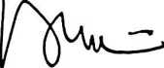

T. PALAMBA, S.Pd ip. 19590802 198603 1 015

«Rantepao, 5 Juni 2014 ' lekolah,

