Karlina

by Lp2m lakn Toraja

^mission date: 14-Aug-2023 11:53AM (UTC+0700) ^mission **ID:** 2145534737

e? name: SKRIPSLKARLINA_CEK_PLAGIASI.docx (493.17K) )'rd count: 11170 fcracter count: 71050

Karlina

|  |  |
| --- | --- |
| ORIGINALITY REPORT | |
| I 8% 17% | 5% 4% |
| SIMILARITY INDEX INTERNET SOURCES | PUBLICATIONS STUDENT PAPERS |
| PRIMARY SOURCES | |
| |r 1 alkitab.sabda.org  *—A Internet Source | 1 % |



text-id.123dok.com

**internet Source**

123dok.com

**Internet Source**

1

## 1

%

%

|  |  |  |
| --- | --- | --- |
| ip~  , j F- —• n | j digilib.uin-suka.ac.id  Internet Source | 1 % |
| i r—~  !  L | robinsontaneo24.blogspot.corn  Internet Source | 1 % |
| 1- | jurnal. i3batu.ac. id  Internet Source | 1 % |
| j | repo.sttsetia.ac.id  Inter net Source | 1 % |
| □ | adinetto.wordpress.com  Internet Source | <1 % |

•r 1 [www.scribd.com](http://www.scribd.com)

**Internet Source**



r ] onego1993.blogspot.com

**Internet Source**

ushuluddin.iainsalatiga.ac.id

**Internet Source**

FI media.neliti.com

**Internet Source**

J katalog.ukdw.ac.id

**—j Internet Source**

] docplayer.info

**Internet Source**

M id.123dok.com

**Internet Source**

repository.uksw.edu

**Internet Source**

] kristologi-reformed.blogspot.com

**Internet Source**

core.ac.uk

Internet Source



"] Iamhotgelis10.blogspot.com

**Internet Source**

Internet Source



repository.ub.ac.id

1 [www.researchgate.net](http://www.researchgate.net)

**Internet Source**

|  |  |
| --- | --- |
| < | 1 % |
| < | 1 % |
| < | 1 % |
| < | l % |
|  | l % |
|  | l % |
| <1 | l % |
| <1 | l % |
| <1 | % |
| <1 | % |
| <1 | % |
| <1 | % |

Submitted to Konsorsium Turnitin Reiawan Jurnal Indonesia

Student Paper

digilib.iain-jember.ac.id

Internet Source digilib.uinsgd.ac.id

Internet Source

journal, uinsgd.ac.id

Internet Source repository.sttikat.ac.id

Internet Source repository, upi.eau

Internet Source

[www.sttintheos.ac.id](http://www.sttintheos.ac.id)

Internet Source es.scribd.com

Internet Source

pt.scribd.com

Internet Source

Alferdi Alferdi. "Tradisi Mupupantunu dan Korban Penebus Salah dalam Kitab Imamat”, CARAKA: Jurnal Teologi Biblika dan Praktika,

2021

<1 % <1 %

<1 % <1 %

<1 % <1 % <1 % <1 % <1 % <1 % <1 %

Eka Kristining Rahayu. "TINJAUAN TEOLOGIS TERHADAP BUDAYA PATRIARKAL DI INDONESIA", Pengarah: Jurnal Teologi Kristen, 2019



Publication

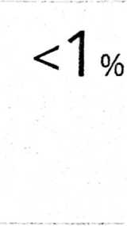

etheses.iainponorogo.ac.id

**Internet Source**



sendawakurasapisang.blogspot.com

**Inter net Source**

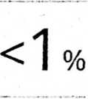

|gj skripsi.sttjaffray.ac.id

**Internet Source**



Iwan Setiawan, Chrest Thessy Tupamahu, Martono Martono, Yulia Vriska Tripena. "Kajian Teologis Terhadap Status Perempuan Dalam Perjanjian Baru", Missio Ecclesiae, 2021

**Publication**

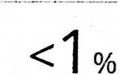

imanyonggi.wordpress.com

**Internet Source**



otanliem.blogspot.com

**Internet Source**

Submitted to Trinity College Duuiin

**—J Student Paper**

Internet Source



e-journal.iaknambon.ac.id

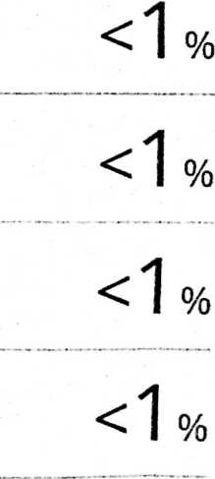

Internet Source



[www.coursehero.com](http://www.coursehero.com)

### <1

%

Internet Source



[www.stttorsina.ac.id](http://www.stttorsina.ac.id)

Internet Source



repository, radenintan.ac. id

Eg] repository.uinjambi.ac.id

**J Internet Source**

<1

<1

<1

%

%

%

repository.unwira.ac.id

**Internet Source**

**H** repository.iainpurwokerto.ac.id

**Internet Source**

<1

<1

%

%

I , sangmisionaris.blogspot.com

**Internet Source**

<1

%

kelompok7relasigenderdalamagama2015.blogspQj;.



Internet Source ■



stakterunabhakti.ac.id

**Internet Source**



'j Mahbub Ghozali. "Ambiguitas tafsir feminis di <>j J Indonesia", Yinyang: Jurnal Studi Islam Gender 0

dan Anak, 2020

Publication



Submitted to The Master's Seminary

**Student Paper**

**5 —**

. r' ejournal.hi.fisip-unmul.ac.id

**L Internet Source**



lucky77khoe.wordpress.com

**Internet Source**

r ] repository.uinbanten.ac.id

**internet Source**



pr ..LCj

l U*

Submitted to Universitas Pendidikan Ganesha

**Student Paper**

domugreeting.blogspot.com

**Internet Source**

t



m]

repository.uinjkt.ac.id

**Internet Source**

r~

sttexcelsius.ac.id

**Internet Source**

amelinadharmaayu.blogspot.com

**Internet Source**

docs.google.com

Internet Sour ce



Inter net Source



jurnal.sttsetia.ac.id

|t; j repository.umy.ac.id

**Internet Source**

<1 % <1 % <1 % <1 % <1 % <1 % <1 % <1 % <1 % <1 % <1 % <1 %

www.scilit.net <1

Internet Source ■

Submitted to Universitas Kristen Duta Wacana <;1 0/

Student Paper ■ ^

dokumen.tips <1%

Internet Source

eprints.uny.ac.id <i

Internet Source ■ ™

journal.stbi.ac.id <1

Internet Source ■

leosiribere.wordpress.com <1

Internet Source

repository.ptiq.ac.id <1 0/

Internet Source

ustadzaris.com %

Internet Source

[www.dodokugmim.com](http://www.dodokugmim.com) <1 %

Internet Sour ce

Olivia Masihoru. "RELEVANSI LUKAS 10:1-12 ^-1

BAGI HAMBA TUHAN SEBAGAI PELAKSANA

MISI ALLAH", Missio Ecclesiae, 2016

Publication

r 1 Steven Tubagus. "KAJIAN TEOLOGIS TENTANG ‘ J PENDIDIKAN AGAMA KRISTEN DALAM ALKITAB", BONAFIDE: Jurnal Teologi dan Pendidikan Kristen, 2020

**Publication**

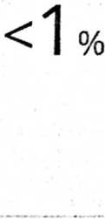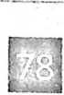

andiosviile.wordpress.com

**Internet Source**

arrheniuspetwien.wordpress.com

**Internet Source**



bagawanabiyasa.wordpress.com

**Internet Source**

btie.kart.edu.ua

Internet Source



clara-indonesia.com

**Internet Source**

**E**dspace.uii.ac.id

**Internet Source**



id.kingdomsalvation.org

**Internet Source**



jonsonsitorus22.blogspot.com

**Internet Source**

journal, unismuh.ac. id

**Internet Source**

kontribusi-mantan2.blogspot.com

**Internet Source**

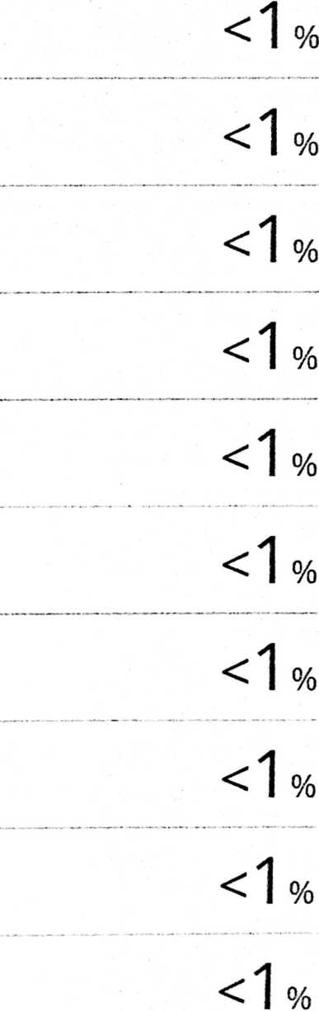

|  |  |  |
| --- | --- | --- |
| krisvalues.blogspot.com  Internet Source | <1 | I % |
| rnirzaazkia.wordpress.com  Internet Source | <1 | l % |
| nanopdf.com  Internet Source | <1 | l % |
| ndafadiiah21 .blogspot.com  Internet Source | <1 | I % |
| normalgigi.blogspot.com  Internet Source | <1 | I % |
| repo.iain-tulungagung.ac.id  Internet Source | <1 | l % |
| repository, poltekkes-kdi.ac.id  Internet Source | <1 | I % |
| rubrikkristen.com  Internet Source | <1 | l % |
| sikodokpesek.blogspot.com  Internet Source | <1 | % |
| sipartalutaiu.biogspot.com  Inter net Source | <1 | % |
| stthami.ac.id  Internet. Source | <1 | % |
| [www.gptkk.org](http://www.gptkk.org)  Internet Source | <1 | % |



|  |  |  |
| --- | --- | --- |
| Bryant. 21 st Century Sociology A Reference Handbook | <1 | I % |
| Publication |  |  |
| ejournal-iakn-manado.ac.id | <1 | I % |
| Internet Source |
| journal-theo.ukdw.ac.id | <1 | I % |
| Internet Sour ce |
| id.scribd.com  Internet Source | <1 | I % |

[G 101

Exclude quotes On

Exclude bibliography On

Exclude matches