LAMPIRAN-LAMPIRAN

1. Lembar Konsultasi Pembimbingan
2. Surat Keterangan Penelitian
3. Instrumen Uji Coba (Variabel X dan Variabel Y)
4. Tabulasi Data Uji Coba Instrumen Variabel X dan Y
5. Tabulasi Data Final Variabel X dan Y
6. Uji Validitas Instrumen Variabel X
7. Uji Validitas Instrumen Variabel Y
8. Uji Realibitas Instrumen Variabel X
9. Uji Realibitas Instrumen Variabel Y
10. Deskripsi Data Variabel X
11. Deskripsi Data Variabel Y
12. Uji Normalitas Data Variabel X dan Y
13. Uji Linearitas Data
14. Uji Hipotesis
15. Lampiran T-Distribution Tabel

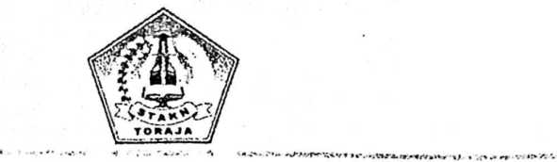

Petunjuk pengisian

* Bacalah dengan sakasama setiap pernyataan yang ada, kemudian beri tanda **(V)** pada kolom SS (sangat setuju), S (setuju), KS (kurang setuju), dan TS (tidak setuju), STS (sangat tidak setuju).
* Apabila ada tanda **(V)** yang akan diganti, gunakan tanda **(x)**
* Data Responden (boleh tidak dicantumkan apabila ada alasan tertentu)

Daftar Pernyataan Variabel X (Kelengkapan Administrasi Guru)

|  |  |  |  |  |  |  |  |
| --- | --- | --- | --- | --- | --- | --- | --- |
| No | Kelengkapa Administrasi Guru | | SS | s | KS | TS | STS |
|  |  | Menyusun dan membuat Silabus | | | | | |
| 1. | Saya membuat silabus sesuai dengan waktu yang telah ditetapkan di awal semester/tahun pelajaran t „ | | I |  |  | L | 1 |
| 2. | Saya membuat silabus dengan sebelumnya memahami setiap unsure-unsur penyusunan silabus | |  |  |  |  |  |
| 3. | Saya membuat silabus sesuai dengan prinsip-prinsip pengembangan silabus | |  |  |  |  |  |
| 4. | Saya membuat silabus sesuai dengan komponen-komponen pengembangan silabus | |  |  |  |  |  |
| 5. | Saya membuat silabus dengan memperhatikan SK dan KD | |  |  |  |  |  |
|  | Menyusun dan Membuat Rencana Pelaksanaan Pembelajaran | |  | | | | |
| 6. | Saya membuat RPP sebelum masuk mengajar (memulai pembelajaran) | |  |  |  |  |  |
| 7. | Saya menyusun RPP sesuai dengan kebutuhan siswa | |  |  |  |  |  |
| 8. | Saya mempersiapkan RPP dengan memperhatikan unsur-unsur penyusunan RPP | |  |  |  |  |  |
| 9. | Saya menyiapkan materi pembelajaran sebelum masuk mengajar | |  |  |  |  |  |
| 10. | Saya membawa setiap kelengkapan ketika masuk mengajar | |  |  |  |  |  |
| 11. | Saya menyiapkan media pembelajaran sebelum masuk mengajar | |  |  |  |  |  |
|  |  | Menyusun Prota, Prose, Remedial dan Pengayaan * r | | | | | |
| 12. | Saya membuat Program Tahunan agar setiap kegiatan yang akan dilakukan dapat tertata | |  |  |  |  |  |
| 13. | Program semester saya buat untuk dijadikan sebagai pedoman dalam satu semester itu | |  |  |  |  |  |
| 14. | Saya perlu melakukan pengayaan saat materi selesai agar dapat tercapai agar dapat diketahui sejauhmana pelajaran itu masih diingat siswa | |  |  |  |  |  |

|  |  |  |  |  |  |  |
| --- | --- | --- | --- | --- | --- | --- |
| 15. | Saya memberi remedial saat nilai KKM tidak tercapai |  |  |  |  |  |
|  | Memiliki daftar hadir dan Jurnal Mengajar |  | | | | |
| 16. | Saya menuliskan dalam jurnal harian setiap poin penting yang akan diajarkan berkaitan dengan pengajaran |  |  |  |  |  |
| 17. | Saya membuat jurnal mengajar untuk merekam setiap perkembangan materi |  |  |  |  |  |
| 18. | Saya memiliki jurnal harian agar setiap kegiatan pembelajaran terkontrol |  |  |  |  |  |
| 19. | Saya dapat menilai melalui pengecekan daftar hadir (absensi) |  |  |  |  |  |
| 20. | Saya mudah mengenal siswa (jumlah siswa) dengan adanya daltar hadir |  |  |  |  |  |
| 21. | Saya dapat mengenal siswa yang malas hadir melalui dattar hadir |  |  |  |  |  |
| 22.  ¥ | Saya membuat jurnal mengajar untuk memudahkan penilaian terhadap sikap siswa  i |  |  |  |  |  |
| 23. | Saya mudah mengatur setiap kegiatan dengan adanya jumal hanan |  |  |  |  |  |
| 24. | Saya menuliskan dalam jumal harian kegiatan-kegiatan pembelajaran yang akan dilakukan agar kegiatan yang akan dilakukan terlaksana dengan baik tidak terhalang oleh kegiatan di luar sekolah |  |  |  |  |  |

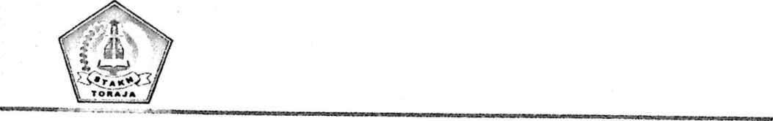

1. Petunjuk pengisian

> Bacalah dengan saksama setiap pernyataan yang ada, kemudian beri tanda (V) pada kolom SS (sangat Setuju), S (setuju), KS (Kurang setuju), TS (Tidak Setuju), dan STS (sangat tidak setuju).

Apabila ada tanda **(V)** yang akan diganti, gunakan tanda **(x)**

1. Data Responden (boleh tidak dicantumkan apabila ada alasan tertentu)

Daftar Pernyataan Kelengkapan Administrasi Guru Terhadap Kualitas Mengajar

Guru Di SDN 4 Rantepao (Variabel X)

|  |  |  |  |  |  |  |  |
| --- | --- | --- | --- | --- | --- | --- | --- |
| No. | Kelengkapan Administrasi Guru | | SS | S KS TS STS | | | |
|  |  | Menyusun dan Membuat Silabus |  | | | | |
| 1. | Saya membuat silabus dengan memperhatikan SK dan KD | |  |  |  |  |  |
|  |  | Menyusun dan Membuat Rencana Pelaksanaan Pembelajaran |  |  |  |  |  |
| 2. | Saya mempersiapkan RPP dengan memperhatikan unsur-unsur penyusunan RPP | |  |  |  |  |  |
| 3. | Saya menyiapkan materi pembelajaran sebelum masuk mengajar | |  |  |  |  |  |
| 4. | Saya menyiapkan media pembelajaran sebelum masuk mengajar | |  |  |  |  |  |
|  |  | Membuat program tahunan, program semester, remedial/pengayaan |  |  |  |  |  |
| 5. | Saya perlu melakukan pengayaan saat materi selesai agar dapat diketahui sejauhmana pelajaran itu masih diingat siswa | |  |  |  |  |  |
| 6. | Saya memberi remedial saat nilai KKM tidak tercapai | |  |  |  |  |  |
|  |  |  |  |  |  |  |  |

|  |  |  |  |  |  |  |
| --- | --- | --- | --- | --- | --- | --- |
|  | Memiliki daftar hadir dan Jumal Mengajar |  |  |  |  |  |
| 7. | Saya menuliskan dalam jumal harian setiap poin penting yang akan diajarkan berkaitan dengan pengajaran |  |  |  |  |  |
| 8. | Saya memiliki jumal harian agar setiap kegiatan pembelajaran terkontrol |  |  |  |  |  |
| 9. | Saya dapat menilai melalui pengecekan daftar hadir (absensi) |  |  |  |  |  |
| 10. | Saya dapat mengenal siswa yang malas hadir melalui daftar hadir |  |  |  |  |  |
| 11. | Saya dapat mengetahui siswa yang malas hadir dengan adanya daftar hadir |  |  |  |  |  |
| 12. | Saya mudah mengatur setiap kegiatan dengan adanya jumal harian |  |  |  |  |  |
| 13. | Saya menuliskan dalam jumal harian kegiatan-kegiatan pembelajaran yang akan dilakukan agar kegiatan itu terlaksana dengan baik tidak terhalang oleh kegiatan di luar sekolah |  |  |  |  |  |

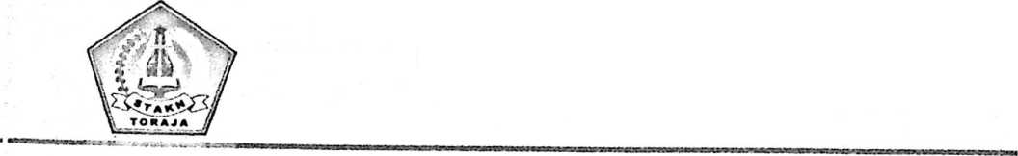

1. Petunjuk pengisian

^ Bacalah dengan saksama setiap pernyataan yang ada, kemudian **beri** tanda **(V)** pada kolom SS (Sangat setuju), S (Setuju), KS (kurang setuju), TS (tidak Setuju), dan STS (sangat **tidak** setuju).

^ Apabila ada tanda **(V)** yang akan diganti, gunakan tanda **(x)**

1. Data Responden (boleh tidak dicantumkan apabila ada alasan tertentu)

Nama ;

Guru Mata Pelajaran :

Daftar Penilaian Kualitas Mengajar Guru di SDN 4 Rantepao (Variabel Y)

|  |  |  |  |  |  |  |  |
| --- | --- | --- | --- | --- | --- | --- | --- |
| No. | Kualitas Mengajar Guru | | SS S | | KS TS | | STS |
|  |  | Kualitas Diri |  | | | | |
| 1. | Saya hadir tepat waktu di sekolah | |  |  |  |  |  |
| 2. | Saya disiplin bertanggung jawab terhadap semua tugas yang dibebankan | |  |  |  |  |  |
| 3. | Saya harus membimbing peserta didik dengan cara yang bijaksana | |  |  |  |  |  |
|  |  | Integritas Moral |  | | | | |
| 4. | Saya menjadi teladan bagi peserta didik (masyarakat) terutama dalam penampilan dan cara berpakaian | |  |  |  |  |  |
| 5. | Saya harus menjadi seorang yang tidak pemarah dan sabar | |  |  |  |  |  |
|  | Kedalaman Ilmu | |  | | | | |
| 6. | Saya menguasai ilmu pengetahuan seturut dengan pengetahuan yang terus berkembang | |  |  |  |  |  |
| 7. | Saya tidak boleh merasa serba tahu tetapi mau mendengarkan pendapat dari peserta didik | |  |  |  |  |  |
|  |  | Terampil |  | | | | |
| 8. | Saya terampil dalam menarik minat siswa dalam mengikuti pembelajaran | |  |  |  |  |  |
| 9. | Saya saat mengajar perlu menggunakan bahasa yang jelas, mudah dipahami, mudah diingat | |  |  |  |  |  |
| 10. | Saya menggunakan metode yang kreatif yang relevan dengan | |  |  |  |  |  |

|  |  |  |  |  |  |  |
| --- | --- | --- | --- | --- | --- | --- |
|  | materi dan kondisi psikologis siswa |  |  |  |  |  |
|  | Penguasaan Materi Ajar |  | | | | |
| 11. | Saya menjelaskan materi dengan tahapan yang sistematis |  |  |  |  |  |
| 12. | Saya mampu mengaitkan materi dengan realitas kehidupan (pengalaman siswa) |  |  |  |  |  |
| 13. | Saya mampu melakukan evaluasi dan bersikap terbuka atas respon siswa. |  |  |  |  |  |

DATA RESPONDEN UJI COBA I VARIABEL X

|  |  |  |  |  |  |  |  |  |  |  |  |  |  |  |  |  |  |  |  |  |  |  |  |  |  |
| --- | --- | --- | --- | --- | --- | --- | --- | --- | --- | --- | --- | --- | --- | --- | --- | --- | --- | --- | --- | --- | --- | --- | --- | --- | --- |
| No.  Resp | 1 | 2 | 3 | 4 | 5 | 6 | 7 | 8 | 9 | 10 | 11 | 12 | 13 | 14 | 15 | 16 | 17 | 18 | 19 | 20 | 21 | 22 | 23 | 24 | Total |
| 1 | 4 | 4 | 4 | 4 | 4 | 4 | 4 | 4 | 4 | 5 | 4 | 4 | 5 | 5 | 5 | 4 | 4 | 5 | 5 | 4 | 5 | 5 | 5 | 5 | 106 |
| 2 | 5 | 4 | 5 | 4 | 4 | 4 | 4 | 5 | 4 | 5 | 4 | 5 | 5 | 5 | 5 | 4 | 4 | 5 | 4 | 4 | 5 | 5 | 5 | 5 | 109 |
| 3 | 5 | 5 | 5 | 5 | 5 | 4 | 4 | 4 | 4 | 4 | 4 | 4 | 4 | 4 | 4 | 5 | 5 | 4 | 4 | 4 | 5 | 5 | 5 | 5 | 107 |
| 4 | 4 | 4 | 4 | 5 | 3 | 3 | 4 | 3 | 3 | 4 | 3 | 3 | 4 | 3 | 3 | 3 | 4 | 3 | 3 | 3 | 3 | 3 | 3 | 3 | 81 |
| 5 | 4 | 4 | 4 | 4 | 4 | 5 | 4 | 5 | 4 | 5 | 4 | 4 | 4 | 4 | 4 | 5 | 4 | 4 | 3 | 4 | 4 | 4 | 4 | 4 | 99 |
| 6 | 5 | 4 | 5 | 4 | 5 | 5 | 4 | 4 | 5 | 4 | 4 | 3 | 5 | 5 | 4 | 5 | 4 | 5 | 4 | 4 | 4 | 5 | 5 | 4 | 106 |
| 7 | 5 | 4 | 4 | 4 | 5 | 5 | 5 | 4 | 4 | 4 | 5 | 5 | 4 | 4 | 4 | 5 | 5 | 5 | 4 | 4 | 4 | 4 | 4 | 4 | 105 |
| 8 | 4 | 4 | 4 | 4 | 4 | 5 | 5 | 5 | 5 | 4 | 5 | 5 | 4 | 4 | 4 | 5 | 5 | 4 | 5 | 4 | 5 | 4 | 5 | 4 | 107 |
| 9 | 4 | 4 | 4 | 4 | 5 | 5 | 5 | 4 | 4 | 4 | 4 | 3 | 5 | 4 | 4 | 4 | 4 | 4 | 4 | 5 | 4 | 5 | 5 | 5 | 103 |
| 10 | 5 | 4 | 5 | 4 | 5 | 5 | 5 | 5 | 5 | 5 | 5 | 4 | 4 | 4 | 4 | 5 | 4 | 4 | 4 | 4 | 5 | 5 | 4 | 4 | 108 |

DATA RESPONDEN UJI COBA (DATA VALID)

|  |  |  |  |  |  |  |  |  |  |  |  |  |  |  |
| --- | --- | --- | --- | --- | --- | --- | --- | --- | --- | --- | --- | --- | --- | --- |
| No  Resp | 1 | 2 | 3 | 4 | 5 | 6 | 7 | 8 | 9 | 10 | 11 | 12 | 13 | Total |
| 1 | 4 | 4 | 4 | 4 | 4 | 4 | 4 | 4 | 4 | 5 | 4 | 4 | 5 | 54 |
| 2 | 5 | 4 | 5 | 4 | 4 | 4 | 4 | 5 | 4 | 5 | 4 | 5 | 5 | 58 |
| 3 | 5 | 5 | 5 | 5 | 5 | 4 | 4 | 4 | 4 | 4 | 4 | 4 | 4 | 57 |
| 4 | 4 | 4 | 4 | 5 | 3 | 3 | 4 | 3 | 3 | 4 | 3 | 3 | 4 | 47 |
| 5 | 4 | 4 | 4 | 4 | 4 | 5 | 4 | 5 | 4 | 5 | 4 | 4 | 4 | 55 |
| 6 | 5 | 4 | 5 | 4 | 5 | 5 | 4 | 4 | 5 | 4 | 4 | 3 | 5 | 57 |
| 7 | 5 | 4 | 4 | 4 | 5 | 5 | 5 | 4 | 4 | 4 | 5 | 5 | 4 | 58 |
| 8 | 4 | 4 | 4 | 4 | 4 | 5 | 5 | 5 | 5 | 4 | 5 | 5 | 4 | 58 |
| 9 | 4 | 4 | 4 | 4 | 5 | 5 | 5 | 4 | 4 | 4 | 4 | 3 | 5 | 55 |
| 10 | 5 | 4 | 5 | 4 | 5 | 5 | 5 | 5 | 5 | 5 | 5 | 4 | 4 | 61 |

|  |  |  |  |  |  |  |  |  |  |  |  |  |  |  |
| --- | --- | --- | --- | --- | --- | --- | --- | --- | --- | --- | --- | --- | --- | --- |
| ' Responden | VARIABEL Y | | | | | | | | | | | | | TOTAL; Y ! |
| 1 | 2 | 3 | 4 | 5 | 6 | 7 | 8 | 9 | 10 | 11 | 12 | 13 |
| 1 | 4 | 5 | 3 | 4 | 4 | 4 | 4 | 4 | 3 | 3 | 3 | 2 | i | 44 |
| 2 | 4 | 4 | 4 | 4 | 4 | 3 | 4 | 4 | 4 | 4 | 3 | 2 | 2 | 46 |
| 3 | 3 | 3 | 4 | 4 | 2 | 2 | 3 | 3 | 3 | 4 | 2 | 3 | 1 | 37 |
| 4 | 5 | 5 | 5 | 4 | 4 | 4 | 5 | 4 | 4 | 5 | 4 | 4 | 5 | 58 |
| 5 | 5 | 5 | 5 | 5 | 5 | 4 | 5 | 5 | 5 | 5 | 4 | 5 | 5 | 63 |
| 6 | 4 | 4 | 3 | 4 | 3 | 3 | 5 | 4 | 4 | 4 | 2 | 2 | 4 | 46 |
| 7 | 5 | 5 | 4 | 4 | 4 | 3 | 4 | 4 | 4 | 4 | 4 | 2 | 4 | 51 |
| 8 | 3 | 5 | 3 | 4 | 4 | 4 | 4 | 3 | 4 | 4 | 4 | 2 | 4 | 48 |
| 9 | 3 | 4 | 3 | 4 | 4 | 3 | 4 | 2 | 4 | 3 | 3 | 3 | 3 | 43 |
| 10 | 3 | 5 | 3 | 4 | 4 | 3 | 4 | 4 | 4 | 4 | 3 | 2 | 4 | 47 |

60

61

60

57

59

57

56

60

59

60

59

58

54

53

59

61

56

51

DATA RESPONDEN VARIABEL X

|  |  |  |  |  |  |  |  |
| --- | --- | --- | --- | --- | --- | --- | --- |
| 5 | 6 | 7 | 8 | 9 | 10 | 11 | 12 |
| 5 | 5 | 4 | 5 | 5 | 4 | 4 | 4 |
| 4 | 5 | 5 | 5 | 5 | 4 | 4 | 5 |
| 5 | 5 | 4 | 5 | 5 | 4 | 5 | 5 |
| 4 | 4 | 4 | 5 | 5 | 4 | 4 | 5 |
| 4 | 4 | 4 | 5 | 5 | 4 | 4 | 5 |
| 5 | 4 | 4 | 5 | 4 | 5 | 4 | 4 |
| 5 | 5 | 5 | 5 | 5 | 4 | 5 | 4 |
| 5 | 5 | 4 | 5 | 5 | 4 | 4 | 4 |
| 4 | 5 | 5 | 5 | 5 | 4 | 4 | 5 |
| 5 | 5 | 4 | 5 | 5 | 4 | 5 | 5 |
| 4 | 4 | 4 | 5 | 5 | 4 | 4 | 5 |
| 4 | 4 | 4 | 5 | 5 | 4 | 4 | 5 |
| 5 | 4 | 4 | 5 | 4 | 5 | 4 | 4 |
| 5 | 4 | 5 | 5 | 4 | 5 | 3 | 4 |
| 5 | 5 | 5 | 5 | 3 | 4 | 4 | 4 |
| 5 | 5 | 4 | 5 | 5 | 5 | 5 | 4 |
| 4 | 5 | 5 | 4 | 3 | 4 | 4 | 4 |
| 4 | 3 | 4 | 4 | 4 | 4 | 5 | 4 |

|  |  |  |
| --- | --- | --- |
| 2 | 3 | 4 |
| 5 | 5 | 5 |
| 5 | 5 | 5 |
| 4 | 4 | 5 |
| 4 | 4 | 4 |
| 5 | 5 | 4 |
| 5 | 4 | 4 |
| 5 | 5 | 4 |
| 5 | 5 | 5 |
| 4 | 4 | 5 |
| 4 | 4 | 5 |
| 5 | 5 | 4 |
| 5 | 4 | 4 |
| 5 | 1 | 4 |
| 5 | 1 | 4 |
| 5 | 5 | 5 |
| 5 | 3 | 5 |
| 4 | 4 | 5 |
| 3 | 4 | 4 |

Total

62

61

62

63

61

57

64

60

58

61

60

56

64

64

58

64

58

59

Tabulasi Data Responden Variabel Y  
(Kualitas Mengajar Guru)

|  |  |  |  |  |  |  |  |  |  |  |  |  |
| --- | --- | --- | --- | --- | --- | --- | --- | --- | --- | --- | --- | --- |
| 1 | 2 | 3 | 4 | 5 | 6 | 7 | 8 | 9 | 10 | 11 | 12 | 13 |
| 5 | 5 | 5 | 4 | 5 | 4 | 4 | 5 | 5 | 5 | 5 | 5 | 5 |
| 5 | 5 | 4 | 5 | 5 | 4 | 4 | 4 | 5 | 5 | 5 | 5 | 5 |
| 5 | 5 | 5 | 5 | 5 | 4 | 5 | 5 | 5 | 4 | 5 | 4 | 5 |
| 5 | 5 | 4 | 5 | 4 | 5 | 5 | 5 | 5 | 5 | 5 | 5 | 5 |
| 5 | 5 | 4 | 5 | 5 | 4 | 5 | 5 | 5 | 4 | 5 | 5 | 4 |
| 4 | 4 | 4 | 4 | 3 | 5 | 4 | 5 | 5 | 5 | 5 | 4 | 5 |
| 5 | 5 | 5 | 5 | 4 | 5 | 5 | 5 | 5 | 5 | 5 | 5 | 5 |
| 4 | 4 | 5 | 5 | 5 | 4 | 4 | 4 | 5 | 5 | 5 | 5 | 5 |
| 5 | 4 | 4 | 5 | 5 | 4 | 4 | 5 | 5 | 5 | 4 | 4 | 4 |
| 5 | 4 | 5 | 5 | 5 | 4 | 4 | 5 | 4 | 5 | 5 | 5 | 5 |
| 5 | 5 | 5 | 4 | 5 | 5 | 5 | 5 | 5 | 4 | 4 | 4 | 4 |
| 5 | 4 | 5 | 4 | 4 | 4 | 4 | 5 | 5 | 4 | 4 | 4 | 4 |
| 5 | 5 | 5 | 4 | 5 | 5 | 5 |  | 5 | 5 | 5 | 5 | 5 |
| 5 | 5 | 5 | 4 | 5 | 5 | 5 | 5 | 5 | 5 | 5 | 5 | 5 |
| 4 | 5 | 5 | 5 | 4 | 4 | 4 | 5 | 5 | 4 | 5 | 4 | 4 |
| 5 | 5 | 5 | 5 | 5 | 5 | 5 | 5 | 4 | 5 | 5 | 5 | 5 |
| 4 | 5 | 5 | 5 | 5 | 4 | 4 | 4 | 3 | 5 | 5 | 4 | 5 |
| 5 | 4 | 5 | 5 | 5 | 4 | 4 | 5 | 5 | 4 | 4 | 5 | 4 |

‘ - ■*— -'V (iv'ICT.

|  |  |  |  |  |  |  |  |  |  |  |  |  |  |  |
| --- | --- | --- | --- | --- | --- | --- | --- | --- | --- | --- | --- | --- | --- | --- |
|  | | total | 1  1 pi | p2 | p3 |  |  | p6 I p7 | |  | p9 | p10 | p11 | p12 |
| al | r-otltson  Correia ti on | 1 | I .497 | .166 | .458 | .580 | .684 | .599 | .276 | .65  1* | .71  8* | .250 | .69  7' | .510 |
|  | Sig. (2-  tailed)  N | 10 | .144  10 | .647  10 | .183  10 | .079  10 | .029  10 | .067  10 | .440  10 | .04  1  10 | .01  9  10 | .486  10 | .02  5  10 | .132  10 |
| pi | Pearson  Correlati  on | .497 | 1 | .333 | .816 | 0.00  0 | .603 | .149 | 0.00  0 | .15  6 | .33  3 | 0.00  0 | .33  3 | .258 |
|  | Sig. (2-  tailod)  N | .144  10 | 10 | .347  10 | .004  10 | 1.00  0  10 | .065  10 | .681  10 | 1.00  0  10 | .66  7  10 | .34  7  10 | 1.00  0  10 | .34  7  10 | .471  10 |
| P2 | Pearson  Correlati | .166 | .333 | 1 | .408 | .667 | .302 | .248 | - |  |  | . |  | 0.00 |
|  | on |  |  |  |  |  |  | .272 | .15 | .11 | .272 | .11 | 0 |
|  | Sig. (2- tailed) | .647 | .347 |  | 242 | .035 | .397 | .489 | .447 | 6  .66 | 1  .76 | .447 | 1  .76 | 1.00 |
|  | N | 10 | 10 | 10 | 10 | 10 | 10 | 10 | 10 | 7  10 | 0  10 | 10 | 0  10 | 0  10 |
| P3 | Pearson  Correlati | .458 | .816 | .408 | 1 | .102 | .431 | 0.00 | _ | .25 | .40 | .167 | .06 | 0.00 |
|  | on |  |  |  |  |  |  | 0 | .250 | 5 | 8 |  | 8 | 0 |
|  | Sig.<2- tailed) | .183 | .004 | .242 |  | 779 | .214 | 1.00 | .486 | .47 | .24 | .645 | .85 | 1.00 |
|  | N | 10 | 10 | 10 | 10 | 10 | 10 | 10 | 10 | 7  10 | 2  10 | 10 | 2  10 | 0  10 |
| p4 | Pearson | - | 0.00 | .667 | 102 | 1 |  |  |  |  |  |  |  |
|  | Correlati | .580 | o |  | .302 | ” | ■ | ■ | - | . | _ |  |
|  | on |  |  |  |  | .745 | .408 | .02 | .58 | .408 | .58 | .323 |
|  | Sig (2- tailed) | .079 | 1.00  0 | .035 | .779 |  | .397 | .013 | .242 | 5  .05 | 3  .07 | .242 | 3  .07 | .363 |
|  | N | 10 | 10 | 10 | 10 | 10 | 10 | 10 | 10 | 3  10 | 7  10 | 10 | 7  10 | 10 |
| P5 | Pearson  Correlati | .684 | .003 | .302 | .431 | .302 | 1 | .874 | .431 | .18 | .55 |  | .55 | 0.00 |
|  | on |  |  |  |  |  |  |  | 8 | 3 | .185 | 3 | 0 |
|  | Sig (2- tailod) | .029 | .065 | .397 | .214 | .397 |  | .033 | .214 | .80 | .09 | .610 | .06 | 1.00 |
|  | N | 10 | 10 | 10 | 10 | 10 | 10 | 10 | 10 | 2  10 | 7  10 | 10 | 7  10 | 0  10 |
| p6 | Pearson  Correlati  on | .599 | .149 | .246 | 0.00  0 | .745 | 074 | 1 | .809 | .58  2 | .74  6* | 0.00  0 | .74  5* | .192 |
|  | Sig (2- tailed) | .067 | .681 | .489 | 1.00  0 | .013 | .033 |  | .062 | .07 | .01 | 1.00 | .01 | .594 |
|  | N | 10 | 10 | 10 | 10 | 10 | 10 | 10 | 10 | 8  10 | 3  10 | 0  10 | 3  10 | 10 |
| P7 | Pearson  Correlati  on | .276 | 0.00  0 | .272 | 250 | .408 | .431 | .606 | 1 | .25  5 | .40  8 | .250 | .74  8* | .264 |
|  | Sig (2- tailod) | .440 | 1.00  0 | .447 | 486 | .242 | .214 | .082 |  | 47  7 | .24 | .480 | .01 | .462 |
|  | N | 10 | 10 | 10 | 10 | 10 | 10 | 10 | 10 | 10 | 10 | 10 | 3  10 | 10 |

"NUKA|,AN IL.iiUJL

|  |  |  |  |  |  |  |  |  |  |  |  |
| --- | --- | --- | --- | --- | --- | --- | --- | --- | --- | --- | --- |
| p13 | p14 | p15 | p16 | p17 | p18 | P19 | I p20 | p21 | p22 | p23 | n?4 |
| .302 | .718 | .732 | .675 | .270 | .711 | .665 | .627 | .838 | .808 | .789 | .691 |
| .396 | .019 | .016 | .032 | .451 | .021 | .036 | .052 | .002 | .005 | .007 | .027 |
| 10 | 10 | 10 | 10 | 10 | 10 | 10 | 10 | 10 | 10 | 10 | 10 |
| 0.00 | .333 | .186 | .447 | .218 | .469 | 0.00 | o.oc | .302 | .447 | .149 | .156 |
| 0 |  |  |  |  |  | 0 | 0 |  |  |  |  |
| 1.00 | .347 | .608 | .195 | .545 | .172 | 1.00 | 1.00 | .397 | .195 | .681 | .667 |
| 0 |  |  |  |  |  | 0 | 0 |  |  |  |  |
| 10 | 10 | 10 | 10 | 10 | 10 | 10 | 10 | 10 | 10 | 10 | 10 |
| .272 | .111 | .062 | .248 | .509 | .156 | 0.00  0 | O.OC  0 | .302 | .248 | .248 | .364 |
| .447 | .760 | .865 | .489 | .133 | .667 | 1.00 | 1.00 | .397 | .489 | .489 | .301 |
|  |  |  |  |  |  | 0 | 0 |  |  |  |  |
| 10 | 10 | 10 | 10 | 10 | 10 | 10 | 10 | 10 | 10 | 10 | 10 |
| .167 | .408 | .227 | .304 | - | .255 | 0.00 | 0.00 | .431 | .609 | .304 | .255 |
|  |  |  |  | .089 |  | 0 | 0 |  |  |  |  |
| .645 | .242 | .527 | .393 | .807 | .477 | 1.00 | 1.00 | .214 | .062 | .393 | .477 |
| 10 | 10 | 10 | 10 | 10 | 10 | 10 | 0  10 | 10 | 10 | 10 | 10 |
| - | - | - | . | .218 | _ |  |  |  |  |  |  |
| .408 | .583 | .557 | .373 |  | .625 | .395 | .559 | .302 | .373 | .373 | .234 |
| .242 | .077 | .094 | .289 | .545 | .053 | .258 | .093 | .397 | .289 | .289 | .515 |
| 10 | 10 | 10 | 10 | 10 | 10 | 10 | 10 | 10 | 10 | 10 | 10 |
| .123 | .302 | .168 | .674 | .263 | .424 | .238 | .674 | .318 | .674 | .449 | .424 |
| .735 | .397 | 643 | .033 | .463 | .222 | .507 | .033 | .370 | .033 | .193 | .222 |
| 10 | 10 | 10 | 10 | 10 | 10 | 10 | 10 | 10 | 10 | 10 | 10 |
| 0.00  0 | .248 | 138 | .778 | .163 | .349 | .236 | .667 | .225 | .333 | .333 | .116 |
| 1.00  0 | .489 | .703 | .008 | .653 | .323 | .512 | .035 | .532 | .347 | .347 | .740 |
| 10 | 10 | 10 | 10 | 10 | 10 | 10 | 10 | 10 | 10 | 10 | 10 |
| .250 | .272 | 152 | .304 | .356 | .064 | .323 | .456 | .123 | 0.00  0 | 0 00 0 | .064 |
| .486 | .447 | 676 | .393 | .312 | .861 | .363 | .185 | .735 | 1.00 | 1 00 | .861 |
| 10 | 10 | 10 | 10 | 10 | 10 | 10 | 10 | 10 | 0  10 | 0  10 | 10 |

|  |  |  |  |  |  |  |  |  |  |  |  |  |  |  |  |  |  |  |  |  |  |  |  |  |  |  |
| --- | --- | --- | --- | --- | --- | --- | --- | --- | --- | --- | --- | --- | --- | --- | --- | --- | --- | --- | --- | --- | --- | --- | --- | --- | --- | --- |
|  |  |  |  |  |  |  |  |  |  |  | |  |  | mHm |  | HI | 4*4 |  | llll | IUU | !4IJ I | *1 l 141 l | | Hi l | IL l ll! 1 | |
|  | on j |  | I |  |  |  |  |  |  |  | © |  | © |  | 004 |  |  |  |  |  |  |  |  |  |  |
|  | Slfl (2- I | .041 | .667 | .667 | 477 | .053 | .002 | .078 | .477 |  | .05 | .083 | 05 | 064 | .601 | .301 | .148 | .078 | 020 | .464 | .402 | .323 | 030 | 323 | .323 | .434 |
|  | tailed) 1 |  |  |  |  |  |  |  |  |  | 3 |  | 3 |  |  |  |  |  |  |  |  |  |  |  |  |  |
|  | N j | 10 | 10 | 10 | 10 | 10 | 10 | 10 | 10 | 10 | 10 | 10 | 10 | 10 | 10 | 10 | 10 | 10 | 10 | 10 | 10 | 10 | 10 | 10 | 10 | 10 |
| p9 | Pearson I | 718 | .333 | . | .408 | _ | .553 | 74 5 | .408 | .62 | 1 | .068 | 72 | .215 | .008 | .444 | .248 | .745 | .145 | .364 | .527 | .373 | .553 | .497 | .497 | .104 |
| Correlati 1 |  |  | .111 |  | .583 |  |  |  | 5 |  |  | 2* |  |  |  |  |  |  |  |  |  |  |  |  |  |
|  | on f Slfl. (2- j | .019 | .347 | .760 | 242 | .077 | .097 | .013 | .242 | .05 |  | .852 | .01 | .551 | .852 | .198 | .490 | .013 | .688 | .301 | .117 | .289 | .097 | .144 | .144 | 775 |
|  | tailed) |  |  |  |  |  |  |  |  | 3 |  |  | 8 |  |  |  |  |  |  |  |  |  |  | 10 | 10 | 10 |
|  | N i | 10 | 10 | 10 | 10 | 10 | 10 | 10 | 10 | 10 | 10 | 10 | 10 | 10 | 10 | 10 | 10 | 10 | 10 | 10 | 10 | 10 | 10 |
| p1 | Pearson 1 | .250 | 0.00 | _ | .167 | _ |  | 0.00 | _ | .57 | .06 | 1 | .06 | .264 | .167 | .408 | .606 | 0.00 |  | .255 | 0.00 | 0.00 | .431 | .304 | 0.00 | .255 |
| 0 | Correlati 1 |  | 0 | .272 |  | .408 | .185 | 0 | .250 | 4 | 8 |  | 6 |  |  |  |  | 0 | .535 |  | 0 | 0 |  |  | 0 |  |
|  | on s Slfl. (2- | .486 | 1.00 | .447 | .645 | .242 | .610 | 1.00 | .486 | .08 | .85 |  | .85 | .462 | .645 | .242 | .063 | 1.00 | .111 | .477 | 1.00 | 1.00 | .214 | .393 | 1.00 | .477 |
|  | tailed) |  | 0 |  |  |  |  | 0 |  | 3 | 2 |  | 2 |  |  |  |  | 0 |  |  | 0 | 0 |  |  | 0 |  |
|  | N | | 10 | 10 | 10 | 10 | 10 | 10 | 10 | 10 | 10 | 10 | 10 | 10 | 10 | 10 | 10 | 10 | 10 | 10 | 10 | 10 | 10 | 10 | 10 | 10 | 10 |
| P1 | Pearson 1 | .697 | .333 | . | .068 | _ | .553 | 745 | .748 | .62 | .72 | .068 | 1 | .645 | _ | .167 | .248 | 745 | .509 | .364 | .527 | .373 | .553 | .248 | .248 | .104 |
| 1 | Correlati 1 on j Slfl. (2- |  |  | .111 |  | .583 |  |  |  | 5 | 2 |  |  |  | .272 |  |  |  |  |  |  |  |  |  |  |  |
|  | .025 | .347 | .760 | 852 | .077 | .097 | .013 | .013 | .05 | .01 | .852 |  | .044 | .447 | .645 | .490 | .013 | .133 | .301 | .117 | .289 | .097 | .489 | .489 | 775 |
|  | tailed) 1 |  |  |  |  |  |  |  |  | 3 | 8 |  |  |  |  |  |  |  |  |  |  |  |  |  |  |  |
|  | N j | 10 | 10 | 10 | 10 | 10 | 10 | 10 | 10 | 10 | 10 | 10 | 10 | 10 | 10 | 10 | 10 | 10 | 10 | 10 | 10 | 10 | 10 | 10 | 10 | 10 |
| P1 | Pearson | .510 | .258 | 0.00 | 0.00 | _ | 0.00 | .192 | .264 | .60 | .21 | .264 | .64 | 1 |  | .215 | .479 | .385 | .563 | .403 | .408 | 0.00 | .584 | 0.00 | .192 | .202 |
| 2 | Correlati  on | ! |  | 0 | 0 | .323 | 0 |  |  | 5 | 5 |  | 5' |  | .264 |  |  |  |  |  |  | 0 |  | 0 |  |  |
|  | Slfl. (2- | | .132 | .471 | 1.00 | 1.00 | .363 | 1.00 | .594 | .462 | .06 | .55 | .462 | .04 |  | .462 | .551 | .161 | .272 | .090 | .248 | .242 | 1.00 | .076 | 1.00 | .594 | .576 |
|  | tailed) 1 |  |  | 0 | 0 |  | 0 |  |  | 4 | 1 |  | 4 |  |  |  |  |  |  |  |  | 0 |  | 0 |  |  |
|  | N | 10 | 10 | 10 | 10 | 10 | 10 | 10 | 10 | 10 | 10 | 10 | 10 | 10 | 10 | 10 | 10 | 10 | 10 | 10 | 10 | 10 | 10 | 10 | 10 | 10 |
| P1 | Pearson | .302 | 0.00 | . | .167 | . | .123 | 0.00 | . |  | .06 | .167 | _ | . | 1 | 748 | .606 | _ |  | .574 | .323 | .456 | .123 | .809 | .609 | .574 |
| 3 | Correlati |  | 0 | .272 |  | .408 |  | 0 | .250 | .06 | 8 |  | .27 | .284 |  |  |  | .304 | .535 |  |  |  |  |  |  |  |
|  | on |  |  |  |  |  |  |  |  | 4 |  |  | 2 |  |  |  |  |  |  |  |  |  |  |  |  |  |
|  | Sig. (2- | .396 | 1.00 | .447 | .645 | .242 | .735 | 1.00 | .488 | .86 | .85 | .645 | .44 | .462 |  | .013 | .063 | .393 | .111 | .083 | .363 | .185 | 735 | .062 | .062 | .083 |
|  | tailed) |  | 0 |  |  |  |  | 0 |  | 1 | 2 |  | 7 |  |  |  |  |  |  |  |  |  |  |  |  |  |
|  | N | ! io | 10 | 10 | 10 | 10 | 10 | 10 | 10 | 10 | 10 | 10 | 10 | 10 | 10 | 10 | 10 | 10 | 10 | 10 | 10 | 10 | 10 | 10 | 10 | 10 |
| P1 | Pearson | •71B. | .333 | _ | .408 | | | .302 | .248 | | | .38 | .44 | .408 | .16 | .215 | 748 | 1 | .807 | .248 | . | .885 | .527 | .373 | .553 | 745 | 745 | .625 |
| 4 | Correlati |  |  | .111 |  | .583 |  |  | .272 | 4 | 4 |  | 7 |  |  |  |  |  | .218 |  |  |  |  |  |  |  |
|  | on  Sig (2- | I .019 | .347 | .760 | 242 | .077 | .397 | .489 | .447 | .30 | .19 | .242 | 04 | .551 | .013 |  | .001 | .489 | .545 | .001 | .117 | .289 | .097 | .013 | .013 | .053 |
|  | tailed) |  |  |  |  |  |  |  |  | 1 | 8 |  | 5 |  |  |  |  |  |  |  |  |  |  |  |  |  |
|  | N | I 10 | 10 | 10 | 10 | 10 | 10 | 10 | I 10 | 10 | 10 | 10 | 10 | 10 | 10 | 10 | 10 | 10 | 10 | 10 | 10 | 10 | 10 | 10 | 10 | 10 |
| P'» | Pearson | I 732. | .186 | . | .227 | I | .168 | .138 | j „ | .49 | .24 | .606 | .24 | .479 | .606 | .867 | 1 | .138 | . | 783 | .587 | .415 | .728 | 892 | .692 | 783 |
| 5 | Correlati |  |  | .002 |  | .657 |  |  | .162 | 3 | 6 |  | 8 |  |  |  |  |  | .122 |  |  |  |  |  |  |  |
|  | on  Slfl. (2- lullod) | I .016 | .608 | .865 | 627 | .094 | .043 | .703 | .676 | .14  8 | .49  0 | .063 | .49  0 | .161 | .063 | .001 |  | 703 | 738 | .007 | .074 | .233 | .017 | .027 | .027  10 | .007  10 |
|  | N | | 10 | 10 | 10 | 10 | 10 | 10 | 10 | 10 | 10 | 10 | 10 | 10 | 10 | 10 | 10 | 10 | 10 | 10 | 10 | 10 | 10 | 10 | 10 |
| P1 | Pearson | I 676. | .447 | .248 | .304 | _ | .674 | 778 | .304 | 58 | .74 | 0.00 | 74 | .385 | . | .248 | .138 | 1 | 488 | .349 | .236 | .333 | .449 | .333 | .333 | .116 |
| 6 | Correlati |  |  |  |  | .373 |  |  | 2 | 5* | 0 | 5* |  | .304 |  |  |  |  |  |  |  |  |  |  |  |
|  | on  Sig. (2- tailed) | I .032 | .195  I | .488 | 392 | .289 | .033 | .008 | .393 | i 07 6 | .01  3 | 1.00  0 | ■ 01 3 | .272 | .393 | .480 | .703 |  | .153 | .323 | .512 | .347 | .193 | 347 | .347 | 749 |

.^IIUIJV ,.U!1

Pw»r*on

Correlati

on

SIg (2- tailed)

N

Pearson

Correlate

on

Sig. (2-

tailed)

N

Pearson

Correlati

on

Sig. (2- tailed)

N

Pearson

Correlati

on

Sig.(2- tailed)

N

Pearson

Correlati

on

Sig (2- tailed)

N

Pearson

Correlati

on

Sig. (2- talied)

N

Pearson

Correlati

on

Sig (2- tailed)

N

Pearson

Correlati

on

Sig (2- tailed)

N

.27 a

.302

.500

|  |  |  |
| --- | --- | --- |
|  | .103 | .360 |
| .463 | .653 | .312 |
| 10 | 10 | 10 |
| 424 | .349 | .064 |
| 222 | .323 | .861 |
| 10 | 10 | 10 |
| .238 | .236 | .323 |
| .507 | .512 | .363 |
| 10 | 10 | 10 |
| .674 | .667 | I .456 |

.sin

|  |  |  |  |  |  |
| --- | --- | --- | --- | --- | --- |
| .397 | .214 | .397 | .370 | .532 | .735 |
| 10 | 10 | 10 | 10 I | 10 | 10 |
| .248 | .609 ] | .373 | .674 | .333 | 0 00 0 |
| .489 | .062 | .269 | .033 | .347 | 1.00  0 |
| 10 | i 10 | i 10 | 10 | 10 | I 10 |
| .248 | .304 | I .373 | I .449 | .333 | 0.00 j o |
| .489 | 393 | I .289 | .193 | .347 | 1.0C |

.302 .431

.302

|  |  |  |  |  |  |  |
| --- | --- | --- | --- | --- | --- | --- |
| 10 | 10 | 10 | 10 | 10 | I 10 | 10 |
| .691 | 156 | .364 | 255 ' | . | 424 | .116 |
|  |  |  |  | .234 |  |  |
| .027 | .687 | .301 | .477 | .515 | .222 | .749 |
| 10 | 10 | 10 | 10 | 10 | 10 | 10 |

. Correlation is significant at Die 0.05 lovel (2-tailed). V Correlation is significant at the 0.01 level (2-tailed).

.007

.081

|  |  |  |  |
| --- | --- | --- | --- |
|  | re | • u |  |
| OJ | . 14 |  | oo |
| 4 | 5 | .636 | 0 |
| .92 | .08 | .111 | .13 |
| 6 | 8 |  | 3 |
| 10 | 10 | 10 | 10 |
| .26 | .36 | .255 | .36 |
| 8 | 4 |  | 4 |
| .45 | .30 | .477 | .30 |
| 4 | 1 |  | 1 |
| 10 | 10 | 10 | 10 |
| .24 | .52 | 0.00 | .52 |
| 7 | 7 | 0 | 7 |
| .49 | .11 | 1.00 | .11 |
| 2 | 7 | 0 | 7 |
| 10 | 10 | 10 | 10 |
| .34 | .37 | 0.00 | | .37 |

.431

1.00

.24 .192

.26

|  |  |  |  |  |  |  |  |  |  |  |
| --- | --- | --- | --- | --- | --- | --- | --- | --- | --- | --- |
| .216 | .122 | .4110  ,*119 | 1 | U>4 I | .«MO | 0.00  r>  0 |  | ms  103 |  | 014 |
| .545 | .738 | .153 |  | .926 | .329 | 1.00  o | .463 | .653 | .653 | .926 |
| 10 | 10 | 10 | 10 | 10 | 10 | 1C)] | 10 | 10 | 10 | 10 |
| .885 | .783 | .349 | .034 | 1 | .494 | .349 | .424 | .582 | .582 | .512 |
| .001 | .007 | .323 | .926 |  | .147 | .323 | .222 | .078 | .078 | .130 |
| 10 | 10 | 10 | 10 | 10 | 10 | 10 | 10 | 10 | 10 | 10 |
| .527 | .587 | .236 | .345 | .494 | 1 | .354 | .715 | .471 | .707 | .494 |
| .117 | .074 | .512 | .329 | .147 ! |  | .316 | .020 | .169 | .022 | .147 |
| 10 | 10 | 10 | 10 | 10 | 10 | 10 | 10 | 10 | j 10 | 10 |
| .373 | .415 | .333 | 0.00  0 | .349 | .354 | 1 | .337 | .667 | .667 | .698 |

|  |  |  |  |  |  |
| --- | --- | --- | --- | --- | --- |
| .185 | .289 | .233 | .347 | 1.00  0 | .323 |
| 10 | 10 | 10 | 10 | 10 | 10 |
| .123 | | .553 | .728 j | .449 | 263 | 424 |

.584

.013 .027

|  |  |  |  |  |  |
| --- | --- | --- | --- | --- | --- |
| 0 | 9 |  |  |  | 10 |
| 10 I | 10 | 10 | 10 | 10 |
| .255 | .10 | .202 | .574 | .625 | 783 |
|  | 4 |  |  |  |  |
| .477 | I 77 | .576 | .083 | .053 | .007 |
|  | 5 |  |  |  |  |
| 10 | 10 | 10 | 10 | to | 10 |

48

.062 .013

.027

|  |  |  |
| --- | --- | --- |
| .035 ! | .033 | j 008 |
| 10 | I 10 | I 10 |
| .698 | .659 | .815 |
| .025 | .038 | 004 |
| 10 | 10 | 10 |

.008 | .004 10 I 10 .815

|  |  |  |  |  |  |  |  |  |  |  |  |  |  |  |  |
| --- | --- | --- | --- | --- | --- | --- | --- | --- | --- | --- | --- | --- | --- | --- | --- |
| TOTAL | Pearson  Correlation | TOTAL  1 | p1  .637 | p2  .632 | p3  .727 | .644 | p5  .782" | p6  .776 | p7  .633* | p8  .736 | p9  .711 | p1Q  .838 | p11  ".831" | p12  .831 | p13  .710 |
|  | Sig. (2- tailed) |  | .047 | .050 | .017 | .045 | .007 | .008 | .050 | .015 | .021 | .002 | .003 | .003 | .022 |
| P1 | N  Pearson  Correlation | 10  .637' | 10  1 | 10  .188 | 10  .553 | 10  .553 | 10  .302 | 10  .168 | 10  .674' | 10  .424 | 10  .238 | 10  .318 | 10  .674' | 10  .449 | 10  .424 |
|  | Sig. (2- tailed) | .047 |  | .602 | .097 | .097 | .397 | .643 | .033 | .222 | .507 | .370 | .033 | .193 | .222 |
| P2 | N  Pearson  Correlation | 10  .632 | 10  .188 | 10  1 | 10  .625 | 10  .625 | 10  .364 | 10  .493 | 10  .582 | 10  .268 | 10  .247 | 10  .659* | 10  .349 | 10  .349 | 10  .268 |
|  | Sig. (2- tailed) | .050 | .602 |  | .053 | .053 | .301 | .148 | .078 | .454 | .492 | .038 | .323 | .323 | .454 |
| P3 | N  Pearson  Correlation | 10  .727* | 10  .553 | 10  .625 | 10  1 | 10  .722* | 10  .444 | 10  .248 | 10  .745* | 10  .364 | 10  .527 | 10  .553 | 10  .497 | 10  .497 | 10  .104 |
|  | Sig. (2- tailed) | .017 | .097 | .053 |  | .018 | .198 | .490 | .013 | .301 | .117 | .097 | .144 | .144 | .775 |
| p4 | N  Pearson  Correlation | 10  .644* | 10  .553 | 10  .625 | 10  .722* | 10  1 | 10  .167 | 10  .248 | 10  .745* | 10  .364 | 10  .527 | 10  .553 | 10  .248 | 10  .248 | 10  .104 |
|  | Sig. (2- tailed) | .045 | .097 | .053 | .018 |  | .645 | .490 | .013 | .301 | .117 | .097 | .489 | .489 | .775 |
| P5 | N  Pearson  Correlation | 10  .782” | 10  .302 | 10  .364 | 10  .444 | 10  .167 | 10  1 | 10  .867*’ | 10  .248 | 10  .885*’ | 10  .527 | 10  .553 | 10  .745* | 10  .745* | 10  .625 |
|  | Sig. (2- tailed) | .007 | .397 | .301 | .198 | .645 |  | .001 | .489 | .001 | .117 | .097 | .013 | .013 | .053 |

|  |  |  |  |  |  |  |  |
| --- | --- | --- | --- | --- | --- | --- | --- |
|  | N | 10 | 10 | 10 I | 10 | 10 | 10 |
| p6 | Pearson  Correlation | .776” | .168 | .493 | .248 | .248 | .867” |
|  | Sig. (2- tailed) | .008 | .643 | .148 | .490 | .490 | .001 |
|  | N | 10 | 10 | 10 | 10 | 10 | 10 |
| p7 | Pearson  Correlation | .633 | .674 | .582 | .745 | .745 | .248 |
|  | Sig. (2- tailed) | .050 | .033 | .078 | .013 | .013 | .489 |
|  | N | 10 | 10 | 10 | 10 | 10 | 10 |
| p8 | Pearson  Correlation | .736* | .424 | .268 | .364 | .364 | .885" |
|  | Sig. entailed) | .015 | .222 | .454 | .301 | .301 | .001 |
|  | N | 10 | 10 | 10 | 10 | 10 | 10 |
| p9 | Pearson  Correlation | .711' | .238 | .247 | .527 | .527 | .527 |
|  | Sig. (2- tailed) | .021 | .507 | .492 | .117 | .117 | .117 |
|  | N | 10 | 10 | 10 | 10 | 10 | 10 |
| p10 | Pearson  Correlation | .838” | .318 | .659' | .553 | .553 | .553 |
|  | Sig. <2- tailed) | .002 | .370 | .038 | .097 | .097 | .097 |
|  | N | 10 | 10 | 10 | 10 | 10 | 10 |
| pH | Pearson  Correlation | .831" | .674 | .349 | .497 | .248 | .745’ |
|  | Sig. (2- tailed) | .003 | .033 | .323 | .144 | .489 | .013 |

10

1

10

**.138**

**.703**

10

**.783”**

**.007**

10

**.587**

**.074**

10

**.728'**

**.017**

10

**.692’**

**.027**

|  |  |  |  |  |  |  |
| --- | --- | --- | --- | --- | --- | --- |
| 10 | 10 | 10 | 10 | 10 | 10 | 10 |
| .138 | .783" | .587 | .728' | .692' | .692' | .783” |
| .703 | .007 | .074 | .017 | .027 | .027 | .007 |
| 10 | 10 | 10 | 10 | 10 | 10 | 10 |
| 1 | .349 | .236 | .449 | .333 | .333 | .116 |
|  | .323 | .512 | .193 | .347 | .347 | .749 |
| 10 | 10 | 10 | 10 | 10 | 10 | 10 |
| .349 | 1 | .494 | .424 | .582 | .582 | .512 |
| .323 |  | .147 | .222 | .078 | .078 | .130 |
| 10 | 10 | 10 | 10 | 10 | 10 | 10 |
| .236 | .494 | 1 | .715 | .471 | .707’ | .494 |
| .512 | .147 |  | .020 | .169 | .022 | .147 |
| 10 | 10 | 10 | 10 | 10 | 10 | 10 |
| .449 | .424 | .715’ | 1 | .674’ | .674’ | .659’ |
| .193 | .222 | .020 |  | .033 | .033 | .038 |
| 10 | 10 | 10 | 10 | 10 | 10 | 10 |
| .333 | .582 | .471 | .674' | 1 | .778" | .815” |
| .347 | .078 | .169 | .033 |  | .008 | .004 |

LAMPIRAN OTOGONAL VARIABEL Y

Pear

son

Corr

elati

on

Sig.



(2-

taile

d)

N

Pear

son

Corr

elati

on

Sig.

(2-

taile

d)

N

Pear

son

Corr

elati

on

Sig.

(2-

taile

d)

N

Pear

;3J

son

Corr

elati

on

Sig.

(2-

taile

d)

N

Pear

:AA

**Correlations**

|  |  |  |  |  |  |  |  |  |  |  |  |  |  |
| --- | --- | --- | --- | --- | --- | --- | --- | --- | --- | --- | --- | --- | --- |
| total | p1 | P2 | p3 | p4 | p5 | p6 | P' | p8 | p9 | p10 | l-EIL. | P12 | p13 |
| 1 | .768,r" | .682' | .683 | .690 | .745 | .684 | .784 | .665 | .792' | .757 | .760 | .657 | .806 |
|  | .009 | .030 | .029 | .027 | .013 | .029 | .007 | .036 | .006 | .011 | .011 | .039 | .005 |
| 10 | 10 | 10 | 10 | 10 | 10 | 10 | 10 | 10 | 10 | 10 | 10 | 10 | 10 |
| 0)  .0°. | 1 | .449 | .724' | .441 | .450 | .432 | .642' | .724' | .425 | .571 | .515 | .443 | .450 |
| .009 |  | .193 | .018 | .202 | .191 | .212 | .045 | .018 | .221 | .085 | .128 | .200 | .192 |
| 10 | 10 | 10 | 10 | 10 | 10 | 10 | 10 | 10 | 10 | 10 | 10 | 10 | 10 |
| .682 | .449 | 1 | .095 | .248 | .79 7 | .815" | .497 | .477 | .415 | .236 | .797 | .074 | .578 |
| .030 | .193 |  | .793 | .489 | .006 | .004 | .144 | .163 | .233 | .512 | .006 | .839 | .080 |
| 10 | 10 | 10 | 10 | 10 | 10 | 10 | 10 | 10 | 10 | 10 | 10 | 10 | 10 |
| .683' | .724 | .095 | 1 | .555 | .240 | .180 | .341 | .508 | .404 | .810 | .445 | .777 | .352 |
| .029 | .018 | .793 |  | .096 | .505 | .619 | .334 | .134 | .247 | .005 | .198 | .008 | .318 |
| 10 | 10 | 10 | 10 | 10 | 10 | 10 | 10 | 10 | 10 | 10 | 10 | 10 | 10 |
| .690 | .441 | .248 | .555 | 1 | .535 | .364 | .444 | .555 | .681' | .527 | .356 | .763 | .400 |
| .027 | .202 | .489 | .096 |  | .111 | .301 | .198 | .096 | .030 | .117 | .312 | .010 | .252 |
| 10 | 10 | 10 | 10 | 10 | . 10 | 10 | 10 | 10 | 10 | 10 | 10 | 10 | 10 |
| .745' | .450 | .797" | .240 | .535 | 1 | .751’ | .535 | .411 | .695' | .211 | .786 | .319 | .528 |

son

Corr

elati

on

Sig.

(2-

taile

d)

N

Pear

son

Corr

elati

on

|  |  |  |  |  |  |  |  |  |  |  |  |  |  |  |  |  |
| --- | --- | --- | --- | --- | --- | --- | --- | --- | --- | --- | --- | --- | --- | --- | --- | --- |
|  | | Sig. | .013 | .191 | .006 | .505 | .111 |  | .012 | .111 | .238 | .026 | .558 | .007 | .369 | .117 |
|  | | (2- |  |  |  |  |  |  |  |  |  |  |  |  |  |  |
|  | | taile |  |  |  |  |  |  |  |  |  |  |  |  |  |  |
|  | | d) |  |  |  |  |  |  |  |  |  |  |  |  |  |  |
|  | | N | 10 | 10 | 10 | 10 | 10 | 10 | 10 | 10 | 10 | 10 | 10 | 10 | 10 | 10 |
| po6 | | Pear | .684’ | .432 | ’m  T-  CO | .180 | .364 | .751' | 1 | .625 | .380 | .377 | .247 | .710’ | .295 | .452 |
|  | | son |  |  |  |  |  |  |  |  |  |  |  |  |  |  |
|  | | Corr |  |  |  |  |  |  |  |  |  |  |  |  |  |  |
|  | | elati |  |  |  |  |  |  |  |  |  |  |  |  |  |  |
|  | | on |  |  |  |  |  |  |  |  |  |  |  |  |  |  |
|  | | Sig. | .029 | .212 | .004 | .619 | .301 | .012 |  | .053 | .279 | .283 | .492 | .022 | .408 | .190 |
|  | | (2- |  |  |  |  |  |  |  |  |  |  |  |  |  |  |
|  | | taile |  |  |  |  |  |  |  |  |  |  |  |  |  |  |
|  | | d)  N | 10 | 10 | 10 | 10 | 10 | 10 | 10 | 10 | 10 | 10 | 10 | 10 | 10 | 10 |
| PD7 | | Pear | .784] | .642* | .497 | .341 | .444 | .535 | .625 | 1 | .555 | .681' | .527 | .356 | .431 | .752 |
|  | | son |  |  |  |  |  |  |  |  |  |  |  |  |  |  |
|  | | Corr |  |  |  |  |  |  |  |  |  |  |  |  |  |  |
|  | | elati |  |  |  |  |  |  |  |  |  |  |  |  |  |  |
|  | | on |  |  |  |  |  |  |  |  |  |  |  |  | .213 | .012 |
|  | | Sig. | .007 | .045 | .144 | .334 | .198 | .111 | .053 |  | .096 | .030 | .117 | .312 |
|  | | (2- |  |  |  |  |  |  |  |  |  |  |  |  |  |  |
|  | | taile |  |  |  |  |  |  |  |  |  |  |  |  |  |  |
|  | | d)  N | 10 | 10 | 10 | 10 | 10 | 10 | 10 | 10 | 10 | 10 | 10 | 10 | 10 | 10 |
| CP8 | | Pear | .665' | .724' | .477 | .508 | .555 | .411 | .380 | .555 | 1 | .404 | .607 | .274 | .268 | .352 |
| ! | | son |  |  |  |  |  |  |  |  |  |  |  |  |  |  |
| 1 | | Corr |  |  |  |  |  |  |  |  |  |  |  |  |  |  |
| i | | elati |  |  |  |  |  |  |  |  |  |  |  |  |  |  |
|  | | on  Sig. | .036 | .018 | .163 | .134 | .096 | .238 | .279 | .096 |  | .247 | .063 | .444 | .455 | .318 |
|  | | (2- |  |  |  |  |  |  |  |  |  |  |  |  |  |  |
|  | | taile |  |  |  |  |  |  |  |  |  |  |  |  |  |  |
| i. | | d)  N | 10 | 10 | 10 | 10 | 10 | 10 | 10 | 10 | 10 | 10 | 10 | 10 | 10 | 10 |
| i | P9 | Pear | .792] | .425 | .415 | .404 | .681' | .695* | .377 | .681* | .404 | 1 | .587 | .546 | .499 | .825" |
| i  i |  | son |  |  |  |  |  |  |  |  |  |  |  |  |  |  |
| 1! | | Corr |  |  |  |  |  |  |  |  |  |  |  |  |  |  |
| ! |  | elati |  |  |  |  |  |  |  |  |  |  |  |  |  |  |
| 1 |  | on  Sig. | .006 | .221 | .233 | .247 | .030 | .026 | .283 | .030 | .247 |  | .074 | .103 | .142 | .003 |
| ‘I |  | (2- |  |  |  |  |  |  |  |  |  |  |  |  |  |  |
| .  •*  ■1 |  | taile |  |  |  |  |  |  |  |  |  |  |  |  |  |  |
| r | | d)  N | 10 | 10 | 10 | 10 | 10 | 10 | 10 | 10 | 10 | 10 | 10 | 10 | 10 | 10 |
| ! p10 | | Pear | .757' | .571 | .236 | .810" | .527 | .211 | .247 | .527 | .607 | .587 | 1 | .423 | .629 | .669' |
| i |  | son |  |  |  |  |  |  |  |  |  |  |  |  |  |  |
| 11 | | Corr |  |  |  |  |  |  |  |  |  |  |  |  |  |  |
| :i | | elati |  |  |  |  |  |  |  |  |  |  |  |  |  |  |
| i | | on  Sig. | .011 | .085 | .512 | .005 | .117 | .558 | .492 | .117 | .063 | .074 |  | .224 | .051 | .034 |
| i | | (2- |  |  |  |  |  |  |  |  |  |  |  |  |  |  |
| •i | | taile |  |  |  |  |  |  |  |  |  |  |  |  |  |  |
| ji |  | d)  N | 10 | 10 | 10 | 10 | 10 | 10 | 10 | 10 | 10 | 10 | 10 | 10 | 10 | 10 |
| I | ;pii | Pear | .760' | .515 | .797" | .445 | .356 | .786 | .710' | .356 | .274 | .546 | .423 | 1 | .346 | .603 |
| 8 |  | son |  |  |  |  |  |  |  |  |  |  |  |  |  |  |
| j: | | Corr |  |  |  |  |  |  |  |  |  |  |  |  |  |  |
|  | ! | elati |  |  |  |  |  |  |  |  |  |  |  |  |  |  |

I

t.

i

1

i

:

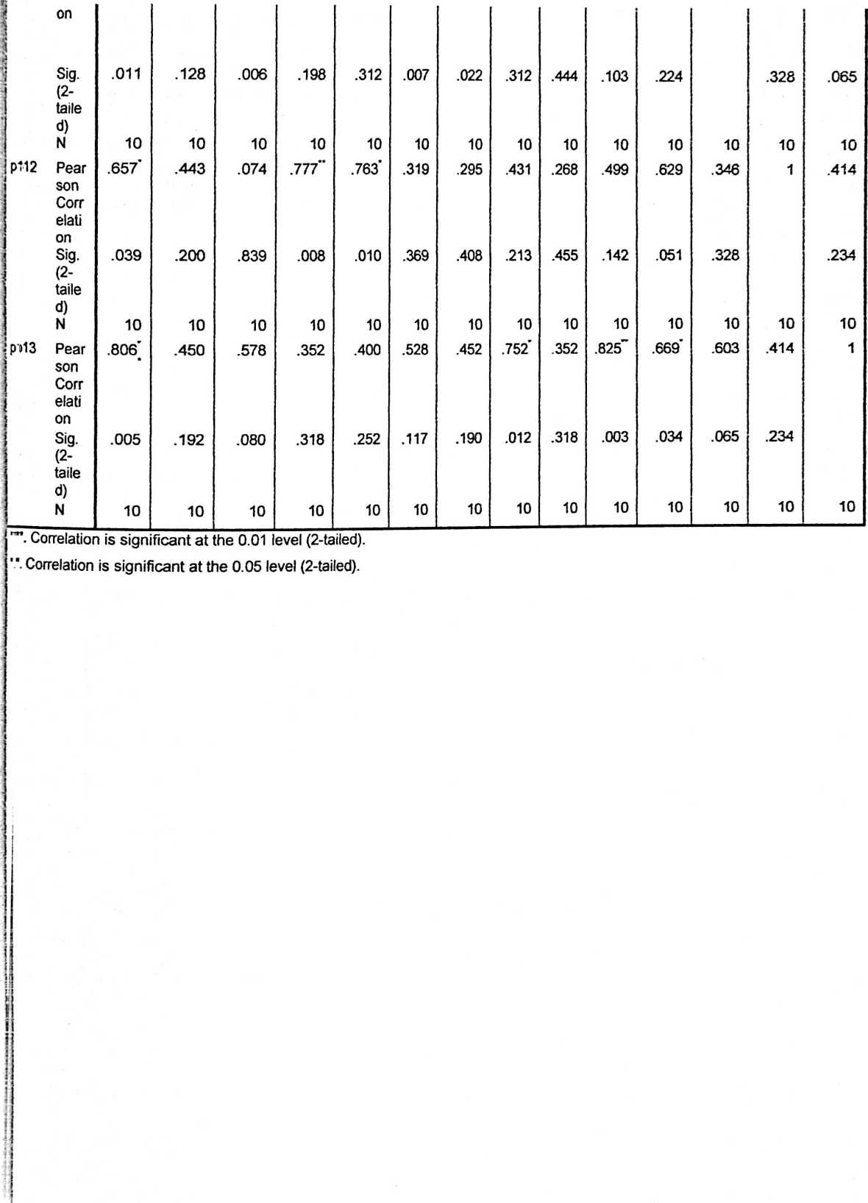

H.

UJI REABILITAS VARIABEL X

**Case Processing Summary**

|  |  |  |
| --- | --- | --- |
|  | N | % |
| Valid | 10 | 100.0 |
| Cases Excluded3 | 0 | .0 |
| Total | 10 | 100.0 |

a. Listwise deletion based on all variables in the procedure.

|  |  |  |
| --- | --- | --- |
| Re | lability Statistics | |
| Cronbach's | Cronbach's | N of Items |
| Alpha | Alpha Based on |  |
|  | Standardized |  |
|  | Items |  |
| .769 | .940 | 14 |

Item Statistics

|  |  |  |  |
| --- | --- | --- | --- |
|  | Mean | Std. Deviation | N |
| total | 55.90 | 6.332 | 10 |
| p1 | 4.40 | .699 | 10 |
| P2 | 4.30 | .675 | 10 |
| P3 | 4.20 | .632 | 10 |
| p4 | 4.20 | .632 | 10 |
| P5 | 4.20 | .632 | 10 |
| P6 | 4.10 | .568 | 10 |
| P7 | 4.50 | .707 | 10 |
| P8 | 4.30 | .675 | 10 |
| p9 | 4.00 | .667 | 10 |
| p10 | 4.40 | .699 | 10 |
| p11 | 4.50 | .707 | 10 |
| P12 | 4.50 | .707 | 10 |
| p13 | 4.30 | .675 | 10 |

.

Uji Reabilitas Variabel Y

**Case Processing Summary**

|  |  |  |
| --- | --- | --- |
|  | N | % |
| Valid | 10 | 100,0 |
| Cases Excluded* | 0 | ,0 |
| Total | 10 | 100,0 |

a. Listwise deletion based on all variables in the procedure.

**Reliability Statistics**

|  |  |  |
| --- | --- | --- |
| Cronbach's Alpha | Cronbach's Alpha Based on Standardized Items | N of Items |
| ,765 | ,940 | 14 |

Item Statistics

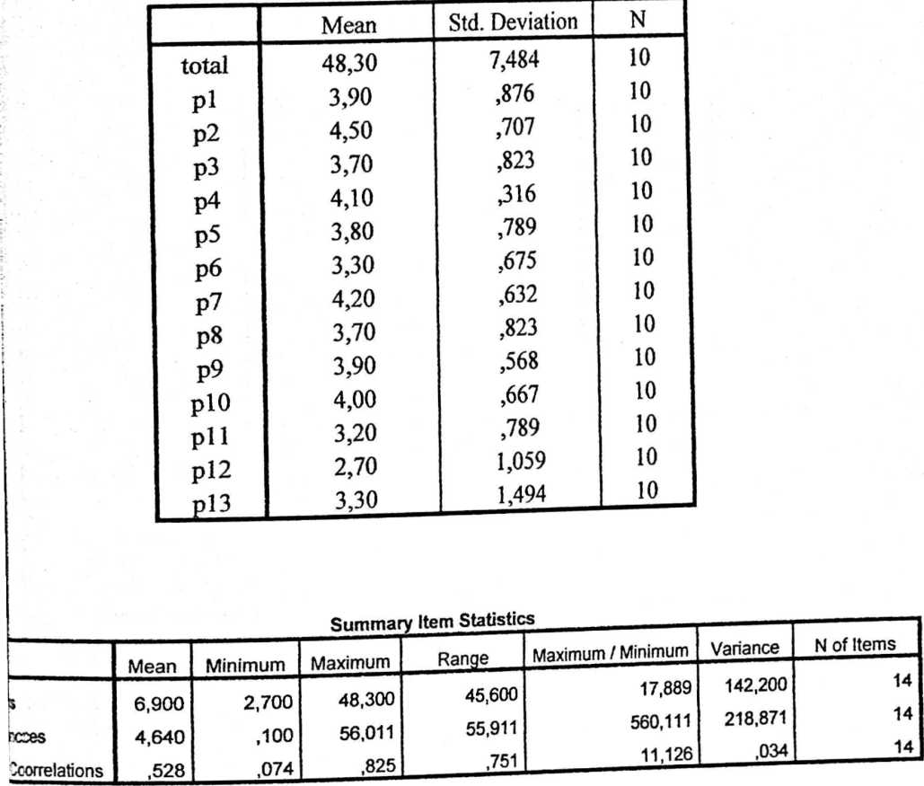

Scale Statistics

|  |  |  |
| --- | --- | --- |
| Variance | Std. Deviation | N of Items |
| 224,044 | 14,968 | 14 |

Uji Deskriptif Variabel X (Kelengkapan Administrasi Guru)

Statistics

**kelengkapan administrasi guru**

|  |  |
| --- | --- |
| Valid | 18 |
| N |  |
| Missing | 0 |
| Mean | 57,78 |
| Median | 59,00 |
| Mode | 59a |
| Std. Deviation | 2,840 |
| Range | 10 |
| Minimum | 51 |
| Maximum | 61 |

a. Multiple modes exist. The smallest value is shown

|  |  |  |  |  |
| --- | --- | --- | --- | --- |
| Keleng | | rkapan At | ministrasi Guru | |
|  | Frequenc  y | Percent | Valid  Percent | Cumulative Percent |
| 51 | l | 5,6 | 5,6 | 5,6 |
| 53 | l | 5,6 | 5,6 | 11,1 |
| 54 | l | 5,6 | 5,6 | 16,7 |
| 56 | 2 | 11,1 | 11,1 | 27,8 |
| 57 | 2 | 11,1 | 11,1 | 38,9 |
| Valid  58 | 1 | 5,6 | 5,6 | 44,4 |
| 59 | 4 | 22,2 | 22,2 | 66,7 |
| 60 | 4 | 22,2 | 22,2 | 88,9 |
| 61 | 2 | 11,1 | 11,1 | 100,0 |
| Total | 18 | 100,0 | 100.0 |  |

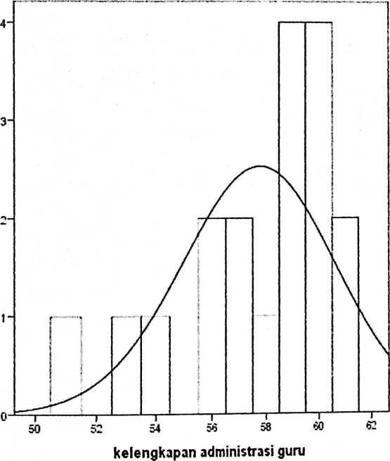

f.ten ° 57.78 SM De v. * 2.84 ll«= 18

Uji Deskriptif Variabel Y (Kualitas Mengajar Guru)

Statistics

**Kualitas Mengajar Guru**

|  |  |
| --- | --- |
| Valid | 18 |
| N |  |
| Missing | 0 |
| Mean | 60,67 |
| Median | 61,00 |
| Mode | 64 |
| Std. Deviation | 2,590 |
| Range | 8 |
| Minimum | 56 |
| Maximum | 64 |

**Kualitas Menga jar Guru**

|  |  |  |  |  |
| --- | --- | --- | --- | --- |
|  | Frequenc  y | Percent | Valid  Percent | Cumulative  Percent |
| 56 | l | 5,6 | 5,6 | 5,6 |
| 57 | l | 5,6 | 5,6 | 11,1 |
| 58 | 3 | 16,7 | 16,7 | 27,8 |
| 59 | 1 | 5,6 | 5,6 | 333 |
| 60 | 2 | 11,1 | 1U | 44,4 |
| Valid  61 | 3 | 16,7 | 16,7 | 61,1 |
| 62 | 2 | 11,1 | 11,1 | 723 |
| 63 | 1 | 5,6 | 5,6 | 77,8 |
| 64 | 4 | 22,2 | 22,2 | 100,0 |
| Total | 18 | 100,0 | 100,0 |  |

Frequency

Mean = 60.67 Sid. Dev. = 2.59 H = 13

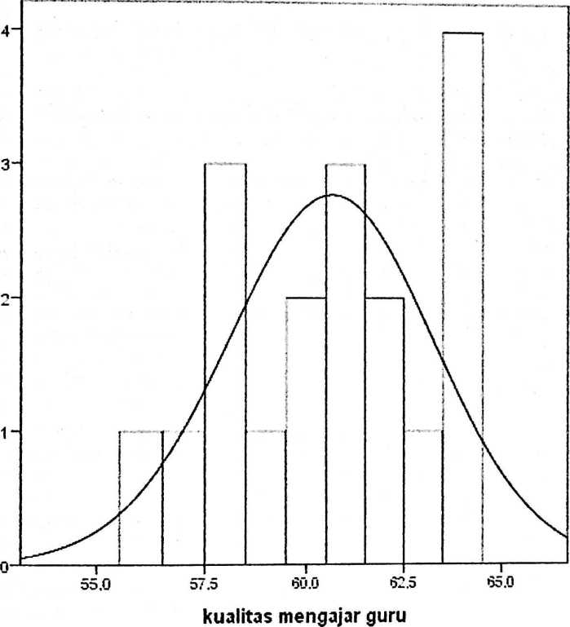

Uji Normalitas Variabel X (Kelengkapan Administrasi Guru)

Case Processing Summary

|  |  |
| --- | --- |
|  | Kelengkapan administrasi guru |
| Series or Sequence Length | 18 |
| User-Missing | 0 |
| Number of Missing Values |  |
| id the Plot Sj,s,em- | 0 |
| Missing |  |

The cases are unweighted.

Estimated Distribution Parameters

|  |  |  |
| --- | --- | --- |
|  |  | kelengkapan administrasi |
|  |  | guru |
| Normal | Location | 57,78 |
| Distribution | Scale | 2,840 |

The cases arc unweighted.

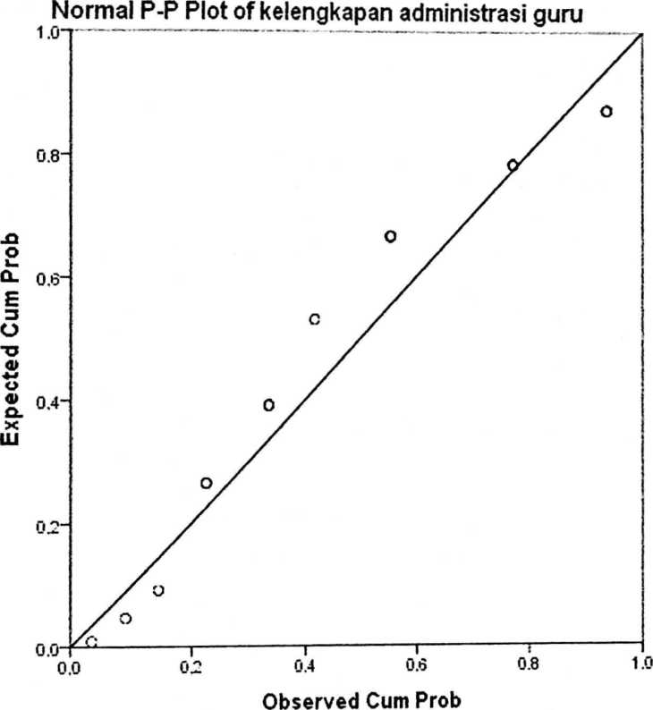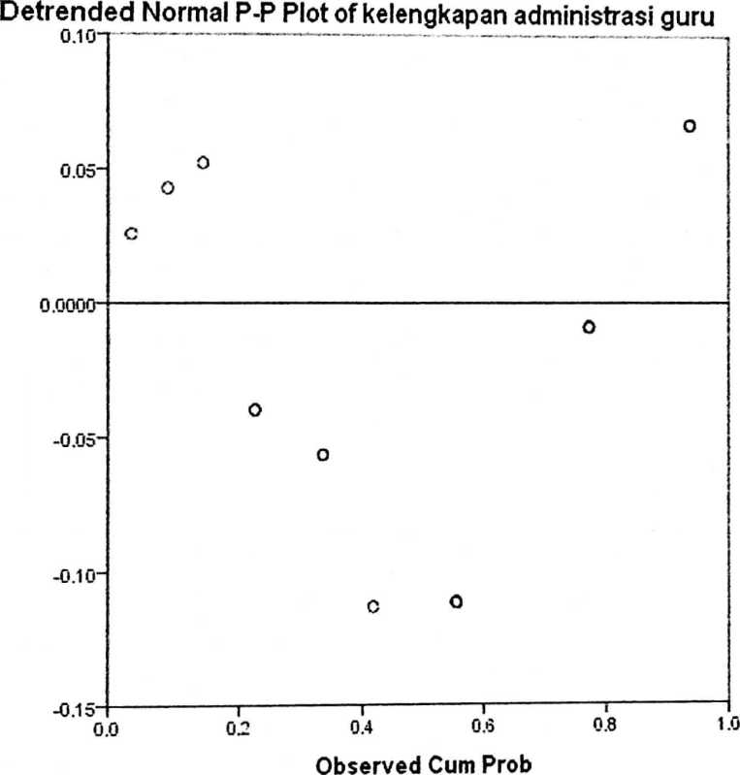

Deviation from Normal

UJI NORMALITAS VARIABEL Y (KUALITAS MENGAJAR GURU)

**Case Processing Summary**

|  |  |
| --- | --- |
|  | kualitas mengajar guru |
| Series or Sequence Length | 18 |
| Number of Missing User-Missing | 0 |
| Values in the Plot System-Missing | 0 |

The cases are unweighted.

Estimated Distribution Parameters

|  |  |
| --- | --- |
|  | kualitas  mengajar  guru |
| Locatio  Normal  n  Distribution  Scale | 60,67  2,590 |

The cases are unweighted.

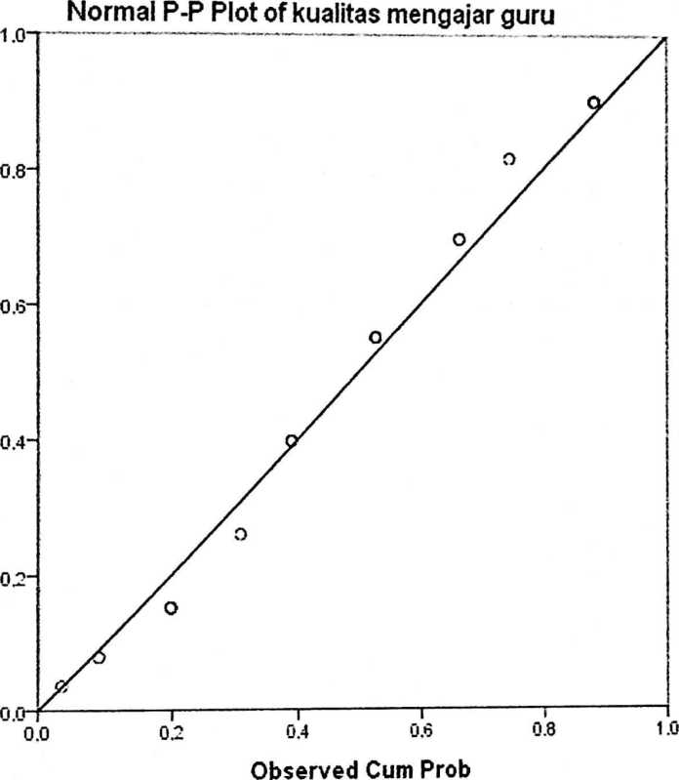

Expected Cum Prob

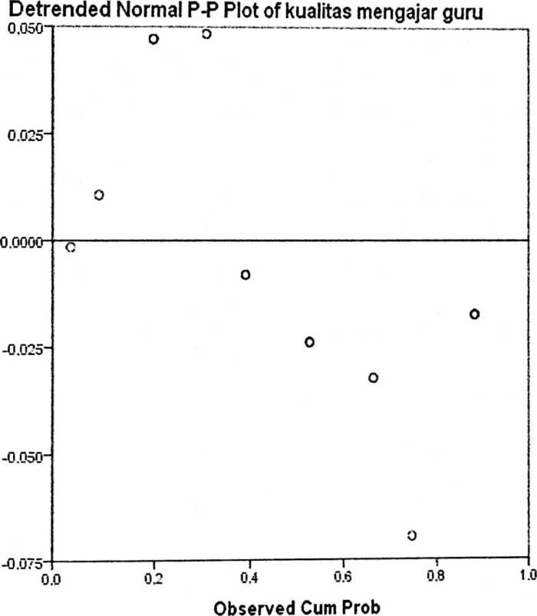

Deviation from Normal

Uji Linear

**Case Processing Summary**

|  |  |  |  |  |  |  |
| --- | --- | --- | --- | --- | --- | --- |
|  | Cases | | | | | |
| Included | | Excluded | | Total | |
| N | Percent | N | Percent | N | Percent |
| kualitas mengajar guru * kelengkapan administrasi guru | 18 | 100,0% | 0 | 0,0% | 18 | 100,0% |

Report

**Kualitas Mengajar Guru**

|  |  |  |  |
| --- | --- | --- | --- |
| Kelengkapan Administrasi Guru | Mean | N | Std. Deviation |
| 51 | 59,00 | 1 | **.** |
| 53 | 64,00 | 1 | • |
| 54 | 64,00 | 1 | • |
| 56 | 61,00 | 2 | 4,243 |
| 57 | 60,00 | 2 | 4,243 |
| 58 | 56,00 | 1 | ■ |
| 59 | 59,25 | 4 | 1,500 |
| 60 | 61,25 | 4 | ,957 |
| 61 | 62,50 | 2 | 2,121 |
| Total | 60,67 | 18 | 2,590 |

ANOVA Table

|  |  |  |  |  |  |  |
| --- | --- | --- | --- | --- | --- | --- |
|  |  | Sum of Squares | df | Mean Square | F | Sig. |
| kualitas mengajar guru * kelengkapan administrasi guru | Between  (Combined)  Groups Within Groups Total | 64.000   1. 114,000 | 8  9  17 | 8,000  5,556 | 1,440 | ,298 |

UJI HIPOTESIS

Variables Entered/Removed*

|  |  |  |  |
| --- | --- | --- | --- |
| Model | Variables  Entered | Variables  Removed | Method |
| 1 | kelengkapan  administrasi  gurub | • | Enter |

1. Dependent Variable: kualitas mengajar guru
2. All requested variables entered.

**Model Summary**

|  |  |  |  |  |
| --- | --- | --- | --- | --- |
| Model | R | R Square | Adjusted R Square | Std. Error of the Estimate |
| 1 | ,067a | ,004 | -,058 | 2,663 |

a. Predictors: (Constant), kelengkapan administrasi guru

ANOVA8

|  |  |  |  |  |  |
| --- | --- | --- | --- | --- | --- |
| Model | Sum of Squares | Df | Mean  Square | F | Sig. |
| Regression | ,506 | 1 | ,506 | ,071 | ,793b |
| 1 Residual | 113,494 | 16 | 7,093 |  |  |
| Total | 114,000 | 17 |  |  |  |

1. Dependent Variable: kualitas mengajar guru
2. Predictors: (Constant), kelengkapan administrasi guru

Coefficients*

|  |  |  |  |  |  |
| --- | --- | --- | --- | --- | --- |
| Model | Unstandardized  Coefficients | | Standardize  d  Coefficients | t | Sig. |
|  | B | Std.Error | Beta |  |  |
| (Constant) | 64,178 | 13,157 |  | 4,878 | ,000 |
| 1 kelengkapan  administrasi guru | -,061 | ,227 | -,067 | -,267 | ,793 |

a. Dependent Variable: kualitas mengajar guru

T-Distribution Table

Lampiran

**t tabel**

|  |  |  |  |  |  |  |  |
| --- | --- | --- | --- | --- | --- | --- | --- |
| df | « = 0.1 | 0.05 | 0.025 | 0.01 | 0.005 | 0.001 | 0.0005 |
| oo | ta=1.282 | 1.645 | 1.960 | 2.326 | 2.576 | 3.09! | 3.291 |
| 1 | 3.078 | 6.314 | 12.706 | 31.821 | 63.656 | 318.289 | 636.578 |
| 2 | 1.886 | 2.920 | 4.303 | 6.965 | 9.925 | 22.328 | 31.600 |
| 3 | 1.638 | 2.353 | 3.182 | 4.541 | 5.841 | 10.214 | 12.924 |
| 4 | 1.533 | 2.132 | 2.776 | 3.747 | 4.604 | 7.173 | 8.610 |
| 5 | 1.476 | 2.015 | 2.571 | 3.365 | 4.032 | 5.894 | 6.869 |
| 6 | 1.440 | 1.943 | 2.447 | 3.143 | 3.707 | 5.208 | 5.959 |
| 7 | 1.415 | 1.895 | 2.365 | 2.998 | 3.499 | 4.785 | 5.408 |
| 8 | 1.397 | 1.860 | 2.306 | 2.896 | 3.355 | 4.50! | 5.041 |
| 9 | 1.383 | 1.833 | 2.262 | 2.821 | 3.250 | 4.297 | 4.781 |
| 10 | 1.372 | 1.812 | 2.228 | 2.764 | 3.169 | 4.144 | 4.5S7 |
| 11 | 1.363 | 1.796 | 2.201 | 2.718 | 3.106 | 4.025 | 4.437 |
| 12 | 1.356 | 1.782 | 2.179 | 2.681 | 3.055 | 3.930 | 4.318 |
| 13 | 1.350 | 1.771 | 2.160 | 2.650 | 3.012 | 3.852 | 4.221 |

|  |  |  |  |
| --- | --- | --- | --- |
| 14 | 1.345 | 1.761 | 2.145 |
| 15 | 1.341 | 1.753 | 2.131 |
| 16 | 1.337 | 1.746 | 2.120 |
| 17 | 1.333 | 1.740 | 2.110 |
| 18 | 1.330 | 1.734 | 2.101 |
| 19 | 1.328 | 1.729 | 2.093 |
| 20 | 1.325 | 1.725 | 2.086 |
| 21 | 1.323 | 1.721 | 2.080 |
| 22 | 1.321 | 1.717 | 2.074 |
| 23 | 1.319 | 1.714 | 2.069 |
| 24 | 1.318 | 1.711 | 2.064 |
| 25 | 1.316 | 1.708 | 2.060 |
| 26 | 1.315 | 1.706 | 2.056 |
| 27 | 1.314 | 1.703 | 2.052 |
| 28 | 1.313 | 1.701 | 2.048 |
| 29 | 1.311 | 1.699 | 2.045 |
| 30 | 1.310 | 1.697 | 2.042 |
| 60 | 1.296 | 1.671 | 2.000 |
| 120 | 1.289 | 1.658 | 1.980 |
| oo | 1.282 | 1.645 | 1.960 |

|  |  |  |  |
| --- | --- | --- | --- |
| 2.624 | 2.977 | 3.787 | 4.140 |
| 2.602 | 2.947 | 3.733 | 4.073 |
| 2.583 | 2.921 | 3.686 | 4.015 |
| 2.567 | 2.898 | 3.646 | 3.965 |
| 2.552 | 2.878 | 3.610 | 3.922 |
| 2.539 | 2.861 | 3.579 | 3.883 |
| 2.528 | 2.845 | 3.552 | 3.850 |
| 2.518 | 2.831 | 3.527 | 3.819 |
| 2.508 | 2.819 | 3.505 | 3.792 |
| 2.500 | 2.807 | 3.485 | 3.768 |
| 2.492 | 2.797 | 3.467 | 3.745 |
| 2.485 | 2.787 | 3.450 | 3.725 |
| 2.479 | 2.779 | 3.435 | 3.707 |
| 2.473 | 2.771 | 3.421 | 3.689 |
| 2.467 | 2.763 | 3.408 | 3.674 |
| 2.462 | 2.756 | 3.396 | 3.660 |
| 2.457 | 2.750 | 3.385 | 3.646 |
| 2.390 | 2.660 | 3.232 | 3.460 |
| 2.358 | 2.617 | 3.160 | J.j ‘5 |
| 2.326 | 2.576 | 3.091 | 3.29! |

<http://www.socr.ucla.edu/Applets.dir/T-tabte.html> (diun&h 22 agj&s 20n)

Sumber:

Statistics Online Computational Resource