Rinus_Teologi_Perbaikan01

**by** Frans Rumbi

Submission date: 01-Sep-2020 08:43AM (UTC-0700)

Submission ID: 1375527667

Fi'lle name: Rinus_Menok_Sara Teologi_Perbaikan01.docx (5.22M)

VWord count: 15023 (Character count: 94805

Rinus_T eologi_Perbaikan01

ORIGINALITY REPORT

i 0% 19% 3%

SIMILARITY INDEX INTERNET SOURCES PUBLICATIONS

PRIMARY SOURCES

**□** murid.co

Internet Source



repository.iainpurwokerto.ac.id

Internet Source



repository.radenintan.ac.id

Internet Source



ppgtjemaatria.biogspot.com

Internet Source

[www.glorianet.org](http://www.glorianet.org)

Internet Source



bidangi .bps-gerejatoraja.org

Internet Source

[www.scribd.com](http://www.scribd.com)

Internet Source

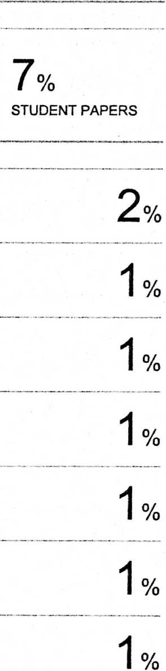

[www.kristenalkitabiah.com](http://www.kristenalkitabiah.com)

Internet Source



eprints.walisongo.ac.id

Internet Source

