KE MENTERI AN AGAMA

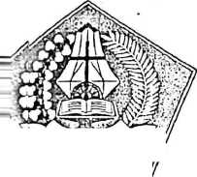

^uniiur

**-ifaat**

-anmpiran

**Eall**

erjasama yang baik, kami ucapkan terima kasih.

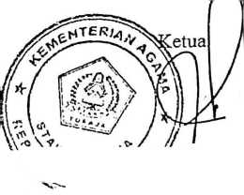

SEKOLAH TINGGI AGAMA KRISTEN NEGERI

(STAKN) TORAJA

JI. Poros Makalc-Makassnr Km. 11,5; Tlp/Fax. (0423) 24620,24064  
Mcngkendek Tana Toraja  
Email : [stakntoraia@vahoo.com](mailto:stakntoraia@vahoo.com)

YAYASAN PERGURUAN KRISTEN TORAJA ( YPKT )

SMA KRISTEN MAXALE



'M». I ANA 1BIIAIA

Alamat: J{. Nusantara No. 16 MakaleKab. TanaToraja  
f'!p./!'MA (0423 >22070 Email : S)-;:.kristenniakal[c22@vahoo.co.id](mailto:c22@vahoo.co.id)

SURAT KETERANGAN

No. : 080/106.! 8/SMA.S.01/YU/20I7

’Yang bertandatangan di bawah ini Kepala SMA Kristen Makale kabupaten Tana Toraja Provinsi ^Sulawesi Selatan,menerangkan bahwa : '•

Steven Tomy Mannti

N a m a STB/ NIRM Jurusan Alamat-

20123529

Pendidikan Agama Kristen Makale

ftcnar telah melakukan Penelitian di SMA Kristen Makale dengan judul “ Pengaruh Isi IPembelajaran PAK Terhadap Kecerdasan Emosional Siswa SMA Kristen Makale pada tianggal 12 s.d. 14 Juni 2017 di SMA Kristen Makale dalam rangka menyelesaikan tugas akhir pperkuliahan di Sekolah Tinggi Agama Kristen Negeri ( STAKN ) Toraja

IDemikian Surat Keleramran ini kami buat untuk dipergunakan seperlunya

Makale, H Juni 2017 i a 1 a,

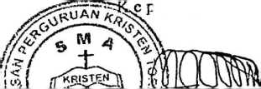

Kala’ Lembang, S.Th. M.Pd.

\ X.. ,^-NljM9690311 200003 1 001

y p*i<

Nnma : Steven Tomy Mauati

Nirm : 20123529

'Judul : Pengaruh Isi Pembelajaran Pendidikan Agama Kristen Terhadap Kecerdasan Emosional Siswa SMA Kristen

Makalc.

|  |  |  |  |  |  |  |  |  |  |
| --- | --- | --- | --- | --- | --- | --- | --- | --- | --- |
| No | Hari/Tanggal | | Materi/IIab  Yang  dikonsultasikan | Catatan/solusi dari Dosen Pembimbing | | Tanggal Setor Perbaikan | | Paraf  Pembimbing | |
| t ■ |  | |  | -t  C | e(\pcL«.  fit'- | 'hl | m | i | r |
| V | <LrV | m | \h • | '1^5 - 16%-Icm A^w  ^ % eh* y | | *( £ | m • |  | i |
| V |  | t  (t*t • | U5'> | ■\  c | ^W(A ^mL/£pu \X>rW^s'  Itorfl** by*  JWfr [$*?[ ■ | *l/ f | Ipf. | * | y |

|  |  |  |  |  |  |
| --- | --- | --- | --- | --- | --- |
| H- |  |  | ' W ^ (W J/V ^ |  | fr |
|  |  | f |  |  |  |
|  |  |  |  |  |  |

Mengkenclek

Dosen Pembimbing

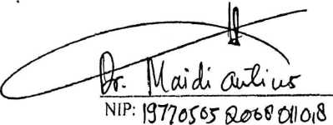

Nnma : Steven Tomy Munati

/

Nirm : 20123529 - ^

Judul : Pengaruh Isi Pembelajaran Pendidikan Agama Kristen Terhadap Kecerdasan Emosional Siswa SMA Kristen

Makalc.

|  |  |  |  |  |  |  |  |  |  |
| --- | --- | --- | --- | --- | --- | --- | --- | --- | --- |
| No | Hari/Yanggal | | MatcrL/Bal) T Yang  dikonsultasikan | Catatan/solusi dari Dosen Pembimbing | Tanggal Setor Perbaikan | | | Paraf  Pembimbing | |
| t • | 3/ | k i m. | Ul$ | - t®U^V)QV,av\ U Aan. | V | ',i | V5\ | 9 | 1  A |
| 2 | 121 | ^ lv |  | *- \cc\a  «. (VW t <^Hur | PT | (r k- | |  | n |
| l- |  |  | U?, |  | 5 | h | ®n | 9 |  |

Etiket

Pengendal ian diri

Tidak memotong

pembicaraan orang lain

Menghargai teman berbeda keyakinan

yang

Menyapa teman jika bertemu

Selalu tampil rapih ketika datang dan pulang sekolah

Memberi salam pada guru atau orang yang lebih tuah jika bertemu

Tidak mementingkan

keinginan diri namun

mengutamakan kepentingan bersama

Tidak mengeluarkan kata- kata kotor kepada orang lain

Memiliki semangat tinggi dalam belajar

yang

Mampu menahan diri untuk tidak memiliki barang- barang canggih di luar kemampuan ekonomi

Tidak memaksakan

kehendak pada orang tua

Berpikir sebelum bertindak

Tidak menganggap diri paling benar

**Variabel**

**Y**

**(kecerda**

**san**

**emosion**

**al)**

Mengenali emosi diri/ kesadaran diri

Mau menerima kritikan teman untuk menjadi lebih baik

Tepat dalam mengambil keputusan untuk kebaikan bersama

Tidak memaksakan

pendapat sendiri untuk dituruti oleh teman-teman kelas.

Selalu memberikan

kemampuan yang terbaik untuk kepentingan bersama

Tidak menyalahkan orang lain jika dihukum karena pelanggaran

|  |  |  |  |  |  |  |  |
| --- | --- | --- | --- | --- | --- | --- | --- |
|  | Mengelola  emosi/  pengatura | Membiasakan diri untul bangun lebih cepat aga tidak terlambat ke sekolah | k I  r |  |  |  |  |
|  | n diri | Menjaga hubungai pertemanan yang bail dengan teman | i |  |  |  |  |
|  |  | Aktif dalam diskusi-diskus pelajaran dalam kelas |  |  |  |  |  |
|  |  | Memberi pinjaman kepada teman yang sangat membutuhkan. | | |  |  |  |  |
|  |  | Selalu meminta maaf terlebih dahulu jika memiliki masalah dengan teman-teman kelas |  |  |  |  |  |
|  | Motivasi | Tidak menyontek ketika ujian |  |  |  |  |  |
|  | diri sendiri | Tidak malu bertanya pada guru jika tidak mengerti |  |  |  |  |  |
|  |  | Memiliki pengharapan yang kuat untuk memperoleh nilai yang baik ketika ujian |  |  |  |  |  |
|  |  | Tidak merasa puas dengan apa yang telah dicapai tetapi terus berusaha untuk lebih baik lag. |  |  |  |  |  |
|  |  | Rela meluangkan waktu untuk membantu teman yang membutuhkan |  |  |  |  |  |
|  | Mengenali | Mau mendengarkan j pendapat teman. |  |  |  |  |  |
|  | emosi orang lain/ empati | Menjaga perasaan orang 1 lain dengan tidak menjelek- jelekkan. |  |  |  |  |  |
|  |  | Selalu siap dan ada ketika I teman-teman membutuhkan |  |  |  |  |  |
|  |  | Aktif dalam kegiatan- kegiatan sosoial di sekolah |  |  |  |  |  |
|  |  | Dapat membantu mencari 1 solusi terbaik terhadap permasalahan yang dihadapi orang lain |  |  |  |  |  |
|  | Membina bubungan t | Selalu berusaha membuat 1 eman merasa nyaman |  |  |  |  |  |

|  |  |  |  |  |  |  |  |  |
| --- | --- | --- | --- | --- | --- | --- | --- | --- |
|  | sosial | Menjadi pemimpin atau ketua kelompok yang didengarkan oleh tema- temannya |  |  |  |  |  |  |
| Membangun hubungan pertemanan yang baik |  |  |  |  |  |  |
| Dekat dengan semua orang |  |  |  |  |  |  |
| Tegas dan mampu meyesuaikan keadaan dengan suasana hati teman kelas. |  |  |  |  |  |  |

Mengkendek, Juni 2017

Dosen Ahli

|  |  |  |  |  |  |
| --- | --- | --- | --- | --- | --- |
| NO | VAL. 1 | VAL. 2 | VAL. 3 | RATA2 | KET |
| 1 | 4 | 5 | 5 | 4.666666667 | SRJ |
| 2 | 4 | 5 | 5 | 4.666666667 | SRJ |
| 3 | 4 | 5 | 5 | 4.666666667 | SRJ |
| 4 | 4 | 5 | 5 | 4.666666667 | SRJ |
| 5 | 5 | 4 | 4 | 4.333333333 | SRJ |
| 6 | 4 | 5 | 5 | 4.666666667 | SRJ |
| 7 | 4 | 4 | 4 | 4 | SRJ |
| 8 | 4 | 3 | 4 | 3.666666667 | RJ |
| 9 | 4 | 4 | 3 | 3.666666667 | RJ |
| 10 | 4 | 5 | 4 | 4.333333333 | SRJ |
| 11 | 5 | 5 | 5 | 5 | SRSJ |
| 12 | 4 | 5 | 4 | 4.333333333 | SRJ |
| 13 | 4 | 3 | 3 | 3.333333333 | RJ |
| 14 | 4 | 5 | 5 | 4.666666667 | SRJ |
| 15 | 5 | 5 | 5 | 5 | SRSJ |
| 16 | 4 | 4 | 3 | 3.666666667 | RJ |
| 17 | 4 | 5 | 5 | 4.666666667 | SRJ |
| 18 | 4 | 3 | 3 | 3.333333333 | RJ |
| 19 | 4 | 4 | 4 | 4 | SRJ |
| 20 | 4 | 5 | 5 | 4.666666667 | SRJ |
| 21 | 4 | 4 | 3 | 3.666666667 | RJ |
| 22 | 5 | 5 | 5 | 5 | SRSJ |
| 23 | 4 | 3 | 3 | 3.333333333 | RJ |
| 24 | 4 | 1 | 2 | 2.333333333 | RTJ |
| 25 | 4 | 3 | 2 | 3 | RJ |
| 26 | 5 | 5 | 5 | 5 | SRSJ |
| 27 | 4 | 5 | 5 | 4.666666667 | SRJ |
| 28 | 4 | 3 | 2 | 3 | RJ |
| 29 | 4 | 5 | 4 | 4.333333333 | SRJ |
| 30 | 5 | 5 | 5 | 5 | SRSJ |
| 31 | 4 | 5 | 5 | 4.666666667 | SRJ |
| 32 | 4 | 5 | 5 | 4.666666667 | SRJ |
| 33 | 4 | 5 | 5 | 4.666666667 | SRJ |
| 34 | 4 | 5 | 5 | 4.666666667 | SRJ |
| 35 | 4 | 5 | 5 | 4.666666667 | SRJ |
| 36 | 4 | 5 | 5 | 4.666666667 | SRJ |
| 37 | 4 | 5 | 5 | 4.666666667 | SRJ |

|  |  |  |  |  |  |
| --- | --- | --- | --- | --- | --- |
| 38 | 5 | 5 | 3 | 4.333333333 | SRJ |
| 39 | 4 | 4 | 4 | 4 | SRJ |
| 40 | 4 | 5 | 5 | 4.666666667 | SRJ |
| 41 | 4 | 5 | 5 | 4.666666667 | SRJ |
| 42 | 4 | 5 | 5 | 4.666666667 | SRJ |
| 43 | 5 | 5 | 5 | 5 | SRSJ |
| 44 | 4 | 5 | 3 | 4 | SRJ |
| 45 | 4 | 5 | 5 | 4.666666667 | SRJ |
| 46 | 5 | 5 | 5 | 5 | SRSJ |
| 47 | 4 | 5 | 5 | 4.666666667 | SRJ |
| 48 | 4 | 5 | 5 | 4.666666667 | SRJ |
| 49 | 5 | 5 | 4 | 4.666666667 | SRJ |
| 50 | 4 | 5 | 5 | 4.666666667 | SRJ |

PENGARUH ISI PEMBELAJARAN PENDIDIKAN AGAMA KRISTEN TERHAD AP  
KECERDASAN EMOSIONAL SISWA SMA KRISTEN MAKALE

PETUNJUK PENGISIAN:

1. Bacalah dengan baik dan cermat pertanyaan/ pernyataan di bawah ini.
2. Jawablah semua pertanyaan/ pernyataan dengan jujur dan objektif.
3. Beri salah satu tanda (V) pada setiap kolom yang dirasa sesuai dan tepat.

SL :SELALU

SR : SERING KK : KADANG-KADANG JR : JARANG TP : TIDAK PERNAH

1. Pastikan tidak ada kolom yang kosong.
2. Peneliti sangat berterima kasih atas bantuan yang saudara/saudari berikan.

Data Responden:

L Nama :

1. Keias :

|  |  |  |  |  |  |  |
| --- | --- | --- | --- | --- | --- | --- |
| No | PERNYATAAN | SL | SR | KK |  | TP |
| 1 | Tulus membahu teman yang kesusahan |  |  |  |  |  |
| 2 | Rela berkorban demi kebaikan bersama |  |  |  |  |  |
| 3 | Tidak membeda-bedakan teman |  |  |  |  |  |
| 4 | Menerima dan menghargai pendapat orang lain |  |  |  |  |  |
| 5 | Tidak memotong pembicaraan orang lain |  |  |  |  |  |
| 6 | Menghargai teman yang berbeda keyakinan |  |  | i  j | |  |
| 7 | Menyapa teman jika bertemu |  |  | i  1 | |  |
| 8 | Selalu tampil rapih ketika datang dan pulang sekolah |  |  | I  1 | |  |
| 9 | Memberi salam pada guru atau orang yang lebih tuah jika bertemu |  |  | 1 | |  |
| 10 | Tidak mementingkan keinginan diri namun mengutamakan kepentingan bersama |  |  | I  1 | |  |
| 11 | Tidak mengeluarkan kata-kata kotor kepada orang lain |  |  | i  1  i | |  |
| 12 | Memiliki semangat yang tinggi dalam belajar |  |  | i  i | |  |

|  |  |  |  |  |  |  |
| --- | --- | --- | --- | --- | --- | --- |
| 13 | Mampu menahan diri untuk tidak memiliki barang- barang canggih di luar kemampuan ekonomi |  |  |  |  |  |
| 14 | Tidak memaksakan kehendak pada orang tua |  |  |  |  |  |
| 15 | Berpikir sebelum bertindak |  |  |  |  |  |
| 16 | Tidak menganggap diri paling benar |  |  | i  t  1 | |  |
| 17 | Mau menerima kritikan teman untuk menjadi lebih baik |  |  |  | 1  ; |  |
| 18 | Tidak memaksakan pendapat sendiri untuk dituruti oleh teman-teman kelas. |  |  |  |  |  |
| 19 | Tidak menyalahkan orang lain jika dihukum karena pelanggaran |  |  |  | 1 |  |
| 20 | Menjaga hubungan pertemanan yang baik dengan teman |  |  |  | 1 |  |
| 21 | Memberi pinjaman kepada teman yang sangat membutuhkan. |  |  |  |  |  |
| 22 | Selalu meminta maaf terlebih dahulu jika memiliki masalah dengan teman-teman kelas |  |  |  |  |  |
| 23 | Tidak malu bertanya pada guru jika tidak mengerti |  |  |  |  |  |
| 24 | Memiliki pengharapan yang kuat untuk memperoleh nilai yang baik ketika ujian i |  |  |  |  |  |
| 25 | Mau mendengarkan pendapat teman. |  |  |  |  |  |
| 26 | Dapat membantu mencari solusi terbaik terhadap permasalahan yang dihadapi orang lain |  |  |  |  |  |
| 27 | Selalu berusaha membuat teman merasa nyaman |  |  |  |  |  |
| 28 | Menjadi pemimpin atau ketua kelompok yang didengarkan oleh tema-temannya |  |  |  |  |  |
| 29 | Tegas dan mampu meyesuaikan keadaan dengan suasana hati teman kelas. |  |  |  |  |  |

PENGARUH ISI PEMBELAJARAN PENDIDIKAN AGAMA KRISTEN TERHADAP  
KECERDASAN EMOSIONAL SISWA SMA KRISTEN MAKALE

PETUNJUK PENGISIAN:

1. Bacalah dengan baik dan cermat pertanyaan/ pernyataan di bawah ini.
2. Jawablah semua pertanyaan/ pernyataan dengan jujur dan objektif.
3. Beri salah satu tanda (V) pada setiap kolom yang dirasa sesuai dan tepat.

SL :SELALU

SR : SERING KK : KADANG-KADANG JR : JARANG TP : TIDAK PERNAH

1. Pastikan tidak ada kolom yang kosong.
2. Peneliti sangat berterima kasih atas bantuan yang saudara/saudan berikan.

Data Responden:

1. Nama :
2. Kelas :

|  |  |  |  |  |  |  |
| --- | --- | --- | --- | --- | --- | --- |
| No | PERNYATAAN | SL | SR | KK | ! JR | TP |
| 1 | Tulus membantu teman yang kesusahan |  |  |  | j  1 |  |
| 2 | Rela berkorban demi kebaikan bersama |  |  |  |  |  |
| 3 | Tidak membeda-bedakan teman |  |  |  | — |  |
| 4 | Menerima dan menghargai pendapat orang lain |  |  |  |  |  |
| 5 | Tidak memotong pembicaraan orang lain |  |  |  |  |  |
| 6 | Menghargai teman yang berbeda keyakinan |  |  |  |  |  |
| 7 | Menyapa teman jika bertemu |  |  |  |  |  |
| 8 | Selalu tampil rapih ketika datang dan pulang sekolah |  |  |  |  |  |
| 9 | Memberi salam pada guru atau orang yang lebih tuah jika bertemu |  |  | I  1  1 |  |  |
| 10 | Tidak mementingkan keinginan diri namun mengutamakan kepentingan bersama |  |  |  |  |  |
| 11 | Tidak mengeluarkan kata-kata kotor kepada orang lain |  |  | i  I |  |  |
| 12 | Memiliki semangat yang tinggi dalam belajar |  |  | j | |  |

|  |  |  |  |  |  |  |
| --- | --- | --- | --- | --- | --- | --- |
| 13 | Mampu menahan diri untuk tidak memiliki barang- barang canggih di luar kemampuan ekonomi |  |  |  | I |  |
| 14 | Tidak memaksakan kehendak pada orang tua |  |  |  | 1 |  |
| 15 | Berpikir sebelum bertindak |  |  |  | 1 |  |
| 16 | Tidak menganggap diri paling benar |  |  |  | j  | |  |
| 17 | Mau menerima kritikan teman untuk menjadi lebih baik |  |  | j  i  j | |  |
| 18 | Tidak memaksakan pendapat sendiri untuk dituruti oleh teman-teman kelas. |  |  | i  I  |  ! | |  |
| 19 | Tidak menyalahkan orang lain jika dihukum karena pelanggaran |  |  |  | j  I |  |
| 20 | Menjaga hubungan pertemanan yang baik dengan teman |  |  |  | J |  |
| 21 | Memberi pinjaman kepada teman yang sangat membutuhkan. |  |  |  |  |  |
| 22 | Selalu meminta maaf terlebih dahulu jika memiliki masalah dengan teman-teman kelas |  |  |  |  |  |
| 23 | Tidak malu bertanya pada guru jika tidak mengerti |  |  |  |  |  |
| 24 | Memiliki pengharapan yang kuat untuk memperoleh nilai yang baik ketika ujian |  |  |  |  |  |
| 25 | Mau mendengarkan pendapat teman. |  |  |  |  |  |
| 26 | Dapat membantu mencari solusi terbaik terhadap permasalahan yang dihadapi orang lain |  |  |  |  |  |
| 27 | Selalu berusaha membuat teman merasa nyaman |  |  |  |  |  |
| 28 | Menjadi pemimpin atau ketua kelompok yang didengarkan oleh tema-temannya |  |  | i |  |  |
| 29 | Tegas dan mampu meyesuaikan keadaan dengan suasana hati teman kelas. |  |  | 1 |  |  |

Reliability VARIABEL X Scale: ALL VARIABLES

**Case Processing Summary**

|  |  |  |
| --- | --- | --- |
|  | N | % |
| Cases Valid | 30 | 100.0 |
| Excluded3 | 0 | .0 |
| Total | 30 | 100.0 |

a. Listwise deletion based on all variables in the procedure.

Reliability Statistics

|  |  |
| --- | --- |
| Cronbach's  Alpha | N of Items |
| .809 | 16 |

Reliability VARIABEL Y Scale: ALL VARIABLES

Case Processing Summary

|  |  |  |
| --- | --- | --- |
|  | N | % |
| Cases Valid | 30 | 100.0 |
| Excluded3 | 0 | .0 |
| Total | 30 | 100.0 |

a. Listwise deletion based on all variables in the procedure.

Reliability Statistics

|  |  |
| --- | --- |
| Cronbach's  Alpha | N of Items |
| .798 | 13 |

TABULASI SAMPEL VARIABEL X

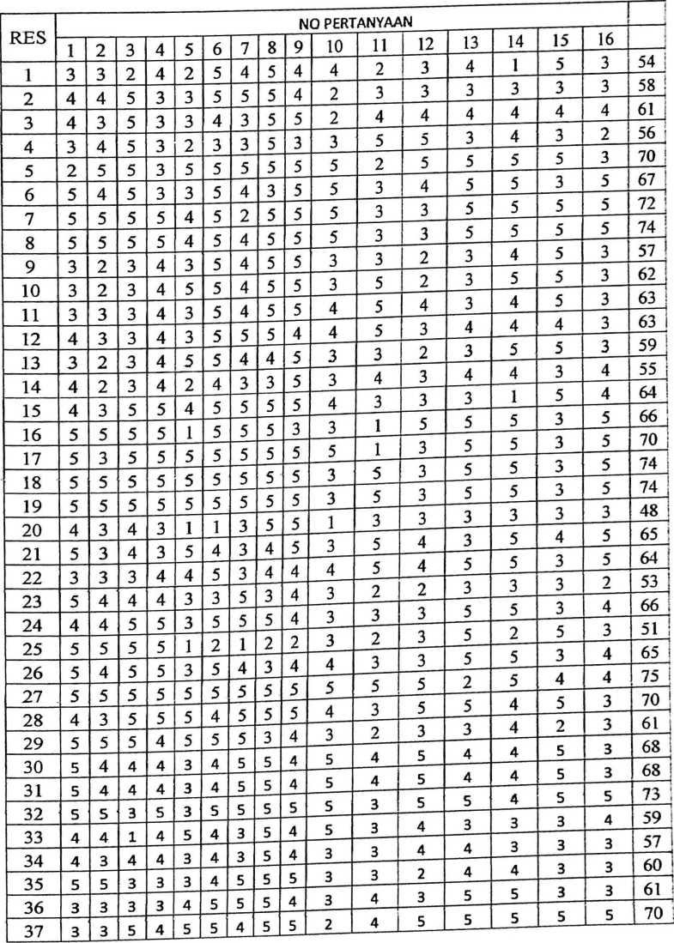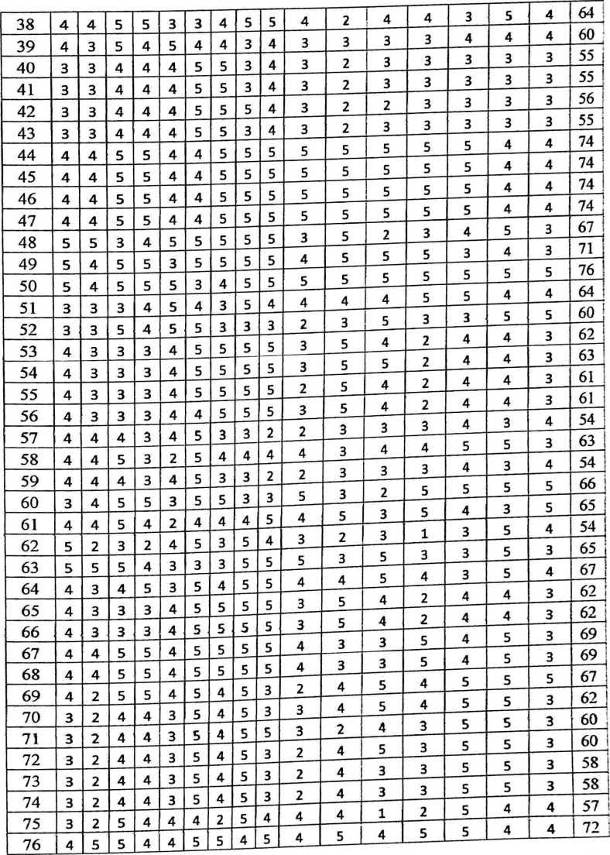

|  |  |  |  |  |  |  |  |  |  |  |  |  |  |  |  |  |  |
| --- | --- | --- | --- | --- | --- | --- | --- | --- | --- | --- | --- | --- | --- | --- | --- | --- | --- |
| 77 | S | S | 4 | 4 | 5 | 4 | 4 | 5 | 4 | 4 | 4 | 5 | 4 | 3 | 3 | 5 | 68 |
| 78 | S | s | 3 | 4 | 3 | 4 | 4 | 5 | 4 | 4 | 4 | 5 | 4 | 3 | 3 | 5 | 69 |
| 79 | 3 | 7 | 3 | 4 | 3 | .3 | 4 | 5 | 3 | 3 | 5 | 3 | 3 | 4 | 3 | 3 | 58 : |
| 80 | 3 | 3 | 3 | 4 | 3 | 3 | 4 | 5 | 3 | 3 | 5 | 5 | 4 | 5 | 5 | 3 | 65 ! |
| 81 | 4 | 3 | 3 | 3 | 3 | 3 | 4 | 5 | 4 | 4 | 3 | 5 | 5 | 5 | 5 | 4 | 69 ; |
| 82 | 3 | 4 | 3 | 3 | 3 | 3 | 4 | 5 | 5 | 4 | 2 | 4 | 4 | 3 | 2 | 3 | 61 1 |
| 83 | 4 | 3 | 3 | 3 | 7 | 3 | 5 | 5 | 3 | 2 | 2 | 3 | 3 | 3 | 4 | 3 | 55 ! |
| 84 | 4 | 4 | 3 | 3 | 4 | 3 | 3 | 5 | 3 | 2 | 2 | 3 | 3 | 3 | 4 | 3 | 58 ! |
| 85 | 3 | 3 | ? | 4 | 3 | 3 | 4 | 5 | 5 | 3 | 2 | 4 | 5 | 1 | 4 | 5 | 58 I |
| 86 | 4 | 4 | 3 | 3 | 3 | 3 | 4 | 5 | 5 | 3 | 5 | 5 | 5 | 1 | 4 | 5 | 64 j |
| 87 | 3 | 3 | 7 | 3 | ? | 3 | 4 | 5 | 5 | 3 | 5 | 5 | 5 | 1 | 5 | 5 | 61_J |
| 88 | 5 | 5 | 3 | 3 | 3 | 4 | 3 | 3 | 4 | 3 | 4 | 4 | 3 | 3 | 3 | 4 | 65 ! |
| 89 | 4 | 3 | 1 | 3 | 3 | 3 | 3 | 3 | 5 | 5 | S | 4 | 3 | 5 | 5 | 5 | 66 j |
| 90 | 4 | 3 | 3 | 4 | 3 | 3 | 3 | 4 | 4 | 3 | 3 | 4 | 3 | 3 | 3 | 4 | 34 : |
| 91 | 4 | 3 | 2 | 3 | 4 | 3 | 3 | 3 | 4 | 3 | 3 | 4 | 4 | 2 | 5 | 3 | 61 j  ! |
| 92 | 4 | 3 | ? | 4 | ? | 4 | 5 | 5 | 4 | 3 | 2 | 3 | 4 | 1 | 5 | 3 | 54 i |
| 93 |  | 4 | 3 | 3 | 3 | 3 | 3 | 3 | 4 | 3 | 3 | 3 | 5 | 3 | 5 | 3 | 58 |
| 94 | 4 | 3 | 4 | 4 | 3 | 4 | 3 | 5 | 5 | 3 | 2 | 5 | 4 | 2 | 5 | 2 | 62 !  1 |
| 95 | a | A | 3 | 5 | 4 | 3 | 3 | 3 | .3 | 3 | 4 | 2 | 4 | 4 | 2 | 3 | 59 ! |
| 96 | 3 | 3 | 3 | 3 | 3 | 3 | 4 | 3 | 5 | 4 | 3 | 4 | 5 | S | 5 | 5 | 69  ! |
| 97 | q | q | 5 | 5 | 3 | 3 | 3 | 3 | 4 | 5 | 5 | 4 | 5 | 5 | 5 | 5 | 74 ; |
| 98 | S | 4 | 3 | ? | 3 | 4 | 4 | 3 | 4 | 3 | 2 | 4 | 5 | 5 | 5 | 4 | 62 ! |
| 99 | 4 | 4 | 5 | 3 | 3 | 3 | 4 | 3 | 5 | 4 | 5 | 4 | 4 | 5 | S | 5 | 70 i |
| 1 Of) | q | q | q | q | 3 | 3 | 3 | 3 | 3 | 3 | 5 | 3 | 3 | 3 | 5 | 5 | 66 i |
| 101 | C | a | q | 5 | 3 | 3 | 3 | 3 | 3 | 3 | 5 | 3 | 3 | 5 | 5 | 5 | 66 |
| 1 0? | q | q | q | 5 | 3 | 3 | 3 | 3 | 3 | 3 | 5 | 3 | 3 | 3 | 5 | 5 | 66 , |
| 103 | 4 | 4 | 3 | 3 | 3 | 3 | 3 | 3 | 4 | 3 | 3 | 5 | 3 | 2 | 3 | 2 | 35 i |
| 1 04 |  | 3 | 3 | 4 | 4 | 5 | 3 | 4 | 4 | 4 | 5 | 4 | 5 | 5 | 3 | 5 | 64 i |
| 1 OS |  | 4 | 4 | 4 | 3 | 3 | 5 | 3 | 4 | 3 | 2 | 2 | 3 | 3 | 3 | 2 | 33 ; |
| L l/J 106 | 4 | 4 | 3 | 3 | 3 | 5 | 5 | 5 | 4 | 3 | 3 | 3 | 5 | 5 | 3 | 4 | 66 |
| 1 07 |  |  | 5 | 3 | 1 | ? | 1 | 2 | 2 | 3 | 2 | 3 | 5 | 2 | 5 | 3 | 51 j |
| 108 | 5 | 4 | 3 | 5 | 3 | 5 | 4 | 3 | 4 | 4 | 3 | 3 | 5 | 5 | 3 | 4 | 65 ; |
| 109 | 3 | 5 | 3 | 3 | 5 | 5 | 5 | 5 | 5 | 5 | 5 | 5 | 2 | 5 | 4 | 4 | 75 j |
| 1 10 | 4 | 3 | 5 | 3 | 3 | 4 | 5 | 5 | 5 | 4 | 3 | 5 | 5 | 4 | 3 | 3 | /0 ; |
| 1 1 1 | q | 3 | 3 | 4 | 3 | 5 | 5 | 3 | 4 | 3 | 2 | 3 | 3 | 4 | 2 | 3 | 61 i |
| 111 11 9 | q | 4 | 4 | 4 | 3 | 4 | 3 | 3 | 4 | 5 | 4 | 5 | 4 | 4 | 5 | 3 | 68 ; |
| 1 13 | q | 4 | 4 | 4 | 3 | 4 | 3 | 3 | 4 | 5 | 4 | 5 | 4 | 4 | 5 | 3 | 68 | |
| 1 14 | q | 5 | 3 | 3 | 3 | 3 | 3 | 5 | 5 | 5 | 3 | 5 | 5 | 4 | 5 | 5 | /3 |
| 115 | 4 | 4 | 1 | 4 | 5 | 4 | 3 | 5 | 4 | 5 | 3 | 4 | 3 | 3 | 3 | 4 | 39 |

|  |  |  |  |  |  |  |  |  |  |  |  |  |  |  |  |  |  |
| --- | --- | --- | --- | --- | --- | --- | --- | --- | --- | --- | --- | --- | --- | --- | --- | --- | --- |
| 116 | 4 | 3 | 4 | 4 | 3 | 4 | 3 | 5 | 4 | 3 | T"i | T- | 4 | 3 | 3 | 3 | 57 j |
| 117 | 5 | 5 | 3 | 3 | 3 | 4 | 5 | 5 | 5 | 3 | 3 | 2 | 4 | 4 | 3 | 3 | 60 |
| 118 | 3 | 3 | 3 | 3 | 4 | 5 | 5 | 5 | 4 | 3 | 4 | 3 | 5 | 5 | 3 | 3 | 61 j |
| 119 | 3 | 3 | 5 | 4 | 5 | 5 | 4 | 5 | 5 | 2 | 4 | 5 | 5 | 5 | 5 | 5 | 70 j |
| 120 | 4 | 4 | 5 | 5 | 3 | 3 | 4 | 5 | 5 | 4 | 2 | 4 | 4 | 3 | 5 | 4 | 64 |
| 121 | 4 | 3 | 5 | 4 | 5 | 4 | 4 | 3 | 4 | 3 | 3 | 3 | 3 | 4 | 4 | 4 | 60 |
| 122 | 3 | 3 | 4 | 4 | 4 | 5 | 5 | 3 | 4 | 3 | 2 | 3 | 3 | 3 | 3 | 3 | 55 ! |
| 123 | 3 | 3 | 4 | 4 | 4 | 5 | 5 | 3 | 4 | 3 | 2 | 3 | 3 | 3 | 3 | 3 | ■iL| |
| 124 | 3 | 3 | 4 | 4 | 4 | 5 | 5 | 5 | 4 | 3 | 2 | 2 | 3 | 3 | 3 | 3 | 56 i |
| 125 | 3 | 3 | 4 | 4 | 4 | S | 5 | 3 | 4 | 3 | 2 | 3 | 3 | 3 | 3 | 3 | 55 i |
| 126 | 4 | 4 | 5 | S | 4 | 4 | 5 | 5 | 5 | 5 | 5 | 5 | 5 | 5 | 4 | 4 | 74 1 |
| 127 | 4 | 4 | S | S | 4 | 4 | 5 | 5 | 5 | 5 | 5 | 5 | 5 | 5 | 4 | 4 | 74 i  ' t |
| 128 | 4 | 4 | 5 | 5 | 4 | 4 | 5 | 5 | 5 | 5 | 5 | 5 | 5 | 5 | 4 | 4 | 74 j |
| 129 | 4 | 4 | 5 | 5 | 4 | 4 | 5 | 5 | 5 | 5 | 5 | 5 | 5 | 5 | 4 | 4 | 74 i |
| 130 | S | 5 | 3 | 4 | 5 | 5 | 5 | 5 | 5 | 3 | 5 | 2 | 3 | 4 | 5 | 3 | JiL\ |
| 131 | 5 | 4 | 5 | 5 | 3 | 5 | 5 | 5 | 5 | 4 | 5 | 5 | 5 | 3 | 4 | 3 | 71 S  — l |
| 132 | S | /1 | s | S | S | 3 | 4 | 5 | 5 | 5 | 5 | 5 | 5 | 5 | 5 | 5 | 76 |
| 133 | 4 | 3 | 5 | 3 | 3 | 4 | 3 | 5 | 5 | 2 | 4 | 4 | 4 | 4 | 4 | 4 | 61 I |
| 134 | 3 | 4 | 5 | 3 | 7 | 3 | 3 | 5 | 3 | 3 | 5 | 5 | 3 | 4 | 3 | 2 | O  ‘•n |
| 135 | 7 | 5 | 5 | 3 | 5 | 5 | 5 | 5 | 5 | 5 | 2 | 5 | 5 | 5 | 5 | 3 |  |
| 136 | 5 | 4 | 5 | 3 | 3 | 5 | 4 | 3 | 5 | 5 | 3 | 4 | 5 | 5 | 3 | 5 | 67 |
| 137 | 5 | 5 | 5 | 5 | 4 | 5 | 2 | 5 | 5 | 5 | 3 | 3 | 5 | 5 | 5 | 5 | 72 I  “TT"! |
| 138 | 'S | 'S | 5 | 'S | 4 | 5 | 4 | 5 | 5 | 5 | 3 | 3 | 5 | 5 | 5 | 5 | 74 ! |
| 139 | 3 | ? | 3 | 4 | 3 | 5 | 4 | 5 | 5 | 3 | 3 | 2 | 3 | 4 | 5 | 3 | 57 | |
| 140 | 3 | 7 | 3 | 4 | 5 | 5 | 4 | 5 | 5 | 3 | 5 | 2 | 3 | 5 | 5 | 3 | 62 j |
| 141 | 3 | 3 | 3 | 4 | 3 | 5 | 4 | 5 | 5 | 4 | 5 | 4 | 3 | 4 | 5 | 3 | -fl |
| 142 | 4 | 3 | 3 | 4 | 3 | 5 | 5 | 5 | 4 | 4 | 5 | 3 | 4 | 4 | 4 | 3 | 63 i  1 |
| 143 | 3 | 7 | 3 | 4 | 5 | 5 | 4 | 4 | 5 | 3 | 3 | 2 | 3 | 5 | 5 | 3 | 59 I |
| 144 | 4 | 7 | 3 | 4 | 2 | 4 | 3 | 3 | 5 | 3 | 4 | 3 | 4 | 4 | 3 | 4 | 55 |
| 145 | 4 | 3 | 'S | 5 | 4 | 5 | 5 | 5 | 5 | 4 | 3 | 3 | 3 | 1 | 5 | 4 | 64 |  i |
| 146 | 5 | 5 | 5 | 5 | 1 | 5 | 5 | 5 | 3 | 3 | 1 | 5 | 5 | 5 | 3 | 5 | 66 j |
| 147 | 'S | 3 | 5 | 5 | 5 | 5 | 5 | 5 | 5 | 5 | 1 | 3 | 5 | 5 | 3 | 5 | 70 j |
| 148 | 5 | 5 | 'S | 'S | 'S | 5 | 5 | 5 | 5 | 3 | 5 | 3 | 5 | 5 | 3 | 5 | 14; |
| 149 | 5 | 'S | 5 | 'S | 5 | 5 | 5 | 5 | 5 | 3 | 5 | 3 | 5 | 5 | 3 | 5 | 74 ; |
| 150 | 4 | 3 | 4 | 3 | 1 | 1 | 3 | 5 | 5 | 1 | 3 | 3 | 3 | 3 | 3 | 3 | 48 | |
| 151 | 3 | 3 | 7 | 4 | ? | 5 | 4 | 5 | 4 | 4 | 2 | 3 | 4 | 1 | 5 | 3 | 54 j |
| 152 | 4 | 4 | 5 | 3 | 3 | 5 | 5 | 5 | 4 | 2 | 3 | 3 | 3 | 3 | 3 | 3 | 58 ! |
| 153 | 4 | 3 | 5 | 3 | 3 | 4 | 3 | 5 | 5 | 2 | 4 | 4 | 4 | 4 | 4 | 4 | 61 i |
| 154 | 3 | 4 | 5 | 3 | 2 | 3 | 3 | 5 | 3 | 3 | 5 | 5 | 3 | 4 | 3 | 2 | 76 ■ |

|  |  |  |  |  |  |  |  |  |  |  |  |  |  |  |  |  |  |
| --- | --- | --- | --- | --- | --- | --- | --- | --- | --- | --- | --- | --- | --- | --- | --- | --- | --- |
| 155 | 2 | 5 | 5 | 3 | 5 | 5 | 5 | 5 | 5 | 5 | 2 | 5 | 5 | 5 | 5 | 3 | 70 j |
| 156 | 5 | 4 | 5 | 3 | 3 | 5 | 4 | 3 | 5 | 5 | 3 | 4 | 5 | 5 | 3 | 5 |  |
| 157 | 5 | 5 | 5 | 5 | 4 | 5 | 2 | 5 | 5 | 5 | 3 | 3 | 5 | 5 | 5 | 5 | 72 ! |
| 158 | 5 | 5 | 5 | 5 | 4 | 5 | 4 | 5 | 5 | 5 | 3 | 3 | 5 | 5 | 5 | 5 | 74 i |
| 159 | 3 | 2 | 3 | 4 | 3 | 5 | 4 | 5 | 5 | 3 | 3 | 2 | 3 | 4 | 5 | 3 | 57 j |
| 160 | 3 | 2 | 3 | 4 | 5 | 5 | 4 | 5 | 5 | 3 | 5 | 2 | 3 | 5 | 5 | 3 | 62 i |
| 161 | 3 | 3 | 3 | 4 | 3 | 5 | 4 | 5 | 5 | 4 | 5 | 4 | 3 | 4 | 5 | 3 | 63 i |
| 162 | 4 | 3 | 3 | 4 | 3 | 5 | 5 | 5 | 4 | 4 | 5 | 3 | 4 | 4 | 4 | 3 | 63 i |
| 163 | 3 | 2 | 3 | 4 | 5 | 5 | 4 | 4 | 5 | 3 | 3 | 2 | 3 | 5 | 5 | 3 | 59 ; |

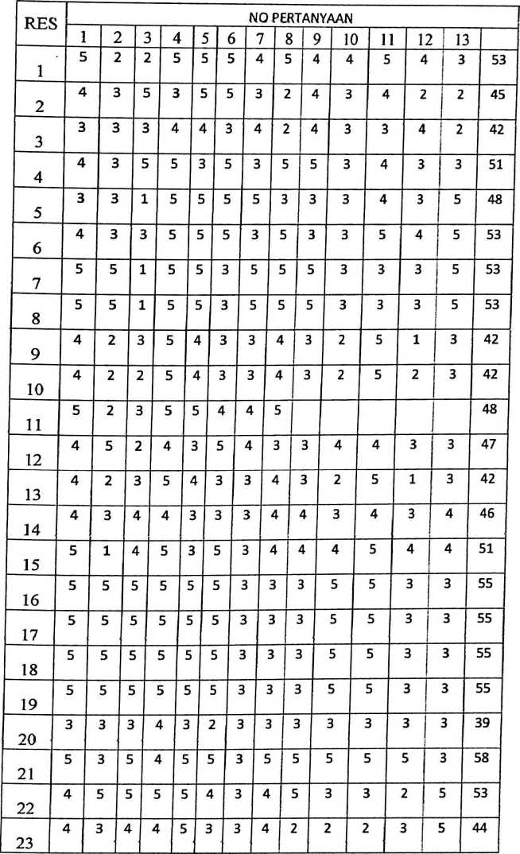

|  |  |  |  |  |  |  |  |  |  |  |  |  |  |  |
| --- | --- | --- | --- | --- | --- | --- | --- | --- | --- | --- | --- | --- | --- | --- |
| 24 | 3 | 3 | 4 | 5 | 3 | 3 | 2 | 5 | 3 | 4 | 5 | 3 | 2 | 45 |
| 25 | 5 | 5 | 2 | 5 | 5 | 5 | 2 | 5 | 5 | 5 | 3 | 1 | 4 | 52 |
| 26 | 3 | 3 | 4 | 5 | 3 | 3 | 2 | 5 | 4 | 4 | 5 | 5 | 4 | 50 |
| 27 | 5 | 3 | 1 | 5 | 3 | 2 | 2 | 5 | 5 | 4 | 5 | 5 | 3 | 48 |
| 28 | 5 | 5 | 4 | 5 | 4 | 2 | 5 | 5 | 5 | 5 | 5 | 4 | 5 | 59 |
| 29 | 3 | 1 | 2 | 5 | 5 | 5 | 3 | 3 | 5 | 4 | 3 | 3 | 5 | 47 |
| 30 | 5 | 3 | 3 | 5 | 5 | 2 | 5 | 3 | 5 | 5 | 5 | 5 | 5 | 56 |
| 31 | 5 | 3 | 3 | 5 | 5 | 2 | 5 | 3 | 5 | 5 | 5 | 5 | 5 | 56 |
| 32 | 4 | 5 | 3 | 5 | 3 | 5 | 3 | 5 | 4 | 3 | 5 | 2 | 3 | 50 |
| 33 | 5 | 5 | 2 | 5 | 4 | 3 | 5 | 5 | 3 | 4 | 5 | 5 | 5 | 56 |
| 34 | 4 | 3 | 3 | 4 | 4 | 4 | 3 | 4 | 4 | 3 | 3 | 3 | 3 | 45 |
| 35 | 4 | 3 | 3 | 5 | 5 | 5 | 4 | 3 | 3 | 5 | 4 | 3 | 4 | 51 |
| 36 | 5 | 5 | 3 | 3 | 4 | 3 | 3 | 5 | 4 | 3 | 3 | 1 | 3 | 4b |
| 37 | 3 | 5 | 5 | 3 | 5 | 3 | 3 | 5 | 3 | 3 | 3 | 2 | 2 | 45 |
| 38 | 4 | 3 | 3 | 5 | 5 | 3 | 3 | 5 | 5 | 4 | 5 | 3 | 3 | 51 |
| 39 | 5 | 5 | 3 | 4 | 4 | 4 | 3 | 5 | 5 | 4 | 3 | 2 | 3 | 50 |
| 40 | 2 | 2 | 4 | 3 | 3 | 2 | 2 | 5 | 3 | 5 | 3 | 3 | 3 | 40 |
| 41 | 2 | 2 | 4 | 3 | 3 | 2 | 2 | 5 | 3 | 5 | 3 | 3 | 3 | 40 |
| 42 | 2 | 2 | 4 | 4 | 3 | 2 | 4 | 5 | 3 | 5 | 3 | 3 | 3 | 43 |
| 43 | 2 | 2 | 4 | 3 | 3 | 2 | 2 | 5 | 3 | 5 | 3 | 3 | 3 | 40 |
| 44 | 5 | 5 | 4 | 4 | 5 | 4 | 4 | 5 | 5 | 5 | 5 | 5 | 5 | 61 |
| 45 | 5 | 5 | 4 | 4 | 5 | 4 | 4 | 5 | 5 | 5 | 5 | 5 | 5 | 61 |
| 46 | 5 | 5 | 4 | 4 | 5 | 4 | 4 | 5 | 5 | 5 | 5 | 5 | 5 | 61 |
| 47 | 5 | 5 | 4 | 4 | 5 | 4 | 4 | 5 | 5 | 5 | 5 | 5 | 5 | 61 |

|  |  |  |  |  |  |  |  |  |  |  |  |  |  |  |
| --- | --- | --- | --- | --- | --- | --- | --- | --- | --- | --- | --- | --- | --- | --- |
| 24 | 3 | 3 | 4 | 5 | 3 | 3 | 2 | 5 | 3 | 4 | 5 | 3 | 2 | 45 |
| 25 | 5 | 5 | 2 | 5 | 5 | 5 | 2 | 5 | 5 | 5 | 3 | 1 | 4 | 52 |
| 26 | 3 | 3 | 4 | 5 | 3 | 3 | 2 | 5 | 4 | 4 | 5 | 5 | 4 | 50 |
| 27 | 5 | 3 | 1 | 5 | 3 | 2 | 2 | 5 | 5 | 4 | 5 | 5 | 3 | 4« |
| 28 | 5 | 5 | 4 | 5 | 4 | 2 | 5 | 5 | 5 | 5 | 5 | 4 | 5 | 59 |
| 29 | 3 | 1 | 2 | 5 | 5 | 5 | 3 | 3 | 5 | 4 | 3 | 3 | 5 | 47 |
| 30 | 5 | 3 | 3 | 5 | 5 | 2 | 5 | 3 | 5 | 5 | 5 | 5 | 5 | 56 |
| 31 | 5 | 3 | 3 | 5 | 5 | 2 | 5 | 3 | 5 | 5 | 5 | 5 | 5 | 56 |
| 32 | 4 | 5 | 3 | 5 | 3 | 5 | 3 | 5 | 4 | 3 | 5 | 2 | 3 | 50 |
| 33 | 5 | 5 | 2 | 5 | 4 | 3 | 5 | 5 | 3 | 4 | 5 | 5 | 5 | 56 |
| 34 | 4 | 3 | 3 | 4 | 4 | 4 | 3 | 4 | 4 | 3 | 3 | 3 | 3 | 45 |
| 35 | 4 | 3 | 3 | 5 | 5 | 5 | 4 | 3 | 3 | 5 | 4 | 3 | 4 | 51 |
| 36 | 5 | 5 | 3 | 3 | 4 | 3 | 3 | 5 | 4 | 3 | 3 | 1 | 3 | 4b |
| 37 | 3 | 5 | 5 | 3 | 5 | 3 | 3 | 5 | 3 | 3 | 3 | 2 | 2 | 45 |
| 38 | 4 | 3 | 3 | 5 | 5 | 3 | 3 | 5 | 5 | 4 | 5 | 3 | 3 | 51 |
| 39 | 5 | 5 | 3 | 4 | 4 | 4 | 3 | 5 | 5 | 4 | 3 | 2 | 3 | 50 |
| 40 | 2 | 2 | 4 | 3 | 3 | 2 | 2 | 5 | 3 | 5 | 3 | 3 | 3 | 40 |
| 41 | 2 | 2 | 4 | 3 | 3 | 2 | 2 | 5 | 3 | 5 | 3 | 3 | 3 | 40 |
| 42 | 2 | 2 | 4 | 4 | 3 | 2 | 4 | 5 | 3 | 5 | 3 | 3 | 3 | 43 |
| 43 | 2 | 2 | 4 | 3 | 3 | 2 | 2 | 5 | 3 | 5 | 3 | 3 | 3 | 40 |
| 44 | 5 | 5 | 4 | 4 | 5 | 4 | 4 | 5 | 5 | 5 | 5 | 5 | 5 | 61 |
| 45 | 5 | 5 | 4 | 4 | 5 | 4 | 4 | 5 | 5 | 5 | 5 | 5 | 5 | 61 |
| 46 | 5 | 5 | 4 | 4 | 5 | 4 | 4 | 5 | 5 | 5 | 5 | 5 | 5 | 61 |
| 47 | 5 | 5 | 4 | 4 | 5 | 4 | 4 | 5 | 5 | 5 | 5 | 5 | 5 | 61 |

|  |  |  |  |  |  |  |  |  |  |  |  |  |  |  |
| --- | --- | --- | --- | --- | --- | --- | --- | --- | --- | --- | --- | --- | --- | --- |
| 48 | 1 | 4 | 4 | 3 | 1 | 1 | 5 | 5 | 3 | 5 | 5 | 5 1 5  1  ' | | 47 |
| 49 | 4 | 5 | 5 | 5 | 5 | 3 | 3 | 5 | 3 | 5 | 5 | 3 | 4 | 55 |
| 50 | 5 | 5 | 5 | 5 | 4 | 3 | 4 | 5 | 5 | 3 | 4 | 4 | 4 | 56 |
| 51 | 5 | 5 | 4 | 4 | 4 | 4 | 4 | 5 | 5 | 4 | 4 | 4 | 3 | 55 |
| 52 | 5 | 5 | 4 | 5 | 3 | 3 | 3 | 5 | 5 | 3 | 5 | 3 | 3 | 52 |
| 53 | 5 | 4 | 5 | 5 | 4 | 2 | 4 | 5 | 4 | 4 | 3 | 3 | 4 | 52 |
| 54 | 5 | 4 | 5 | 5 | 4 | 2 | 4 | 5 | 4 | 4 | 2 | 2 | 4 | 50 |
| 55 | 4 | 4 | 5 | 5 | 4 | 2 | 4 | 4 | 5 | 4 | 2 | 2 | 4 | 49 |
| 56 | 5 | 4 | 5 | 5 | 4 | 2 | 4 | 5 | 4 | 4 | 2 | 2 | 4 | 50 |
| 57 | 5 | 5 | 3 | 4 | 4 | 3 | 4 | 3 | 2 | 4 | 4 | 2 | 1 | 44 |
| 58 | 4 | 3 | 4 | 5 | 4 | 5 | 4 | 3 | 4 | 5 | 4 | 4 | 5 | 54 |
| 59 | 5 | 5 | 3 | 4 | 4 | 3 | 4 | 3 | 2 | 4 | 4 | 2 | 1 | 44 |
| 60 | 2 | 5 | 5 | 5 | 5 | 5 | 3 | 5 | 5 | 3 | 5 | 2 | 2 | 52 |
| 61 | 5 | 5 | 5 | 5 | 5 | 3 | 3 | 5 | 4 | 4 | 4 | 3 | 4 | 55 |
| 62 | 4 | 3 | 3 | 5 | 3 | 2 | 5 | 3 | 3 | 3 | 2 | 2 | 3 | 41 |
| 63 | 3 | 3 | 3 | 5 | 5 | 3 | 5 | 5 | 3 | 5 | 5 | 3 | 5 | 53 |
| 64 | 3 | 5 | 3 | 4 | 3 | 2 | 3 | 5 | 4 | 3 | 2 | 3 | 2 | 42 |
| 65 | 5 | 4 | 5 | 5 | 4 | 2 | 4 | 5 | 4 | 4 | 2 | 2 | 4 | 50 |
| 66 | 5 | 4 | 5 | 5 | 4 | 2 | 4 | 5 | 4 | 4 | 2 | 2 | 4 | 50 |
| 67 | 4 | 5 | 3 | 5 | 5 | 3 | 4 | 3 | 4 | 5 | 5 | 5 | 5 | 56 |
| 68 | 4 | 5 | 3 | 5 | 5 | 3 | 4 | 3 | 4 | 5 | 5 | 5 | 5 | 5b |
| 69 | 5 | 5 | 5 | 4 | 2 | 2 | 4 | 5 | 4 | 4 | 3 | 1 | 1 | 45 |
| 70 | 4 | 5 | 1 | 5 | 4 | 3 | 3 | 5 | 5 | 5 | 5 | 5 | b | 55 |
| 71 | 4 | 5 | 1 | 5 | 4 | 3 | 3 | 5 | 5 | 5 | 5 | 5 | 5 | 55 |

|  |  |  |  |  |  |  |  |  |  |  |  |  |  |  |
| --- | --- | --- | --- | --- | --- | --- | --- | --- | --- | --- | --- | --- | --- | --- |
| 48 | 1 | 4 | 4 | 3 | 1 | 1 | 5 | 5 | 3 | 5 | 5 | 5 1 5  i  ! | | 47 |
| 49 | 4 | 5 | 5 | 5 | 5 | 3 | 3 | 5 | 3 | 5 | 5 | 3 | 4 | 55 |
| 50 | 5 | 5 | 5 | 5 | 4 | 3 | 4 | 5 | 5 | 3 | 4 | 4 | 4 | 56 |
| 51 | 5 | 5 | 4 | 4 | 4 | 4 | 4 | 5 | 5 | 4 | 4 | 4 | 3 | 55 |
| 52 | 5 | 5 | 4 | 5 | 3 | 3 | 3 | 5 | 5 | 3 | 5 | 3 | 3 | 52 |
| 53 | 5 | 4 | 5 | 5 | 4 | 2 | 4 | 5 | 4 | 4 | 3 | 3 | 4 | 52 |
| 54 | 5 | 4 | 5 | 5 | 4 | 2 | 4 | 5 | 4 | 4 | 2 | 2 | 4 | 50 |
| 55 | 4 | 4 | 5 | 5 | 4 | 2 | 4 | 4 | 5 | 4 | 2 | 2 | 4 | 49 |
| 56 | 5 | 4 | 5 | 5 | 4 | 2 | 4 | 5 | 4 | 4 | 2 | 2 | 4 | 50 |
| 57 | 5 | 5 | 3 | 4 | 4 | 3 | 4 | 3 | 2 | 4 | 4 | 2 | 1 | 44 |
| 58 | 4 | 3 | 4 | 5 | 4 | 5 | 4 | 3 | 4 | 5 | 4 | 4 | 5 | 54 |
| 59 | 5 | 5 | 3 | 4 | 4 | 3 | 4 | 3 | 2 | 4 | 4 | 2 | 1 | 44 |
| 60 | 2 | 5 | 5 | 5 | 5 | 5 | 3 | 5 | 5 | 3 | 5 | 2 | 2 | 52 |
| 61 | 5 | 5 | 5 | 5 | 5 | 3 | 3 | 5 | 4 | 4 | 4 | 3 | 4 | 55 |
| 62 | 4 | 3 | 3 | 5 | 3 | 2 | 5 | 3 | 3 | 3 | 2 | 2 | 3 | 41 |
| 63 | 3 | 3 | 3 | 5 | 5 | 3 | 5 | 5 | 3 | 5 | 5 | 3 | b | 53 |
| 64 | 3 | 5 | 3 | 4 | 3 | 2 | 3 | 5 | 4 | 3 | 2 | 3 | 2 | 42 |
| 65 | 5 | 4 | 5 | 5 | 4 | 2 | 4 | 5 | 4 | 4 | 2 | 2 | 4 | 50 |
| 66 | 5 | 4 | 5 | 5 | 4 | 2 | 4 | 5 | 4 | 4 | 2 | 2 | 4 | 50 |
| 67 | 4 | 5 | 3 | 5 | 5 | 3 | 4 | 3 | 4 | 5 | 5 | 5 | 5 | 56 |
| 68 | 4 | 5 | 3 | 5 | 5 | 3 | 4 | 3 | 4 | 5 | 5 | 5 | 5 | 56 |
| 69 | 5 | 5 | 5 | 4 | 2 | 2 | 4 | 5 | 4 | 4 | 3 | 1 | 1 | 45 |
| 70 | 4 | 5 | 1 | 5 | 4 | 3 | 3 | 5 | 5 | 5 | 5 | 5 | 5 | 55 |
| 71 | 4 | 5 | 1 | 5 | 4 | 3 | 3 | 5 | 5 | 5 | 5 | 5 | 5 | 55 |

|  |  |  |  |  |  |  |  |  |  |  |  |  |  |  |
| --- | --- | --- | --- | --- | --- | --- | --- | --- | --- | --- | --- | --- | --- | --- |
| 1 4  72 1 | | 5 | 1 | 5 | 4 | 3 | 3 | 5 | 5 | 5 | 5 | 5 | 5 | 55 |
| 73 | 4 | 5 | 1 | 5 | 4 | 3 | 1 | 4 | 4 | 5 | 5 | 5 | 5 | 51 |
| 74 | 4 | 5 | 5 | 5 | 4 | 3 | 3 | 5 | 4 | 5 | 5 | 5 | 5 | 58 |
| 75 | 5 | 5 | 4 | 5 | 5 | 5 | 4 | 4 | 4 | 5 | 5 | 5 | 5 | 61 |
| 76 | 4 | 4 | 5 | 5 | 5 | 3 | 4 | 4 | 4 | 4 | 4 | 4 | 4 | 54 |
| 77 | 3 | 3 | 4 | 5 | 5 | 2 | 3 | 5 | 3 | 4 | 3 | 3 | 4 | 47 |
| 78 | 3 | 3 | 4 | 5 | 5 | 2 | 3 | 5 | 4 | 4 | 3 | 3 | 4 | 48 |
| 79 | 5 | 4 | 4 | 5 | 3 | 4 | 2 | 5 | 5 | 3 | 4 | 2 | 3 | 49 |
| 80 | 3 | 4 | 4 | 5 | 4 | 4 | 2 | 5 | 5 | 3 | 4 | 2 | 3 | 48 |
| 81 | 4 | 5 | 5 | 5 | 4 | 4 | 5 | 5 | 5 | 5 | 3 | 3 | S | 58 |
| 82 | 4 | 4 | 3 | 5 | 5 | 4 | 3 | 5 | 4 | 4 | 4 | 3 | 4 | 52 |
| 83 | 4 | 3 | 5 | 5 | 5 | 5 | 3 | 3 | 3 | 3 | 3 | 3 | 3 | 48 |
| 84 | 5 | 4 | 2 | 5 | 5 | 3 | 4 | 3 | 5 | 3 | 5 | 3 | 3 | 50 |
| 85 | 5 | 5 | 5 | 5 | 5 | 5 | 3 | 5 | 5 | 5 | 3 | 5 | 5 | 61 |
| 86 | 5 | 5 | 3 | 5 | 5 | 5 | 5 | 5 | 4 | 5 | 5 | 5 | 5 | 62 |
| 87 | 5 | 3 | 3 | 5 | 5 | 5 | 5 | 5 | 4 | 5 | 5 | 5 | 5 | 60 |
| 88 | 5 | 5 | 2 | 5 | 4 | 3 | 5 | 5 | 3 | 4 | 5 | 5 | 5 | 56 |
| 89 | 5 | 4 | 5 | 5 | 4 | 5 | 5 | 5 | 3 | 4 | 5 | 5 | 5 | 60 |
| 90 | 5 | 5 | 2 | 5 | 3 | 5 | 5 | 3 | 4 | 5 | 5 | 5 | 5 | 5/ |
| 91 | 5 | 2 | 2 | 5 | 5 | 5 | 5 | 5 | 4 | 4 | 4 | 3 | 4 | 53 |
| 92 | 5 | 2 | 2 | 5 | 5 | 5 | 5 | 5 | 4 | 4 | 4 | 3 | 4 | 53 |
| 93 | 3 | 2 | 4 | 5 | 5 | 3 | 2 | 5 | 3 | 4 | 3 | 1 | 5 | 45 |
| 94 | 5 | 5 | 1 | 5 | 5 | 5 | 2 | 5 | 5 | 5 | 5 | 1 | 1 | 50 |
| 95 | 4 | 4 | 3 | 5 | 3 | 4 | 4 | 5 | 4 | 2 | 5 | 2 | 5 | 50 |

|  |  |  |  |  |  |  |  |  |  |  |  |  |  |  |
| --- | --- | --- | --- | --- | --- | --- | --- | --- | --- | --- | --- | --- | --- | --- |
| 72 | 4 | 5 | 1 | 5 | 4 | 3 | 3 | 5 | 5 | 5 | 5 | 5 | 5 | 55 |
| 73 | 4 | 5 | 1 | 5 | 4 | 3 | 1 | 4 | 4 | 5 | 5 | 5 | 5 | 51 |
| 74 | 4 | 5 | 5 | 5 | 4 | 3 | 3 | 5 | 4 | 5 | 5 | 5 | 5 | 58 |
| 75 | 5 | 5 | 4 | 5 | 5 | 5 | 4 | 4 | 4 | 5 | 5 | 5 | 5 | 61 |
| 76 | 4 | 4 | 5 | 5 | 5 | 3 | 4 | 4 | 4 | 4 | 4 | 4 | 4 | 54 |
| 77 | 3 | 3 | 4 | 5 | 5 | 2 | 3 | 5 | 3 | 4 | 3 | 3 | 4 | 47 |
| 78 | 3 | 3 | 4 | 5 | 5 | 2 | 3 | 5 | 4 | 4 | 3 | 3 | 4 | 48 |
| 79 | 5 | 4 | 4 | 5 | 3 | 4 | 2 | 5 | 5 | 3 | 4 | 2 | 3 | 49 |
| 80 | 3 | 4 | 4 | 5 | 4 | 4 | 2 | 5 | 5 | 3 | 4 | 2 | 3 | 48 |
| 81 | 4 | 5 | 5 | 5 | 4 | 4 | 5 | 5 | 5 | 5 | 3 | 3 | 5 | 58 |
| 82 | 4 | 4 | 3 | 5 | 5 | 4 | 3 | 5 | 4 | 4 | 4 | 3 | 4 | 52 |
| 83 | 4 | 3 | 5 | 5 | 5 | 5 | 3 | 3 | 3 | 3 | 3 | 3 | 3 | 48 |
| 84 | 5 | 4 | 2 | 5 | 5 | 3 | 4 | 3 | 5 | 3 | 5 | 3 | 3 | 50 |
| 85 | 5 | 5 | 5 | 5 | 5 | 5 | 3 | 5 | 5 | 5 | 3 | 5 | 5 | 61 |
| 86 | 5 | 5 | 3 | 5 | 5 | 5 | 5 | 5 | 4 | 5 | 5 | 5 | 5 | 62 |
| 87 | 5 | 3 | 3 | 5 | 5 | 5 | 5 | 5 | 4 | 5 | 5 | 5 | 5 | 60 |
| 88 | 5 | 5 | 2 | 5 | 4 | 3 | 5 | 5 | 3 | 4 | 5 | 5 | 5 | 56 |
| 89 | 5 | 4 | 5 | 5 | 4 | 5 | 5 | 5 | 3 | 4 | 5 | 5 | 5 | 60 |
| 90 | 5 | 5 | 2 | 5 | 3 | 5 | 5 | 3 | 4 | 5 | 5 | 5 | 5 | 57 |
| 91 | 5 | 2 | 2 | 5 | 5 | 5 | 5 | 5 | 4 | 4 | 4 | 3 | 4 | 53 |
| 92 | 5 | 2 | 2 | 5 | 5 | 5 | 5 | 5 | 4 | 4 | 4 | 3 | 4 | 53 |
| 93 | 3 | 2 | 4 | 5 | 5 | 3 | 2 | 5 | 3 | 4 | 3 | 1 | 5 | 4b |
| 94 | 5 | 5 | 1 | 5 | 5 | 5 | 2 | 5 | 5 | 5 | 5 | 1 | 1 | 50 |
| 95 | 4 | 4 | 3 | 5 | 3 | 4 | 4 | 5 | 4 | 2 | 5 | 2 | 5 | 50 |

|  |  |  |  |  |  |  |  |  |  |  |  |  |  |  |
| --- | --- | --- | --- | --- | --- | --- | --- | --- | --- | --- | --- | --- | --- | --- |
| 96 | 5 | 5 | 5 | 5 | 4 | 3 | 3 | 4 | 3 | 3 | 3 | 3 | 5 | 51 |
| 97 | 5 | 5 | 5 | 5 | 4 | 3 | 3 | 4 | 4 | 3 | 3 | 3 | 5 | 52 |
| 98 | 5 | 4 | 5 | 5 | 3 | 3 | 3 | 4 | 3 | 3 | 3 | 3 | 5 | 49 |
| 99 | 4 | 3 | 3 | 4 | 5 | 3 | 3 | 4 | 3 | 3 | 3 | 3 | 5 | 46 |
| 100 | 5 | 3 | 5 | 5 | 3 | 3 | 5 | 3 | 5 | 5 | 5 | 3 | 3 | 53 |
| 101 | 3 | 3 | 5 | 5 | 5 | 3 | 5 | 3 | 5 | 5 | 5 | 3 | 5 | 55 |
| 102 | 5 | 3 | 5 | 5 | 3 | 3 | 5 | 3 | 5 | 5 | 5 | 3 | 3 | 53 |
| 103 | 4 | 3 | 2 | 4 | 4 | 4 | 5 | 5 | 3 | 4 | 3 | 2 | 5 | 48 |
| 104 | 4 | 5 | 5 | 5 | 5 | 4 | 3 | 4 | 5 | 3 | 3 | 2 | 5 | 53 |
| 105 | 4 | 3 | 4 | 4 | 5 | 3 | 3 | 4 | 2 | 2 | 2 | 3 | 5 | 44 |
| 106 | 3 | 3 | 4 | 5 | 3 | 3 | 2 | 5 | 3 | 4 | 5 | 3 | 2 | 45 |
| 107 | 5 | 5 | 2 | 5 | 5 | 5 | 2 | 5 | 5 | 5 | 3 | 1 | 4 | 52 |
| 108 | 3 | 3 | 4 | 5 | 3 | 3 | 2 | 5 | 4 | 4 | 5 | 5 | 4 | 50 |
| 109 | 5 | 3 | 1 | 5 | 3 | 2 | 2 | 5 | 5 | 4 | 5 | 5 | 3 | 48 |
| 110 | 5 | 5 | 4 | 5 | 4 | 2 | 5 | 5 | 5 | 5 | 5 | 4 | 5 | 59 |
| 111 | 3 | 1 | 2 | 5 | 5 | 5 | 3 | 3 | 5 | 4 | 3 | 3 | 5 | 47 |
| 112 | 5 | 3 | 3 | 5 | 5 | 2 | 5 | 3 | 5 | 5 | 5 | 5 | 5 | 56 |
| 113 | 5 | 3 | 3 | 5 | 5 | 2 | 5 | 3 | 5 | 5 | 5 | 5 | 5 | 56 |
| 114 | 4 | 5 | 3 | 5 | 3 | 5 | 3 | 5 | 4 | 3 | 5 | 2 | 3 | 50 |
| 115 | 5 | 5 | 2 | 5 | 4 | 3 | 5 | 5 | 3 | 4 | 5 | 5 | 5 | 5b |
| 116 | 4 | 3 | 3 | 4 | 4 | 4 | 3 | 4 | 4 | 3 | 3 | 3 | 3 | 45 |
| 117 | 4 | 3 | 3 | 5 | 5 | 5 | 4 | 3 | 3 | 5 | 4 | 3 | 4 | 61 |
| 118 | 5 | 5 | 3 | 3 | 4 | 3 | 3 | 5 | 4 | 3 | 3 | 1 | 3 | 45 |
| 119 | 3 | 5 | 5 | 3 | 5 | 3 | 3 | 5 | 3 | 3 | 3 | 2 | 2 | 45 |

|  |  |  |  |  |  |  |  |  |  |  |  |  |  |  |
| --- | --- | --- | --- | --- | --- | --- | --- | --- | --- | --- | --- | --- | --- | --- |
| 96 | 5 | 5 | 5 | 5 | 4 | 3 | 3 | 4 | 3 | 3 | 3 | 3 | 5 | 51 |
| 97 | 5 | 5 | 5 | 5 | 4 | 3 | 3 | 4 | 4 | 3 | 3 | 3 | 5 | 52 |
| 98 | 5 | 4 | 5 | 5 | 3 | 3 | 3 | 4 | 3 | 3 | 3 | 3 | 5 | 49 |
| 99 | 4 | 3 | 3 | 4 | 5 | 3 | 3 | 4 | 3 | 3 | 3 | 3 | 5 | 46 |
| 100 | 5 | 3 | 5 | 5 | 3 | 3 | 5 | 3 | 5 | 5 | 5 | 3 | 3 | 53 |
| 101 | 3 | 3 | 5 | 5 | 5 | 3 | 5 | 3 | 5 | 5 | 5 | 3 | 5 | 55 |
| 102 | 5 | 3 | 5 | 5 | 3 | 3 | 5 | 3 | 5 | 5 | 5 | 3 | 3 | 53 |
| 103 | 4 | 3 | 2 | 4 | 4 | 4 | 5 | 5 | 3 | 4 | 3 | 2 | 5 | 48 |
| 104 | 4 | 5 | 5 | 5 | 5 | 4 | 3 | 4 | 5 | 3 | 3 | 2 | 5 | 53 |
| 105 | 4 | 3 | 4 | 4 | 5 | 3 | 3 | 4 | 2 | 2 | 2 | 3 | 5 | 44 |
| 106 | 3 | 3 | 4 | 5 | 3 | 3 | 2 | 5 | 3 | 4 | 5 | 3 | 2 | 45 |
| 107 | 5 | 5 | 2 | 5 | 5 | 5 | 2 | 5 | 5 | 5 | 3 | 1 | 4 | 52 |
| 108 | 3 | 3 | 4 | 5 | 3 | 3 | 2 | 5 | 4 | 4 | 5 | 5 | 4 | 50 |
| 109 | 5 | 3 | 1 | 5 | 3 | 2 | 2 | 5 | 5 | 4 | 5 | 5 | 3 | 48 |
| 110 | 5 | 5 | 4 | 5 | 4 | 2 | 5 | 5 | 5 | 5 | 5 | 4 | 5 | 59 |
| 111 | 3 | 1 | 2 | 5 | 5 | 5 | 3 | 3 | 5 | 4 | 3 | 3 | 5 | 47 |
| 112 | 5 | 3 | 3 | 5 | 5 | 2 | 5 | 3 | 5 | 5 | 5 | 5 | 5 | 56 |
| 113 | 5 | 3 | 3 | 5 | 5 | 2 | 5 | 3 | 5 | 5 | 5 | 5 | 5 | 56 |
| 114 | 4 | 5 | 3 | 5 | 3 | 5 | 3 | 5 | 4 | 3 | 5 | 2 | 3 | 50 |
| 115 | 5 | 5 | 2 | 5 | 4 | 3 | 5 | 5 | 3 | 4 | 5 | 5 | 5 | 56 |
| 116 | 4 | 3 | 3 | 4 | 4 | 4 | 3 | 4 | 4 | 3 | 3 | 3 | 3 | 45 |
| 117 | 4 | 3 | 3 | 5 | 5 | 5 | 4 | 3 | 3 | 5 | 4 | 3 | 4 | 51 |
| 118 | 5 | 5 | 3 | 3 | 4 | 3 | 3 | 5 | 4 | 3 | 3 | 1 | 3 | 45 |
| 119 | 3 | 5 | 5 | 3 | 5 | 3 | 3 | 5 | 3 | 3 | 3 | 2 | 2 | 45 |

|  |  |  |  |  |  |  |  |  |  |  |  |  |  |  |
| --- | --- | --- | --- | --- | --- | --- | --- | --- | --- | --- | --- | --- | --- | --- |
| 96 | 5 | 5 | 5 | 5 | 4 | 3 | 3 | 4 | 3 | 3 | 3 | 3 | 5 | 51 |
| 97 | 5 | 5 | 5 | 5 | 4 | 3 | 3 | 4 | 4 | 3 | 3 | 3 | 5 | 52 |
| 98 | 5 | 4 | 5 | 5 | 3 | 3 | 3 | 4 | 3 | 3 | 3 | 3 | 5 | 49 |
| 99 | 4 | 3 | 3 | 4 | 5 | 3 | 3 | 4 | 3 | 3 | 3 | 3 | 5 | 46 |
| 100 | 5 | 3 | 5 | 5 | 3 | 3 | 5 | 3 | 5 | 5 | 5 | 3 | 3 | 53 |
| 101 | 3 | 3 | 5 | 5 | 5 | 3 | 5 | 3 | 5 | 5 | 5 | 3 | 5 | 55 |
| 102 | 5 | 3 | 5 | 5 | 3 | 3 | 5 | 3 | 5 | 5 | 5 | 3 | 3 | 53 |
| 103 | 4 | 3 | 2 | 4 | 4 | 4 | 5 | 5 | 3 | 4 | 3 | 2 | 5 | 48 |
| 104 | 4 | 5 | 5 | 5 | 5 | 4 | 3 | 4 | 5 | 3 | 3 | 2 | 5 | 53 |
| 105 | 4 | 3 | 4 | 4 | 5 | 3 | 3 | 4 | 2 | 2 | 2 | 3 | 5 | 44 |
| 106 | 3 | 3 | 4 | 5 | 3 | 3 | 2 | 5 | 3 | 4 | 5 | 3 | 2 | 45 |
| 107 | 5 | 5 | 2 | 5 | 5 | 5 | 2 | 5 | 5 | 5 | 3 | 1 | 4 | 52 |
| 108 | 3 | 3 | 4 | 5 | 3 | 3 | 2 | 5 | 4 | 4 | 5 | 5 | 4 | 50 |
| 109 | 5 | 3 | 1 | 5 | 3 | 2 | 2 | 5 | 5 | 4 | 5 | 5 | 3 | 48 |
| 110 | 5 | 5 | 4 | 5 | 4 | 2 | 5 | 5 | 5 | 5 | 5 | 4 | 5 | by |
| 111 | 3 | 1 | 2 | 5 | 5 | 5 | 3 | 3 | 5 | 4 | 3 | 3 | 5 | 47 |
| 112 | 5 | 3 | 3 | 5 | 5 | 2 | 5 | 3 | 5 | 5 | 5 | 5 | b | 56 |
| 113 | 5 | 3 | 3 | 5 | 5 | 2 | 5 | 3 | 5 | 5 | 5 | 5 | b | 56 |
| 114 | 4 | 5 | 3 | 5 | 3 | 5 | 3 | 5 | 4 | 3 | 5 | 2 | 3 | 50 |
| 115 | 5 | 5 | 2 | 5 | 4 | 3 | 5 | 5 | 3 | 4 | 5 | 5 | b | 56 |
| 116 | 4 | 3 | 3 | 4 | 4 | 4 | 3 | 4 | 4 | 3 | 3 | 3 | 3 | 45 |
| 117 | 4 | 3 | 3 | 5 | 5 | 5 | 4 | 3 | 3 | 5 | 4 | 3 | 4 | 51 |
| 118 | 5 | 5 | 3 | 3 | 4 | 3 | 3 | 5 | 4 | 3 | 3 | 1 | 3 | 45 |
| 119 | 3 | 5 | 5 | 3 | 5 | 3 | 3 | 5 | 3 | 3 | 3 | 2 | 2 | 45 |

|  |  |  |  |  |  |  |  |  |  |  |  |  |  |  |
| --- | --- | --- | --- | --- | --- | --- | --- | --- | --- | --- | --- | --- | --- | --- |
| 96 | 5 | 5 | 5 | 5 | 4 | 3 | 3 | 4 | 3 | 3 | 3 | 3 | 5 | 51 |
| 97 | 5 | 5 | 5 | 5 | 4 | 3 | 3 | 4 | 4 | 3 | 3 | 3 | 5 | 52 |
| 98 | 5 | 4 | 5 | 5 | 3 | 3 | 3 | 4 | 3 | 3 | 3 | 3 | 5 | 49 |
| 99 | 4 | 3 | 3 | 4 | 5 | 3 | 3 | 4 | 3 | 3 | 3 | 3 | 5 | 46 |
| 100 | 5 | 3 | 5 | 5 | 3 | 3 | 5 | 3 | 5 | 5 | 5 | 3 | 3 | 53 |
| 101 | 3 | 3 | 5 | 5 | 5 | 3 | 5 | 3 | 5 | 5 | 5 | 3 | 5 | 55 |
| 102 | 5 | 3 | 5 | 5 | 3 | 3 | 5 | 3 | 5 | 5 | 5 | 3 | 3 | 53 |
| 103 | 4 | 3 | 2 | 4 | 4 | 4 | 5 | 5 | 3 | 4 | 3 | 2 | 5 | 48 |
| 104 | 4 | 5 | 5 | 5 | 5 | 4 | 3 | 4 | 5 | 3 | 3 | 2 | 5 | 53 |
| 105 | 4 | 3 | 4 | 4 | 5 | 3 | 3 | 4 | 2 | 2 | 2 | 3 | b | 44 |
| 106 | 3 | 3 | 4 | 5 | 3 | 3 | 2 | 5 | 3 | 4 | 5 | 3 | 2 | 4b |
| 107 | 5 | 5 | 2 | 5 | 5 | 5 | 2 | 5 | 5 | 5 | 3 | 1 | 4 | 52 |
| 108 | 3 | 3 | 4 | 5 | 3 | 3 | 2 | 5 | 4 | 4 | 5 | 5 | 4 | 50 |
| 109 | 5 | 3 | 1 | 5 | 3 | 2 | 2 | 5 | 5 | 4 | 5 | 5 | 3 | 48 |
| 110 | 5 | 5 | 4 | 5 | 4 | 2 | 5 | 5 | 5 | 5 | 5 | 4 | b | 59 |
| 111 | 3 | 1 | 2 | 5 | 5 | 5 | 3 | 3 | 5 | 4 | 3 | 3 | 5 | 47 |
| 112 | 5 | 3 | 3 | 5 | 5 | 2 | 5 | 3 | 5 | 5 | 5 | 5 | b | 56 |
| 113 | 5 | 3 | 3 | 5 | 5 | 2 | 5 | 3 | 5 | 5 | 5 | 5 | b | 56 |
| 114 | 4 | 5 | 3 | 5 | 3 | 5 | 3 | 5 | 4 | 3 | 5 | 2 | 3 | 50 |
| 115 | 5 | 5 | 2 | 5 | 4 | 3 | 5 | 5 | 3 | 4 | 5 | 5 | b | 56 |
| 116 | 4 | 3 | 3 | 4 | 4 | 4 | 3 | 4 | 4 | 3 | 3 | 3 | 3 | 45 |
| 117 | 4 | 3 | 3 | 5 | 5 | 5 | 4 | 3 | 3 | 5 | 4 | 3 | 4 | 51 |
| 118 | 5 | 5 | 3 | 3 | 4 | 3 | 3 | 5 | 4 | 3 | 3 | 1 | 3 | 4b |
| 119 | 3 | 5 | 5 | 3 | 5 | 3 | 3 | 5 | 3 | 3 | 3 | 2 | 2 | 45 |

|  |  |  |  |  |  |  |  |  |  |  |  |  |  |  |
| --- | --- | --- | --- | --- | --- | --- | --- | --- | --- | --- | --- | --- | --- | --- |
| 120 | 4 | 3 | 3 | 5 | 5 | 3 | 3 | 5 | 5 | 4 | 5 | 3 | 3 | 51 |
| 121 | 5 | 5 | 3 | 4 | 4 | 4 | 3 | 5 | 5 | 4 | 3 | 2 | 3 | 50 |
| 122 | 2 | 2 | 4 | 3 | 3 | 2 | 2 | 5 | 3 | 5 | 3 | 3 | 3 | 40 |
| 123 | 2 | 2 | 4 | 3 | 3 | 2 | 2 | 5 | 3 | 5 | 3 | 3 | 3 | 40 |
| 124 | 2 | 2 | 4 | 4 | 3 | 2 | 4 | 5 | 3 | 5 | 3 | 3 | 3 | 43 |
| 125 | 2 | 2 | 4 | 3 | 3 | 2 | 2 | 5 | 3 | 5 | 3 | 3 | 3 | 40 |
| 126 | 5 | 5 | 4 | 4 | 5 | 4 | 4 | 5 | 5 | 5 | 5 | 5 | 5 | 61 |
| 127 | 5 | 5 | 4 | 4 | 5 | 4 | 4 | 5 | 5 | 5 | 5 | 5 | 5 | 61 |
| 128 | 5 | 5 | 4 | 4 | 5 | 4 | 4 | 5 | 5 | 5 | 5 | 5 | 5 | 61 |
| 129 | 5 | 5 | 4 | 4 | 5 | 4 | 4 | 5 | 5 | 5 | 5 | 5 | 5 | 61 |
| 130 | 1 | 4 | 4 | 3 | 1 | 1 | 5 | 5 | 3 | 5 | 5 | 5 | 5 | 47 |
| 131 | 4 | 5 | 5 | 5 | 5 | 3 | 3 | 5 | 3 | 5 | 5 | 3 | 4 | 55 |
| 132 | 5 | 5 | 5 | 5 | 4 | 3 | 4 | 5 | 5 | 3 | 4 | 4 | 4 | 56 |
| 133 | 3 | 3 | 3 | 4 | 4 | 3 | 4 | 2 | 4 | 3 | 3 | 4 | 2 | 42 |
| 134 | 4 | 3 | 5 | 5 | 3 | 5 | 3 | 5 | 5 | 3 | 4 | 3 | 3 | 51 |
| 135 | 3 | 3 | 1 | 5 | 5 | 5 | 5 | 3 | 3 | 3 | 4 | 3 | 5 | 48 |
| 136 | 4 | 3 | 3 | 5 | 5 | 5 | 3 | 5 | 3 | 3 | 5 | 4 | 5 | 53 |
| 137 | 5 | 5 | 1 | 5 | 5 | 3 | 5 | 5 | 5 | 3 | 3 | 3 | 5 | 53 |
| 138 | 5 | 5 | 1 | 5 | 5 | 3 | 5 | 5 | 5 | 3 | 3 | 3 | 5 | 53 |
| 139 | 4 | 2 | 3 | 5 | 4 | 3 | 3 | 4 | 3 | 2 | 5 | 1 | 3 | 42 |
| 140 | 4 | 2 | 2 | 5 | 4 | 3 | 3 | 4 | 3 | 2 | 5 | 2 | 3 | 42 |
| 141 | 5 | 2 | 3 | 5 | 5 | 4 | 4 | 5 | 3 | 3 | 5 | 1 | 3 | 48 |
| 142 | 4 | 5 | 2 | 4 | 3 | 5 | 4 | 3 | 3 | 4 | 4 | 3 | 3 | 47 |
| 143 | 4 | 2 | 3 | 5 | 4 | 3 | 3 | 4 | 3 | 2 | 5 | 1 | 3 | 42 |

|  |  |  |  |  |  |  |  |  |  |  |  |  |  |  |
| --- | --- | --- | --- | --- | --- | --- | --- | --- | --- | --- | --- | --- | --- | --- |
| 120 | 4 | 3 | 3 | 5 | 5 | 3 | 3 | 5 | 5 | 4 | 5 | 3 | 3 | 51 |
| 121 | 5 | 5 | 3 | 4 | 4 | 4 | 3 | 5 | 5 | 4 | 3 | 2 | 3 | 50 |
| 122 | 2 | 2 | 4 | 3 | 3 | 2 | 2 | 5 | 3 | 5 | 3 | 3 | 3 | 40 |
| 123 | 2 | 2 | 4 | 3 | 3 | 2 | 2 | 5 | 3 | 5 | 3 | 3 | 3 | 40 |
| 124 | 2 | 2 | 4 | 4 | 3 | 2 | 4 | 5 | 3 | 5 | 3 | 3 | 3 | 43 |
| 125 | 2 | 2 | 4 | 3 | 3 | 2 | 2 | 5 | 3 | 5 | 3 | 3 | 3 | 40 |
| 126 | 5 | 5 | 4 | 4 | 5 | 4 | 4 | 5 | 5 | 5 | 5 | 5 | 5 | 61 |
| 127 | 5 | 5 | 4 | 4 | 5 | 4 | 4 | 5 | 5 | 5 | 5 | 5 | 5 | 61 |
| 128 | 5 | 5 | 4 | 4 | 5 | 4 | 4 | 5 | 5 | 5 | 5 | 5 | 5 | 61 |
| 129 | 5 | 5 | 4 | 4 | 5 | 4 | 4 | S | 5 | 5 | 5 | 5 | 5 | 61 |
| 130 | 1 | 4 | 4 | 3 | 1 | 1 | 5 | 5 | 3 | 5 | 5 | 5 | 5 | 47 |
| 131 | 4 | 5 | 5 | 5 | 5 | 3 | 3 | 5 | 3 | 5 | 5 | 3 | 4 | 55 |
| 132 | 5 | 5 | 5 | 5 | 4 | 3 | 4 | 5 | 5 | 3 | 4 | 4 | 4 | 56 |
| 133 | 3 | 3 | 3 | 4 | 4 | 3 | 4 | 2 | 4 | 3 | 3 | 4 | 2 | 42 |
| 134 | 4 | 3 | 5 | 5 | 3 | 5 | 3 | 5 | 5 | 3 | 4 | 3 | 3 | 51 |
| 135 | 3 | 3 | 1 | 5 | 5 | 5 | 5 | 3 | 3 | 3 | 4 | 3 | 5 | 48 |
| 136 | 4 | 3 | 3 | 5 | 5 | 5 | 3 | 5 | 3 | 3 | 5 | 4 | 5 | 53 |
| 137 | 5 | 5 | 1 | 5 | 5 | 3 | 5 | 5 | 5 | 3 | 3 | 3 | 5 | 53 |
| 138 | 5 | 5 | 1 | 5 | 5 | 3 | 5 | 5 | 5 | 3 | 3 | 3 | 5 | 53 |
| 139 | 4 | 2 | 3 | 5 | 4 | 3 | 3 | 4 | 3 | 2 | 5 | 1 | 3 | 42 |
| 140 | 4 | 2 | 2 | 5 | 4 | 3 | 3 | 4 | 3 | 2 | 5 | 2 | 3 | 42 |
| 141 | 5 | 2 | 3 | 5 | 5 | 4 | 4 | 5 | 3 | 3 | 5 | 1 | 3 | 48 |
| 142 | 4 | 5 | 2 | 4 | 3 | 5 | 4 | 3 | 3 | 4 | 4 | 3 | 3 | 47 |
| 143 | 4 | 2 | 3 | 5 | 4 | 3 | 3 | 4 | 3 | 2 | 5 | 1 | 3 | 42 |

|  |  |  |  |  |  |  |  |  |  |  |  |  |  |  |
| --- | --- | --- | --- | --- | --- | --- | --- | --- | --- | --- | --- | --- | --- | --- |
| 144 | 4 | 3 | 4 | 4 | 3 | 3 | 3 | 4 | 4 | 3 | 4 | 3 | 4 | 46 |
| 145 | 5 | 1 | 4 | 5 | 3 | 5 | 3 | 4 | 4 | 4 | 5 | 4 | 4 | 51 |
| 146 | 5 | 5 | 5 | 5 | 5 | 5 | 3 | 3 | 3 | 5 | 5 | 3 | 3 | 55 |
| 147 | 5 | 5 | 5 | 5 | 5 | 5 | 3 | 3 | 3 | 5 | 5 | 3 | 3 | 55 |
| 148 | 5 | 5 | 5 | 5 | 5 | 5 | 3 | 3 | 3 | 5 | 5 | 3 | 3 | 55 |
| 149 | 5 | 5 | 5 | 5 | 5 | 5 | 3 | 3 | 3 | 5 | 5 | 3 | 3 | 55 |
| 150 | 3 | 3 | 3 | 4 | 3 | 2 | 3 | 3 | 3 | 3 | 3 | 3 | 3 | 39 |
| 151 | 5 | 2 | 2 | 5 | 5 | 5 | 4 | 5 | 4 | 4 | 5 | 4 | 3 | 53 |
| 152 | 4 | 3 | 5 | 3 | 5 | 5 | 3 | 2 | 4 | 3 | 4 | 2 | 2 | 45 |
| 153 | 3 | 3 | 3 | 4 | 4 | 3 | 4 | 2 | 4 | 3 | 3 | 4 | 2 | 42 |
| 154 | 4 | 3 | 5 | 5 | 3 | 5 | 3 | 5 | 5 | 3 | 4 | 3 | 3 | 51 |
| 155 | 3 | 3 | 1 | 5 | 5 | 5 | 5 | 3 | 3 | 3 | 4 | 3 | 5 | 48 |
| 156 | 4 | 3 | 3 | 5 | 5 | 5 | 3 | 5 | 3 | 3 | 5 | 4 | 5 | 53 |
| 157 | 5 | 5 | 1 | 5 | 5 | 3 | 5 | 5 | 5 | 3 | 3 | 3 | 5 | 53 |
| 158 | 5 | 5 | 1 | 5 | 5 | 3 | 5 | 5 | 5 | 3 | 3 | 3 | 5 | 53 |
| 159 | 4 | 2 | 3 | 5 | 4 | 3 | 3 | 4 | 3 | 2 | 5 | 1 | 3 | 42 |
| 160 | 4 | 2 | 2 | 5 | 4 | 3 | 3 | 4 | 3 | 2 | 5 | 2 | 3 | 42 |
| 161 | 5 | 2 | 3 | 5 | 5 | 4 | 4 | 5 | 3 | 3 | 5 | 1 | 3 | 48 |
| 162 | 4 | 5 | 2 | 4 | 3 | 5 | 4 | 3 | 3 | 4 | 4 | 3 | 3 | 47 |
| 163 | 4 | 2 | 3 | 5 | 4 | 3 | 3 | 4 | 3 | 2 | 5 | 1 | 3 | 42 |

|  |  |  |  |  |  |  |  |  |  |  |  |  |  |  |
| --- | --- | --- | --- | --- | --- | --- | --- | --- | --- | --- | --- | --- | --- | --- |
| 144 | 4 | 3 | 4 | 4 | 3 | 3 | 3 | 4 | 4 | 3 | 4 | 3 | 4 | 46 |
| 145 | 5 | 1 | 4 | 5 | 3 | 5 | 3 | 4 | 4 | 4 | 5 | 4 | 4 | 51 |
| 146 | 5 | 5 | 5 | 5 | 5 | 5 | 3 | 3 | 3 | 5 | 5 | 3 | 3 | 55 |
| 147 | 5 | 5 | 5 | 5 | 5 | 5 | 3 | 3 | 3 | 5 | 5 | 3 | 3 | 55 |
| 148 | 5 | 5 | 5 | 5 | 5 | 5 | 3 | 3 | 3 | 5 | 5 | 3 | 3 | 55 |
| 149 | 5 | 5 | 5 | 5 | 5 | 5 | 3 | 3 | 3 | 5 | 5 | 3 | 3 | 55 |
| 150 | 3 | 3 | 3 | 4 | 3 | 2 | 3 | 3 | 3 | 3 | 3 | 3 | 3 | 39 |
| 151 | 5 | 2 | 2 | 5 | 5 | 5 | 4 | 5 | 4 | 4 | 5 | 4 | 3 | 53 |
| 152 | 4 | 3 | 5 | 3 | 5 | 5 | 3 | 2 | 4 | 3 | 4 | 2 | 2 | 45 |
| 153 | 3 | 3 | 3 | 4 | 4 | 3 | 4 | 2 | 4 | 3 | 3 | 4 | 2 | 42 |
| 154 | 4 | 3 | 5 | 5 | 3 | 5 | 3 | 5 | 5 | 3 | 4 | 3 | 3 | 51 |
| 155 | 3 | 3 | 1 | 5 | 5 | 5 | 5 | 3 | 3 | 3 | 4 | 3 | 5 | 48 |
| 156 | 4 | 3 | 3 | 5 | 5 | 5 | 3 | 5 | 3 | 3 | 5 | 4 | 5 | 53 |
| 157 | 5 | 5 | 1 | 5 | 5 | 3 | 5 | 5 | 5 | 3 | 3 | 3 | 5 | 53 |
| 158 | 5 | 5 | 1 | 5 | 5 | 3 | 5 | 5 | 5 | 3 | 3 | 3 | 5 | 53 |
| 159 | 4 | 2 | 3 | 5 | 4 | 3 | 3 | 4 | 3 | 2 | 5 | 1 | 3 | 42 |
| 160 | 4 | 2 | 2 | 5 | 4 | 3 | 3 | 4 | 3 | 2 | 5 | 2 | 3 | 42 |
| 161 | 5 | 2 | 3 | 5 | 5 | 4 | 4 | 5 | 3 | 3 | 5 | 1 | 3 | 48 |
| 162 | 4 | 5 | 2 | 4 | 3 | 5 | 4 | 3 | 3 | 4 | 4 | 3 | 3 | 47 |
| 163 | 4 | 2 | 3 | 5 | 4 | 3 | 3 | 4 | 3 | 2 | 5 | 1 | 3 | 42 |

DESKRIPSI DATA X1

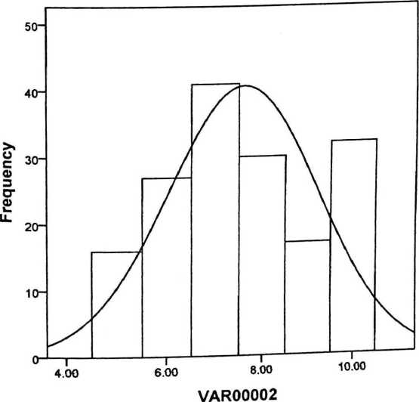

VAR00002

|  |  |
| --- | --- |
| Valid | 163 |
| Missing | 0 |
| Mean | 7.6196 |
| Median | 7.0000 |
| Mode | 7.00 |
| Std.... | 1.59942 |
| Range | 5.00 |
| Minimum | 5.00 |
| Maximu... | 10.00 |

DESKRIPSI DATA X1

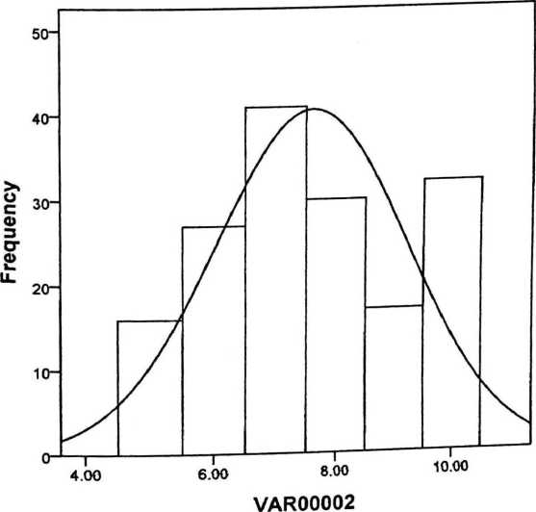

VAR00002

|  |  |
| --- | --- |
| Valid | 163 |
| Missing | 0 |
| Mean | 7.6196 |
| Median | 7.0000 |
| Mode | 7.00 |
| Std.... | 1.59942 |
| Range | 5.00 |
| Minimum | 5.00 |
| Maximu... | 10.00 |

Variables: VAR00001

|  |  |
| --- | --- |
| Valid | 163 |
| Missing | 0 |
| Mean | 16.3926 |
| Median | 17.0000 |
| Mode | 18.00 |
| Std. Deviation | 2.11530 |
| Range | 11.00 |
| Minimum | 9.00 |
| Maximum | 20.00 |

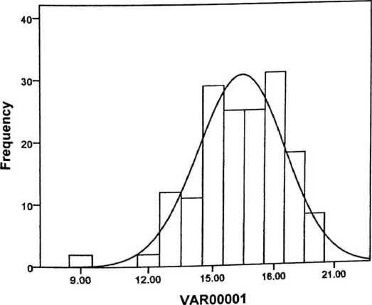

**Variables: VAR00001**

|  |  |
| --- | --- |
| Valid | 163 |
| Missing | 0 |
| Mean | 16.3926 |
| Median | 17.0000 |
| Mode | 18.00 |
| Std. Deviation | 2.11530 |
| Range | 11.00 |
| Minimum | 9.00 |
| Maximum | 20.00 |

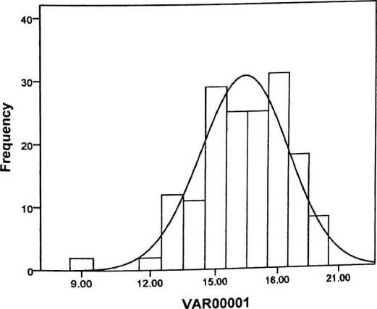

VAR00001

|  |  |
| --- | --- |
| N Valid | 163 |
| Missing | 0 |
| Mean | 20.2331 |
| Median | 20.0000 |
| Mode | 20.00 |
| Std. Deviation | 2.74553 |
| Range | 15.00 |
| Minimum | 10.00 |
| Maximum | 25.00 |

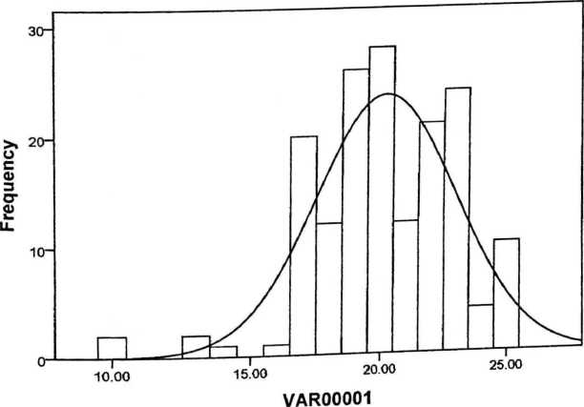

VAR00001

|  |  |
| --- | --- |
| N Valid | 163 |
| Missing | 0 |
| Mean | 20.2331 |
| Median | 20.0000 |
| Mode | 20.00 |
| Std. Deviation | 2.74553 |
| Range | 15.00 |
| Minimum | 10.00 |
| Maximum | 25.00 |

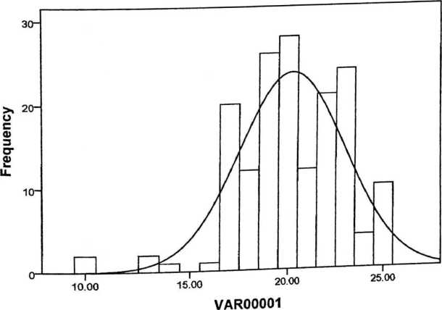

VAR00001

|  |  |
| --- | --- |
| N Valid | 163 |
| Missing | 0 |
| Mean | 19.3313 |
| Median | 19.0000 |
| Mode | 17.00a |
| Std. Deviation | 2.92088 |
| Range | 12.00 |
| Minimum | 13.00 |
| Maximum | 25.00 |

a. Multiple modes exist. The smallest value is shown

Mean =19.33 Std. Dev. =2.921 N = 163

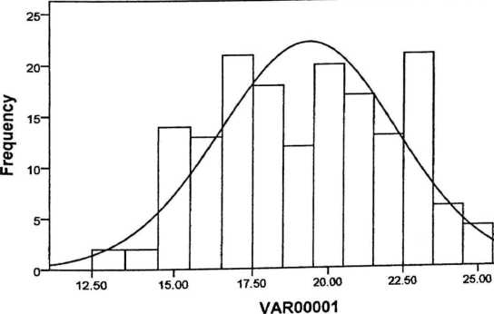

VAR00001

|  |  |
| --- | --- |
| N Valid | 163 |
| Missing | 0 |
| Mean | 19.3313 |
| Median | 19.0000 |
| Mode | 17.00a |
| Std. Deviation | 2.92088 |
| Range | 12.00 |
| Minimum | 13.00 |
| Maximum | 25.00 |

a. Multiple modes exist. The smallest value is shown

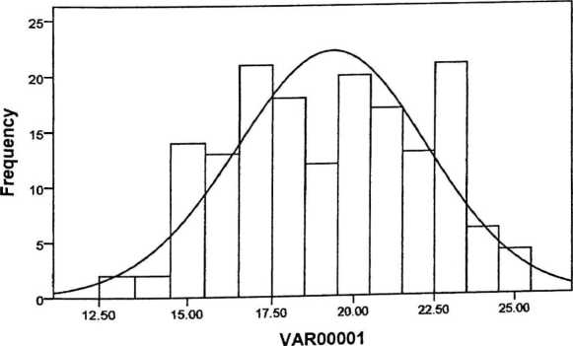

|  |  |
| --- | --- |
| N Valid | 163 |
| Missing | 0 |
| Mean | 11.3681 |
| Median | 11.0000 |
| Mode | 10.00a |
| Std. Deviation | 2.27698 |
| Range | 9.00 |
| Minimum | 6.00 |
| Maximum | 15.00 |

VAR00001

a. Multiple modes exist. The smallest value is shown

Mean = 11.37 Std Dev. = 2.277 N = 163

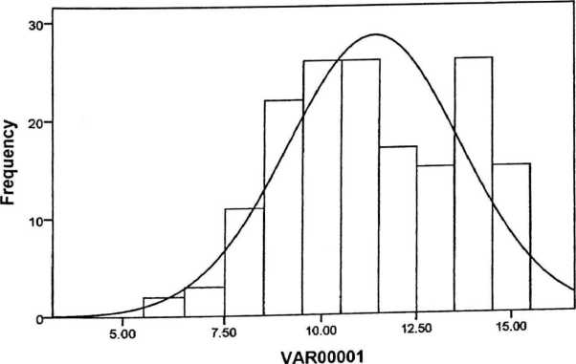

VAR00001

|  |  |
| --- | --- |
| N Valid | 163 |
| Missing | 0 |
| Mean | 11.3681 |
| Median | 11.0000 |
| Mode | 10.00a |
| Std. Deviation | 2.27698 |
| Range | 9.00 |
| Minimum | 6.00 |
| Maximum | 15.00 |

a. Multiple modes exist. The smallest value is shown

Mean = 11.37 Std Dev. = 2.277 N = 163

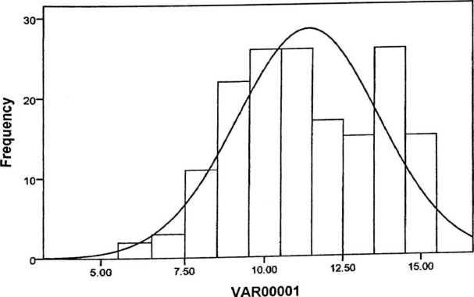

|  |  |
| --- | --- |
| N Valid | 163 |
| Missing | 0 |
| Mean | 12.3374 |
| Median | 12.0000 |
| Mode | 12.00 |
| Std. Deviation | 1.98830 |
| Range | 10.00 |
| Minimum | 5.00 |
| Maximum | 15.00 |

VAR00001

Graph

Mean = 12.34 Std. Dev. = 1.98« N = 163

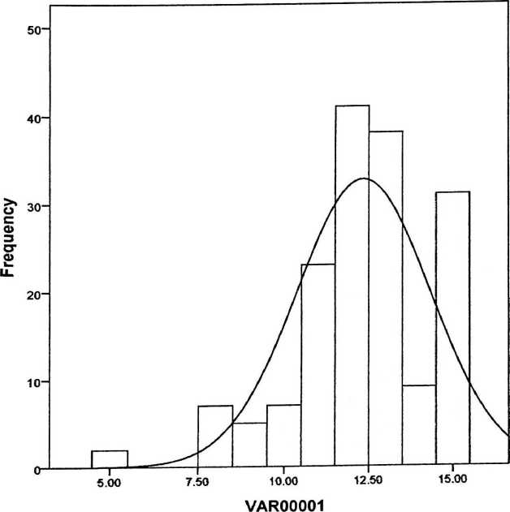

VAR00001

|  |  |
| --- | --- |
| N Valid | 163 |
| Missing | 0 |
| Mean | 7.8405 |
| Median | 8.0000 |
| Mode | 7.00 |
| Std. Deviation | 1.23691 |
| Range | 5.00 |
| Minimum | 5.00 |
| Maximum | 10.00 |

Mean = 7.84 Std. Dev. = 1.237 N = 163

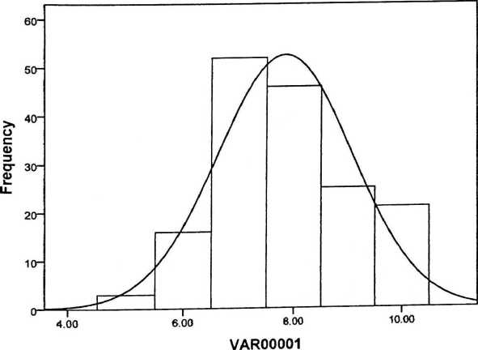

VAR00001

|  |  |
| --- | --- |
| N Valid | 163 |
| Missing | 0 |
| Mean | 7.7975 |
| Median | 8.0000 |
| Mode | 8.00 |
| Std. Deviation | 1.44939 |
| Range | 6.00 |
| Minimum | 4.00 |
| Maximum | 10.00 |

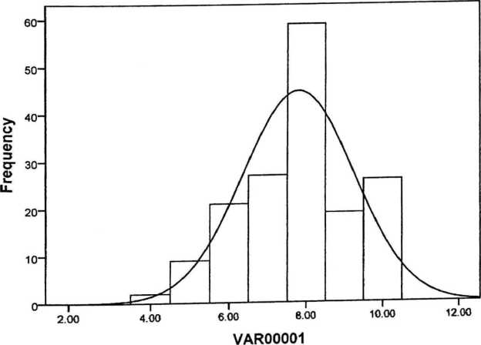

**LAMPIRAN 9**

UJI NORMALITAS DATA X

**Case Processing Summary**

|  |  |  |  |  |  |  |
| --- | --- | --- | --- | --- | --- | --- |
|  | Cases | | | | | |
|  | Valid | | Missing | | Total | |
|  | N | Percent | N | Percent | N | Percent |
| VAR00001 | 163 | 100.0% | 0 | 0.0% | 163 | 100.0% |
| VAR00002 | 163 | 100.0% | 0 | 0.0% | 163 | 100.0% |

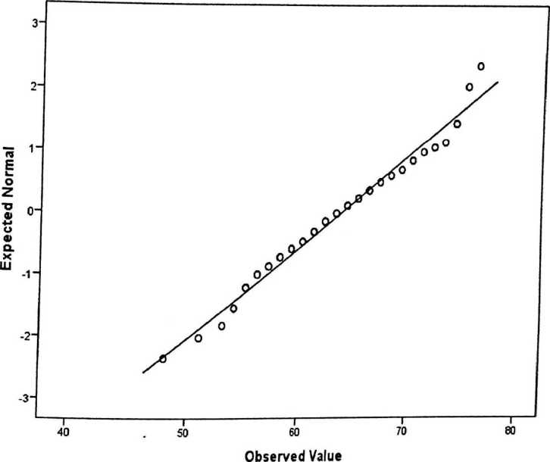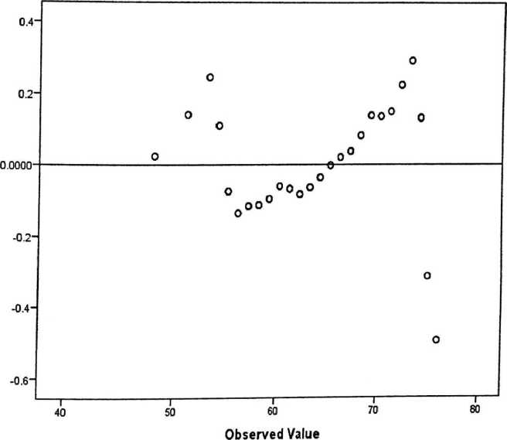

Dev from Normal

3i

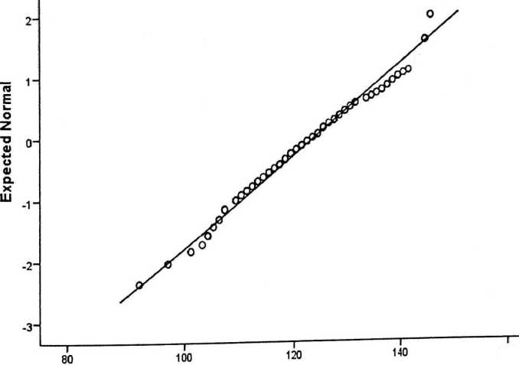

Observed Value

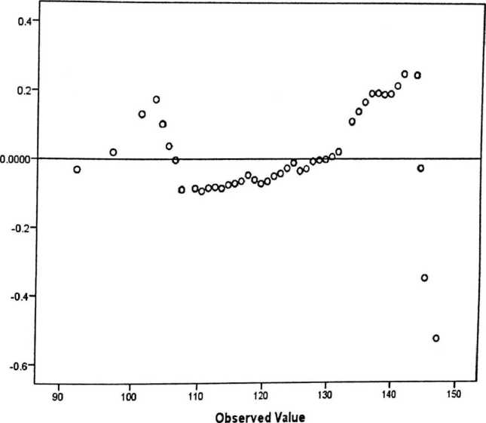

Dev from Normal

Case Processing Summary

|  |  |  |  |  |  |  |
| --- | --- | --- | --- | --- | --- | --- |
|  | Cases | | | | | |
| Valid | | Missing | | Total | |
| N | Percent | N | Percent | N | Percent |
| VAR00001 | 163 | 100.0% | 0 | 0.0% | 163 | 100.0% |

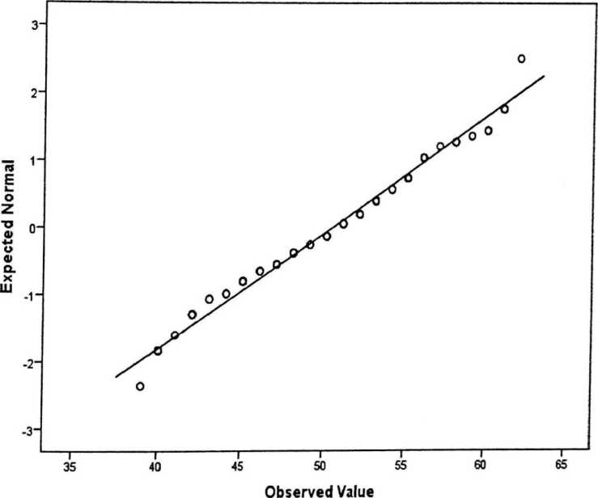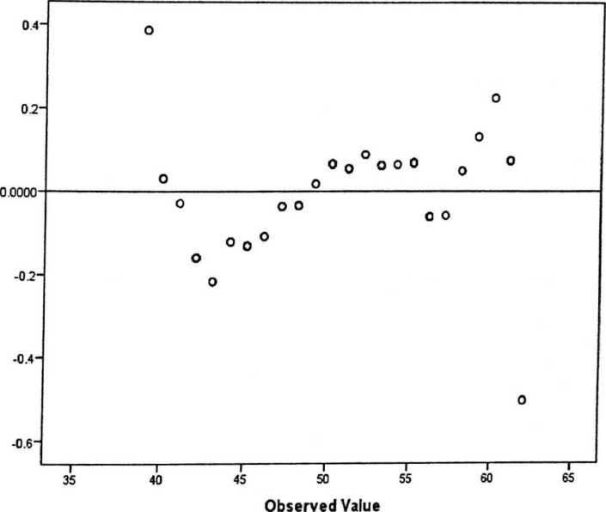

Dev from Normal

Case Processing Summary

|  |  |  |  |  |  |  |
| --- | --- | --- | --- | --- | --- | --- |
|  | Cases | | | | | |
|  | Included | | Excluded | | Total | |
|  | N | Percent | N | Percent | N | Percent |
| VAR00002 * VAR00001 | 163 | 100.0% | 0 | 0.0% | 163 | 100.0% |

A NOVA Table

|  |  |  |  |  |  |  |
| --- | --- | --- | --- | --- | --- | --- |
|  | | Sum of Squares | df | Mean Square | F | Sig. |
| VAR00002 * | Between (Combined) | 2534.872 | 25 | 101.395 | 4.805 | .000 |
| VAR00001 | Groups Linearity | 1456.635 | 1 | 1456.635 | 69.033 | .000 |
|  | Deviation from Linearity | 1078.237 | 24 | 44.927 | 2.129 | .004 |
|  | Within Groups | 2890.760 | 137 | 21.100 |  |  |
|  | Total | 5425.632 | 162 |  |  |  |

Case Processing Summary

|  |  |  |  |  |  |  |
| --- | --- | --- | --- | --- | --- | --- |
|  | Cases | | | | | |
|  | Included | | Excluded | | Total | |
|  | N | Percent | N | Percent | N | Percent |
| VAR Y | 163 | 100.0% | 0 | 0.0% | 163 | 100.0% |

ANOVA Table

|  |  |  |  |  |  |
| --- | --- | --- | --- | --- | --- |
|  | Sum of |  |  |  |  |
|  | Squares | df | Mean Square | F | Sig. |
| VAR Y Between (Combin ■ups ed) | 27455.37  8 | 25 | 1098.215 | 2696.9  29 | .000 |
| Linearity | 27416.75  4 | 1 | 27416.754 | 67328.  378 | .000 |
| Deviatio |  |  |  |  |  |
| n from | 38.624 | 24 | 1.609 | 3.952 | .000 |
| Linearity |  |  |  |  |  |
| Within Groups j | 55.788 | 137 | .407 |  |  |
| Total | 27511.16  6 | 162 |  |  |  |

Regression

Model Summary

|  |  |  |  |  |
| --- | --- | --- | --- | --- |
| Model | R | R Square | Adjusted R Square | Std. Error of the Estimate |
| 1 | .518* | .268 | .264 | 4.96509 |

a. Predictors: (Constant), VAR00001

ANOVA*

|  |  |  |  |  |  |
| --- | --- | --- | --- | --- | --- |
| Mode! | Sum of Squares | df | Mean Square | I F | Sig. |
| 1 Regression | 1456.635 | 1 | 1456.635 | 59.088 | ,000s |
| Residual | 3968.997 | 161 | 24.652 |  |  |
| Total | 5425.632 | 162 |  |  |  |

1. Dependent Variable: VAR00002
2. Predictors: (Constant), VAR00001

Coefficients*

|  |  |  |  |  |  |
| --- | --- | --- | --- | --- | --- |
|  | Unstandardized Coefficients | | Standardized  Coefficients |  |  |
| Model | B | Std. Error | Beta | t | Sig. |
| 1 (Constant) | 21.833 | 3.739 |  | 5.839 | .000 |
| VAR00001 | .450 | .058 | .518 | 7.687 | .000 |

a. Dependent Variable: VAR00002

1224/Stk.05/PP.00.9/05/2017 19 Mei 2017

Biasa

Permohonan Penelitian

Yth. Kepala SMA Kristen Makale . di —

Tempat

Dengan hormat,

Dalam rangka menyelesaikan studi SI di Sekolah Tinggi Agama Kristen Negeri (STAKN) Toraja, maka perlu diadakan penelitian lapangan. Untuk itu, kami mohon

• kesediaan Bapak/Ibu untuk memberikan izin penelitian kepada:

NAMA : Steven Tomy Manati

; NIRM : 20123529

Jurusan : Pendidikan Agama Kristen

Alamat : Makaie

yang akan meneliti tentang: Pengaruh Isi Pembelajaran PAK Terhadap Kecerdasan Emosional Siswa SMA Kristen Makale.

Demikian, atas perhatian dan

\\^,yv v**S-Sah/ion Pnmantung. M.Th**.

M/* * lNO 197607272004041001