Oktavin 5

ORIGINALITY REPORT



.SIMILARITY INDEX

{PRIMARY SOURCES

% % %

INTERNET SOURCES PUBLICATIONS STUDENT PAPERS

rn [www.solidaritasperempuan.org](http://www.solidaritasperempuan.org)

LI ' 1 Internet Source

TXj docplayer.info

i ._J Internet Source

rx] itministrybiogaddress.blogspot.com

i i Internet Source

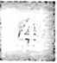

H. van der Veen. "The Merok Feast of the Sa’Dan Toradja", Springer Science and Business Media LLC, 1965

Publication

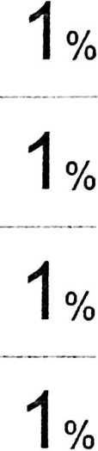

TH vdocuments.site

——i Internet Source



eprints.waiisongo.ac.id

Internet Source

repository.unhas.ac.id

Internet Source

[www.scribd.com](http://www.scribd.com)

Internet Source

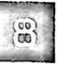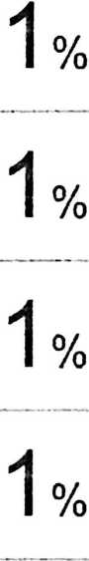

I «



pelangikasihministry.blogspot.com

Internet Source

repository.radenintan.ac.id

Internet Source

eprints.ums.ac.id

Internet Source

i FI

rr



Submitted to Konsorsium Turnitin Relawan Jurnal Indonesia

Student Paper

digilib.unila.ac.id

Internet Source

repository, iainpurwokerto.ac.id

Internet Source

Submitted to Universitas Muhammadiyah Surakarta

1°/c 1 °/c 1 % <1 %

<1 % <1 % <1 %

Student Paper

sprints, uny.ac. id

Internet Source



1 ■«

*



Submitted to President University

Student Paper

Submitted to Universitas Islam Indonesia

Student Paper

Submitted to Universitas Negeri Surabaya The State University of Surabaya

<1

<1

<1

<1



|Sj digilib.uin-suka.ac.id

Internet Source

Sj

es.scribd.com

Internet Source

‘M

relasigender07pab.blogspot.com

Internet Source

<1

<1

<1

%

%

%

stanleyrambitan.blogspot.com

Internet Source

^3 Submitted to Universitas Pelita Harapan

/I'Jj Student Paper

<1

<1

%

%

|  |  |  |
| --- | --- | --- |
| r  RS | ©theses, uin-malang.ac.id  Internet Source | <1 |
| r  pi | Submitted to State Islamic University of Alauddin Makassar  Student Paper | <1 |
| '—^ fi | contohmakalahs.biogspot.com  Internet Source | <1 |
| —- | id.123dok.com  Internet Source | <1 |

0/

/o

%

%

%

r-flfoY

[/•■--Mi

Submitted to Universitas Internationa! Batam

Student Paper

e-repository.perpus.iainsalatiga.ac.id

Internet Source



<1

<1

%

%



|  |  |
| --- | --- |
| Submitted to Universitas Nasional  Student Paper | <1 |
| docobook.com | ^A |
| Internet Source | < I % |
| Submitted to Universitas Islam Negeri Sunan | 0/ |
| Gunung Djati | ^ 1 °/ |
| Student Paper |  |
| herisihaloho.blogspot.com |  |
| Internet Source | ^ 1 °A |
| bonasumbayak27.blogspot.com  Internet Source | <1 °A |



©journal, uin-suka.ac.id

Internet Source

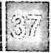

michantroublemaker.blogspot.com

Internet Source



ebookdig.biz

Internet Source

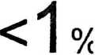

Noor Aniba Maysharoh, Isna Fitria Agustina. "Efektifitas Pembayaran luran BPJS Kesehatan Dengan Si stem 1 Virtual Account (VA) Keluarga", JKMP (Jurnal Kebijakan dan Manajemen Publik), 2020

Publication pitrilianhoguItom.biogspot.com

Internet Source

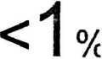

buddhazine.com

Internet Source



rawapada.wordpress.com

Internet Source



easternlightningislifesalvation. home, blog

Internet Source

3 judyhusin.blogspot.com

Jlj Internet Source



siranaorg.wordpress.com

Internet Source



budimana81 .blogspot.com

Internet Source

adellanadia.blogspot.com

—J Internet Source

www. i a w-j u st i ce. co

Internet Source



53 gudangifrnu79.blogspot.com

i Internet Source



angii-vs-jason.blogspot.com

Internet Source

<1 % <1 % <1 % <1 % <1 % <1 % <1 % <1 % <1 % <1 %

Jg| rafika-niiamsari.blogspot.com

L---J Internet Source



untag-banyuwangi.ac.id

Internet Source



PI

hmp2k.blogspot.com

Internet Source

<1

%

blyanlexiano.blogspot.com

Internet Source

<1 %

ri

pM

i -£

gkinrevival.blogspot.com

Internet Source

<1

%

5»)

U —^

punya-nirza.blogspot.com

Internet Source

id.scribd.com

internet Source

<1

<1

%

%

I LIT '(o 5-*

sendawakurasapisang.blogspot.com

Internet Source

fr.scribd.com

Internet Source

|gj kebenaraniman.blogspot.com

c -J Internet Source

<1

<1

<1

%

0/

/O

%

■; lib.geo.ugm.ac.id

til J Internet Source

Exclude quotes

Ofl

Exclude matches

%

