Desti Rone'

by Johan Kurnianto



sion date: 01-Sep-2020 01:27AM (UTC-0500) ion ID: 1371793827

s: BABJ-V_yang_sudah_diperbaiki_dari_plagiarism_-_Copy.docx (73.17K)

AJnt: 9486 r count: 60890

sti Rone'

JAUTY REPORT

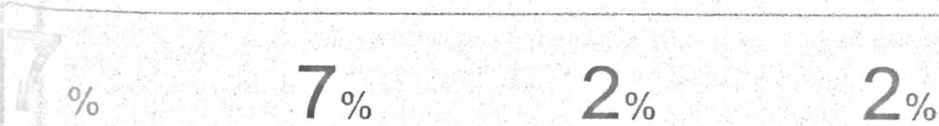

1LARITY INDEX INTERNET SOURCES PUBLICATIONS STUDENT PAPERS

:ary sources

|  |  |  |  |
| --- | --- | --- | --- |
|  | repository.radenintan.ac.id  Internet Source | ' ' :<1 | l % |
| V■ | text-id. 123dok.com  Internet Source | <1 | l % |
| 1 | sejarahmula.blogspot.com  Internet Source | <1 | % |
| J | uppmstakntoraja.blogspot.com  Internet Source | <1 | % |
| J | eprints.wafisongo.ac.id  Internet Source | <1 | % |
| J | adoc.tips  Internet Source | <1 | I % |
| i | docplayer.info  Internet Source | <1 | % |
|  | alexnova-alex.blogspot.com  Internet Source | <1 | l % |
|  | Submitted to iGroup  Student Paper | \ <1 | l % |

1

i