

7kz RoV-.. ■: Creative Arts And Songs In r .ii ■ ■;-,k Fv •' FFluy fidiccj Children At

-■ -iv :v ■ FhF. sn Congregation



**r in Owe Of The**

**: -raeftts For The Bsv^Jor’s Degree**

**: Aiberthin Banne**



**Nirm** : **981** 864

STAKN TORAJA  
2004

CREATIVE ARTS AND SONGS

A Study Of The Role Of Creative Arts And Songs In  
Building Character Of Sunday School Children At  
Kalvari Patongloan Congregation

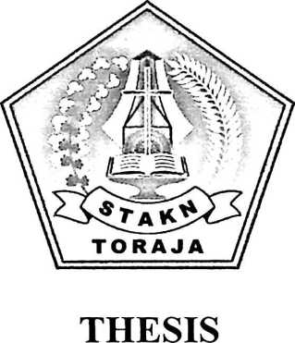

Submitted To STAKN Toraja As One Of The Requirements For The Bachelor’s Degree

By : Alberthin Banne

Nirm : 981 864

STAKN TORAJA  
**2004**

After reading and editing this thesis with the title Creative Arts and Songs

Written by:

|  |  |
| --- | --- |
| Name | : Alberthin Banne |
| Nirm | : 981 864 |
| Department | : Pastoral Theology |

It will be defended before the examination board.

Rantepao, 2004

Supervision

(W k c*^c\ j l-hy? end

BARBARA J. HOPWOOD, Ph. D

CONFIRMATION PAGE

CREATIVE ARTS AND SONGS

The Thesis Title Written By Guided By

Alberthin Banne

Barbara J. Hopwood, Ph.D

It has been defended before the examination board 24 September 2004

Rantepao, 2004

©

