Yusri Kutana

ORIGINALITY REPORT

% 17 % 4%

SIMILARITY INDEX INTERNET SOURCES PUBLICATIONS



8%

STUDENT PAPERS

PRIMARY SOURCES



eddypapayungan.blogspot.com

Internet Source



solata-sejarahbudaya.blogspot.com

Internet Source



Submitted to Universitas Jember

Student Paper



repositori.kemdikbud.go.id

Internet Source



Submitted to Universitas Negeri Jakarta

Student Paper



toraja-culture.blogspot.com

Internet Source

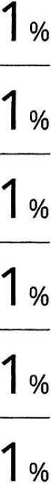

hanatadaniel.blogspot.com

Internet Source

[www.scribd.com](http://www.scribd.com)

Internet Source



docobook.com

Internet Source



<1 % <1 %

<1 %

la