SKRIPSI UNA

originality REPORT

10% 19% 0%

1 %

STUDENT PAPERS

SIMILARITY INDEX INTERNET SOURCES PUBLICATIONS

PRIMARY SOURCES



|  |  |
| --- | --- |
| ppgtjemaatria.blogspot.com  Internet Source | 5%' |
| repository, radenintan.ac.id  Internet Source | 3% |
| [www.scribd.com](http://www.scribd.com)  Internet Source | 2% |
| fekonunima.ac.id  Internet Source | 1 % |
| andosipayung.wordpress.com  Internet Source | 1 % |
| repositori.usu.ac.id  Internet Source | 1 % |
| [www.gsja.org](http://www.gsja.org)  Internet Source | 1 % |
| kampuske2.blogspot.com  Internet Source | 1 % |
| repository, usu.ac.id  Internet Source | 1 % |

repository.uksw.edu



Internet Source

ilhamanjir.blogspot.com

Internet Source

tariezra.blogspot.com

Internet Source

YU ejournal.psikologi.fisip-unmul.ac.id

.'M Internet Source

melayanibersama.blogspot.com

Internet Source

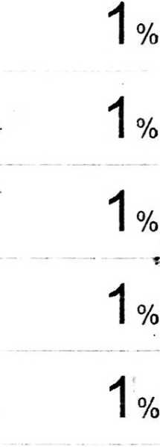

Exclude quotes Exclude bibliography

Off

On

Exclude matches