

SIMILARITY INDEX INTERNET SOURCES PUBLICATIONS STUDENT PAPERS

PRIMARY SOURCES



[www.materi.carageo.com](http://www.materi.carageo.com)

Internet Source



abstrak.uns.ac.id

Internet Source

sidangsinodeam.blogspot.com

Blj! Internet Source



repository.uinjkt.ac.id

Internet Source

gt-jemaatsudiang.com

tL- 'J Internet Source

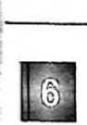

paulusmtangke.wordpress.com

Internet Source

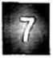

repository.sttjaffray.ac.id

Internet Source

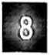

alamsyahlevinus.blogspot.com

Internet Source

[www.scribd.com](http://www.scribd.com)

Internet Source

