Kleterangan:

|  |  |  |  |  |  |  |  |  |  |  |  |  |  |  |  |  |  |  |  |  |  |  |  |  |  |  |  |  |  |  |  |
| --- | --- | --- | --- | --- | --- | --- | --- | --- | --- | --- | --- | --- | --- | --- | --- | --- | --- | --- | --- | --- | --- | --- | --- | --- | --- | --- | --- | --- | --- | --- | --- |
| KOI | NAMA SISWA |  | | | | | PEMANFAATAN LITERASI DICrTAL " ' | | | | | | | | | | | | | | | | | | | | | | | | |
|  | M | cng*lu |  |  |  | M | cojrtel | U |  |  | M | nulnl | | | Mtmubii | | | | | MemtrWkj* | | | | | Magrrdul | | | | |
| ' | 2 | S | 4 | s | ‘ | 2 | J | 4 | S | J | 2 | J | 4 | s | t | 2 | I | 4 | J | • | 1 | J | 4 | i | I | 2 | S | 4 | i |
| 1.. | ADEL JENT1KA BURA |  |  |  |  |  |  |  |  |  |  |  |  |  |  |  |  |  |  |  |  |  |  |  |  |  |  |  |  |  |  |
| J.. | AMANDA KOMBONG KtLA’ |  |  |  |  |  |  |  |  |  |  |  |  |  |  |  |  |  |  |  |  |  |  |  |  |  |  |  |  |  |  |
| J.. | ARIANTO HUBDN |  |  |  |  |  |  |  |  |  |  |  |  |  |  |  |  |  |  |  |  |  |  |  |  |  |  |  |  |  |  |
| 4.. | ASELUMJS MANCCUALI |  |  |  |  |  |  |  |  |  |  |  |  |  |  |  |  |  |  |  |  |  |  |  |  |  |  |  |  |  |  |
| s.» | ASR1ANI PANGGALQ |  |  |  |  |  |  |  |  |  |  |  |  |  |  |  |  |  |  |  |  |  |  |  |  |  |  |  |  |  |  |
| L* | BRAVYENSAUNDINC |  |  |  |  |  |  |  |  | |  |  |  |  |  |  |  |  |  |  |  |  |  |  |  |  |  |  |  |  |  |
| 7J. | CHEL5Y MANABUNC |  |  |  |  |  |  |  |  |  |  |  |  |  |  |  |  |  |  |  |  |  |  |  |  |  |  |  |  |  |  |
| u | DANENDRA WAHV U |  |  |  |  |  |  |  |  |  |  |  |  |  |  |  |  |  |  |  |  |  |  |  |  |  |  |  |  |  |  |
| W- | ELIMTULAK |  |  |  |  |  |  |  |  |  |  |  |  |  |  |  |  |  |  |  |  |  |  |  |  |  |  |  |  |  |  |
| ico. | EUNTULAK |  |  |  |  |  |  |  |  |  |  |  |  |  |  |  |  |  |  |  |  |  |  |  |  |  |  |  |  |  |  |
| 11L | ER1CSO.V SALLATA |  |  |  |  |  |  |  |  |  |  |  |  |  |  |  |  |  |  |  |  |  |  |  |  |  |  |  |  |  |  |
| nt | GIFTA DEIVALENT |  |  |  |  |  |  |  |  |  |  |  |  |  |  |  |  |  |  |  |  |  |  |  |  |  |  |  |  |  |  |
| ux | CLELN PHILUSBATARA |  |  |  |  |  |  |  |  |  |  |  |  |  |  |  |  |  |  |  |  |  |  |  |  |  |  |  |  |  |  |
| 1U | GLENN FIERANSA |  |  |  |  |  |  |  |  |  |  |  |  |  |  |  |  |  |  |  |  |  |  |  |  |  |  |  |  |  |  |
| 05. | BERLIN NEPRI SIAM PA' |  |  |  |  |  |  |  |  |  |  |  |  |  |  |  |  |  |  |  |  |  |  |  |  |  |  |  |  |  |  |
| Mi. | 11ERMIN SAMARA |  |  |  |  |  |  |  |  |  |  |  |  |  |  |  |  |  |  |  |  |  |  |  |  |  |  |  |  |  |  |
| 117. | JEM IS HERIANTO AMBEN |  |  |  |  |  |  |  |  |  |  |  |  |  |  |  |  |  |  |  |  |  |  |  |  |  |  |  |  |  |  |
| m. | MAGITA MANGNGAPA |  |  |  |  |  |  |  |  |  |  |  |  |  |  |  |  |  |  |  |  |  |  |  |  |  |  |  |  |  |  |
| n». | OLIVIA TAHITALLO |  |  |  |  |  |  |  |  |  |  |  |  |  |  |  |  |  |  |  |  |  |  |  |  |  |  |  |  |  |  |
| na. | RESKI PASIANC |  |  |  |  |  |  |  |  |  |  |  |  |  |  |  |  |  |  |  |  |  |  |  |  |  |  |  |  |  |  |
| ML | R2CHAR PARINDING |  |  |  |  |  |  |  |  |  |  |  |  |  |  |  |  |  |  |  |  |  |  |  |  |  |  |  |  |  |  |
| 222. | STANLEY TANGDIRA PAK |  |  |  |  |  |  |  |  |  |  |  |  |  |  |  |  |  |  |  |  |  |  |  |  |  |  |  |  |  |  |
| MJ. | TIARA PATANDUK |  |  |  |  |  |  |  |  |  |  |  |  |  |  |  |  |  |  |  |  |  |  |  |  |  |  |  |  |  |  |
| 224. | Y AKSES PAYUNG |  |  |  |  |  |  |  |  |  |  |  |  |  |  |  |  |  |  |  |  |  |  |  |  |  |  |  |  |  |
| 221 | YEZA SAMPE TONDO K |  |  |  |  |  |  |  |  |  |  |  |  |  |  |  |  |  |  |  |  |  |  |  |  |  |  |  |  |  |  |
| 221 | YUSNAWATI CHIN OlIA |  |  |  |  |  |  |  |  |  |  |  |  |  |  |  |  |  |  |  |  |  |  |  |  |  |  |  |  |  |  |
| 22T. | DESKI PAS 1ANG |  |  |  |  |  |  |  |  |  |  |  |  |  |  |  |  |  |  |  |  |  |  |  |  |  |  |  |  |  |  |

Tabel **2.** Lembar Observasi Pemanfaatan Literasi Digital Pada Siswa Kelas VTIIE di SMP Kristen Makale Siklus II Yesus Teladanku

|  |  |
| --- | --- |
| Predikat | Keterangan |
| 4 | Sangat Baik |
| 3 | Baik |
| 2 | Cukup |
| 1 | Kurang |

III: Yesus Teladanku

|  |  |  |  |  |  |  |  |  |  |  |  |  |  |  |  |  |  |  |  |  |  |  |  |  |  |  |  |  |  |  |  |
| --- | --- | --- | --- | --- | --- | --- | --- | --- | --- | --- | --- | --- | --- | --- | --- | --- | --- | --- | --- | --- | --- | --- | --- | --- | --- | --- | --- | --- | --- | --- | --- |
| NO | NAMA SISWA | pemanfaatan literasi digital | | | | | | | | | | | | | | | | | | | |  | | | | |  | | | | |
| Mengalun | | | | | Menyeleksi | | | | | Memahami | | | | | Menganalisa | | | | |  | Men | nrril | kail |  |  | Me* | gerai | B&SI |  |
| 1 | 2 | 3 | 4 | 5 | 1 | 2 | 3 | 4 | 5 | I | 2 | 3 | 4 | 5 | 1 | 2 | 3 | 4 | 3 | I | 2 | 3 | 4 | 3 | 1 | t | J | 4 | 5 |
| I. | ADEL JENTIKA BURA |  |  |  |  |  |  |  |  |  |  |  |  |  |  |  |  |  |  |  |  |  |  |  |  |  |  |  |  |  |  |
| 2. | AMANDA KOMBONG KILA’ |  |  |  |  |  |  |  |  |  |  |  |  |  |  |  |  |  |  |  |  |  |  |  |  |  |  |  |  |  |  |
| 3. | ARIANTO BUBUN |  |  |  |  |  |  |  |  |  |  |  |  |  |  |  |  |  |  |  |  |  |  |  |  |  |  |  |  |  |  |

|  |  |  |  |  |  |  |  |  |  |  |  |  |  |  |  |  |  |  |  |  |  |  |  |  |  |  |  |  |  |  |  |
| --- | --- | --- | --- | --- | --- | --- | --- | --- | --- | --- | --- | --- | --- | --- | --- | --- | --- | --- | --- | --- | --- | --- | --- | --- | --- | --- | --- | --- | --- | --- | --- |
| IL  '9. | ELIMTULAK |  |  |  |  |  |  |  |  |  |  |  |  |  |  |  |  |  |  |  |  |  |  |  |  |  |  |  |  |  |  |
| 11». | EUN TULA K |  |  |  |  |  |  |  |  |  |  |  |  |  |  |  |  |  |  |  |  |  |  |  |  |  |  |  |  |  |  |
| III. | ERICSON SALLATA |  |  |  |  |  |  |  |  |  |  |  |  |  |  |  |  |  |  |  |  |  |  |  |  |  |  |  |  |  |  |
| lit | GIFTA DEIVALENT |  |  |  |  |  |  |  |  |  |  |  |  |  |  |  |  |  |  |  |  |  |  |  |  |  |  |  |  |  |  |
| 113, | GLE1N PHILUS BATARA |  |  |  |  |  |  |  |  |  |  |  |  |  |  |  |  |  |  |  |  |  |  |  |  |  |  |  |  |  |  |
| m | GLENN FIERANSA |  |  |  |  |  |  |  |  |  |  |  |  |  |  |  |  |  |  |  |  |  |  |  |  |  |  |  |  |  |  |
| IS. | HERLIN NEPRI SIAM PA’ |  |  |  |  |  |  |  |  |  |  |  |  |  |  |  |  |  |  |  |  |  |  |  |  |  |  |  |  |  |  |
| u. | HERMIN SAMARA |  |  |  |  |  |  |  |  |  |  |  |  |  |  |  |  |  |  |  |  |  |  |  |  |  |  |  |  |  |  |
| IT. | JEMIS IIERLANTO AMBEN |  |  |  |  |  |  |  |  |  |  |  |  |  |  |  |  |  |  |  |  |  |  |  |  |  |  |  |  |  |  |
| 1*. | MA GITA MANGNGAPA |  |  |  |  |  |  |  |  |  |  |  |  |  |  |  |  |  |  |  |  |  |  |  |  |  |  |  |  |  |  |
| 19. | OLIVIA TARU’ALLO |  |  |  |  |  |  |  |  |  |  |  |  |  |  |  |  |  |  |  |  |  |  |  |  |  |  |  |  |  |  |
| 20. | RESKI PASIANG |  |  |  |  |  |  |  |  |  |  |  |  |  |  |  |  |  |  |  |  |  |  |  |  |  |  |  |  |  |  |
| 21. | RIC11AR PARIND1NG |  |  |  |  |  |  |  |  |  |  |  |  |  |  |  |  |  |  |  |  |  |  |  |  |  |  |  |  |  |  |
| 22. | STANLEY TANG DIRA’ PA K |  |  |  |  |  |  |  |  |  |  |  |  |  |  |  |  |  |  |  |  |  |  |  |  |  |  |  |  |  |  |
| 23. | TIARA PATANDUK |  |  |  |  |  |  |  |  |  |  |  |  |  |  |  |  |  |  |  |  |  |  |  |  |  |  |  |  |  |  |
| —  22. | YANSES PAYUNG |  |  |  |  |  |  |  |  |  |  |  |  |  |  |  |  |  |  |  |  |  |  |  |  |  |  |  |  |  |  |
| 25. | YEZA SAMPE TON DOK |  |  |  |  |  |  |  |  |  |  |  |  |  |  |  |  |  |  |  |  |  |  |  |  |  |  |  |  |  |  |
| 24. | YL'SNAWATl CHIN CHJA |  |  |  |  |  |  |  |  |  |  |  |  |  |  |  |  |  |  |  |  |  |  |  |  |  |  |  |  |  | — |
| 27. | DESKI PASIANG |  |  |  |  |  |  |  |  |  |  |  |  |  |  |  |  |  |  |  |  |  |  |  |  |  |  |  |  |  |

Keterangan:

|  |  |
| --- | --- |
| Predikat | Keterangan |
| 4 | Sangat Baik |
| 3 | Baik |
| 2 | Cukup |
| 1 | Kurang |



DAFTAR PERTANYAAN PRE-TES DAN POST-TES Berdasarkan mata pelajaran Kelas viii di SMP Kristen makale pada bab 5

dan bab 6

Materi bab 5 : Roh Kudus Penopang hidup Orang Beriman Soal-soal pre-tes dan post-tes pada siklus 1:

1. Siapakah itu Roh Kudus?
2. Dalam bahasa Yunani Roh Kudus Yunani disebut Parakletos yang artinya adalah...
3. Apa sajakah peran Roh Kudus?
4. Apa itu karunia Roh Kudus berdasarkan Yesaya 11:2?
5. Apa yang dijanjikan Tuhan Yesus saat naik ke sorga?

Materi bab 6: Yesus Teladanku

Soal-soal pre-tes dan post-tes pada siklus 2:

1. Apa saj akah yang dapat kita teladani dari kehidupan Yesus?
2. Penyakit apakah yang ditakutkan orang-orang pada zaman Yesus?
3. Siapakah orang yang menjadi penginjil pertama yang mengajak sanak keluarganya menemui Yesus?
4. Sebutkan 1 kelompok yang penting pada zaman Yesus f
5. Dari manakah Yesus memiliki kekuatan dan kemampuan untuk dapat menjalani kehidupan-Nya?

"''H™ «j«> "H'roA. AHUOH

Mengkendek Tana Toraja

; stJKntorajagyahoo.com

Nomor : 3539/Ikn.05/PP.00.9/l0/2021 25 Oktober 2021

Sifat : Biasa

Lampiran : -

Hal : Permohonan Penelitian

Yth. Kepala SMP Kristen Makale

di

Tempat

Dengan hormat,

Dalam rangka menyelesaikan studi SI di IAKN Toraja, maka perlu diadakan penelitian lapangan. Untuk itu kami mohon kesediaan Bapak/lbu untuk memberikan izin penelitian kepada: Nama : Toding

NIRM : 1020175539

Program Studi : Pendidikan Agama Kristen

Yang akan meneliti tentang: “Pemanfaatan Literasi Digital dalam Pembelajaran PAK Untuk iMeningkatkan Prestasi Siswa Kelas VIII melalui Lembar Kerja Siswa di SMP Kristen Makale”.

Demikian permohonan ini, atas perhatian dan kerjasama yang baik diucapkan terimakasih. Tuhan memberkati.

a.n. Rektor

Wakil Dekan Bidang Administrasi Umum, ■Perencanaan dan Keuangan,

Tembusan:

- y-

V'^NoYita.Toding

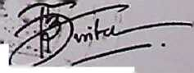

1. Rektor IAKN Toraja di Tana Toraja
2. Dekan Fakultas Keguruan dan Ilmu Pendidikan Kristen
3. Koordinator Prodi Pendidikan Agama Kristen



iww.tuiiM ciwu I nw. LML. i u i V\J£.\JV£. NroiN : W «3U040U

AKREDITASI: A N0.150/SK/BAP-SM/X/2016 TGL.28 OKTOBER 2016  
Alamat : Jl. Nusantara No. *6/102* Telp.0423-22052 Makale Kabupaten Tana Toraji  
*e-mail: smpkristenmakale(a),zmail.com*



Yang bertanda tangan di bawah ini, Kepala SMP Kristen Makale Kabupaten Tana Toraja

Propinsi Sulawesi Selatan menerangkan bahwa i

Nama

NIM

**: TODING**

:1020175539

: Pendidikan Agama Kristen : Institut Agama Kristen Negeri (IAKN) Toraja

Program Studi Universitas



Tana Toraja sejak tanggal 11 s.d. 16 November 2021, judul penelitian adalah : “PEMAMFAATAN LITERASI DIGITAL DALAM PEMBELAJARAN PAK UNTUK MENINGKATKAN PRESTASI SISWA DI SMP KRISTEN MAKALE

Demikian surat keterangan ini kami buat dan diberikan kepada yang bersangkutan untuk dipergunakan sebagaimana mestinya.

Makale, 17 November 2021

n bung, S.Pd

199703 1 012

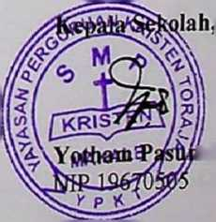

**SURAT KETERANGAN PENGECEKAN PLAG1ASI**

Setelah melalui proses pengecekan dengan menggunakan aplikasi tumitin, maka kami lembaga penelitian dan pengabdian kepada masyarakat (LPPM) IAKN Toraja dengan ini menerangkan skripsi yang ditulis oleh:

Nama : Toding

Nirm : 1020175539

Judul skripsi : Pemanfaatan literasi digital dalam pembelajaran PAK

untuk meningkatkan prestasi siswa Kelas VIII di SMP Kristen Makale

Tanggal pemeriksaan : 29 Desember 2021 Similarity : 18 %

Dinyatakan MEMENUHI SYARAT ambang batas toleransi. Jika dikemudian hari ditemukan kekeliruan karena keterbatasan aplikasi, seperti adanya kesamaan dengan karya ilmiah lain yang lebih awal mendapat pengakuan sebagai hak cipta (misalnya karya ilmiah tersebut belum publislisscara online), maka semua konsekuensi yang ditimbulkan menjadi tanggung jawab penulis skripsi.

Demikian surat keterangan ini, untuk dipergunakan sebagai mana mestinya.

Tana Toraja, 18 Januari 2022.

Penulis

Toding

NIRM 1020175539

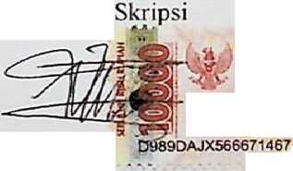

METERAI

TEMPEL

lin Rumbi 200912005

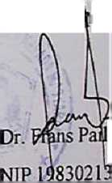

Ketua LPP A IAKN Toraja

Nama :Toding

NIRM : 1020175539

Judul : Pemanfaatan Literasi Digital Dalam Pembelajaran PAK untuk Meningkatkan Prestasi Siswa Kelas VIII

di SMP Kristen Makale

Pembimbing I

|  |  |  |  |  |  |
| --- | --- | --- | --- | --- | --- |
| No | Hari/Tanggal | Materi  Bimbingan | Catatan Solusi Bimbingan | Tanggal Setor Perbaikan | Paraf  Pembimbing |
| \. | 3 ob-SA 3^3 YJLoy | i v' | tabei-CeXvtateovv» ckck>k jita* ^£-C£evA<7\£€. | i^awAvj.oa ^Je-StuAWy  AD2-\ | f |
| A. | Zot-\ | IV | - (2>u»--VW -Hoel |  | f |

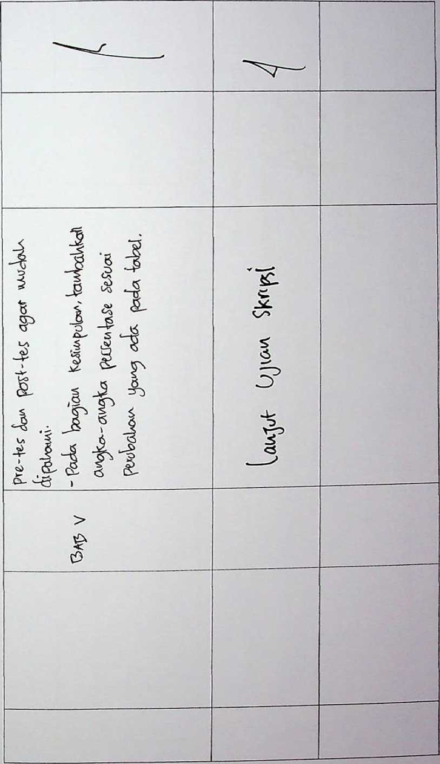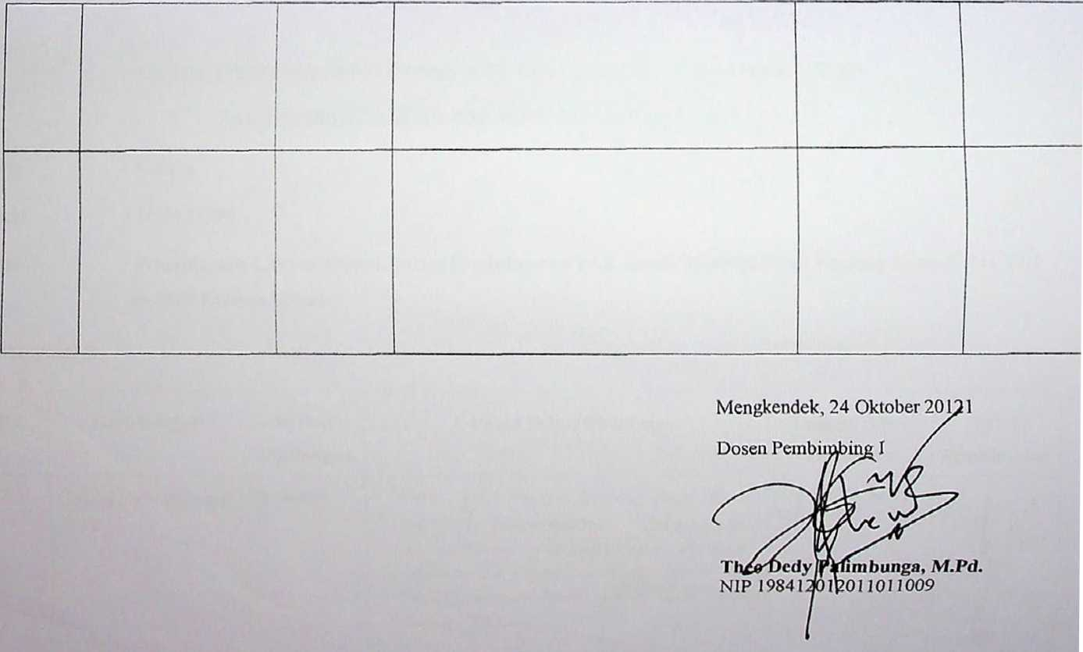

Nama :Toding

NIRM : 1020175539

Judul : Pemanfaatan Literasi Digital Dalam Pembelajaran PAK untuk Meningkatkan Prestasi Siswa Kelas **VIII**

di SMP Kristen Makale

Pembimbing II

|  |  |  |  |  |  |
| --- | --- | --- | --- | --- | --- |
| No | Hari/Tanggal | Materi  Bimbingan | Catatan Solusi Bimbingan | Tanggal Setor Perbaikan | Paraf  Pembimbing |
|  | cer  202.V | : | - GurnU JuAuU o  tA^WacXv ^JAA0yV) XatjJ Vy 9XM,t^r ticVA ^-«£Iaa\q^C  ~~ <zOMU0' -(edli ‘’lo^\ L&tb&r JT"? cu«^ . | Wt'5/ -2.^ VvS^v/c^ 'Lo'LK | f.  4- |

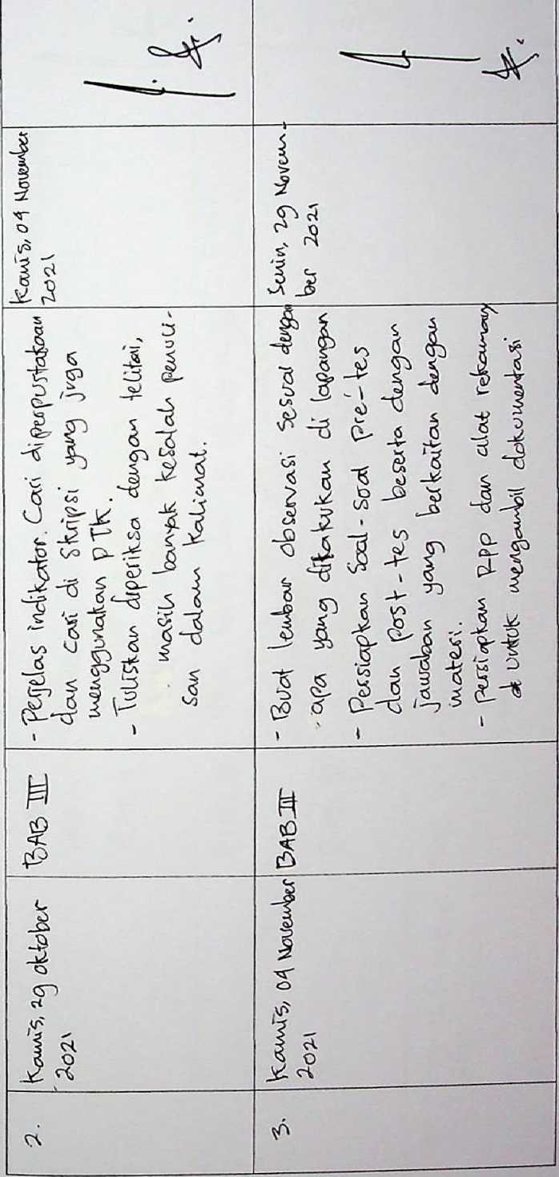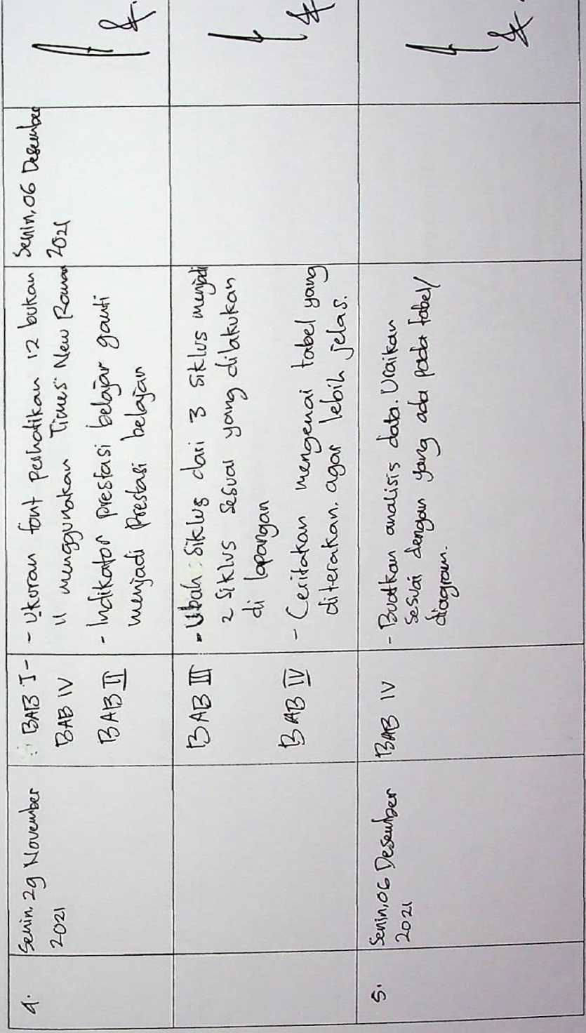

|  |  |  |  |  |  |
| --- | --- | --- | --- | --- | --- |
| G. | 2&x\ | IV  £«3 V | - TauAbobviScMA Ax <Xualfo*s,^ertVai/'0  l* tacXvfc 1/WXvJ pUV\  3eJi/cSaU xlka^ UTfawf ' W<MfcAa<ALja tebp |  | ^ • |
|  |  |  | <A^ rsr Se(3£»<ff |  |  |

Mengkendek, 14 Oktober 2021 Dosem Pembimbing II

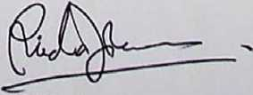

Alfrida Lembang, M.Pd.K.

N l P 108504102019032012